

What is a virus?
- What did the BTN story explain?
- Give three examples of things that are caused by viruses.
- Viruses are one of the four families of _________________.
- What are the other three types of pathogens?
- When were viruses first discovered?
- What do viruses need to spread?
- What is the name of the body’s inbuilt virus defence?
- What is a vaccination and how does it work?
- What can you do to stop the spread of viruses?
- Name three facts you learnt about viruses.

COVID-19 Contact Tracing
- Discuss the BTN COVID-19 Contact Tracing story as a class and record the main points of the discussion.
- What is contact tracing?
- Contact tracing speeds up the spread of infectious diseases. True or false?
- Why is contact tracing important?
- What Australian city is currently in lockdown?
- What New Zealand city is currently in lockdown?
- How do lockdowns help reduce the spread of COVID-19?
- What app is the government encouraging people to download?
- How does the app work?
- What questions do you have after watching the BTN story?

Handwashing
- Before watching the BTN story discuss what you know about hand hygiene.
- What did the BTN Handwashing story explain?
- What year did Dr Semmelweis realise that handwashing was important for our health?
- What famous nurse supported Dr Semmelweis’ views about handwashing?
- What is another word for germs?
- What did the experiment in the BTN story show?
- How many seconds should you wash your hands for?
- What are good handwashing practices? Write step-by-step instructions.
- Why are countries releasing videos about hand hygiene?
- What did you learn from the BTN Handwashing story?

Teacher Resource
What is a virus?

Students will investigate what a virus is and how viruses spread. Students will create a biography on the discoverer of viruses.


Science – Year 5 & 6
Scientific knowledge is used to solve problems and inform personal and community decisions.

With guidance, pose clarifying questions and make predictions about scientific investigations.

Science – Year 7
Scientific knowledge has changed peoples’ understanding of the world and is refined as new evidence becomes available.

Identify questions and problems that can be investigated scientifically and make predictions based on scientific knowledge.


- What did the BTN story explain?
- Give three examples of things that are caused by viruses.
- Viruses are one of the four families of _________________.
- What are the other three types of pathogens?
- When were viruses first discovered?
- What do viruses need to spread?
- What is the name of the body’s inbuilt virus defence?
- What is a vaccination and how does it work?
- What can you do to stop the spread of viruses?
- Name three facts you learnt about viruses.


Class discussion
After watching the BTN What is a virus? story, hold a class discussion about the information raised in the story. The following questions may help guide the discussion:

- What did you SEE in this video?
- What does this video make your WONDER?
- What did you LEARN from this story?
- What QUESTIONS do you have after watching the story?

Questions about COVID-19
Do your students have questions about the coronavirus COVID-19? Watch BTN’s Coronavirus Questions story and Ask A Reporter to learn more and find out if your students questions about COVID-19 are answered.
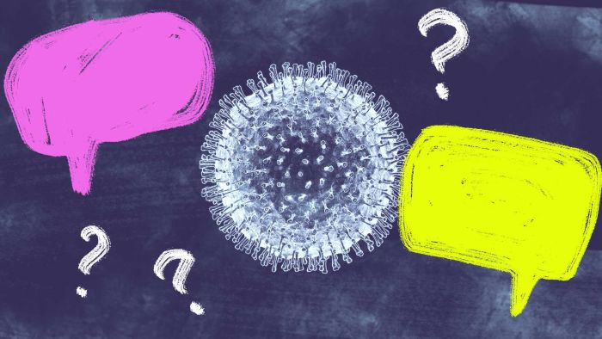
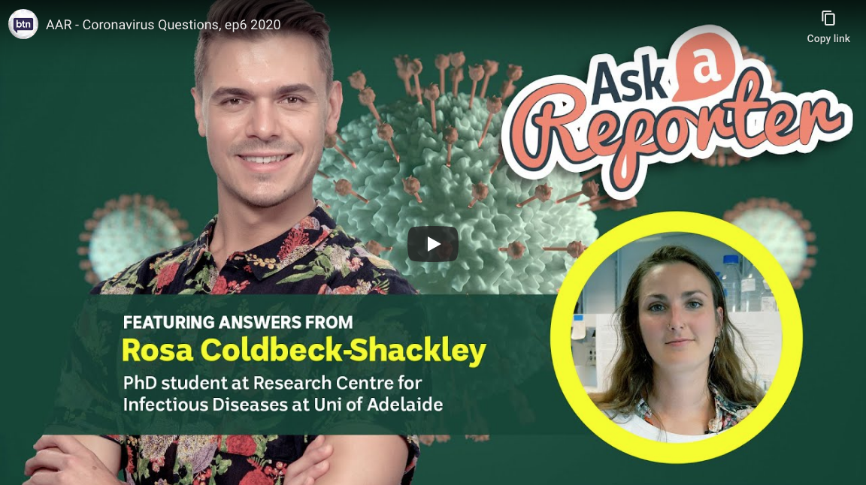


Glossary
Students will brainstorm a list of key words that relate to the BTN What is a virus? story. Students may want to use pictures and diagrams to illustrate the meaning and create their own glossary. Here are some words to get you started.
Pathogen | Immune system | Vaccine
Virus | Germs | Bacteria

KWLH
Hold a class discussion after watching the BTN What is a virus? story. What questions were raised in the discussion (what are the gaps in their knowledge)? The following KWLH organiser provides students with a framework to explore their knowledge on this topic and consider what they would like to know and learn.

What do I know? | What do I want to know? | What have I learnt? | How will I find out?

Research questions for inquiry
Students will determine a focus for their inquiry and develop a key question to guide their inquiry (below are some examples). Students will collect and record information from a wide variety of sources (internet, books, newspaper and magazines).

- What is a virus? Choose one type of virus to research in more detail.
- How do viruses spread?
- Who first discovered viruses? Create a biography on the scientist who made the discovery.
- What is the difference between viruses and bacteria?

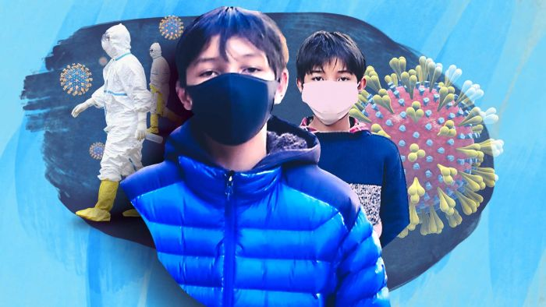
BTN story – COVID-19 Explained
Watch the following BTN COVID-19 Explained story to learn more about the coronavirus. Watch the story as a class and students will then respond to the focus questions.

- Discuss the BTN Coronavirus Explained story as a class and record the main points of the discussion.
- Where was the coronavirus first found? Find using Google Maps.
- What type of market do they think the virus started in?
- What does the Latin word ‘corona’ mean?
- What are the symptoms of coronavirus?
- Coronavirus can be transmitted from animals to humans. True or false?
- What is China doing to stop the spread of coronavirus?
- Which organisation has declared a global health emergency?
- How did the BTN story make you feel? Discuss with another student.

Create a biography
Using the Biography Organiser template at the end of this activity, students will find and record information about Dmitri Ivanovsky, the discoverer of viruses. Some possible areas of research include:

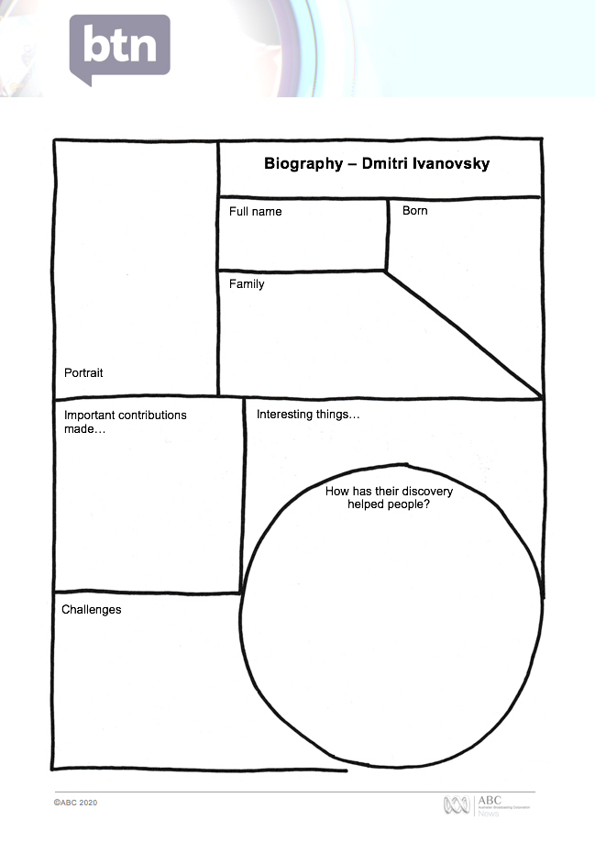
- Where and when were they born?
- What are some of their achievements? Choose one to explore in more detail.
- What inspired/motivated them?
- What were their challenges?
- How are their achievements recognised?
- How have they made an impact on people’s lives?
- How did they change our understanding of the world?
- What do you admire about them?
- Imagine you could sit down and talk to them. What questions would you ask about their life and work?

Present your findings in an interesting way.
- Give a presentation on their achievements.
- Make a “Did you know?” for other students.
- Write a letter thanking them for their achievements and how they have changed the world.
- Create a timeline highlighting significant events.


Coronavirus Questions – BTN
https://www.abc.net.au/btn/classroom/coronavirus-questions/12024698

COVID-19 Explained – BTN
https://www.abc.net.au/btn/classroom/coronavirus-explained/11933838

How does a virus work? – ABC Education
https://education.abc.net.au/home/#!/media/2238712/how-does-a-virus-work-

Biography – Dmitri Ivanovsky
Family
Full name

Portrait
Important contributions made…
Born
How has their discovery helped people?
Interesting things…
Challenges


Teacher Resource
Handwashing
Students will plan and practise strategies to promote good hand hygiene in their community.

Health – Year 3-4
Identify and practise strategies to promote health, safety and wellbeing.

Describe strategies to make the classroom and playground healthy, safe and active spaces.

Discuss and interpret health information and messages in the media and internet.

Health – Year 5-6
Plan and practise strategies to promote health, safety and wellbeing.

Investigate the role of preventive health in promoting and maintaining health, safety and wellbeing for individuals and their communities.

Health – Year 7-8
Investigate and select strategies to promote health, safety and wellbeing.

Plan and use health practices, behaviours and resources to enhance health, safety and wellbeing of their communities.

- Before watching the BTN story discuss what you know about hand hygiene.
- What did the BTN Handwashing story explain?
- What year did Dr Semmelweis realise that handwashing was important for our health?
- What famous nurse supported Dr Semmelweis’ views about handwashing?
- What is another word for germs?
- What did the experiment in the BTN story show?
- How many seconds should you wash your hands for?
- What are good handwashing practices? Write step-by-step instructions.
- Why are countries releasing videos about hand hygiene?
- What did you learn from the BTN Handwashing story?

What do you see, think and wonder?
After watching the BTN Handwashing story, students will respond to the following questions:

- What did you SEE in this video?
- What do you THINK about what you saw in this video?
- What did you LEARN from this story?
- What was SURPRISING about this story?
- What QUESTIONS do you have about this story?

Glossary
Students will brainstorm a list of key words and terms that relate to the BTN Handwashing story. Students may want to use pictures and diagrams to illustrate the meaning and create their own glossary. Here are some words to get you started.
Germs | Hygiene | Contagious
Virus | Bacteria | Preventative
Contamination | Public health | Infectious

Campaign
Students will design a public education campaign to raise awareness about good hand hygiene and the importance of handwashing. Students will need to think about their campaign’s aim, target audience, and the value of raising awareness at their school. Use Canva to design a poster to put up around your school and the wider community.

To create a school awareness campaign, students will need to identify the following:
- When should you wash your hands? Make a list.
- What are good handwashing practices? Write step-by-step instructions.
- Why is handwashing so important?
- How can you teach other kids about good hand hygiene? Think of creative ways you can teach kids your message about handwashing.

Some questions to consider when designing your campaign:
- What is the campaign’s main aim?
- Do you have a slogan or message? What is it?
- Who is your target audience?
- What is the best way to communicate the message?

Discuss with students how they will get their message out there to help raise public awareness. Some possibilities include:
- Short film or animation
- Community service announcement (for television or radio).
- Press release (create posters to be put up around the school or pamphlets to give to all students).

Public service announcements
Because the coronavirus COVID-19 is a global concern, video PSAs (public service announcements) are emerging from all corners of the globe. As well as government productions, individuals including comedians, musicians and TikTokers, are making and sharing their own videos about handwashing.

Watch the following videos to see how people in other countries are communicating the message about good hygiene and handwashing.

  Instagram – Danial Kheirikhah from Iran | 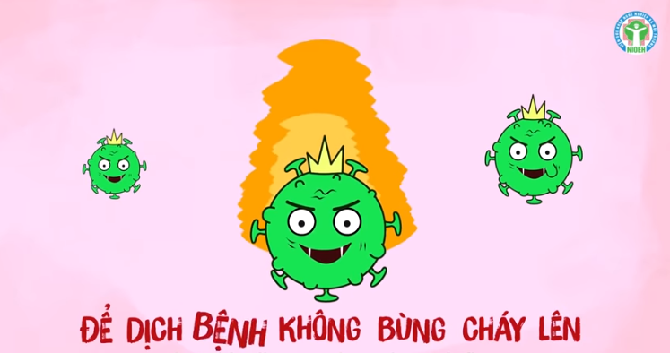  YouTube - Vietnam’s Ministry of Health
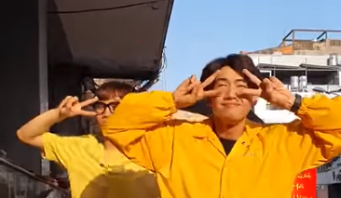  YouTube - Quang Đăng | 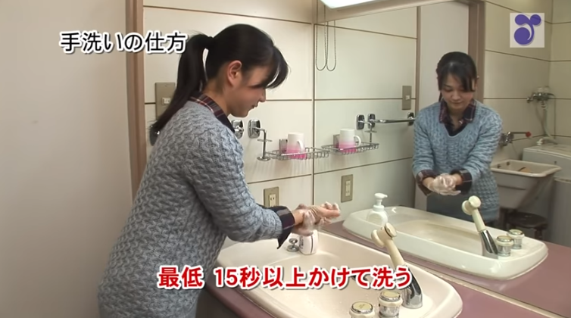  YouTube - Japan's Ministry of Health

After watching the videos hold a discussion about PSAs (public service announcements) and why they are important. Students will then respond to the following:
- What is a public service announcement?
- What was your favourite video about handwashing? Why?
- What video most effectively communicated good hand hygiene?
- Choose one of the videos and describe what is happening. What message does it communicate? What is the purpose of the video?
- In small groups create your own short video about handwashing and why it is important.

Handwashing – BTN
https://www.abc.net.au/btn/classroom/handwashing/10539976

Handwashing – Health Direct
https://www.healthdirect.gov.au/hand-washing

Global Handwashing Day
https://globalhandwashing.org/global-handwashing-day/

Handwashing: why it’s important – Better Health
https://www.betterhealth.vic.gov.au/health/ConditionsAndTreatments/handwashing-why-its-important

Coronavirus Explained – BTN
https://www.abc.net.au/btn/classroom/coronavirus-explained/11933838

Hands are important in containing coronavirus and now is the time to start good hygiene habits – ABC News
https://www.abc.net.au/news/health/2020-03-01/hand-washings-role-in-stopping-coronavirus-covid-19-spread/12014020

