EPISODE 30
26th October 2021

KEY LEARNING
Students will view a range of BTN stories and use comprehension skills to respond to a series of focus questions.

CURRICULUM
English – Year 4
Use comprehension strategies to build literal and inferred meaning to expand content knowledge, integrating and linking ideas and analysing and evaluating texts.

English – Year 5
Use comprehension strategies to analyse information, integrating and linking ideas from a variety of print and digital sources.

English – Year 6
Use comprehension strategies to interpret and analyse information and ideas, comparing content from a variety of textual sources including media and digital texts.

English – Year 7
Use comprehension strategies to interpret, analyse and synthesise ideas and information, critiquing ideas and issues from a variety of textual sources.
  - Teacher Resource

Focus Questions

Back to School
- How do the kids in the BTN story feel about going back to face-to-face learning?
- According to the UN, about how many students around the world have been affected by schools closing because of the pandemic?
- What have been some of the challenges of remote learning?
- What are some of the changes students will notice being back in the classroom?
- How did this story make you feel?

Heritage Protection Laws
- What was the main point of the BTN story?
- What did mining company Rio Tinto destroy?
- Explain the significance of the rock shelters.
- What changes did a recent report recommend to better protect cultural heritage sites?
- Why is protecting Indigenous cultural heritage important?

Media Literacy Week 2021
- Why is it important to question the information you see online?
- What is bias and what can influence it?
- What is clickbait?
- Why is it sometimes hard to know when something is an ad?
- What did you learn watching this story?

Check out the Media Literacy Week 2021 resource on the Teachers page.

New Antarctic Icebreaker
- What is the job of an icebreaker?
- Why has Nuyina been described as `Disneyland for Scientists’?
- What is the ‘moon pool’ and what is its function?
- What does Nuyina mean in Palawa Kani?
- Which ship does Nuyina replace?

Check out the New Antarctic Icebreaker resource on the Teachers page.

Her Way Sports Magazine
- What is Abbie’s magazine about?
- What gave her the idea for the magazine?
- What skills has Abbie learnt creating the magazine?
- Where does half of the money from the sale of the magazine go?
- How have people responded to Her Way?

EPISODE 30
26th October 2021

KEY LEARNING
Students will learn more about how to be critical consumers of news. Students will plan and produce their own BTN style news report.

CURRICULUM
Media Arts – Years 5 & 6
Plan, produce and present media artworks for specific audiences and purposes using responsible media practice.

Media Arts – Years 7 & 8
Develop and refine media production skills to shape the technical and symbolic elements of images, sounds and text for a specific purpose and meaning.

Plan, structure and design media artworks that engage audiences.

English – Year 6
Analyse how text structures and language features work together to meet the purpose of a text.

Analyse strategies authors use to influence readers.

English – Year 7
Analyse and explain the ways text structures and language features shape meaning and vary according to audience and purpose.

Compare the text structures and language features of multimodal texts, explaining how they combine to influence audiences.

  - Teacher Resource

Media Literacy Week 2021

Focus Questions
Discuss the BTN story as a class and record the main points of the discussion. Students will then respond to the following:
- Why is it important to question the information you see online?
- What is bias and what can influence it?
- What is clickbait?
- Why is it sometimes hard to know when something is an ad?
- What did you learn watching this story?

Activity: Class discussion
After watching the BTN Media Literacy Week 2021 story, use the following questions to find out what your students know about media literacy and how they consume the news.
- What is media literacy and why is it important?
- Where do you get your news from? How do you consume the news?
- What do you know about media bias?
- What is fake news?
- What surprising information did you learn in the BTN story?

Activity: News vocabulary
Students will brainstorm a list of keywords that relate to understanding the news. Here are some words to get them started. Students will create their own class glossary of keywords and terms. Students can use illustrations and diagrams to help explain each keyword.
FAKE NEWS | BIAS
NEWS VALUES | JOURNALIST
SOURCE | RELIABLE
CLICKBAIT | CREDIBLE

Activity: KWLH
After watching and discussing the BTN Media Literacy Week 2021 story, what questions do students have? The following KWLH organiser provides students with a framework to explore their knowledge on this topic and consider what they would like to know and learn.
What do I know? | What do I want to know? | What have I learnt? | How will I find out?

Students will develop their own question/s for inquiry, collecting and recording information from a wide variety of sources. Students may develop their own question for inquiry or select one or more of the questions below.

- What is fake news? How can you tell the difference between real and fake news? Write some tips for kids to help them become media savvy.
- What does it mean to consume the news? Make a list of the top 5 best ways kids should consume and think about the news. Think about the following concepts when responding to this question: news bias, fake news, reliable news sources.
- How has social media changed the way we consume the news? Conduct a survey to find out where people the get their news from. What do you results tell you about where people get the majority of their news?
- Students will make comparisons between how the news is made now with how it was done in the 1960s, 1970s, 1980s, 1990s or 2000s. Students will find out what has changed and stayed the same.
- Make a prediction about how the way news is reported will change in the future. Illustrate your prediction/s and provide an explanation.

Activity: How do you consume the news?
Class Discussion
Facilitate a class discussion to find out where your students get their news from and how they engage with the news. Use the following questions to guide the discussion:
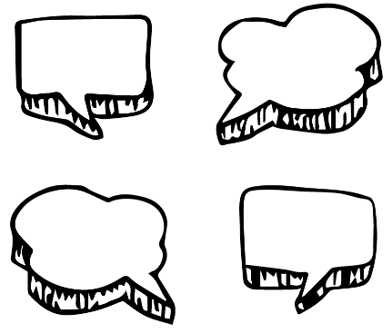
- What news are you most interested in?
- What news are you least interested in?
- Where do you hear, see or listen to news you are interested in?
- When are you most likely to learn about the news?
- How is your news diet different to your classmates?

News Diet Challenge
Students can complete the ABC Education News Diet Challenge, which asks students to:
- Keep a news diary for one or two days.
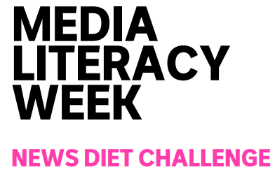
- Rank the stories in the diary for `most nutritional’ to `least nutritional’.
- Take one of the `most nutritional’ stories and look at how it’s covered by news services.
- Students can create a short video about the experience.

News Diet Challenge: Toolkit

Activity: Fact vs Opinion vs Analysis
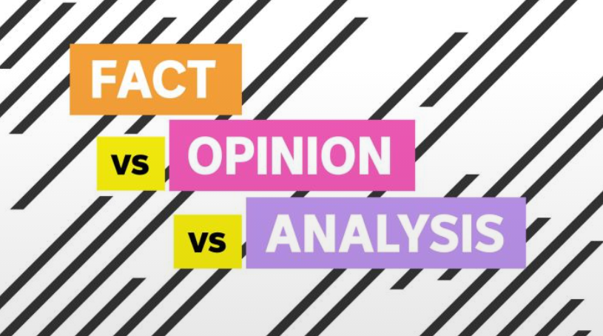
This ABC Education all in one interactive resource for teachers is an engaging introduction to the topic that works seamlessly in the classroom on laptops, tablets and projectors.

Designed so you can mix and match to suit your unit of work, it integrates an explainer video, talking points for the class and quick tests, as well as example content - perfect for media literacy or text analysis.

Before you begin this interactive, explain to your students what the terms FACT, OPINION and ANALYSIS mean.

Interactive: Fact vs Opinion vs Analysis

Activity: Fake News
Students will watch one or both of the following BTN stories to learn more about fake news, and then respond to the questions below.

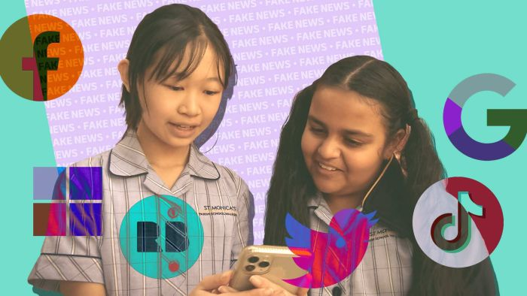  Fake News Fight (BTN) | 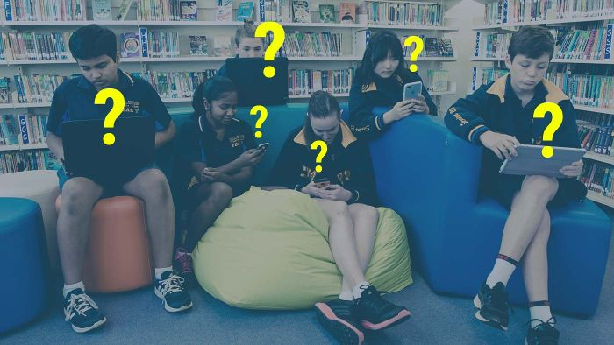  Fake News (BTN)

Focus questions
- What is an example of a fake news story?
- Why are a lot of fake news stories created?
- Why are some fake news stories meant to deliberately trick people?
- What does Facebook say about the problem of fake news?
- What can people do to be more aware of fake news?
- Why is it important to question everything you read online?

Further learning
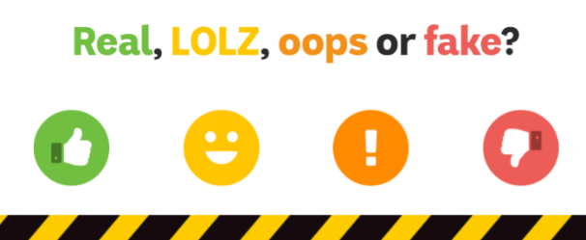
- Test your knowledge by playing the Real, LOLZ, oops or fake? game
- For older students, the BTN Media Literacy series explains How to Spot Fake News.
- The eSafety Commissioner has Fake News resources for teachers and students.

Activity: What makes something ‘news’?
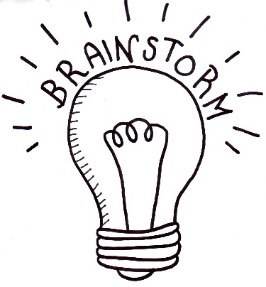
Students will investigate what makes an event newsworthy. Before starting this activity, brainstorm some ideas as a class.

Watch BTN’s News Values video, which explores what makes news, news. In this video we look at the news values that determine which stories we see and hear about and which ones we don't and how those news values can subtly shape the way we see the world.

Make your own news story
Students will then put together their own news program. Students will need to include a good balance of stories across different topics (for example: science, politics, world news, environment, arts, sport and human interest).

Respond to the following questions for each news story.
- Why did you choose this story?
- Summarise the main issue/message.
- Is the news story about a current local issue or an issue from the past?
- Where and when did it happen?
- What new information have you found about it?
- Who is affected by the issue?
- How are they affected by the issue?
- Why is it important for people to know about the issue?
- Why will people be interested in watching the news story?

Useful Websites
- Media Literacy Video Series – BTN
- Media Literacy – ABC Education
- Fake News Fight – BTN
- Fake News – eSafety Commissioner
- Kids’ News Service – BTN
- Behind the Scenes at BTN – BTN
- Becoming a journalist – BTN
- Use the News – ABC Education

  - Teacher Resource
EPISODE 30
26th October 2021

KEY LEARNING
Students will learn more about Australia’s new Antarctic icebreaker Nuyina. They will also explore the important role ships have played in Australia’s scientific endeavours in Antarctica.

CURRICULUM
Science – Years 5 & 6
Scientific knowledge is used to solve problems and inform personal and community decisions.

Science – Year 6
The growth and survival of living things are affected by physical conditions and their environment.

New Antarctic Icebreaker

Focus Questions
Discuss the BTN story as a class and record the main points of the discussion. Students will then respond to the following:
- What is the job of an icebreaker?
- Why has Nuyina been described as `Disneyland for Scientists’?
- What is the ‘moon pool’ and what is its function?
- What does Nuyina mean in Palawa Kani?
- Which ship does Nuyina replace?

Activity: Class Discussion
Before students watch the BTN story, ask them what they already know about Antarctica. Have they heard of icebreakers that travel to Antarctica? Record their responses.
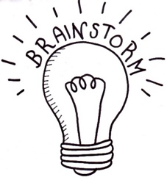
Discuss the BTN New Antarctic Icebreaker story as a class. Ask students to record what they know about the topic. What questions do they have? Use the following questions to guide discussion:

- Where is Antarctica? Locate on a map.
- What is an icebreaker?
- What does Nuyina mean in Palawa Kani?
- Which icebreaker did it replace?
- How does the icebreaker help with scientific research?
- What words best describe the new icebreaker?
- What questions do you have about the story?

Activity: Glossary
Students will brainstorm a list of key words that relate to the BTN New Antarctic Icebreaker story. Students may want to use pictures and diagrams to illustrate the meaning and create their own glossary. Here are some words to get you started.

ICEBREAKER | ANTARCTICA | EXPEDITION
SCIENTIFIC RESEARCH | SEA ICE | VOYAGE

Activity: Antarctic Icebreaker Research
After watching and discussing the BTN New Antarctic Icebreaker story, what questions do students have? Below are some questions students can research.
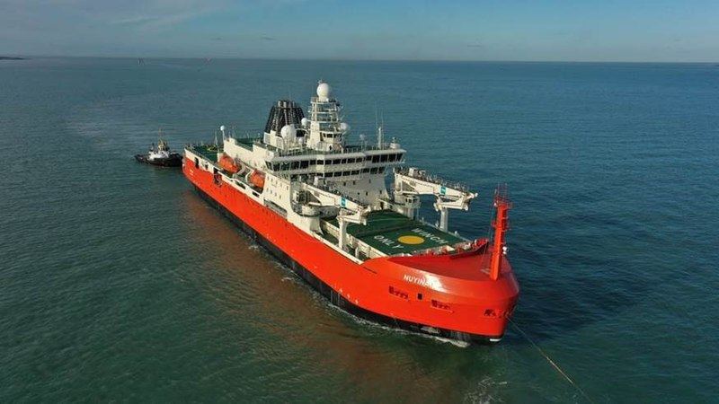
- What is an icebreaker? What special features do they have? What happens when the ships move through ice covered water?
- What makes the Nuyina better suited to Antarctic travel than the previous icebreaker, Aurora Australis?
- Investigate the history of Antarctic icebreakers. How have they changed over time?
- Why is Nuyina described as the `triathlete of Antarctic vessels’? Research and explain the three important functions of the ship.
- Nuyina is home for scientists and expeditioners during long voyages. Find out more about what life is like aboard the icebreaker. Here is some information to get you started.
- Investigate the marine science research the Antarctic icebreaker does. What special research features does the Nuyina have? Take a look at the different capabilities onboard the Nuyina in this video.

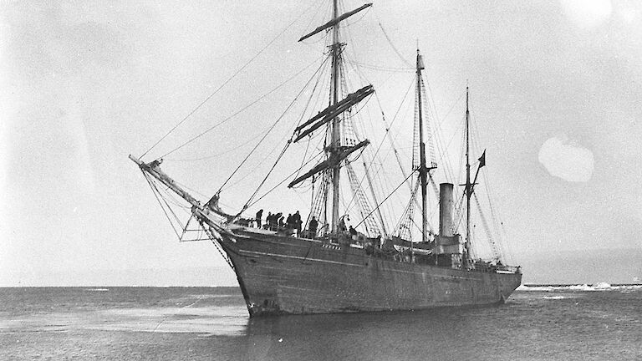
Students can learn more about the important role ships have played in our understanding of Antarctica. Watch the Ships of Science video and respond to the following questions:
- Why have ships played an important role in Australia’s scientific endeavours in Antarctica?
- What did you learn watching the Science of Ships video?
- What questions do you have?

Activity: Antarctic Explorer App
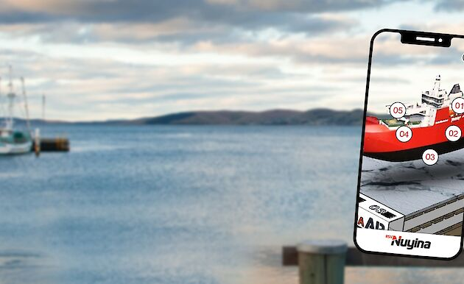
Students can check out the Antarctic Explorer App to experience an interactive 3D augmented reality model of the icebreaker Nuyina. There are also augmented reality portals that open to real unique scenes from Antarctica.

Activity: Choose a project
Individually or in small groups, students will choose one of the following projects to work on and then present their findings to the class.

Extreme Weather
Investigate some of the ways animals and people are affected by the extreme weather conditions in Antarctica. What equipment, behaviours and adaptations do they have for coping with extreme conditions?

Expedition to Antarctica
Imagine you are an adventurer visiting Antarctica for the first time. What will you need to understand about Antarctica’s environment before embarking on your trip? Plan an itinerary for your adventure. What challenges might you face?

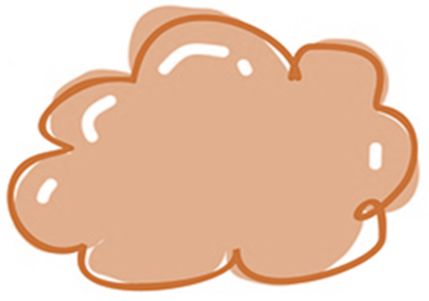
Australia’s connection to Antarctica
Describe Australia’s connection to Antarctica. Create a timeline showing major expeditions and discoveries made by Australians in Antarctica.

Origami Icebreaker
Get crafty – make your own Antarctic origami icebreaker. Follow the instructions here

Activity: Create Useful Websites

Activity: Douglas Mawson - Science Legend
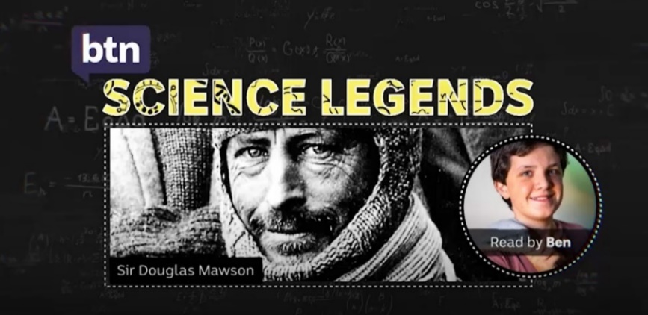
This BTN Science Legends profile about Antarctic explorer Sir Douglas Mawson gives a snapshot of his life and achievements. For a more detailed look at his expedition, watch the BTN Mawson Expedition story. Here is the teacher resource for this story.

Activity: BTN Antarctica Special
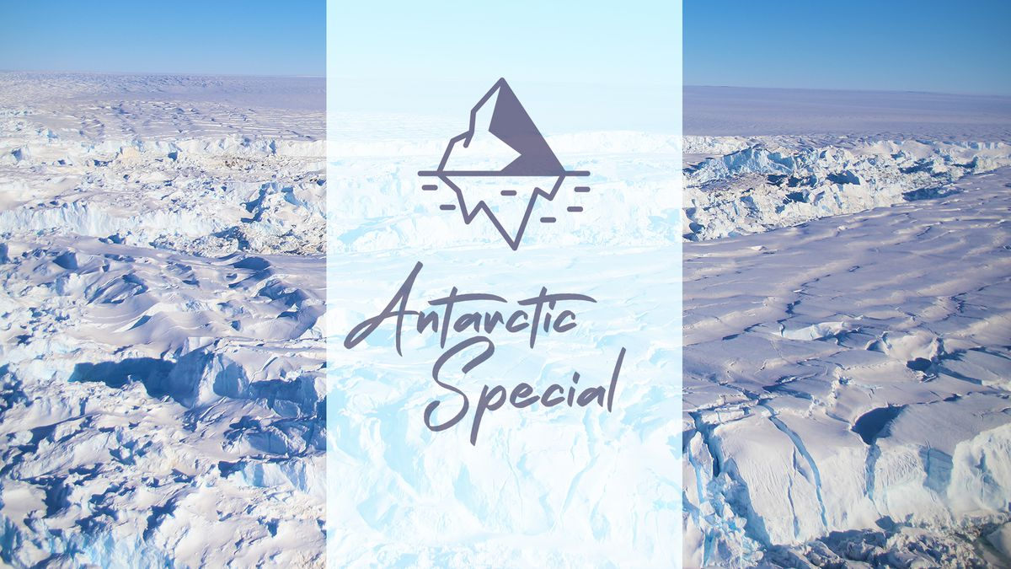
BTN reporter Emma went on a journey to one of the world’s most remote and amazing places - Antarctica! She’s met the people that live and work there, discovered why the frozen continent is so important to science and spotted some of the amazing animals that call it home. Check out the special here.

Take a look at this BTN video, where a group of experts answer questions that kids had about Antarctica and the people and animals that live there. What questions would they ask an expert about Antarctica?

Useful Websites
- Antarctic Icebreaker – BTN
- Aurora Australis – BTN
- Australia’s New Icebreaker RSV Nuyina – Australian Antarctic Division
- New Antarctic icebreaker RSV Nuyina docks in locked-down Hobart – ABC News
- Icebreakers and Strengthened Ships – Cool Antarctica
- Nuyina Poster – Australian Antarctic Division

  - Teacher Resource

BTN Transcript: Episode 30 - 26/10/2021

Hey, I’m Amelia Moseley and you’re watching BTN. Here’s what’s coming up. We get the lowdown on Australia's brand-new icebreaker, meet the publisher of a women's sport zine and learn how to tell if the news you see is trustworthy.

Back to School

Reporter: Amelia Moseley

INTRO: But first it's back to school, real school, in an actual classroom. For some of you it's been months since that happened but now with vaccination targets met, kids in NSW, the ACT and Victoria are returning to face-to-face learning. But school won't be exactly the same as it was before the pandemic, and some say Aussie kids are going to need some help as things get back to, well, kinda normal. Take a look.
AMELIA, REPORTER: Hey, where are you watching this from? Yeah, I mean you. If you're in New South Wales, the ACT or Victoria you might've just answered "from school" for the first time in a while. Yup, kids here and here and here are finally back to the classroom after months in lockdown.
FLORA: I'm excited to see my friends and teachers, but I'm also a bit nervous because I’m not really sure what to expect.
According to the UN, more than 1.5 billion students, that's 87 per cent of the world's student population, across 165 countries have been affected by schools closing because of the pandemic. And most Australian kids can count themselves in that billion. Of course, there are some upsides to learning from home. I mean it's pretty good rolling out of bed and straight into class, right?
FLORA, VIC: Sleeping in and wearing casual clothes and getting to eat whenever you want.
Exactly. But for a lot of kids, it was also tougher to focus, get help and get motivated.
LIV, NSW: I'm not a fan of online learning. It's hard to stay motivated and productive when you're just sitting in the same spot staring at a screen all day.
Now some people are worried staying home might've left some kids behind in their learning.
ANNE HOLLONDS, AUSTRALIAN NATIONAL CHILDREN'S COMMISSIONER: For some kids, you know, they haven't had a computer at home. Or maybe they didn't have a quiet place where they could do their schoolwork, or their parents weren't able to help them with their schoolwork.
Some states have put money towards providing kids with extra help like tutoring, but some reckon more could be done to help students catch up, and take care of their mental health in these weird times.
ANNE HOLLONDS, AUSTRALIAN NATIONAL CHILDREN'S COMMISSIONER: Many kids will need some extra help. So, I'm saying to government that really, we should be listening to kids and to provide them with the extra help that they need.
Setting foot back here will also come with a few changes. Like you'll probably see more of these around, hey, you might even be wearing one now.
OLIVER: Well, it is annoying wearing a mask but can't get jabbed so best thing I can do is wear a mask and do all the stuff to stop COVID.
FLORA: I do feel like it'll help me be safer, but no I'm not looking forward to it at all.
AMELIA, REPORTER: And there's another thing you might notice, is your classroom window open? Go on. Check.
If it is, it might be because schools have been told to make sure there's proper air flow in classrooms, so germs don’t stick around.
AMAL: Who are you talking to?
AMELIA, REPORTER: Um, no one..
CHARLOTTE, VIC: The way they're keeping us safe is you keep the windows open, you keep the doors open.
BEN, VIC: And they're putting air purifiers in some of the rooms.
One thing most people are hoping schools won't be doing though is closing again.
FLORA, VIC: I do feel safe in my school environment, though I do wish we could get vaccinated cause we're the next generation, so we should be able to get the vax.
LIV, NSW: We're gonna have to adjust to what this new version of school looks like so stay safe and enjoy the rest of the year.
AMELIA, REPORTER: Oh. Hey, why are you still watching? The story is over, silly. Cut.
News Quiz

Last week Australia passed a big vaccination milestone. What was it? 50 percent of Aussies over 16 fully vaccinated, 70 percent of over 16s fully vaxxed or 80 percent of over 16s fully vaxxed? It was 70 percent. The ACT and New South Wales are leading the way with more than 80 percent of over 16s with a double dose and more than 90 percent with a single dose. Victoria and Tassie have passed 70 percent, but the PM says the rest of us have a bit of catching up to do.

SCOTT MORRISON, PRIME MINISTER OF AUSTRALIA: The message is very clear. Let’s get those vaccination rates up.

Which city is about to host COP26, a massive UN meeting about climate change? Is it Paris, London or Glasgow? It’ll be in Glasgow. Australia’s Prime Minister will be amongst the world leaders who’ll be there to outline their plans to fight climate change.

And what Wiggle announced they were leaving the band last week? It was the Yellow Wiggle Emma Watkins.

EMMA WATKINS: After 11 years performing with The Wiggles and 9 of those as the Yellow Wiggle, the time has now come for me to pass the yellow skivvy on.

Emma was the first female wiggle and her replacement, Tsehay Hawkins, has set her own Wiggle record.

JOE, BTN REPORTER: You are the youngest member of The Wiggles in the band’s history. How old are you?

TSEHAY: I am 15 years old, and it feels amazing.

Heritage Protections Laws

Reporter: Cale Matthews
INTRO: Last week a report came out saying Australia needs to make some changes to protect cultural heritage sites. It came after a big investigation which began when two 46-thousand-year-old rock shelters were destroyed by a mining company. Cale explains.

Australia. It's home to the oldest living cultures on the planet and some pretty amazing cultural sites. Like the Red Hands Cave in Ku-Ring-Gai, Burrungkuy rock art in Kakadu, or the Wilgie Mia Ochre Mines on Wajarri country.
KADO MUIR, CHAIRMAN NATIONAL NATIVE TITLE COUNCIL: Wherever your viewers are, there will be evidence of Aboriginal occupation
This is Kado Muir.
KADO MUIR, CHAIRMAN NATIONAL NATIVE TITLE COUNCIL: Hello, everyone. My name is Kado. I'm from Western Australia, in the desert region, and a cultural leader for the Ngalia people.
As chairman of the National Native Title Council he says protecting Indigenous cultural heritage is incredibly important.
NEWS ANCHOR: Rio Tinto has apologised for blowing up rock shelters dating back 46,000 years.
CLINTON WALKER, NGARLUMA TRADITIONAL OWNER: When I find out these companies destroy this sort of thing they're destroying our history.
PAT DODSON, WA SENATOR: This is an international disaster that's happened here.
Last year, many people in Australia and overseas were horrified when mining company Rio Tinto destroyed two 46,000 year old rock shelters at Juukan Gorge in Western Australia's Pilbara, to expand a nearby mine. Inside these shelters archaeologists had found evidence of human habitation dating back to before the last ice age, like a 28,000 year old blade made from Kangaroo bone and a 6,000 year old belt made from human hair.
KADO MUIR, CHAIRMAN NATIONAL NATIVE TITLE COUNCIL: On a purely archaeological basis. Here was a site that linked living people today, to their ancestors who lived 6,000 years ago.
Like other significant heritage sites, Juukan Gorge was protected under state law but in Western Australia companies or land owners can apply for an exemption to this law and in this case the development went ahead.
KADO MUIR, CHAIRMAN NATIONAL NATIVE TITLE COUNCIL: For the first time people realise that some of these places are getting destroyed and they're getting destroyed legally by mining companies.
After the destruction there were massive protests, Rio Tinto apologised and the boss resigned, and the government started a big inquiry to find out what went wrong and to try and stop this sort of thing happening again. Now a report’s come out recommending a bunch of changes to Aussie laws to better protect cultural heritage sites. That includes new national guidelines for each state to follow and making the federal minister for Indigenous Australians responsible for approving developments. It also recommends mapping all the cultural heritage sites around Australia and making sure traditional landowners are involved in decisions.
KADO MUIR, CHAIRMAN NATIONAL NATIVE TITLE COUNCIL: What we're asking for is the opportunity to actually be consulted and at times to say no.
Not everyone thinks change is necessary and some worry new laws might take away job opportunities or economic benefits for Indigenous communities, but others say it would be a step in the right direction.
KADO MUIR, CHAIRMAN NATIONAL NATIVE TITLE COUNCIL: It is an opportunity for miners, government, Aboriginal people and other Australians to get together to find a way that celebrates the rich culture and heritage that we have. That's part of the fabric of what makes Australia, Australia.
Media Literacy Week 2021

Reporter: Nat Kelly

INTRO: This week is Media Literacy Week when we're encouraged to think a bit harder about all that information we consume. As you probably know, lots of experts are worried about the spread of misinformation and fake news. So, Nat's gone undercover to find out how you can spot a fake.
NAT: Hello and welcome to Undercover Journalist. The show where we go undercover to find out if your news is playing "Fair", or "Viewer Beware". Let’s get inside. Today's location, The Local Times Newspaper headquarters. G’day, hello.

MATT: How are you?

NAT: Good thanks, I'm just here to have a look at the lights.

MATT: The?

NAT: The lights. Um, you called earlier about having a light problem.
MATT: No, no I didn't.
NAT: Oh, well someone did. You can get anywhere with a high vis and a clipboard.
Yeah, when it comes to the news, we're often bombarded with a lot of information. But here's the thing. Not all of it is trustworthy. And being able to tell the difference between something that's legit, and something that's not, can be pretty hard.
OLIVIA: Yes, I knew it. Cats are better than dogs.
NAT: Fake news. It's not a new problem. But thanks to social media, fake news has become way easier to find and share than ever before. It helps to know where the news is coming from. And whether it's a source you can trust. Hmm. You know what I’m smelling? An unreliable source.
OLIVIA: This article seems biased. What’s a bias?
Bias. That's when people lean towards one opinion over the another, like whether they prefer cats or dogs. A lot of things can influence bias. It could just be personal preference.
OLIVIA: Hey, I just like cats.
NAT: Bias can also be influenced by other things too, like money.
Or political interests. Organisations or individuals might use the media to influence the way people think or the way they vote.
NAT: Or maybe, they're just trying to sell you ad space, so that you click on something. Maybe because you already agree with it, or maybe it's, you know, too outrageous to be true. These stories we often call "clickbait".
CALE: Yeah, knew it.
NAT: Speaking of ads.

CALE: How did you get in here?

NAT: Look out for those too. Sorry mate, I’m just trying to get through here.

CALE: Thank you.
Ads aren't just those 3 second skippable ones at the start of a YouTube video. They're also here and here. And while online creators are supposed to let their audience know when something's an ad, it's not always easy to tell when someone's been paid to promote a product.
NAT: OK, 3-2-1. G’day, I'm Nat from Undercover Journalist, I've come to ask you about reports of bias in your publication. Follow him, don’t let him go, come on. Follow him, hey, stop. We’ve got some questions to ask you mate.
Good job team. I think we've had a positive impact here today. But I'm still gonna rate this publication a solid "Viewer Beware". Stay safe out there, kids.
Ask a Reporter

And if you've got more questions about media literacy you can ask me live on Friday. Check the website for details.

Media Literacy Promo

ABC Education has some great resources online to help you learn about media literacy, including classroom activities and videos. You might even recognise some of the actors in these ones. They'll help to you learn about things like sources, news values, media ethics, bias and fake news.

New Antarctic Icebreaker

Reporter: Cale Matthews

INTRO: They’re pretty fun and speaking of fun a ship has just docked in Hobart that's been described as Disneyland for scientists. It's Australia's brand-new icebreaker and it's been designed to help researchers unlock the mysteries of the Antarctic. Here's Cale.
If you're a big fan of Antarctica, and a big fan of big boats, well you'll love this. This big boat is the Research and Supply Vessel Nuyina, and it’s just reported for duty in Hobart. The RSV Nuyina is Australia's brand new Antarctic icebreaker.

That's a ship specifically designed to plough its way through sea ice, and it'll be the main way Aussies get to and from the icy continent. Nuyina took more than 5 years to build, cost 500 million dollars, is the length of 5 basketball courts, and will be the most technologically advanced ship in the Southern Ocean.
ROB BRYSON, AUSTRALIAN ANTARCTIC DIVISION: Even if I just broke it down into the science functions, I'd be on the TV for another 40-50 minutes.
That's Rob Bryson one of the leaders of the Nuyina Project and he says this ship is pretty impressive.
ROB: It just has a raft of different kinds of capabilities that we haven't had before.
Like 20 interchangeable laboratories, hydrophones that can listen to whales and seals, and a bunch of cameras and sensors to track things like fish or krill. But possibly the coolest feature is something called a moon pool. It’s not what you think. It’s pretty much a hole in the ship, that's supposed to be there, that acts like a doorway straight down into the ocean.
ROB: So, in the past, we used to park the ship in the ice, and then actually put people on the ice to go out and dig a hole and actually do the testing that way. So, now they can actually sit in their board shorts and actually do it from inside the comfort of the ship.
Alright, enough about the science, let’s talk about the name. Nuyina means Southern Lights in the Tasmanian Aboriginal language Palawa Kani. It was named by these guys back in 2017 after an Australia-wide competition. As part of their prize, they got to fly to Antarctica and actually became the youngest people to touch down on the icy continent as part of the Australian Antarctic Program.
COMPETITION WINNER: It's a very once in a lifetime opportunity and not most people get it, so it’s quite good.
Nuyina is taking over from this old hunk o' metal, the Aurora Australis, which was lovingly nicknamed the Orange Roughy. It was in service to the Australian Antarctic Division for 30 years and last year it floated off to Dubai where it is now waiting to be bought by a new owner.

The journey to Tassie hasn't exactly been smooth sailing for Nuyina, it was being built in Romania, but then had to be shifted to the Netherlands during COVID. Then after its 6 week voyage down to Tassie, engineers discovered an electrical fault in the ship. Oopsie. The Aussie Antarctic Division say they'll fix it quick smart and Nuyina will be good to go for the next 30 years. So, for all you budding Antarctic explorers watching this, you just might find yourself setting sail on Nuyina sometime soon.

Quiz

Can you name this famous Australian explorer who led Australia's first Antarctic expedition in 1911? It's Sir Douglas Mawson.

Sport

The T20 World Cup is well underway and while Australia opened the tournament with a win over South Africa, it was a close call. They only needed to chase down 118 runs and got there with just 2 balls to spare.
Over to the WBBL and defending champions the Sydney Thunder are still winless so far this season. On Sunday they were thumped by the Perth Scorchers in Launceston falling 81 runs short. Perth skipper Sophie Devine led the way with her third ever century in the WBBL.
And in the UK, Liverpool has pulled off a stunning and historic 5-nil victory against arch rivals Manchester United. It's United's biggest home loss to Liverpool in its 143 year history and its worst home loss to any team since 1955.
Her Way Sports Magazine

Rookie Reporter: Abbie

INTRO: Finally, today, to our rookie reporter Abbie. She loves sport, but she realised there seemed to be a lot more articles written about men in sport than women. So, she decided to try to change that by starting her own magazine. I'll let Abbie tell you more.

ABBIE, ROOKIE REPORTER: Hi BTN. My name is Abbie and I'm 11-years-old. I live in Sydney with my mum, dad and youngest sister. I enjoy most sports but if I had to pick two favourites, they would be AFL and cricket. I like sport because it's a great way to stay active and make friends.
In AFL I really look up to Haneen Zreika and Georgia Gee. Beth Mooney from the Australian cricket team is really cool, and I've actually got to meet her as well. I also look up to Madison De Rozario and Sam Kerr. For a long time, female athletes haven't been treated the same as male athletes. They haven't been given the same resources or opportunities. However, they’re just as good as the male athletes.

At the end of September, I launched an online magazine called Her Way. Her Way is all about what's happening in the world of women's sport. I remember getting the idea when I was in a waiting room at a medical appointment. That's when I said, 'why aren't there any magazines about women's sport?', so my dad said, 'why don't you make one?' and here I am.
The whole process is actually really fun. I've learned a lot from creating Her Way, whether it's researching about what women’s sporting events are coming up, or even interviewing the athletes, which has been really cool. I create the magazine using an online website which has been really fun, and I've got to choose lots of colours and different fonts to use to create the magazine. The whole process takes about two weeks.
The magazine is $2 and half the money from every magazine bought goes to one of UNICEF Australia's programs to empower girls through their cricket project. This helps girls in developing countries like Sri Lanka have the opportunity to play cricket.
The response has been way bigger than I expected. I didn't expect any of this to happen. I've received a lot of messages from journalists and female athletes, and I've also been asked to be on a few radio sessions and podcast interviews and here I am on BTN.
ELYSE VALLANI, AUSTRALIAN CRICKETER: Abbie you’re pretty incredible what you are achieving at just 11 years of age, making the women’s sporting magazine. It’s pretty amazing and I loved purchasing my very own copy.

HANEEN ZREIKA, GWS MIDFIELDER: Hi Abbie, it’s me here. I just want to give you a huge congratulations on your amazing magazine that you have done. Just seeing the way, you support women’s sport is amazing.

AMANDA FARRUGIA, FORMER GWS CAPTAIN: Hey there, Amanda Farrugia here, former captain of the GWS Giants AFLW team. It was very easy for me to purchase Abbie's magazine. It's very, very well written. There's nothing out there that exists at the moment, and I just really love the way that Abbie goes about trying new things, challenging herself and her love and passion for women's sport is something that should be really nurtured. So brilliant work, Abbie. I look forward to reading December/January issue, well done and keep up the great work.

ABBIE: This is so cool. I hope I can keep creating magazines every month so that I can raise lots of money for UNICEF. I also want to create a platform for some woman supporting events that aren't heard much of.
Creating this magazine has made me want to be either a sports journalist or an athlete. These are both two things I'm really passionate about. Because I really love writing and watching women’s sport. If you have an idea, don't let anyone tell you, you can't do it because you never know what might happen. Just go for it.
Closer

Thanks so much for that Abbie. Well, that's it for another week. I hope you've enjoyed the show. As usual, we've got heaps of stuff online that you can check out during the week including more videos and teacher resources. There's also our YouTube channel if you're 13 or over and Newsbreak will keep you up to date every weeknight. Enjoy being back in the classroom, stay safe and I'll catch next week. Bye.

