
EPISODE 16
3 June 2025

KEY LEARNING
Students will view a range of BTN stories and use comprehension skills to respond to a series of focus questions.

CURRICULUM
English – Year 4
Use comprehension strategies to build literal and inferred meaning to expand content knowledge, integrating and linking ideas and analysing and evaluating texts.

English – Year 5
Use comprehension strategies to analyse information, integrating and linking ideas from a variety of print and digital sources.

English – Year 6
Use comprehension strategies to interpret and analyse information and ideas, comparing content from a variety of textual sources including media and digital texts.

English – Year 7
Use comprehension strategies to interpret, analyse and synthesise ideas and information, critiquing ideas and issues from a variety of textual sources.
  - Teacher Resource

Focus Questions
As a class, discuss the stories featured in the episode of BTN Classroom and record the main points of the discussion. Students will then respond to the following focus questions.

Tariff Update
- Discuss the BTN Tariff Update story as a class and record the main point of the discussion.
- What is a tariff?
- Which country has recently introduced lots of new tariffs?
- What is a reciprocal tariff?
- What questions do you have about tariffs?

Music Rights
- Summarise the BTN Music Rights story.
- What do record labels do? Give an example.
- What is it called when a music artist gets paid for their music?
  - Monarchy
  - Royalty
  - Stately
- Why do some artists create their own record labels?
- What do you understand more clearly since watching the BTN story?

Gold Price
- In pairs, discuss the BTN Gold Price story. What were the main points discussed?
- Approximately, how much does a kilo of gold cost at the moment?
- How has gold been used by people in ancient history? Give an example.
- When was the gold rush in Australia?
- Which countries are the top 3 gold producers in the world?

Check out the teacher resource on the Archives page.

Animal Communication
- Before watching the BTN story think of ways you think animals communicate.
- Which animal performs a waggle dance to communicate?
- Which animal performs a signature whistle to communicate?
- What technology are scientists using to study bats vocalisations?
- Name three facts you learnt watching the story.

Dino School
- What was the main point of the BTN story?
- Who studies dinosaur fossils?
  - Archaeologist
  - Palaeontologist
  - Biologist
- What type of dinosaur did the footprints on the fossil match with?
- What else did the scientists discover after studying the fossil?
- It is rare to find dinosaur fossils from the Jurassic period. True or false?

Check out the teacher resource on the Archives page.

EPISODE 16
10 June 2025

KEY LEARNING
Students will learn more about the significance of gold over time and find out more about the gold rush in Australia and its impact on the country.

CURRICULUM
HASS – Year 5
The impact of a significant development or event on an Australian colony.

The reasons people migrated to Australia and the experiences and contributions of a particular migrant group within a colony.
  - Teacher Resource

Gold Price

Focus Questions
Discuss the BTN story as a class and record the main points of the discussion. Students will then respond to the following:
- In pairs, discuss the BTN Gold Price story. What were the main points discussed?
- Approximately, how much does a kilo of gold cost at the moment?
- How has gold been used by people in ancient history? Give an example.
- When was the gold rush in Australia?
- Which countries are the top 3 gold producers in the world?

Activity: Note Taking

Students will practise their note-taking skills while watching the BTN Gold Price story. After watching the story, ask students to reflect on and organise the information into three categories. What information in the story was positive, negative, or interesting?

Activity: Class Discussion
Discuss the information raised in the BTN Gold Price story. Record the main points of the discussion on a mind map. Here are some questions to guide the discussion:

- What words do you associate with gold?
- Think of as many uses as you can for gold. Make a list.
- When was gold discovered in Australia?
- What impact did the Gold Rush have on Australia?


What questions do you have about the story?
What did you learn from the story?

Activity: Word Cloud
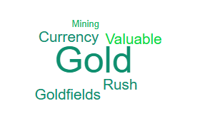
Students will brainstorm a list of key words that relate to the BTN Gold Price story and create a word cloud. A word cloud is a visual made up of important/key words relating to a topic. Ask students to think of words they associate with gold. Create a word cloud using a free online word cloud creator such as Word It Out. Working in pairs, students can clarify the meanings of the words included in their word clouds.

Activity: Gold Research
Discuss the information raised in the BTN Gold Price story. What questions were raised in the discussion and what are the gaps in students’ knowledge? Students will develop their own question/s to research or choose one or more of the questions below.
- What are the properties of gold?
- Why was gold so important to ancient civilizations?
- Why was gold used as currency in the past?
- What does gold symbolise in our society? Think about images and references in advertising, films, music etc.
- What was the gold standard and why did countries use it?
- What impact did the discovery of gold have on Australia? Consider the wealth it created, immigration and social change.
- Who was Edward Hargraves and what role did he play in Australia’s gold rush?
- Why was the gold rush a key event in the development of democracy in Australia?
- What impact did the gold rush have on Australia’s population?
- Where in Australia can you find gold? Research and create a map of goldfields and mines (both past and present) in Australia.

Activity: Snapshot of Australia’s Gold Rush
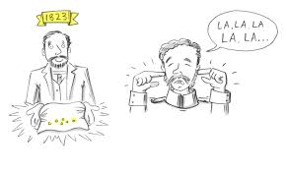
Watch this live sketch animation about the gold rush from the National Museum of Australia. It gives a snapshot of the events leading up to the gold rush in Australia and the impact it had on the country. Students can respond to the following questions:
- Briefly summarise the events leading up to the Gold Rush in Australia.
- What was Edward Hargraves role in the discovery of gold in Australia?
- What impact did the discovery of gold have on Australia?
- Name three facts you learnt watching the animation.

Activity: Choose a project
Students will choose one of the following activities to work on and then present their findings to the class.

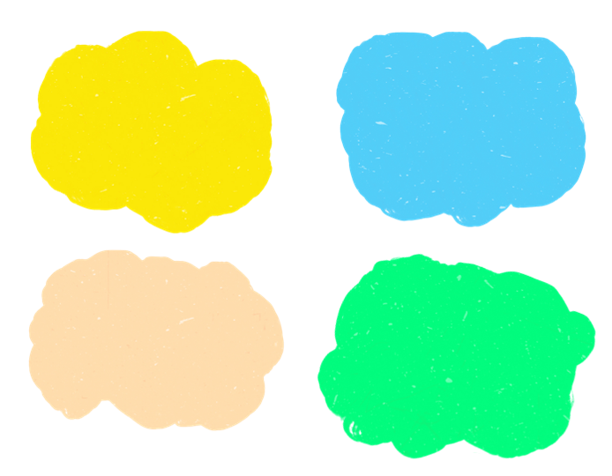
Largest Gold Nugget
Investigate the largest gold nugget ever discovered. What was its weight and value? Find out what the value of gold is at the moment. Calculate the value of an ounce of gold in Australian dollars.

Gold Rush Game
Can you strike it rich during the gold rush?
Play this game to learn more about the discovery of gold in Australia in the 1800s.
Did you know?
Using the information in the BTN story and your own research, create a Did You Know fact sheet about gold. Publish using Canva.

Summary
Summarise the BTN Gold story in three sentences. Share your summary with another student. How did your summaries differ?

Activity: Quiz
Students will use the facts they have discovered about gold to create a quiz and then test their classmates. Students will include a range of quiz styles, for example:
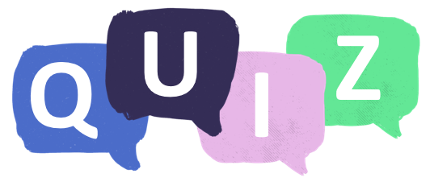
- Multiple choice
- True or false
- Fill in the blank
- Use photos or pictures
- When an answer is revealed, provide extra information to explain the answer.
Students can make their quizzes in Kahoot or Quizizz. Make it fun, engaging, and educational!

Useful Websites
- Record high gold prices prompt revival of outback Queensland mines – ABC News
- Gold Rush - BTN
- Gold Rushes – National Museum Australia

EPISODE 16
10 June 2025

KEY LEARNING
Students will develop a deeper knowledge of fossils and how scientists use them to understand extinct animals.

CURRICULUM
Science - Year 4
Earth’s surface changes over time as a result of natural processes and human activity.
Science - Year 5
Living things have structural features and adaptations that help them to survive in their environment.
Science - Years 5 & 6
Science involves testing predictions by gathering data and using evidence to develop explanations of events and phenomena and reflects historical and cultural contributions.
Scientific knowledge is used to solve problems and inform personal and community decisions.
Science - Year 6
Sudden geological changes and extreme weather events can affect Earth’s surface.
Science - Year 7
Classification helps organise the diverse group of organisms.
Scientific knowledge has changed peoples’ understanding of the world and is refined as new evidence becomes available.

  - Teacher Resource

Dino School

Focus Questions
Discuss the BTN story as a class and record the main points of the discussion. Students will then respond to the following:
- What was the main point of the BTN story?
- Who studies dinosaur fossils?
- What type of dinosaur did the footprints on the fossil match with?
- What else did the scientists discover after studying the fossil?
- It is rare to find dinosaur fossils from the Jurassic period. True or false?

Activity: Class Discussion
Pre-viewing questions
Before watching the BTN Dino School story, students will discuss the following and record their responses on an A3 piece of paper.
- What do you think the BTN story will be about?
- Have you ever seen a fossil? Where did you see it and what did it look like?
- Do you know where fossils come from? Describe.
- What else do you know about fossils?

After watching the BTN story
After watching the BTN Dino School story students will respond to the following:
- What do you THINK about what you saw in the story?
- What does this video make you WONDER?

- Think of three questions you have about the BTN Dino School story. Remember that good questions are open-ended (have no right or wrong answer and can’t be answered with a ‘yes’ or ‘no’).
- What do you now know about fossils that you didn’t know before watching the BTN story?

Activity: Glossary
Students will brainstorm a list of key words that relate to the BTN Dino School story. Here are some words to get them started.

FOSSIL | EXTINCT | DINOSAUR
PALAEONTOLOGY | SILICON MOLD | JURASSIC PERIOD

Ask students to write what they think is the meaning of each word (including unfamiliar words). They will swap definitions with a partner and ask them to add to or change the definition. Check these against the dictionary definition.

Activity: Fossils Research
Discuss the information raised in the BTN Dino School story. What questions were raised in the discussion and what are the gaps in students’ knowledge? The following KWLH organiser provides students with a framework to explore their knowledge on this topic.

What do I know? | What do I want to know? | What have I learnt? | How will I find out?

Students will develop their own question/s to research or choose one or more of the questions below. Encourage students to collect and record information from a wide variety of sources and present the information they find in an interesting way.
- What can the size and shape of a fossilised bone tell us about the animal it belonged to?
- How are fossils formed? Use illustrations to help describe the process.
- How does finding fossils help scientists learn about the past?
- How do the layers of the Earth help us to work out the age of fossils?
- What are the different types of fossils? Create a graphic that explains each type.
- What is the role of a palaeontologist? What are the different parts to the job of a palaeontologist and what skills do they need to have?
- What tools and techniques do palaeontologists use to excavate and study fossils?
- Investigate an extinct animal that lived in Australia. What do we know about them?
- What extinct animals have been discovered in Australia? Choose one to research in more detail. How was it discovered? What did scientists learn from their discovery? When did the animal exist? How did it become extinct?
- How does finding fossils help scientists learn about the past?
- What are the four stages of fossilisation? Use illustrations to help describe the process.
- Research one of the periods – Triassic, Jurassic or cretaceous.

Activity: Animal Profile
Students will imagine they are palaeontologists and study the Ornithischian in as much detail as possible. Students will investigate the Ornithischian using the following questions to guide their research and then present their findings in an interesting way.
- What was its scientific name? What does its name mean?
- Was it known by any other names?
- What did it look like?
- How big was it?
- What was its habitat? Describe the environment that it lived in.
- What did it eat?
- How long ago did it live?
- When did it become extinct? What were some of the causes of its extinction?
- What did its footprints look like? What fossils have been found of this dinosaur?

Activity: When did it happen?
In small groups students will work together to identify and organise key events from the history of the universe and Earth on a timeline. Provide each group with pictures which represent the following events:

- The Big Bang
- Formation of Earth
- First life on Earth
- Triassic Period
- Jurassic Period
- Cretaceous Period
- Meteor that caused dinosaur extinction
- Appearance of humans

Working together students will guess which events came first and place each event in chronological order on a blank timeline strip. Challenge your students by asking them how long ago each event happened. For example, how long ago do you think the big bang happened?

Come together as a class and compare your students’ timelines. Start a discussion using the following questions:
- Which timelines were correct?
- What was surprising? Think about the scale of time between each of the events.
- How long did life exist on Earth before humans?

Activity: Who am I?
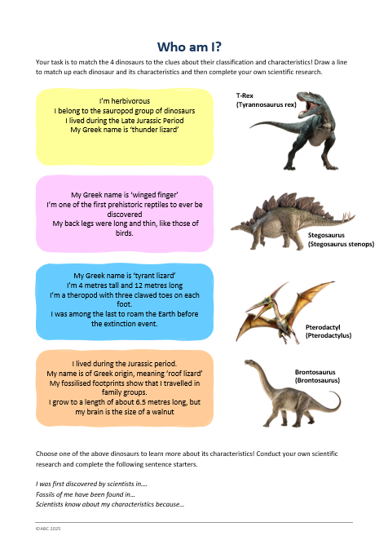
Students will play the Who Am I? game to learn more about dinosaurs. See worksheet at the end of this activity.
Students will…
- Match the 4 dinosaurs to the clues about their characteristics. Students may need to do some research to help them complete this activity.
- Draw a line to match each dinosaur with their correct characteristics.
- Choose one of the dinosaurs and then conduct their own scientific research.

Answers to the Who Am I? game
Clues: 1. Brontosaurus, 2. Pterodactylus, 3. Tyrannosaurus rex, 4. Stegosaurus.

Activity: Memory Game
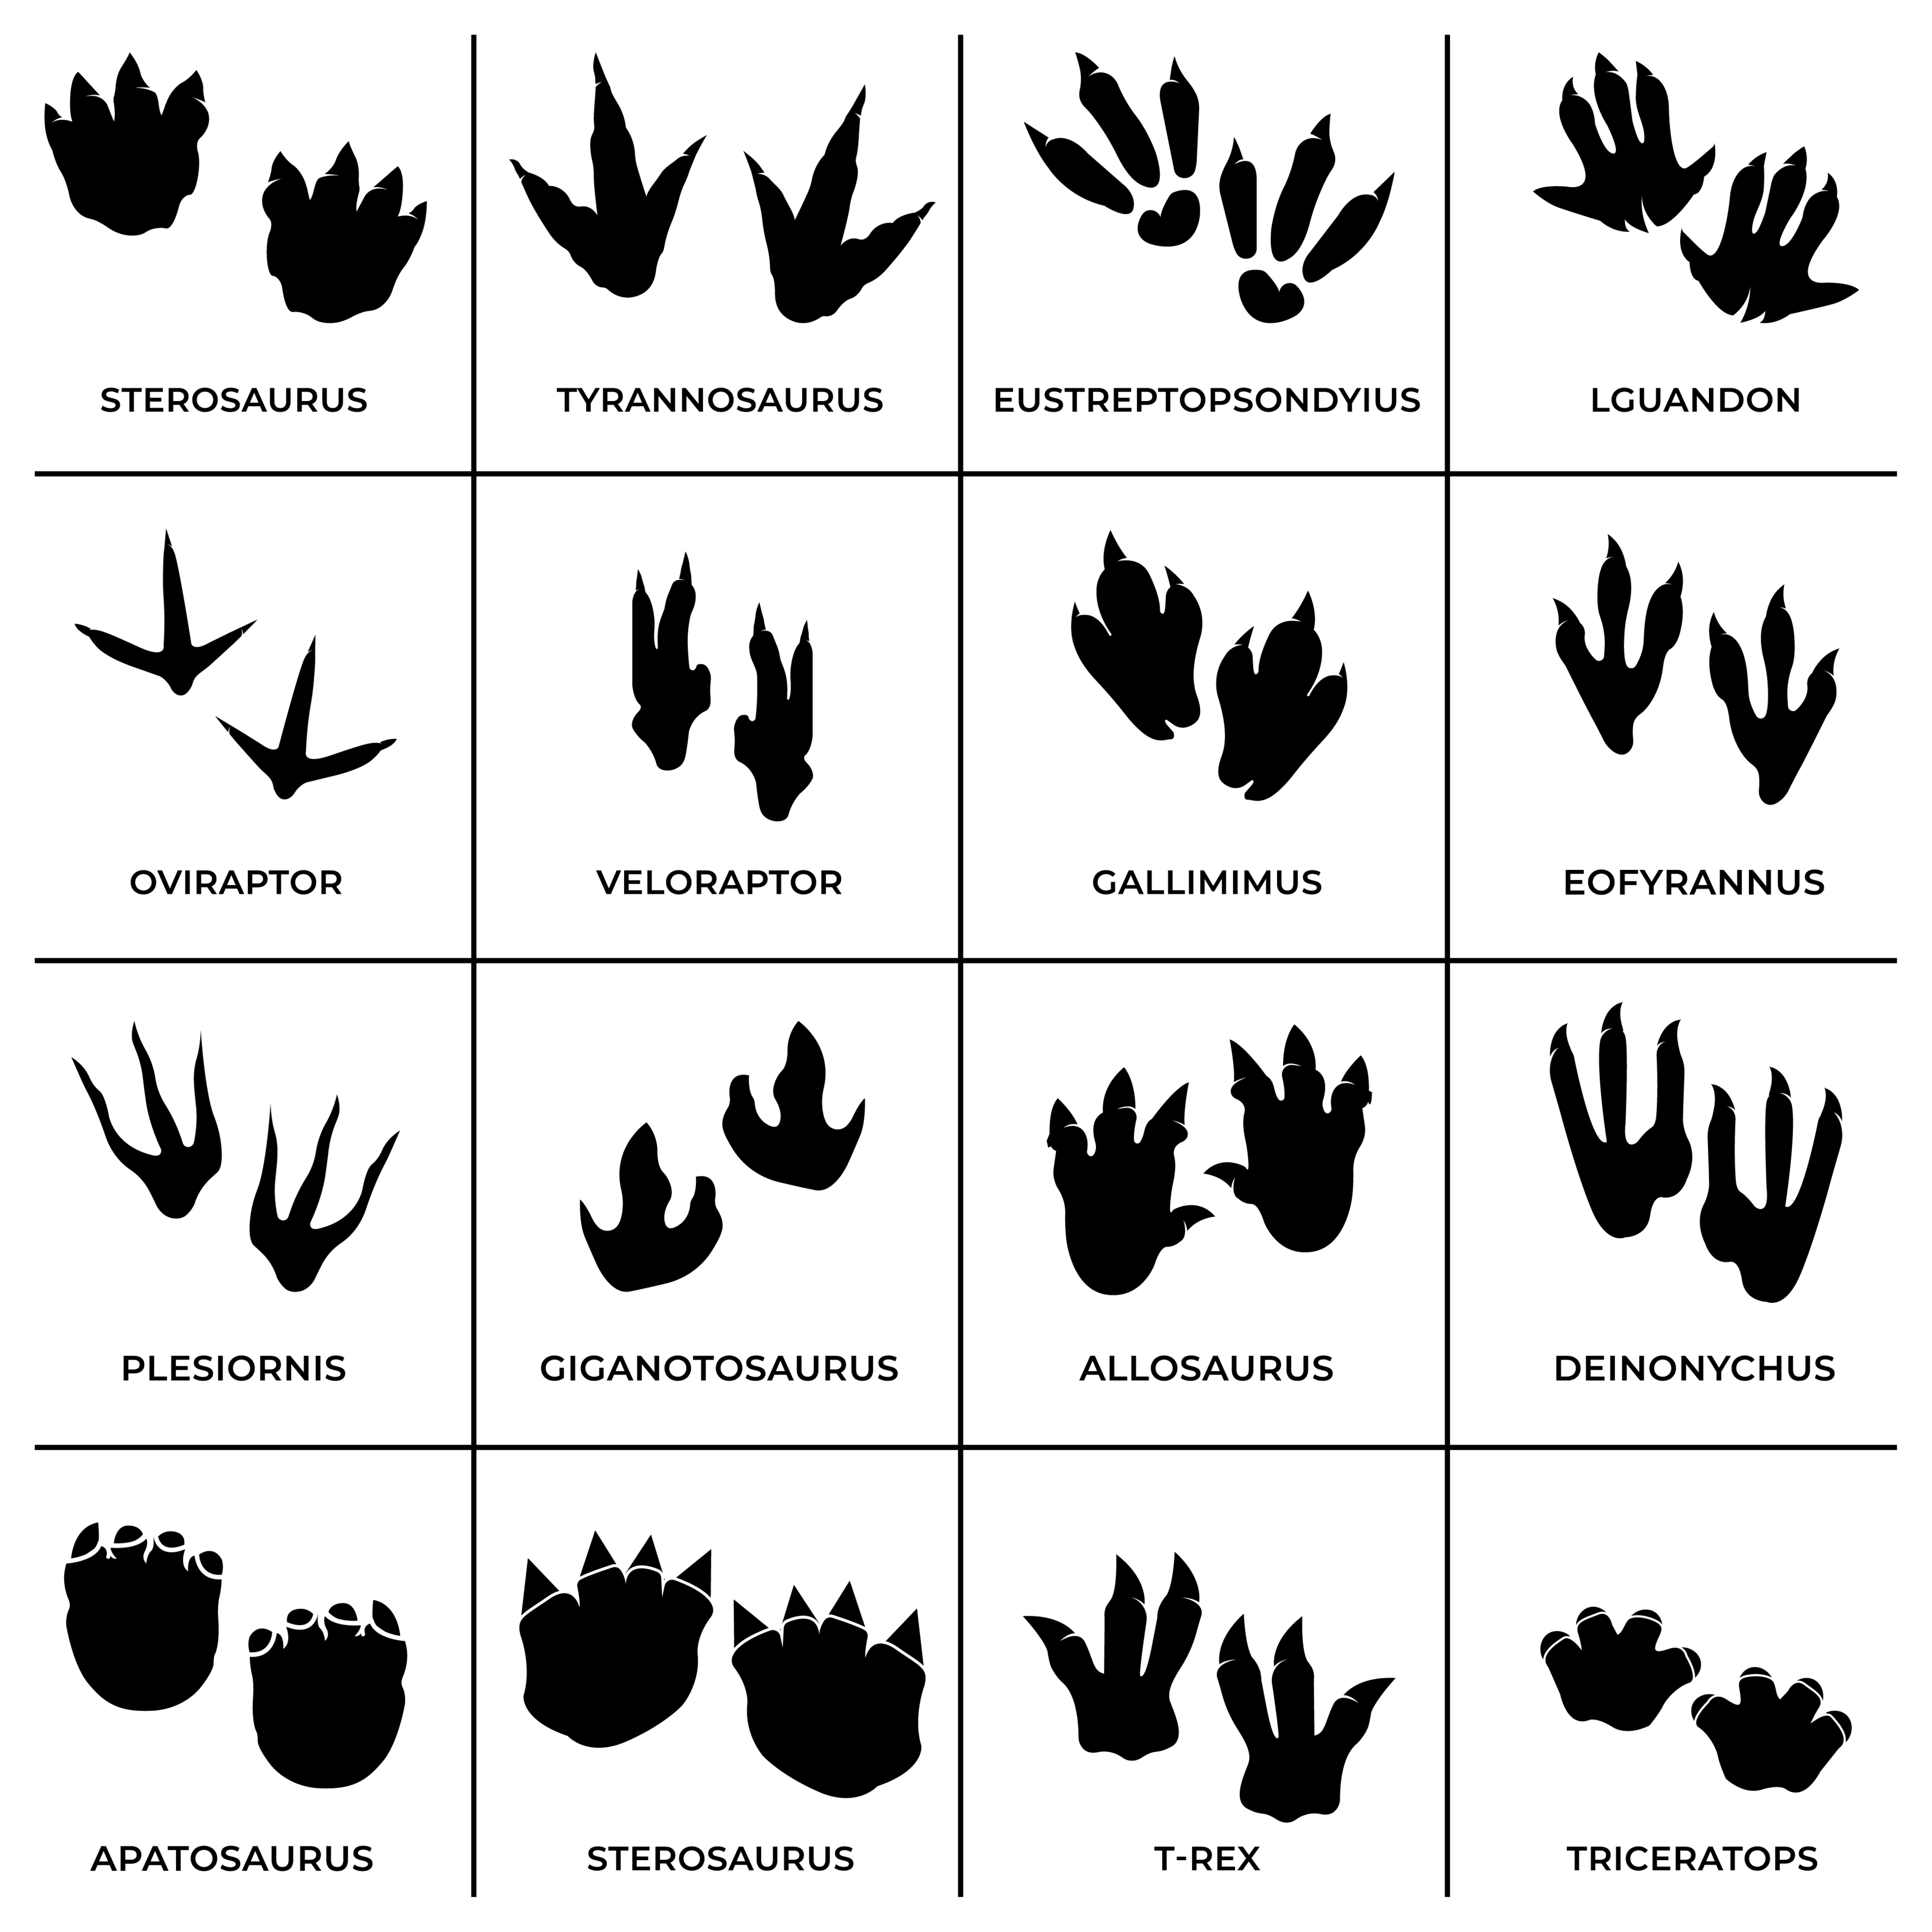
Students will create their own game of memory to test which dinosaur footprint matches the correct dinosaur. Start by providing your students with the following dinosaur footprints (see printout at the end of this activity).

Students will then…
- Find pictures of each dinosaur and create memory cards to match each footprint.
- Design the back of the memory cards (to stick on the back of each dinosaur and each footprint).
- Test their memory by playing the game in small groups.

Useful Websites
- Dino School – BTN Newsbreak
- What are fossils? – Australian Museum
- Boulder displayed in school foyer found to have 200-million-year-old footprints – ABC News
- Australian Dinosaurs – Australian Museum

Who am I?
Your task is to match the 4 dinosaurs to the clues about their classification and characteristics! Draw a line to match up each dinosaur and its characteristics and then complete your own scientific research.
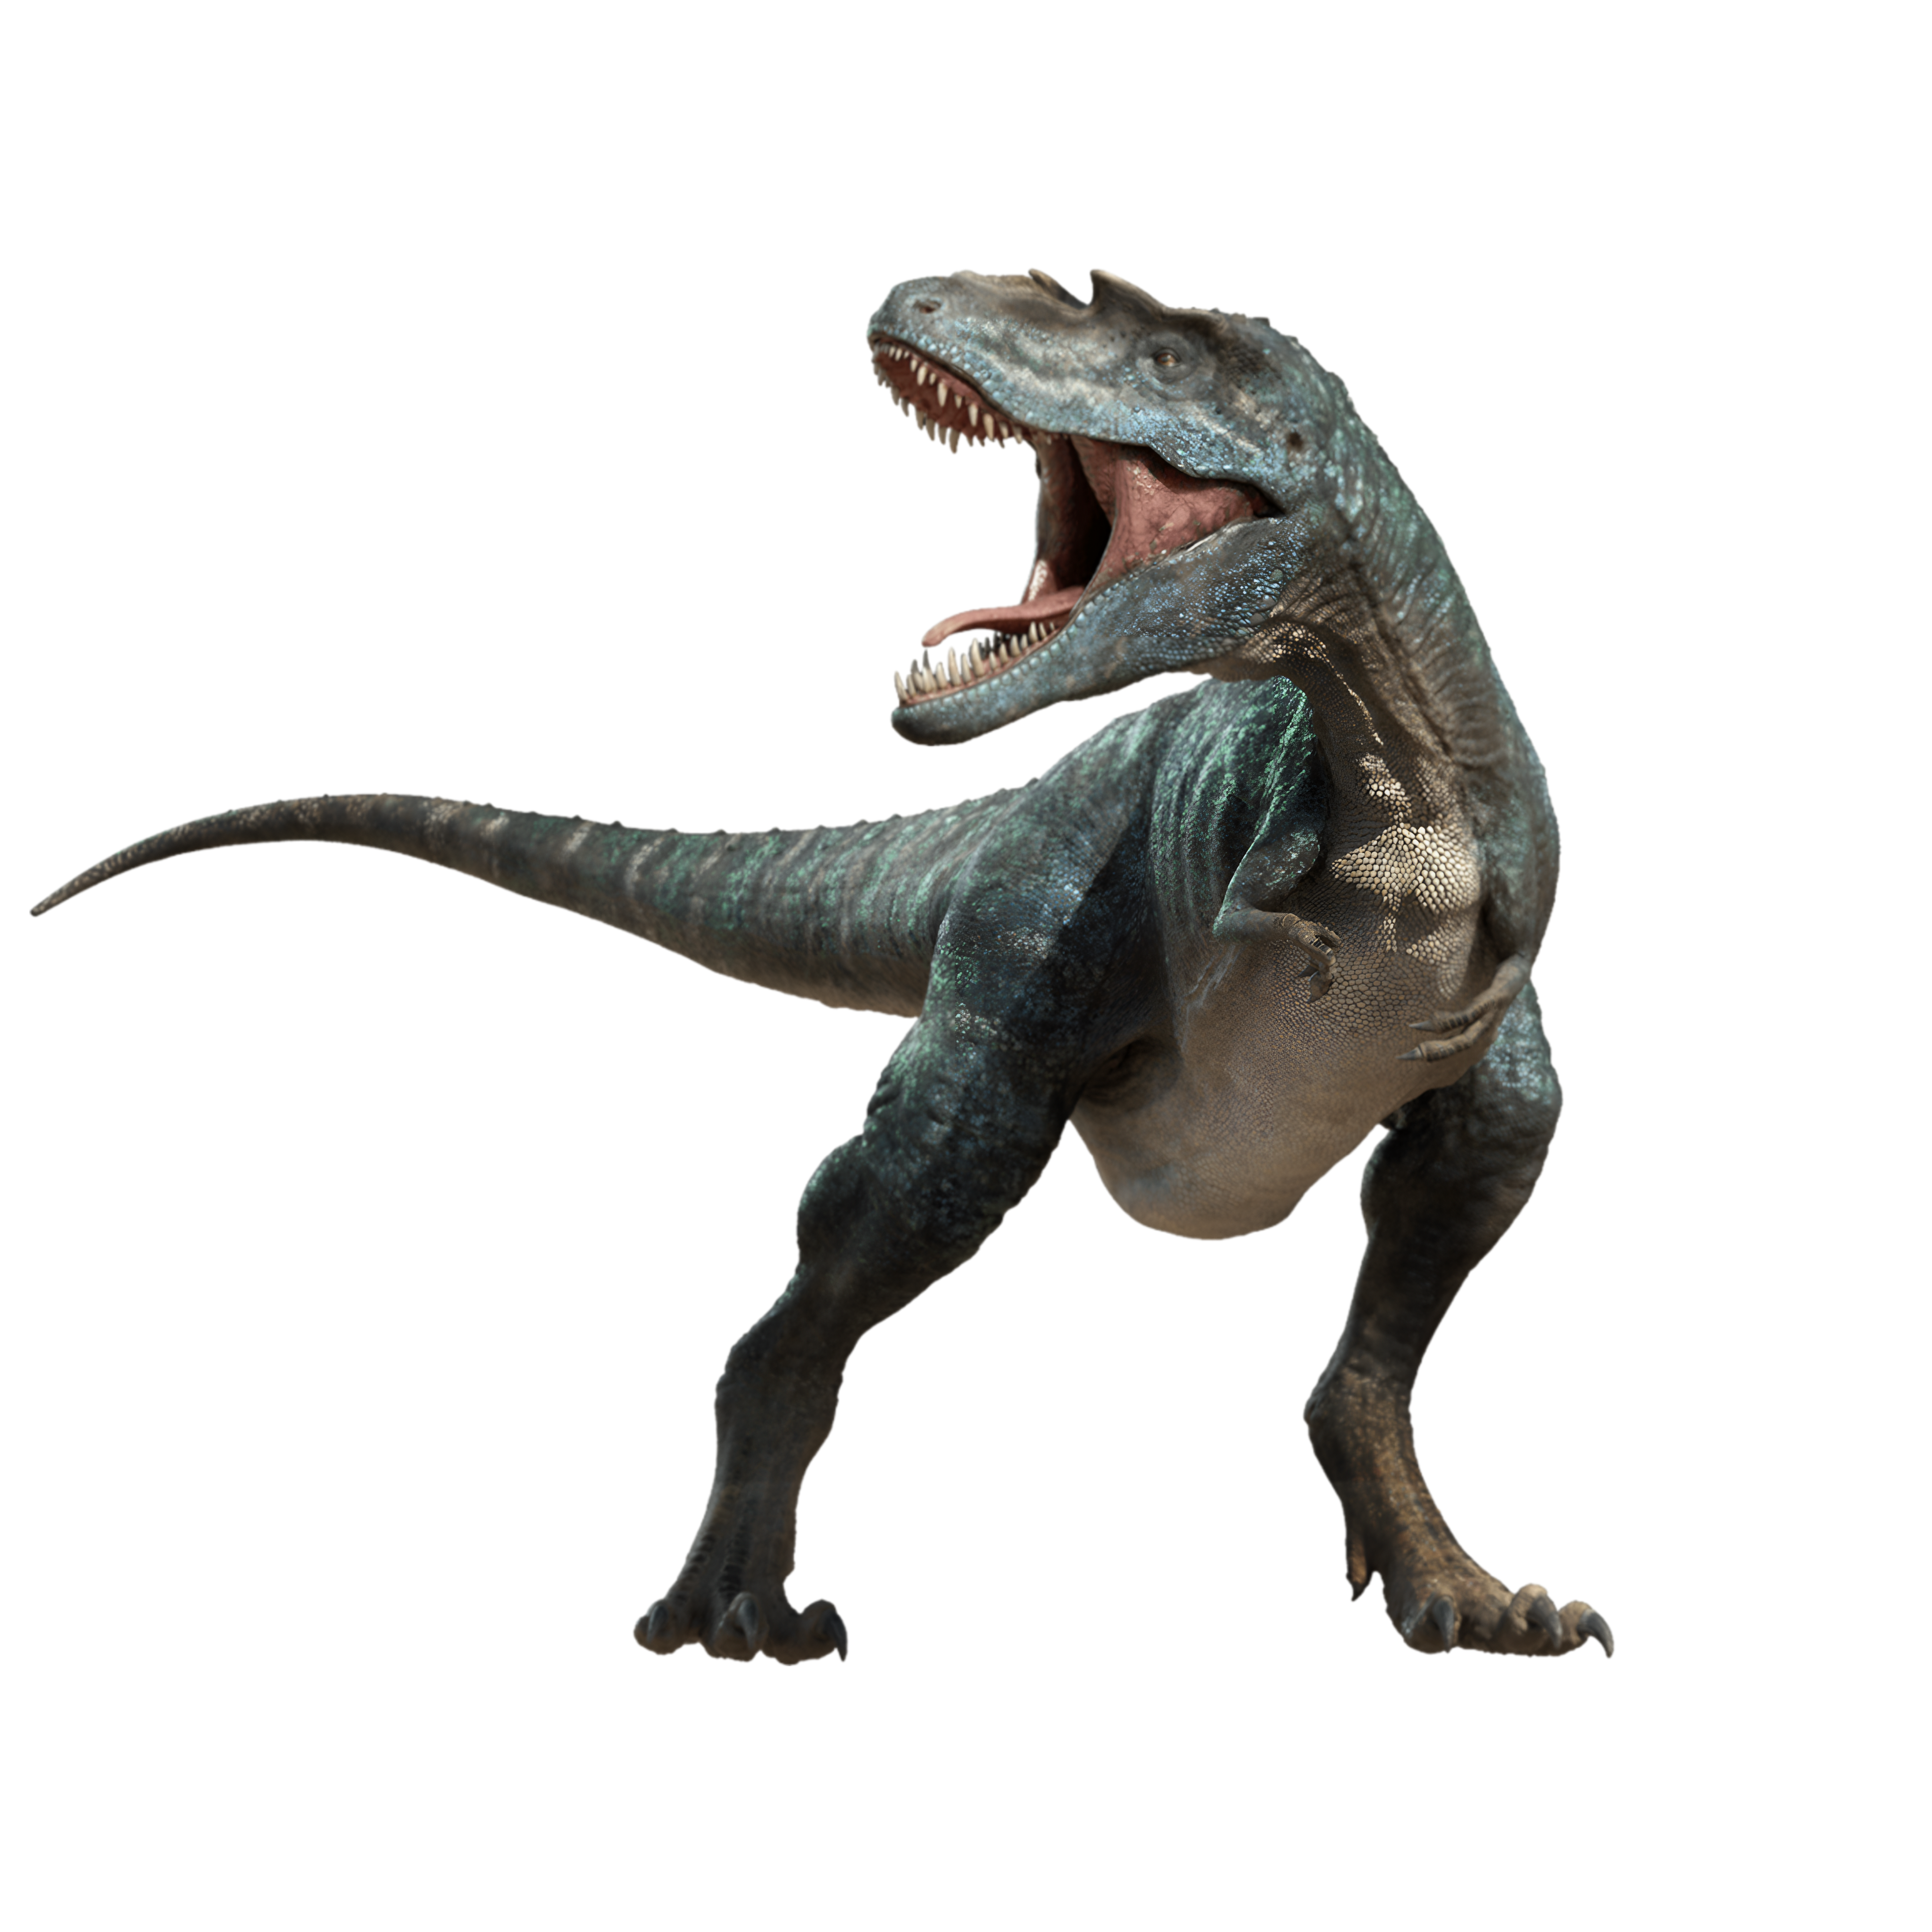
T-Rex
(Tyrannosaurus rex)
I’m herbivorous
I belong to the sauropod group of dinosaurs
I lived during the Late Jurassic Period
My Greek name is ‘thunder lizard’

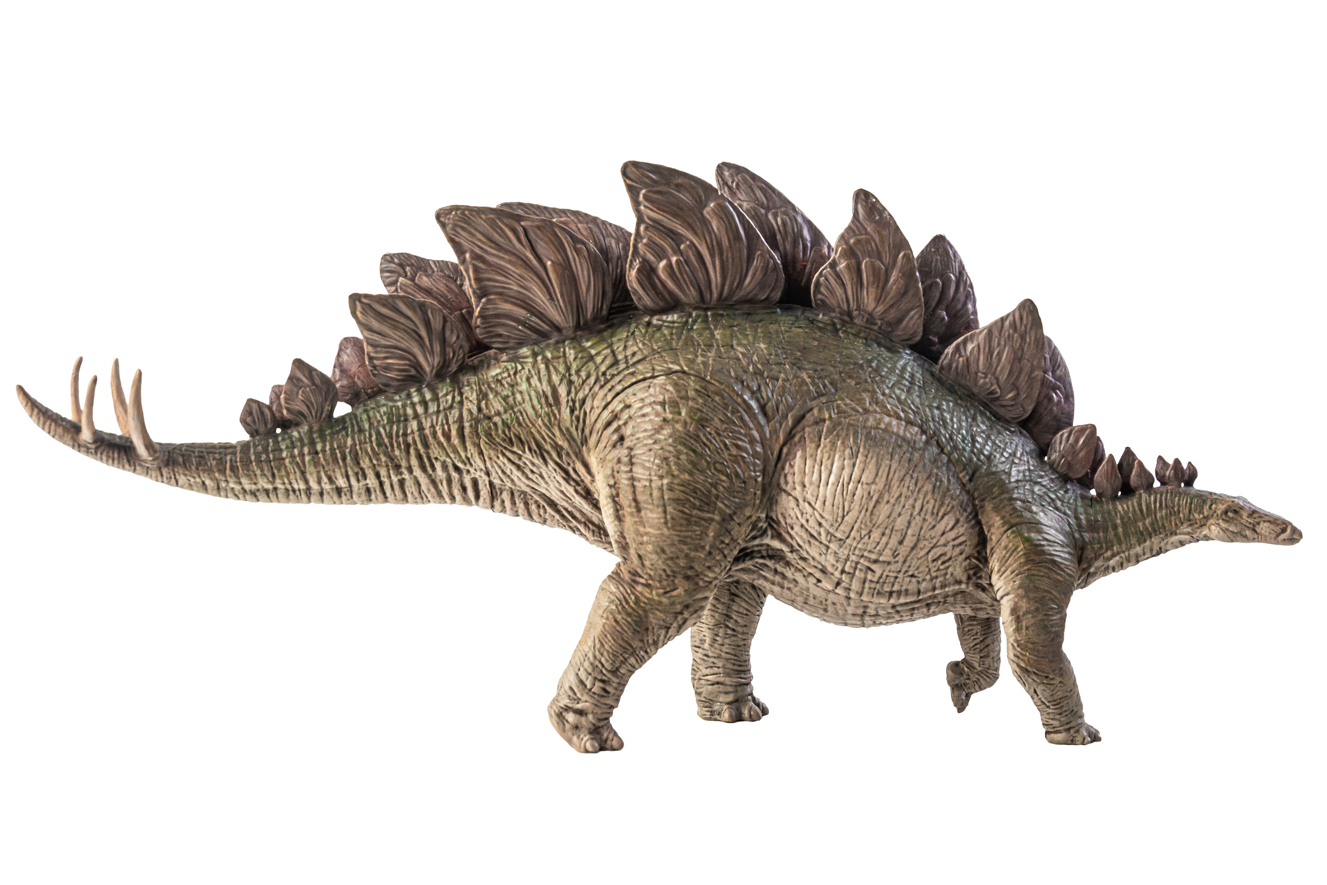
Stegosaurus
(Stegosaurus stenops)
My Greek name is ‘winged finger’
I’m one of the first prehistoric reptiles to ever be discovered
My back legs were long and thin, like those of birds.

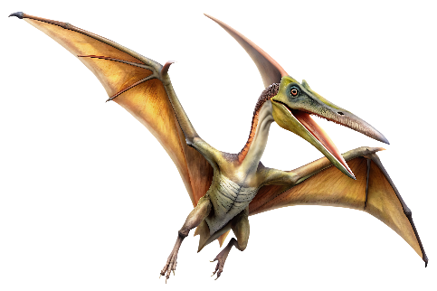
Pterodactyl
(Pterodactylus)
My Greek name is ‘tyrant lizard’
I’m 4 metres tall and 12 metres long
I’m a theropod with three clawed toes on each foot.
I was among the last to roam the Earth before the extinction event.

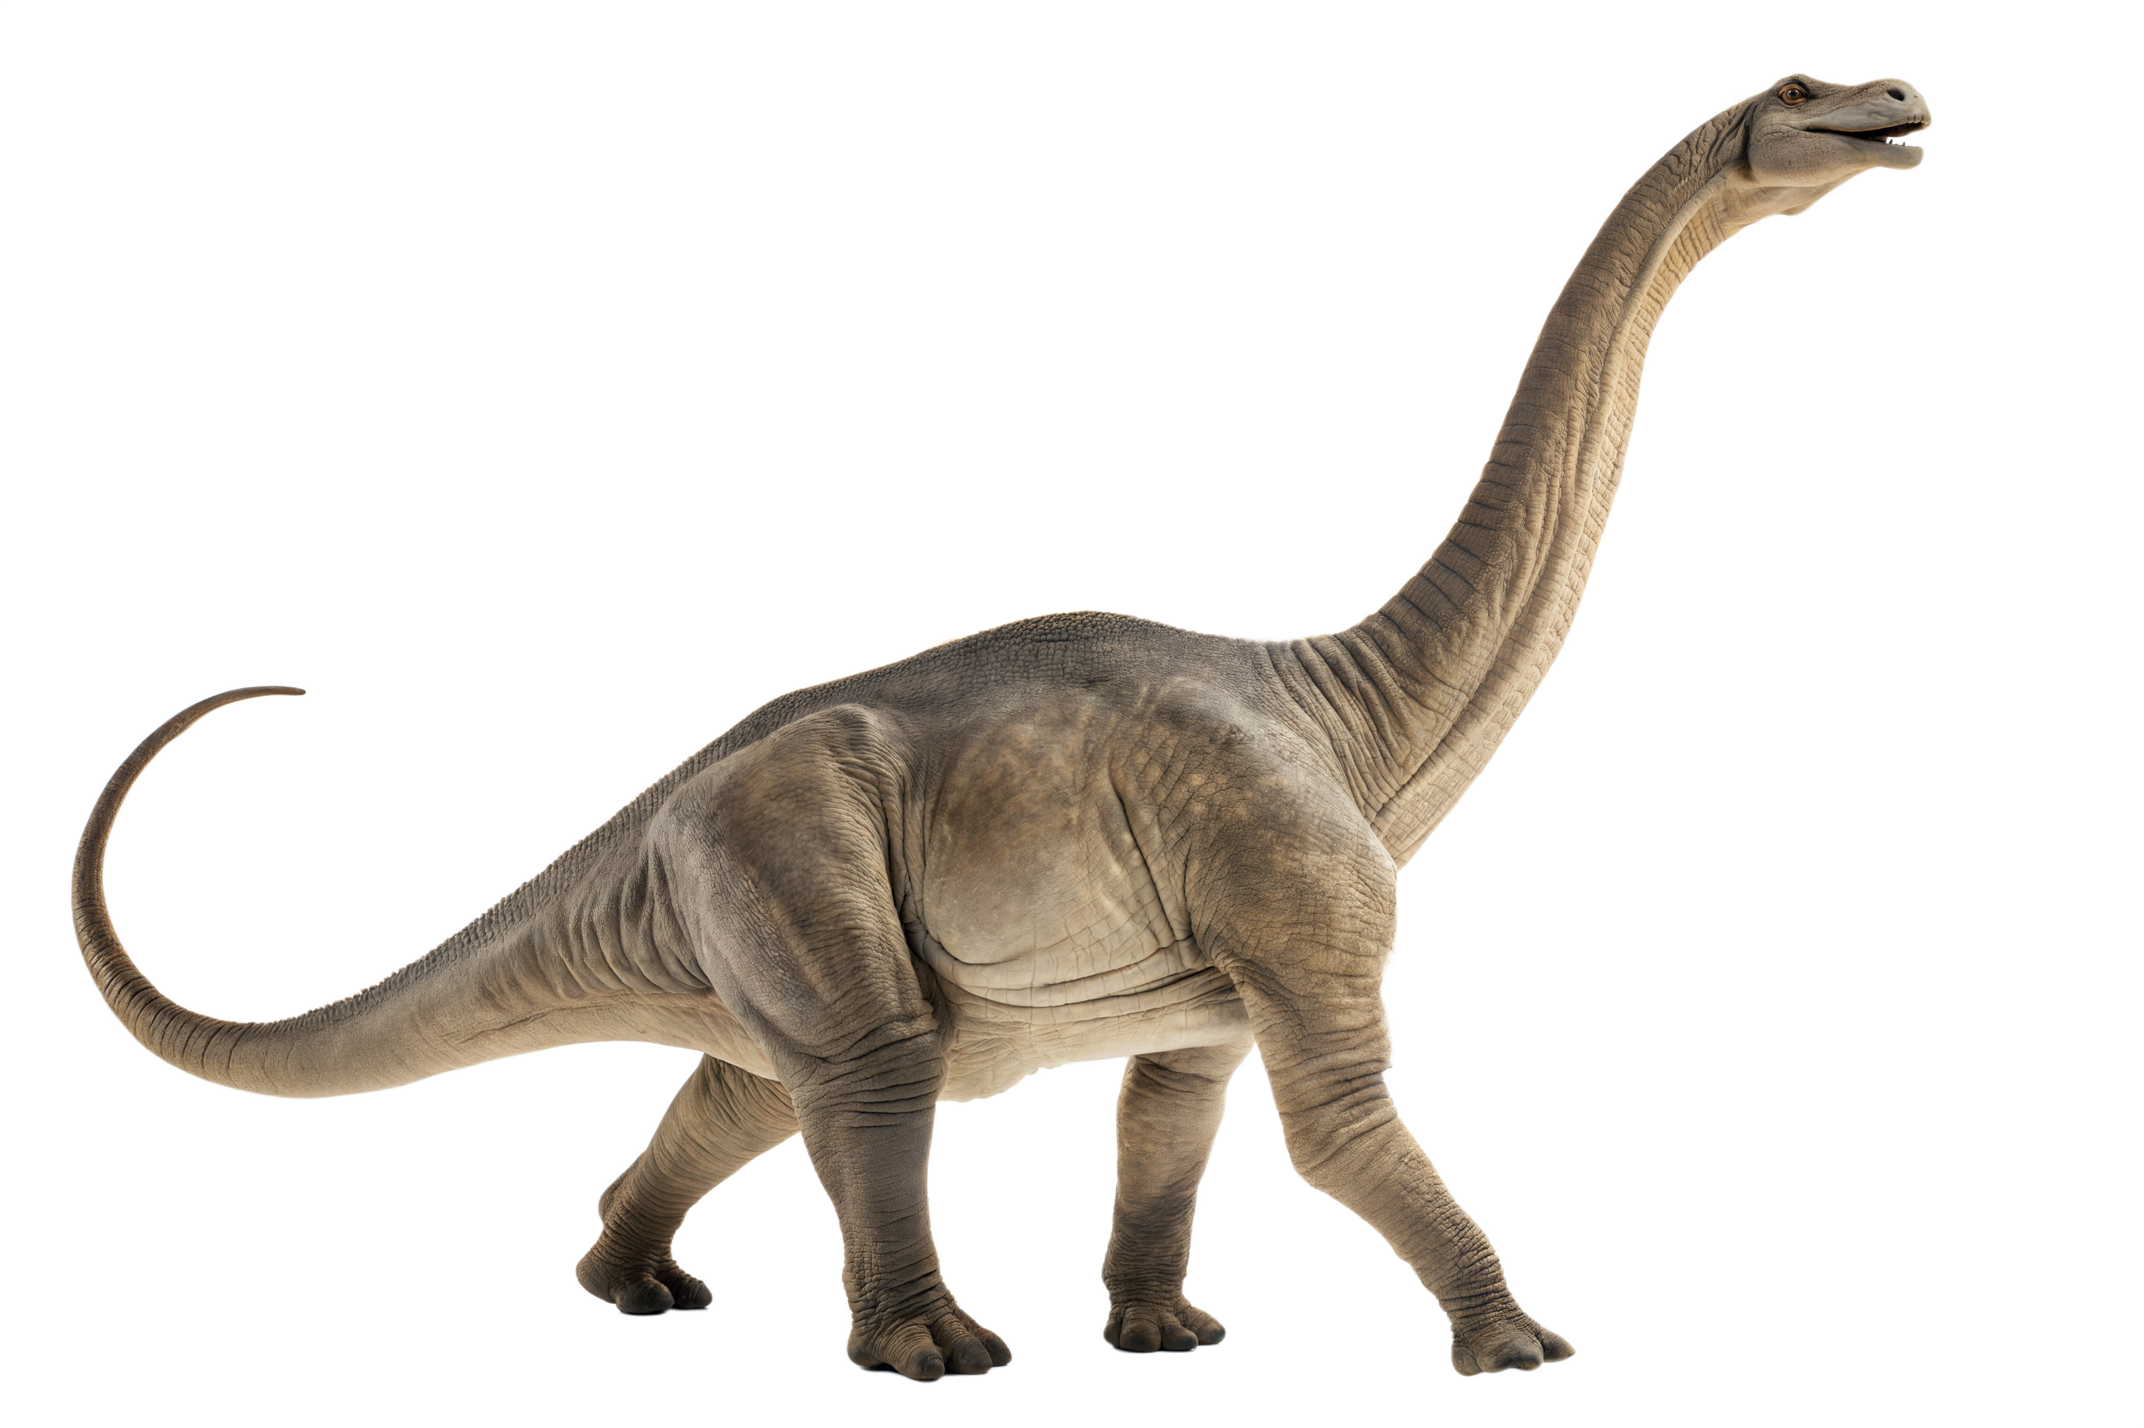
Brontosaurus
(Brontosaurus)
I lived during the Jurassic period.
My name is of Greek origin, meaning ‘roof lizard’
My fossilised footprints show that I travelled in family groups.
I grow to a length of about 6.5 metres long, but my brain is the size of a walnut

Choose one of the above dinosaurs to learn more about its characteristics! Conduct your own scientific research and complete the following sentence starters.

I was first discovered by scientists in….
Fossils of me have been found in…
Scientists know about my characteristics because…
Memory Game
Your task is to create your own dinosaur footprint memory game. Below you’ve been given the footprints of 16 dinosaur species. Find images of each of these dinosaurs to match with the footprints below. Make sure the size of footprint cards is the same size as the dinosaur pictures. Design the back of your memory cards. Test your memory by playing the game in small groups.

  - Teacher Resource

BTN Transcript: Episode 16 - 10/6/2025

Yaama. I'm Jack Evans and you're watching BTN. Here's what's coming up. We'll find out why Taylor Swift had to buy back her own music, learn more about this precious metal and hear about a competition to try and talk to animals.

Tariffs Update

Reporter: Jack Evans

INTRO: But first up to something you've probably heard a lot about for, well, a while now and that's tariffs. We've told you before about the US President's controversial plans to tax goods coming in from other countries but since then, a lot has happened. Let's find out more.

KING: Alright, what else is on the list of imports.
RIGHT HAND: We've got Iced Tea imported from England.
KING: Tariff.
RIGHT HAND: Olives imported from Spain.
KING: Tariff.
RIGHT HAND: Towels imported from Turkey.
KING: Tariff.
RIGHT HAND: And turkey imported from Maine.
KING: Tariff.
JACK EVANS, REPORTER: When we last left our King, he was only getting started with this whole tariff thing.
KING: I want Tariffs, that is my simple request. All things…
RIGHT HAND: Tariffed.
KING: Bigger and better is best.
And just like this made-up kingdom, the real world has seen something similar.
In case you need a reminder. A tariff is a tax or an extra cost that governments put on products that come from another country. Since first implementing tariffs earlier this year, US President Donald Trump, has put a tariff on just about every country, even places where there isn't anything to tariff.
KING: Right, I've marked out all the kingdoms I plan to tariff.
RIGHT HAND: But this is the whole map?
KING: It's not the WHOLE kingdom. I left out there.
On the 2nd of April, which President Trump declared as…
DONALD TRUMP, US PRESIDENT: Liberation Day.
He announced a baseline 10% Universal Tariff on imports from every country, except Canada and Mexico. As well as Reciprocal Tariffs of up to 50% on countries that Mr Trump said were engaging in unfair trade practices.
DONALD TRUMP: Our country and its taxpayers have been ripped off for more than 50 years. But it is not going to happen anymore. It's not going to happen.
Here in Australia, on top of the 10% universal tariff, we also got Reciprocal Tariffs including a 25% tariff on Steel and Aluminum, although recently Mr Trump said that Tariff would be doubled.
The liberation day tariffs caused a massive ripple effect across the world and wiped billions of dollars from the stock market. But on the 9th of April when the Reciprocal Tariffs were meant to kick in Mr Trump announced a 90-day suspension for all countries. Oh, except China which ended up seeing Tariffs of up to 145%. To which China kicked back with its own tariffs that peaked at 147.6%. But before it could turn into an outright Trade War, the US and China agreed to a 90 day suspension on some tariffs.
SCOTT BESSENT, US TREASURY SECRETARY: We have reached an agreement.
RIGHT HAND: Are you sure we should be tariffing so much?
KING: Of course, I'm using them as a tool for negotiation.
RIGHT HAND: Like a hammer?
KING: More like wrench, applying pressure on other kingdoms to enter trade agreements with us.
Some, including Mr Trump, say that's partly what all these tariffs are about.
DONALD TRUMP: Tariffs are very powerful both economically and in getting everything else you want
RIGHT HAND: Oh, well that sounds tariff-ic. But also, do we need to be running this past the Court of International Trade or something?
KING: Who?
At the end of May the US Court of International Trade ruled that most of Trump’s tariffs weren't allowed. Saying that the president had overstepped his authority. But the next day the president's team appealed the court decision and won which means for now the tariffs are still in place.
DONALD TRUMP: Without the tariffs, our nation would be in peril.
RIGHT HAND: Right, I think that's just about everything we can tariff.
KING: Oh, well what about the moon? Is there anything we can tariff on the moon?

News Quiz

Lee Jae-myung has been elected president of which country? North Korea or South Korea? It's South Korea. Lee Jae-myung, from the Democratic Party, won the top job after months of political chaos. The former president, Yoon Suk Yeol, was removed from office after trying to bring in martial law, that's when the military takes control of a country's law and order. Mr Lee, a former lawyer, says he's focused on bringing back trust in democracy and boosting South Korea's economy.
Australia's Fair Work Commission has announced a 3.5% increase of the minimum wage. It means Aussie workers who are over 21 and not under any other agreement will earn at least what? $14.95 an hour, $24.95 an hour or $30.95 an hour? It's 24.95 an hour. A pay rise is on the way for millions of Aussie workers earning the minimum what?
One of the world's most famous, and most active, volcanoes has erupted. Where is Mt Etna located? Iceland, Italy or Hawaii? It's in Italy, on the island of Sicily, to be exact. Eruptions are nothing new for Mt Etna. This latest one happened after part of the volcano's southeast crater collapsed, triggering an explosive reaction.

Music Rights

Reporter: Wren Gillett

INTRO: Now, to some big news in the music world. Last week, Taylor Swift officially bought back all of her old music. If you're wondering how or why she didn't own it in the first place, well, Wren can fill you in.

WREN GILLETT, REPORTER: So, you've made it. You wrote a surprisingly catchy song about...
ROCKSTAR: Highlighters.
Random, anyway, you manage to hit number 1 on the charts, announce a global tour, and people everywhere are asking for your autograph. But ahh, while you might have achieved fame, the fortune part isn't necessarily guaranteed.
ROCKSTAR: WAIT WHAT. WHY?
Look, there's a bit to unpack here. So, ahh, buckle up. While your favourite artists might have big fan bases these days, there was likely a time when nobody knew who they were. Like this guy.
RECORD LABEL: Don't worry, I'll get your name out there.
Enter the record label. Record Labels are basically companies with money and connections in the music industry. When they see potential in an artist, they invest time, money and other resources into hopefully making them a big success.
RECORD LABEL: I see it. 'You light up my page' that's our first album title. Bang.
They might help to cover the costs of recording, producing, advertising, and making sure the artist's music is actually played and heard by people. They also help with a lot of the legal stuff, like copyright, and helping the artist navigate the music world. Every time the artist's music is sold, streamed, played, or used, they're paid a share of profits, called royalties. But quite often, it's the label that owns the recording, because of all the help they provided at the start. Meaning they get to keep more of the money.
RECORD LABEL: I'd give more of this to ya, but ahhh, you owe me. Remember?
NIC KELLY, MUSIC JOURNALIST: It's not always split evenly, and especially once the artist has made back the money that the label has loaned them in the first place, then things start to feel a little bit unfair.
Yeah, sometimes it can actually be pretty hard for artists to make money from their own music. Streaming services don't always pay artists a whole lot of money, and quite often, a lot of what they do earn goes to their labels. It's why some artists create their own record labels, why a lot of your favourite singers will go on tour, release merch or perfumes, and why some artists like Taylor Swift decide to re-record their music.
TAYLOR SWIFT: I think that artists deserve to own their work, I just feel very passionately about that.
Back in 2019, Taylor Swift's former label, Big Machine, sold the recordings of her first six albums. Taylor wanted to own them, but says she wasn't given the chance to buy them directly. So, she started releasing Taylor's Version, a re-recording of her old albums that she could fully own and control. But now, after years and years of trying, Tay Tay has finally bought back her early music, for a measly ahh 360 million buckaroonies.
These days, a lot of artists are trying to hold onto more of their independence, which, thanks to new tech and social media, has never been easier.
NIC KELLY: No longer do you have to ask a record label to put your song out and beg them to give you the funding to record it. Things can be recorded on a phone or a laptop that you can buy for 1000 or 2000 dollars, and you can upload that song to every single platform on the Internet for free.
There are also calls for artists to be treated better by their labels.
CHAPPELL ROAN: I would demand that labels in the industry profiting millions of dollars off of artists would offer a liveable wage and health care, especially to developing artists.
NIC KELLY: There's definitely a really exciting opportunity now for these relationships between these record labels, who are still a massive and deeply important part of the music ecosystem and the artists that they represent to have fairer conversations, fairer splits.
So, artists like you can continue doing what ya love.
ROCKSTAR: THANK YOU EVERYONE.
Quiz
Which of these albums has Taylor Swift not re-recorded? Lover, Midnights or The Tortured Poets Department? Ah sorry, it's a trick question. None of these albums have been re-recorded by Taylor Swift because she owns the rights to them.

Gold Price

Reporter: Tatenda Chibika

INTRO: Now to a precious metal that's particularly precious right now. Gold. Gold prices have gone up so much that several old mines in Queensland may soon reopen. Tatenda digs into why this shiny metal has held such high value throughout history. Take a look.

Dora and the Lost City of Gold: We're on to something big Dora, an ancient city made of gold.
Finding Ohana: My kids are inside a mountain looking for some Spanish gold?.
Uncharted: It's the biggest treasure that's never been found, five billion easy.
Tatenda Chibika, Reporter: Gold isn't just something people are obsessed with in movies. Right now, it's so valuable, just a kilo costs around $160,000 dollars.
While there are rarer metals out there, experts say gold has properties that make it unique.
Professor Rick Valenta, UQ Sustainable Minerals Institute: It doesn't tarnish. It doesn't oxidise if you have a piece of gold now, you can leave it out in the backyard, in the rain and the cold weather and the hot weather and bury it in the dirt and dig it up again and it will still be shiny.
Gold has been a part of many civilisations throughout history.
The Sumerians moulded it into jewellery, like these earrings gifted from King Shulgi.
Egyptian Pharaoh's like Tutankhamun were buried with it believing it was the "Flesh of the Gods". And the Mali Empire's Mansa Musa is considered one of the wealthiest people in history because of how much gold he had.
The precious metal has also been used as a form of currency for ages. From the 1870s to the 1920s, many countries around the world adopted the gold standard where the value of money was directly linked to real gold held in the vaults of banks. It was called the Gold Standard, and it ensured cash was worth the same as something that had a lot of value like gold.
While the policy was used here in Australia because of our ties with Britain our history with Gold was shaped in the mid-1800s. Although people had discovered gold before then, authorities didn't trust the convict population, so they kept it a secret.
But their attitudes changed when the California gold rush began. It brought a lot of money to America but lured much needed workers away from Australia. So, governments in New South Wales and Victoria, offered rewards to anyone who found a gold deposit big enough to be mined.
In 1851, Edward Hargraves and a group of prospectors discovered a bunch of gold flakes in a town near Orange in New South Wales.
Edward showed the gold to officials and was eventually given 10,000 pounds for the discovery which he didn't share with the others. Word of the discovery quickly spread and within months, hundreds of diggers flocked to the area. It sparked the beginning of Australia's Gold Rush which brought hundreds of thousands of migrants to the country and helped make the nation rich.
Today, Australia is the third-highest gold producer in the world behind China and Russia. As for the value of gold nowadays.
Professor Rick Valenta: The price of gold is very high right now. There's no doubt about that. The last time the gold price was this high was in 1980.
Experts say when things aren't going well in the global economy gold prices tend to go up.
Professor Rick Valenta: People can't print more gold coins. You have to go find more gold. So, people look at that and they say it's you know, it's something that has a tangible value of a value that you can sort of rely on.
So, are we entering modern gold rush era? Well Professor Valenta says while things are going well now people shouldn't get too carried away.
Professor Rick Valenta: One of the most dangerous things always to say is 'ohh this time is different'. This time probably isn't different. It's probably the same as other gold price spikes in the in the past and it's probably gonna come back.

Animal Communication

Reporter: Wren Gillett

INTRO: Ever wished you could have a conversation with an animal? Well, it's something scientists have been working on and now, a major competition is offering a huge cash prize for anyone who can crack the code of interspecies communication. Here's Wren.

PRINCESS: If you listen closely, you'll hear their voices, their songs. Ahh, music to my ears. Oh, hello there, how are you?
BIRD: Yeah, I'm good mate how are you?
PRINCESS: Oh, I wasn't expecting that accent.
WREN GILLETT, REPORTER: Okay, while talking to animals might seem like something only fictional characters can do. It's an idea scientists are taking seriously.
Over the years we've discovered lots about the ways animals communicate. Take octopuses for example. They can change the colour and texture of their skin to communicate mood.
PRINCESS: Other animals use their voices, like us.
Male humpbacks sing long, detailed songs during mating season. And some animals even use names. Like elephants and dolphins.
A while ago, scientists worked out that each individual dolphin whistles something completely unique to them. Something called a signature whistle.
LAELA SAYIGH, PROFESSOR OF ANIMAL BEHAVIOR: So, these are these individually specific whistles that are very much like our names.
This is Laela. She's been researching dolphins for 40 years. And recently, her research team won the first phase of a competition called the Coller Dolittle Prize. It's a massive competition, offering hundreds of thousands of dollars to scientists who can help us get closer to...
BIRD: Talking to us animals.
PRINCESS: Yes. What he said.
LAELA SAYIGH: So, the whistles have very distinctive shapes that we call contours, and they really are just so distinctive.
Laela says when dolphins aren't busy saying their own names, the other whistles they make might actually mean something. She thinks these non-signature whistles could work a bit like words that dolphins use to talk to each other. Like for instance, sounding an alarm.
LAELA SAYIGH: So, when I first saw that, I honestly thought I was going crazy. I just thought I've never seen anything like this. I almost thought nobody was going to even believe me that I was seeing it.
But there's still so much we don't know. Which is why some researchers are enlisting the help of AI. Like Yossi, he's part of the team who started the Dolittle Prize, and recently, he's been studying the language of bats.
YOSSI YOVEL, PROFESSOR IN ZOOLOGY: So, we put bats in large cages for a short period of several months and then we release them. But during this period, we video them continuously and record everything.
Yossi and his team recorded 15,000 vocalisations of bats, along with who was making the call, who to, and what the bats were doing when they made the call
YOSSI YOVEL: Then we fed this into an AI machine. So, AI is a big advantage in that indeed it is very good at trying to identify patterns that might be hidden.
What they found after it was given the detailed data, was that the AI was able to take a random sample and say who was calling, the context of the call, whether the bats were fighting or playing, and in some instances who the call was addressed to.
YOSSI YOVEL: But again we're humans and often we don't understand exactly what the animal is doing. So, I mean collecting data and filtering the data and annotating the data. That's all very, very challenging.
Right now, researchers say it will be a long time before humans, not just fairytale princesses, can properly talk to animals. But they say everything we're learning is important.
LAELA SAYIGH: I think that the more we learn about animals, it can only increase everyone's empathy for them.
BIRD: Alright. I'll see ya round.
PRINCESS: Oh of course, I'll speak to you later. goodbye now.
Did You Know?

Did you know honeybees communicate with a "waggle dance" to tell hive-mates where food is located.

Sport

It was a big win for Carlos Alcaraz against Jannik Sinner concluding a five-hour final at the French Open, the longest ever. And in the women’s, after a rocky start, Coco Gauff turned it around to defeat Aryna Sabalenka making her the first American to take home the title since Serena Williams a decade ago. Phwoah.
Now let's keep that win streak going with our Australian Olympic champion, Jess Fox, who's snagged her 34th gold in the C1 at the Women's Canoe World Cup leg in Spain.
And let's finish with a plunge into a different kind of win with the 11th annual AFL Big Freeze. Every year, well-known Aussies dressed in costume of course, take to the slide and the icy cold waters at the bottom all to raise awareness for the fight against motor neurone disease. This year's dress code: "Iconic Australians". Gee, you get cold just watching it, don't you?

Dino Footprints

Reporter: Tatenda Chibika

INTRO: Now to rural Queensland, where some school kids have found out more about a very special rock that sits in their foyer, which, apparently, has one of the highest concentrations of dinosaur footprints ever seen in Australia. Here's Tatenda with more.

STUDENT: I was absolutely shocked; I thought this boulder was fake.
STUDENT: I was pretty shocked that the fossil was really important
STUDENT: I had no clue. It's honestly just another rock to me
STUDENT: I just thought it was a normal display in the office, nothing important really.
From a distance, this slab of rock at Biloela State High isn't much to look at.
David Hall, Deputy Principal: You walk past it every day, you talk to kids every day and you have very different conversations and it's just a backdrop to everything we do in our school.
In the early 2000s, a Geologist saved it from being destroyed in a nearby mine and donated to the school.
But that's not what makes this old rock interesting. If you look closely, there are dinosaur footprints on it a lot of them.
Dr Romilio, Palaeontologist: Hi, my name is Dr Anthony Romilio. I'm a palaeontologist from the University of Queensland.
And when he finds out about it Dr Romilio drove 6 hours to get a look.
Dr Romilio: The rock itself is around 200 million years old, so in the lower part of the Jurassic.
He used a silicon mould to make a copy of the fossil and studied it in his lab. That's where he discovered the slab had 66 footprints on it he says they came from an Anomoepus scambus dinosaur.
Dr Romilio: Overseas, they've kind of done the hard work for us where they've done the Cinderella effect where they've matched the Dinosaur foot bones to this particular shape of footprint and so that's why we know these were made by a bipedal, a two legged, small dinosaur known as an Ornithischian.
Dr Romilio reckons these guys were moving at around six kilometres per hour and used the slab like a highway.
Dr Romilio: Most of them are heading this direction or that direction which kind of indicates to us that they were either crossing a river this way or that way or maybe they were going up and down a river.
This discovery is a pretty big deal because it's rare to find Dinosaur fossils from the early Jurassic period and it's not only palaeontologists who are excited about uncovering this part of our dino history.
The school is working with Dr Romilio to make a copy of the fossil so they can share this find with even more people.
STUDENT: It's so exciting that our school has been recognised for such a such an old fossil and now it's just I want to know more about what dinosaurs were here and how many more.
STUDENT: There's no way that they just disappeared and there's no other continuation of where their footprints are. So, I think that if you were to dig deep enough or go looking hard enough, you'd definitely find some.
STUDENT: We should all start a big search for more fossils because I'm just quite excited that this could bring the community together.
Closer

Well, that's all we have for you, but we'll be back next week with more. In the meantime, you can catch Newsbreak every weeknight right here in the studio and there's plenty to see and do on our website. Have an awesome week and I'll see you next time. Bye.

