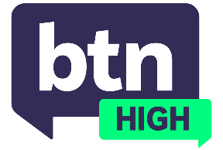
  EPISODE 58
  23rd October 2024
  KEY LEARNING
  Students will explore the rise of misinformation and disinformation, and look at the problems Artificial Intelligence has added to the mix.
  CURRICULUM
  Digital Technologies – Year 7 & 8 (v8.4)
  Digital Technologies – Years 7 & 8 (v9.0)
  English – Year 9 (v8.4)
  English – Year 9 (v9.0)
  - Teacher Resource

Misinformation

Focus Questions
Discuss the BTN High story as a class and record the main points of discussion. Students will then respond to the following:
- What is the difference between misinformation and disinformation?
- Have you ever come across misinformation online? If so, explain what it was and how you discovered it wasn’t real.
- What could be some consequences of believing misinformation or disinformation?
- What can social media/tech companies do to make users aware of misinformation and disinformation?
- What strategies could you use to be more aware of misinformation?

Activities
- Hold a class discussion about misinformation. Students will discuss their experiences with misinformation/disinformation and how easily it spreads.
- Write an essay explaining what misinformation is, and how to check the reliability of a source.
- In small groups, brainstorm strategies on how to avoid being caught out by misinformation and how to be more media literate. Present your answers to the class.
- How can misinformation and disinformation influence important global events, such as an election or a public health crisis? Give an example.

