EPISODE 22
13th August 2024

KEY LEARNING
Students will explore the topics explained in the BTN Science Week 2024 Special including evolution, mass extinction and conservation.

CURRICULUM
Science – Year 4
Living things have life cycles.

Science – Year 5
Living things have structural features and adaptations that help them to survive in their environment.

Science – Year 6
The growth and survival of living things are affected by physical conditions of their environment.

Science – Year 7
Classification helps organise the diverse group of organisms.

Science – Years 5 & 6
Scientific knowledge is used to solve problems and inform personal and community decisions.

Science – Year 7
Scientific knowledge has changed peoples’ understanding of the world and is refined as new evidence becomes available.

Science – Year 7
People use science understanding and skills in their occupations, and these have influenced the development of practices in areas of human activity.

  - Teacher Resource

Science Week 2024

Focus Questions
As a class, discuss the stories featured in the BTN Science Week 2024 Special. Students will then respond to the following focus questions:

Evolution
- What is a species?
- The diversity of species came about through the process known as _________________.
- What is evolution?
- What is the theory of natural selection? Give an example.
- What questions do you have about the story?

Mass Extinction
- Give an example of a plant or animal that has become extinct in the past 100 years.
- What is a mass extinction event?
- How many mass extinctions has the planet had?
- Scientists believe we’re living through a mass extinction now which is caused by what?
- Give at least two examples of things being done to protect species from extinction.

Youth Conservation
- Why is Django’s local environment important to him?
- What does Alice love about her local environment?
- Explain the conservation project Django has been working on.
- What advice do Django and Alice give about getting involved in conservation?
- What did you learn watching this story?

Activity: What do you see, think & wonder?
After watching the BTN Science Week 2024 Special hold a class discussion, using the following as discussion starters:
- What do you THINK about what you saw in the Science Week special?
- What does this video make you WONDER?
- What did you LEARN from the BTN story?
- Think of three QUESTIONS you have about the BTN Science Week 2024 Special.

Questions and Answers
All scientific discoveries start with a question! As a class, come up with some questions you think scientists ask and solve. Organise the questions into common themes. As a class, make a list of questions that you would like to ask a scientist.

Activity: Evolution Glossary
Students will brainstorm a list of key words that relate to the BTN Evolution story. Here are some words to get them started.

EVOLUTION | SPECIES | SURVIVAL
NATURAL SELECTION | DIVERSITY | DNA

Ask students to write what they think is the meaning of each word (including unfamiliar words). They will swap definitions with a partner and ask them to add to or change the definition. Check these against the dictionary definition.

Activity: Research Inquiry
The KWLH organiser provides students with a framework to explore their knowledge on the topic and consider what they would like to know and learn.

What do I know? | What do I want to know? | What have I learnt? | How will I find out?

Questions to research
Students will develop their own question/s to research about evolution. Students will collect and record information from a wide variety of sources. Students may develop their own question for inquiry or select one of the questions below.
Inquiry Questions
- What is evolution and how does it help plants and animals survive in their environments?
- How do fossils provide evidence for evolution?
- What is natural selection?
- What is an adaptation? Give examples of physical and/or behavioural adaptations.
- How have different animals adapted to extreme environments? Explore the adaptations of animals living in extreme conditions, such as deep-sea creatures or desert animals.
- What are some examples of animals that have changed over time?
- Investigate what is meant by evolutionary `fitness’.
- Who was Charles Darwin and why is he important in the study of evolution? (Watch the Science Week biography about Charles Darwin to help with your research).

Activity: Create a new species
Working individually or in pairs, students will use their imagination and create a new species of their own. They will imagine they have discovered a new species which has never been seen before. Use the following as a guide for this activity:
- Illustrate the new species using only a black felt-tip pen on a piece of A4 art paper – include as much detail as you can.
- Give your new species a common and scientific name.
- Describe what it looks like – what are some of its physical features?
- Describe its habitat.
- What does it eat? Does it have any predators?
- Include any adaptations it has that helps it survive in its environment.

Further investigation: Make a model of your new species and present it to your classmates.

Activity: Improve biodiversity in your local environment
Students will work together to help and introduce a native animal species into their school yard. Ask them to consider the following:
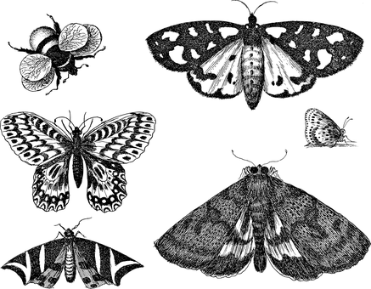
- What kind of animals could you reintroduce into your school yard? E.g., birds, bees, frogs, butterflies. Research the species native to your local area. Contact a ranger at a park near your school or the local council to learn more about the local species.
- Do you have the right type of habitat in your school yard for the native animal species to survive? Describe the climate and identify the plants in your school yard.
- What are some threats to the species that are caused by humans? How can you reduce these threats in your school yard?
- What materials and tools will you need to build the habitat or introduce new species to your area? Consider writing a guide or procedure manual.
- Build the habitat as a class and present the habitat to your school community. Teach students in other classes about the new habitat and involve them in caring for the new habitat.
- Prepare a map of the habitat which highlights key features. Include information labels in the habitat (for example, QR codes) for other students to learn more about the habitat and the biodiversity of your school yard. Include scientific information about the species.

Activity: Extinction Word Cloud
Students will brainstorm a list of key words that relate to the BTN Extinction story and create a word cloud. A word cloud is a visual made up of important/key words relating to a topic. Ask students to think of words they associate with the extinction of plants and animals. Create a word cloud using a free online word cloud creator such as Word It Out. Working in pairs, students can clarify the meanings of the words included in their word clouds.
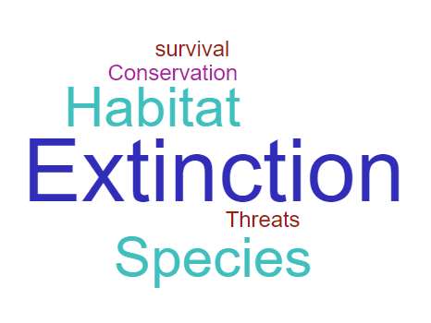

Activity: Extinction Research
Discuss the information raised in the BTN Mass Extinction story. What questions were raised in the discussion and what are the gaps in students’ knowledge? Students will develop their own question/s to research or choose one or more of the questions below.

- What causes species loss? Explore issues such as habitat loss, introduced species, pollution, population growth and overharvesting/hunting.
- What is a mass extinction? How is it different from the extinction of a single species, or even several different species?
- Which species have become extinct in modern times?
- What are the connections between human activities and species extinctions?
- What happens when an animal becomes extinct? If one species in the food chain becomes extinct, how would it affect the rest of the chain? Choose an endangered species and explore its role in the food chain.
- Who do you think should be responsible for addressing the problem? List some of the responsibilities of individuals, communities and the government. Think of ways you can make a difference at home and at school.
- What are the periods of mass extinction on Earth? Choose one to research in depth, their causes and their impacts.
- What evidence have scientists found to help understand how dinosaurs became extinct?

Activity: Extinct Animal Profile
Students will research and write a profile of an extinct Australian animal. Here is the Australian government’s list of extinct animals or the Australian Museum has an extinct Australian animals list. Students can use the animal profile worksheet at the end of this activity to record their findings. Encourage students to use a range of sources to find their information.

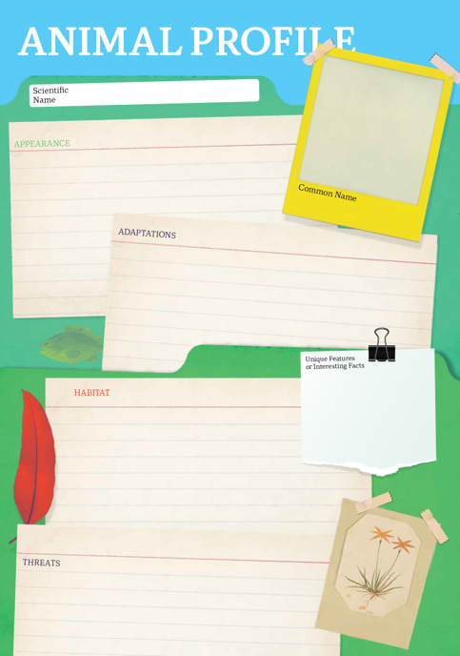
Research
Students will research and create a profile of an extinct Australian animal. Students can use the Animal Profile at the end of this activity to record their findings.
- Illustration or photo
- Scientific and common name
- Appearance
- Habitat
- Feeding and diet
- Behaviours and adaptations
- When did it become extinct?
- What were some of the causes of its extinction?
- What were the effects of its extinction? Did it have an impact on humans, plants, or other animals?

Activity: Seed Vault
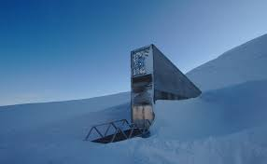
The Svalbard Global Seed Vault in Norway is a back-up collection of seeds from the world's food and fibre plants. It's known as the 'Doomsday Vault' because if something terrible were to happen and crops were wiped out, humans would be able to feed themselves. Watch the BTN story to learn more about the Doomsday Seed Vault.

Go on a virtual tour of the Svalbard Global Seed Vault to learn more.

Activity: Personal Response
Respond to the Naturalist Profiles featured in the BTN Science Week 2024 Special as a class. Students will choose one or more of the profiles and complete the following incomplete sentences:
- [Scientist’s name] is an important person because…
- It was interesting to learn…
- These are five words that I would use to describe [Scientist name] …
- This story made me feel…
- It is important to celebrate [Scientist’s name] because…

Activity: Become a Naturalist
Provide students with the opportunity to think and behave like a naturalist, a person who studies and observes nature. In this activity students will explore a natural habitat in their local area, identify plants and animals in the area and document what they find.

Students can work individually or in small groups, using the following as a guide.

Step 1: Plan
Plan a visit to a local nature reserve or your own school yard to explore and identify plants and animals. You will need to write a list of tools you may need for the investigation, for example: pen and paper for taking notes, camera and magnifying glass. Predict what you might see and find. Think about what a naturalist would need on an investigation.

Step 2: Explore
Visit the habitat and carry out an exploration of the area. Choose a spot in the environment to investigate. Consider exploring the area from different angles, closeup or far away. Look and listen for evidence that animals live in the area.

Step 3: Collect
Once you have found an animal in the area, begin to study the animal and the plants around it in more detail. Collect as much data as you can about it and record what you find. You may write notes and sketch what you see to help in your investigation. Record what you see with a stills or video camera.
- What does the species look like? Take photos and draw pictures. Describe its characteristics.
- What is the animal doing? How does it interact with the environment? Record the behaviour of the animal.
- What does the environment look like? Describe. Can you identify any plants?
- Ask one “how” and one “why” question about what you see.

Return to the classroom and share/compare your findings.

Step 4: Analyse
Analyse your findings and write a short summary of your investigation.
- Did you find any animals during your investigation? If yes, identify and describe what you found. If you didn’t see any, did you find any evidence that animals live in the area?
- How could you help protect this habitat?

Step 5: Research
Respond to one or more of the following:
- What is the scientific name of the species?
- Explore the taxonomy of the species and categorise the information you find using the classification system.
- Why is this animal or plant important?
- Investigate what citizen science projects are happening to help monitor or protect this species.
- What might you notice if you visit this animals’ habitat at different times of the day or year?
- How has this species adapted over time to survive in their environment? Research some specific adaptations they have made to survive in their habitat.
- Where is this species on the food chain? Predict what might happen if they are removed from the food chain.
- Are there any examples of a conservation project helping this species?

Step 6: Reflect
Reflect on the investigation by responding to one or more of the following questions:
- What did you enjoy about this investigation?
- What did you find surprising?
- What would you do differently next time?

Activity: Scientist Profiles
Students will research the life and achievements for one of the naturalists featured in the BTN Science Week 2024 Special, Jane Goodall, Charles Darwin, Mary Anning or David Attenborough. Students will create a timeline poster and prepare an oral presentation summarising key events in their life and their contributions to science. Alternatively, students can choose another scientist that has contributed to the survival and thriving of different species.

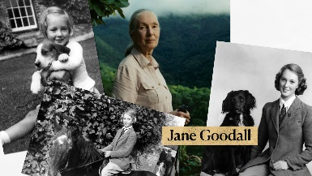 | 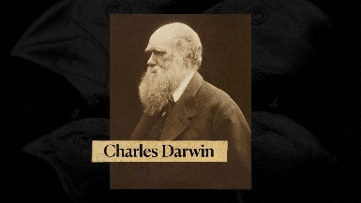
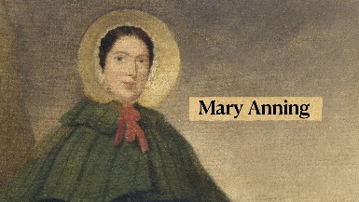 | 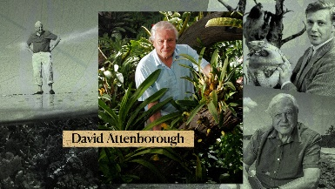
Timeline Poster
Your students’ task is to create a timeline poster, responding to the following areas of research.

Research
- Early Life - Information about your significant person’s parents. When/where was your significant person born? What type of education did your significant person receive?
- Family - Personal information; Was your significant person married? Did they have children?
- Legacy - What event and/or action led to them becoming a significant person? What did they do that had an impact on the lives of others?
- ‘Where are they now?’ If your significant person has died, you can outline where they are buried. If they are still alive you can outline what their life looks like now.
- 2 x ‘Interesting Facts’ and 2 x ‘Did You Know?’
- A minimum of 6 and a maximum of 10 photos with captions.
- Include a bibliography on the back of your poster.

Oral Presentation
Students will prepare a short oral presentation, speaking in ‘first person’. They will speak about their life, their family, character, the decisions they made and why, and their impact and influence on society. Students are encouraged to dress up in-character and bring along 3-4 ‘props’/artefacts to support their presentation.

Further Research
Students will choose one of the activities to further investigate their significant person.

Interview
- Imagine you could sit down and talk to them.
- What questions would you ask about their life and achievements?
- Find answers to your questions.
Portrait
- Plan and create a portrait.
- Explore and experiment with different techniques and mediums to produce a portrait.
- Organise a class exhibition of your artworks.
5 w’s
- What are some of the key events in their life?
- Write a summary for one key event, which answers the 5 W’s – Who, What, Where, When and Why?

Activity – Choose a Project
Individually or in small groups, students will choose one of the following projects to work on and then present their findings to the class.

Citizen Science
Become a citizen scientist and take part in a koala survey! There are various koala surveys, including these in NSW.

Bee Friendly Garden
Design a honeybee garden for your school. Include a map, special features and make a list of the top 10 honeybee attracting plants.

How do Bees Communicate?
Why is it important for bees to communicate? Watch this ABC Education video Why do bees’ boogie? to find out more.

Bird Calling
Do you know what a king parrot sounds like? What about a turtle dove? Or a barking owl? Watch this BTN story to learn more about bird calling.

Useful Websites
Evolution
- Species Survival Teacher Resource – National Science Week 2024
- Evolution Resources – ABC Education
- What is evolution? – BBC Bitesize
- Human Evolution – BTN
- Charles Darwin Day – BTN

Mass Extinction
- Extinction Report – BTN
- Insect Extinction – BTN
- Doomsday Seed Vault - BTN
- What’s happening to Australia’s biodiversity? – Australian Museum
- Mass Extinctions - Australian Environmental Education

Zoos and Conservation
- Conservation – Zoos SA

Scientist profiles
- Who was fossil hunter Mary Anning? – BBC Bitesize
- Mary Anning: the unsung hero of fossil discovery - Natural History Museum
- Charles Darwin Day – BTN
- Charles Darwin: History’s most famous biologist – Natural History Museum
- David Attenborough – Britannica Kids
- Jane Goodall – National Geographic

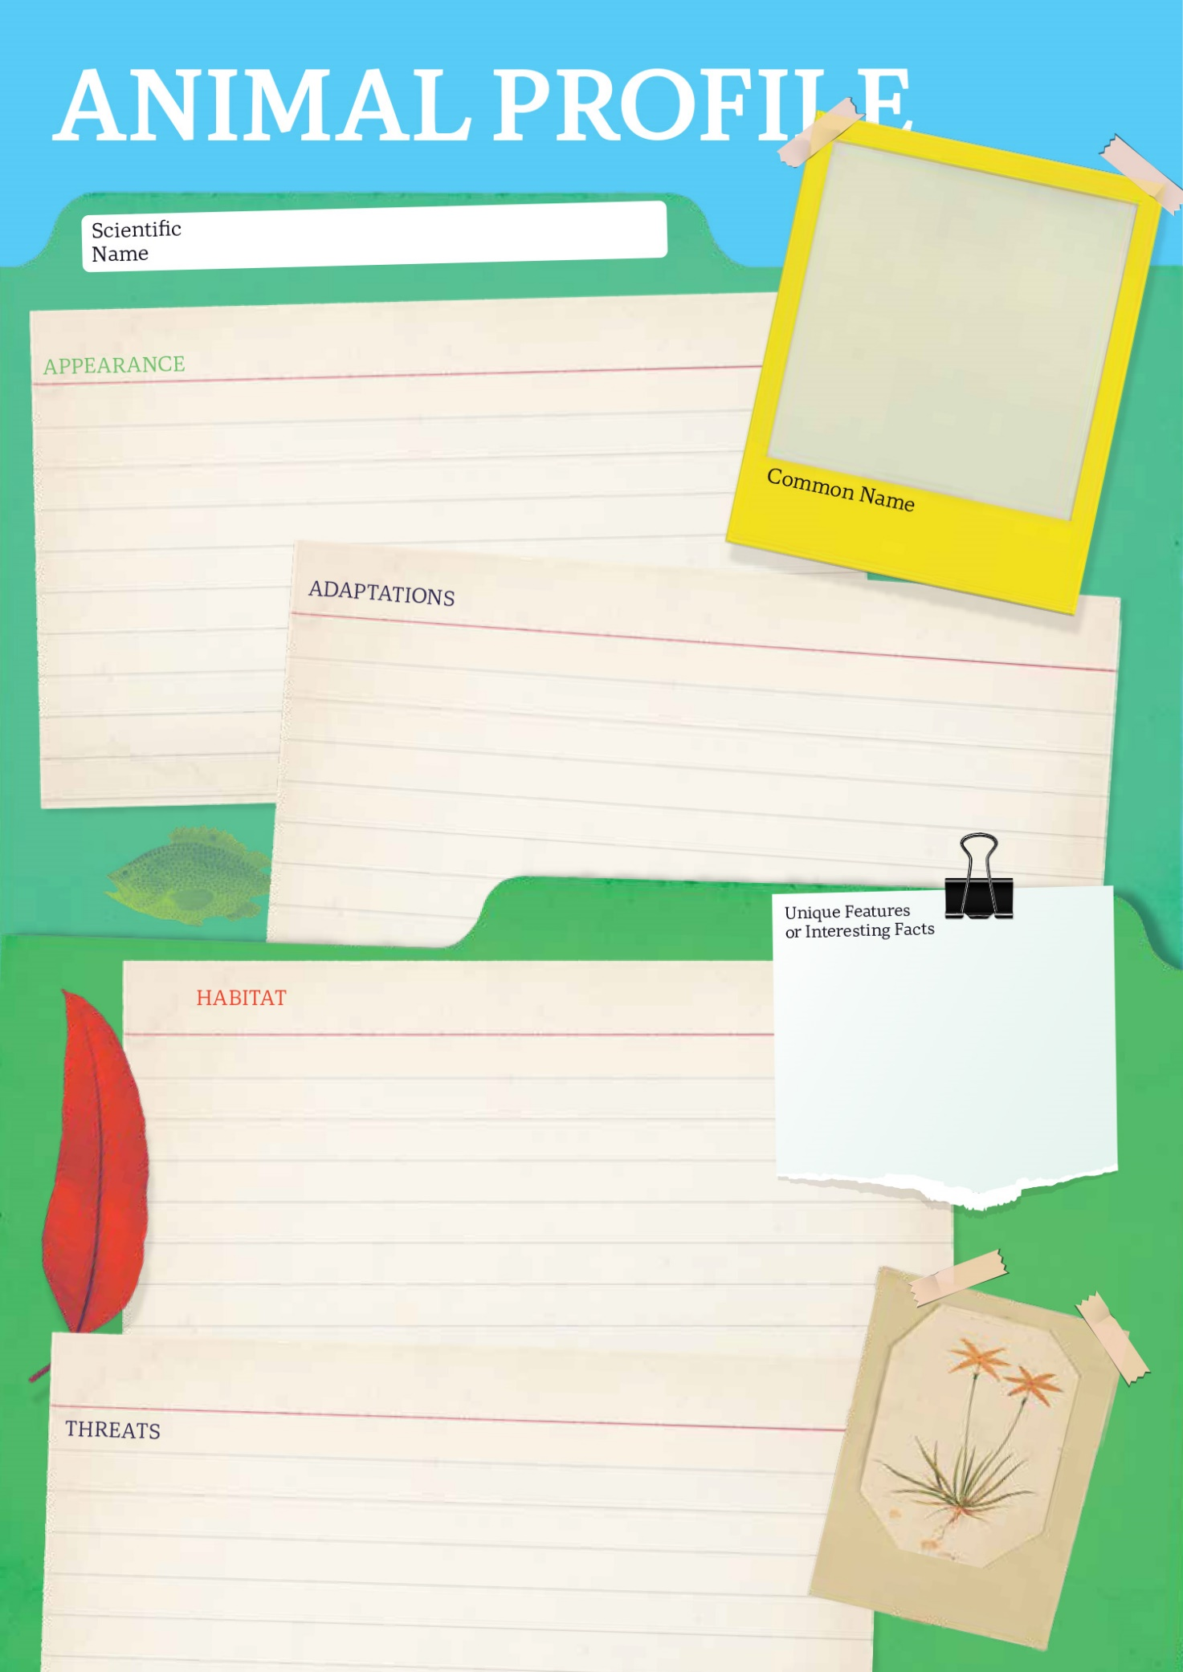

  - Teacher Resource

BTN Transcript: Episode 22 - 6/8/2024

Hey, I'm Amelia Moseley, and you're watching this BTN Science Week Special. As you can see, I'm not in the studio today. I'm here at the zoo! And there's a good reason for that because we're going to be exploring this year's Science Week theme, which is Species Survival. We're going to find out about the threats facing some of the plants and animals of planet Earth, and what's being done to protect them. We're also going to learn about the lives of some very famous naturalists with the help of our Rookie Reporters.

Evolution

Reporter: Cale Matthews

INTRO: All that's soon but first, have you ever looked at a creature like this one and thought, "How did that happen?" No offence, buddy. Well, we share the planet with a whole heap of amazing plants and animals, and Cale decided to look into how it is that life on Earth became so diverse. Check it out.
The diversity of life on Earth is magnificent. Millions of species grow, flower, fly, and… oh hurry up… across the planet. So where did all of these feathers, fur, and fins come from?
CALE MATTHEWS, REPORTER: (COUGHS) Oh, hey. Sorry, it is just me, but I kind of thought the story needed a David Attenborough voice. Anyway, let's go find out.
Hi Rachael.

DR RACHAEL KING, SOUTH AUSTRALIAN MUSEUM: Hi!

There are so many different animals on Earth, some are microscopic, some are as big as elephants. What is a species?
DR RACHAEL KING, SOUTH AUSTRALIAN MUSEUM: So it's a great question. Um, we have a whole scientific system of classifying living things. It's called taxonomy. And in that classification, the smallest, most specific part of it is the species.
The definition of a species is not actually that straightforward. And sometimes there's disagreement over which species an organism belongs to. But basically, it's a group of organisms that can reproduce - that is, make babies - share characteristics that make them look pretty similar and share a majority of DNA.
DR RACHAEL KING, SOUTH AUSTRALIAN MUSEUM: DNA is a very clear scientific method to be able to use to look at relatedness of things.
Okay so that's a species, but I still have a few more questions…
Now, Steve, I think I know what a species is now, but clearly, there are lots of them. So how did we get so many species?
DR STEVE COOPER, SOUTH AUSTRALIAN MUSEUM: This incredible diversity of species came to us through the process of evolution.
Evolution is the process of change over time. It's an idea that's been around for ages, but we didn't quite understand how it worked until these two guys, Charles Darwin and Alfred Russel Wallace came up with the theory of Natural Selection. They recognised that within a population of animals each individual is slightly different and some of those differences will mean that animal is better at surviving in its specific environment. It might be a slightly skinnier beak that's good at picking up insects, or a slightly stronger beak that's good at cracking nuts, or perhaps a slightly longer neck that's good for eating hard to reach leaves. Those animals are then more likely to eat and survive and have babies with skinny beaks or strong beaks or long necks too. Over a really long time those tiny changes can become big changes and give rise to a whole new species.
DR STEVE COOPER, SOUTH AUSTRALIAN MUSEUM: Take, for example, an animal moving into a cave environment, if they have an ability to smell their environment much better, then they're going to be adapted better, they'll find their food, and they'll survive and reproduce.
Through the use of DNA, and the fossil record, we can trace where all of these millions of species came from, and all of the species before them, and before them, and before them, right back to the beginning of life on Earth.
Charles Darwin Profile

Rookie Reporter: Aled

Charles Darwin is one of the most famous scientists who ever lived, whose ideas changed history. But he didn't always seem destined for greatness.
Charles Darwin was born in Shrewsbury, England in 1809. His family was wealthy. His father was a respected doctor, and his mother was a member of Wedgewood family - famous for making pottery. But she died when Charles was just eight and he was cared for by his sisters.
Charles didn't do that well at school. He didn't like learning the classics and preferred to dabble in chemistry which was not a respectable subject for a gentleman earning him the nickname, "Gas".
His father worried that he was aimless and sent him to study medicine at Edinburgh University. There, he learned a lot. How to identify the age of rocks, how to classify plants and stuff animals and radical ideas about evolution - the change of living things over time.
He didn't learn much medicine. In fact, surgery made him sick, so he swapped universities and prepared for life as an Anglican gentleman.
But his life changed when he decided to take a trip on the HMS Beagle. It was setting out to chart the coast of Patagonia and Charles came on board to keep the captain company and do his own exploring.
He was wrapped.
He saw jungles that left his mind in a "Chaos of delight", collected amazing creatures and ancient fossils and watched as geological forces shaped the earth. He marvelled at the beauty and the cruelty of nature and of human beings. And all of it made him wonder about time, and life and change.
By the time the Beagle had sailed home, via Tahiti, New Zealand and Australia, Darwin was full of questions.
Why did ancient animals become extinct? Why did they share traits with living creatures? Why did creatures differ from place to place? He began to think perhaps all these things were connected.
Charles published the diaries of his trip and spent the next few years starting a family, breeding pigeons and studying barnacles all the while, exploring his theory of Natural Selection.
Another naturalist named Alfred Russel Wallace had come up with a similar theory on his own travels, and he wrote to Darwin. In 1858 the two men published what's seen as one of the most important scientific papers ever written. One year later, Darwin published his book, On the Origin of Species. It was controversial, because it flew in the face of what a lot of people had been taught - that the world was created by God as it is. But it was also a huge success.
Darwin spent the rest of his life testing his theory and in the years since, it's become the foundation of modern biology, forever changing our understanding of the world and our place in it.

Mass Extinction

Reporter: Wren Gillett

INTRO: As we now know, life on Earth has changed a lot over the past billion years or so, and in that time, a lot of species have come and gone. And, unfortunately, in recent times we've seen quite a few disappear. In fact, scientists think we're in the middle of something called a mass extinction. Wren looked into what that is and the impact it could have on creatures like this.
Picture your favourite tree. Your favourite flower. Your favourite animal. Your favourite fruit - disappearing.
WREN GILLETT, REPORTER: Yeah look, it's not a fun thing to think about. But the truth is, a lot of the beautiful things around us are starting to go extinct.
Have you ever seen a Pyrenean ibex? An Acaena exigua? A Golden toad? A Saint Helena olive? A thylacine? You haven't have you? And that's because they're amongst the many plants and animals that have become extinct in the past 100 years.
WREN: Now, extinction is nothing new. In fact, it's believed that 99 per cent of all species that have ever existed don't anymore.
As new species evolve, It's normal for other ones to fade away. But there have been a few times in the past 500 million years where a whole lot of species have disappeared in a short amount of time, in events we call mass extinctions. There have been five of them, the most recent famously killed the dinosaurs.
WREN: But uh, here's a not so fun fact for you. Experts believe we're actually living through our sixth mass extinction right now.
While past mass extinctions were caused by things like natural changes in the environment, volcanic eruptions, and an asteroid. Scientists believe this mass extinction is because of us. It's said to have started about 100,000 years ago, when humans started moving around to different countries, and changing their environments and ramped up when we invented agriculture about 12,000 years ago. Today, humans are clearing rainforests and wetlands to make way for cities and farms. We're overhunting, overfishing, polluting our oceans with plastic, and changing the climate. We've introduced lots of invasive species to new environments and our plants and animals are suffering the consequences.
WREN: So what are we doing to fix this?
Well, there are researchers trying to understand more about why species are going extinct, and what we can do to save them. And many organisations, governments and ordinary people are working really really hard to protect things that are at risk. There are even some more out there solutions, like this so called Dooms Day vault hidden deep in the Arctic. Inside are about 642 MILLION seeds, mostly for crops that humans rely on, so if we do cause them to go extinct, we have a backup! There are similar banks around the world, full of frozen reproductive cells of animals, which could be used in the future to save them from extinction. There are even people working on a thing called de-extinction, using advanced genetic technologies to try and bring back some animals that are no longer with us, like Tasmanian tigers and woolly mammoths. But in the meantime, many are hoping we can save the species that are still here.
WREN: So we can continue to enjoy the amazing natural world that’s all around us.

Mary Anning Profile

Rookie Reporter: Evie

She sells seashells by the seashore. It's a rhyme you might have heard before. But do you know the scientist who's thought to have inspired it?
Her name was Mary Anning, and she was born in 1799 in Lyme Regis in England. As a child she could be found collecting seashells and fossils with her father, who sold them to make extra money.
But when Mary was 11, her father died leaving the family in poverty. Mary and her brothers continued to collect shells and fossils which they sold to collectors and scholars.
One day her brother found a fossilised skull he thought belonged to a crocodile. But he didn't have time to investigate. Mary did, and the 12-year-old carefully excavated the first known specimen of an ichthyosaur; a fishlike creature that lived in the Jurassic period. It was put on display and caused a big stir. Back then the idea of an extinct animal was still controversial.
Of course, Mary didn't get credit for the discovery, but geologists did start to visit Lyme Regis, and she learned all she could from them. She read books and even dissected creatures that washed up on the beach to learn about anatomy. And her fossil finds continued. She found the world's most complete skeleton of a Plesiosaurus and a few years later, a Pterodactyl.
Despite her lack of education, Mary became known as an expert the new scientific field of palaeontology.
One of her most important discoveries was coprolites. Alongside her friend, Geologist William Buckland, she figured out that these rocks were actually fossilised poos that contained evidence of their owners last meals.
Despite all of this, Mary remained poor.

In 1945 she was diagnosed with breast cancer. Her friends in the Royal Geological Society raised money to support her and when she died, two years later, they donated a stained-glass window made in her honour to her local church.
Still, for many years, Mary Anning wasn't well known, except as the girl who sold seashells by the seashore.
Today she's seen as one of the most important palaeontologists ever and her life-long quest for knowledge is an inspiration for those who search for answers in the world around them.
Zoo Interview
AMELIA: So to tell us a bit more about endangered species and what’s been done to help them I’m here with zookeeper Erin and you’ve brought a special guest with you. Who is this?

ERIN: I certainly have. This is Rambo and he is a Brush-tailed Bettong.

AMELIA: Oh Rambo.

ERIN: So they are a native macropod, so they do hop around like kangaroos. They are unfortunately critically endangered. They were found in 90% of Australia and now only 10-15% of their original population. So not doing great but they are part of an amazing program here in South Australia called Marna Banggara. Which basically has translocated populations around Australia to Yorke Peninsula Innes National Park and they’re doing really well down there at the moment.

AMELIA: That’s so good to hear. What are some of the rarer species in the zoo that you’re helping to protect?

ERIN: Our Orange-bellied Parrot program. It’s a bird about the size of a budgerigar. It flies from South Australia and Victoria down to Tasmania and back every year. Um, pretty amazing trip. Unfortunately, they're not doing great out in the wild. Very, very low numbers. So we work with other zoos to breed them up in captivity for release.

AMELIA: So Erin what about your average person, what can we do to help endangered species around Australia?

ERIN: So there are a couple of things you can do. Number one, putting things like nesting boxes up in your backyard. And then something’s that’s really important is keeping things like your cats inside. Unfortunately cats are one of the biggest killers of native animals and things like bettongs here have been affected by feral cats and foxes.

AMELIA: Such good advice. And I do have cats but they’re indoor cats. So don’t worry Rambo. They're not coming anywhere near you. Thanks, Erin.

ERIN: No worries.

Jane Goodall Profile

Rookie Reporter: Ada

Jane Goodall always loved animals. When she was a little girl, she was given a toy chimpanzee named Jubilee and she took it with her everywhere. She read Tarzan and Dr. Dolittle and dreamed of going to Africa.
When she left school she trained as a secretary and worked as a waitress and for a documentary film company saving every penny to fulfil her dream. It finally came true in 1957, when Jane went to visit her friend who lived on a farm in Kenya.
While she was there she met a famous paleoanthropologist, Dr Louis Seymour Bazett Leakey. He was impressed by Janes passion and arranged for her to go to the Gombe Stream Game Reserve to study chimpanzees.
It wasn't easy. At first the chimps would run when they saw her but eventually, she gained their trust.
She observed behaviour than no-one else had seen before, like hunting for meat and using and even making tools – something most thought only humans could do.
Jane continued her work in the field and got a PHD from Cambridge University. Eventually her focus shifted from research to conservation.
She founded the Jane Goodall Institute, which helps African communities to protect chimpanzees and their environments and Roots and Shoots, which empowers kids around the world to help the environment.
JANE GOODALL: My mission today the reason I keep going age 90 is because if we lose hope, we do nothing, we don't' want to bring children into a world where from the very beginning they believe everything is hopeless. If we get together, if we roll up our sleeve and take action then there is hope for the future of the planet.

Young Conservationist
Rookie Reporters: Django and Alice

INTRO: As Erin told us, we can all play a part in species survival, and it starts with taking care of the environment we live in. We caught up with some young conservationists to find out what they're doing to help. What do you reckon, guys? Shall we take a look? I think that's a yes.
DJANGO: My name is Django and I live in the Southern Fleurieu. I've always been really interested in looking after the environment and conservation. It's just a good way to zone out. My local environment is very important for me because I've grown up here and I see the importance that each ecosystem has.
ALICE: My name is Alice and I live in the most beautiful place on earth, Willunga. I've grown up always loving the environment. We have Grey Shrike- thrushes come into our veranda because the acoustics are good. We've had native birds nest on our like, fuse box, because it's nice and warm there. There's so much biodiversity. There's so many native plants.
DJANGO: I first joined the Youth Environment Council, in year eight because I wanted to meet like-minded people.
ALICE: You do a project which could be anything to do with the environment. I'm doing a project at the moment. It's kind of in collaboration with the environment club at my school. We did a talk with all the year sevens about what to put in what bin. We're trying to get some plants to plant in a plot.
DJANGO: My project is to create and restore habitat for Fleurieu birds. I've planted well over 1000 Indigenous, scientific endemic species across multiple different ecosystems and habitats, as well as putting up nest boxes, which have had major success with breeding, kookaburras, brush and ring tail possums and owlet-nightjars. I'm very passionate about the environment because I see it as a great way to make change.
ALICE: It's so crucial that we look after our native fauna. The cute little bandicoots and bettongs, they actually move like a ridiculous amount of soil each night, which is so crucial for seed distribution.
DJANGO: I think it feels hard for young people to get involved in the environment, but in reality, it's quite simple. Young people can do lots of different little things to make a difference, whether that be planting a plant, weed around some native plants.
ALICE: Join a group and talk to your friends and get them to be passionate about it.
DJANGO: Young people have a big impact on how we can look after different ecosystems, and it's because of their voice, ‘cause it's our generation coming up.

David Attenborough Profile
Rookie Reporter: Tom

If I asked you to think of a nature documentary any nature documentary, chances are this is the voice that comes into your head.

DAVID ATTENBOROUGH: This magnificent creature preparing... Whoops!

It belongs to David Attenborough, naturalist, conservationist and broadcaster.
David was born in 1926 in England. His dad was the principle of the University of Leicester, where he spent his childhood collecting fossils, stones and specimens. He even made some money supplying newts to the university's zoology department!
At uni, David studied geology and zoology. But it was when he got a job at the BBC that David got to combine his love of nature with a newfound talent for broadcasting.
DAVID ATTENBOROUGH: Tonight, we've got a rather different program for you.
His first TV program was about animals from London Zoo which gave him the idea to follow zoo workers on an animal collecting expedition. It was the first of many, many documentaries.
Attenborough became controller of BBC in 1965 but kept travelling and presenting.
He also commissioned some very famous programs that weren't about nature but never lost his passion for exploring and filming the natural world.
Eventually he stepped down from leadership so he could focus on what he loved.
In 1979 he released Life on Earth - a series that would change wildlife documentaries forever. It was serious, scientific, and spectacular. The crew came up with new techniques to get the shots the Attenborough wanted and filmed animals and events that had never been filmed before.
He followed it up with documentaries that explored the lives and environments of all sorts of living things – plants, birds, mammals, insects, reptiles and amphibians.
He also used his films draw people's attention to the impact humans were having on the natural world.
In the past few decades he's become a passionate campaigner for environmental issues.
DAVID ATTENBOROUGH: We are, after all, the greatest problem-solvers to have ever existed on Earth.
David Attenborough may have seen more of the natural world than anyone else and after 70 years on our screens, may have done more than anyone else to make ordinary people aware of the extraordinary planet we live on.
Closer
Well, that's it for this year's Science Week Special. A huge thank-you to Zoos SA for having us and to all of our animal friends. Also, a big thank you to our rookie reporters. You guys are awesome! Keep up the good work. We'll be back with a regular episode of BTN next week, but, as always, in the meantime, you can check out our website for more specials and stories. And there are teaching resources up there as well. Have a good one and I'll see you soon. Bye.

