Episode 15
4th June 2019



Everest Danger
- Before watching the BTN story discuss what you know about Mount Everest.
- Mount Everest is the 2nd highest mountain in the world. True or false?
- Mount Everest is on the border of which two countries? Find using Google Maps.
- In which mountain range can you find Mount Everest?
- Complete this sentence. Mount Everest’s peak is 8 thousand 8 hundred and 48 metres above _____ level.
- Who were the first people to successfully climb to the top of Mount Everest?
- Who are the Sherpa people?
- What are some of the challenges for climbers on Mount Everest?
- Why was Mount Everest recently in the news?
- What questions do you have after watching the BTN story?

Check out the Everest Danger resource on the Teachers page. Get your class involved in BTN’s Ask A Reporter. This week’s topic is Mount Everest.

Adani Mine Future
- Discuss the Adani Mine Future story as a class and record the main points of the discussion.
- In which country is company Adani based? Find using Google Maps.
- Which state in Australia does Adani want to build a mine?
- What rock will be mined if the Adani mine goes ahead?
- Why were a lot of people excited about the announcement that there would be a new mine?
- Complete this sentence. A lot of other people were worried about its ______________ impact.
- Give one reason why people are against the mine.
- Who will decide on whether the mine is approved or not?
- Do you think the Adani mine should be approved? Hold a class opinion poll.
- What questions do you have after watching the BTN story?

Indigenous Place Names
- Summarise the BTN Indigenous Place Names story.
- Newcastle was named after a coal port in which country?
  - England
  - Scotland
  - Ireland
- How did the Flinders Ranges get its name?
- What place got its name from the Dharawal word woolyungah which means five islands?
- Where does the name Canberra come from and what does it mean?
- What iconic landmark became the first in the Northern Territory to get two official names?
- Which Australian city is considering renaming many of its landmarks?
- What do they want to rename Franklin square as?
- Complete this sentence. The council says it would be a great step towards ______________.
- Find out more about your town’s name.

Young STEM Inventor
- What did the BTN Young STEM Inventor story explain?
- When did Max get involved in STEMSel?
- What does Max do at STEMSel?
- Explain what Max’s invention BioBin does.
- The waste put into the BioBin decomposes into…
  - Fertiliser
  - Methane gas
  - Both
- Methane gas is worse than carbon dioxide. True or false?
- What inspired Max to invent the BioBin?
- How is Max helping to fight climate change?
- Explain the success that Max has had with BioBin.
- Illustrate an aspect of the BTN Young STEM Inventor story.

Check out the Young STEM Inventor resource on the Teachers page.

Eid Festival
- Retell the BTN Eid Festival story using your own words.
- Islam is the world's second-largest religion around the world. True or false?
- What are you called if you follow Islam?
- What is one of the rules that Muslims follow?
- How long does Ramadan last?
  - 1 day
  - 1 week
  - 1 month
- Explain what happens during Ramadan.
- What is one of the challenges during Ramadan?
- Complete this sentence. Eid al-Fitr is the Festival of Breaking the ______.
- What do the kids in the BTN story like about Eid?
- What did you like about the BTN story?

Teacher Resource
Episode 15
4th June 2019

Everest Danger

Students will investigate the challenges climbers face on Mount Everest. Students will explore the environmental characteristics of Mount Everest.


Geography – Year 6
The geographical diversity of the Asia region and the location of its major countries in relation to Australia.

Geography – Year 8
Different types of landscapes and their distinctive landform features.

Geography – Year 7 & 8
Develop geographically significant questions and plan an inquiry, using appropriate geographical methodologies and concepts.

Geography – Year 7 & 8
Interpret geographical data and other information using qualitative and quantitative methods, and digital and spatial technologies as appropriate, to identify and propose explanations for spatial distributions, patterns and trends, and infer relationships.


- Before watching the BTN story discuss what you know about Mount Everest.
- Mount Everest is the 2nd highest mountain in the world. True or false?
- Mount Everest is on the border of which two countries? Find using Google Maps.
- In which mountain range can you find Mount Everest?
- Complete this sentence. Mount Everest’s peak is 8 thousand 8 hundred and 48 metres above _____ level.
- Who were the first people to successfully climb to the top of Mount Everest?
- Who are the Sherpa people?
- What are some of the challenges for climbers on Mount Everest?
- Why was Mount Everest recently in the news?
- What questions do you have after watching the BTN story?


Pre-viewing questions
Before students watch the Everest Danger story ask them to respond to the following questions:
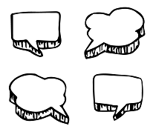
- What do you know about Mount Everest?
- What do you know about the weather conditions on Mount Everest?
- What do you know about the landscape?
- What challenges do climbers face on Mount Everest?

What do you see, think and wonder?
After watching the BTN Everest Danger story, students will respond to the following questions:

- What did you SEE in this video?
- What do you THINK about what you saw in this video?
- What did you LEARN from this story?
- What was SURPRISING about this story?
- How did this story make you FEEL?


KWLH
Hold a class discussion after watching the BTN Everest Danger story. What questions were raised in the discussion (what are the gaps in their knowledge)? The following KWLH organiser provides students with a framework to explore their knowledge on this topic and consider what they would like to know and learn.

What do I know? | What do I want to know? | What have I learnt? | How will I find out?

Questions for inquiry – Mount Everest
Students will develop their own question/s for inquiry about Mount Everest, collecting and recording information from a wide variety of sources. Students may develop their own question for inquiry or select one or more of the questions below.
- What danger does the environment of Mount Everest pose for climbers? E.g. lack of oxygen, altitude sickness, frostbite and snow blindness.
- What do you think should be done to reduce fatalities on Mount Everest? Consider restricting the number of permits given to climbers, only letting experienced climbers on the mountain and the responsibility of the Nepalese government.
- How has climbing Mount Everest changed over time? Analyse how communications, transport and clothing has changed. Write a news article reporting on the first expedition to the summit of Mount Everest and then write a news article reporting on an expedition to the summit of Mount Everest today.
- Explore the first successful ascent made by Edmund Hilary and Tenzing Norgay on Mount Everest. What challenges did they face? What did they do on the summit? Write a diary entry describing the feeling when they reached the summit.

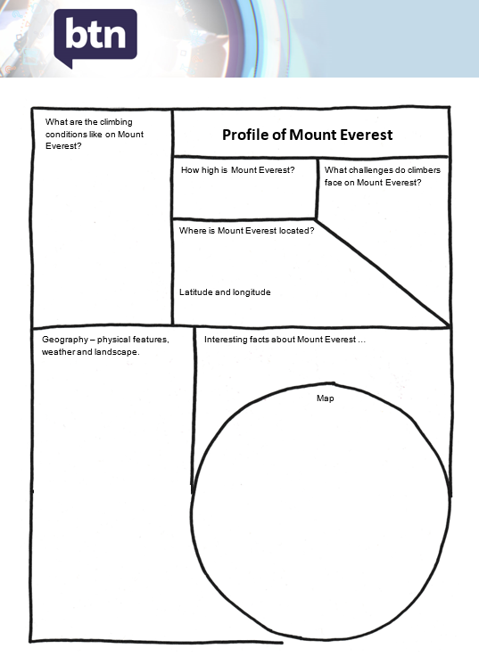
Profile of Mount Everest
Students will create a profile of Mount Everest using a range of sources of information. Students will use the following questions to help guide their research and use the template at the end of this activity to record their findings.
- Where is Mount Everest?
- How high is Mount Everest?
- Describe the landscape and illustrate an aspect of the mountain.
- What is the weather like?
- What are the climbing conditions like on Mount Everest?
- List 10 interesting facts about Mount Everest.
- Use a Venn diagram to compare and contrast Mount Everest with other mountains around the world. Compare the size of the mountains and other physical features.

Imagine you are an explorer
Students will imagine they are an explorer visiting Mount Everest. Below is a suggested framework for their research.

Preparation | What will you need to do to prepare for your journey?  - Make a list of what you will need to take with you on your expedition, including clothing, food, scientific equipment and shelter.  - How far do you have to travel to get there?  - How will you get there? What transport will you need?  - Calculate approximately how far you need to travel and how long it will take to get there. Create an itinerary for your journey.  - What support will you need for the expedition?
Expedition | Imagine you have begun your expedition to Mount Everest.  - What do you see on your journey? Describe your first impressions of Mount Everest.  - Analyse and describe the environment, using geographical terms like peak, ridge, glacier and crevasse.  - Describe the conditions on Mount Everest. What is the weather like? Check out these live webcams to get an idea of the conditions.  - What are some of the challenges?  - Describe how you feel during the expedition. How does altitude sickness make you feel?  - How long does your expedition take?
Reflection | Reflect on your expedition to Mount Everest.  - Write a journal entry in your diary about your experiences.  - Choose one part of the expedition to write about in detail.


ABC News – Mount Everest death toll rises to eight in a week after number of climbers causes congestion
https://www.abc.net.au/news/2019-05-25/death-toll-climbs-amid-traffic-jam-on-mount-everest/11149420

BTN Newsbreak – Climbers line-up to reach summit of Everest
https://www.abc.net.au/btn/newsbreak/climbers-line-up-to-reach-summit-of-everest/11156426

BTN – Sherpas
https://www.abc.net.au/btn/classroom/sherpas/10528476



Where is Mount Everest located?

Latitude and longitude
How high is Mount Everest?

Map
Geography – physical features, weather and landscape.
What challenges do climbers face on Mount Everest?
What are the climbing conditions like on Mount Everest?

Interesting facts about Mount Everest …
Profile of Mount Everest

Teacher Resource
Episode 15
4th June 2019

Young STEM Inventor
Students will learn more about inventions created by kids that have an environmental benefit and design their own invention.

Geography – Year 4
The use and management of natural resources and waste, and the different views on how to do this sustainably.

HASS – Year 4
Reflect on learning to propose actions in response to an issue or challenge and consider possible effects of proposed actions.

Science – Year 4
Living things depend on each other and the environment to survive.

Science – Years 5 & 6
Scientific knowledge is used to solve problems and inform personal and community decisions.

With guidance, pose clarifying questions and make predictions about scientific investigations.

Reflect on and suggest improvements to scientific investigations.

- What did the BTN Young STEM Inventor story explain?
- When did Max get involved in STEMSel?
- What does Max do at STEMSel?
- Explain what Max’s invention BioBin does.
- The waste put into the BioBin decomposes into…
  - Fertiliser
  - Methane gas
  - Both
- Methane gas is worse than carbon dioxide. True or false?
- What inspired Max to invent the BioBin?
- How is Max helping to fight climate change?
- Explain the success that Max has had with BioBin.
- Illustrate an aspect of the BTN Young STEM Inventor story.


What do you think?
Students will respond to one or more of the following questions:
- What do you THINK about what you saw in the BTN Young STEM Inventor story?
- What does this story make you WONDER?
- Think of three questions you have about the story. Remember that good questions are open-ended (have no right or wrong answer and can’t be answered with a ‘yes’ or ‘no’).

- What did you learn from the BTN story?

Hold a class discussion about the BTN Young STEM Inventor story. Here are some questions to help guide the discussion:
- What is Max’s invention?
- What inspired his invention?
- How does it work?
- What materials is it made from?
- What problem does it solve?
- How does it help the environment?
- What is unique about the design?
- What questions do you have about the invention?

To learn more about the benefits of composting organic material, watch the BTN Composting Awareness story.
Kid Inventions
Here are some examples of kids’ inventions that have an environmental benefit. Watch the video for each invention and respond to the questions.
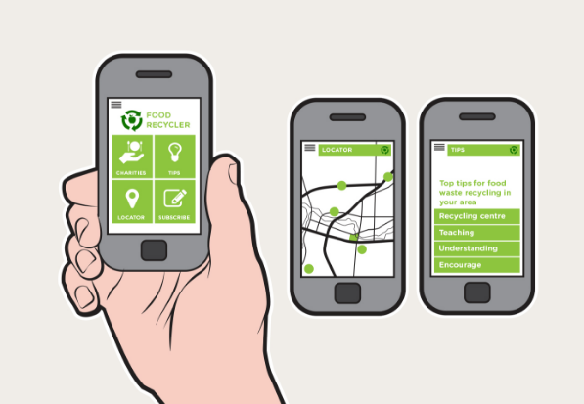
Dylan’s Food Recycling App
Watch the short video about Dylan’s invention and respond to the following:
- Briefly describe the invention.
- What inspired Dylan’s invention?
- How does it work?
- What materials is it made from?
- What problem does it solve?
- What is unique about the design?
- How does it help the environment?
- What questions do you have about the invention?

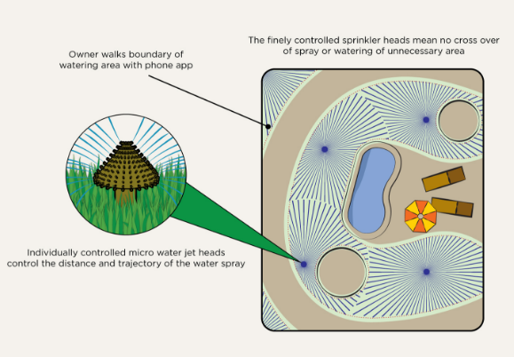
Kern’s Smart Sprinkler
Watch the short video about Kern’s invention and respond to the following:
- Briefly describe the invention.
- What inspired Kern’s invention?
- How does it work?
- What materials is it made from?
- What problem does it solve?
- What is unique about the design?
- How does it help the environment?
- What questions do you have about the invention?
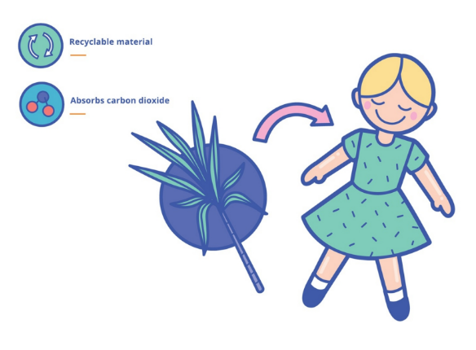
Bella’s Sugarcane Plastic Toys
Watch the short video about Bella’s invention and respond to the following:
- Briefly describe the invention.
- What inspired Bella’s invention?
- How does it work?
- What materials is it made from?
- What problem does it solve?
- What is unique about the design?
- How does it help the environment?
- What questions do you have about the invention?

Design your own invention
Students can design their own invention that has a positive impact on the environment. Students will respond to the following:
- Name their invention
- What problem does it solve?
- How does it work?
- What materials is it made from?
- What is unique about the design?
- How does it help the environment?
- Draw a picture of their invention
Kids Taking Action
BTN has featured lots of stories about kids who are taking action on climate change. Below are some examples. Students will investigate ways they can make a difference to an environmental problem. Working in pairs, brainstorm some solutions to the problem. For example, conducting a beach clean-up or reducing the amount of plastic packaging. Look at Molly Steer’s Straw No More campaign website and check out her Ted Talk for inspiration.
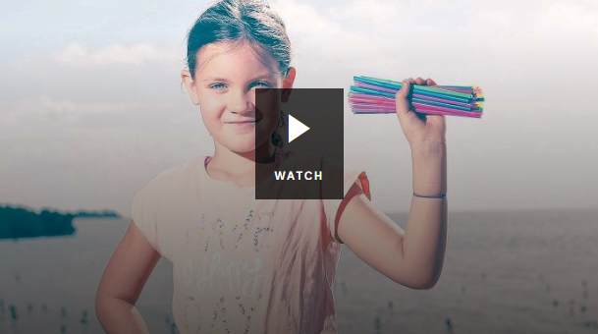
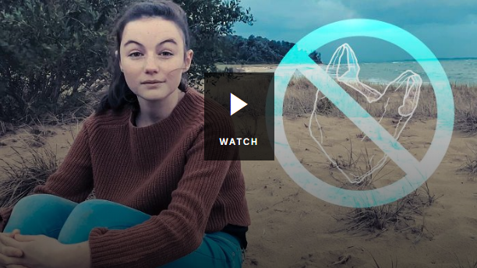

Straw No More Plastic Bag Ban
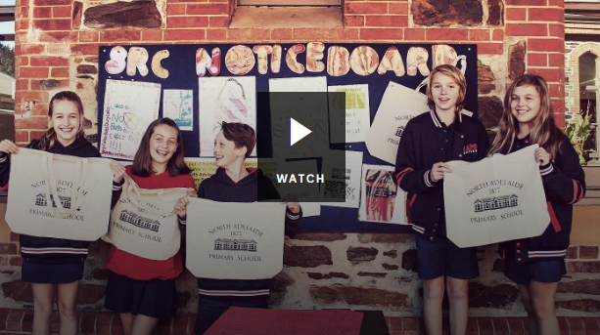
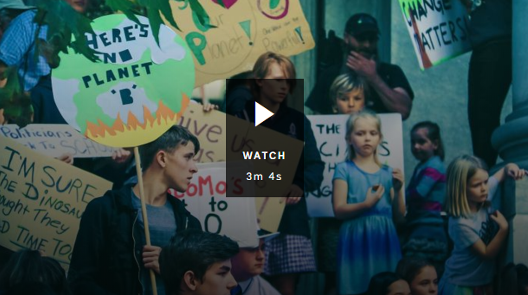

War on Waste School Climate Change Protests

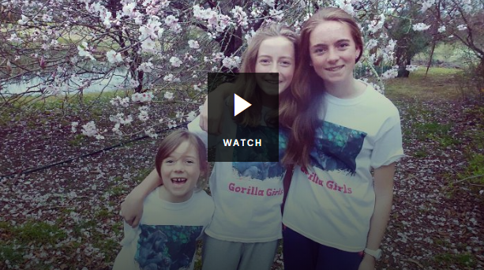
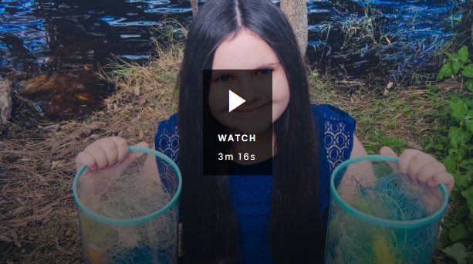

Gorilla Girls Recycling Storm Girl

Discuss with students’ ways they can present the information. Some ideas include:
- Make a news report. Visit the BTN Rookie Reporter page for some ideas.
- Create a website using Wix
- Create a podcast using PodOmatic, Buzzsprout to share with the school community.


BTN – Young Inventors
https://www.abc.net.au/btn/classroom/young-inventors/10523760

STEMSEL – Inventors Club
http://www.stemsel.com/index.php

BTN – Composting Awareness
https://www.abc.net.au/btn/classroom/composting-awareness/10489162

BTN Transcript: Episode 15 – 4/6/19

Hi everyone, Amelia Moseley here with another episode of BTN. Here's what's coming up. Some big questions about a really big mountain, we find out more about the names of Aussie places and a young inventor shows us his award-winning creations.

Everest Danger
Reporter: Olivia Mason

INTRO: First up today to one of the most extreme places on Earth, Mount Everest. It's the world's highest mountain, and for many people climbing it is the experience of a lifetime. But it can also be deadly. This climbing season has been one of the worst ever and it's got people asking whether too many are risking their lives to get to the top of the world.
As far as insta-worthy moments go, this one is definitely up there. Standing on top of the world's highest mountain. Of course, people who climb Everest don't just do it for the 'gram. For many climbers it's a once in a lifetime achievement; taking on one of the toughest challenges a human can face. Everest is in the Himalayas, here on the border of Nepal and Tibet. Its peak is 8,848 metres above sea level. To put that into perspective, New Zealand's tallest mountain is only 3,724 metres and Australia's is only 2,228 metres.
The first people to attempt to climb Everest, that we know of anyway, were two British men, George Mallory and Andrew Irvine in 1924 but they never came down and no one knows if they actually made it to the summit. 31 years later in 1953 New Zealander, Sir Edmund Hillary and Tenzing Norgay, a Nepalese Himalayan Sherpa, made it to the top. At the time it was seen as a massive achievement for humankind, kind of like the moon landing of mountaineering. Since then, thousands have followed in Tenzing and Hillary's footsteps, some setting their own record, like the youngest climber, the oldest climber, the first blind climber and the highest ever base jump.
Everest has also become a massive business. Attempting a climb usually costs around $60,000 which provides money for the Nepalese government and jobs for Sherpa people, who are the Indigenous people of Nepal's Himalayan mountains. There are lots of tour companies that help people get to the top, but it isn't easy.

OLIVIA MASON, REPORTER: Actually, it's really, really hard and dangerous. In climbing season, it can get down to minus 20 degrees and on the slopes, the weather can change dramatically going from sunny to stormy really quickly. Possibly an even bigger challenge is the altitude.

You see, as you go further up in the Earth's atmosphere, the less oxygen there is to breathe and while many climbers take oxygen tanks to the top of Everest, it can still be deadly. More than 300 people have died on the mountain, and a lot of those bodies are still up there because it's too difficult and dangerous to get them down. This year has been particularly bad for climbers on Everest. At least 11 people have died already and just last week, an Aussie man was rescued after being found unconscious and is now recovering in a Nepalese hospital.
Some say that Everest's popularity has become a problem. More people are attempting the summit every year and this year there's been some shocking images of a line-up at the top. Some say that's really dangerous because having to wait at that altitude can be deadly. Some are also blaming the fact that you don't need any sort of qualifications to get a climbing permit.
Rizza Alee, Everest Climber: It has become a death race there because there was massive traffic jam and people are pushing themselves who are not even capable of doing it.
Many are calling for changes like a limit on permits and tougher requirements for climbers. While there will probably always be people willing to risk their lives to get to the top of the world, many want to make sure this formidable mountain gets the respect it deserves.

Ask a Reporter

Have you got a question about Mount Everest? Ask me live on Friday during Ask a Reporter. Head to the website for all the details.

Did You Know?

Did you know? The Nepalese name for Mount Everest is Sagarmatha which means 'forehead in the sky' and the Tibetan name is it Chomolungma which means 'mother of the world'.

This Week in News

In another part of the Himalayas authorities are searching for 8 climbers who've gone missing. They were climbing a mountain called Nanda Devi, which is the world's 23rd highest peak. Officials think their route was hit by an avalanche and they've sent a search team to look for them, but the difficult terrain and bad weather has slowed things down.

Meanwhile in Venice there's an investigation going on after this scary accident. This massive cruise ship lost control and crashed into a busy dock. Five people, including two Australians and a New Zealander, were injured trying to run away and bystanders said it was like watching a disaster movie. It's got many calling for a ban on cruise ships in the busy Giudecca canal.

Things have just become a lot safer for a colony of penguins near Sydney. These little guys live on Lion Island which is free of feral predators, but a freak lightning strike last year caused a bushfire that wiped out 85 percent of their population. Now special burrows have been made with fireproof concrete to protect them if the same thing happens again. Luckily this comes just in time for mating season. So hopefully there will be plenty of little baby penguins soon.

And finally, for the first time ever, eight spellers have been named co-champions of the US Scripps National Spelling Bee. Organisers say that the contestants were just too good this year.

Bougainvillea B-o-u-g-a-i-n-v-i-l-l-e-a
The contestants spent five and a half hours of spelling some really difficult words including some that I've honestly never heard before.
Erysipilelas E-r-y-s-i-p-i-l-e-l-a-s
Cernurous C-e-r-n-u-r-o-u-s
See never heard of that one. Eventually the judges ran out of words to give the kids, so they had to call it a draw. In its 92-year history, the spelling bee has only ever had two-way ties and organisers say that each of the 8 winners will walk away with the full cash prize of $50,000.

Adani Mine Future
Reporter: Emma Davis

INTRO: Phew, not bad. I wish I could spell that well. Now to a story that's been big in the news over the past few weeks. Actually, it's been big in the news over the past few years. It played a big part in the recent election and it's caused a big debate. I'm talking about Adani. If you don't know what that is, Emma is about to tell you.

OLIVIA: Adani? Isn't that the new guy in the office? The one with the beard?
JACK: Isn't Adani that new restaurant in town? They have really good food.
MATT: Adani. That's the one about the genie. Do you mean Aladdin? No?
What we need now is for Adani to be given the proper treatment.
Approve the Adani mine now.
Fast tracking approvals for Adani.
A major risky project like Adani.
Stop Adani.
EMMA DAVIS, REPORTER: Yeah, Adani's a word that we've all heard a lot of recently and it's not this or this or this. Adani's the name of a company from India that's planning to build a mine, a really big one, and one that's caused a lot of debate in Australia for a long time now.
Way back in 2010, Adani put in an application to build a mine here in the Galilee Basin. That's in Queensland. Under the ground in this area there's a fair bit of coal and quite a lot of mines nearby, but Adani's Carmichael mine would be the first one in the Galilee Basin. A lot of people were excited about the announcement because it meant a lot of jobs and potentially more money coming into Queensland. But a lot of other people were really worried about its environmental impact and it was the start of years of debate.
Fast forward to 2019 and everyone's still talking about Adani. It was a massive issue during the election. In fact, some people reckon it was one of the reasons the Liberal party won so many seats in Queensland. Just before the election it approved the Carmichael mine and while it's set to be much smaller than the original plan, it's still pretty controversial.
There are a few reasons that some people are against the mine. First up there's the greenhouse gases released by mining and burning coal. Some people say we should be investing in renewable energy not building more coal mines. The other issue is the water that Adani would need to pump from the ground to run the mine. Farmers nearby say they need that water too and taking too much could cause serious damage to the environment. Some of the area's traditional owners are also against the mine. But for many other locals, Carmichael is a much-needed opportunity.
Dave Donaldson, Business Owner: I think it'll boost everything up and Rockie will turn around and we'll start seeing shops opening again.
So what now? Well Adani still needs approval from the Queensland Government. Last week that got a step closer when it approved Adani's plan to protect a rare bird species and the Premier says a final decision is on the way.
Annastacia Palaszczuk, Queensland Premier: Weeks not months, everybody needs to have these issues resolved.
While we may not have seen the end of the Adani debate just yet, at least now, when you hear about it in the news, you'll know what it actually means.
MATT: Are you sure? I think Adani is a brand of chicken salt my mum loves.
Indigenous Place Names
Reporter: Jack Evans

INTRO: You probably know that the capital city of Tasmania is called Hobart, right? But did you know that to some Tasmanians it's known as Nipaluna. That's the Palawa kani word for the city and some reckon it should be officially given that name. It wouldn’t be the first time a place has been given an extra name in the language of its traditional owners. Let’s find out more about how that works.
Have you ever wondered how places got their names? Like, why is Sydney, Sydney? Who is Kimberley anyway? Was this place just really great at sweeping? And what makes this reef so great? Oh, I guess that's pretty obvious isn't it really. Anyway, where was I? Names, that's right.
Australia's full of all sorts of interesting names. Some places are named after towns in the UK. Like Newcastle, named after a coal port in the north of England. Some are named after people. Like the Flinders Ranges, named after the English navigator and cartographer. Which, by the way is a person who draws maps. But many other names are taken from one of the many Indigenous languages across Australia. Take Wollongong for example. It comes from the Dharawal word woolyungah, meaning the five islands. And Canberra comes from the word Kanbarra meaning meeting place in the Ngunnawal language.
And then there are dual names. Probably the best-known dual name in Australia is Uluru. It's also known as Ayers Rock, the name given by British surveyor William Gosse back in 1872. But for the Pitjantjatjara people this sacred site had been Uluru for thousands of years and in 1993 the iconic landmark became the first in the Northern Territory to get two official names. Which meant changes to road signs, maps and other things like postcards.
JACK EVANS, REPORTER: This change led to a whole bunch of dual naming's across Australia. In Adelaide the Torrens River was dual-named with its original Kaurna name Karrawirra Parri and Victoria Square was dual-named Tarntanyangga. Hey, that's my line.
Now many in Tasmania are hoping that their capital Hobart will soon also be known by its Palawa kani name Nipaluna. It's something the Tasmanian Aboriginal Centre has been urging the council to consider for a while now. The council is also considering renaming a bunch of other landmarks to honour Palawa people. For example, Franklin Square could become Truganini Place, in honor of a Palawa woman who fought to protect her people. And while they haven't made a decision yet, the council says it would be a great step towards reconciliation.

Many people are pushing for more dual naming in other parts of Australia as a way of recognising the cultures that were here before colonisation and the original names of these spectacular Aussie sites.
Quiz

Which one of these Aussie towns is named in a First Nations language? Is it?
Echuca
Geelong
or Wangaratta
Trick question. It's actually all three of them. Echuca is a Yorta Yorta word which means `meeting of the waters’, Geelong comes from the Wathaurong name for the area, Djillong and Wangaratta is a Waywurru word for `resting place of cormorants’.

Young STEM Inventor
Reporter: Emma Davis

INTRO: Now to Adelaide where a 13-year-old named Max has just won an international award for his eco-friendly invention. It's a high-tech compost bin that helps people make the most of their kitchen scraps. And it's not his only creation. Here's Max to tell you more.

Hello, my name's Max. I'm 13 years old at Glenunga International High School. I play soccer, but I really love to invent. I do that at STEMSel Foundation club and I started in primary school at year 6 starting year 7 when my friend Kosta introduced me to STEMSel.
Here at STEMSel every Saturday, kids my age and even younger come to program. We do workshops for about 2 hours or so. Before going to STEMSel Foundation I had no prior knowledge about programming but now I've made my first big invention called BioBin here at STEMSel.

This prototype is a small scale but when it's commercialised it'll be way bigger. Basically, when you put in the leftovers of your lunch, grass clippings, any decomposable item it goes through the lid. Inside the bin there is a light sensor that picks up how much waste is being inputted into the bin and then decomposes it into fertiliser and methane gas which can then be sold for revenue. Methane gas is 28 times worse than carbon dioxide as a greenhouse gas so instead of ventilating it out into the atmosphere creating climate change we store it so that the owner of BioBin can sell it for more money.
I was inspired to do the BioBin project after listening to a story of a girl in Sweden. She's 16, her name is Greta Thunberg and every Friday she misses out on school to do climate change protests with kids on the streets. My main goal is to help Greta create a global movement of kids fighting climate change with artificial intelligence and solar in schools. After finishing my BioBin project in primary school I took it to the Royal Adelaide Show competition where I won first prize and that gave me the opportunity to go overseas for the international competition. Thousands of entries compete against each other and I was lucky to win first prize. After I won the competition I was really happy, and the High Commissioner of Australia tweeted about my win and that made me excited for the future.
Another project that I was working on with my friend Kosta was the smart bee-hive. Together we created a online monitoring system for farmers who enclosure bees. It has features using Internet Of Things and artificial intelligence to predict when there's going to be a disease, how many bees are going inside the bee hive and how much honey is being made. If you're interested in programming then look around, try to join a club like STEMSel Foundation, join it with a friend and maybe one day you can win a big prize like mine.

Did You Know

Did you know that a lot of the things we use all the time were invented by kids including braille, trampolines, ice-blocks and flippers?
Sport

Liverpool fans around the world are going nuts rights now. They're celebrating the team's sixth Champions League Title after beating Tottenham 2-nil in the final. The Reds took an early lead after Mo Salah was given a penalty and their final goal came just minutes before the end of the match. After the game, 750 thousand fans lined the streets to welcome the team home and celebrate the historic victory.
The Aussies have made a good start at the Cricket World Cup. They beat Afghanistan pretty easily over the weekend and are now preparing to face the West Indies on Thursday. But the best highlights from the comp are always the awesome catches, like this one from English player Ben Stokes. And this cameraman who really impressed the crowd.

And if this is the world's next big sport well count me in. One of these guys wants to create the world's first international jet suit race. His name is Richard Browning, and he's known as the real-life iron man. His plan is to kick off the race next year. But buying a jet pack to practice with will set you back a bit. Browning sold a few recently for about 600 thousand dollars. Phew.

Eid Festival
Reporter: Olivia Mason
INTRO: Finally, this week there's a really important celebration for the millions of Muslim people around the world. It's Eid al-Fitr which marks the end of Ramadan. Let's meet some kids to find out more about it.

JOSEPH: Hi BTN, my name is Joseph.
AFSA: And I'm Afsa.
FAISAL: I'm Faisal.
KHADIJA: And I'm Khadija.
AFSA: Today we're going to be teaching you about Ramadan and Eid.
JOSEPH: Ramadan is a special time in the Islamic calendar.
AFSA: Islam is the world's second-largest religion with 1.8 billion followers around the globe. Those who follow Islam are called Muslims.
KHADIJA: There are five pillars of Islam, which are rules Muslims follow. They are trusting and understanding the Shahadah, or the Declaration of Faith.
JOSEPH: Prayer five times a day.
AFSA: Giving money to charity.
FAISAL: Participating in Hajj at least once in your lifetime which is a pilgrimage to a place called Mecca.
KHADIJA: And fasting during the holy month of Ramadan.
FAISAL: Ramadan is a month in Islam where people from all around the world fast for a whole month.
AFSA: Of course having no food or water for a whole month is impossible.
JOSEPH: Actually we have a meal before dawn, it is called Suhoor so we can get ready to fast.
FAISAL: And then after a long day of fasting we share an evening meal called the 'Iftar'.
AFSA: When I first started it was very hard but then a couple days after it got really easy because I obviously got more patient and I got stronger.
FAISAL: The hardest bit about Ramadan is when people eat in front of your face like your siblings and you feel tempted to eat with them, like that delicious food that your parents cook for your siblings and you just have to stay strong.
JOSEPH: But it's meant to be challenging and it's a really important month for Muslim community.
AFSA: Of course, not everyone has to fast, people who are sick, pregnant, elderly or young don't have to take part.
FAISAL: During Ramadan it's important for us to focus on stuff like praying reading our religious book called the Quran and also helping those in need.
KHADIJA: When the month wraps up, we celebrate with a big party called Eid.
JOSEPH: The best part about Eid is enjoying the rewards for all of the hard work during Ramadan.
AFSA: We go and pray in the morning, and after that we eat some food and talk about how it was and yeah, just have fun.
FAISAL: And of course there are plenty of sweets.
AFSA: My favourite thing about Eid is receiving gifts and giving them back to the little kids.
FAISAL: The thing that I really like about Eid is when you meet your relatives and friends that you didn't meet in a long time because they live far away.
KHADIJA: It's not just for Muslims either. There are big celebrations all around the world and everyone is invited.
FAISAL: Thanks for letting us teach you about our religion.
JOSEPH: Back to you Amelia.
Bye.

Closer

Thanks guys and happy Eid. That's it for today but we'll be back with more next week. And in the meantime, there's heaps to see and do on our website, and don't forget you can also check out Newsbreak every weeknight on ABC Me and online. See you next week.

