Episode 12
14th May 2019

Extinction Report
- Discuss the Extinction Report story as a class and record the main points of the discussion.
- A recent UN report says that there are ____________ plant and animal species being threatened with extinction. Complete this sentence.
- What is a mass extinction?
- How many mass extinctions has the planet had?
- About how long does each mass extinction last?
- Choose a mass extinction explained in the BTN story and give two facts about it.
- What is the geological term for the time we live in now?
- How is human activity impacting on the rate of extinction?
- What did the report suggest are solutions to the problem?
- What questions do you have after watching the BTN story?
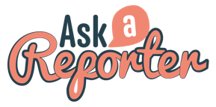
Check out the Extinction Report resource on the Teachers page. Get your class involved in BTN’s Ask A Reporter! This week’s topic is Extinction Report.

Royalty
- Summarise the BTN Royalty story.
- The new royal baby is ______ in line to the throne of the United Kingdom.
- Which country just finished crowning its new king?
- Which country just got a new emperor?
- A monarchy is…
- Over the years, the number of monarchies around the world has decreased. Why?
- In Australia, who is the Queen’s representative?
- Why do some people want an Aussie head of state?
- What do you understand more clearly since watching the BTN story?
- Name three facts that you learnt watching the BTN Royalty story.

Instagram Likes
- Discuss the BTN Instagram Likes story in pairs. What points were raised in the discussion?
- There has been a lot of research lately on the impact social media sites are having on young people’s __________ health.
- What criticism have social media companies received?
- What is an `influencer’?
- What changes did TicTok make recently after it was fined?
- What is Instagram trialling in Canada?
- Why are some people against the idea?
- Do you think the Instagram trial should be introduced in Australia? Give reasons for your answer.
- What other changes could be made to make social media a more positive experience for young people?
- What do you understand more clearly since watching the Instagram Likes story?

Check out the Instagram Likes resource on the Teachers page.

Democracy Sausage
- What was the main point of the BTN story?
- Sausages have appeared in which cultures?
- Briefly summarise the history of sausages in Australia.
- When was the first election sausage sizzle held?
- Australia is one of the few countries with ________________voting.
- In 1989, what was the Western Australian Premier accused of?
- What did the investigation into the scandal find?
- Why do you think election sausage sizzles have become a tradition?
- What was surprising about this story?
- When is the Federal Election being held?

Teacher Resource
Episode 12
14th May 2019

Extinction Report
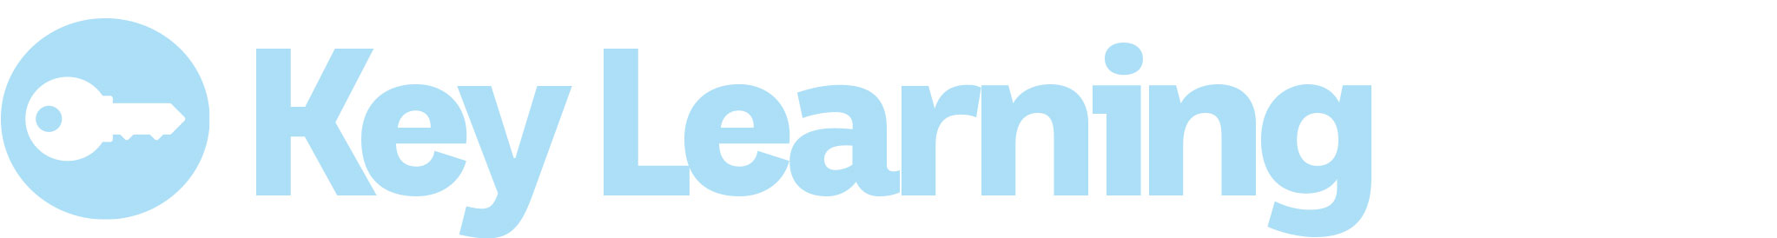
Students will investigate what mass extinction is and what is causing species loss

Science – Year 5
Living things have structural features and adaptations that help them to survive in their environment.

Science – Year 6
The growth and survival of living things are affected by physical conditions of their environment.

Science – Year 7
Classification helps organise the diverse group of organisms.

Interactions between organisms, including the effects of human activities can be represented by food chains and food webs.

- Discuss the Extinction Report story as a class and record the main points of the discussion.
- A recent UN report says that there are ____________ plant and animal species being threatened with extinction. Complete this sentence.
- What is a mass extinction?
- How many mass extinctions has the planet had?
- About how long does each mass extinction last?
- Choose a mass extinction explained in the BTN story and give two facts about it.
- What is the geological term for the time we live in now?
- How is human activity impacting on the rate of extinction?
- What did the report suggest are solutions to the problem?
- What questions do you have after watching the BTN story?

What do you see, think and wonder?
After watching the BTN Extinction Report story, students will respond to the following questions:

- What did you SEE in this video?
- What do you THINK about what you saw in this video?
- What did you LEARN from this story?
- What was SURPRISING about this story?
- What QUESTIONS do you have about this story?

Glossary
Students will develop a glossary of words and terms that relate to the BTN Extinction Report story. Below are some words to get them started. Students will add words and meanings to their glossary as they come across unfamiliar words throughout their research.

Biodiversity | Pollution | Extinction
Conservation | Threats to survival | Endangered species
Habitat | Population growth | Introduced species

Species Extinction Research
Define: What do I want to know?
Key questions to research
Students can choose one or more of the following questions or come up with their own:
- What is causing species loss? Explore issues such as habitat loss, introduced species, pollution, population growth and overharvesting/hunting.
- What is a mass extinction? How is it different from the extinction of a single species, or even several different species?
- Which species have become extinct in modern times?
- What are the connections between human activities and species extinctions?
- What is biodiversity and why is it important?
- What happens when an animal becomes extinct? If one species in the food chain becomes extinct how would it affect the rest of the chain? Choose an endangered species and explore its role in the food chain.
- Who do you think should be responsible for addressing the problem? List some of the responsibilities of individuals, communities and the government. Think of ways you can make a difference at home and at school.
- What are the periods of mass extinction on earth? Choose one to research in depth; their causes and their impacts.
Locate: Where do I find the information?
What resources will help answer my questions? (Internet, people, resource centre, organisations, print). Discuss with students what a reliable source is.
Select: What information is important for the investigation?
Students may need support to sort through and select relevant information.
Organise: How do I make sense of the information?
Students can organise their research by creating main headings from their questions. Write each heading on a separate piece of paper. Record the information found for each question.
Present: How do we let others know about this information?
Each group needs to discuss then decide on the best way to present the information. Possibilities could include:
- A ‘Did You Know’ Facts sheet
- Infographic
- Oral presentation
- Prezi presentation
- Create an infographic using Canva
Evaluate: What have we learnt?
Each group reflects on what they have learnt about species extinction during their investigation. Students will reflect on their learning and respond to the following.
- What I learned...
- What I found surprising...
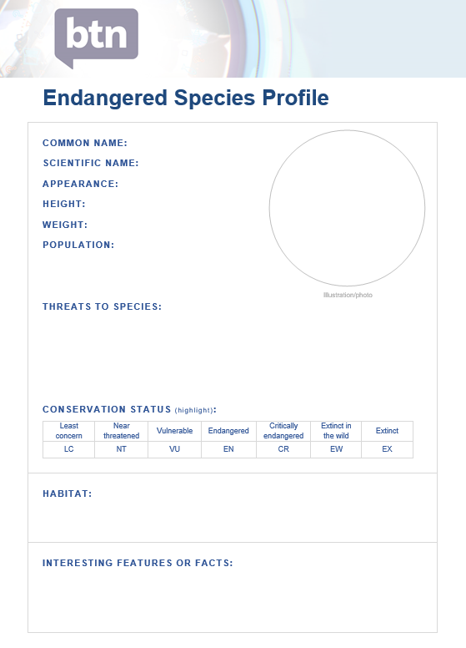
Endangered species profile
Students will research and write an endangered species profile. Students can use the Endangered species profile worksheet at the end of this activity to record their findings. Encourage students to use a range of sources to find their information. The following websites may help students choose a species to profile.
WWF Species Profile
Red List of Threatened Species
Students will research the following for their profile:
- Common and scientific name
- Appearance - what are some of their physical characteristics?
- Habitat - where do they live? Describe their habitat.
- Conservation status
- Threats to species
- Interesting features or facts

BTN Extinction Stories

BTN Animal Extinction
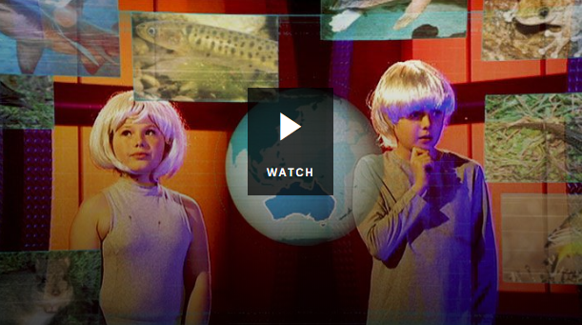
- How many mammals have become extinct in Australia since the arrival of Europeans?
- How could climate change affect some animal species?
- Why do you think it can cost a lot of money to save endangered species?
- What are some of the reasons that animals can be important?
- Why does Corey say we should keep the “creepy crawlies”?
- Think of an example of an animal that’s important to other animals.
- What do you think the scientist meant when he described some animals as “zombie species”?
- Give some reasons for trying to preserve critically endangered species.
- Do you think the government should put more money into saving some species than others? Give reasons for your answer.

BTN Insect Extinction
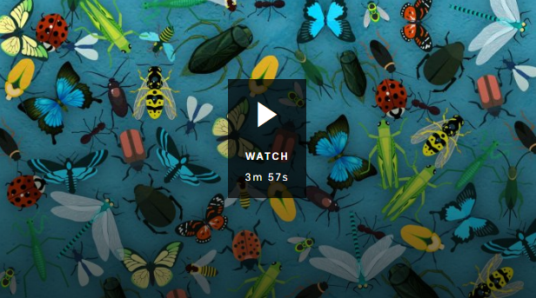
- In pairs, discuss the Insect Extinction story and record the main points of the discussion.
- How many different insect species are there in the world?
- A study has found that over the past decade the world’s insect populations have reduced by…
- Why are our insect populations declining? Give one reason.
- What do you call someone who studies insects?
- Why are insects so important to our ecosystem? Give an example of one of their important roles.
- What would happen if insects were removed from the food web?
- How can people help care for insects?

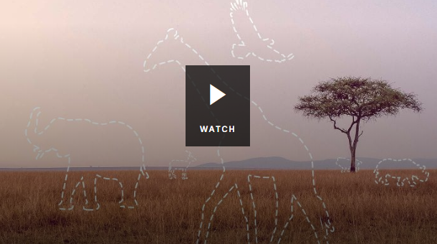
BTN WWF Living Planet Report
- Why are scientists calling the period since the mid-1900s The Great Acceleration?
- What is happening to biodiversity?
- Biodiversity includes…
  - Plants
  - Animals
  - Bacteria
  - All of the above
- What percentage of the planet’s animals have been lost over the last 40 years?
- What do humans depend on healthy ecosystems for?
- What does the report say we need to do to help the situation?

ABC News – One million species at risk of extinction, UN report warns, and we are mostly to blame
https://www.abc.net.au/news/2019-05-06/biggest-global-assessment-of-biodiversity-sounds-dire-warnings/11082940

CBBC Newsround – One million species face extinction, says UN
https://www.bbc.co.uk/newsround/48041537

BTN – Insect Extinction
http://www.abc.net.au/btn/classroom/insect-extinction/10811500

BTN - Animal Extinction
https://www.abc.net.au/btn/classroom/animal-extinction/10528592

BTN – WWF Living Planet Report
https://www.abc.net.au/btn/classroom/wwf-living-planet-report/10611702

WWF - Species Directory
https://www.worldwildlife.org/species/directory

The IUCN Red List - Threatened Species
https://www.iucnredlist.org/

Endangered Species Profile
COMMON NAME:
SCIENTIFIC NAME:
APPEARANCE:
HEIGHT:
WEIGHT:
POPULATION:

Illustration/photo
THREATS TO SPECIES:

CONSERVATION STATUS (highlight):
Least concern | Near threatened | Vulnerable | Endangered | Critically endangered | Extinct in the wild | Extinct
LC | NT | VU | EN | CR | EW | EX

HABITAT:
INTERESTING FEATURES OR FACTS:

Teacher Resource
Episode 12
14th May 2019

Instagram Likes

Students will explore the positive and negative impact that social media has on their mental health. Students will explore their identity through discussion, writing and art.

Health and PE – Years 5 & 6
Recognise how media and important people in the community influence personal attitudes, beliefs, decisions and behaviours.

Examine how identities are influenced by people and places.

Examine the influence of emotional responses on behaviour and relationships.

Investigate the role of preventive health in promoting and maintaining health, safety and wellbeing for individuals and their communities.

Health and PE – Years 7 & 8
Investigate the impact of transition and change on identities.

- Discuss the BTN Instagram Likes story in pairs. What points were raised in the discussion?
- There has been a lot of research lately on the impact social media sites are having on young people’s __________ health.
- What criticism have social media companies received?
- What is an `influencer’?
- What changes did TicTok make recently after it was fined?
- What is Instagram trialling in Canada?
- Why are some people against the idea?
- Do you think the Instagram trial should be introduced in Australia? Give reasons for your answer.
- What other changes could be made to make social media a more positive experience for young people?
- What do you understand more clearly since watching the Instagram Likes story?

Class Discussion
After watching the BTN Instagram Likes story, hold a class discussion about the information raised in story then ask students to respond to the following questions:

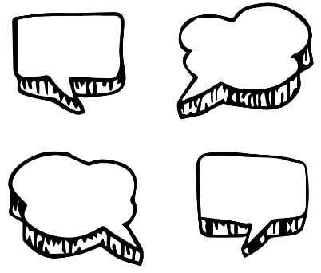
- Make a list of the emotions you feel before, during and after checking the likes/streaks on your social media posts.
- Do you think it’s a good idea to hide the number of ‘likes’ on Instagram posts? Why or why not?
- How do you think other people will feel about this announcement?
- Why do you think Instagram is doing this?
Further discussion:
- What are some of the things on social media that can have a negative impact on your emotions?
- How can you tell if social media is having a negative affect on your mental health? What can you do about it?
- How can we maintain good mental health while using social media?
Pros and cons of social media
In small groups students will brainstorm the pros and cons of using social media. Students will organise the information into two columns and then share their thoughts with the rest of the class. Below are some examples:

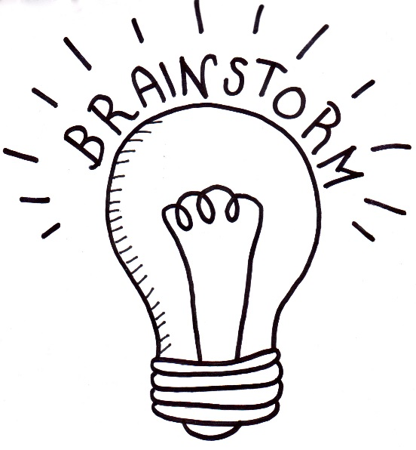
What are the benefits of social media?
- Improves communication skills.
- Helps you get in touch with friends, classmates and people with similar interests.
- Improves your technical skills.

What are the risks of social media?
- You may feel like you are missing out on things.
- It can make you feel bad about yourself.
- Cyber bullying.
- Using social media before bedtime can affect your sleep.
- There is no body language or tone of voice to help understand what someone is saying.

Compare and contrast
Students will research a range of different social media websites or apps, learn what they are used for and explore the pros and cons of these sites. Refer to this quick guide to popular social media sites and apps.

Social media | How old do you have to be to have an account? | What is it used for? | Pros | Cons
Facebook Messenger
Snapchat
TikTok
Instagram
WhatsApp
Twitter
YouTube
Other…

Self-esteem helpline – class discussion
Students will imagine they are volunteering at their school’s self-esteem helpline. Students will give advice and helpful tips on how to improve their self-esteem. These are fictional scenarios, and the issues discussed in this activity may be difficult for some students, and teachers should attempt to anticipate and be ready to respond to a range of student reactions.

- Before starting this activity brainstorm, as a class, a list of tips for coping with the social and emotional pressures of social media. Make a list of good choices that you make when using social media.

Helpline scenarios
Students will read the scenarios below and respond by giving practical, positive advice and tips. Alternatively, students can write their own scenarios.

“I always ‘like’ my friends’ posts, but when I post or share something I hardly ever get any ‘likes’. Sometimes I wait for hours to get just one ‘like’. It’s hard not to compare the number of likes I get to the number of likes my friends get. I feel anxious a lot of the time. What can I do to stop feeling this way?”

“I know that I spend a lot of time on social media sites, and sometimes this can have a bad affect. Like I don’t get to sleep until really late and then I’m tired at school the next day. But I just can’t help checking my notifications and looking at what’s been recently posted by my friends. I know I need to reduce the amount of time I spend using social media, but I don’t want to miss out on anything! Can you give me any tips on what I should do?”

“I’m always posting and sharing things on social media, like pics of me playing sport, going to parties with my friends and photos of my new dog. I get heaps of likes all the time. The more likes I get the happier I feel. But why do I still feel lonely?”
“I follow quite a few people that have become famous on social media. I’m always looking at what they’re doing from the clothes they wear to the food they eat. I feel there is a lot of pressure to be beautiful, and do exciting things all the time. It makes me feel inadequate a lot of the time.”

Reflection
Students will respond to the following reflective questions after completing the above activity:
- What was hard or easy about this activity? Explain.
- Helping other people can help boost your own self esteem. Why do you think this happens?
- Think of a time when you have felt sad or anxious when using social media. Think of your own positive self-talk that could have helped you feel good about yourself at the time. Check out this website for ways to improve your self-talk.

Who are you?
Students will reflect positively on this question and explore their own identity through discussion, writing and art. Students will brainstorm and record how they see themselves, responding to the following questions. Students will then take the information they have learnt about themselves and create a self-portrait.

- Who are you? (How do you see yourself?)
- What words best describe you?
- What are some objects, events, people or occasions that are important to you?
- What are you really passionate about?
- What are your most important values?
- What do you think is unique and special about you?
- What are your strengths?
- What are your challenges?
- How are you similar/different to other people? How do you feel about your differences?
- When do you feel most like yourself?
- How do you want people to see you?
- Why is it so important to be yourself?

Create a self-portrait
Students will create a self-portrait which represents how they see themselves on the inside. Looking at a mirror, students will experiment with poses, costumes and props and produce a self-portrait. Initially students can do some quick, detailed sketches of different features and then use these sketches to help create a final self-portrait. Students will write an artist's statement to go with it. Curate a class exhibition of your students’ self-portraits and choose a title for the exhibition.

Below are some guidelines for students as they create their own self-portrait:
- Use colours that you feel reflect your mood or feelings.
- What style will you use to create your self-portrait? How will it help portray your identity?
- Where are you going to sit? Think about the background of your self-portrait. Is it real or imaginary?

ABC News – Instagram will trial making the number of likes on post invisible – here’s why
https://www.abc.net.au/news/2019-05-01/instagram-trial-to-change-visibility-of-likes-on-posts/11061562?pfmredir=sm

CBBC Newsround – Facebook, Instagram and Snapchat could be saying goodbye to likes and streaks
https://www.bbc.co.uk/newsround/47932671

BTN – Social Media Anxiety
http://www.abc.net.au/btn/classroom/social-media-anxiety/

BTN – Screen Addiction
http://www.abc.net.au/btn/classroom/screen-addiction/10528738

BTN – Mental Health Special
http://www.abc.net.au/btn/campaigns/mental-health/

Reachout – 3 ways to talk yourself up
https://au.reachout.com/articles/3-ways-to-talk-yourself-up#better

BTN Transcript: Episode 12 – 14/5/19

Hey everyone. Amelia Moseley here and you're watching BTN. Here's what's coming up today. We get answers to more of your election questions, find out about the royals that rule around the world and Jack takes an in-depth look at the history of sausages. Can’t wait for that one.

Extinction Report
Reporter: Ruby Cornish

INTRO: But before we get to democracy sausages and the latest in the election, let's have a look at a story that concerns well, all of life on Earth. A new, UN backed report came out last week saying the planet is heading towards a mass-extinction, and humans may well be to blame. Take a look.

If you’re a human being living in the world today, and if you’re watching this, I assume you probably are, life is arguably the peachiest it's ever been for our species.

RUBY, REPORTER: The data tells us we're getting richer, better educated, better fed, more peaceful. Obviously things are far from perfect, but historically speaking, it's a pretty good time to be a homo sapiens.

For Earth's other inhabitants, it's a different story. A new United Nations report put together by hundreds of the world's top scientists has painted a very grim picture indeed for the world's plants and animals. The report says that nature is experiencing the fastest decline in human history and right now, there are a million plant and animal species being threatened with extinction. Yep, a million. That includes 40 per cent of frogs, a third of marine mammals, and a third of all reef-forming corals. This species collapse is big enough to be classified as a mass extinction, when more than 50 per cent of the species on Earth are wiped out.

RUBY: It's not actually the first time our planet has experienced a mass extinction, or even the second, or the third. As far as scientists can tell it’s actually the sixth.

These events don't tend to happen all of a sudden. Each generally lasts tens of thousands of years. The first one was more than 440 million years ago, when the cooling of the Earth killed off 60 to 70 percent of the Earth's species. Most of them lived in the ocean and they didn't look much like the creatures around these days. A series of extinctions about 375 million years ago, probably also a cooling event, saw the planet farewell about 70 per cent of its species.

Then there was the big one, cheerfully dubbed "The Great Dying", which happened 200 million years ago, when the Earth warmed up by up to 10 degrees, killing 96 percent of species including some some pretty legit looking creatures like pelycosaurs and therapsids. Then there was the Triassic-Jurassic extinction, and the last big one which happened just the other day, about 65 million years ago when these guys kicked the bucket, probably with the help of an asteroid or two.
The geological term for the time we’re living in now is the Holocene and so the extinction we're living through is known as the Holocene extinction. It's thought to have begun about a hundred thousand years ago, about halfway through homo sapiens' time on the planet so far. Some people call this extinction the Anthropocene extinction, "anthropo" meaning "of humans", because scientists think that humans are the ones making this extinction happen. Or at least making it happen much faster.
This UN report says that in the past 50 years, human activity has seriously ramped up the rate of extinction. We're clearing rainforests and wetlands to make way for cities and livestock, over-fishing the oceans, and polluting with plastic and carbon dioxide. Our population has tripled, and doesn't show any sign of slowing down, and if we don't make some serious changes we could all go the same way as these guys.
Of course, we've known for a while now that the planet’s in trouble, and there are plenty of people right around the world trying to change things. The UK Parliament just became the first in the world to declare an environment and climate emergency after some big protests from a group called Extinction Rebellion. The UN report says solving this extinction crisis is possible. We humans need to set aside more room for nature, reduce the amount of plastic we produce and do what we can to slow down global warming. It's a monumental task, but many say it is possible if we work together.

Quiz

In which of these geological periods would you not have seen any dinosaurs?
The Cretaceous period
The Jurassic Period
or the Cambrian Period?

The answer is the Cambrian Period. That happened way before the dinosaurs about 500 million years ago. The dinosaurs were around in the Triassic, the Jurassic and the Cretaceous Periods.
Ask a Reporter

If you've got a question about that story, I'll be around to answer it on Friday during Ask a Reporter. Check out our website for all the deets.

This Week in News

Of course, the big news this week and last week, and well, for a while now, has been the election. In case you’ve missed it here’s what’s been going down. Unless something wildly unexpected happens, one of these guys will be the next Prime Minister. Leader of the Liberal Party Scott Morrison or Labor Party leader Bill Shorten. And they've been working hard to get voters on their side. Some of the smaller parties have been making a lot of noise too. No surprise which big issue The Greens are highlighting.

SARAH HANSON-YOUNG, SENATOR: We can't take our environment for granted.

And recognise this guy?

CLIVE PALMER, UNITED AUSTRALIA PARTY: Aussies not gonna cop it anymore.
It’s musical Mr Clive Palmer, who was once a member of parliament and is now attempting a big comeback with his United Australia Party. It wouldn't be an election campaign without a bit of good old controversy. A bunch of candidates have had to step down because of inappropriate things they've posted on social media. There was an unfortunate egging incident, some awkward moments.

BILL SHORTEN, OPPOSITION LEADER: You're a classic space invader.

And some nice moments too, like when Bill Shorten defended his mum after some claims in a newspaper article and Scott Morrison backed him up. Then there was all the usual election fun and games, sports and rec, high fashion in hi-vis and all the baby-kissing stuff. Wait, that's not a baby.

Election Q & A
Reporter: Annabel Crabb

INTRO: Ahh, it’s even cuter. Now if you've still got some questions about the election you're in luck because we've got some answers thanks to political expert Annabel Crabb. Over the past few weeks she's been answering questions from kids about politics and politicians and elections. Let's have a look at the final instalment of our Ask Annabel Anything election special.

How does the government make sure everybody has voted?
Well in Australia we have a special organisation that runs the elections and actually that's a system that was invented in South Australia which is responsible for a lot of our election policies. The Australian Electoral Commission is an organisation that runs the elections. It is a completely neutral agency. Because you can imagine if you had one of the parties running the elections that would get very confusing very quickly. In the old days actually before Australia became a federation they used to run elections at the pub and the drinks would be paid for by the candidates. And people would vote by stepping up onto a stage and calling out the name of the candidate they were voting for. But can you spot the problem with that system? Basically, people would vote for whoever just bought them a beer. So, you could get elected if you had lots of money to spend on beer. Shocking arrangement. So, when Australia became a federation we created an independent voting authority that would oversee the elections. So, if you've ever gone with your parents to vote on election day. First of all, you go to the local school or hall or wherever it’s being held. Hopefully you get a sausage in bread because that is traditional on voting day or there might be a cake stall which I really like and then if you've ever gone in with your parents you might see that they get their names ticked off a giant big thick roll of names and addresses. And so, once you've voted your name’s been crossed off the roll you can't vote again each person just gets one vote. And if you haven't voted if at the end of the day your name hasn't been crossed off somewhere, then you get fined because in Australia we take voting very seriously.
Do you think 16-year-olds should be able to vote?
Wow that is such a big question. So, I've grown up all my life knowing that I would have to wait until I was 18 to be able to vote. I think there is a good argument for letting 16-year old's vote. I think most of the 16 years olds I know are not only highly opinionated but really capable of researching issues that they are passionate about. Every time you change the rules though with voting it's always a hotly contested matter because all of a sudden, the parties are saying, hmm well if 16-year olds could vote would 16-year olds be more likely to vote for me or for the other party. So that's what drives the arguments. I bet you anything you like the Greens would like 16-year olds to be able to vote because they think, hmm there's lots of greenies who are 16, let’s get them to vote. These are the sort of arguments that happen all the time. Personally, I think that 16-year olds are I'm very open to the idea of 16-year old's voting. The sooner they become super responsible the better for all of us I think.

Is our voting system fair?
I think that the Australian voting system is incredibly fair, I'm really, really proud of it. And the more I find out about the history of the way Australia's voting system evolved the more proud I am. I really like the fact that we ask all people of elegible voting age their opinion. We didn't always do that. In the olden days women couldn't vote and Aboriginal people couldn't vote and that was a disgrace in our history. And we sorted that out and now we make sure that we ask everybody, and we actually go out and seek out their vote and make sure they vote through our compulsory voting system. I think there are lots of countries in the world where the voting system is corrupted, where the people running the election are also the people running in the election and that's bad. We've poured time, thought and resources into making sure that our voting system is incorruptible and it's one of the great elements of Australian democracy.

Royalty
Reporter: Matthew Holbrook

INTRO: There are heaps more of those Q & As online, just head to our website to check them out. Now to something a little less democratic. I'm talking about royalty. It's been a big couple of weeks for the royals of the world between a new royal baby, and a new Thai King and a new Japanese emperor. So, Matt decided to have a closer look at the royal rulers of the world.

You're a baby. Before you've been given a name, before you've done anything more interesting than poo your pants, people are already losing their minds over you.

PEOPLE ON STREET: Happy baby boy and a happy mother. We love babies, yes yes.
Welcome to being a royal baby, or rather, this royal baby. Archie Harrison Mountbatten-Windsor is 7th in line to the throne of the United Kingdom under the reign of Queen Elizabeth II. While this royal family may be the most well-known to us Aussies, it's not the only one. Thailand, for example, just finished crowning its new king in spectacular style. And then there's Japan, which just got a new emperor. In fact, there are dozens of royal rulers around the world, sometimes they're called kings and queens, or sultans, or emirs, or grand dukes. All of them are monarchs. A monarchy is a form of government with typically a single person at its head. And normally, people are born into that position.
KING MATT: Once upon a time, monarchies were everywhere. People thought it was perfectly normal to have one person ruling everything. Off with his head. For some reason, it didn't always last. Fetch me the grapes.
Over the years, many societies rebelled against their monarchs. And as the world changed, more people thought being born into the right family wasn't a good enough qualification for being leader. By the 20th century, a bucket load of royals got the flick, or their powers were drastically reduced. That didn't happen everywhere, and there are still a few royals that actually have a big say in how their country is run. But, back in the UK, the royal family doesn't really make the rules anymore, that's up to the elected government and the Prime Minister. That form of government is a constitutional monarchy.
And it's technically what Australia has as well. The British Queen is our head of state, and her representative is the governor general. While the GG doesn't often interfere with the running of the country, they have some important jobs to do, and the governor general has even sacked the government before. But for the most part, our relationship with these guys is about visits and handshakes and photo ops. And for that reason, some Aussies don't see the point in having a queen and would prefer an Aussie was our head of state instead. Some don't think it matters.
KING MATT: Some think King Matt would do quite good for the job, as a kind and wise ruler with unlimited power. Get me my slippers. What could possibly go wrong? Now.

Did You Know?

Did you know that Prince Harry's name isn't actually Harry? His real name is Prince Henry Charles Albert David. Harry is a nickname.

Instagram Likes
Reporter: Jack Evans

INTRO: Next up, one of the world's biggest social media platforms is trialing a really big change. In Canada, Instagram is going to start hiding likes on people's photos. It’s because some people have been worried about the effect that little heart button can have on young people’s mental health. Check it out.

KIARA: I like to follow meme pages, sometimes dance memes because I'm a dancer and I just find them really funny.
VANI: I do like to follow these horoscopes on Instagram, I find them really interesting.
JEMMA: I'm a big fan of Marvel and Harry Potter so it's good to keep up and see what's going on.
IAN: I use it to talk with my friends and mainly to follow my favourite soccer teams.
While you might not be old enough for Instagram just yet. It's the place a lot of older teens go to check out well anything really. And while these are all interesting and pretty things there can be an ugly side to Instagram too. There's been a lot of research lately on the impact social media sites are having on young people’s mental health. And companies have been under pressure for the way they target young people. Whether it’s turning a blind eye to underage users, encouraging constant use with Snapchat streaks or turning your posts into a popularity contest.
KIARA: With likes and all that they'll be like oh I got this amount of likes oh I'm so popular I've got this and I've got that.
DR HUU KIM LE: The likes show that we are comparing ourselves with a number compared to the people with like millions of followers who we call Insta influencers to your everyday kid who has maybe 10 friends and it’s teaching us that the more likes the better.
Social media companies are starting to recognise the problems and have been looking at solutions. For example, TicTok cracked down on underage users and brought in a security feature after it got slapped with a fine. And now Instagram is trying out a big change that could have a massive impact on how the apps used in the future.
The trials happening in Canada at the moment. Over there users can still like posts and see how many likes they get. But they can't see how many likes other posts get instead they see this. The idea is that you won't be able to compare your posts to other people and you won't worry so much about how many likes you're getting. Instead you might spend more time looking at the actual photos and videos and just enjoying your friends.
It's a big change and not everybody likes it. For example, there are lots of people who make a living as "influencers" and rely on likes for business. Plus, some people just like likes and think they're a great way of connecting with your friends and the wider world by showing you what's popular and what people are talking about. Of course, it could be a long time before the change hits Australia if it hits at all. So, what do you think?
DAT: I think it would be a good idea because people like to compare with other people and like to show boat or boast to them.
KIARA: I feel like influencers who get paid and get their income through these likes, if they're not seeing the amount of likes they get will that affect their income.
JEMMA: I think it would be a good idea in the sense of you won’t get judged anymore cause I know a lot of people who will judge you on the likes you have, friends will do it, classmates will do it, even siblings will do it sometimes they're like "ha you don't have as many likes as me” so you're obviously not that popular.
Sport

In the English Premier League, Manchester City has come from behind to clinch the title on the final day of the season, with a 4-1 win against Brighton. It ended a fantastic challenge from runners up, Liverpool. Liverpool lost just one game all season, and finished on 97 points, the club's highest ever points tally, but it wasn't enough to stop City lifting the trophy.

Sydney FC has smashed Melbourne Victory 6-1 to book their place in the A-League grand final next weekend. It was the 50th meeting between Australia's biggest football clubs. Sydney will now face Perth in the Grand Final who scraped through after a nail-biting penalty shootout.

Is it a bird? Is it a plane? No, it’s US hurdler Infinite Tucker. Not only does he have a very cool name this superman style finish literally helped him over the line to win the 400 metre hurdles at SEC Championships in the US.

Democracy Sausage
Reporter: Jack Evans

INTRO: Finally, we promised you a story about sausages and we’re about to deliver. You see, Australia's known for its famous election day BBQs. You might have had a democracy sausage or two yourself or if not, you might get one this weekend. So, let’s have a look at where this distinctly Aussie tradition began.

It was a brisk Autumn morning, I was on my way to cover one of the biggest stories of my journalistic career, sausages sizzles.
JACK: Today's a big day for me. Today I uncover the little-known origin of Australia's democracy sausage.
BUTCHER: Mmm.
An Aussie Icon, an election day essential, a cooked cylinder of minced meat beautifully caressed by a slice of white bread, delish. But where did it all start? Sausages have been around for thousands of years and have appeared in just about every culture in some way or another from Ancient Greece, to China and Italy.
JACK: But what about the Aussie snag? Where did you come from?
SAUSAGE: The butcher.
JACK: Yeah, but before that.
SAUSAGE: Probably Germany.
JACK: Oh, true.
In the 1800s the Germans brought with them their famous sausages like Frankfurts, Bratwürste, Rindswürste, Knackwürste, and Bockwürste, all the best würstes. Meanwhile the Brits introduced us to the thick Cumberland sausage and the thin English breakfast sausage. But despite all that it was a long time before the sausage was seen as a typically Aussie cuisine and the sausage sizzle made its way into school sports days, fundraisers, hardware stores and of course elections.
The very first election sausage sizzle is thought to have been held in 1940, changing voting days forever. It makes sense really. Australia is one of the few countries with compulsory voting, which means there are lots of people turning up to vote and sausages are a cheap and easy way to keep them full and happy. Over the years the democracy sausage became a full-on Aussie institution with plenty of leaders getting involved either behind the barbie or chowing down on them.
Although sausage sizzles can be scandalous, and no, not just because of the way politicians eat them. In 1989 the Western Australian Premier Peter Dowding was accused of bribing voters with free sausages. Mr Dowding then accused the opposition of providing unsolicited sausages to would be voters. Believe it or not, there was an investigation which eventually found that providing free snags was not actually considered political bribery. Turns out it takes a lot more than a sausage to snag votes.
JACK: And despite which side voters sit on or whether it's a sausage, a veggie sausage or not a sausage at all, most Aussies can agree that elections just wouldn't be the same without this sizzling Australian tradition. I’m Jack Evans, BTN News.
AMELIA: Wait, wait, that’s Behind the News, news?
JACK: Psshk.

Closer
Well that was fun. But that's all we have for you today. Have a great week and a great snag if you end up at a polling booth this weekend. And if you've got questions about processed meat or the election or politics or anything else, jump onto our website and you might just find some answers and don't forget to tune into Newsbreak on ABC Me and online every weeknight. See you soon.

