EPISODE 10
27th April 2021

KEY LEARNING
Students will view a range of BTN stories and use comprehension skills to respond to a series of focus questions.

CURRICULUM
English – Year 4
Use comprehension strategies to build literal and inferred meaning to expand content knowledge, integrating and linking ideas and analysing and evaluating texts.

English – Year 5
Use comprehension strategies to analyse information, integrating and linking ideas from a variety of print and digital sources.

English – Year 6
Use comprehension strategies to interpret and analyse information and ideas, comparing content from a variety of textual sources including media and digital texts.

English – Year 7
Use comprehension strategies to interpret, analyse and synthesise ideas and information, critiquing ideas and issues from a variety of textual sources.
  - Teacher Resource

Focus Questions
As a class, discuss the stories featured in the episode of BTN Classroom and record the main points of the discussion. Students will then respond to the following focus questions.

Travel Bubble
- Describe what the BTN story is about in one sentence.
- What is the Trans-Tasman Bubble?
- What countries are part of the Trans-Tasman Bubble?
- Complete the following sentence. Aussies can travel to New Zealand without having to _____________.
- How is the travel bubble helping families?
- What will the travel bubble help boost?
- What per cent of New Zealand’s tourists are Australian?
  - 20%
  - 40%
  - 60%
- Why is Australia’s vaccination rollout taking longer than expected?
- The AstraZeneca vaccine isn't being recommended anymore to people under 50. True or false?
- What questions do you have about this story?

Afghanistan Withdrawal
- As a class, discuss the Afghanistan Withdrawal story. Record the main points of your discussion.
- How long has Afghanistan been at war?
- Where is Afghanistan? Find using a map.
- Who is the Taliban?
- How did the Taliban affect people in Afghanistan?
- What attack happened on the 11th of September 2001?
- Who is Osama Bin Laden?
- Who are the United States’ allies?
- Who announced that the war in Afghanistan will soon come to an end?
- How did this story make you feel?

Cinema Future
- What decade did we see our first movie theatres?
- What did travelling theatre films look like?
- Why were some of the first cinemas called nickelodeons?
- When was television invented?
- How did television affect cinema goers?
- What impact has streaming services had on cinemas?
- What did Warner Brothers decide to do with its movies made in 2021?
- How were the Oscars awards different this year?
- What do you think is the history of cinemas?
- Name three things you learnt watching the BTN story.

Check out the Cinema Future resource on the Teachers page.

William Shakespeare
- Where was William Shakespeare born? Find on a map.
- When was William Shakespeare born?
- Who was he married to?
- Why was William Shakespeare’s earlier life referred to as the “lost years”?
- Why did men often play female characters in theatre performances?
- How many plays did William Shakespeare write?
  - 7
  - 17
  - 37
- Name one of William Shakespeare’s tragedies.
- How many words did Shakespeare introduce to the English language? Name one.
- What Shakespeare play is The Lion King based on?
- What was surprising about this story?

Check out the William Shakespeare resource on the Teachers page.

Guide Dog Training
- In pairs, discuss the BTN Guide Dog Training story.
- How do guide dogs help the vision impaired?
- What breed of dogs are used for guide dogs in America?
- What can’t you do when a guide dog is wearing its harness?
- What is the puppy personality test?
- What other jobs can dogs do if they do not become a guide dog?
- What are guide dogs taught during the 20 weeks of specific guide dog training?
- How much does it cost to train a guide dog?
- What should you do if you see a handler walking with a guide dog?
- What questions do you have about the story?
EPISODE 10
27th April 2021

KEY LEARNING
Students will learn more about the history of motion pictures and the different roles involved in making a film.

CURRICULUM
Media Arts – Year 3 & 4
Plan, create and present media artworks for specific purposes with awareness of responsible media practice.

Use media technologies to create time and space through the manipulation of images, sounds and text to tell stories.

Media Arts – Year 5 & 6
Plan, produce and present media artworks for specific audiences and purposes using responsible media practice.

Develop skills with media technologies to shape space, time, movement and lighting within images, sounds and text.

Media Arts – Year 7 & 8
Develop and refine media production skills to shape the technical and symbolic elements of images, sounds and text for a specific purpose and meaning.

  - Teacher Resource

Cinema Future

Focus Questions
Discuss the BTN story as a class and record the main points of the discussion. Students will then respond to the following:
- What decade did we see our first movie theatres?
- What did travelling theatre films look like?
- Why were some of the first cinemas called nickelodeons?
- When was television invented?
- How did television affect cinema goers?
- What impact has streaming services had on cinemas?
- What did Warner Brothers decide to do with its movies made in 2021?
- How were the Oscars awards different this year?
- What do you think is the history of cinemas?
- Name three things you learnt watching the BTN story.

Activity: Class Discussion
After watching the BTN Cinema Future story, hold a class discussion, using the following discussion starters.
- What impact has COVID had on the film industry?
- How have cinemas been affected?
- Describe the experience of watching a movie in a cinema. How is it different to watching a movie at home?
- What do you think the future of cinema is? Give reasons to support your answer.

Activity: Glossary
Students will brainstorm a list of key words that relate to film production and cinema. Here are some words to get them started.

CINEMA | DIALOGUE | MOTION PICTURE
PRODUCTION | CINEMATOGRAPHY | AUDIENCE

Activity: Research
Discuss the information raised in the BTN Cinema Future story. What questions were raised in the discussion about films and the film industry, and what are the gaps in their knowledge? The following KWLH organiser provides students with a framework to explore their knowledge on this topic and consider what they would like to know and learn.

What do I know? | What do I want to know? | What have I learnt? | How will I find out?

Research questions
- Before the invention of film, how were audiences entertained?
- In 1878 Eadweard Muybridge captured a horse in motion on film. How did he do it?
- Who were the Lumiere brothers and what was their role in motion pictures? Explore how the device they created, the Cinematographe, worked.
- Investigate the silent era of films. How did film makers use music to create mood?
- What was the first film to be made in Australia? Find out 3 interesting facts about the film.
- What was the `Golden Age’ of Hollywood? Why did it come to an end?
- When was sound on film introduced? What was the first film with sound and what was the first line spoken in the movie?
- What impact did the popularity of television have on cinema?
- If you found a roll of 'old fashioned' movie film, what sort of equipment do you think you would need to screen it?
- How has cinema projection changed over the past 100 years? How does digital projection differ from film projection? What elements remain the same?
- What do you think is the future of movie theatres? Explain your answer.

Activity: Roles in the Film Production Team
Who is involved in making a film? Watch the closing credits of a film or look at the different categories in the Oscars award ceremony, to see who is involved in the film making process. Make a list of the different roles and their responsibilities. Choose one role to research in more detail and display the information in an interesting way.
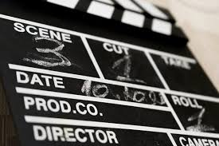
- Director
- Producer
- Screenwriter
- Production Designer
- Art Director
- Costume Designer
- Cinematographer
- Editor
- Actor
- Music Supervisor
Activity: Persistence of Vision
Movies use technology to produce an optical illusion. When you look at a picture your eye and brain retains an image for a fraction of a second after the image has gone. This is known as persistence of vision. The thaumatrope demonstrates persistence of vision because when the device spins, the drawings combine to make a complete picture.

How to make a thaumatrope
- Piece of cardboard
- Rubber bands or string
- Drawing equipment
- Hole punch

Instructions
- Before you begin, choose two related pictures to draw – fish and a fishbowl, bird and a birdcage.
- Cut a circle from a piece of cardboard.
- On one side of the cardboard, draw a fish (or a bird).
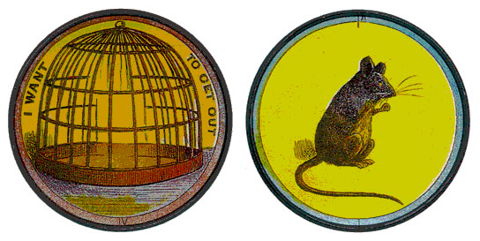
- On the other side of the cardboard, draw a fishbowl (or other picture). Remember one image has to be upside down.
- Punch a hole in each side of the cardboard circle.
- Attach the rubber bands or string to each hole.
- Twist the string/rubber bands and pull tight to spin the cardboard. The two images should appear as one.
- Click here and here to see how a thaumatrope works.

Activity: Investigating Films

Create a timeline of either the history of motion pictures or significant moments in the history of the Australian film industry.

Investigate the role of a Foley artist. Think about why films have sound effects and how they are created. Watch the BTN Movie Sounds story to find out more

Choose a film and write a review about it. Include a brief summary of the plot and why you liked or disliked it and why. Give the film a star rating out of 5.
Make your own short film. The Behind the News website has some tips to help you with the filming process.

BTN Film Stories
Watch these BTN stories to learn more about the film industry.
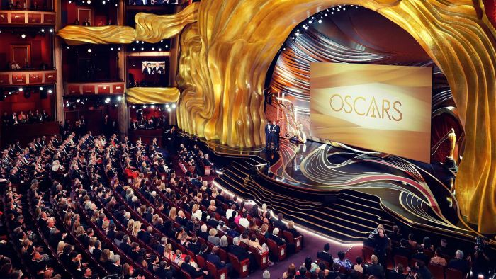  BTN History of the Oscars story | 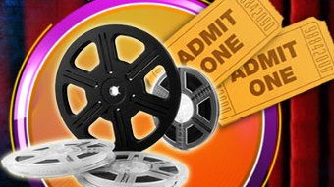  BTN Cinema story
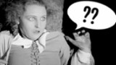  BTN Silent Films story | 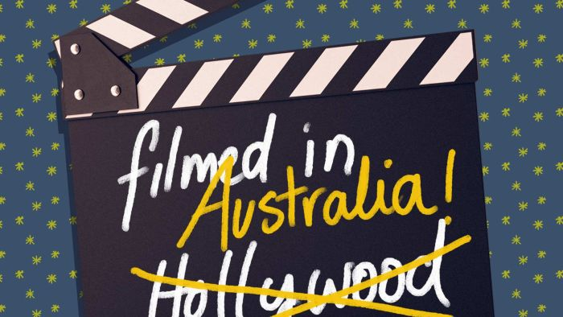  BTN Australian Film Boom story

Useful Websites
- World’s first feature film – National Museum Australia
- A very short history of cinema – Science and Media Museum
- Australian Film Boom – BTN
- Cinema – BTN
- Silent Films – BTN
- History of the Oscars – BTN
- Visual Effects - BTN

EPISODE 10
27th April 2021

KEY LEARNING
Students will explore the meaning, use and form of Shakespeare’s language. Students will experiment with language to create their own ‘Shakespearean’ words. Students will learn more about the life and work of William Shakespeare.

CURRICULUM
English – Year 5
Understand how to use knowledge of known words, base words, prefixes and suffixes, word origins, letter patterns and spelling generalisations to spell new words.

Explore less common plurals and understand how a suffix changes the meaning or grammatical form of a word.

English – Year 6
Understand how to use knowledge of known words, word origins including some Latin and Greek roots, base words, prefixes, suffixes, letter patterns and spelling generalisations to spell new words including technical words.

Identify the relationship between words, sounds, imagery and language patterns in narratives and poetry such as ballads, limericks and free verse.

English – Year 7
Understand how to use spelling rules and word origins, for example Greek and Latin roots, base words, suffixes, prefixes, spelling patterns and generalisations to learn new words and how to spell them.
  - Teacher Resource

William Shakespeare

Focus Questions
Discuss the BTN story as a class and record the main points of the discussion. Students will then respond to the following:
- Where was William Shakespeare born? Find on a map.
- When was William Shakespeare born?
- Who was he married to?
- Why was William Shakespeare’s earlier life referred to as the “lost years”?
- Why did men often play female characters in theatre performances?
- How many plays did William Shakespeare write?
  - 7
  - 17
  - 37
- Name one of William Shakespeare’s tragedies.
- How many words did Shakespeare introduce to the English language? Name one.
- What Shakespeare play is The Lion King based on?
- What was surprising about this story?

Activity: Personal response
Write a personal response to the BTN Shakespeare story. Ask students to finish one or more of the following incomplete sentences:
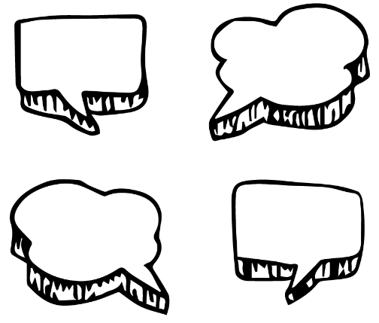
- William Shakespeare was a famous…
- It was interesting to learn…
- It was surprising to learn that...
- It’s important to remember Shakespeare because…
- These are five words that I would use to describe William Shakespeare…

Activity: Inquiry
Discuss the story as a class and ask students to pose questions about William Shakespeare, a famous English playwright, poet, and actor. They can develop their own key questions to investigate or respond to one or more of the questions below. Students can complete the following KWLH organiser to explore their knowledge and consider what they would like to know and learn. Below are some possible questions for students to research.

What do I know? | What do I want to know? | What have I learnt? | How will I find out?

- Who is William Shakespeare? Use a timeline to record the significant events in William Shakespeare’s life.
- Why is Willian Shakespeare remembered as a significant person? Create a biography to tell us more about Willian Shakespeare.
- Do you think it is important that we learn more about William Shakespeare? Why or why not?
- How do primary sources (for example photos, letters, diaries and official documents) help us understand what might have happened at a place in time? Find 1 or 2 primary sources that help you learn more about the life of William Shakespeare.
- What are some of the key events in the life of William Shakespeare? Write a summary for one key event, which answers the 5 W’s – Who, What, Where, When and Why?
- How did William Shakespeare influence the English language?
- What era did William Shakespeare live in? Explore what it was like to live during this era.
- What are some of William Shakespeare’s greatest plays? Choose one of his stories that interests you and find an interesting way to teach your classmates about an aspect of the story. For example:
  - Retell the story in the form of a children’s picture book.
  - Make a comic book telling the story.
  - Choose your favourite scene from the story and write a rap using Shakespearean language.
- Imagine you could sit down and talk to William Shakespeare. What questions would you ask him about his life and achievements?

Primary and Secondary sources
Students will collect and record information from a wide variety of primary and secondary sources and present the information they find in an interesting way.
- Primary sources – Through using primary sources, that is a document like a diary, paintings or a physical object such as stone tools, that was written or created at a particular time, we can gain an understanding of what might have happened at a place in time.
- Secondary sources – Secondary sources are documents written after an event has occurred, providing “second-hand” accounts of that event, person, or topic. Unlike primary sources, which provide first-hand accounts, secondary sources offer different perspectives, analysis, and conclusions of those accounts.

As part of their research, students will need to:
- Use appropriate terms and concepts in their presentation and refer to evidence and sources. Write down the name of the source of the information.
- Look for facts and opinions that answer their inquiry question/s. Write down using their own words facts and opinions from the source.

Activity: Everyday Shakespearean language
Over the centuries Shakespeare’s plays have gained a reputation for being difficult to understand. But did you know that you have probably quoted Shakespeare without even realising it? In fact, 95% of the words and phrases used in Shakespeare’s plays are the same that we use today. For example:

Belongings | Eyeball | Uncomfortable
Manager | Fashionable | Break the ice
Wild-goose chase | Cruel to be kind | The world is my oyster

As a class, watch Shakespeare: The History of English for a fun animated look at the words and phrases invented by Shakespeare.

Ask students what Shakespearean phrases and words they use in their everyday conversation. Students will write a list of Shakespearean words and phrases they use and then complete the following:
- Think of situations when you would use these phrases and put into a sentence.
- Use the internet to find out which of Shakespeare’s plays used these phrases.
- Create an illustrated dictionary of your 5 favourite words or phrases invented by Shakespeare.

Activity: Invent a word
Challenge students to invent their own word which they would like introduced into the English language. Students will invent a word they believe we need or is missing from the English language. Students will then try to get their classmates to use the word with the aim to get the word to ‘stick’ and become a part of their everyday language. Encourage students to have fun inventing their new words!

Students will experiment with grammar to invent their new word (see below for tips on how to write like William Shakespeare). To invent a new word, students can:
- Change a noun into a verb.
- Change a verb into an adjective.
- Connect two words together.
- Add a prefix or suffix.
- Make up a word which is completely original!

Students will share their invented words with the class and create a class dictionary which contains all of their words and meanings. Students will find a creative way to use as many of the new words as they can, for example a word search or a rap.

Reflection
- How successful where you in getting your classmates to use your new word? Hold a class poll to see which word was most popular.
- What did you enjoy about this activity?

Activity: Blackout poetry
This fun classroom activity is a great way to get your students excited about poetry. Provide a collection of excerpts (photocopied from his books or poems) written by William Shakespeare which can be cut-up and drawn on, as well as a selection of coloured markers and pencils. Students will then follow these steps to create their own blackout poem:

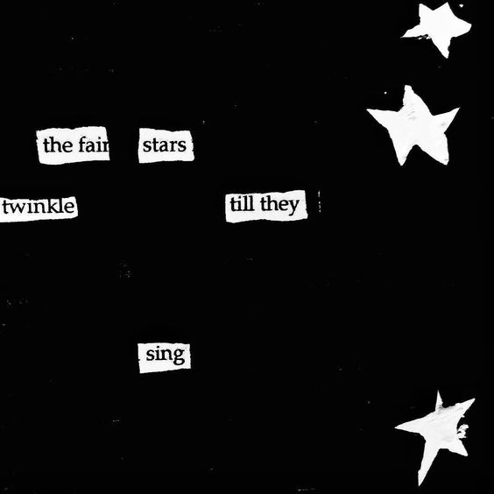
- Choose one page of text from a book or poem written by William Shakespeare. Photocopy the page which you will use to create your own blackout poem.
- Using your eyes, scan the page of text, looking for prominent or striking words which will form part of your poem. Circle your first word using a pen or pencil.
- Continue scanning the text and circling words, sentences and letters to create a poem.
- Scribble over or black out any words that aren’t part of your poem. What you will be left with are the prominent words which form your blackout poem.

Useful Websites
- Shakespeare – BTN
- Modern Shakespeare – BTN
- Shakespeare in School – BTN
- Globe Theatre – BTN
- The History of English Shakespeare – YouTube
- Playground (interactive) – Shakespeare’s Globe

  - Teacher Resource

BTN Transcript: Episode 10 - 27/4/2021

Hey, I'm Amelia Moseley and welcome to a whole new term of BTN. Hope you had a great holiday. Here's what's coming up. We look in into the future of cinema, celebrate the birthday of a very famous playwright and meet a guide dog with a big future.
NZ Travel Bubble

Reporter: Jack Evans

INTRO: But first today we're going overseas, well, some people are for the first time in a long time. Australia's travel bubble with New Zealand is finally open. Let’s find out more about it and whether it might be a sign of better travelling days on the horizon.
Kiwis fancy a trip across the ditch?
WOMAN: Australia? I'd like to go there, I think.
WOMAN 2: I've got some neighbours that come from Australia.
WOMAN 4: Oh well I think it's a quite nice country. A lot of sharks though I don't like it.
And what say you Aussies, fancy a cheeky dip in a Kiwi thermal pool? I'll take that as a yes. Well, you're in luck, because the Trans-Tasman Tourism bubble is open for business. Now Quarantine Free. After months of planning and a couple of setbacks, the Trans-Tasman Bubble has finally opened. Meaning Aussies and Kiwis can visit each other without having to quarantine.
JACINDA ARDERN, PRIME MINISTER OF NEW ZEALAND: Just consider your travel in the same way that you would travel between states in Australia.
It means Aussies can go overseas for the first time since the pandemic began and a lot of families who have been separated for a year can be reunited.
NADIA: We had a family reunion planned to New Zealand the date changed a couple of times because of border closures. When I get back, I'm going to meet loads of cousins I haven't met before and I get to eat amazing Māori food.
Of course, like all things COVID, things can change quickly. Western Australians had their New Zealand travel plans put on hold last week when a case of community transmission put Perth into a snap lockdown. But fingers crossed they'll be able to join in soon. The bubble will be a great boost to both country’s economies, especially considering Aussies usually make up 40 per cent of tourists in New Zealand.
So, it's probably got you wondering, does this mean we'll be able to travel to other places soon too? While there has been talk about other bubbles to countries that have COVID more or less under control. The PM, Scott Morrison, says he's more concerned with getting people vaccinated so those who really need to get overseas can do it safely. But that could be a while off.
See our vaccination roll out is taking a little longer than expected. Partly because of supply problems and some rare cases of side effects. Which has meant the AstraZeneca vaccine isn't being recommended anymore to people under 50. But the government says it's trying to get everyone vaccinated as soon as possible. Other countries are trying to do the same thing, but the pandemic is far from over and it could be a while before the world gets back to normal and we can start thinking of travelling to other places. It's what makes this bubble so special and a lot of Aussies, and Kiwis, are grateful to be back together again.
News Quiz

The Queen has thanked people around the world for their support after the death of her husband, Prince Phillip. How long were the couple married? 63 years, 73 years or 93 years? They were married for 73 years, making Prince Phillip the longest serving royal consort in history.

Do you know the name of this American man, whose death last year sparked massive protests around the US? It’s George Floyd and last week many in the US celebrated as the former police officer who killed him was found guilty of murder.

JOE BIDEN, US PRESIDENT: No one should be above the law and today’s verdict send that message. But it’s not enough. This can be a moment of significant change.

Which Sesame Street character was kidnapped, or costume-napped at least, from a circus in Adelaide? Was it Big Bird, Elmo or Snuffleupagus? It was Big Bird. The handmade costume, which is worth a whopping 160,000 dollars, was taken from a dressing room. But the story had a happy ending, with the bird nappers returning Mr Bird safe and sound along with a note apologising for being such a “bird-en”.

Afghanistan Withdrawal

Reporter: Amal Wehbe

INTRO: Sunday was Anzac Day, when we pay tribute to all of the Australians who've served in conflicts around the world and today, we're going to find out about one of the more recent wars in Afghanistan. Australian defence force workers have served there for nearly 20 years, but now the PM's announced it's nearly time for them all to come home. Let’s find out more.
From Africa to the Western Front, to Vietnam, Australians have served in many places and in many conflicts. But the longest war was in Afghanistan a conflict that has spanned nearly two decades, kept families apart and cost more than 40 Australian lives.
Afghanistan is here in Central Asia. It's a country of mountains and deserts with a rich history. For part of the 20th century, it was a peaceful and prosperous place. But in the late 70s the country was torn apart by political unrest, violence, and civil wars that lasted decades. In the 90s, a group called the Taliban began to gain more power. They were an extremist Islamic group who tried to control many aspects of people's lives, from banning the flying of kites to stopping girls from going to school. The Taliban killed many people in Afghanistan, but it wasn't until 2001 that other countries became involved.
On the 11th of September 2001, a group called Al-Qaeda carried out the biggest terrorist attack in history against the US.
GEORGE W. BUSH, 43RD US PRESIDENT: We will find those who did it and we’ll bring them to justice.
Al-Qaeda's leader, Osama Bin Laden, wasn't from Afghanistan, but he trained there, and the Taliban was protecting him and other terrorists.
GEORGE W. BUSH, 43RD US PRESIDENT: On my orders, the United States military has begun strikes against Al-Qaeda terrorist training camps and military installations of the Taliban regime in Afghanistan.
It wasn't just the US against the Taliban. Its allies including Australia, the UK and other members of the North Atlantic Treaty Organisation, or NATO, joined the Afghan army in fighting against the extremists. But it was difficult and dangerous. More than 2,300 US soldiers along with hundreds of their allies died and many more were physically and mentally injured.
Many innocent Afghan people were also killed. And the US and some of its allies have been accused of committing war crimes. A recent investigation has found 19 Australian defence workers illegally killed people in Afghanistan. But the Australian government says most did the right thing and Australian soldiers did a lot of good. From building roads and schools to training Afghan soldiers to protect their country which held its first election in 2005. In 2011, the US captured and killed Osama Bin Laden.
BARACK OBAMA, 44TH US PRESIDENT: Good evening. Tonight, I can report to the American people and to the world the United States has conducted an operation that killed Osama Bin Laden, the leader of Al-Qaeda.
By 2013, Australian soldiers were no longer fighting against the Taliban. But that wasn't the end of our involvement in Afghanistan. Since then, a small number of soldiers have been working alongside the US and NATO to support the Afghan army. But the new US President has announced that will soon come to an end.
JOE BIDEN, US PRESIDENT: I concluded that it's time to end America's longest war.
The last 13,000 American troops will leave Afghanistan by September 11, 20 years after the terrorist attack that started the war. And Australian soldiers will be coming home too. But back in Afghanistan, some are worried about what this means for their future. The country has taken some big steps forward. It now has a free media, fairly elected leader, girls can go to school and women can work. But the Taliban is still in control in parts of the country, and some are worried about what will happen if they become more powerful. While Afghanistan's future is far from certain, here in Australia, many are happy to see our longest war finally come to an end.
Cinema Future

Reporter: Cale Matthews

INTRO: The Oscars were handed out in the US on Monday, and like so many things, they were a little unusual this year. The format was different and also films were eligible, even if they were never shown in cinemas. It makes sense given that a lot of people around the world haven’t been able to go to cinemas for a long time. But some reckon it could signal a bigger change in the way we watch movies. Take a look.
Welcome to the history of the cinema.
CALE: The movie’s starting.
The story of the cinema begins in the late 1890s. Most early films were shown as part of a travelling theatre program and would only be a few seconds long showing parts of everyday life, from people walking around their garden, to a train arriving at a station. It's really not that exciting but audiences at the time loved it.
NIC: Is that magic?
In the next few years movies became longer, had a story, and even got a splash of colour.
CALE: By the 1930s the cinema was the bee’s knees.

NIC: Shush.

CALE: Sorry.
CALE as DOROTHY, WIZARD OF OZ: For working class people, movies of the make believe became a distraction from all of the terrible things that were happening at the time like the war and the Great Depression. There's no place like the movies.
Back then a movie ticket only cost 5 cents, or a nickel. Which is why some of the first cinemas were known as nickelodeons. Nickel, 5 cents and odeon, the Latin word for theatre. Over time, cinemas became extravagant, movies got sound, and seats got, well, comfier.

CALE as DICK VAN DYKE, MARY POPPINS: Thousands of moviegoers went to the cinemas, rain, hail or shine.

CALE as FRED ASTAIRE, SINGING IN THE RAIN: It's why these early days are often called the Golden Age of Cinema.
CALE: But in the 1950s and 60s television came along and everything changed.

People started staying home and watching their TV.

CALE as VITO CORLEONE, THE GODFATHER: So, cinemas were forced to make the patrons an offer they couldn't refuse.

Drive-in cinemas became a thing, screens got wider and multiplexes, which had multiple movies playing at once, started popping up all over the world.

CALE as DARTH VADER, STAR WARS: Since then, the cinema business has been pretty steady, with or without the force.
CALE as KEVIN, HOME ALONE: That was until streaming came along. Aghhhh.

Thanks to the 200 streaming services available worldwide, it's never been easier to watch a blockbuster from home. It led to the death of DVD shops and a dip in movie ticket sales, and then came COVID. Yeah, it probably goes without saying 2020 wasn't the best year to go to the movies. In fact, it was the first time in 25 years that no movie made more than 500 million dollars. Warner Brothers made the big decision to send all of its 2021 movies straight to streaming and to some it looked like the beginning of the end for cinemas.
CALE as HARRY POTTER, HARRY POTTER: Of course, this could just be a weird year or two. Alohomora.

And some reckon once COVID settles down everything will be awesome.

CALE as SPIDERMAN, THE AVENGERS: But others say this is a bigger trend and we could start to see cinemas disappear.

CALE: While the future is foggy a lot of people agree there is nothing like seeing a movie on the big screen.

NIC: Oh well, it would be good if you weren’t talking the whole time.

Ask a Reporter

If you want to know more about the history or the future of cinema, you can ask me live on Ask a Reporter, this Friday. Just head to our website for all the details.

William Shakespeare

Reporter: Jack Evans

INTRO: Now, our dancing souls doth celebrate the birthday of a very famous playwright. Perchance the most famous playwright who ever lived. Do you know who I'm talking about? It's Shakespeare. Last Thursday was Shakespeare Day so we thought it'd be a good time to find out a little bit more about him. Here's Jack.
JACKLET: Ah Shakespeare and no I'm not talking about the competitive sport of shaking a spear. I'm talking about the playwright, the Bard, Will to his friends. Yes, that's right, William Shakespeare. ACT 1: The Shake-who of Shakespeare's.
Our protagonist was born in Stafford-Upon-Avon, in England, in the month of April 1564. The day on which he was born is a mystery, no, really. He was the third child of eight to Mary Arden and John Shakespeare, who BTW's was a rather good glove maker. And he grew up and married Anne Hathaway, just not the actor.
JACKLET: Over the next several years Shakespeare, oh, well this page is blank?
Yeah not much is known about Shakespeare's earlier life. Historians often refer to them as the "lost years". But whatever he was doing, it led to him performing in London in 1592.
JACKLET: Which brings us to ACT 2: Get Thee to A Theatre.
Shakespeare performed his plays with an acting group called the Lord Chamberlain's Men. Who later became known as the Kings Men.
JACKLET: And yes, they were all men because women weren't allowed to act back then. Something I and Anne Hathaway are very glad is no longer a thing.
Lord Chamberlain's Men performed here at the Globe Theatre. Well, not this one, this is a replica, the real one burnt down. But what about the actual plays? During his lifetime Shakespeare wrote 37 plays, that we know about, anyway. From tragedies, comedies and historical dramas. He also wrote a whole bunch of poems and sonnets. All with his now famous Shakespearean way using stylish language and elaborate metaphors and the audience were eating up what he was serving.
JACKLET: Just like I'm about to sink my teeth into ACT 3: Playwright, Play Right. Right?
While there is no one clear answer as to why Shakespeare's plays have stood the test of time and continue to be very popular. Many agree that it's because, well, they are well written. The themes and characters are still relatable to a lot of different people and they've been the inspiration for countless movies, TV shows, songs. In fact, you've probably seen some of Shakespeare's work without even realising it. Shakespeare is also credited with introducing more than 17 hundred words to the English language like bandit and bubble and unreal and swagger. As well as common phrases we still use today. Like jealousy is the green-eyed monster and the world is my oyster and all that glitters isn't gold.
JACKLET: Which brings us to the epilogue. I know Shakespeare plays typically have 5 acts, but we just don't have the time plus this wig is getting itchy. But I will leave you with this quote, Hakuna Matata.

CREW: Shakespeare didn't write that.
JACKLET: What? He didn't?
CREW: The Lion King was inspired by Hamlet?
JACKLET: Oh. No, no, no. I totally see that now. Yeah.
Did You Know?

Did you know Shakespeare's play Macbeth has a reputation of being cursed? It has witches in it, and there's a legend that real ones put a spell on it. Yeah, they probably didn't, but there are lots of stories of accidents and disasters happening during productions of the play and some actors don't like to say its name out loud.

Sport

You know what they say, two's company, 78,000's a crowd. That's how many fans packed the MCG to watch the ANZAC Day match between Collingwood and Essendon. It broke the world record as the biggest sporting event since the COVID-outbreak began. In a hard-fought game, the Bombers brought it home by 24-points.
Ash Barty's driving some hot new wheels this week after taking out both the singles and doubles events at the Stuttgart Open in Germany. The Aussie took home a cash prize and a Porsche for her efforts just in time for her 25th birthday too. Oh, happy birthday Barty.
And welcome to the battle of the Joshes. This somewhat strange competition took place in a park in the US over the weekend. A whole bunch of people named Josh were invited on social media to fight it out for the right to be named Josh. Apparently there can be only one and in the end 5-year-old Josh Vinson Jnr or Little Josh was crowned King of the Joshes.
MAN at EVENT: That was pretty awesome man, he’s going to remember this for the rest of his life.
Guide Dogs Training

Reporter: Cale Matthews

INTRO: Finally, today we're going to find out more about guide dogs. Those highly trained canines who make a huge difference in the lives of people who are blind or vision impaired. Cale found out what it takes to turn a puppy into a pro.

Most dogs know a trick or two. Sit, shake, ride a bike. Actually, that one’s pretty awesome. But what about teaching a dog to cross a road, navigate a crowd, or even catch a train. Across Australia there are thousands of super smart puppers helping blind and vision impaired people to get around. But before guide dogs can get guiding, they've gotta go through a whole lot of training.
CALE: So, that's why I've popped down to guide dogs SA/NT to see exactly what this training entails. Because it’s a tail. Anyway.
CALE: Hi Taylor, nice to meet you. So, we're about to go meet Jo Jo the guide dog, is there anything I need to know before we meet her?
TAYLOR, GUIDE DOG TRAINER: There is. She’s in harness. So, no patting, talking, distracting in any way. While she’s in harness she’s a working dog.
CALE: Cool. So, when we meet the cute, adorable, fluffy little puppy hands to myself.
TAYLOR, GUIDE DOG TRAINER: That's the one.
CALE: Let's go meet her.
Say g'day to Jo Jo. G’day Jo Jo. Like all guide dogs, Jo Jo has spent 12 months of her puppyhood going everywhere with a volunteer puppy raiser, learning the basics like sit and stay and getting used to all sorts of situations. Be careful. After that, she came here to Guide Dogs SA/NT for a puppy personality test.
TAYLOR, GUIDE DOG TRAINER: So, we have a look at their temperament, their personality, we see if they've got any issues with surfaces, dog distraction, anything like that.
See not every dog is suited to guiding, but there are lots of other jobs they can do.
TAYLOR, GUIDE DOG TRAINER: So, apart from the guide dogs, we have autism assistance dogs, we use facility dogs, court dogs.
But Jo Jo was picked to be a guide dog which meant another 20 weeks of specific guide dog training.
TAYLOR, GUIDE DOG TRAINER: So, we teach them how to be able to walk in a straight line from curb to curb, how to turn left and right, and then we progressed through busy areas, how to catch buses, taxis, trains, all the way into walking into central markets and going through all the busy areas.
It costs about 50,000 dollars to train one guide dog, most of which comes from donations and Taylor says International Guide Dog Day is a great way to show people just how valuable these puppers are. It's also a good time to teach people what to do when they see a guide dog, a little something Taylor likes to call petiquette.
TAYLOR, GUIDE DOG TRAINER: The first thing that they should do is if the handler is walking along, give them some space to come through, don't interact with them, don't distract them, don't try and pat them feed them, whistle, or any distraction.
That means no pats guys no matter how cute the dog is. So, you never know you might see Jo Jo and her new owner out on the streets and if you do, keep your distance, but spare a thought for the important work that she and her puppy pals do every day.
Closer

Aww, way to go Jo Jo. Well, that's it for BTN today, I hope you've enjoyed it. We'll have more stories for you next week and in the meantime there's heaps to see and do on our website and if you're 13 or over, you can always subscribe to our YouTube channel, so you never miss a thing. I’ll catch you next time. Bye.

