Episode 4
25th February 2020



Quarantine
- Discuss the BTN Quarantine story as a class and record the main points of the discussion.
- How many people live in Wuhan China?
- How has the coronavirus COVID-19 impacted people living in Wuhan?
- What does quarantine mean?
- Where does the word quarantine come from?
- What is another name for the bubonic plague?
- What other diseases were people quarantined for in Australia in the 1800s? Name one.
- It’s rare to hear about people being quarantined. True or false?
- Where were a group of Aussies recently sent to be quarantined for 2 weeks?
- What questions do you have after watching the BTN story?

Holden Scrapped
- What did the BTN Holden Scrapped story explain?
- What year does the history of Holden date back to?
  - 1756
  - 1856
  - 1956
- Who founded Holden?
- What did Holden specialise in before making the automobile?
- What year did Holden make its first Australian car for mass production?
- Complete the following sentence. By the 1950s Holden made up ____ percent of all Aussie car sales.
- What is the name of Holden’s most popular car?
- The Falcon is made by Holden. True or false?
- Why did Australian car manufacturers close their factories?
- How do people feel about the closure of Holden?

Plastic-free Produce
- Before watching the BTN story discuss what you know about single-use plastics.
- What did the Plastic-free Produce story explain?
- What are some good reasons for using packaging on fresh food?
- Plastic packaging doesn’t take very long to break down. True or false?
- How does plastic pollution affect marine animals?
- Which country is Woolworths trialling plastic-free produce?
- Complete the following sentence. Reduce, reuse and _________.
- What are beeswax wraps?
- Create a t-chart with the pros and cons of plastic-free produce.
- What did you learn watching the BTN story?

Check out the Plastic-free Resource on the Teachers page.

Anne Frank
- Briefly summarise the BTN Anne Frank story.
- Where was Anne Frank from? Find using Google Maps.
- What did Anne Frank call her diary?
- How old was Anne when she started keeping a diary?
- Where did Anne Frank and her family flee from before arriving in the Netherlands?
- What political party was Adolf Hitler a leader of?
- How were Jewish people treated by the Nazis?
- What happened to Anne Frank’s family when the Nazis invaded the Netherlands?
- How did you feel watching the BTN Anne Frank story?
- What questions do you have about this story?

Check out the Anne Frank resource on the Teachers page.

Beatboxing
- Discuss the BTN Beatboxing story with another student.
- Why is the beatboxing performance called Frankenstein?
- Where are the performers in the BTN story from? Find using Google Maps.
- Complete the following sentence. The Beat Box Academy started ___ years ago.
- What decade did beatboxing start?
  - 1970s
  - 1980s
  - 1990s
- What is beatboxing?
- How did beatboxing begin?
- What do the kids in the story like about beatboxing?
- Describe beatboxing using 3 words.
- What did you like about this story?

Teacher Resource
Episode 4
25th February 2020

Plastic-free Produce

Students will investigate ways to reduce single use plastics. Students will research the impact of single use plastics on the environment.


Geography Year 4
The use and management of natural resources and waste, and the different views on how to do this sustainably.

HASS – Year 4
Reflect on learning to propose actions in response to an issue or challenge and consider possible effects of proposed actions.
Science Year 4
Science knowledge helps people to understand the effect of their actions.
Science – Year 5 & 6
Scientific knowledge is used to solve problems and inform personal and community decisions.


- Before watching the BTN story discuss what you know about single-use plastics.
- What did the Plastic-free Produce story explain?
- What are some good reasons for using packaging on fresh food?
- Plastic packaging doesn’t take very long to break down. True or false?
- How does plastic pollution affect marine animals?
- Which country is Woolworths trialling plastic-free produce?
- Complete the following sentence. Reduce, reuse and _________.
- What are beeswax wraps?
- Create a t-chart with the pros and cons of plastic-free produce.
- What did you learn watching the BTN story?


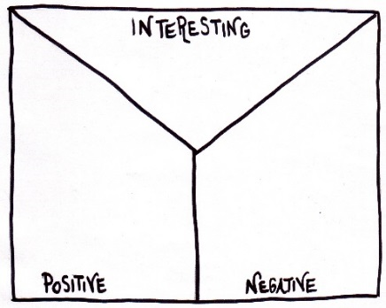
Note taking
Students will practice their notetaking while watching the BTN Plastic-free Produce story. After watching the story, ask students to reflect on and organise the information into three categories.
What information in the story was...?
- Positive
- Negative or
- Interesting


Class Discussion
As a class discuss the BTN Plastic-free Produce story using the following questions as a guide. Record the main points of the discussion on a mind map with plastic-free at the centre. Use the following questions to guide the discussion:
- Which supermarket will introduce plastic-free produce?
- Why are they introducing plastic-free produce?
- What are single-use plastics? Give some examples.
- Why do we have packaging?
- What impact do single-use plastics have on the environment?
- What are the alternatives to single-use plastics?

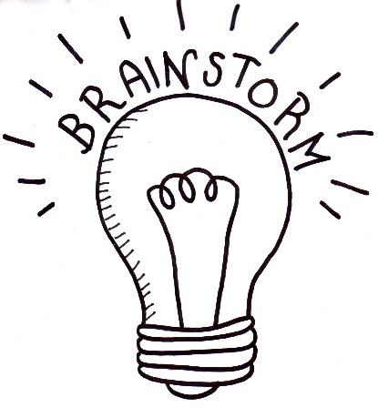
Glossary
Students will brainstorm a list of key words and terms that relate to the BTN Plastic-free Produce story and inventions. Students may want to use pictures and diagrams to illustrate the meaning and create their own glossary. Here are some words to get you started.
Packaging | Food waste | Landfill
Single-use plastic | microplastics | Shelf life

Six Hat Thinking
As a class, use Edward De Bono’s Six Hat Thinking to explore the issues raised in the BTN Plastic-free Produce story. Make your own coloured hat cut-outs and place on the floor. Students will take it in turns answering questions in relation to what they already know about the issue, what they have learnt from the BTN Plastic-free Produce story and what they want to learn further about the topic. Ask students to respond to the following questions:

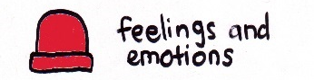 | How did the Plastic-free Produce story make you feel?
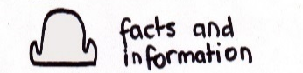 | What do you know about the issue?  What have you learnt from the story?
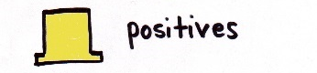 | Were there any positives from the story? If so, what were they?
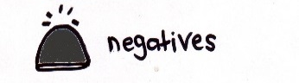 | What are some of the negatives or challenges that you learnt from the story?
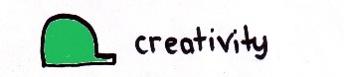 | Why is it important to find out more about the issue?
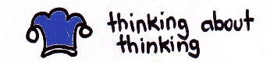 | What questions were raised during this activity?  What do you want to learn further about this topic?

Reflection
After this activity, ask students to reflect on what they have learnt. Students can include details about how their thinking on this issue has changed and why they think we should act.

KWLH
Watch the BTN Plastic-free Produce story and discuss as a class. What questions were raised in the discussion and what are the gaps in their knowledge. The following KWLH organiser provides students with a framework to explore their knowledge on this topic and consider what they would like to know and learn.

What do I know? | What do I want to know? | What have I learnt? | How will I find out?

Students will develop their own question/s for inquiry, collecting and recording information from a wide variety of sources. Students may develop their own question for inquiry or select one or more of the questions below.

- What’s the best way to store fresh fruit and vegetables without using plastic? Investigate ways that you can keep produce fresh for longer without using plastic packaging. Choose 5 fruit and/or vegetables and research how they can be stored without plastic.
- Should all supermarkets have plastic-free produce? Write a persuasive piece of writing explaining your reasons.
- How can we convince people that plastic pollution is a serious problem? Think of creative ways to raise awareness about the issues raised in the BTN Plastic-free Produce story.
- What happens to the plastic you throw away? Explore the journey of plastic from production, to landfill and its impact on the environment.

Persuasive text
Students will develop a persuasive text for or against the following statement: `All fresh produce should be plastic-free. Students can use the information recorded on the mind map and their own research to help develop their argument. Encourage students to use a range of sources. Provide students with the following structure to follow when completing this activity.
Structure of a persuasive text
Introduction
- What is the point you are trying to argue? Construct an introductory paragraph which states the issue or topic.
- Introduce the arguments that will be developed in the body of the text.

Body
- Construct arguments that support your point of view.
- Each paragraph starts with a topic sentence which introduces each point.
- The rest of the paragraph gives more reasons.
- Arguments can be ordered from strongest to weakest.

Conclusion
- Restate your position on the argument.
- Construct a concluding paragraph that provides a summary of your arguments and a call to action.

Tips for writing persuasive texts
- Who is your audience? For example, are you directing your argument at kids, teachers or politicians?
- Explore how language choices can have a big impact on persuading your audience.
- Which language devices give the report credibility and authority?
- Which are designed to create an emotional response in the listener?
- Provide facts and evidence to support your argument.
- Write in the present tense.
- Check your spelling and punctuation.

Use this Read Write Think persuasion map to plan your exposition text.

Aussie kids’ campaigns
See below for a collection of BTN stories which focus on kids campaigning to reduce plastic pollution. After watching any one of the BTN videos ask students to respond to the discussion questions which can be found on the story page. Teacher resources are also provided for some of these stories.

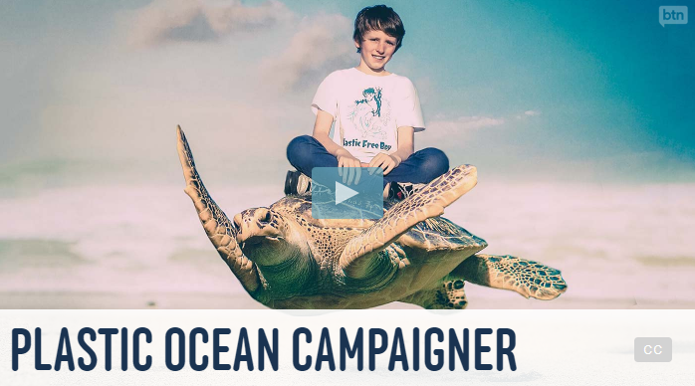  Video | 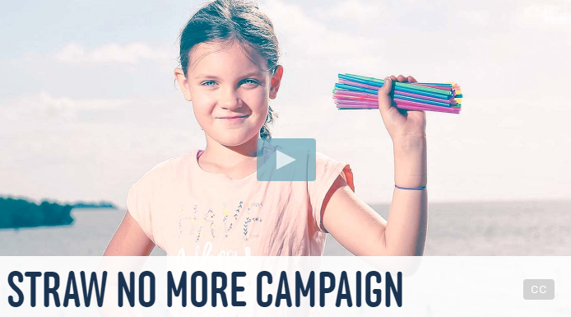  Video
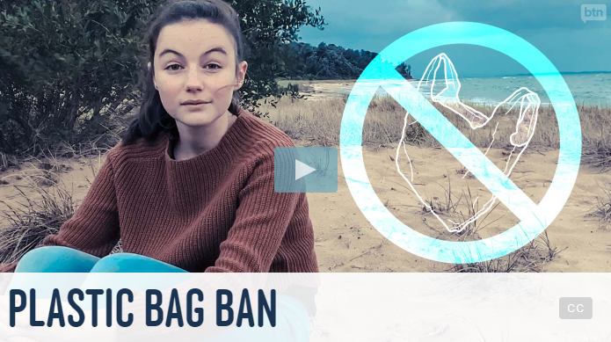  Video Resource PDF | 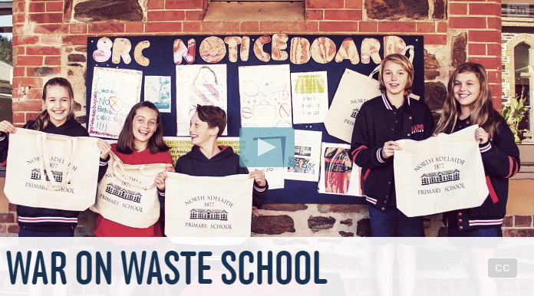  Video Resource PDF
Campaign
Students will design a public education campaign to raise awareness about single use plastics and its impact on the environment. Students will need to think about their campaign’s aim, target audience and the value of raising awareness in their school community. Students can use Canva to design a poster which can be put up around their school and the wider community.


Single-use Plastic Ban – BTN
https://www.abc.net.au/btn/classroom/single-use-plastic-ban/10876650

Plastic Bag Ban – BTN
https://www.abc.net.au/btn/classroom/plastic-bag-ban/10522750

Plastic packaging – BTN
https://www.abc.net.au/btn/classroom/plastic-packaging/10525094

War on Waste – ABC
https://www.abc.net.au/ourfocus/waronwaste/

Reducing Plastic – Woolworths
https://www.woolworths.com.au/shop/discover/sustainability/recycling

Teacher Resource
Episode 4
25th February 2020

Anne Frank
Students will learn more about the life of Anne Frank and the treatment of Jewish people during WWII.

HASS / Inquiry and skills – Year 5 & 6
Develop appropriate questions to guide an inquiry about people, events, developments, places, systems and challenges.

Locate and collect relevant information and data from primary sources and secondary sources.

Sequence information about people’s lives, events, developments and phenomena using a variety of methods including timelines.

HASS / Inquiry and skills – Year 7
Construct significant questions and propositions to guide investigations about people, events, developments, places, systems and challenges.

Present ideas, findings, viewpoints, explanations and conclusions in a range of texts and modes that incorporate source materials, citations, graphic representations and discipline-specific terms, conventions and concepts.

- Briefly summarise the BTN Anne Frank story.
- Where was Anne Frank from? Find using Google Maps.
- What did Anne Frank call her diary?
- How old was Anne when she started keeping a diary?
- Where did Anne Frank and her family flee from before arriving in the Netherlands?
- What political party was Adolf Hitler a leader of?
- How were Jewish people treated by the Nazis?
- What happened to Anne Frank’s family when the Nazis invaded the Netherlands?
- How did you feel watching the BTN Anne Frank story?
- What questions do you have about this story?

Personal Response
Students will write a personal response to the BTN Anne Frank story. Leave a comment on the BTN Anne Frank story page. Ask students to finish one or more of the following incomplete sentences:

- This story made me feel….
- It was interesting to learn that…
- This story made me wonder…
- Anne Frank’s story is important because...
- Five words that I would use to describe Anne Frank…

Class Discussion
Hold a class discussion about the information raised in the Anne Frank story. Students will then create a class mind map about Anne Frank. Use the following questions to guide discussion:
- Who was Anne Frank?
- Who were the Nazis and how did they treat Jewish people?
- Why did she and her family hide in the annex at her father’s work?
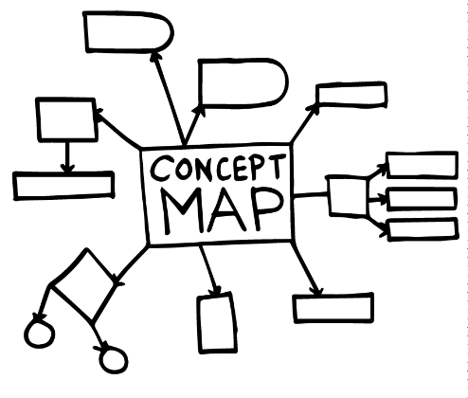
- What was life like for Anne and her family hiding in the annex?
- What did Anne write about in her diary?
- What happened to Anne and her family when they were discovered by German soldiers?

Students may find it useful to watch the BTN Second World War story which explains the events that led up to the Second World War and gives a brief history of the war. The Who was Anne Frank? video gives an overview of Anne’s life.
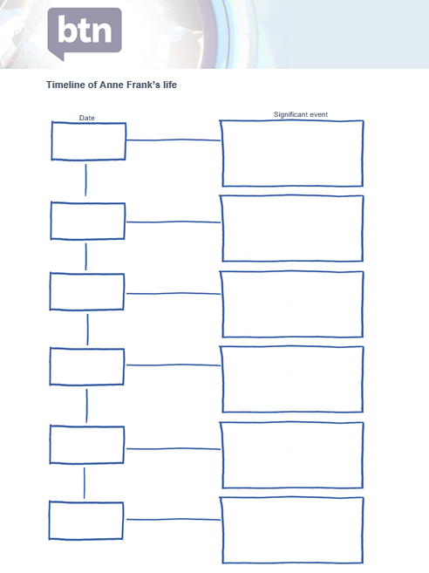
Anne Frank Timeline
Students create a timeline to sequence the main events in Anne Frank’s life. Use the timeline template at the end of this activity to record key dates and events. Here is some information they may like to include:
- When and where was Anne Frank was born?
- Anne and her family move to the Netherlands
- Germany invades the Netherlands
- Anne receives a diary
- Anne and her family go into hiding in the Secret Annex
- The Annex is raided and the people in the Secret Annex were put in prison.
- The people from the Secret Annex were sent to Auschwitz.
- Anne and her sister Margot are taken to Bergen-Belsen concentration camp.
- Anne and Margot die in the concentration camp.
- WWII ends
- Anne’s book was published

Anne Frank Research
Discuss the story as a class and ask students to pose questions about Anne Frank, her life hiding in the annex and after she was sent to a concentration camp. Students will develop an appropriate question to guide an inquiry about Anne Frank (below are some example key questions). Alternatively, students may want to choose to investigate a question about the Holocaust and the treatment of Jewish people during WWII.
- What historical events affected Anne Frank’s life?
- How were Jewish people treated during WWII?
- How did the German invasion of the Netherlands affect Jewish people living there during WWII?
- What did a typical day in the Secret Annex look like?
- How did writing her diary help Anne deal with living in hiding?
- What impact did Anne Frank’s diary have on the world?
- Why do we remember Anne Frank today?

Students will collect and record information from a wide variety of primary and secondary sources and present the information they find in an interesting way.

- Primary sources – Through using primary sources, that is a document like a diary, paintings or a physical object, that was written or created at a particular time, we can gain an understanding of what might have happened at a place in time.

- Secondary sources – Secondary sources are documents written after an event has occurred, providing “second-hand” accounts of that event, person, or topic. Unlike primary sources, which provide first-hand accounts, secondary sources offer different perspectives, analysis, and conclusions of those accounts.

As part of their research, students will need to:
- Use appropriate terms and concepts in their presentation and refer to evidence and sources.
- Write down the name of the source of the information.
- Look for facts and opinions that answer their inquiry question/s.
- Write down using their own words facts and opinions from the source.

Students can present the information in one of the followng ways:
- A ‘Did You Know’ Facts sheet
- Prezi presentation
- Oral presentation
- An infographic using Canva

Anne Frank – Create a biography
Before students begin to construct their biographies, hold a class discussion to find out what they already know about biographical writing. Discuss what type of information is included in a biography and what they tell us about a person. The Civics and Citizenship website has some examples of biographies for students to look at.

Using the Biography template at the end of this activity, students will find and record information about Anne Frank. Alternatively, students may want to choose another person in Anne’s family or one of the people that helped them while they were hiding in the Secret Annex.

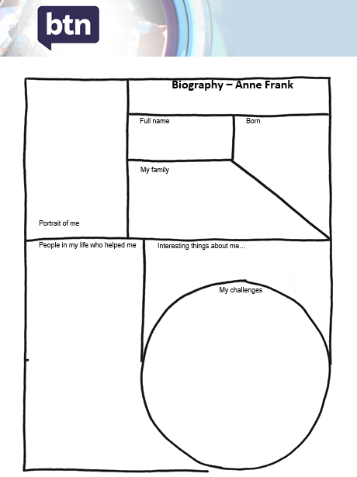
Some possible areas of research include:
- Where was Anne Frank born? Locate using Google Maps.
- When was she born?
- When and why did her family move to Amsterdam?
- Why did her family hide in the Secret Annex above her father’s business?
- What challenges did she face while she was hiding in the Annex?
- Why did Anne record her thoughts in a diary?
- What happened when Anne and her family were discovered by German soldiers?
- What do you admire about Anne Frank?
- Sketch a portrait of Anne Frank. Explore and experiment with different techniques and media to produce a portrait.

Further investigation
- Imagine you could sit down and talk to Anne Frank. What questions would you ask about her life?

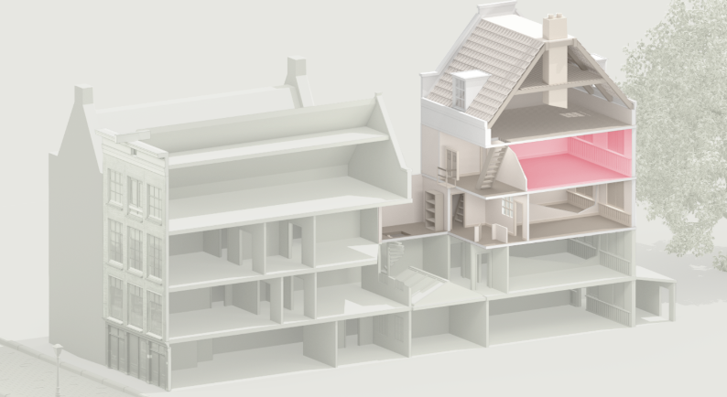
Virtual Tour – The Secret Annex
Students go on a virtual tour of the Secret Annex where Anne and her family hid for more than two years during WWII.

Start the virtual tour here. To move from room to room in the Secret Annex, click on the door icon.

The tour starts in the secret bookcase. Students can explore the space where the revolving bookcase hid the entrance to the Secret Annex. Use the toggle to move around the room then watch the video to learn more about how the revolving bookcase works. Students then respond to the following questions:

- Look around the space. What words would you use to describe the space?
- Why were the Nazis searching Dutch people’s houses?
- Why was the secret bookcase built?
- How does the secret bookcase work?
- What happened on the 4th of August 1944?

Otto, Edith and Margot Frank’s room
- Look around the room. What can you see?
- What does the room tell you about the Frank family?
- Click on the icon that describes a day in the Secret Annex. Watch the short video that describes the daily routine. What did you learn watching the video? What was surprising?

Anne Frank’s room
- Look around Anne’s room. What words would you use to describe it?
- How did Anne decorate her room?
- What game did Anne play when she was bored?
- Who did Anne share the room with? How did she feel about sharing the space?
- Click on the icon that describes Anne’s diary and watch the short video.
- Who did Anne address her letters to and what did she write about in her diary?
- Why was Otto Frank surprised when he read Anne’s diary?

Students can explore other rooms in the Secret Annex and respond to these questions:
- What does the room tell us about what life was like living in the Secret Annex?
- What challenges did the people hiding in the Secret Annex face?

Who was Anne Frank? Anne Frank House
https://www.annefrank.org/en/anne-frank/who-was-anne-frank/
The Secret Annex – Anne Frank House
https://www.annefrank.org/en/anne-frank/secret-annex/
A typical day in the Secret Annex - Anne Frank House
https://www.annefrank.org/en/anne-frank/go-in-depth/typical-day-secret-annex/

Second World War – BTN
https://www.abc.net.au/btn/classroom/second-world-war/11460762
Anne Frank: A Life in Hiding – Newsround
https://www.bbc.co.uk/newsround/46987263

Timeline of Anne Frank’s life

Date
Significant event






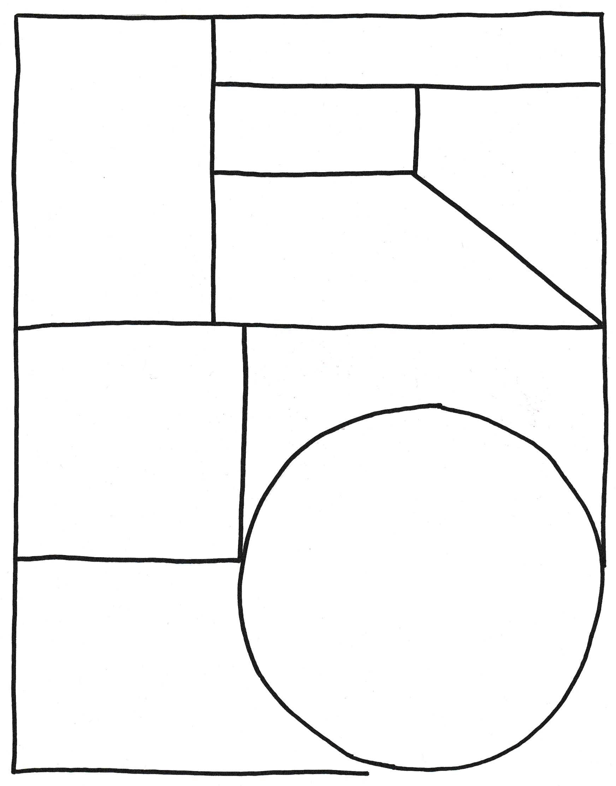

My family
Full name
Portrait of me
Born
My challenges
Interesting things about me
Biography – Anne Frank
People in my life who helped me

BTN Transcript: Episode 4 – 25/2/20

Hey. I'm Amelia Moseley and you're watching BTN. Here's what's coming up. We say goodbye to an Aussie automotive icon, find out about the push for plastic free produce and meet some masters of beatbox.

Quarantine
Reporter: Olivia Mason

INTRO: But first today to something you might have heard about a lot in the news recently and that's quarantine. People have been quarantined on cruise ships, on Christmas Island, in hospitals and in their homes, all to try to stop the spread of the coronavirus COVID-19. So, what is quarantine? Let’s find out more about its history and how it's being used now.
OLIVIA MASON, REPORTER: Looking at these pictures it's hard to believe that Wuhan in China is a city with a population of 11 million, that's nearly half of Australia in one city. And while the streets are usually full of cars and people - right now they're abandoned.
People are being forced to stay in their homes or in specially designed centres to try to stop the spread of the coronavirus COVID-19 as part of what's been called the biggest quarantine operation in human history. Quarantine is something that's been used to stop the spread of diseases for thousands of years. But the name actually comes from Venice. In the 1300s, authorities there were trying to stop the spread of the bubonic plague or Black Death which was killing millions of people throughout Europe. So, they ordered that all passengers on arriving ships had to wait on-board for 40 days or 'quaranta giorni' to make sure they weren't sick. Eventually that became quarantine.
It's always been controversial because it means taking away people's freedom just because they're sick, or because there's a chance they're sick. But for centuries it was one of the few things we could do to stop the spread of deadly diseases like yellow fever, cholera, smallpox and the Spanish flu.
This is a quarantine station that was built in Australia in the 1800s. People were sent here when they arrived by boat so that authorities could make sure they were healthy.
LINDL LAWTON, SA MARITIME MUSEUM: I guess smallpox was one of the first diseases that was dealt with here. They had an outbreak of bubonic plague in Port Adelaide and then you had Spanish influenza after the First World War so it was to remove people who were potentially bringing disease into the Port and therefore Adelaide from the population until they were deemed safe.
The last passengers were quarantined here in the 1960s. Definitely by 1979-80 it had completely shut down.
OLIVIA: Lindl says that's because we got better at treating diseases with things like penicillin and vaccines.
These days when we talk about quarantine we are usually talking about this. Australia has some of the strictest quarantine laws in the world when it comes to the plants and animals that are allowed in the country. But it's really rare to hear about people being quarantined. The reason it's happening now is because there isn't a vaccine or a cure yet for COVID-19 and governments around the world want to try to stop it from spreading.
Last week, a group of Australians were sent into quarantine in the Northern Territory after being stuck for weeks on-board a cruise ship where some cases of the virus were found. Meanwhile, another group of Australians were reunited with friends and family after spending two weeks quarantined on Christmas Island.
KID 1: At first, I like I don't wanna go. I wanna go back to Daddy.
OLIVIA: But most said the experience wasn't too bad in the end.
KID 2: It was good, it was much better than expected. We're just glad to be back, to go to school and work.
KID 3: Actually, really good. Made some new friends and actually enjoyed the place.
OLIVIA: Back in China, lots of people are finding their own ways to get through their time quarantined from friends and family.
While it's a scary and sad time for a lot of people, they're hoping it'll be over soon so life can get back to normal.

Ask a Reporter
Do you have a question about quarantine? You can ask me live on Friday during Ask a Reporter. Just head to our website for all the details.

News Quiz

Time to test your news knowledge now with a quiz. Which Italian city had to cancel the last two days of its famous Carnival festival because of an outbreak of the coronavirus COVID-19? Was it:

Rome
Milan or
Venice?
It was Venice. Carnival was supposed to go until Tuesday but then two people in the city got sick. More than 150 cases of the coronavirus have been found in Italy now and authorities are trying to stop it spreading by quarantining towns, closing schools and cancelling big events.
Australia's new space agency has opened in which Aussie city? It's Adelaide. The new agency will be in charge of space research and exploration. But it's all those space jobs that have the PM excited.
SCOTT MORRISON, PRIME MINISTER: But at the end of the day, as exciting as space is it's about the jobs in space that really matters.
What's Germany going to stop using by 2038? Is it:

Petrol cars
Coal or
Plastic straws?

It's coal. Germany's decided to stop mining and using coal for energy.
Who's this famous sportsperson who’s won a big award? It’s gymnastic star Simone Biles, who's just been named World Sportswoman of the Year at the Laureus awards. It's the third time she's won the award.
Holden Scrapped
Reporter: Jack Evans

INTRO: Fans of famous Aussie car brand Holden, were devastated by news last week that by the end of this year, it's gonna be scrapped for good. We thought we'd find out more about Holden and it's place in automotive history.

JACK: Oh, hello there, I'm just taking my brand new Holden FX for a spin. Check out this move. Such precision, such grace, such fun. This boomin' beauty not only looks good, it helped to kick start Australia's car industry. But Holden's story actually began in 1856. If this were a time travelling car I'd take you there, but it's not. Roll the clip.
Holden was founded by this guy, James Alexander Holden. At first, they specialised in Horse saddles, talk about horsepower. But as cars were becoming increasingly popular Holden decided to jump on the band wagon or rather the band automobile? Anyway, they started making car upholstery and car shells. In 1948 Holden joined forces with US company, General Motors, to make the first Australian car designed for mass production.
NEWSCASTER: The job is done, and an Australian car is born.
It was a pretty big deal at the time for a young country like Australia to be able to drive a car that was designed and made by Australians for Australians.
HOLDEN AD: Australia's own car, Australia's finest value.
By the 1950s Holden made up 40 percent of all Aussie car sales. And more and more factories started opening around the country to meet the demand. In the 70s it brought out its most popular car the commodore cementing its place as an Aussie Icon.
HOLDEN AD: We love football, meat pies, kangaroos and Holden cars.
Of course, Holden wasn't the only Aussie car maker and over the years a massive rivalry developed between Holden and Ford, which challenged the Commodore’s dominance with its Falcon. But as times changed so did cars. It became easier and cheaper to make them overseas and one by one Australian car manufacturers including Holden started closing their local factories. In 2017, the last Holden to be made in Australia rolled off the production line. In fact, it was the last car to be made in Australia. It was devastating for the thousands of people who worked in the Australia car manufacturing industry. Holden still made cars, they were designed in Australia and made overseas. But they still struggled to compete and last week General Motors announced they'll be axing Holden by the end of this year.
JULIAN BLISSETT, GM VICE PRESIDENT: We have just informed our employees and our dealer partners and I can confirm to you that GM has taken the very difficult decision to wind down Holden operations in Australia and New Zealand by 2021.
A lot of people were pretty upset by the news. It means hundreds of Aussies will lose their jobs. It's also devastating for Holden fans. Many of whom came together in Adelaide last week for the Superloop.
KID 1: I think it was a bit silly for the decision.
WOMAN: It's disappointing, Holden's part of Australia.
The Holden Ford rivalry has always been a big part of motor sports in Australia and many say it just won't be the same without Holden.
KID 2: It's pretty sad because it's such a legendary brand and it's just a part of Australia.
KID 3: I felt really sad. A lot of jobs have been lost and it's just not really that fun that jobs have been lost and Holden was a really good company, so I just wish they stayed.
Did You Know?

Did you know that Holden was the first Aussie car company to put seatbelts in all of their vehicles?
That was back in 1966.
Anne Frank
Reporter: Amelia Moseley
INTRO: This next story is a sad, but important one from history. It's about a German teenager named Anne Frank who died this month 75 years ago. Her diary has become one of the most famous accounts of a terrible event that happened during the Second World War known as the Holocaust. Let's find out more.
In early 1942, Anne Frank was your average teenager. She lived with her family in Amsterdam in the Netherlands and loved reading and writing. When she was 13, she started keeping a diary, which she named Kitty.
ANNE FRANK DIARY ENTRY JUNE 12, 1942: Dear Kitty, I hope I will be able to confide everything to you, as I have never been able to confide in anyone, and I hope you will be a great source of comfort and support.
Little did she know that her diary would one day become one of the most famous books in the world. You see, Anne was growing up in a world that was at war for a second time. She and her family had fled from Germany to the Netherlands to escape this man, Adolf Hitler and his political party known as the Nazis. Hitler was obsessed with the idea of a "pure" German race which he called "Aryan" and he wanted that race to control all of Europe.
The Nazis started persecuting people who they didn't think were worthy members of society, mostly Jewish people like Anne and her family. The Nazis discriminated against Jews and took away their rights. Eventually, they went one step further and planned to wipe out Europe's Jewish population, so they started arresting them and sending them to thousands of specially built prisons called concentration camps. Millions of Jewish people were deliberately killed or died from terrible living conditions and these events are now known as The Holocaust.
The Frank family thought they'd be safe in the Netherlands, but in 1940 the country was invaded by the Nazis and in 1942 Anne's older sister Margot was ordered to go to work in a camp. So, the Franks went into hiding in a secret apartment behind her dad, Otto's, business. They were joined by a Jewish man and another Jewish family and they were helped by Otto's loyal friends. Anne continued to write in her diary as she lived a strange new life.
ANNE FRANK DIARY ENTRY JULY 8, 1942: It's as if the whole world has suddenly turned upside down, but as you can see, Kitty, I'm still alive, and that's the main thing.
The place they lived in was small and cramped and they could never go outside. Everyone had to stay completely silent during the day so that people on the other side of the walls wouldn't hear them and report them to the Nazis.
ANNE FRANK DIARY ENTRY MAY 25, 1944: The world's been turned upside down. The most decent people are being sent to concentration camps, prisons and lonely cells, while the lowest of the low rule over young and old, rich and poor.
Sadly, on the 4th of August,1944 the thing the Franks feared most happened. The Nazis discovered the secret apartment and sent everyone there to a concentration camp. Anne, her mother and her sister all died in this concentration camp, called Bergen-Belsen before it was liberated by British troops in 1945 when the war ended. The only one to survive the concentration camps was Otto, Anne's Dad. In 1947, he decided to publish Anne's diary so her story and her memory could live on.
Since then, 30 million copies have been sold and it's been translated into 70 different languages. It's read by kids and adults all around the world. The secret apartment is now a museum that stands as a reminder of Anne, her family and the millions of other Jewish people who died during one of the worst events in human history.

Plastic-free Produce
Reporter: Olivia Mason

INTRO: This Sunday is Clean Up Australia Day which means some of you might be out there picking up rubbish and I bet a fair bit of what you’ll find will be plastic packaging. It’s a real problem, so recently one Aussie supermarket chain announced it would try to reduce plastic on fresh produce. But is that enough? Olivia looked into it.

OLIVIA: Ah. How good are fresh fruit and veggies, nothing but natural goodness. Wait a second.
KIDS: It's all wrapped in plastic. It doesn't even fit. All of it is wrapped in plastic. Even the bananas?
OLIVIA: Yep, plastic wrapping on fresh produce. It's something that annoys quite a few fruit and veggie lovers.
KID 1: When I see like bananas wrapped in plastic or like a cucumber wrapped in plastic, I feel ashamed that we have come to this and we wrap things in plastic when we don't really need to.
KID 2: We've only got one planet so why waste it on wrapping things that you don't need to wrap in plastic.
KID 3: I just think it's a waste because most of them don't actually need it.
OLIVIA: There can be good reasons for putting packaging on fresh food. It protects it and can make some items last longer which prevents food waste, but some reckon there's way too much of it and that it's contributing to a massive problem the world is facing right now - that's plastic pollution. See, while plastic can be super handy stuff, it also takes a really long time to break down.
In fact, every piece of plastic that's ever been made still exists and every year, millions of tons end up in the world's oceans. More than a million sea birds and a hundred thousand marine mammals die because of plastic pollution every year. And experts reckon that if something isn't done soon there'll be more plastic than fish in the ocean by 2050.
It's why many businesses and governments are trying to cut down on single use plastic. Whether it’s by banning plastic bags or ditching straws. Now, over in New Zealand the Kiwi version of Woolworths has started a trial where for 10 weeks plastic wrapping will be ditched on a whole bunch of fresh produce. If that goes well, they say they might do the same thing in Australia. Overseas, supermarkets have come up with all sorts of ways to cut down on plastic pollution like phasing out hard to recycle plastics, letting customers refill their own containers with meat or cheese or pasta or even shampoo. Some are even phasing out glitter which often ends up in waterways. While some people say that's a really good start, others say there's still heaps more that they could do to cut down on plastic. There are also things that we can do to reduce, reuse and recycle.
KID 3: We use containers or beeswax wraps.
KID 1: We can stop buying single use plastic bags, things wrapped in plastic and we can stop using plastic as much as we do.

Did You Know?

Did you know there's a giant island of plastic rubbish in the northern Pacific Ocean? It's called the Great Pacific Garbage Patch and it's about the size of Queensland.

Sport

Imagine leading a car race, then forgetting one thing - petrol. That's what happened to Holden Red Bull racing's Shane Van Gisbergen in race 2 of the Superloop 500 in Adelaide.
DRIVER: Ultimately, we didn't put enough fuel in. We’re still trying to ascertain exactly why.
This mistake meant that Ford's Scott Mclaughlin was able to take the win, for his second year in a row.

Australia's start to the Women's T20 World Cup hasn't quite gone to plan. They fell to India in their tournament opener after being absolutely bamboozled by leg spinner Poonam Yadav. Yadav ended up taking four wickets and was this close to a hat trick. The Aussies ended up falling 17 runs short.

Sydney FC's Marco Tilio made his A-League debut on the weekend and then, 75 seconds later, this happened. The 18-year-old snagged his first goal and the record for the fastest debut goal in the A league. That's one way to start your career.
Beatboxing
Reporter: Jack Evans

INTRO: Finally, today, to some beatboxing. Jack's been out to meet a group of young performers from London who've been teaching Aussie school kids to do pretty amazing things with their voices.
It might be hard to believe but every sound you're hearing is being made by the people on stage. They're beat boxing, using their voice to create amazing sounds and to retell the classic story of Frankenstein.
CONRAD: It's about monsters and how monsters are created in society today and how people are monstered. Young people are kind of like demonised and it’s kinda using their individual stories and their words and their pallet of sounds to create the show.
The performers are from the Beat Box Academy in London. Yep that's right, a school for beat boxing.
CONRAD: The Beat Box Academy is a place I started 11 years ago. I started the academy with some other people. A place for young people to come to make friends and to make friends and create a community around making beat box sounds.
Conrad says beat boxing started in the 80s as a way of making music without instruments or stereos.
CONRAD: People would play the music and people would be dancing, people would be rapping, breaking it down and then the batteries would run out. And apparently one time there was this mysterious figure in the corner just there and all of sudden and then people started dancing and people started rapping and going crazy and that's how beat boxing started.
He says the great thing about beat boxing is that everyone can do it and he's been running workshops to help local school students master their own styles.
NATE: The workshops we've been running have been really sick. Just come to a couple of schools and give them the basics of beat boxing seeing their reactions from like the way they just react to loving it so much for me I just love that.
CONRAD: I didn't realise Australians could rap so well. That sounds kinda ignorant, but you don't really know. Like you're in your own little world. But like they've got mad sick flow.
For these students it's an opportunity to work with some of the best beat boxers around and after the workshop some even get a chance to go on stage and show off what they've learned.
KID 1: Dude it's incredible dude like honestly like just the opportunity just to be here and like you know see the DJ on the desk and like you know like how he's doing all that stuff man it’s absolutely wicked dude and just to learn that is a really blissful opportunity in my opinion.
KID 2: The best part about beat boxing is the melody. So like I learnt that the quicker I do it and the quicker I hooked onto it I can like just like go with it and just like it’s a flow it’s just like loop after loop after loop.
KID 3: I think this changed my whole perspective on beat boxing. I was like oh it's not really a thing. But like wow, like seeing and hearing these guys and like they do it as a profession and like wow, like it's just crazy, it's just amazing.
Closer

They're so good. Well that's it for today's show. I hope you've enjoyed it. We'll be back next week, but in the meantime, you can jump online to check out more stories and articles and don't forget you can tune in to Newsbreak every weekday. Plus, if you're 13 or over, you can subscribe to our YouTube channel where there's heaps of interesting stuff to watch. I'll see you soon. Bye.

