Episode 6
19th March 2019



Climate Protest
- Discuss the Climate Protest story as a class and record the main points of the discussion.
- Why have students around the world been protesting?
- Where is Greta from?
- How often did Greta strike for climate change?
- Where did she go to strike?
- Why did Greta start protesting for climate change?
- Greta was recently nominated for which award?
- Why have strikes caused some controversy in Australia?
- How do you feel about the recent strikes?
- What do you understand more clearly since watching the BTN story?

Migration History
- Briefly summarise the BTN Migration History story.
- What percentage of Australians were born overseas?
  - 25%
  - 50%
  - 75%
- When did the First Fleet arrive in Australia?
- Where did the first wave of migrants to Australia mainly come from?
- Why did many people migrate to Australia in the 1850s?
- What was the name of the policy that stopped non-Europeans from living in Australia?
- Complete this sentence. Australia is now a nation of people from more than ______ different countries.
- Where are your ancestors from? Discuss in pairs.
- What contributions have migrants made to Australia over the years?
- What did you learn watching the BTN story?

Check out the Migration History resource on the Teachers page.

Periodic Table
- What did the BTN Periodic Table story explain?
- How old is the periodic table?
- Describe what the periodic table looks like.
- Name one of the elements in the periodic table.
- Brass is made up of which two elements?
- How many elements are there in the periodic table?
- What is the symbol for copper?
  - Co
  - Cu
  - Cp
- Who invented the periodic table?
- Why were their gaps left in the periodic table when it was first invented?
- What questions do you have about the periodic table?

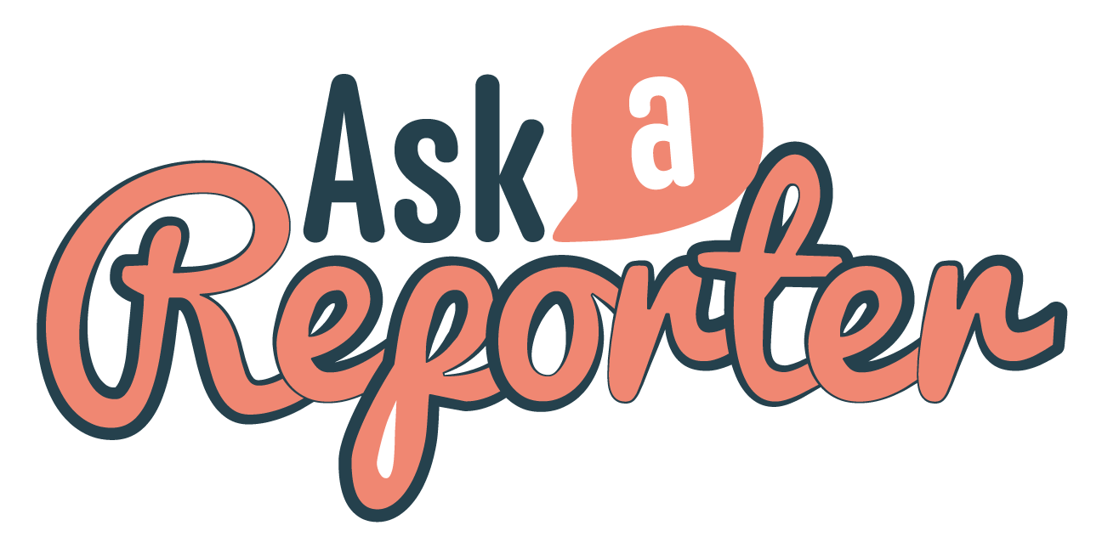
Check out the Periodic Table resource on the Teachers page. Get your class involved in BTN’s Ask A Reporter! This week’s topic is the Periodic Table.

Antarctic Science
- Where is Antarctica? Find using Google Maps.
- What words would you use to describe Antarctica?
- How is the North Pole different to the South Pole?
- Antarctica is a continent. True or false?
- Antarctica holds what percentage of the Earth’s ice?
  - 9%
  - 19%
  - 90%
- How many metres would sea levels rise if all of Antarctica was to melt?
- Why are scientists in Antarctica using mini-explosives in their research?
- Complete this sentence. The ice in Antarctica is made up of ____________ that fell thousands of years ago.
- What is an ice core?
- What do ice cores tell us about our planet?

Virtual Farmers
- In pairs, discuss the Virtual Farmers story and record the main points of the discussion.
- What is the aim of the virtual reality (VR) experience?
- Describe what the kids saw during the VR experience?
- What industry are they learning about?
- What aspects of farming do the kids learn about?
- Complete this sentence. The VR experience follows the journey from the ____________ to the plate.
- What career path are the creators trying to inspire kids about?
- What other projects are the creators working on? Give one example.
- Name three facts you learnt watching the BTN story.
- What was surprising about this story?

Teacher Resource
Episode 6
19th March 2019

Migration History

Students will learn more about the history of migration in Australia.


History – Year 5
The reasons people migrated to Australia and the experiences and contributions of a particular migrant group within a colony.

History – Year 6
Stories of groups of people who migrated to Australia since Federation (including from ONE country of the Asia region) and reasons they migrated.

The contribution of individuals and groups to the development of Australian society since Federation.

Civics and Citizenship – Year 6
The obligations citizens may consider they have beyond their own national borders as active and informed global citizens.

Civics and Citizenship – Year 5 & 6
Identify over-generalised statements.in relation to civics and citizenship topics and issues.

- Briefly summarise the BTN Migration History story.
- What percentage of Australians were born overseas?
  - 25%
  - 50%
  - 75%
- When did the First Fleet arrive in Australia?
- Where did the first wave of migrants to Australia mainly come from?
- Why did many people migrate to Australia in the 1850s?
- What was the name of the policy that stopped non-Europeans from living in Australia?
- Complete this sentence. Australia is now a nation of people from more than ______ different countries.
- Where are your ancestors from? Discuss in pairs.
- What contributions have migrants made to Australia over the years?
- What did you learn watching the BTN story?


What do you see, think and wonder?
After watching the BTN Migration History story, students will respond to the following questions:
- What did you SEE in this video?
- What do you THINK about what you saw in this video?
- What did you LEARN from this story?
- What was SURPRISING about this story?

KWLH
Discuss the BTN Migration History story as a class. What questions were raised in the discussion and what are the gaps in their knowledge? The following KWLH organiser provides students with a framework to explore their knowledge on this topic and consider what they would like to know and learn.
What do I know? | What do I want to know? | What have I learnt? | How will I find out?

Glossary of key terms
Students will develop a glossary of terms that relate to migration. Below are some key terms and concepts to get you started:

migration | migrant | refugee
emigrate | `push’ factors | `pull’ factors

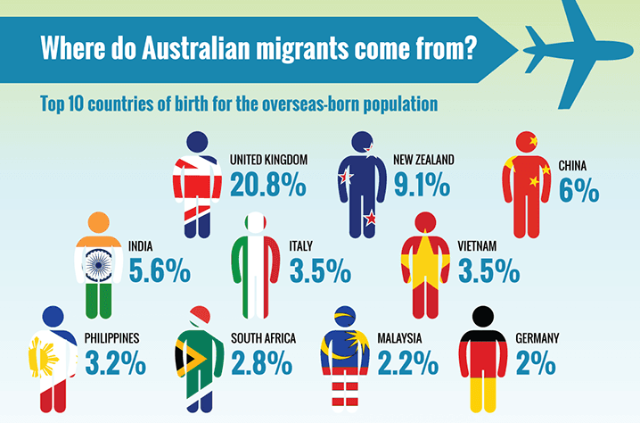
Migration in Australia
Hold a class discussion about the reasons why people emigrate to another country. Make a list of the ‘push’ and ‘pull’ factors that have contributed to people migrating to Australia. ‘Push’ factors are conditions that drive people to leave their country, for example, a natural disaster. `Pull’ factors are conditions that attract people to a new country, for example, job opportunities. Think about environmental, economic, social and political factors.

Where do Australian migrants come from?
- Go to the ABC’s infographic to learn more about where Australian migrants come from. What surprised you about these statistics?

Create your own classroom set of statistics about migration. Survey your class to find out how many students come from migrant families. Create a graph to illustrate the results.

Migration Research
Students will be exploring how Australia’s identity has been influenced by immigration. They will investigate their own family heritage by researching migration of family members. Alternatively, they could learn about the experiences of a friend who migrated to Australia.

Before students begin their research, ask them to discuss and record what they think it means to be Australian. Share and record the class responses. Keep these responses and compare them with students’ thinking at the end of the activity. Discuss what students understand about multiculturalism in Australia. What does cultural diversity mean for Australia? What impact has migration had on the Australia we live in today?

Ask them to think about their own family heritage. What do they know about their own migration stories? Where did family members migrate from and what was the reason for their migration? They may need to speak to their family to find out more information. Using photographs, memorabilia or other culturally significant objects, student will present their migration story in an interesting format. This could include:
- Object/photo display
- Oral presentation
- Short video
- Photo story

After the migration stories have been shared with the class, ask students to reflect on the question posed earlier `what does it mean to be Australian?’. Compare responses with earlier ones. Identify and explore the migration experience through the eyes of one migrant group that has come to Australia. For example:
- Chinese migrants who worked in the goldfields in the 1850s
- Afghan cameleers who arrived in the 1860s
- Italian or Greek migrants that came to Australia during the 1950s and 60s
- Vietnamese refugees who arrived in Australia after fleeing their homeland in 1975

Students will display their research in an interesting way and include images, text and audio. Students will answer some or all of the following questions:
- Who came?
- Where did they come from?
- When did they come?
- Why did they come?
- What was life like in Australia for them?
- What contributions to Australian life did these individuals or cultural groups make?
- Write a letter from the point of view of a newly arrived person describing their experiences to a family member who remained back home.

Imagine arriving to a new country as a migrant. Discuss some of the experiences you might have if you were to make your home in a new country. What types of things would help you settle in your new home?

Visual literacy
Below are images of different migrant groups that have come to Australia since colonisation. Students look at the image and then respond to the following questions:

- What do you see in this image? Describe the setting and who is in the image.
- What do you think is happening?
- If there are people in the image who do you think they are? How do you think they might be feeling?
- What question/s would you like to ask the people in the image?
- Create a caption for each image.

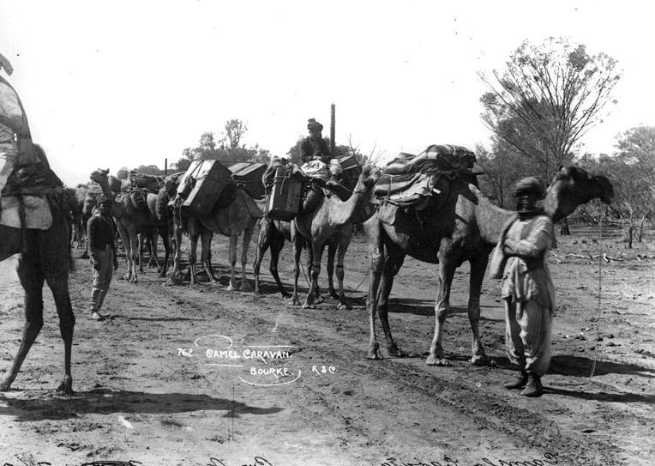  Afghan Cameleers | 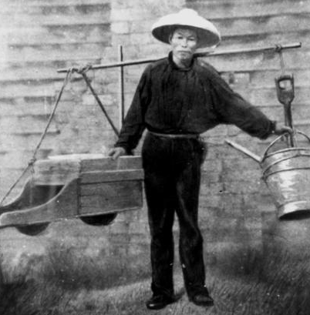  Chinese Migrant
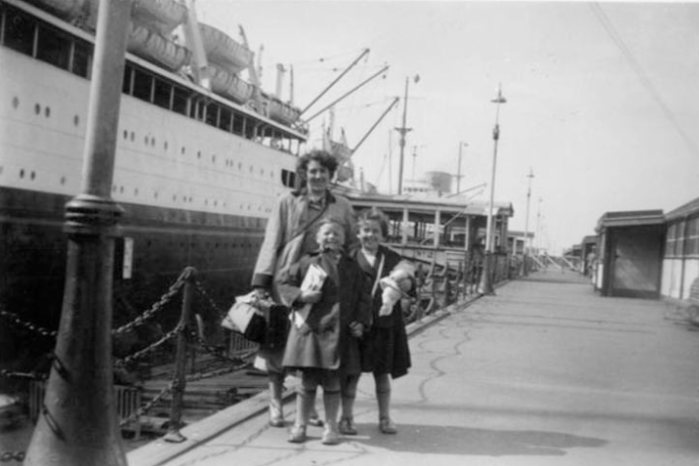  English Migrants | 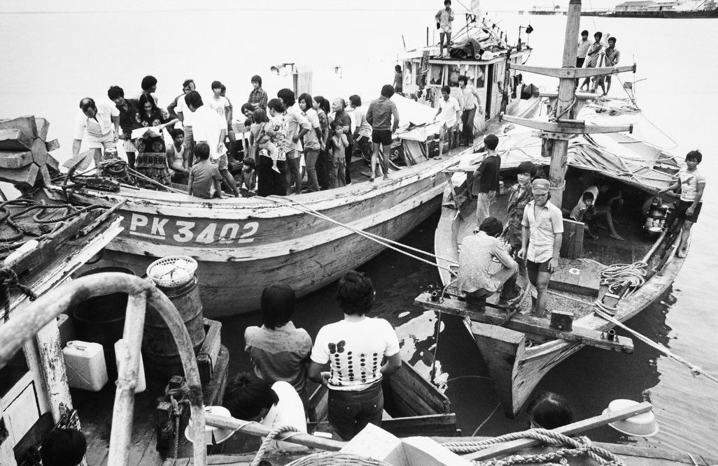  Vietnamese Refugees

Further Investigation - White Australia Policy
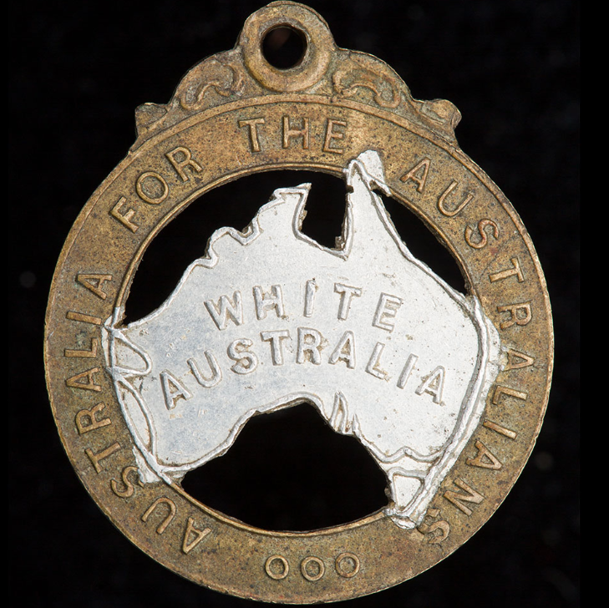
The BTN Migration History story briefly explains the White Australia Policy introduced in Australia. Students will investigate the policy in more detail. Watch the ABC Education videos How people felt about the White Australia policy and Reflections on ending the White Australia policy
The following questions can help guide their research:
- When was the White Australia Policy introduced?
- Why was it introduced?
- What impact did the policy have?
- When and why did the policy end?
- What were the range of opinions about the ending of the policy?
- What impact did the ending of the White Australia policy have?


Museums Victoria – Journeys to Australia
https://museumsvictoria.com.au/longform/journeys-to-australia/

SBS – A brief history of immigration to Australia
https://www.sbs.com.au/news/a-brief-history-of-immigration-to-australia

BTN – Chinese Migration
http://www.abc.net.au/btn/classroom/chinese-migration/10527080

BTN – Refugees and Migrants
http://www.abc.net.au/btn/classroom/refugees-and-migrants/10524176

ABC Splash – Where do Australian migrants come from?
http://education.abc.net.au/statistics-game/#/view/country-of-birth/big-picture

Teacher Resource
Episode 6
19th March 2019

Periodic Table
Students will explore elements in the periodic table and present the information they find in an interesting way. Students will explore the way solids, liquids and gases change under different situations.

Science – Years 5 & 6
Scientific knowledge is used to solve problems and inform personal and community decisions.

Science – Year 7
Scientific knowledge has changed peoples’ understanding of the world and is refined as new evidence becomes available.

Science – Years 5, 6 & 7
Solids, liquids and gases have different observable properties and behave in different ways.

Changes to materials can be reversible or irreversible.

Mixtures, including solutions, contain a combination of pure substances that can be separated using a range of techniques.

Science – Year 8
Differences between elements, compounds and mixtures can be described at a particle level
- What did the BTN Periodic Table story explain?
- How old is the periodic table?
- Describe what the periodic table looks like.
- Name one of the elements in the periodic table.
- Brass is made up of which two elements?
- How many elements are there in the periodic table?
- What is the symbol for copper?
  - Co
  - Cu
  - Cp
- Who invented the periodic table?
- Why were their gaps left in the periodic table when it was first invented?
- What questions do you have about the periodic table?

Class discussion
Before watching the BTN Periodic Table story, show your class a picture of the periodic table. Ask students if they know what it is and what they know about it.

KWLH
Discuss the BTN Periodic Table story as a class. Record what students know about the periodic table on a mind map. What questions do they have about what they have learnt in the BTN story? The following KWLH organiser provides students with a framework to explore their knowledge on this topic and consider what they would like to know and learn.
What do I know? | What do I want to know? | What have I learnt? | How will I find out?

Glossary of key terms
Students will create a classroom glossary about the periodic table. Students will start by brainstorming words as a class using a mind map to record their responses. Add to your class list of words by downloading the BTN Periodic Table story transcript and highlighting all the words that relate to the periodic table.

Molecule | Atomic number | Chemistry | Periodic Table
Element | Symbol | Properties | Compound

Students will find definitions for each term and consider using pictures and diagrams to illustrate meanings. Students will demonstrate their understanding by writing their own sentences using terms and concepts from the glossary.

Element profile
Students will choose an element from the periodic table to research in detail and create a profile. Once students have chosen an element from the periodic table to research they will find information under the following headings:

- Name
- Atomic symbol
- Atomic number
- How is it used and where does it occur?
- Description – what are some of the characteristics of this element?
- What makes this element useful?

Students will then think of creative ways to present the information they have found and present to the class. For example, students may:

- Create a poster including a unique artwork for the element (students will combine their finished posters to make up the periodic table. Display the posters in the classroom to celebrate the 150th anniversary of the periodic table).
- Write a news report as if you were covering the discovery of a new element. Give the element a name, symbol, number and description.
- Design and illustrate a comic strip explaining the element and what it is used for.
- Create a short animation about the element. Look at this animation on ABC Education about Zirconium. Refer to this BTN resource for steps on creating a stop motion animation.
- Create your own mini science lesson about what you have learnt to teach to students in another class.

Below is a range of interactive periodic tables for your students to refer to during their research.
- https://elements.wlonk.com/ElementsTable.htm
- http://www.periodictable.com/index.html
- http://www.rsc.org/periodic-table

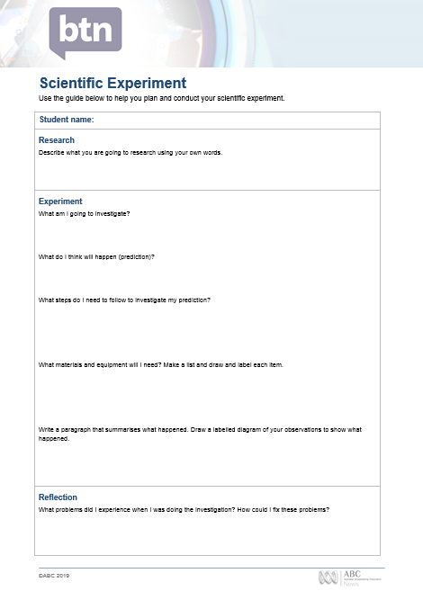
Scientific Experiment
Provide students with the opportunity to think and behave like scientists. In pairs or small groups, students will conduct a classroom experiment. Before starting this activity, explain to students what a science investigation is and why we do them. Think of words that relate to “science investigation” and then find and explain their meanings. Here are some concepts to get you started: variable, observation, diagram, fair test and prediction.

Students will choose one of the following ABC Education experiments to conduct in small groups:

- Egg experiment
- Elephant toothpaste experiment
- Hot air experiment
- Rainbow milk experiment

Students will use the investigation framework (at the end of this activity) before, during and after their investigation.
- What am I going to investigate?
- What do I think will happen (prediction)?
- Why do I think this will happen?
- What steps do I need to follow to investigate my prediction?
- What materials and equipment will I need? Make a list and draw and label each item.
- Write a sentence that summarises what happened.

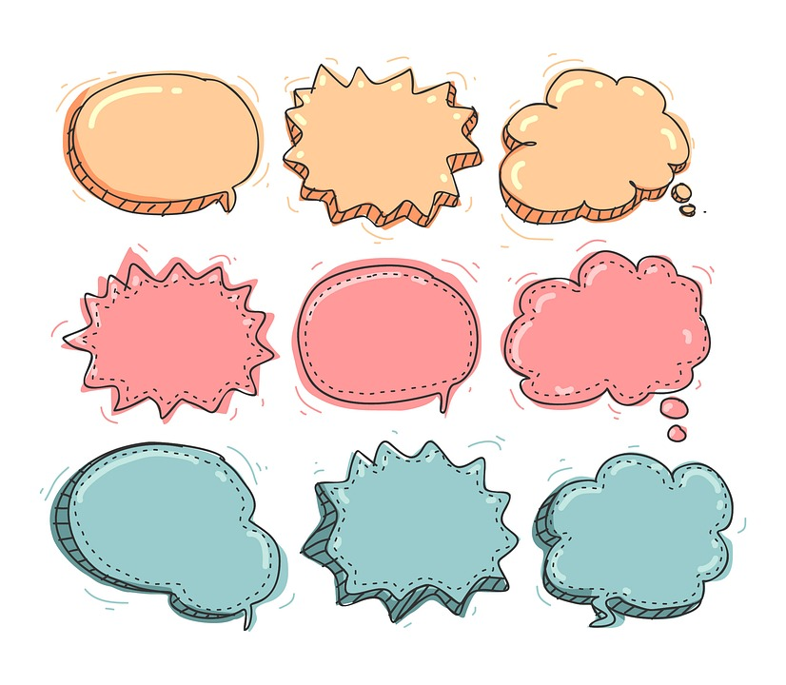

Quiz
How much do your students know about the periodic table? Do Newsround’s interactive quiz as a class. https://www.bbc.co.uk/newsround/46963919

The Periodic Table Song
Watch this YouTube video as a class. It’s a fun way to learn the elements in the periodic table.
https://www.youtube.com/watch?v=VgVQKCcfwnU

BTN – Science Kids
http://www.abc.net.au/btn/classroom/science-kids/10531226

ABC The Science Show – Happy 150th birthday to the Periodic Table
https://www.abc.net.au/radionational/programs/scienceshow/happy-150th-birthday-to-the-periodic-table/10883874

BBC Newsround – What is the periodic table?
https://www.bbc.co.uk/newsround/46963919

BBC Newsround – Cool facts about the periodic table
https://www.bbc.co.uk/newsround/47035202

TED-Ed - The genius of Mendeleev's periodic table
https://www.youtube.com/watch?v=fPnwBITSmgU

Scientific Experiment
Use the guide below to help you plan and conduct your scientific experiment.

Student name:
Research
Describe what you are going to research using your own words.

Experiment
What am I going to investigate?

What do I think will happen (prediction)?

What steps do I need to follow to investigate my prediction?

What materials and equipment will I need? Make a list and draw and label each item.

Write a paragraph that summarises what happened. Draw a labelled diagram of your observations to show what happened.

Reflection
What problems did I experience when I was doing the investigation? How could I fix these problems?

BTN Transcript: Episode 6 – 19/3/19

Hey Everyone. I'm Amelia Moseley and it's time for another episode of BTN. Check out what we've got for you today. The world comes together to support New Zealand after last week's terrorist attack. We celebrate Harmony Day with a look at the history of Aussie migration and a big happy birthday to a very clever table.

Climate Protest
Reporter: Jack Evans

INTRO: But first today. To a story you might have heard about, in fact, you might even have been a part of it. Last week thousands of students around Australia and overseas hit the streets for a massive protest. Jack went to find out more.
From the US to France, Chile to India and Spain to Australia, students around the world walked out of class and onto the streets to call for change.
I've come down to one of the school’s strike for climate action that are happening right around the country. Actually, they're happening right around the world. And as you can see there are a lot of young people here with a very clear message.
KID 1: We are the future and if nothing is done now than when we're older it's going to be absolute mayhem.

KID 2: This is our future that the politicians are destroying and it’s not fair.
Most of the marches have been completely organised by young people like Doha.
DOHA: At the moment we're not seeing our right to a livable climate upheld by our politicians they're not considering us when they're making our laws and I think that it's important that students take a stand against this type of inconsiderate policy making and they strike because that's historically what people do. They strike when they see unfairness they strike, and they demand better conditions and that's what students are doing.
This world-wide movement was actually started by a teenager from Sweden.
GRETA: My name is Greta Thunberg and every Friday I am school striking for the climate outside the Swedish parliament alongside hundreds of thousands of other children from all around the world.
Greta started protesting because she said she was fed up with her government not doing enough to fight climate change and what started with one student quickly grew. Now the School Strike for Climate Action has become a global movement and last week Greta was nominated for a Nobel Peace Prize.
But here in Australia the strikes caused some controversy. A few politicians and education leaders have spoken out against the event saying that kids shouldn't have been skipping school to make a political statement.
DAN TEHAN, EDUCATION MINISTER: If they want to take other action on issues they think are important they should do after school or on weekends.
Some schools said kids would miss out on grades or be punished if they walked out of class. But others say kids deserve to have a say especially on an issue that will affect their futures.

KID 3: I think it's so important that we stand up for our future and we call on our politicians to protect us but also protect people and children in countries all across the world who don't have the privilege of striking because they're in developing nations.
KID 4: We don't have a chance to vote so if we stand together then we are going to make a bigger impact then we would with just one voice.
New Zealand Attack

INTRO: Of course, there's been another big story in the news over the past few days. I'm talking about the terrible attack that happened in Christchurch on Friday. 50 people were killed and 50 more were injured in the worst mass shooting in New Zealand's history. It's been a terrible time for New Zealanders and people around the world. So today we're going to have a look at how people have been coming together to support each other. Here's Martin.

After what many described as the country's darkest day, New Zealanders of all ages, from all backgrounds came to the mosques where the shooting took place to show their support for the victims and to show the world that this tragedy doesn't represent them.
JACINDA ARDERN, NEW ZEALAND PM: We represent diversity, kindness, compassion, a home for those who share our values, a refuge for those who need it, and those values, I can assure you, will not and cannot and will not be shaken by this attack.
New Zealand's Prime Minister has promised to look after the victim's families and change the country's gun laws to try to stop this sort of thing from happening again. Here in Australia landmarks were lit in support for New Zealand while people found different ways to honour the victims. The Prime Minister met with people in the Muslim community and said the world needs to stand together against hate and violence. Overseas, people had similar messages. It's been a really horrible time for a lot of people and it's normal to feel sad about what’s happened.
So, what can you do if you're upset about the news? Well, first of all, try to remember that these things don't happen very often. In fact, it’s in the news because it’s unusual and whenever something awful happens you can see examples of people helping each other and showing kindness and courage. But it is ok to switch off if you are feeling overwhelmed by the news you can take a break from it. That doesn't mean you don't care. And finally make sure you talk to someone you trust and don't be afraid to ask questions. You might find that talking about it makes you feel better.

Migration History
Reporter: Amelia Moseley

INTRO: Now to a much happier story. This week Australians will be celebrating Harmony Day. It's about appreciating all of the different cultures that make up our nation. So, this week we decided to look at how Australia became the multicultural country that it is now. Take a look.
You only have to look around to see that Australia is a pretty multicultural place.
AMELIA, REPORTER: Did you know that nearly half of all Australians were born overseas or have at least one parent who was? I actually fit into both those categories. My dad's from a place called Barbados in the Caribbean and my mum's from a little island between France and England. And I was born in New Zealand. I have a feeling there are lots of other Aussies with a story like mine. Am I right?
KIDS: Yeah.
BIDUSHI: I came to Australia from Nepal with my parents.
SHANZAY: And I was born in Australia, but my parents came from Pakistan.
SHAUNA: My Poppa migrated from Germany by boat when he was six years old.
ELLIOT: My ancestors came from England to Australia, I assume on a boat because it was a very long time ago.
Ancestors, ha? That's where Australia's story of migration really begins. You'd know that Indigenous Australians have been here for around 60 thousand years; long before anyone else. Then in the late 1700s, the First Fleet arrived beginning the first wave of migrants. They were convicts as well as free settlers mainly from Britain and Ireland. It was a shiny new discovery that brought the next wave of migrants in the 1850s gold. Around 600 thousand people migrated during the Gold Rush and while many came from Britain and Ireland, they also came from European countries and from China. In the years that followed more people came here from non-European countries. They helped to build cities and systems of transport and left their mark on a changing Australia. But things didn't always go smoothly and many faced prejudice.

Soon after Federation, Australia's government brought in the White Australia Policy and tried stop non-Europeans from migrating here. After the First and Second World Wars, hundreds of thousands of people came from European countries and built homes and businesses and brought their different foods, beliefs and traditions. The government also encouraged more British, Irish and Dutch people to migrate to try to build Australia's economy. Eventually, the White Australia Policy was scrapped. And, over the years, people continued to come here from all over the world as refugees and as migrants.
AMELIA, REPORTER: Australia is now a nation of people from more than 190 different countries and 300 different ancestries. And most people agree it's part of what makes this country a pretty awesome place to live.
ELLIOT: I like that Australia is a multicultural country because I get to learn about different festivals and celebrations from people that actually celebrate them like Ramadan or Eid.
BIDUSHI: I like to go to the school and learn about different cultures of different countries.
SHAUNA: I like how there's lots of communities like when my Poppa, he used to go to the German Club and play table tennis with all of his friends.
SHANZAY: I like that Australia is a multicultural place because it's got different foods from different countries and I like pizza.
Did you know?

Did you know that a Greek migrant named Athanassio Comino is credited with opening Australia's first fish and chip shop in Sydney's Oxford Street in 1873? Although some say he copied the idea from a Welshman down the road.
Periodic Table
Reporter: Martin Dougan

INTRO: Another fun fact, it’s thought the world’s first fish and chip shop was opened by a Jewish migrant in the UK. Now, speaking of very important inventions, this month the world celebrated the 150th birthday of the periodic table. It's a chart you've probably seen before and it's thought of as one of the greatest scientific discoveries ever made. Here's Martin.

Coffee tables. Side tables. Tennis tables. Tables everywhere. I love a good table. And guess what? The table is celebrating its 150th birthday. Happy birthday to you. Martin you've got it all wrong. We are saying happy birthday to the periodic table. Oh, I knew that, I mean who would say happy birthday to a table. I mean it was a joke, obvs. Oh, the good old periodic table. You've probably seen one before, maybe on the wall of your science class or maybe on cool T-shirts like this. There's even a song about it. The periodic table is a chart showing all of the known elements. The building blocks of the world.
REPORTER: Basically, we know it’s an element, if it’s not made up of other stuff and you can’t be separated into anything else. What I’ve got here is copper and it’s made out of nothing but lots of little copper atoms which means it’s an element. And on this hand, I have brass, which is made of both copper and zinc, so it’s not an element.

All up there are 118 elements that we know about and you can find them all here on the periodic table laid out nicely with some handy numbers and their symbols. Oh, there's our pal copper he's CU on the table. Where an element sits on the table tells you lots about it like the makeup of its atoms are and how it reacts to other elements. For example, some of these ones tend to explode when they come into contact with air.

It's a very, very clever table and this is the very, very clever guy who came up with it 150 years ago. Dimitri Mendeleev. Bonafide science hall of famer. Dimitri here was born in 1834 in Siberia, in Russia. His father was a chemist and it's thought he had 10 brothers and sisters. Bit of a squeeze, eh? Sadly, his dad died when Dimitri was young and despite having very little money his mother was determined to get her son into university. From then on Dimitri here made it his life’s mission to understand more about the elements.

Back then people only knew about 60 of them and for years they'd been trying to put them neatly together. They knew that certain elements had similar properties. You could kinda almost sorta see some patterns, but they didn't quite work. While other chemists might have said "oh well, tough luck" not Dimitri. He realised the patterns did exist, it was just that not all the elements had been discovered yet.
He made up a table of elements with some empty spaces in it. He even described what the missing elements would be like before they were even discovered. And he was right. More elements were discovered in Mendeleev's lifetime and they fitted perfectly in his periodic table. Good job. Mendeleev's periodic table was a huge breakthrough in chemistry. It's been shuffled around in the 150 years since it was born and a whole heap of new elements have been added. But it's still seen as one of the most important scientific tools around. Boom. I suppose there's only one thing left to do. Happy birthday to the periodic table.

Ask a Reporter

If you want to know more about the mighty periodic table, I'll be here to answer your questions live on ask a reporter this Friday. It’s gonna be brilliant. Don’t miss it.

Quiz

Water is made up of which two elements? Is it

Nitrogen and oxygen
Hydrogen and oxygen
Or helium and oxygen?

It's hydrogen and oxygen. Two parts hydrogen to one-part oxygen to be precise which is why the chemical symbol for water is H2O.

Antarctic Science
Reporter: Emma Davis

INTRO: You know what else is made up of H2O? Ice and that's what your about to see a whole lot of.
It's time for part two of our Antarctic special. Our reporter, Emma, has just been on a big trip down there and this week she's going to tell you about some of the fascinating research going on there. Check it out.

For 200 years, people all over the world have been obsessed with solving Antarctica's secrets. But before I tell you what some of them have been working on and some of the stuff they've found, I need to explain what makes Antarctica such an amazing and unique environment in the first place. Especially when it comes to science.
Donna Roberts, AAD Science Planning Manager: Antarctica is the most pristine environment on the planet so if you want to look at how climate is changing you've got to look in the most pristine place so we can get a baseline to see what’s actually really happening without the noise of pollution.
Unlike the North Pole, where all the ice is actually floating in the water, the South Pole is a continent which means under all this ice is rock, an actual land mass. Antarctica actually has holds 90 per cent of the planet's ice so if all this ever melted, well that would be catastrophic.
Ben Galton-Fenzi, Glaciologist: If all of Antarctica was to melt, sea levels would rise about 60 metres. But that amount of fresh water that went into the oceans as well is gonna change the habitat for ecosystems and it’s also going to change the environmental characteristics across the planet.
While it's unlikely all this ice will disappear anytime soon, with global temperatures rising it's important scientists understand just how quickly the ice is melting. That's what Dr Ben Galton-Fenzi and Madi Gamble Rosevear are doing. They're focusing on the Totten Glacier which is an ice shelf near Casey Station.
Madi Gamble Rosevear, PhD Student: It drains a lot of ice, a lot of ice moves through that glacier towards the ocean and it’s changing.
To see what’s underneath the ice, they're using mini explosives to set off sound waves which bounce off different surfaces, kind of like the sonar a bat uses.
Madi Gamble Rosevear, PhD Student: We want to know what's underneath there, whether it's soft and malleable or hard and grippy because that alters how the ice moves across it.
Now while Dr Ben and Madi are thinking about the future, scientists like Dr Tas van Ommen are more concerned with the past. He's also a glaciologist but his specialty is ice cores. An ice core is a cylinder of ice drilled from glaciers or ice sheets. It's kind of like a natural time capsule because it holds heaps of information about what Earth was like years and years ago.
Tas van Ommen, Glaciologist: The ice in Antarctica is really made up of snowflakes that fell thousands of years ago. And as the snowflakes build up, one on top of the other, they actually trap things that get rained out or snowed out from the atmosphere, could be dust, it can be salt that gets blown in from the ocean far away, it can be compounds, chemicals from volcanoes that erupted.
Ice cores have already told us a lot about what the Earth was like thousands of years ago but we want to go back further. Dr Tas is trying to find a million-year-old section of ice.
Tas van Ommen, Glaciologist: We know that before 800,000 years the climate was actually behaving a bit differently to what it did for the last 800,000 years and we’d like to actually probe why it changed, what was the cause. We think maybe it’s to do with CO2 in the atmosphere. That’s pretty important because we know we’re changing the CO2 in the atmosphere now.
Drilling that deep is going to take years of work, but Dr Tas, Dr Ben and Madi say it's more than worth it to get a little more insight into how our planet used to be and what it might look like in the future.
Ben Galton-Fenzi, Glaciologist: I have children, what we're trying to do is understand the future that they're going to inherit. By the year 2100 the global climate system's going to be very different from what we understand it to be now. The sooner we understand what that will look like, the better we'll be able to adapt to that.
Sport

Valtteri Bottas has dominated the Australian Grand Prix after overtaking world champion team-mate Lewis Hamilton. But it was a day to forget for Australian driver Daniel Ricciardo, who was outqualified by his teammate Nico Hulkenberg. Then, before the first corner this happened, and he eventually had to drop out of the race.

There were big celebrations for basketball fans in Perth over the weekend. On Sunday the Wildcats claimed the NBL championship with a 97-84 win over Melbourne United and a 3-1 series victory.

And get ready to see one of the best catches ever. This freak play happened during a T20 match in India. Batsman Manjeet Singh smashed what looked a certain six on the last ball of the game but then this happened. Wow. Rahul Tripathi produced a truly unbelievable piece of magic in the outfield.
Virtual Farmers
Reporter: Jack Evans

INTRO: Finally, today. Have you ever wondered what it would be like to be a farmer? Well you're about to meet some kids who are getting to experience life on the land. Well, kinda. Here's Jack with more.
This might look like a normal bus, but once these guys step on board and put these headsets on, they're transported to a virtual world. Which happens to look a lot like the real world just with a lot more cows than you'd see on a usual school day.
KID1: It went up in a helicopter flying over all these lands and when you came down to the truck you could look out and there were cows everywhere, just cows, only cows.
These guys are experiencing what it's like to be a cattle farmer and learn just how beef is produced. They follow the journey from paddock to plate from every angle. The creators say it's important for kids to understand all aspects of the beef industry including the less glamourous parts. So, included in the tour was a trip to a meat processing factory.
KID 2: I had to take my thing off because I felt sick.
KID 1: I didn't know they hung the cows down and get all the blood out of them, I thought they just killed them and drained them then put them on the plate and cook them and eat them.
Tim Gentle is the creator of this VR farming experience. He and his dad have been travelling to schools around the country hoping to get kids excited about a career in agriculture.
Tim Gentle: When it comes to kids what I'm trying to do is inspire them to take up ag as a career path. So, we have to make farming look exciting and so VR when they put on the headset they go into a whole new world. But they actually go into a farmer’s world and that's what I like.
Tim reckons virtual reality has a bigger part in the farming world than you might think. He's been busy working on other projects, including using 360-degree cameras to capture farming equipment so that people can learn to use it. As well as an app that lets cattle buyers to see just what they're getting, and he's even built a virtual fair ground where famers can meet up, have a chat and pat a pig. As for these guys it's been a pretty exciting trip and even if they don't decide to become famers later on they now understand a bit more about just where their food comes from.
Closer

Well that's virtually all we have for you today. But don't forget to head to our website or our YouTube channel for more awesome content including BTN Newsbreak every weeknight. I'll catch you next week. Bye.

