
KEY LEARNING
Students will view a range of BTN stories and use comprehension skills to respond to a series of focus questions.

CURRICULUM
English – Year 4
Use comprehension strategies to build literal and inferred meaning to expand content knowledge, integrating and linking ideas and analysing and evaluating texts.

English – Year 5
Use comprehension strategies to analyse information, integrating and linking ideas from a variety of print and digital sources.

English – Year 6
Use comprehension strategies to interpret and analyse information and ideas, comparing content from a variety of textual sources including media and digital texts.

English – Year 7
Use comprehension strategies to interpret, analyse and synthesise ideas and information, critiquing ideas and issues from a variety of textual sources.
  - Teacher Resource

Space Special
As a class, discuss the stories featured in the BTN Special and record the main points of the discussion. Students will then respond to the following focus questions.

Water on Mars
- Discuss the Water on Mars story in pairs or small groups. What were the main points of the discussion?
- Where on Mars do scientists think the liquid water is?
- How did scientists discover the water on Mars?
- Why is the discovery significant?
- What do Mars and Earth have in common? Use a Venn diagram to show similarities and differences.

Astronauts Return
- Discuss the BTN story with another student. Record the main points of your discussion.
- Why were two NASA astronauts recently stranded in space?
- What is microgravity?
- How does space travel affect the human body? Give 2 examples.
- Why do we get taller when we’ve been in space?

Black Hole Discovery
- Why can’t we see black holes?
- How do black holes usually form?
- What is the centre of a black hole called?
  - Accretion disk
  - Event Horizon
  - The Singularity
- What is the name of the black hole at the centre of the Milky Way galaxy?
- What did you learn about the newly discovered black hole called J0529?

KEY LEARNING
Students will explore the characteristics of the planet Mars.

CURRICULUM
Science – Year 5
Scientific understandings, discoveries and inventions are used to solve problems that directly affect peoples’ lives.

The Earth is part of a system of planets orbiting around a star (the sun).

Science – Years 5 & 6
Scientific knowledge is used to solve problems and inform personal and community decisions.
Science – Year 6
The growth and survival of living things are affected by the physical conditions of their environment.
Science – Year 7
Predictable phenomena on Earth, including seasons and eclipses, are caused by the relative positions of the sun, Earth and the moon.
Scientific knowledge has changed peoples’ understanding of the world and is refined as new evidence becomes available.
  - Teacher Resource

Water on Mars

Activity: Class Discussion
After watching the BTN Water on Mars story, hold a class discussion responding to the following questions:

- What do you know about Mars?
- What does Mars look like?
- How similar are Earth and Mars?
- Describe the location of Mars in relation to the Earth and the sun.
- Why do you think scientists want to explore Mars?
- What might be some challenges of exploring Mars?
- Think of 3 unanswered questions you have about Mars.

Activity: Q&A
Are you curious about Mars? Students will make a list of questions they have about the BTN story and space exploration. Students will use the internet to find answers to their questions and share their findings with the class.

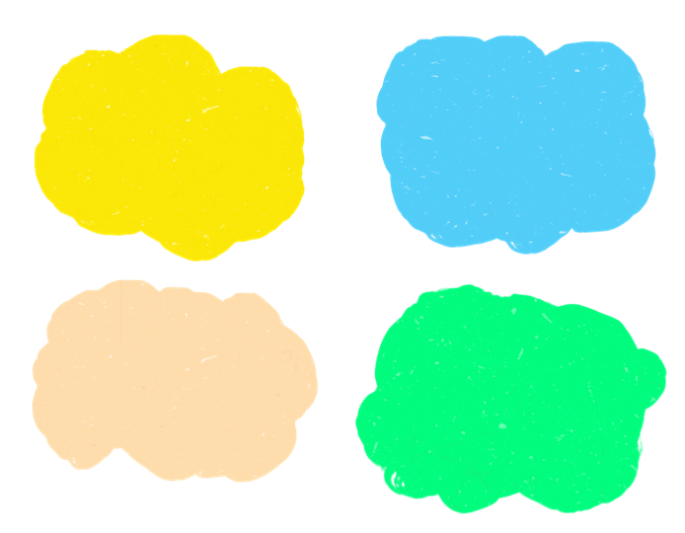
Why do we study planets?
What do you know about Mars?

Activity: Glossary
Students will brainstorm a list of key words that relate to the BTN Water on Mars story. Here are some words to get them started.

MARS | PLANET | SOLAR SYSTEM
SOLAR SYSTEM | RESOURCES | EXPLORATION

Ask students to write what they think is the meaning of each word (including unfamiliar words). They will swap definitions with a partner and ask them to add to or change the definition. Check these against the dictionary definition.

Further activities for students:
- Where did Mars get its name? Explore its meaning. Why are most of the planets in the solar system named after Roman gods? Learn more by watching this video How Do Planets Get Their Names? We Asked a NASA Expert (Source: NASA).
- What is the difference between an icy giant, a gas giant and a terrestrial planet? Include an illustration or diagram with your explanation.
- Use as many of the following words to write a summary about Mars: Martian, Red Planet, terrestrial, space exploration, solar system, Phobos, Deimos, Perseverance rover and iron oxide.
- Who explores planets? Learn more about the jobs involved with space exploration. Choose one job and investigate what the job involves and what you need to study to become one. Explore job roles at the Australian Space Agency.

Activity: Jigsaw Learning
In this jigsaw learning activity students will work cooperatively to learn more about the 8 planets in our solar system. Each group will become experts on one of the planets and then share what they have learnt with other students.

Visit NASA’s website to learn all about the 8 planets in the solar system: Mercury, Venus, Earth, Mars, Jupiter, Saturn, Uranus, and Neptune.

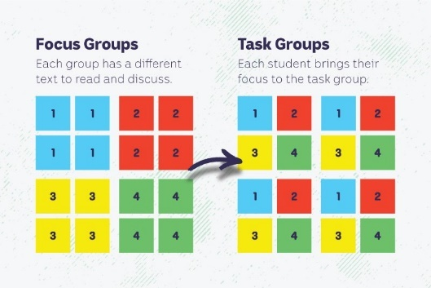
Form groups
Divide the class into 8 x Focus Groups. Each Focus Group will be assigned a different planet and become experts. Each group will need to decide how they will collect and communicate the information they find during their research.

Research
Each Focus Group will work as a team to learn as much as they can about their topic. They will use the following as a guide for their research.
- What is the name of the planet? Investigate the origins of the planet’s name.
- When was the planet discovered?
- How big is the planet?
- Where is the planet in the solar system in relation to Earth and the Sun? Draw a diagram.
- How far away is the planet from the Sun?
- What does it look like? Describe the surface of the planet and find pictures that illustrate these features. Use words from your class glossary when describing the planet.
- What important scientific discoveries have been made about the planet? List any missions.
- Optional: Write 1-3 scientific questions to research and answer.
- Include diagrams.
- Include a glossary of key words.
- Interesting facts!

Share
Mix the Focus Groups to form Task Groups (Tasks Groups include one student from each of the Focus Groups) to share the information they have collected. Students will share the information they have collected and learn from one another.

Reflect
Students will reflect on the activity by responding to one or more of the following questions:
- What did you enjoy about this investigation?
- What did you find surprising?

Activity: Scientific Investigation
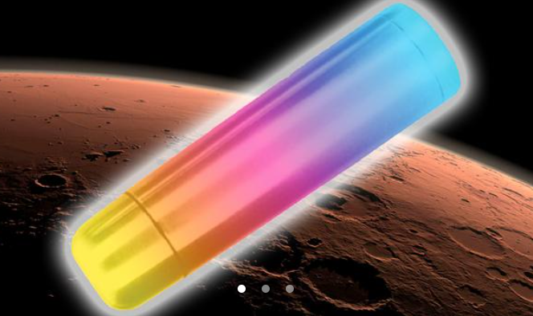
In this NASA classroom activity: Mars Thermos student teams use the engineering design process and everyday materials to design an insulator that will keep a small amount of water from rapidly changing temperature. The goal of this activity is to keep cold water cold and warm water warm.

Mars Thermos Classroom Activity (Source: NASA)

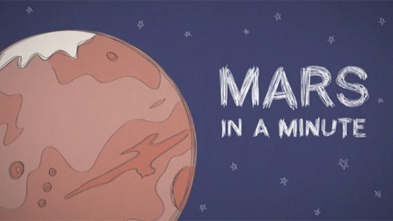
Begin this activity by watching this NASA video as a class Mars in a Minute: Is Mars Red Hot?

Link to NASA Classroom Activity
Mars Thermos

Activity: Graphic Organisers
Graphic organisers are a helpful learning tool for students to organise, clarify, or simplify complex information. Students will choose one type of graphic organiser to help them explore, understand and analyse our solar system and the importance of space exploration.

Venn Diagram  Purpose: To compare the similarities and differences between two or more things.  Procedure: Write the items being compared in the circles. Where the circles overlap, record similarities. Record the characteristics which are different in the areas that do not overlap.  Activity: Compare the similarities and differences between Earth and Mars.   | Mind Map  Purpose: To assist in activities that involve planning, brainstorming, making notes, organising or problem solving.  Procedure: An issue or topic is written in the centre. Related ideas are linked to the central issue and other ideas are developed from these.  Activity: Use a mind map to record what you know about Mars.   | KWL Chart  Purpose: To help organise your thoughts before, during, and after a learning exercise.  Procedure: Identify what you know about a topic. Then, think about what you want to research or learn. After the lesson, reflect on what you have learned.  Activity: Use a KWL chart to organise information about Mars.  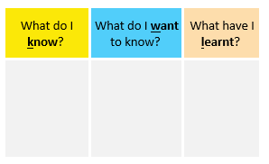

Activity: Mars Facts
In small groups, students will find out as much as they can about Mars and compile the information they find into a list of facts. Provide students with a list of suggested questions and/or topics to guide their research.

Facilitate a class discussion by asking each group to share one interesting fact they learned during their exploration. Record students’ responses on the white board to create a collective list of facts about Mars.


Students will use the facts they have discovered about Mars to create a quiz and then test their classmates. Students will include a range of quiz styles, for example multiple choice, true or false or fill in the blank. Students can make their quizzes in Kahoot or Quizizz. Make it fun, engaging, and educational!

Activity: Mars Quiz

- What is Mars?  A. Rocky planet  B. Gas giant  C. Ice giant  - Why is Mars called the ‘Red Planet’?  A. It is hotter than Earth  B. It is the closet planet to the Sun  C. There is rusty iron on the surface  - Scientists have found evidence of water on Mars.  A. True  B. False  - How many moons does Mars have?  A. 1  B. 2  C. 3  - What was Mars named after?  A. Roman god of the underworld  B. Roman god of love and beauty  C. Roman god of war | - Humans have not set foot on Mars before.  A. True  B. False  - What was the first spacecraft to land on Mars?  A. Curiosity  B. Perseverance  C. Viking 1  - What is the average temperature on Mars?  A. -60 degrees Celsius  B. 0 degrees Celsius  C. 60 degrees Celsius  - Where is Mars in the solar system?  A. 1st planet from the Sun  B. 4th planet from the Sun  C. 8th planet from the Sun  - Mars is the only planet that has been explored by rovers.  A. True  B. False

Quiz Answers: 1A, 2C, 3A, 4B, 5C, 6A, 7C, 8A, 9B, 10A

Useful Websites
- Water on Mars – Newsbreak
- Scientists find evidence of `oceans’ of underground water on Mars – Newsround
- Life on Mars – BTN
- Mars Class – BTN
- Space Food – BTN High
- Mars – NASA
- About the Planets – NASA
- Mars in a Minute: Is Mars Red Hot? – NASA Jet Propulsion (YouTube)

KEY LEARNING
Students will learn more about the impact space has on the human body.

CURRICULUM
Science – Year 5
The Earth is part of a system of planets orbiting around a start (the sun).

Scientific understandings, discoveries and inventions are used to solve problems that directly affect peoples’ lives.

Science – Years 5 & 6
Scientific knowledge is used to solve problems and inform personal and community decisions.

Science – Year 7
Scientific knowledge has changed peoples’ understanding of the world and is refined as new evidence becomes available.
  - Teacher Resource

Astronauts Return

Activity: Note taking

Students will practise their note-taking skills while watching the BTN Astronauts Return story. After watching the story, ask students to reflect on and organise the information into three categories. What information in the story was positive, negative, or interesting?

Activity: Comprehension
After watching the BTN Astronauts Return story students can answer one or more of the following comprehension questions, for example:
- What are some keywords from the BTN story?
- What did you learn from the story? Write a summary.
- What is the purpose of this news story? To entertain, persuade, inform, explain or describe?

What questions do you have?
What surprised you about this story?

Activity: Key words
Students will brainstorm a list of key words that relate to the BTN Astronauts Return story. Here are some words to get them started.
International Space Station
Immune system
Microgravity
Weightlessness
Astronaut

Weight-bearing
Gravity
Space mission

Ask students to write what they think is the meaning of each word (including unfamiliar words). They will swap definitions with a partner and ask them to add to or change the definition. Check these against the dictionary definition.

Activity: Effects of space on the human body
Discuss the information raised in the BTN Astronauts Return story. What questions were raised in the discussion and what are the gaps in students’ knowledge? Students will develop their own question/s to research or choose one or more of the questions below.
- Why do astronauts have to exercise in space? How do they exercise? Watch the Exercising in Space video to learn more.
- How does space radiation affect the body and what do astronauts do to stay safe?

- What health problems have astronauts had in the past? What changes have been made to overcome the health problems?
- What happens to the body’s sleep patterns in space?
What would it be like living in microgravity -eating, sleeping, having a shower, going to the toilet? What would be some of the positives and challenges?

- What are the ethical considerations of sending humans on long-duration space missions, considering the impact on their bodies?
- What are the psychological effects of long space missions?
- Investigate the effect space has on an aspect of the human body, include information about what happens, why it happens and what can be done to reduce the effects. Choose one from the following:
  - Bones
  - Muscle
  - Eyes
  - The spine
  - Inner ear and balance system
  - Sense of taste

Further investigation
Astronauts going to the ISS can sign up for a range of experiments that will help scientists understand how the human body reacts to long-duration space missions. Learn more about the NASA experiments here
Students will imagine they are an astronaut on the ISS and design an experiment to study one of the effects of space on the body. Think about – what they need to measure (bone density, muscle strength), how they will conduct the experiment, how often they would collect measurements, and what equipment they will need. Create a labelled diagram or write a short explanation of their experiment to share with the class.

Activity: Choose a project
Individually or in small groups, students will choose one of the following projects to work on and then present their findings to the class.

Puffy Head Bird Legs
Find out what is meant by the term Puffy Head Bird Legs and why it happens. This video helps to explain it. Summarise the explanation.
Did you know?
Using the information in the BTN story and your own research, create a Did You Know fact sheet about space and the human body. Publish using Canva.

Onboard the ISS
Tour the ISS with astronaut Suni Williams. What information was surprising? What did you learn?
https://theconversation.com/what-happens-to-the-brain-in-zero-gravity-106256
What’s your space height?
Did you know that you grow taller in space? You can try your own experiment here on Earth. Measure your height in the morning and again before you go to bed in the evening. Did you grow taller or get shorter?
How does it relate to astronauts in space?

Activity: Quiz
Hold a class discussion asking students to share one interesting fact they learned about how space effects the human body. Record students’ responses to create a list.

Students will use the information they have discovered to create a quiz and then test their classmates. Students will include a range of quiz styles, for example:
- Multiple choice
- True or false
- Fill in the blank
- Use photos or pictures
- When an answer is revealed, provide extra information to explain the answer.

Students can make their quizzes in Kahoot or Quizizz.

Useful Websites
- Living on the ISS - BTN
- Astronauts: What are the effects of space travel on the human body? Newsround
- Butch Wilmore and Suni Williams are back on Earth. What does nine months in space do to the body? ABC News
- Gravity and the human body – TED Ed
- What outer space does to your body – TED Ed

KEY LEARNING
Students will investigate the characteristics of black holes.

CURRICULUM
Science – Year 5 & 6
Science involves testing predictions by gathering data and using evidence to develop explanations of events and phenomena and reflects historical and cultural contributions.

With guidance, pose clarifying questions and make predictions about scientific investigations.

Compare data with predictions and use as evidence in developing explanations.

Science – Year 7
Predictable phenomena on Earth, including seasons and eclipses, are caused by the relative positions of the sun, Earth and the moon.

Scientific knowledge has changed peoples’ understanding of the world and is refined as new evidence becomes available.

  - Teacher Resource

Black Hole Discovery

Activity: Are you Curious about black holes?
Are your students curious about black holes? Black holes are among the most mysterious cosmic objects. They have been widely studied but are difficult to understand and prove they exist.

Students will make a list of questions they have about the BTN Black Holes Discovery story. For example:
- What does a black hole look like?
- Why is a black hole ‘black’?
- Why is a black hole a ‘hole’?
- If a black hole is invisible, then how do you see one?

Ask your students how they will find answers to their questions. NASA has answered 10 Questions You Might Have About Black Holes. Students will use the internet to find answers to their questions and share their findings with the class.

What is at the centre of black holes?

How do black holes form?

Activity: Vocabulary
Students will brainstorm a list of key words that relate to the BTN Black Hole Discovery story. Here are some words to get them started.

Light Years
Gravity
Mass
Astrophysicist
Supermassive
Black Hole
Quasar
Galaxy

Ask students to write what they think is the meaning of each word (including unfamiliar words). They will swap definitions with a partner and ask them to add to or change the definition. Check these against the dictionary definition.

Further activities for students:
- Students will add to their glossary by downloading the transcript for the BTN Black Hole Discovery story and highlight all the words that relate to the topic. For example, accretion disk, event horizon, the singularity, supernova and spaghettification.
- Who explores the universe? Learn more about the jobs involved with space exploration. Choose one job and investigate what the job involves and what you need to study to become one.
- Astronomers generally divide black holes into three categories. There are stellar mass black holes, supermassive black holes, and intermediate mass black holes. Do some research and then write a definition for each using your own words. Visit the NASA website to learn more.

Activity: Guide to Black Holes
NASA – Guide to Black Holes  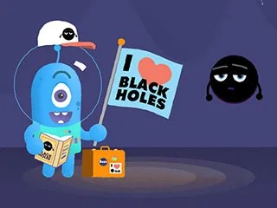 | Thinking about doing some black hole watching the next time you’re on an intergalactic vacation, but you’re not quite sure where to start? Well, look no further!  This series of animated NASA videos shows you everything you need to know. With topics ranging from basic black holes, to fancy black holes, to giant black holes and their companions. Watch this NASA animation to learn more about black holes.
NASA – Inside a Black Hole  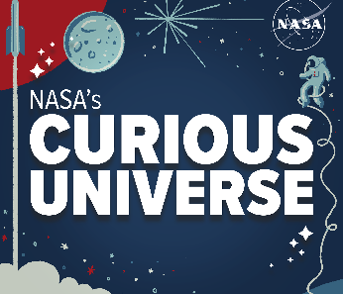 | Don’t let the name fool you: a black hole is anything but empty space. Black holes are some of the most extreme, bizarre and fascinating objects in the universe. Regina Caputo and Jeremy Schnittman describe what it might be like to go hunting for one.  NASA - Link to podcast

Activity: Life Cycle of a Star
Most black holes form from the remnants of a large star that dies in a supernova explosion. To help explain how black holes form it is useful to understand the life cycle of a star.

Class Discussion
Begin with a brief discussion to find out what your students know about stars. Encourage them to share their ideas. Explain the following concepts to your students. You may want to refer to NASA’s Star Basics, which looks at the birth, life, and death of stars. As you explain new concepts to your students identify new words to add to your class glossary.

Facts about stars:
- Stars are the most basic building blocks of galaxies.
- Stars are giant balls of hot gas – mostly hydrogen, with some helium and small amounts of other elements.
- Stars are non-living, but they have a life cycle, similar to plants and animals.
- Stars can have different masses.
- Depending on the mass of the star, there are two possible outcomes.
  - Low and medium mass stars burn cool and last for billions of years.
  - For stars much larger and hotter than our Sun, high-mass stars, the ending will be a spectacular explosion called a supernova.
- After a high-mass star explodes, a black hole is formed.
- The 2 most common types of black holes are called stellar-mass and supermassive.
- It is likely that our Milky Way Galaxy contains around 10 million black holes, but we will probably only ever 'see' about 1,000 of these.

Create
- Students will use neon paints to create their impression of a black hole. Display in your classroom or a room that can be darkened to highlight student’s artworks.
- Students will find images of the different stages in the life cycle of a star. Use these images to display the life cycle of stars as a concept map. Students will include the following in their life cycle: massive star, red supergiant star, supernova, and a black hole.

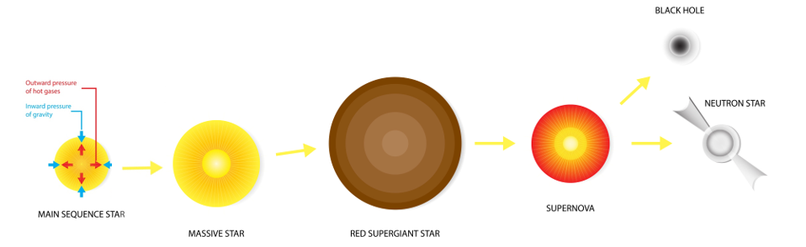

Activity: Science Investigation
Modelling the formation of a black hole
This 'Science in School’ activity will demonstrate to students how a black hole is formed through the collapse of a massive star, once the core of the star is unable to support the weight of the outer layers of gas surrounding it. The materials required for this activity include a balloon, aluminium foil, and a pin.



Activity: Black Hole Facts
In small groups, students will find out as much as they can about black holes and compile the information they find into a list of facts. Provide students with a list of suggested questions and/or topics to guide their research, for example:
- What is a black hole?
- How do black holes form?
- Characteristics of black holes
- Significant black holes in the universe

Facilitate a class discussion by asking each group to share one interesting fact they learned during their exploration. Record students’ responses on the white board to create a collective list of facts about black holes.

Students will use the facts they have discovered about black holes to create a quiz and then test their classmates. Students will include a range of quiz styles, for example:
- Multiple choice
- True or false
- Fill in the blank
- Use photos or pictures
- When an answer is revealed, provide extra information to explain the answer.

Students can make their quizzes in Kahoot or Quizizz. Make it fun, engaging, and educational!

Useful Websites
- Researchers discover fastest-growing black hole that consumes the mass of 'the Sun and all the planets' combined — every day – ABC News
- Black Hole Basics – NASA
- Black Hole Photo – BTN
- Black Holes – National Geographic
- Space and our Solar System – ABC Education
- What is a black hole? (Grades 5-8) – NASA
- A Field Guide to Black Holes – NASA

