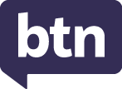
KEY LEARNING
Students will view a range of BTN stories and use comprehension skills to respond to a series of focus questions.

CURRICULUM
English – Year 4
Use comprehension strategies to build literal and inferred meaning to expand content knowledge, integrating and linking ideas and analysing and evaluating texts.

English – Year 5
Use comprehension strategies to analyse information, integrating and linking ideas from a variety of print and digital sources.

English – Year 6
Use comprehension strategies to interpret and analyse information and ideas, comparing content from a variety of textual sources including media and digital texts.

English – Year 7
Use comprehension strategies to interpret, analyse and synthesise ideas and information, critiquing ideas and issues from a variety of textual sources.
  - Teacher Resource

Civics and Citizenship Special
As a class, discuss the stories featured in the BTN special and record the main points of the discussion. Students will then respond to the following focus questions.

Foreign Aid
- In pairs, discuss the BTN story and record the main points of your discussion.
- What is an example of foreign aid?
- How many countries does Australia provide foreign aid to?
- The United States have put a pause on giving foreign aid. True or false?
- What questions do you have about the BTN story?

Poems for Peace
- What is the aim of the Poems for Peace project?
- What organisation started Poems for Peace?
  - Amnesty International
  - Save the Children
  - UNICEF
- How many children around the world live where there is war or violent conflicts?
- Which poem had the biggest impact on you? Explain your answer.
- How did this story make you feel?

World Children’s Day
- Give an example of a right included in the Convention on the Rights of the Child.
- Why is it important for children to have special rights?
- What rights are important to you?
- What is the theme for World Children’s Day this year?
- What did you learn watching the BTN story?

KEY LEARNING
Students will learn about children's rights through the Convention on the Rights of the Child.

CURRICULUM
HASS – Years 5 and 6
Work in groups to generate responses to issues and challenges.

Present ideas, findings, viewpoints, and conclusions in a range of texts and modes that incorporate source materials, digital and non-digital representations and discipline-specific terms and conventions.

HASS – Year 7
Collaborate to generate alternatives in response to an issue or challenge and compare the potential costs and benefits of each.

Present ideas, findings, viewpoints, explanations, and conclusions in a range of texts and modes that incorporate source materials, citations, graphic representations and discipline-specific terms, conventions, and concepts.

  - Teacher Resource

World Children’s Day

Activity: Class Discussion
After watching the BTN World Children’s Day story, hold a class discussion using the following discussion starters.
- What are some rights in the Convention of the Rights of the Child? Make a list.
- What issues are important to you?
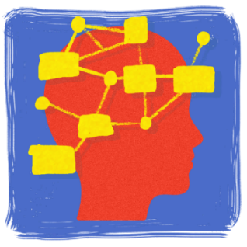
- Complete the following sentence. It is important that young people’s voices are heard because…
- How could you celebrate World Children’s Day in your class?
- Think of three questions you have about the BTN story.
- What did you like about the BTN story?




What issues are important to you?
What did the BTN story make you wonder?

Activity: Vocabulary
Students will brainstorm a list of key words that relate to the BTN World Children’s Day story. Below are some words to get them started. As a class discuss the meaning of each word/terminology.

Take Action
Opinion
Freedom
Priorities
Children’s Rights
Human Rights
Advocate
Voice

Class Discussion
- Explore the difference between human rights and children’s rights.
- Introduce students to the UN Convention on the Rights of the Child. Explain any terms or words in the document that children might find difficult to understand.

Activity: The Right to be Heard
Before starting this activity hold a class discussion to help students understand their rights. Focus on Article 12 in the Convention on the Rights of the Child, as below. Refer to the UNICEF’s simplified version, to read article 12 with your class.

UNCRC Article 12
Children have the right to have a say on things that are important to them.

Start a class discussion using these questions:
- Can you think of a time when you’ve seen or heard a child expressing their views on matters affecting them?
- What sort of issues affect children? Make a list.
- Who can children talk to if they want to express their views about an issue?
- What are some different ways that children can express their views and have their voices heard? (for example, start a petition, create a podcast, write a letter).
- Why is it important for young people to have a voice in the community?

Students may want to watch one of the following BTN stories which feature children who are making change and bringing new ideas and perspectives that can help shape a better future for all of us.

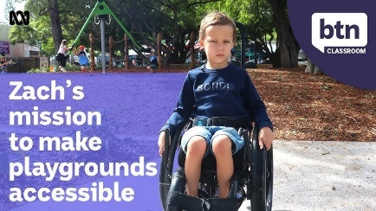  BTN Inaccessible Playground | 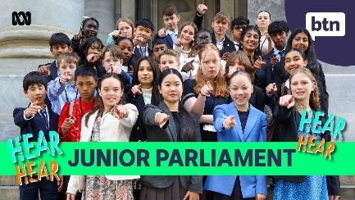  BTN Junior Parliament | 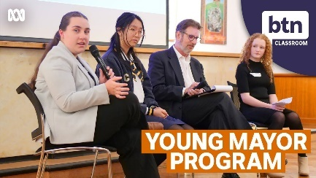  BTN Young Mayors Program

What’s Important to You?
Encourage your students to think about issues that are important to them. Hold a brainstorming session with your students to find out what matters most to them. Use the following questions to help guide a discussion (either as a class or in small groups).
- What issues are important to you? Make a list and then choose your top 1. For example:
  - Social media and online safety
  - Education
  - Environment
  - Mental health
  - Family
  - Community
- Complete the following sentence. It is important that young people’s voices are heard because…
- How can young people have their voice heard about issues they care about? Who can kids talk to, to have their voices heard?

Activity
Students will think about what is most important to them in their community and express this through writing a letter, starting a petition or running a poll.

Before starting this activity, students will think about what they appreciate about their community, the issues they observe and what they would like to see improved. Students will write their ideas and thoughts using dot points or on sticky notes.
- What are some of your ideas, priorities and dreams for the future? Make a list.
- List some of the big issues facing young people today.

Write a Letter
- Write a letter to your principal, your local MP or a CEO of an organisation in your community.
- Your letter will need to address the issues or improvements you would like to see in your community.
- Include language that is persuasive, respectful, and specific.
Start a Petition
- Would you like to raise awareness about an issue in your school, local community or in parliament?
- Get involved and have your say by starting a petition.
Run a Poll
- What’s important to your school community?
- Conduct a poll in your class or whole school to learn more about your community’s needs and opinions.
- How will you conduct the poll? (Face to face interviews or written responses).

Reflection
- How did this activity make you feel?
- What surprised you when completing the activity? Consider the impact that you can have on social change and the empowerment of young people in the community.
- Write a short paragraph reflecting on why you believe it is important for all individuals to have a voice in society. Having the right to voice allows people to participate in decision-making, share their experiences, and advocate for change.

Activity: UNICEF Resources 2024

A Minute of Loudness  This World Children’s Day, UNICEF invites every child in Australia to speak up through A Minute of Loudness, where they’re encouraged to share their ideas how to make Australia an even better place for all children – a country where every child is healthy, safe, educated and involved.  Register here to take part in A Minute of Loudness | 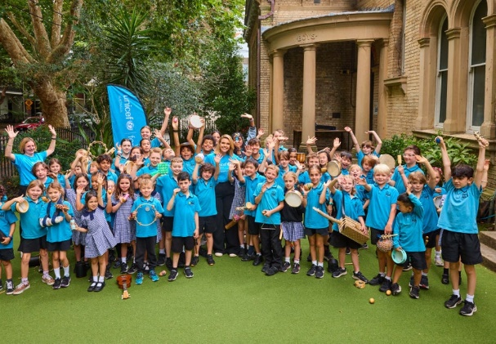
Dear Adults  This World Children’s Day, UNICEF is asking children to write letters calling for a better world. To reflect on their rights, and to share their priorities and dreams for the future. Across countries, across languages, children are calling out for peace, for safe and healthy environments, for love and care.  Link to letters here | 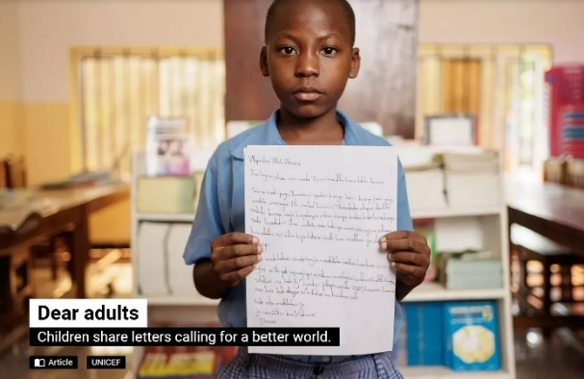
Know Your Rights Workbook  Download the UNICEF Know Your Rights workbook for your students to work through. The workbook helps children learn about the Convention on the Rights of the Child, designed for ages 10-12.  Download the Workbook | 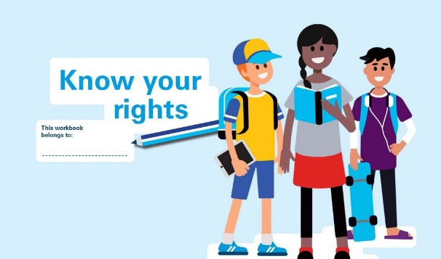
Kahoot Quiz  Use one of these Kahoot quizzes to test your students’ knowledge on Children’s Rights.  Link to Quizzes here | 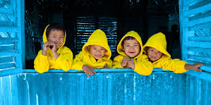

Useful Websites
- World Children’s Day 2024 – UNICEF
- Convention on the Rights of the Child (Simplified Version) – UNICEF
- Know Your Rights (Workbook) – UNICEF
- Kids’ Rights – BTN

