
KEY LEARNING
Students will view a range of BTN stories and use comprehension skills to respond to a series of focus questions.

CURRICULUM
English – Year 4
Use comprehension strategies to build literal and inferred meaning to expand content knowledge, integrating and linking ideas and analysing and evaluating texts.

English – Year 5
Use comprehension strategies to analyse information, integrating and linking ideas from a variety of print and digital sources.

English – Year 6
Use comprehension strategies to interpret and analyse information and ideas, comparing content from a variety of textual sources including media and digital texts.

English – Year 7
Use comprehension strategies to interpret, analyse and synthesise ideas and information, critiquing ideas and issues from a variety of textual sources.
  - Teacher Resource

The Arts Special
As a class, discuss the stories featured in the episode of BTN Classroom and record the main points of the discussion. Students will then respond to the following focus questions.

Photography Prize
- The Australian Geographic photographic prize focusses on what type of photography?
  - Portrait
  - Nature
  - Sports
- What did Maya choose to photograph for the photographic competition?
- What is your first impression of Maya’s photograph? What did you notice?
- How would you describe the image to someone who hasn’t seen it?
- What do you think makes a photograph interesting?

First Nations Arts
- Discuss the BTN Indigenous Art story as a class.
- What type of art did the artists featured in the story make? Name the medium/s they used.
- What are ochres and how are they used in First Nations art?
- What type of art was Albert Namatjira famous for?
  - Dot art
  - Rock art
  - Watercolour painting
- Name three facts you learnt watching the BTN story.

Womad Puppets
- When did puppetry originate?
  - 40 years ago
  - 400 years ago
  - 4,000 years ago
- Describe the puppets featured in the BTN story.
- How do the puppeteers operate the puppets? Describe.
- What is the puppet ‘Little Amal’ based on?
- What did you like about the BTN story?

KEY LEARNING
Students will learn more about the key elements of photography and analyse images created by young nature photographers. They will also create their own nature photographs.

CURRICULUM
Visual Arts – Years 5 & 6
Explore ideas and practices used by artists, including practices of Aboriginal and Torres Strait Islander artists, to represent different views, beliefs and opinions.

Develop and apply techniques and processes when making their artworks.

Plan the display of artworks to enhance their meaning for an audience.

Teacher Resource
Photography Prize

Activity: Class Discussion

Discuss the information raised in the BTN Photography Prize story. Here are some questions to guide the discussion:
- What did you SEE in this video?
- What did you LEARN from this story?
- What was SURPRISING about this story?
- What QUESTIONS do you have about this story?
- In pairs, students discuss what they think makes an interesting nature photograph. Share the main points of their discussion with the class.

Activity: Photographic Techniques
Students will explore some key concepts of photography. Discuss what they think makes an interesting photo.

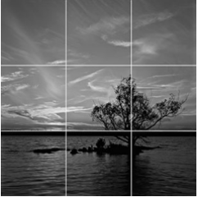
An important element when composing a photo is the Rule of Thirds. This makes photos more interesting. Imagine a photo divided into 9 squares – two vertical lines and two horizontal lines. Instead of putting the main subject in the middle of the photo, place it where the lines cross, to the side. BTN also has a video explaining Rule of Thirds
Rule of Thirds (Source: Wikipedia)

Lighting Sources of light, for example, daylight or camera flash, affect the mood and appearance of photographs. Ask the students how light changes throughout the day – sunrise or sunset (softer and warmer) as opposed to light in the middle of the day (harsher). When might be a good time of day to take photographs outside?

Perspective The position where you take a photo affects how the subject appears. Different perspectives include a birds-eye view – a photo taken from above, or a shot from ground level looking up. Close-up photos can capture interesting details like the texture or pattern in a leaf. Changing the perspective can create a more interesting photo.

Activity: Responding to Photographs
Students will select their favourite image/s from the Junior category of the 2024 Australian Geographic Nature Photographer of the Year competition. They will analyse and reflect on the image/s and then respond to the questions below.
- What is your first impression of the image? Look at the photo closely. What do you notice?
- What techniques is the photographer using to create the image? (colour, light, pattern, texture, contrast)
- What is the mood of the photograph?
- How would you describe the image to someone who hasn’t seen it?
- What do you think the photographer is trying to communicate?
- How does the image make you feel? What do you like about it?

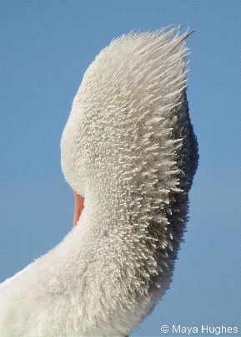  Elegance (winner) Maya Hughes | 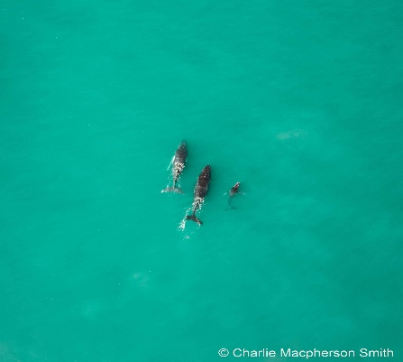  Family Charlie Macpherson Smith
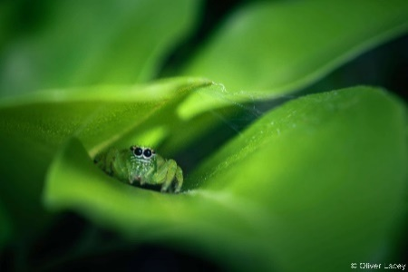  Nest of Silk (runner-up) Oliver Lacey | 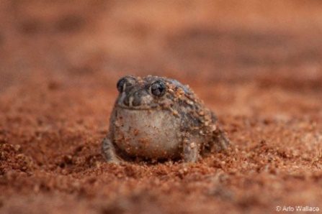Burrowing Beauty Arlo Wallace | 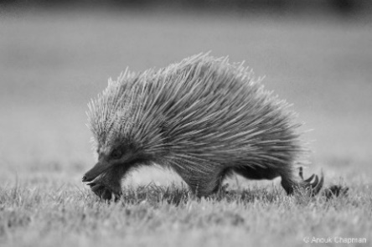  Prickly Anouk Chapman
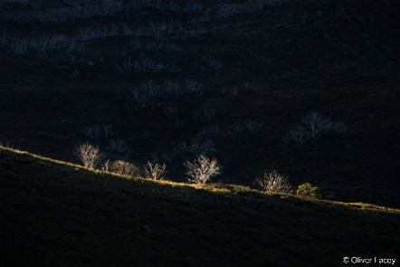  Spotlight on Dieback Oliver Lacey | 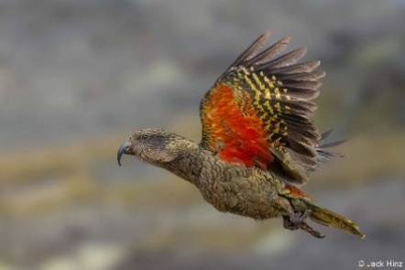The World’s Only Alpine Parrot Jack Hinz |   Blurred Horizons Levi Trapp

Activity: Nature Photography Shoot
Students will need access to a tablet, smartphone or camera for this activity.
Begin with a class brainstorm of possible locations to take nature photographs in or near the school grounds. Remember, it doesn’t need to be a large space, it can be as small as a patch of grass. Students can then practise taking photos in their chosen natural environment. Ask them to experiment with the following:
- Rule of Thirds
- Different perspectives – birds-eye view, ground level looking up, close-up details
- Different patterns, textures and colours
- Different light – full sun versus shade/part shade

Back in the classroom, students can share their favourite photos explaining why they chose them and what photographic techniques they used.

Class Exhibition
Curate a class exhibition of your students’ photographs. Students choose one or two or their favourite images and give the photo a title. Invite students from other classes at your school to attend your exhibition. Consider holding your exhibition at your local library, council or gallery.

Useful Websites
- Nature Photographer of the Year – SA Museum
- Conversation Starter Cards Resource – SA Museum
- Photo Quest – SA Museum
- Take awesome outdoor shots – National Geographic Kids

KEY LEARNING
Students will explore and analyse Aboriginal and Torres Strait Islander art and create their own artwork inspired by their family.

CURRICULUM
Visual Arts – Years 5 & 6
Explore ideas and practices used by artists, including practices of Aboriginal and Torres Strait Islander artists, to represent different views, beliefs and opinions.

Develop and apply techniques and processes when making their artworks.

Visual Arts – Years 7 & 8
Experiment with visual arts conventions and techniques, including exploration of techniques used by Aboriginal and Torres Strait Islander artists, to represent a theme, concept or idea in their artwork.

Analyse how artists use visual conventions in artworks.
Teacher Resource
Indigenous Art

Activity: See, think and wonder

After watching the BTN Indigenous Art story, students will respond to the following questions:
- What did you SEE in this video?
- What did you LEARN from this story?
- What was SURPRISING about this story?
- What QUESTIONS do you have about this story?

Activity: Class Discussion
Discuss the BTN story as a class. Ask students to record what they know about Aboriginal and Torres Strait Islander art. What questions do they have? In small groups, ask students to brainstorm responses to the following questions:
- How would you describe the art in the BTN Indigenous Art story? Describe the style, technique and colours.
- Complete this sentence. Something that really caught my eye was….
- What did you like about the art?
- What questions do you have about the artwork?

Activity: Exploring Indigenous Art
Students will explore and analyse Aboriginal and Torres Strait Islander art to understand its cultural significance and techniques. They will then create their own artwork inspired by their family heritage, reflecting on how their family story can be expressed visually.

Class Discussion
Begin with an introduction to Aboriginal and Torres Strait Islander cultures. Highlight the diversity of Aboriginal and Torres Strait Islander cultures and the role of art in storytelling and cultural expression.

Art Analysis
Provide students with a range of Aboriginal and Torres Strait Islander artworks, including dot paintings, bark paintings, carvings, and weavings. Explain common themes, symbols, and techniques used in these artworks. Below are some examples of artworks created by Aboriginal and Torres Strait Islander artists. Students will analyse one or more artworks and then respond to the questions below.

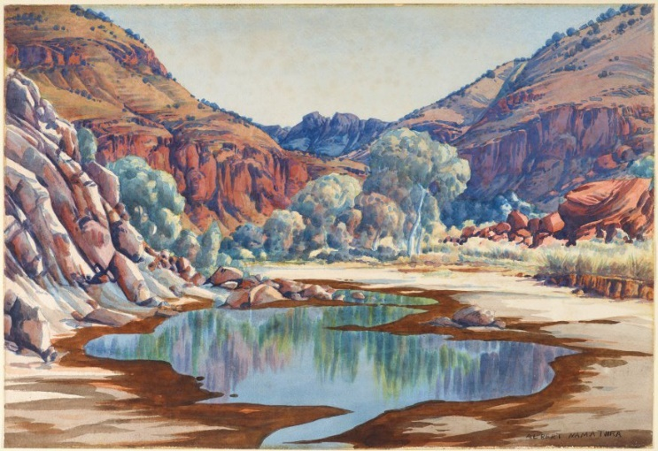  Albert Namatjira (Source: Art Gallery NSW) | 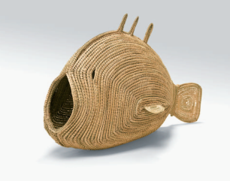  Pondi (Murray River cod), Yvonne Koolmatrie  (Source: Art Gallery of South Australia)
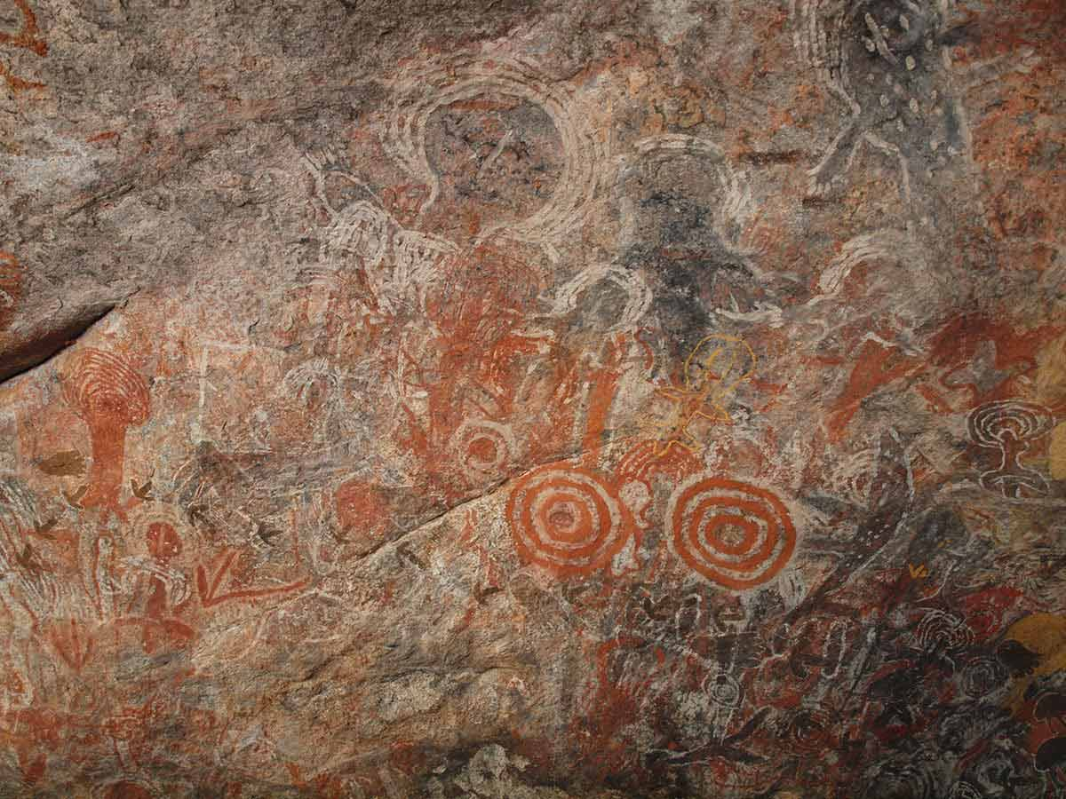  First Rock Art (Source: National Museum Australia) | 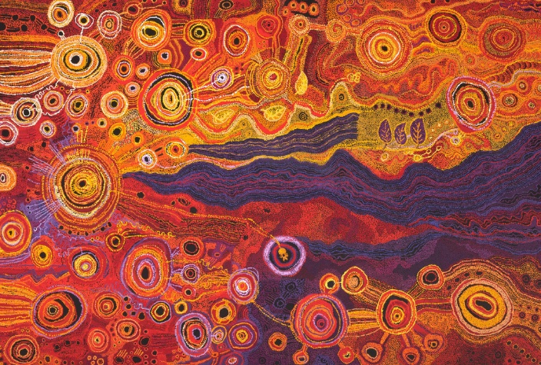  Tjungkara Ken, Sandra Ken, Yaritji Young, Freda Brady, Maringka Tunkin, Pitjantjatjara people, (Source: NGA)

Students will analyse an Aboriginal and Torres Strait Islander artwork and respond to one or more of the questions below.
- Record as much information as you can about the artwork in 15 minutes. Record everything you see. The longer you look the more you will see. Write 5 dot points about your first reactions of the artwork. Who or what do you think the artwork is about? What does it remind you of? What does it make you think about?
- Who created the artwork?
- What is the name of the artwork?
- What colours have been used in the artwork? How do the colours contribute to the artwork’s meaning?
- What symbols or patterns do you notice? What might these symbols represent?
- How was the artwork made? Is it a painting, print, sculpture or another type of artwork? What materials were used to make it? What techniques does the artist use?
- What do these artworks tell us about Aboriginal and Torres Strait Islander culture and their connection with the land?
- What questions do you have about the artwork?

Create an Artwork
Students will create their own artwork inspired by their family heritage, reflecting on how their family story can be expressed visually. Students will brainstorm ideas for their artwork including family symbols, significant events, or personal stories.

Brainstorm

Students can respond to the following questions to help guide their brainstorming.
- Where were you born?
- What language/s do you speak?
- What is your favourite activity to do as a family?
- What do you celebrate?
- Do you have any special ceremonies that your family participates in?
- What are some symbols that represent these celebrations and ceremonies?
- What do you think is unique and special about your family?

Create
Students will create an artwork based on their family. They will include symbols or styles that reflect their family’s heritage or a personal story. They can use techniques learned from Aboriginal and Torres Strait Islander art if they choose.

Below are some guidelines for students as they create their artwork.
- Use colours that you feel reflect you and your family.
- What style will you use to create your artwork?
- What symbols might reflect your culture?

Experimenting with Colour
Experiment with paints and mixing colours to find a colour or a palette of colours that represents you and your family.

- What is your favourite colour? Why?
- Think about how this colour makes your feel or if it reminds you of a personal experience.
- What does the colour represent?

You can create different tints of the colour by adding varying amounts of white paint to make it lighter. You can create different shades of the colour by adding varying amounts of black paint to make it darker. Experiment with different brushstrokes and different amounts of paint on your brush.

Themes and Symbols
Think about the things that you love and the things that are precious to you and your family. How can you represent these stories in your artwork, though symbols?

It could be your pets, family celebrations, or a personal story about an event that you experienced with your family.

What symbols can you use in your art to represent these things?

Students will write an artist's statement to go with their artwork, explaining the symbols they’ve used and the story they have told through their art.

Exhibition
Curate a class exhibition of your students’ artworks and choose a title for the exhibition. Invite students from other classes at your school to attend your exhibition. Consider holding your exhibition at your local library or local council.

Activity: Visit an Art Gallery
Plan a trip to your local art gallery to explore its Aboriginal and Torres Strait Islander art collection. Look for prints, paintings, and sculpture. Alternatively, if you are unable to physically visit an art gallery, visit an online art gallery. For example, visit the National Gallery of Australia to explore a range of Aboriginal and Torres Strait Islander art. Students can work individually or in small groups, using the following as a guide.

Step 1: Plan your visit
As a class, plan a trip to your local art gallery to explore its Aboriginal and Torres Strait Islander art collection. You will need to think about the following:

- What do you already know about Aboriginal and Torres Strait Islander art?
- What do you want to learn? Write 5 questions that you would like to investigate.
- How will you get there and how long will you need to visit the exhibition?
- Can you meet a tour guide or education guide to show you around?
- What will you need to take with you?

Step 2: Explore the art gallery
When you arrive at the art gallery, visit the Aboriginal and Torres Strait Islander art collection. Spend time visiting each artwork. Choose one of the artworks (painting, print, sculpture) that you will focus on for this project.

Write down as much information as you can about the artwork in 15 minutes. Record everything you see in detail. The longer you look the more you will see. Consider looking at it from different angles, up close and far away.
- Is it a painting, print, sculpture or another type of artwork?
- What materials were used to make it?
- Describe what it looks like, including colours, shapes and patterns.
- How does the artwork make you feel?

Draw a picture of the artwork including as much detail as possible.

Step 3: Back at school
When you get back to school you will write a short description explaining more about the artwork you focused on.

Reflect on the artwork and use the internet to learn more about the artist. Respond to the following.
- What attracted you to the artwork?
- Did you enjoy looking at the artwork? Why?
- What were your first impressions of the artwork?
- How would you describe the artwork to someone who has never seen it before?
- Is it contemporary or traditional?
- If you could interview the artist, what questions would you ask them about the artwork? If the artist is alive, find out if you can contact them for an interview.
- What is the ‘story’ behind this artwork?
- Where is the artist from?
- Interesting facts

Useful Websites
- Who Are We? – Adelaide Festival Centre
- First Rock Art – National Museum Australia
- Indigenous Art – BTN

