
EPISODE 14
26 May 2026

KEY LEARNING
Students will view a range of BTN stories and use comprehension skills to respond to a series of focus questions.

CURRICULUM
English – Year 4
Use comprehension strategies such as visualising, predicting, connecting, summarising, monitoring and questioning to build literal and inferred meaning, to expand topic knowledge and ideas, and evaluate texts.
English – Year 5
Use comprehension strategies such as visualising, predicting, connecting, summarising, monitoring and questioning to build literal and inferred meaning to evaluate information and ideas.

English – Year 6
Use comprehension strategies such as visualising, predicting, connecting, summarising, monitoring and questioning to build literal and inferred meaning, and to connect and compare content from a variety of sources.

  - Teacher Resource

Focus Questions
As a class, discuss the stories featured in the episode of BTN Classroom and record the main points of the discussion. Students will then respond to the following focus questions.

World Health Organization
- In pairs or small groups, discuss the BTN story and record the main points of the discussion.
- When was the World Health Organization (WHO) founded?
  - 1928
  - 1948
  - 1968
- Why was the WHO set up?
- What is the WHO doing to try to stop Ebola from spreading?
- What questions do you have about the BTN World Health Organization story?

Mouse Plague
- Where in Australia is there currently a mouse plague?
  - Western Australia
  - Victoria
  - Queensland
- The house mouse is native to Australia. True or false?
- What conditions cause mice to breed in large numbers?
- What damage can mice cause?
- How are farmers trying to control the mice?

Reconciliation Week
- In your own words, explain what reconciliation is.
- Reconciliation Week is held between two important anniversaries. What are they?
- What does the theme for Reconciliation Week, All In, mean to you?
- What is another important milestone for reconciliation in Australia?
- How does your school celebrate Reconciliation Week or support reconciliation?

Check out the teacher resource on the Archives page.

Reconciliation Action Plan Kids
- Briefly summarise the BTN Reconciliation Action Plan Kids story.
- What does RAP stand for?
- What are the students doing to work towards reconciliation?
- How do the students use the bush tucker garden?
- What did you learn watching the BTN story?

UK Social Media
- Why did the kids in the UK want to talk to Aussie kids about the social media ban?
- What questions did the kids from the UK ask? Give an example.
- How do Aussie kids feel about the ban?
- How do the kids feel about a ban on social media being introduced in the UK?
- What do you think about the social media ban?

EPISODE 14
26 May 2026

KEY LEARNING
Students will learn about key events in Australia’s reconciliation history and explore the Reconciliation Week theme.

CURRICULUM
HASS – Year 3
Significant events, symbols and emblems that are important to Australia’s identity and diversity, and how they are celebrated, commemorated or recognised in Australia, including Australia Day, Anzac Day, NAIDOC Week, National Sorry Day, Easter, Christmas, and other religious and cultural festivals.

HASS – Year 4
The diversity of First Nations Australians, their social organisation and their continuous connection to Country/Place.

HASS – Year 5 and 6
Develop appropriate questions to guide an inquiry about people, events, developments, places, systems and challenges.

HASS – Year 6
Changes in Australia's political system and to Australian citizenship after Federation and throughout the 20th century that impacted First Nations Australians, migrants, women and children.

This document contains the names and images of Aboriginal and Torres Strait Islander people now deceased. It also contains links to sites that may use images of Aboriginal and Torres Strait Islander people now deceased.

  - Teacher Resource

Reconciliation Week

Focus Questions
Discuss the BTN stories as a class and record the main points of the discussion. Students will then respond to the following:

Reconciliation Week
- In your own words, explain what reconciliation is.
- Reconciliation Week is held between two important anniversaries. What are they?
- What does the theme for Reconciliation Week, All In, mean to you?
- What is another important milestone for reconciliation in Australia?
- How does your school celebrate Reconciliation Week or support reconciliation?

Reconciliation Action Plan Kids
- Briefly summarise the BTN Reconciliation Action Plan Kids story.
- What does RAP stand for?
- What are the students doing to work towards reconciliation?
- How do the students use the bush tucker garden?
- What did you learn watching the BTN story?

Activity: Class Discussion
After watching the BTN Reconciliation Week story, students will respond to the following questions:
- What is reconciliation?
- Why is reconciliation important in Australia?
- What values are important to reconciliation?
- Why do we have special days or weeks like Reconciliation Week, Sorry Day, Mabo Day and NAIDOC Week?
- How does your class and/or school support reconciliation?

Activity: Reconciliation Week Theme
Reconciliation Australia’s theme for 2026 is All in for Reconciliation, which calls for all Australians to commit wholeheartedly to reconciliation every single day.

National Reconciliation Week (NRW) is a time for all Australians to learn about our shared histories, cultures, and achievements, and to explore how each of us can contribute to achieving reconciliation in Australia.

Class Discussion
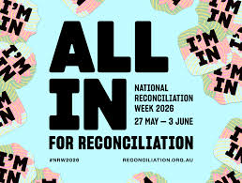
Discuss the theme as a class, using the following questions to get the discussion started:
- What does the theme ‘All In’ mean to you?
- Why do you think reconciliation involves everyone not just Aboriginal and Torres Strait Islander peoples?
- What actions does your school take to help support reconciliation? (For example, Acknowledgement of Country, celebrate Reconciliation Week with school activities).

Practical Action
Design a practical action that shows what being “ALL IN” could look like at your school. For example:
- Create an Indigenous garden space that includes edible bush tucker plants. Use these native ingredients in school cooking classes.
- Write an Acknowledgement of Country to give at your school assembly. Consider including a section about your own sense of belonging and connection to Australia. Include a positive message about community, respect or inclusion.
- Design signage around your school that uses local Indigenous language words.
- Create a display of books in your library written by First Nations authors. Include books that talk about reconciliation.
- Fly or display two flags representing the Aboriginal peoples and Torres Strait Islander peoples. Talk with the local Aboriginal and Torres Strait Islander community about how the flags should be flown or displayed at your school.

School Plan
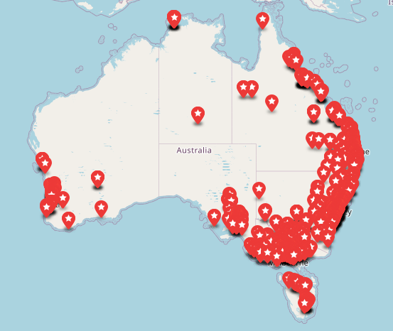
A Reconciliation Action Plan (RAP) gives your school a framework to contribute to the reconciliation movement.

Who has a Reconciliation Action Plan (RAP)? Use the RAP map to search for schools with a published RAP.

Explore a range of RAP actions which are important for strengthening relationships, respect and opportunities in the classroom, around the school, and with the community.
Reconciliation Australia: What is a RAP?

Activity: Key moments in reconciliation
In this activity students will analyse images which show key moments in Australia’s history where Indigenous and non-Indigenous people have come together for reconciliation. Students will choose one or more of the images below and respond to the following:
- What is happening in the image?
- How does the image make you feel?
- What does the image tell you about reconciliation?
- Why is it a key moment in reconciliation in Australia?

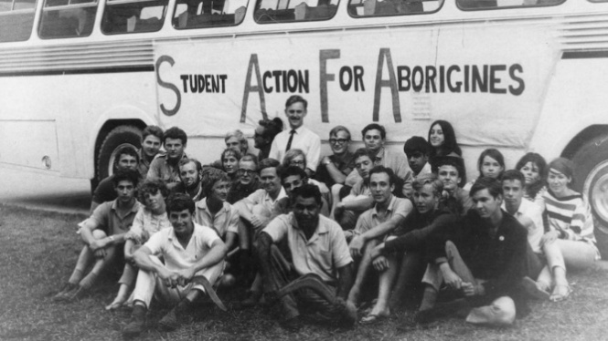  Freedom Ride | 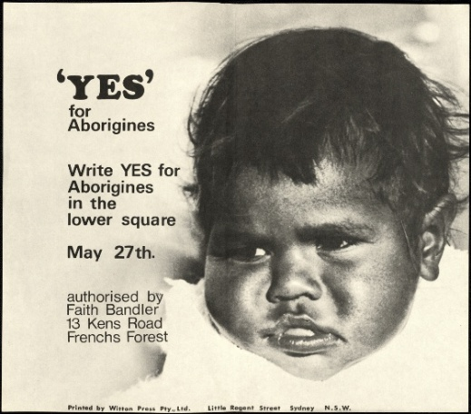  1967 Referendum
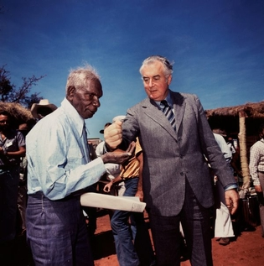  Wave Hill | 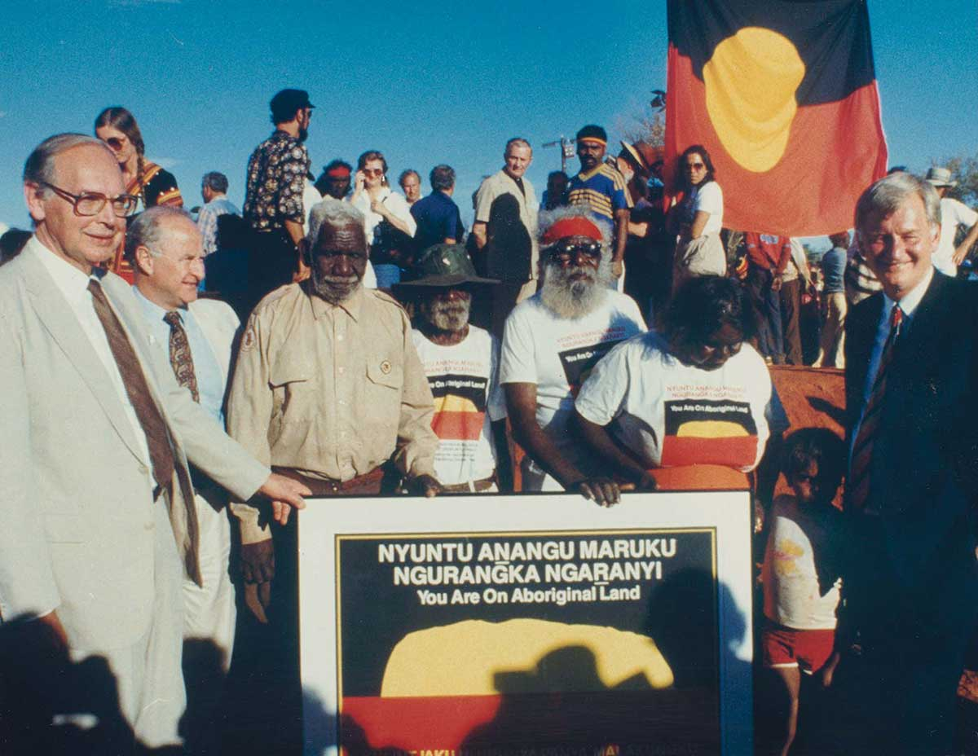Uluru Handback
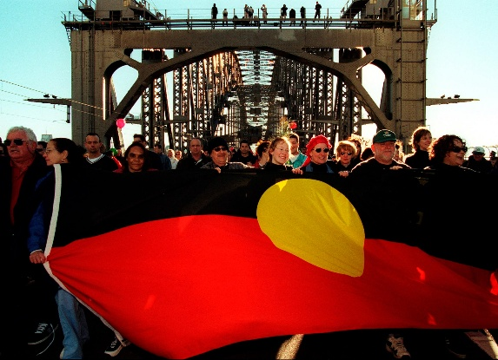  Walk for Reconciliation | 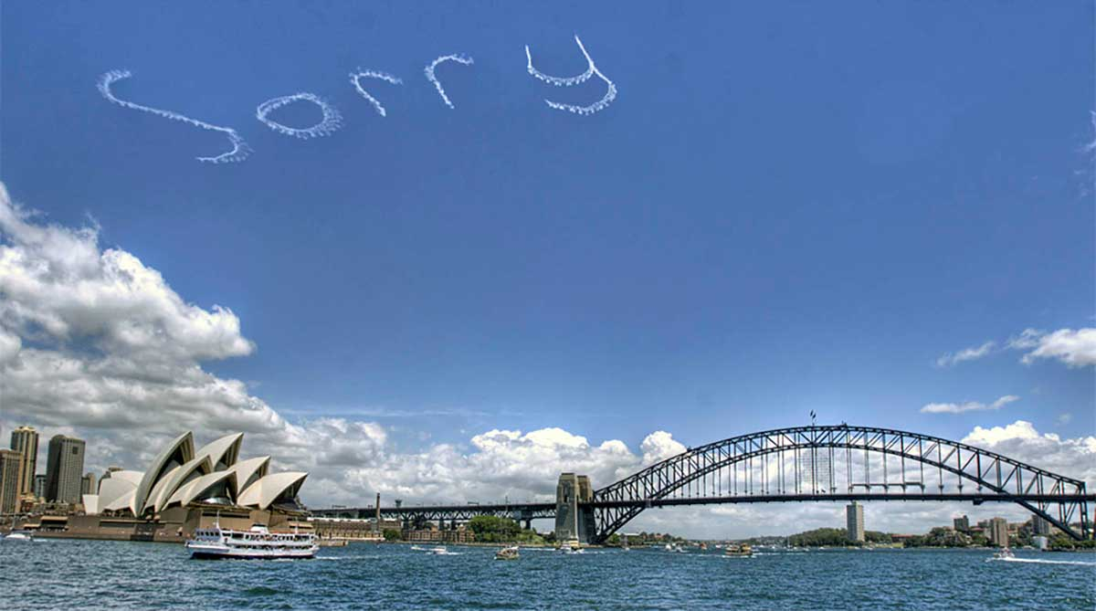  National Apology to the Stolen Generations

Further Investigation
Students choose one key event to explore in more detail and write a summary, which answers the 5 W’s – Who, What, Where, When and Why?
- What is the event? Describe.
- When did the event occur?
- Where did it happen?
- Who was involved in the event?
- Why is it significant?
- How does it recognise Aboriginal and Torres Strait Islander peoples?
- Is there a special day to commemorate or celebrate the event? What happens on this day.
- Include 2-3 images which are related to the event. Include captions.

To help with their research, students can explore the following BTN stories which look at significant events that have helped move Australia towards reconciliation. Students will then present their findings to the class.

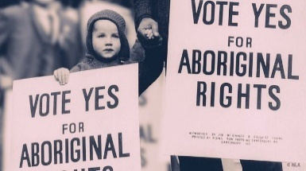  1967 Referendum | 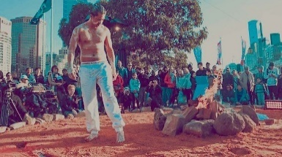  What is a treaty? | 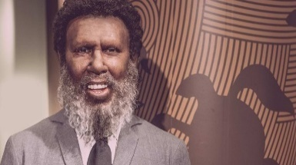  Mabo Legacy
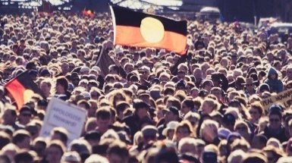  Bridge Walk Anniversary | 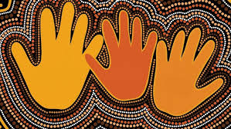  Apology Anniversary | 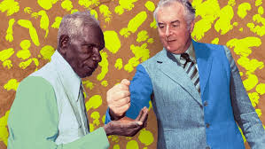  Vincent Lingiari

Activity: Bush Tucker Garden
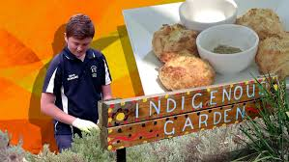
Create your own bush tucker garden Students create their own garden at school or home. Watch the BTN Bush Tucker Garden story for inspiration. Brainstorm possible garden designs and locations. Things to consider when designing a garden include position, type of soil and how much water the plants will need, then find edible plants that are native to the area. Students will need to consider how easy the plants are to obtain and the size of the plants – how large will they grow (how much space is available for the garden). Think about signage for the garden or an information brochure.

Explore cooking with native ingredients! The students in the BTN story made lemon myrtle biscuits. Students can have a go at making their own biscuits following this recipe.

Activity: First Nations Perspectives
Visit your school or community library to find a book written by a First Nations author. Find a book (fiction or non-fiction) that is age-appropriate that your students will connect with and you can read aloud as a class. It is a great way to share First Nations perspectives with your class and develop understanding of Aboriginal and Torres Strait Islander people, cultures and histories. Students will reflect on the story and respond to one or more of the following questions.
- Who is the author and/or illustrator of the book?
- What traditional lands are they from?
- What parts of the story could you relate to personally?
- What First Nations voices are heard in the story?
- What did you learn about First Nations experiences or culture?
- Are there Indigenous language words you learnt in the book?
- Were there cultural practices or traditions mentioned in the book?
- Were there historical events or references included in the book?

Build other reconciliation activities around the book you have read!

Activity: Listening, Learning and Sharing
Students will learn about First Nations cultures through storytelling, language and listening. Students will partner with younger students (buddy classes) to listen to an episode of the ABC’s Little Yarns.

- Together with your buddy listen to an episode of Little Yarns. You may want to pause the episode to help explain new words or ideas.
- After listening to the episode complete these sentence starters together.
  - I learned…
  - I felt…
  - My favourite part was….
- What new Indigenous language words did you learn? Choose one new word and learn the correct pronunciation. What does the word mean?
- Draw a picture that shows something your learned or found interesting from the story.
- Share one thing you learned with the class.

BTN First Nations collection
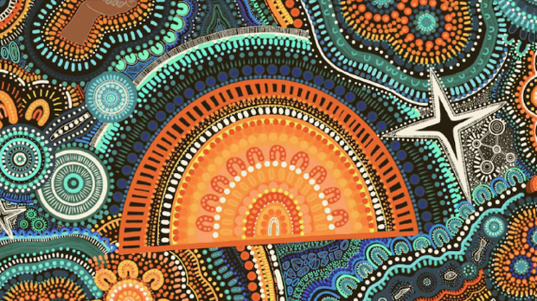
Visit BTN’s collection of stories which focus on First Nations. Look for BTN stories with the pencil icon to find supporting teacher resources all linked to the Australian Curriculum. BTN – First Nations Collection

Useful Websites
- Reconciliation Action Plans – Reconciliation Australia
- Curriculum Resources – Reconciliation Australia
- Bush Tucker Garden – BTN
- Ngani Café – BTN
- Planting Indigenous Foods – Australian Museum
- Deep Time – BTN (video and teacher resource)

  - Teacher Resource

BTN Transcript: Episode 14 - 26/5/2026

Hey, I'm Amelia Moseley and you're watching BTN. Thanks for hanging out with us again. Let's see what's coming up on today's show. We'll find out how one school is working towards reconciliation, learn about Australia's mouse plague and talk to kids in the UK about our social media ban.

World Health Organization
Reporter: Saskia Mortarotti

INTRO: We'll get to all that soon, but first up today, to an organisation that you've probably seen in the news a lot lately. The WHO or World Health Organization has been helping governments deal with a few disease outbreaks, like hantavirus on a cruise ship and now, Ebola in Uganda and the Democratic Republic of the Congo. So, who exactly is the WHO, and what do they do? Well, Sas can tell us more.

HEDWIG: Hoo. Hoo. Achoo.

HERMIONE GRANGER: Oh, Hedwig, are you getting sick? Hmm... Who can help if you're sick?

HEDWIG: Who!

HERMIONE: Yes, who?

HEDWIG: Who!

HERMIONE: Oh, I see. You mean WHO, not 'who'. As in the World Health Organization.

SASKIA MORTAROTTI, REPORTER: Yeah, while it wasn't made with, uh, owls in mind, the who... I mean, WHO is there to look after our health. The World Health Organization was created in 1948. The world was recovering from the Second World War, and in an effort to stop that sort of thing from happening again, the United Nations was created. But those who set up the UN knew it wasn't just war that posed a threat to humanity.

PRESENTER: The struggle against epidemics is a global one. For the danger of death is worldwide.

You see, before the WHO existed, the world had gone through some pretty terrible epidemics and pandemics, like the so-called Spanish flu. It started spreading towards the end of World War I and was actually deadlier than the war itself. It killed 50 million to 100 million people worldwide and infected a third of the world's population. And it was exactly this sort of thing that the WHO wanted to prevent.

The World Health Organization will make full use of every existing means — education, prevention, cure.

The WHO employs thousands of doctors, public health specialists, scientists and epidemiologists who study the way diseases are spread. They coordinate vaccinations and help train local health care workers. They also come up with health recommendations for things like food, drugs and lifestyle. And when there is an outbreak of a disease, they're the ones that let the world know.

DR TEDROS ADHANOM GHEBREYESUS, WORLD HEALTH ORGANIZATION DIRECTOR-GENERAL: Last week, more than 60% of all reported cases and deaths from COVID-19, globally, were once again in Europe.

Now, the WHO has got a new challenge.

FARHAN HAQ, WORLD HEALTH ORGANIZATION SPOKESPERSON: The Ebola outbreak in the Democratic Republic of the Congo and Uganda constitutes a public health emergency of international concern.

Ebola is a deadly disease that spreads through bodily fluids like saliva and blood. We've known about it since the '70s, and there are several strains. Between 2014 and 2016, there was an outbreak of Ebola in West Africa which infected more than 28,000 people and killed more than 11,000 people. This current outbreak of Ebola has been caused by a strain of the virus called Bundibugyo, which, unlike the last strain, doesn't have an approved vaccine yet. It's suspected there have already been more than 750 cases and 177 people have died, and for the people who live in the affected countries, it's a scary situation.

TRANSLATOR: Last time, it killed a lot of people, and we've heard that it's reappeared, which makes us really afraid.

The WHO is working with countries around the world to try to stop Ebola from spreading. They've put together an emergency committee to help advise and control the outbreak and sent medical supplies and response teams to affected areas. It's come at a difficult time for the WHO, which lost a lot of its funding when the US pulled out of the organisation this year.

DR ANNE ANCIA, WHO REPRESENTATIVE IN THE DEMOCRATIC REPUBLIC OF THE CONGO: We understand that we cannot receive the funding. It's OK, but we want to keep talking.

Because of the way Ebola spreads, the WHO says it's not a pandemic emergency, but it is a really serious situation and they'll continue to do what they always set out to do - try to keep the world healthy.

News Quiz

AMELIA MOSELEY: What colour is used to describe the group of Aussie independent politicians who are now in talks about forming a new political party? Are they the Purple Independents, the Aqua Independents or the Teal Independents? They're known as Teal, which is a combination of green, which is the colour of the Greens, and blue, which is the colour of the Liberal Party. And these MPs are seen to be a bit of a combination of the two.

ZALI STEGGALL, FEDERAL MP FOR WARRINGAH: And I think a lot of people in the Australian public are really frustrated with the major parties.

The world's most powerful rocket has gone for a test flight. Do you know who made it? Was it NASA, Space X or Blue Origin? The Starship V3 was made by SpaceX, and NASA is hoping it'll one day take astronauts to the moon. Although there were a few engine failures, it managed to deploy 20 dummy satellites in space before splashing down on Earth, in the Indian Ocean. Oh, and exploding!

What was found in a bag of lettuce in a WA supermarket last week? A wasp, a watch or a frog? It was a live frog. And, no, he didn't end up in a salad.

CUSTOMER: We set him free with his little snack of lettuce. We live close to a dam, so he was able to get next to the water again and get outside.

Mouse Plague
Reporter: Sharne Wakefield

INTRO: Now to a problem that's plaguing farmers and communities in parts of Western Australia and South Australia. Mice. Over the past few months, the numbers of these little rodents has exploded and it's causing big problems. Here's Sharne to explain.

SHARNE WAKEFIELD, REPORTER: Imagine opening a cupboard... putting something in the bin... getting in the shower... or into bed and seeing... mice.

KAREN CHAPPEL, PRESIDENT OF THE SHIRE OF MORAWA: We have mice in our homes. We have mice in our cars. They're in our sheds. They're in our paddocks. They're at the school. They're everywhere.

Yep. For the past few months, this has been the reality for people here in Morawa, WA. This night vision shows just how many are running around in the fields. See all those little dots there? Farmers say that driving on the roads is a bit like popping bubble wrap, yuck. It's not just in WA. Parts of SA are starting to see swarms of these little squeakers too. And it's becoming a huge problem, not just for people like me who aren't their number one fan — it's having a huge impact on farmers, who are starting to plant their seeds at this time of year.

STEVE HENRY, CSIRO MOUSE EXPERT: Generally, they rely on eating grains. But all kinds of grains — so wheat, barley, oats — but also, oilseeds like canola.

MATT DAVEY, SA FARMER: They'll just find the furrow, dig along and eat the seed as you're putting it in.

Their big appetite is one reason why mice are such a big problem in Australia. They didn't originate here. While Australia has lots of native rodents, the common house mouse, or Mus musculus, arrived with British colonists on the first fleet. They hopped off the ship, spread their paws all around the country, and basically never left. Not only are they eating machines, they are also baby-making machines. They can start having babies as young as six weeks, and have six to ten in each litter, and it takes about three weeks for them to grow in their mum's tummy. And some years, they have more babies than others.

Every five to ten years, Australia faces a mouse plague. The last big one was in 2021, in New South Wales, and it caused about $1 billion worth of damage. Mouse plagues often happen when there's been a lot of rain, and conditions are perfect for crops that both humans and mice like to eat.

STEVE HENRY: When we get farmers growing really good crops, that provides a lot of food for the mice.

And not-so-fun fact — mouse plagues only happen in Australia and China. Scientists don't really know why, but it could be a combination of things, like a lack of natural predators or our climate.

To qualify as a mouse plague, there needs to be 800 mice per hectare. And at the moment, in some parts of WA, there are 1,000. In SA, it's not quite as bad, but scientists are worried it could get worse. Shops say they're struggling to keep up with the demand for mouse traps and poison.

BEN LANG, INDEPENDENT RURAL NORTHAMPTON RETAIL MANAGER: If I'm not ordering 100 mouse traps, then there's something wrong. And then, the same with the RATSAK — we're ordering the same amount as well. Yeah, it's just crazy.

Meanwhile, the National Chemical Regulator is temporarily letting farmers double the dosage of poison used to get rid of them, as long as they have a permit. Many are hoping that will help stop the plague, but it could be a tough season, still, for Aussie farmers.

Did you know?

AMELIA MOSELEY: Did you know a group of mice is known as 'a mischief'? Pretty appropriate.

Reconciliation Week
Reporter: Tatenda Chibika

INTRO: This Wednesday is the start of Reconciliation Week. It's a time when First Nations people and non-Indigenous Australians come together to share, learn and try to make Australia better. Tatenda found out more about the week and the important milestones that it marks. Check it out.

TATENDA CHIBIKA, REPORTER: From the handing back of traditional lands, to speeches recognising past injustices.

PAUL KEATING, FORMER PRIME MINISTER: We took the traditional lands and smashed the traditional way of life.

KEVIN RUDD, FORMER PRIME MINISTER: On behalf of the Government of Australia, I am sorry.

Big gatherings…

PERSON: I’m sure we can walk that road towards true reconciliation.

…and small gatherings too. These are just some of the moments in our country's history where First Nations and non-Indigenous people have come together and tried to right the wrongs of the past. This is what Reconciliation Week is all about. It's a chance for Australians to learn, share, celebrate, acknowledge the past and look to the future.

The week is held between two really important anniversaries. One of them is the 1967 referendum.

On 27 May 1967, Aussies went to the polls to decide whether First Nations people should be counted as citizens of their own country. Since the time of colonisation, Indigenous people were denied the same rights as non-Indigenous people. Children were taken away from their families, and people were segregated based on their race and denied their language and culture.

There was also discrimination in our constitution, the document that defines the country and its laws.

That was something a lot of people fought hard to change.

MAN: We want to become a part of our country.

FAITH BANDLER, ACTIVIST: It is important that we should have the maximum vote because the eyes of the world are on Australia.

More than 90% of voters said yes to changing the Constitution, making it the most successful referendum in Australian history.

The second anniversary marked by Reconciliation Week is Mabo Day.

Eddie Koiki Mabo was a Meriam man from Mer Island in the Torres Strait, who went to Australia's highest court to fight the concept of 'terra nullius'. 'Terra nullius' is a Latin word, meaning 'land belonging to no-one', and it was the legal principle used by the British to justify colonising Australia. Eddie led a fight to show that it was wrong, and that his ancestors had a legal right to the land that they had lived on for thousands of years.

EDDIE KOIKI MABO, LAND RIGHTS ACTIVIST: Those fish, the prawn, whatever is in that sea belongs to me and my people. That is important.

On 3 June 1993, the court made its decision.

RICHARD MORECROFT, NEWS ANCHOR: The High Court has recognised there were people here, and their descendants have rights.

The Mabo case paved the way for other First Nations to claim Native Title over their traditional lands and waters. And while Eddie died before he got to see his victory, today, we mark it every year.

But while we celebrate these milestones, another part of Reconciliation Week is recognising the work that still needs to be done, like bridging the gaps between First Nations and non-Indigenous Australians and fighting racism and discrimination.

COHEN: Reconciliation means, to me, just celebrating Aboriginal culture and recognising the past.

ISABELLA: This week is kind of our week to speak out and talk about what we need.

This year's theme is All In, and it's a reminder that all of us have a role to play in Reconciliation, no matter who we are or where we come from.

ISABELLA: We all really need to work together and be all in on making sure that our future is as good as it can be.

COLLEEN: If we're not all in, how can we make a change?

As part of it, people around the country are coming together to sing the Midnight Oil classic Beds Are Burning, which calls for justice and reconciliation.

CHOIR: How do we sleep? How do we sleep? The time has come.

Quiz

AMELIA MOSELEY: In what year did more than a quarter of a million people walk across Sydney Harbour Bridge to show their support for reconciliation? Was it in 1990, 2000 or 2010? It was in 2000, and it was the biggest demonstration in Australia's history.

Reconciliation Action Plan Kids
Reporter: Tatenda Chibika

INTRO: Now, we're going to meet some kids whose school has just launched its Reconciliation Action Plan, or RAP. It's a formal document that outlines the things they're doing to work towards reconciliation. Let's find out more.

NATE: Nina Mani, and welcome to Karrendi Primary School. We are so happy to welcome you to our school on Kaurna land.

MARY JOY: This week, we are celebrating Reconciliation Week.

TY: It's a time where we learn about Aboriginal and Torres Strait Islanders' culture, history and traditions.

HOLLY: And try to make the future better for all Australians so everyone is respected and included.

MARY JOY: My name is Mary Joy and I'm from Kaurna land, and I am Aboriginal and Torres Strait Islander.

MARY JOY: Reconciliation and NAIDOC Week is a celebration for all the Aboriginal people out there. Everyone is respecting the Aboriginal culture again.

BROCK: RAP stands for Reconciliation Action Plan.

MARY JOY: The RAP launch is basically about, like, the cultural stuff and people coming together.

TY: During our ongoing continuation of reconciliation, we decided to invite artist Harley Hall to create a mural for our school.

TY: We decided to rename them in Kaurna language. So, on our mural, we decided to have our team mascots with our birds that are native to Australia.

JUANITA: They've been on our land for millions of years. And we also added songlines, which is the elders' knowledge, passing it down.

HOLLY: We have a Bush Tucker garden because it is where we can yarn and learn about other people's cultures, and it's a culturally safe space. 'Bush tucker' is a food that you can find in the wild.

NATE: In the Bush Tucker Trail, we use it for smoking ceremonies, welcoming ceremonies, storytelling, native-plant growing for traditional meals. We had our lovely canteen manager, Michelle, and two First Nation Year 6s help her make lemon myrtle cookies.

TESSALEE: I made lemon myrtle, and it was very messy in the canteen, and it was pretty hard to make at first. But you just... like, when you keep just making things, it gets easier and easier, I guess.

WYNTER: For reconciliation, we are really looking forward to Pancake Day on Monday and sharing our histories of First Nations.

HOLLY: Because it's good to share things with others, and so that everybody has the knowledge of what's happened.

BROCK: So we don't recreate what happened in the past because it wasn't very good, what happened back then.

JONATHON: One of the ways I like to describe it, in a really short word, is we acknowledge the past, but we look forward to the future.

KIDS TOGETHER: Happy Reconciliation Week!

Sport

REPORTER: Auckland and Sydney treated a sold-out crowd to some exciting moments during the men's A-League final on the weekend. But it wasn't until this moment, in the 60th minute, that the Black Knights managed to kick the only goal of the match to claim victory over the Sky Blues. This victory means Auckland has officially made history as the first team from New Zealand to win an A-League championship.

Speaking of making history, Collingwood's Scott Pendlebury has now played more AFL games than anyone else, ever. He broke the record with this game against the West Coast Eagles, which was Scott's 433rd. The Magpies wore gold numbers to mark the special occasion, and were determined to get the win for their team-mate, though the Eagles did make them work for it. In the end, Collingwood managed to snag the win, 92-82.

While we're at it with all this record-breaking, history-making talk, we can't forget about Bianca Adler, who, in her last year of high school, has become the youngest Aussie to summit Mount Everest. Bianca, here, is 18 years old but has been climbing alongside her parents since she was 12, and they came along for part of her journey to the world's highest peak.

BIANCA’s DAD: We’re so proud of you Bianca, it’s amazing what you’ve done.
BIANCA ADLER: Thanks, Dad. I feel really good up here, actually.

UK Social Media
Rookie Reporters

INTRO: Alright, finally, today we're going to have a chat about the social media ban. I know, I know — for you guys, it's old news. But over in the UK, the government is looking at following Australia's lead and restricting social media for kids. So, the BBC's Newsround got in touch to see if Aussie kids could answer some questions that kids have over there. Check it out.

RICKY BOLETO, NEWSROUND PRESENTER: Morning, everyone.

UK STUDENTS: Hi.

RICKY: Take a seat. We've got Australia, ready and waiting for us. Should we link up and chat to them? Yeah.

Hi, guys. Hello.

ALL: Hi!

RICKY: It's morning for us here.

NAT KELLY, BTN PRESENTER: It's about 4:30 in the afternoon here, so everyone's finished school.

RICKY: For the last 12 weeks, the government here have been deciding whether or not there should be an under-16 ban on social media usage, for children here in the UK. And that's something which I think you guys wanted to explore a little bit more about, because, in Australia, you've had this ban now for almost six months, haven't you?

NAT: That's right, Ricky. These students have been living with the ban for about six months now.

THEODORA: What were your first thoughts on the ban, and how have they changed?

TILLY: I thought it was one of the most stupidest ideas I've ever heard. But after it, I kind of saw the point that it had. But I also thought that they could have executed it better, since you don't need an account to access certain social medias, like YouTube and TikTok.

CASPER: I didn't have social media before the ban because my parents said I can't have it till I'm 16, so it didn't really affect me anyway. But with all my friends, they were all saying how bad it was going to be. But now, they actually understand because, now, I don't feel, like, as left out anymore.

KENITH: Do you feel like your behaviour has changed since the social media ban?

SUMMER: I didn't experience any change at all when the ban was enacted, but for some people that I know, they've had to create new accounts to stay on social media. And even on Snapchat, there's an age-verification face scan, I think. I don't really use it, but one of my friends, I'm pretty sure, just got, like, an eyebrow pencil, drew on a moustache, slicked back their hair, and then did the face scan, and it registered them as, like, a 40-year-old.

ISABELLA: How has bullying been affected by the social media ban, and has it decreased?

TILLY: For me, personally, it has not changed at all.

NAT: Yeah, that's an unfortunate reality, I think, of bullies, is whether it's online or in the schoolyard, they'll find a way.

CASPER: I, uh... Not used to get teased, but, hopefully, playful banter about me not having social media. So, all my friends or random people would be like, "Oh, ha-ha, you don't have social media," and kind of make fun of me for it. But now that, like, most people don't have it, I'm kind of glad because, then, if people make fun of me for it, I can be like, "Well, you also don't have it."

RICKY: What are your thoughts about the idea of having a ban, here in the UK?

THEODORA: I think it would be better with a ban because people would be able to socialise more, instead of just staying behind a screen. I don't want to go on TikTok, it's just I feel like I need to go on it to, like, be included.

NOAH: Well, there's no point if everyone's still using it. It's just like they've put in an effort for nothing to happen.

RICKY: Do any of the guys sitting on the sofa have a question for the children here in the UK?

CASPER: Do you drink tea with every meal?

PRISCILLA: I tend to actually drink a lot of tea, but when it gets near, like, a lot hotter, I don't really drink a lot. Do you guys have, like, massive spiders?

ERIKA: The biggest spider that I've seen, it was probably the size of, like, those plates that you put your, like, teacups on.

RICKY: Thank you so much for talking to us. You're off to have your dinner, I suppose. And we're off to start school.

NAT: Yeah. Have a good day at school. And thanks for having a chat to us. It's been fun. Catch you later.

OTHERS: Bye.

Closer

AMELIA MOSELEY: Argh! Did they have to talk about spiders? Gross! That's all we have for today, but we'll be back next week with more news. And of course, Newsbreak will be right here in the studio, every weeknight, keeping you up to date. Have the best week, and I'll see you really soon. Bye.

