Learning to Thrive
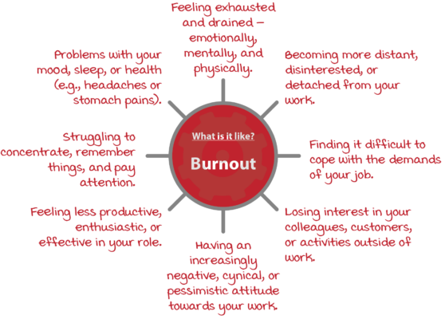
Three words are being heard all too frequently in educational settings – burnout, anxiety and depression. They apply to both teachers and students

Psychology Today describes burnout as "a state of chronic stress that leads to physical and emotional exhaustion, cynicism, detachment, and feelings of ineffectiveness and lack of accomplishment."
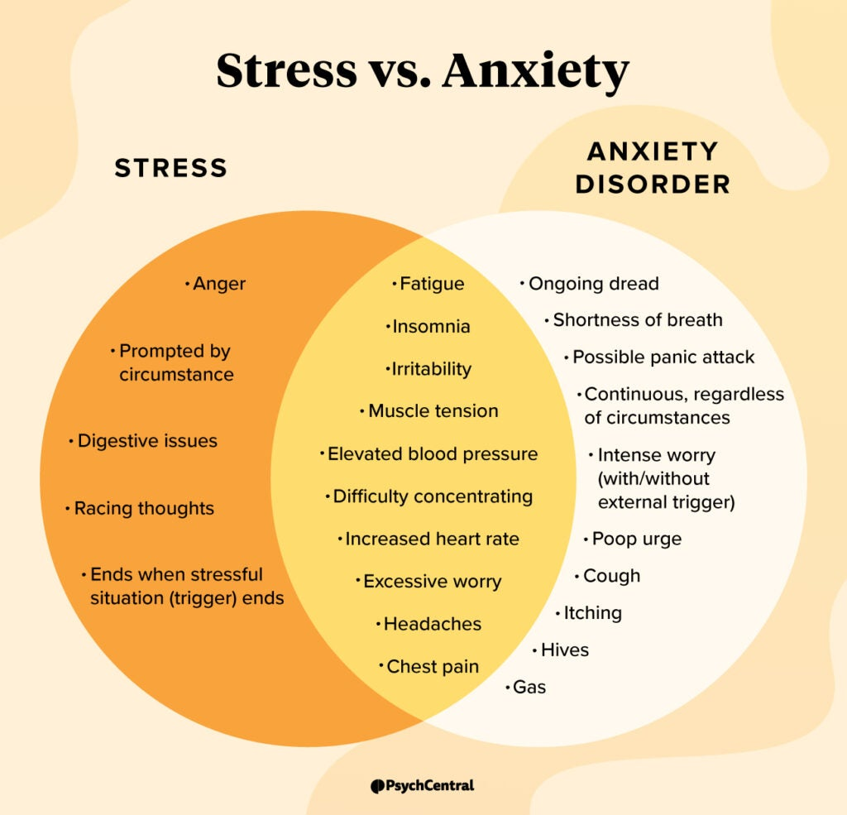
The Mayo Clinic states that ‘anxiety can be normal in stressful situations such as public speaking or taking a test. Anxiety is only an indicator of underlying disease when feelings become excessive, all-consuming and interfere with daily living’.

Depression and feeling depressed is more than just sadness; it’s a combination of how we think, feel and behave. (Headspace Aust.) It may include some of these changes for a period of longer than two weeks.

Burnout happens when you’re mentally, emotionally and physically exhausted – activities which were once of interest or importance to you no longer seem to matter -work, study, hobbies or relationships may all feel ‘empty’. You may lose motivation and feel helpless, drained and cynical. You may be struggling at work and at home. Burnout presents a sense of being completely overwhelmed, a sense that you can no longer cope. Burnout is given as the number one reason for teachers walking away from their careers in Australia.

Anxiety is the most common mental health condition in Australia – 1 in 3 females and 1 in 5 males will experience it at some stage in their lives. At any given time in a 12 month period over 2 million Australians experience anxiety. (Black Dog)

When our brains think we might be in danger, it responds by trying to help us feel safe – it’s called the ‘fight / flight / freeze’ response and once you feel safe again things return to normal. Sometimes in our lives threats or danger seem to come at us so quickly and so often, we don’t get to ‘flick the switch’ and return our brain to normal activity. This constant perceived threat or danger overwhelms us and sometimes we need help to get back to our ‘normal program’.

Sadly, we are more likely to remember negative experiences than positive ones. This was part of a survival instinct developed long, long ago during human evolution (Kids Help Line). Evolution is slow and this will change slowly. We need to ensure that there are many positive and proactive experiences stored in our brain to balance out the negatives.

If you or your child experience any of these symptoms for a period in excess of two weeks, it’s a good idea to talk to your family doctor and discuss what kind of support might be available.
Changes to feelings or emotions:
- feeling unhappy, numb, empty, moody or irritable/snappy;
- less interest in things that used to be enjoyable;
- feeling worthless or guilty a lot of the time; and / or
- feeling like everything is becoming ‘too hard’.

Changes to thoughts:
- negative thoughts about themselves, the world and the future
- having a hard time concentrating, making decisions, or remembering things
- having thoughts of self-harm
- having thoughts of death or suicide.

Physical changes:
- feeling tired most of the time
- low energy and motivation
- having trouble sleeping, experiencing changes in sleeping habits or not feeling rested regardless of the amount of sleep
- changes in appetite, loss of interest in food or eating too much − leading to weight loss or gain
- aches and pains that can’t be explained.
Behaviour changes:
- withdrawing from family and friends
- not getting things done
- difficulty with school, uni, TAFE or work
- using more alcohol and/or other drugs
- getting into trouble and fights.

Depression currently affects around 8% of Australians and is considered to be on the rise for many reasons. Social capital is falling – we don’t spend as much time with others engaged in conversation, entertainment, sport or even healthy debate.

‘Modern populations are increasingly overfed, malnourished, sedentary, sunlight-deficient, sleep-deprived, and socially-isolated. These changes in lifestyle each contribute to poor physical health and affect the incidence and treatment of depression’. (National Library of Medicine - https://www.ncbi.nlm.nih.gov/pmc/articles/PMC3330161/#:~:text=Modern%20populations%20are%20increasingly%20overfed,incidence%20and%20treatment%20of%20depression.)

- The light/dark cycle of the sun has a powerful effect on your circadian clock, sleep, and alertness.
- Your body's circadian clock responds to light, as a signal to be awake, and dark, as a signal to fall asleep.
- Increase your amount of light during the day to be more alert.
- The best time to expose the skin to sunlight is during the early morning sun — that is, from 7 am to 9 am — that helps generate Vitamin D. After 10 am, exposure to sunlight is harmful for the body.
- During the early light (before 10.00am) UVB rays are most intense, should do the job. You could step into your balcony, terrace, garden, the neighbourhood park or any spot outdoors, with your upper and lower limbs uncovered.
- Too much ultraviolet radiation (UV) from sunlight is dangerous. Nearly half of UV radiation is received between 10 a.m. and 4 p.m., when the sun's rays are the strongest. Even on a cloudy day, you can be sunburned by UV radiation. Unprotected exposure to sun can even damage eyes causing cataracts – so slide on some quality sunglasses.

How can we all incorporate strategies into our day to day lives which will make us more resilient to negative influences?

We need to develop the ability to bounce back after challenges – not to get stuck in a cycle of flight / flight / freeze, but to learn strategies which help us to become more resilient to negative forces in our lives. We all suffer setbacks, but we need to help our children and ourselves learn that uncomfortable emotions do not last forever.

As parents we need to start building stronger, more confident and resilient people early.
- Support your child, but try not to solve every minor problem or disappointment. For example, if your child doesn’t get invited to a birthday party or didn’t get what they want for their birthday, you could talk about how they feel instead of trying to fix the problem.
- Always let your child know that they are loved unconditionally – they are not loved because they are fast or clever, they are loved because they are uniquely ‘them’. It does not mean that you’re going to love everything that they do, but you’ll love them. It is possible to tell a child, ‘I will always love you and I will always be here for you. When I am cross about your behaviour, I am cross about a choice you made that had bad outcomes for you or for others.
- Avoid predicting and preventing problems for your child. This might mean letting your child hand in homework that’s wrong or not replacing a broken toy. Overcoming small challenges builds your child’s resilience for bigger setbacks.
- Help your child to see that they may not come first, but as long as they gave it their best effort then they have done well.
- Help your child to identify and manage strong emotions. For example, your child might be worried about a family member who’s sick. You could say, ‘I can see you’re really worried about Grandpa. It’s OK to be worried. But remember we’re doing everything we can to help him get better’. Give them time to ask questions and answer honestly.
- Encourage your child to have another go when things don’t work out the first time they try something. Praise your child for trying, no matter the result. You could say ‘I’m proud of you for finishing the race’ or ‘Well done for giving it another go’.
- Build your child’s self-compassion. Self-compassion helps your child deal with disappointment, failures or mistakes by being kind to themselves. In turn, this helps them to move on from difficult experiences.
- Make it a habit to recognise and acknowledge when things are going well. For example, during family meals you could each share one positive thing from your day.
- Help your child to develop problem-solving skills in an age-appropriate way. For example, if a child at school says or does something unkind to your child, brainstorm how your child might respond next time.
- Find a positive role model who has experienced similar challenges to your child. For example, your child might find support in an older friend whose parents have separated or who has lost a family member.
Resilience is not magic – it does not make your child invulnerable to stress, anxiety, fear of what others may say, bullying and more – it is a means by which they learn to bounce back after setbacks and move on to become the best they can be in whatever field of endeavour that may be.

If you are going to help your child to grown mentally strong and resilient remember and discuss these ‘7 C’s’ developed by the American Academy of Paediatrics.

Confidence
- Young people with confidence will have the belief in themselves that they will ultimately succeed.
- They’ll be more likely to take the chances needed to learn about themselves. They may be willing to try harder and have less fear of failure.
- More importantly, they’ll rebound from failure, seeing it as an opportunity for growth rather than a catastrophe.
- Confidence is not gained from an abundance of unearned praise.
- Rather, it comes from adults authentically noticing effort and nurturing and supporting skills (or competence).

Competence
- Youth need to possess real skill sets to be able to navigate the world.
- Those include communication skills, self-advocacy skills, peer negotiation skills, and academic skills to name a few.
- Young people also need to be able to make wise decisions if they are going to make the kind of choices that will contribute to, versus undermine, their health and well-being.
- Adults can teach and model effective competencies. We can listen to them as they work through solutions to problems. Support their ability to manage school and peers. Talk with them instead of at them.
- On the other hand, we undermine competence by telling our children what to do, or by talking to them in a way that shuts down their ability to come up with their own solutions. In other words, lectures backfire!
- Similarly, saying “Let me do that for you,” says, “I don’t think you are capable of doing it yourself.”

Connection
- Human connection allows us to more fully celebrate during joyous times and to recover during challenging times.
- It is the connection with your children — based on knowing who they really are — that is the most protective force in their lives.
- Hopefully, your adolescent will develop amongst many other protective connections as well. The more, the better.

Character
- Young people with strong core values make the strongest contributions, have the best sense of self, and have the most secure and healthy relationships.
- Think of character strengths as those things that ensure we do the right thing – even if nobody is watching. We need people who know how to do the right thing!
- Adults must notice and nurture children’s inherent character strengths and teach and reinforce others.
- We also must never forget that our actions speak so loudly that sometimes our kids can’t hear a word that we are saying. In other words, they are watching what we do. We must uphold those character strengths that we hope to see in them.

Contribution
- Young people want to matter.
- Ultimately, they want to have a sense of meaning and purpose in their lives. When children and adolescents are given an opportunity to make a difference they also gain strong protections for themselves.
- They learn firsthand of the joy of giving. This means that ultimately when they need to receive from others they can do so without shame. Why? Because they’ll understand that the person supporting them does so out of pleasure not pity.
- When they contribute to other lives they gain appreciation. Youth surrounded by gratitude rather than condemnation thrive. Plus, they earn an extra set of protective eyes to watch over them.

Coping
- Life is about making choices.
- Stress is a part of life — an uncomfortable reality.
- We do what we can to minimize discomfort.
- The choices we make to cope with our discomfort can be negative or positive. Negative ones can work in the short run, but bring great harm to us and our communities in the long run. So many of the quick-fix behaviours we hope our children never choose are negative coping strategies.
- Telling our children what not to do barely makes an impact and sometimes backfires. Instead, when we raise them with a range of healthy coping strategies (and model them as well), they make wiser, healthier choices during challenging times.

Control
- Core to resilience is knowing that your actions matter.
- Without a sense of control we cannot possess hope. And without hope, we crumble in challenging times.
- How we parent makes a large difference in our children’s sense of control.
- Young people who know that their parents are pro-development — supporting all stages of their growth — understand privileges are earned with demonstrated responsibility.
- Young people raised being told, “You’ll do what I say, because I said so!” do not learn how to make their own choices. We must let tweens and teens understand that they have control over their lives. Remember though that their experience of life is limited, so we need to help them to understand the consequences of action.
- The protective forces that allow us to recover after difficult times are the same ones that prepare us to flourish in the best of times. They challenge us and enable us to get the most out of every opportunity.

What can you do starting today?

- Get out into the sunshine early – before 9.00am is good – expose your skin to the sun as it helps the body to release serotonin. Serotonin is associated with boosting mood and helping a person feel calm and focused. At night, darker lighting triggers the brain to make another hormone called melatonin.
- When it’s time for bed, ensure the room is dark and peaceful. At night, darker lighting triggers the brain to make another hormone called melatonin. It helps with the timing of your circadian rhythms (24-hour internal clock) and with sleep. Being exposed to light at night can block melatonin production.
- No devices in the bedroom – leave them out in the house to charge.
- Go for a walk together – discuss the day – it’s an opportunity for a chat – don’t turn it into an inquisition.
- Put your phone or device down and have a conversation – chat over afternoon tea. Preparing dinner.
- Be a model of how to plan – let the children see how you plan and how you stay on task.
- Have a weekly family activity night – games night, jigsaw puzzle – it’s all wonderful for your children.
- Watch your social media use – they see you valuing it highly, they’ll want it too.
- Read together – share a story – with older teens share the plays and novels they are reading for school – talk about them.
- Volunteer – we’re not alone on this planet and building compassionate humans is important. Crochet beanies, help at a charity shop, volunteer at the local sports club, get involved with local greening or weeding projects – these are all positive activities.
- Make fresh food together and enjoy it together at the table – share positives from the day and if you can’t think of one of them, share something that you learnt – interesting fact, human behaviour, coping strategy whatever.
- Remember adults and children – use your words well! Remember, we are more likely to remember the negatives, so fill up on meaningful positives.
- Use your positive strategies all the time – then they become a habit – habits take only 2 weeks to set – be consistent – together!
- Build and tend to your strong emotional connection – in this time you model your strategies, ask them what they’d do, empower them in feeling they can respond to their issues. You’ll set them up for success as adults.
- In a world where everyone gets a trophy and playgrounds are filled with soft fall and safe play equipment, encourage children to step out of their comfort zone. It’s not foolhardy if you are prepared – enter a competition, try out for a team or the play, introduce yourself to someone new at school. When we try something new we push ourselves – even if we don’t succeed in our goal, we still gain by the experience. Life is measured in memories!
- Resist the urge to fix it – is the homework not done – don’t do it, have a chat with them and help them understand they need to accept the consequence and plan better next time. Just guide with questions to help them arrive at a better outcome.
- Resilience does not mean total self-reliance – we ALL need help from time to time.
- Label emotions – when the wheels start to fall off that queasy tummy sets in and the fight / flight / freeze comes in strongly. Explain it’s okay to feel worried – it’s your body’s way of warning you of possible danger – how you respond is the important bit.
- Learn to stop, think and do – take a long deep breath and blow it all the way out. No think about how this can be solved and when you’re happy, take action.
- Avoid understating things – a child who is told that Grandma just went to sleep, who then attends her funeral, may just be frightened of going to bed at night. Speak with honest compassion.
- Own and embrace mistakes – ALL of you. If you make an error then work out how to avoid it next time – work backwards and find out where the error occurred. Life is rarely yes/no, right/wrong.
- Look on the bright side – from every action there is something we can learn and often, with time, what happened in the past … it could always have been worse!

Life is a work in progress and we need to work at it. In days past, there were so many wonderful aphorisms to guide the young and now we don’t use them:
- a chain is only as strong as its weakest link.
- absence makes the heart grow fonder
- actions speak louder than words.
- all that glitters is not gold.

There are hundreds of aphorisms and they shine with a gentle ageless wisdom – introduce them to your children and talk about what they mean.

Be kind to yourself – try, learn, let those you love know they are loved, if you make errors, acknowledge them and try again – ask for help if it’s needed – be there for yourself and others.

Best of luck

Sue-Belinda

