
KEY LEARNING
Students will view a range of BTN stories and use comprehension skills to respond to a series of focus questions.

CURRICULUM
English – Year 4
Use comprehension strategies to build literal and inferred meaning to expand content knowledge, integrating and linking ideas and analysing and evaluating texts.

English – Year 5
Use comprehension strategies to analyse information, integrating and linking ideas from a variety of print and digital sources.

English – Year 6
Use comprehension strategies to interpret and analyse information and ideas, comparing content from a variety of textual sources including media and digital texts.

English – Year 7
Use comprehension strategies to interpret, analyse and synthesise ideas and information, critiquing ideas and issues from a variety of textual sources.
  - Teacher Resource

STEM Special
As a class, discuss the stories featured in the episode of BTN Classroom and record the main points of the discussion. Students will then respond to the following focus questions.

Solar Car Challenge
- Where does the World Solar Challenge start and finish? Find on a map.
- What is the distance of the race?
- What is used to power the cars?
- How did the World Solar Challenge begin?
- What do solar cars look like? Describe their features.

Quantum Computing
- Which prize did Professor Michelle Simmons win recently?
- What is quantum mechanics? Describe in your own words.
- In the quantum world, what is it called when something can be in two states at the same time?
  - a. Supernatural
  - b. Superimposed
  - c. Superposition
- What is entanglement in the quantum world?
- What can quantum computers do?

Watch the BTN Science Legends video about Michelle Simmons to learn more about her life.

Black Hole Discovery
- Why can’t we see black holes?
- How do black holes usually form?
- What is the centre of a black hole called?
  - Accretion disk
  - Event Horizon
  - The Singularity
- What is the name of the black hole at the centre of the Milky Way galaxy?
- What did you learn about the newly discovered black hole called J0529?
Space Kids Competition
- What is the purpose of the kids’ SOS project?
- What was the aim of the Kids in Space competition?
- Who were the winners of the competition?
- What did Team NT invent? Describe.
- What did you like about the BTN story?

KEY LEARNING
Students will learn more about solar powered cars. Students will guide their own scientific investigation to learn more about solar energy.

CURRICULUM
Science – Years 5 & 6
Scientific knowledge is used to solve problems and inform personal and community decisions.

Science involves testing predictions by gathering data and using evidence to develop explanations of events and phenomena and reflects historical and cultural contributions.

Science – Year 7
Solutions to contemporary issues that are found using science and technology, may impact on other areas of society and may involve ethical considerations.

Design and Technologies – Years 3 & 4
Recognise the role of people in design and technologies occupations and explore factors, including sustainability that impact on the design of products, services and environments to meet community needs.

Design and Technologies – Years 5 & 6
Examine how people in design and technologies occupations address competing considerations, including sustainability in the design of products, services, and environments for current and future use.

  - Teacher Resource

Solar Car Challenge

Activity: Class Discussion
Discuss the BTN Solar Car Challenge story as a class and record the main points on a mind map with SOLAR CARS in the centre.

Students will respond to the following:

- What do you know about solar energy?
- What did you learn from this story?
- What does this story make you wonder?
- Think of three questions you would like to ask about the story.
- Make a list of words related to this story. Use this list of words to help form a class glossary.


What questions do you have?
What surprised you about this story?

Activity: Glossary
Students will brainstorm a list of key words that relate to the BTN Solar Car Challenge story. Here are some words to get them started.
SOLAR POWERED CAR | CARBON EMISSIONS | SUSTAINABLE
INNOVATION | SOLAR ENERGY | RENEWABLE

Ask students to write what they think is the meaning of each word (including unfamiliar words). They will swap definitions with a partner and ask them to add to or change the definition. Check these against the dictionary definition.

Further activities for students:
- Students will add to their glossary by downloading the transcript for the BTN Solar Car Challenge story and highlight all the words that relate to the topic.
- What is the difference between renewable and non-renewable energy? Give examples and write a short explanation for each type. Make comparisons.

Activity: Solar Car Research
Discuss the information raised in the BTN Solar Car Challenge story. What questions were raised in the discussion and what are the gaps in students’ knowledge? The following KWLH organiser provides students with a framework to explore their knowledge on this topic.

What do I know? | What do I want to know? | What have I learnt? | How will I find out?

Students will develop their own question/s to research or choose one or more of the questions below. Encourage students to collect and record information from a wide variety of sources and present the information they find in an interesting way.

- What are the pros and cons of solar powered cars? Create a T-chart to record your findings.
- How are solar powered cars different to petrol fuelled cars?
- How have cars changed since their invention? Explore the history of cars in more detail and create a timeline of significant events.
- What is solar energy? List the different ways we use solar energy.
- Make a prediction about how transport will change in the future. Illustrate your predictions.
- How much energy (in kilowatts) does the sun output each day? Watch this video on ABC Education to learn more about the sun’s power.

Activity: Science Experiment
Provide students with the opportunity to think like scientists. In pairs or small groups, students will guide their own scientific investigation to learn more about solar energy. Students will design and produce a solar car, solar oven, or mini greenhouse to explore how the effects of light and heat energy can be used to perform a function.

Class Discussion
Before students begin their investigation, facilitate a class discussion to find out what your students already know about solar energy, where it comes from and how it is used to generate power. Use one or more of these questions to get the discussion started:

- Where does solar energy come from?
- Is solar energy renewable or non-renewable?
- How do we use solar energy? Give examples.
- What else do you know about solar energy? Share your ideas as a class and record ideas on a whiteboard.
- What keywords relate to solar energy? Make a list as a class and create a kid-friendly glossary.
- Have you used or seen solar panels or solar powered devices? Describe.
- What do you think are the benefits of using solar energy?

Investigation
Working individually or in small groups, students can choose to design and make a solar oven or plant greenhouse to learn more about solar energy. Students will use the investigation framework to guide them during their investigation.

Investigation Framework
Below is an investigation framework to guide students when planning and conducting their experiments.
- What am I going to investigate?
- What do I think will happen (prediction)?
- Why do I think this will happen?
- What steps do I need to follow to investigate my prediction?
- What materials and equipment will I need? Make list or draw and label each item.
- How will I make it a fair test? What variables am I going to keep the same?
- Write down as much information as you can about what happened during your investigation.
- Write a report which summarises the discoveries you made during the investigation. Include the following in your report: photos, a labelled diagram, a table of your results and observations to demonstrate what happened.
- Was this what I expected? Explain in more detail.

Students will choose one of the following for their scientific investigation.

Solar-powered oven
Students will experiment with a solar powered oven to explore the mathematical and scientific relationship among reflection, transmission, and absorption. Students will build and test a solar oven of their own invention.

Students will respond to the following questions:
- What shape will your oven be? What shape best captures the sun’s energy.
- Will your oven have insulation? How does insulation increase the temperature?
- What direction will it face?
- What colour will the surface of the oven be (white, black or reflective)? Consider that some colours reflect heat while others absorb it.

Questacon instructional video – Solar-powered oven

Mini greenhouse
Students will experiment with a mini greenhouse to explore how solar energy is absorbed and retained. Students will build and test a mini greenhouse of their own invention.

Students will respond to the following questions:
- What shape will your greenhouse be?
- Where will you position your greenhouse to capture the sun’s energy?
- What direction will it face?
- What type of material will you use to cover your greenhouse? Compare the effect of different materials.
- Will you use insulation? What will it be made from?

Questacon instructional video – Mini greenhouse

Solar-powered rover
Students will build and test their own solar powered car to explore the power of the sun. Students will learn the physics of how a solar panel converts sunlight into electrical energy.

Students will respond to the following questions:
- Did the angle of the solar panel affect the performance of your rover? Why?
- How does the weather affect the performance of the rover?
- How could you improve your rover’s performance? Think about your rover’s shape, size and other features.

Questacon kit – Solar-powered rover

Useful Websites
- Solar Car Challenge 2019 – BTN
- World Solar Challenge 2023
- Exploring the Sun – BTN
- How Do Solar Panels Work? – TEDEd
KEY LEARNING
Students will investigate the characteristics of black holes.

CURRICULUM
Science – Year 5 & 6
Science involves testing predictions by gathering data and using evidence to develop explanations of events and phenomena and reflects historical and cultural contributions.

With guidance, pose clarifying questions and make predictions about scientific investigations.

Compare data with predictions and use as evidence in developing explanations.

Science – Year 7
Predictable phenomena on Earth, including seasons and eclipses, are caused by the relative positions of the sun, Earth and the moon.

Scientific knowledge has changed peoples’ understanding of the world and is refined as new evidence becomes available.

  - Teacher Resource

Black Hole Discovery

Activity: Are you curious about black holes?
Are your students curious about black holes? Black holes are among the most mysterious cosmic objects. They have been widely studied but are difficult to understand and prove they exist.

Students will make a list of questions they have about the BTN Black Holes Discovery story. For example:
- What does a black hole look like?
- Why is a black hole ‘black’?
- Why is a black hole a ‘hole’?
- If a black hole is invisible, then how do you see one?

Ask your students how they will find answers to their questions. NASA has answered 10 Questions You Might Have About Black Holes. Students will use the internet to find answers to their questions and share their findings with the class.

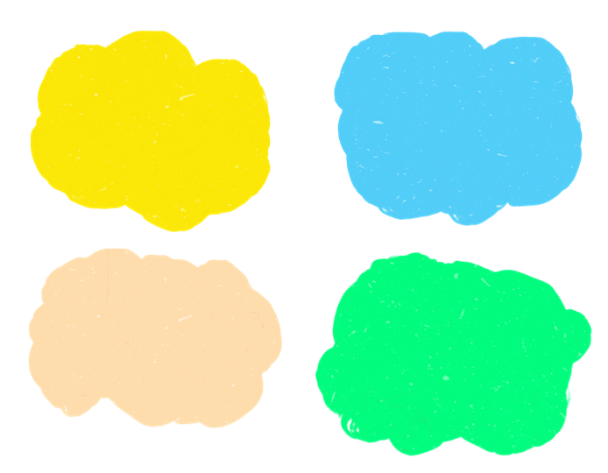
What is at the centre of black holes?

How do black holes form?

Activity: Vocabulary
Students will brainstorm a list of key words that relate to the BTN Black Hole Discovery story. Here are some words to get them started.

Quasar
Black Hole
Light Years
Supermassive

Mass
Astrophysicist

Ask students to write what they think is the meaning of each word (including unfamiliar words). They will swap definitions with a partner and ask them to add to or change the definition. Check these against the dictionary definition.

Further activities for students:
- Students will add to their glossary by downloading the transcript for the BTN Black Hole Discovery story and highlight all the words that relate to the topic. For example, accretion disk, event horizon, the singularity, supernova and spaghettification.
- Who explores the universe? Learn more about the jobs involved with space exploration. Choose one job and investigate what the job involves and what you need to study to become one.
- Astronomers generally divide black holes into three categories. There are stellar mass black holes, supermassive black holes, and intermediate mass black holes. Do some research and then write a definition for each using your own words. Visit the NASA website to learn more.

Activity: Guide to Black Holes
NASA – Guide to Black Holes  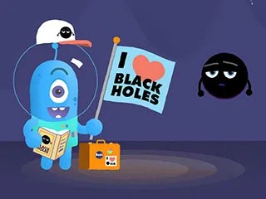 | Thinking about doing some black hole watching the next time you’re on an intergalactic vacation, but you’re not quite sure where to start? Well, look no further!  This series of animated NASA videos shows you everything you need to know. With topics ranging from basic black holes, to fancy black holes, to giant black holes and their companions. Watch this NASA animation to learn more about black holes.
NASA – Inside a Black Hole  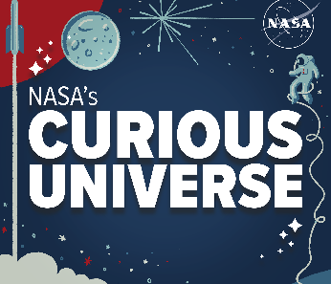 | Don’t let the name fool you: a black hole is anything but empty space. Black holes are some of the most extreme, bizarre and fascinating objects in the universe. Regina Caputo and Jeremy Schnittman describe what it might be like to go hunting for one.  NASA - Link to podcast

Activity: Life Cycle of a Star
Most black holes form from the remnants of a large star that dies in a supernova explosion. To help explain how black holes form it is useful to understand the life cycle of a star.

Class Discussion
Begin with a brief discussion to find out what your students know about stars. Encourage them to share their ideas. Explain the following concepts to your students. You may want to refer to NASA’s Star Basics, which looks at the birth, life, and death of stars. As you explain new concepts to your students identify new words to add to your class glossary.

Facts about stars:
- Stars are the most basic building blocks of galaxies.
- Stars are giant balls of hot gas – mostly hydrogen, with some helium and small amounts of other elements.
- Stars are non-living, but they have a life cycle, similar to plants and animals.
- Stars can have different masses.
- Depending on the mass of the star, there are two possible outcomes.
  - Low and medium mass stars burn cool and last for billions of years.
  - For stars much larger and hotter than our Sun, high-mass stars, the ending will be a spectacular explosion called a supernova.
- After a high-mass star explodes, a black hole is formed.
- The 2 most common types of black holes are called stellar-mass and supermassive.
- It is likely that our Milky Way Galaxy contains around 10 million black holes, but we will probably only ever 'see' about 1,000 of these.

Create
- Students will use neon paints to create their impression of a black hole. Display in your classroom or a room that can be darkened to highlight student’s artworks.
- Students will find images of the different stages in the life cycle of a star. Use these images to display the life cycle of stars as a concept map. Students will include the following in their life cycle: massive star, red supergiant star, supernova, and a black hole.

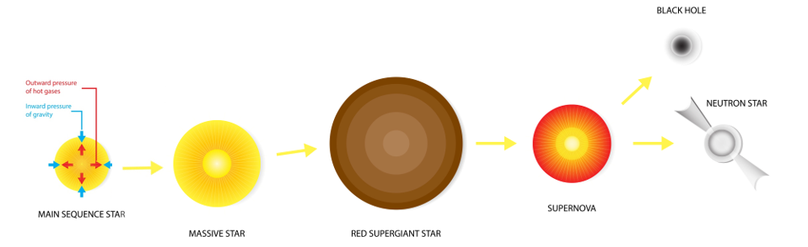

Activity: Science Investigation
Modelling the formation of a black hole
This 'Science in School’ activity will demonstrate to students how a black hole is formed through the collapse of a massive star, once the core of the star is unable to support the weight of the outer layers of gas surrounding it. The materials required for this activity include a balloon, aluminium foil, and a pin.



Activity: Black Hole Facts
In small groups, students will find out as much as they can about black holes and compile the information they find into a list of facts. Provide students with a list of suggested questions and/or topics to guide their research, for example:
- What is a black hole?
- How do black holes form?
- Characteristics of black holes
- Significant black holes in the universe

Facilitate a class discussion by asking each group to share one interesting fact they learned during their exploration. Record students’ responses on the white board to create a collective list of facts about black holes.

Students will use the facts they have discovered about black holes to create a quiz and then test their classmates. Students will include a range of quiz styles, for example:
- Multiple choice

- True or false
- Fill in the blank
- Use photos or pictures
- When an answer is revealed, provide extra information to explain the answer.

Students can make their quizzes in Kahoot or Quizizz. Make it fun, engaging, and educational!

Useful Websites
- Researchers discover fastest-growing black hole that consumes the mass of 'the Sun and all the planets' combined — every day – ABC News
- Black Hole Basics – NASA
- Black Hole Photo – BTN
- Black Holes – National Geographic
- Space and our Solar System – ABC Education
- What is a black hole? (Grades 5-8) – NASA
- A Field Guide to Black Holes – NASA

