EPISODE 17
14th June 2022

KEY LEARNING
Students will view a range of BTN stories and use comprehension skills to respond to a series of focus questions.

CURRICULUM
English – Year 4
Use comprehension strategies to build literal and inferred meaning to expand content knowledge, integrating and linking ideas and analysing and evaluating texts.

English – Year 5
Use comprehension strategies to analyse information, integrating and linking ideas from a variety of print and digital sources.

English – Year 6
Use comprehension strategies to interpret and analyse information and ideas, comparing content from a variety of textual sources including media and digital texts.

English – Year 7
Use comprehension strategies to interpret, analyse and synthesise ideas and information, critiquing ideas and issues from a variety of textual sources.
  - Teacher Resource

Focus Questions
As a class, discuss the stories featured in the episode of BTN Classroom and record the main points of the discussion. Students will then respond to the following focus questions.

Gas Shortage
- Gas is not a fossil fuel.
  - True
  - False
- Why is there a shortage of gas at the moment? Give at least two reasons.
- Which countries does Australia export natural gas to?
- Which state keeps 15% of gas produced for Aussies?
- What are some solutions to the gas shortage problem?

Check out the teacher resource on the Teachers page.

Cost of Living
- Name three things that have gone up in price recently.
- What recent weather event has caused the price of fruit and vegetables to rise?
- What other things are affecting the price of goods at the moment?
- What does CPI stand for?
  - Consumer Price Iceberg
  - Consumer Price Index
  - COVID Pandemic Index
- What questions do you have about the Cost of Living story?

Blood Donation Crisis
- How many Australians will need to be give blood at some point in their life?
  - 1 in 3
  - 1 in 10
  - 1 in 50
- What are the components of blood?
- Why is there a shortage of blood at the moment?
- The Red Cross needs about 33,000 donations of blood and plasma each week. True or false?
- What was surprising about this story?

Check out the teacher resource on the Teachers page.

Indigenous Seasons Part II
- Gunbalanya is about 300km east of which capital city?
- How many seasons are in the Gunbalanya seasonal calendar?
- What animal tells us that the season Yekke is beginning?
  - Dragon Fly
  - Fish
  - Turtle
- What is the most important part about eating food on country?
- What did you learn watching this story?

Champion Roller Skater
- How old is Ivy?
- Where did Ivy win the Artistic Skating World Cup?
- What is artistic roller skating similar to?
- How many hours a day does Ivy train?
- What message would you send to Ivy about her roller skating achievements?

EPISODE 16
14th June 2022

KEY LEARNING
Students will develop a deeper knowledge of what natural gas is and why it’s in short supply at the moment.

CURRICULUM
Geography – Year 4
The use and management of natural resources and waste, and the different views on how to do this sustainably.

Science – Year 4
Science knowledge helps people to understand the effect of their actions.

Science – Year 5 and 6
Scientific knowledge is used to solve problems and inform personal and community decisions.

Science – Year 7
Some of Earth’s resources are renewable, including water that cycles through the environment, but others are non-renewable.

  - Teacher Resource

Gas Shortage

Focus Questions
Discuss the BTN story as a class and record the main points of the discussion. Students will then respond to the following:
- Gas is not a fossil fuel.
  - True
  - False
- Why is there a shortage of gas at the moment? Give at least two reasons.
- Which countries does Australia export natural gas to?
- Which state keeps 15% of gas produced for Aussies?
- What are some solutions to the gas shortage problem?

Activity: Class Discussion
Discuss the information raised in the BTN Gas Shortage story. Ask students to record what they know about natural gas on a mind map. What questions do students have? Use the following questions to guide the discussion.
- What is natural gas?
- Give some examples of what natural gas is used for.
- Where is natural gas found?
- Why is there a natural gas shortage in some parts of Australia at the moment?
- What impact is the war in Ukraine having on world gas supplies?
- Create a T-chart with the pros and cons of selling natural gas to other countries.

Activity: Glossary
Students will brainstorm a list of key words that relate to the BTN Gas Shortage story. Here are some words to get them started.

NATURAL GAS | ENERGY | NON RENEWABLE
FOSSIL FUEL | EXPORT | ECONOMY

Activity: Fossil Fuel Research
Discuss the information raised in the BTN Gas Shortage story. What questions were raised in the discussion and what are the gaps in students’ knowledge? The following KWLH organiser provides students with a framework to explore their knowledge on this topic.

What do I know? | What do I want to know? | What have I learnt? | How will I find out?

Students will develop their own question/s to research or choose one or more of the questions below.
- What is natural gas and how does it form?
- When and where was natural gas first discovered in Australia?
- Where in Australia are natural gas reserves? Mark on a map.
- What are fossil fuels and what are the issues with continuing fossil fuel use?
- How do living things turn into fossil fuels?
- How much of the world’s energy supply comes from natural gas?
- Will we ever run out of natural gas? Why or why not?
- What is the difference between renewable and non-renewable energy? Record your responses on a Venn diagram.

Activity: Design a Sustainable Community
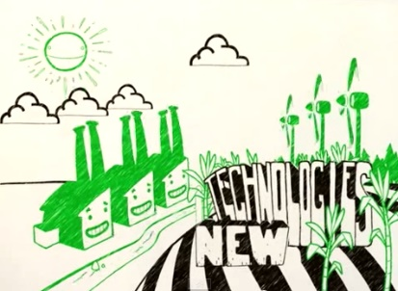
Students will design a community that relies more on renewable resources. For example, redesign a community with an emphasis on pedestrians, bikes and public transport, rather than on cars. Students may create a community where we can work, go to school and shop closer to where we live, create more bike lanes, have more people living closer together so they can support public transport and create safer streets to encourage walking and riding.
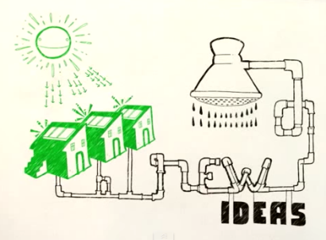
Students should consider the following:
- What renewable energies will you need to power your city?
- How can your city be more water smart? Consider including storm water harvesting technology.
- Will you build lots of little houses or a few high-density apartment buildings?
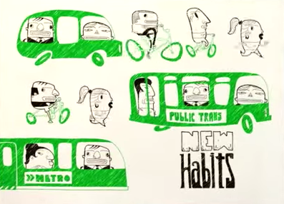
- Is your city pedestrian and cyclist friendly?
- What sort of transport will your city use?
- What recycling programs will your city have?

Watch this YouTube animation about climate change, energy and action to get inspired!

Activity: Quiz

- Natural gas is a fossil fuel.  A. True  B. False  - Which of these countries does Australia export natural gas to?  A. Japan  B. China  C. South Korea  D. All of the above  - What is the main component of natural gas?  A. Hydrogen  B. Nitrogen  C. Methane | - Natural gas is a renewable resource.  A. True  B. False  - Which state keeps 15% of gas produced for Aussies?  A. Western Australia  B. South Australia  C. Queensland

Quiz Answers: 1A, 2D, 3C, 4B, 5A

Useful Websites
- Federal government’s `gas trigger’ to keep supplies onshore may not be pulled just to put a lid on high prices – ABC News
- Gas Bonanza – BTN
- Fossil Fuels – BTN
- Coal Explainer – BTN

EPISODE 17
14th June 2022

KEY LEARNING
Students will develop an understanding of the biology of blood and ways to encourage people to donate blood.

CURRICULUM
Science – Year 4
Science knowledge helps people to understand the effect of their actions.

Science – Year 5 and 6
Scientific knowledge is used to solve problems and inform personal and community decisions.

Science – Year 7
People use science understanding and skills in their occupations, and these have influenced the development of practices in areas of human activity.

Scientific knowledge has changed peoples’ understanding of the world and is refined as new evidence becomes available.

  - Teacher Resource

Blood Donation Crisis

Focus Questions
Discuss the BTN story as a class and record the main points of the discussion. Students will then respond to the following:
- How many Australians will need to be give blood at some point in their life?
  - 1 in 3
  - 1 in 10
  - 1 in 50
- What are the components of blood?
- Why is there a shortage of blood at the moment?
- The Red Cross needs about 33,000 donations of blood and plasma each week. True or false?
- What was surprising about this story?

Activity: Class Discussion
Discuss the BTN story as a class. Create a class mind map with BLOOD DONATION in the middle. Ask students to record what they know about blood donation. What questions do they have? In small groups, ask students to brainstorm responses to the following questions:
- What is blood donation?
- Do you know anyone who has either donated blood or has received a blood donation?
- How do you feel about blood donation?
- Why is there a shortage of blood donations at the moment?
- What questions do you have about this topic?

Activity: Glossary
Students will brainstorm a list of key words that relate to the BTN Blood Donation Day story. Below are some words to get them started. Students will create their own class glossary of scientific keywords and terms. Consider using photos, illustrations and/or diagrams to help explain each keyword.

PLATELETS | PLASMA | WHITE BLOOD CELLS
BLOOD GROUPS | RED BLOOD CELLS | BLOOD DONATION

Activity: Six Hat Thinking
As a class, use Edward De Bono’s Six Hat Thinking to explore the issues raised in the BTN Blood Donation Crisis story. Make your own coloured hat cut outs and place on the floor. Students will take it in turns answering questions in relation to what they already know about the issue, what they have learned from the story and what they want to learn further about the topic. Ask students to respond to the following questions:

- How did the Blood Donation Crisis story make you feel?
- What do you know about blood donation?
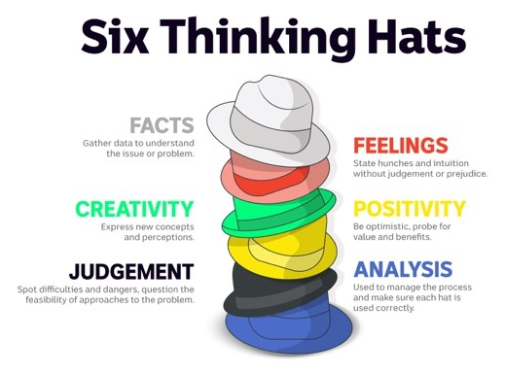
- What have you learnt from the story?
- Were there any positives from the story? If so, what were they?
- What are some of the negatives or challenges that you learnt from the story?
- Why is it important to find out more about blood donation?
- What questions were raised during this activity?
- What do you want to learn further about this topic?

Reflection
After this activity, ask students to reflect on what they have learnt. Students can include details about how their thinking on this issue has changed.

Activity: Research inquiry
The KWLH organiser provides students with a framework to explore their knowledge and consider what they would like to know and learn. Students will develop their own question/s to research. Students will collect and record information from a wide variety of sources.

What do I know? | What do I want to know? | What have I learnt? | How will I find out?

Activity: The science of blood
Students will learn more about the basics of blood including the four main components of blood, blood’s biological properties and the function of blood. Students will create their own class glossary of scientific keywords and terms that relate to blood and blood donation.

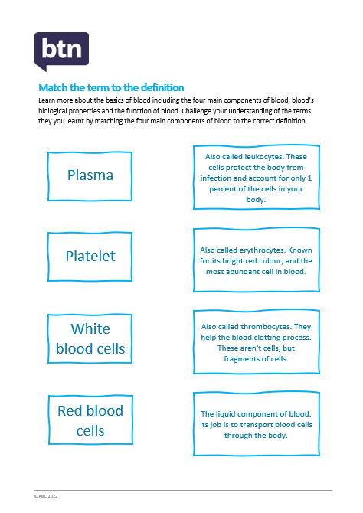
Challenge students understanding of the terms they have learnt by matching basic blood terms to the correct definition. See the template at the end of the activity.

Students will then research and complete one or more of the following:
- Create a quiz about the components of blood and then challenge your classmates.
- Design a public education campaign to raise awareness about blood donation.
- Build on your glossary by adding more terms related to the biology of blood. For example, antigens, antibodies, haemoglobin or circulatory system. Use photos, illustrations and/or diagrams to help explain each keyword.

Activity: Jigsaw learning
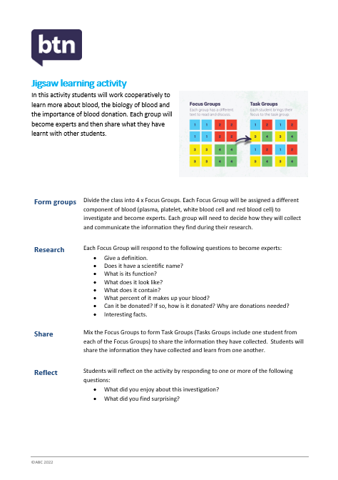
Consider using jigsaw learning in your classroom, a cooperative activity that enables students to specialise in an aspect of a topic, and then teach what they have learnt to their classmates. See the template at the end of the activity.

Useful Websites
- Blood Donation Day – BTN
- Learn about blood donation – Australian Red Cross
- How bones make blood? – TEDEd
- How the heart actually pumps blood – TEDEd
- Blood Types – Healthdirect
- Why Donate Blood? – Red Cross
- World Blood Donor Day 2022 – World Health Organisation
- Know Your Blood Type Essentials – Red Cross

Match the term to the definition
Learn more about the basics of blood including the four main components of blood, blood’s biological properties and the function of blood. Challenge your understanding of the terms you have learnt by matching the four main components of blood to the correct definition.

Plasma
Platelet
White blood cells
Red blood cells
The liquid component of blood. Its job is to transport blood cells through the body.
Also called erythrocytes. Known for its bright red colour, and the most abundant cell in blood.
Also called leukocytes. These cells protect the body from infection. These cells are produced by bone marrow.
Also called thrombocytes. They help the blood clotting process. These aren’t cells, but fragments of cells.

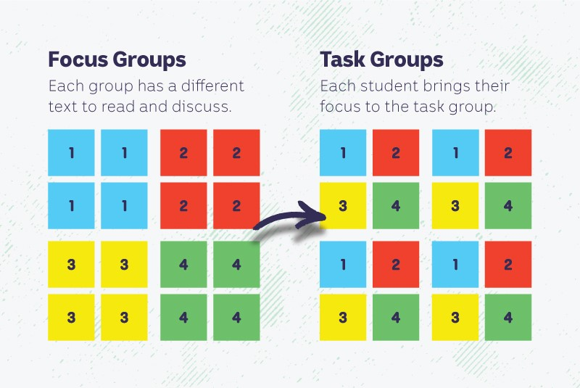
Jigsaw learning activity
In this activity students will work cooperatively to learn more about blood, the biology of blood and the importance of blood donation. Each group will become experts and then share what they have learnt with other students.

Form groups | Divide the class into 4 x Focus Groups. Each Focus Group will be assigned a different component of blood (plasma, platelets, white blood cells and red blood cells) to investigate and become experts. Each group will need to decide how they will collect and communicate the information they find during their research.
Research | Each Focus Group will respond to the following questions to become experts:  - What is its scientific name?  - What is its function?  - What does it look like?  - What does it contain?  - What percent of it makes up your blood?  - Can it be donated? If so, how is it donated? Why are donations needed?  - Interesting facts.
Share | Mix the Focus Groups to form Task Groups (Tasks Groups include one student from each of the Focus Groups) to share the information they have collected. Students will share the information they have collected and learn from one another.
Reflect | Students will reflect on the activity by responding to one or more of the following questions:  - What did you enjoy about this investigation?  - What did you find surprising?

  - Teacher Resource

BTN Transcript: Episode 17 - 14/6/2022

Hey, I'm Amelia Moseley and you're watching BTN. Thanks for hanging out with us again, let’s see what’s coming up on today’s show. We find out why lettuce is a hot ticket item, head down to the Red Cross to learn why donating blood is super important and Amal gets her skates on to roll with a world champ.

Gas Shortage

Reporter: Amelia Moseley

INTRO: That looks like fun, and we'll get to it soon. But first, a lot of the country is going through a cold snap right now which means more of us are switching on our heaters and having nice hot showers to stay warm. And that would be all well and good except Australia's facing a gas shortage. Let's find out how that's happened and what's being done to fix it.

Gas. We cook with it. Heat with it. Power stuff with it. So, what would happen if we didn't have enough of it? Well, that's a problem lots of Aussies are facing right now, a gas shortage. Gas is a fossil fuel, just like oil and coal. It comes from deep inside the earth. When plants and animals died millions of years ago, intense heat and pressure over a long time turned them into fossil fuels. Gas can be found in layers of rock with tiny holes, and we get it out by drilling. We can store it underground send it through pipes burn it to create electricity, or even chill it to turn it into liquid and transport it in a tanker.
Australia is actually one of the world's biggest gas producers which means we have access to a lot of it. But gas is also one of our biggest exports. Countries like China and Japan pay for us to send it over to them so they can use it to power their own stuff and that brings in billions of dollars a year to our economy. But right now, there's way more demand around the globe than usual. Many countries are experiencing a shortage because they're no longer buying gas and oil from Russia, another really big exporter, after it invaded Ukraine. At the same time, there's a cold snap hitting parts of Australia so more people are powering up to stay all warm and cosy. And on top of that quite a few coal fired power stations in Australia have gone offline lately because of outages and maintenance. Which means gas generators are taking a heavier load.

So, what does that mean for your average Joe? Well, it means energy is more expensive for many Aussies. In some cases way more expensive. And not just for families, but for businesses and manufacturers too. Which means all sorts of other stuff we buy could become more pricey or harder to get. Now you might be thinking can't we just stop sending so much gas overseas? But no Joe, it's not that simple. Australia has long-term contracts that we can't easily back out of, although there is an option called the Australian Domestic Gas Security Mechanism. It's a "trigger" the government can pull to limit how much gas we send overseas in circumstances where we really need it. It's not an easy or quick fix, though.
So, if we wanted to, say, produce more energy the fastest way would be to power up old coal fired stations which some people say we should do. But that's not great news for the environment and the federal government says it wants to phase out fossil fuels not use more of them. So, recently Australia's federal, state and territory energy ministers got together to try to work out a solution.
CHRIS BOWEN, FEDERAL ENERGY MINISTER: There was a real spirit of teamwork between all of us, Labor, Liberal and Greens.
Aw that's nice. They decided the best option for now is to let energy companies store some gas for emergencies. Something Western Australia’s government already does. They also want to make energy supplies more reliable, concentrate on bringing more renewable energies onto the grid like wind and solar and find better ways to store the energy they produce. Of course, that's gonna take some time and money and energy, so it won't be the last time we all hear about this stuff.

News Quiz

Prime Minister, Anthony Albanese, has hosted his first foreign leader since winning power last month. Who is this international leader? It's New Zealand's Prime Minister Jacinda Ardern. The two have a lot to talk about including the global economy, COVID-19 and the war in Ukraine.
NASA's getting ready to launch three rockets later this month from right here in Australia. Where are the rockets launching from? Is it the Northern Territory, Australian Capital Territory or South Australia? It's the Northern Territory. Between the 26th of June and the 12th of July three rockets will blast off from the Arnhem Space Centre. It'll be NASA's first launch from a commercial site outside of the US and the first take off from Australia this century.

ANTHONY ALBANESE, AUSTRALIAN PRIME MINISTER: It’s about sending a message to younger Australians of how important science is.

The rockets will have equipment onboard that can study things like the light coming from stars.
And Australia's longest running soap-opera, Neighbours is leaving our TV screens forever. It finished up production this week, after almost 9000 episodes. So, how many years has Neighbours been running for? 17, 27 or 37 years? It's 37 years. Neighbours helped launch the careers of actors and performers like Kylie Minogue, Liam Hemsworth, and Margot Robbie.
Cost of Living

Reporter: Joe Baronio

INTRO: Now, all of these things are costing Aussies way more than they used to, which is why you've probably heard people talking about the "cost of living" going up. Joe explains what that means.
Michelle: Wow, this place looks amazing.
Joe: Yep, it's the best place in town. You're in for a real treat.
Michelle: Where's the menu?
Joe: No need. I've already ordered us the finest, most expensive meal they have.
Michelle: You shouldn't have.
Waiter: Madame. Monsieur. Your first course.
Joe: Go on. tuck in. Go on, have a go.
Okay, so maybe this isn't what you'd expect an expensive meal to look like, but right now, it kinda is. See, recently the price of just an iceberg lettuce has gone ballistic. From a humble $2.80 ball of leaves to a $12 lump of green gold in some places. It's causing some people to get a bit desperate and even some fast-food chains are having to find alternatives. But it isn't just lettuce where we're feeling the crunch. Ha, get it? Crunch? Never mind. Meat, dairy, cereals, and other vegetables have all got more expensive this year. In fact, if you look around, it might seem like everything has.
JOE: Ah, waiter, to drink, can we get a glass of whatever's the most expensive.
WAITER: Ah, of course.
JOE: Yep, that looks good to me.
MICHELLE: What is that?
WAITER: This? Ah, it's our finest unleaded 91.
JOE: Ooh. Mm, that's good.

MICHELLE: You can drink that.
Yep, petrol prices have gone through the roof. Along with electricity and gas. Those everyday expenses are things we refer to as the cost of living, and right now millions of Australian households are needing to foot hundreds of extra dollars a week just to pay for the essentials. So, what's going on with all the price hikes? Well, a lot, really. Some are easy to understand, like the recent flooding in eastern Australia, which destroyed millions of dollars of crops and lead to produce shortages. Others are a bit more complicated, like the COVID-19 pandemic, supply bottlenecks, and the on-going war in Ukraine.
Jim Chalmers, Treasurer: This inflation challenge will get harder before it gets easier.
When everything becomes more expensive and you get less for your money, that's called inflation, and it's measured by the Consumer Price Index, or CPI, and since last year that's risen to 5.1 per cent.
WAITER: For you. A little taster, compliments of the chef.
JOE: Ooh, this is going to be really expensive.

MICHELLE: What?
On top of the inflation problem, Aussies have been just hit with another challenge: higher interest rates. The Reserve Bank of Australia, or RBA, has increased them for the second time this year. That makes borrowing money more expensive, and it means some people will have to pay hundreds of dollars more per month on their home loans.
Kate Gallagher, Finance Minister: Jim and I aren't pretending that anything's easy or that there's a silver bullet for many of these issues that are facing the economy and facing households right now, but we're working hard.
It all sounds pretty negative but there's help on the way. The government says many Aussies will get a one-off payment at tax time and it's already reduced the fuel tax to bring prices at the pump down. And while it might be harder at the moment, higher interest rates will hopefully help bring inflation down and make things more affordable, eventually. But, until then, fine dining might look a little bit different.

Blood Donation Crisis

Reporter: Amal Wehbe

INTRO: Today is World Blood Donor Day. In Australia 1 in 3 Aussies will need a blood donation in their lifetime but only 1 in 30 actually donates. Red Cross Lifeblood wants to change that, especially because it's been facing shortages recently. Amal looks into it.

AMAL: I'm here at a blood donor centre and I'll be joining a regular blood donor to find out what it's all about. Speaking of, here he is. Hey Savon.
SAVON: Hey, how are you?
AMAL: I'm good how are you?
SAVON: I’m excellent.
AMAL: Alright, so should we head up?
SAVON: Yep.
AMAL: Let's go.
This is Savon's third time donating. Repeat donors like Savon are really important because one in three Aussies will need to be given blood at some point in their life. That's the same portion of Aussies who listen to podcasts or are born overseas or love their pet more than their family. It's a lot of people.
AMAL: So, can you walk me through what you're doing here?
SAVON: So right now, I'm just filling out this survey before I donate my blood to make sure that it is clean and healthy, and ready to give to those people in the hospitals.
AMAL: Alright well let’s fill in your documents so you can go donate.
AMAL: So, how are you feeling?
SAVON: I’m pumped.
AMAL: Gonna get your blood pumped.
NURSE: You got a beautiful vein thank you so much again, alright.

AMAL: And can you like tell me exactly what’s happening here?
SAVON: So right now, there's a needle in my arm, they're taking out a total of 500 ml of blood. So, that's whole blood in terms of plasma, platelets, and red blood cells as well.
Most blood donations end up going to people who have cancer or other diseases. Then there's people having surgery, people with broken bones, mums and their newborn babies, and people who’ve been in accidents.
AMAL: So, donating blood is pretty important all year round. But the Red Cross says it's more important than ever, because here in Australia, we've got a blood shortage.
Blood stocks have dropped recently because around the country there's been a surge in flu cases, colds, and yes COVID-19 is still with us. They've all meant fewer donors lining up to give blood and up to half of all appointments have been cancelled.
JEN SALTER, RED CROSS: Blood is one of those things that can't be stockpiled, and it can't be made out of anything else. It's not like pasta or toilet paper, we can't keep it in the cupboard. It has to be fresh. So, that's why we need people to keep coming in and keep donating, because that's what patients need.
And they need a lot of it.
JEN SALTER, RED CROSS: What we know is that we need about 33,000 donations of blood and plasma every single week just to meet the demands of patients.
Which is why you might have seen more campaigns recently targeting new donors. Back to Savon, and he's done, which means it's time for a quick snack and drink, to help recover and rehydrate.
AMAL: So, now you're having your well-deserved snack, how do you feel?
SAVON: I'm good. I'm excited for a day of rest and relaxation.
AMAL: Sounds like a great idea. And so why is it important for people to donate?
SAVON: Well, it's really important for hospitals to keep a healthy supply of healthy blood and especially with Australia's blood shortage now is more important than ever, that you come in and donate blood.

Indigenous Seasons Part II
Reporter: Rulla Kelly-Mansell

INTRO: Now, let's dive back into the many seasonal calendars used by different Indigenous groups around Australia. The Gunbalanya community in the Northern Territory follows six seasons which tells them when to do things like fish and hunt. Rulla headed to the Top End to learn more as part of a new series by the ABC and CSIRO. Check it out.
RULLA: G'day you mob, I'm Rulla Kelly-Mansel, I'm in Gunbalanya, West Arnhem Land and I'm here to learn about the seasonal calendar and why it's important to the local mob here. Some come with me.
Gunbalanya is approximately 300 kilometres east of Darwin in the Northern Territory and one of the closest towns to the Kakadu National Park.
JULIE, ELDER: There are six seasons in the Gunbalanya seasonal calendar, each play a role in telling us something about Country.
RULLA: We’re on Country. What season are we in at the moment?
KIDS: Yekke.
RULLA: Yekke. What are some things we are going to see in Yekke? These two things here hey?
KIDS: Yes.
RULLA: Helena, what's the most important part about eating food on Country?
HELENA, ELDER: We follow the seasons, so we know exactly what to eat, in quantities, following the food chain is important so we can eat our omega oils in our fish, in our turtle and vitamins, in our plums and yam. It's important to us so our children can be healthy, our old people can be healthy. And it’s been practised from generation after generation, and it’s important for us to eat it so to keep healthy eating alive. And we go out there, as soon as the season, and we know exactly when.
One of the edible plants found in Gunbalanya this time of the year is the water lily. And they are very very nutritious.

RULLA: Is this in season at the moment?
KIDS: Yes.
RULLA: And what do you do with it when it's in season?
KIDS: We eat the stem part.
RULLA: What does that taste like?
KIDS: Celery.
RULLA: Celery, ooh, can we try some?
KIDS: Yes.
RULLA: Beautiful. Taste like the Top End.

RULLA: Do you have a favourite season?

GUNBALANYA ELDER: My favourite season is Kurrung, when it’s really dry and I go turtle hunting. That’s the time when I go out and hunt and find lots of turtles. I hunt with a crow bar, before long time old people used to hunt with a stick, they used to look, go and look for the special tree that would make, like a digging stick but, used for looking for turtle. Hitting the turtle in the shell when we go stabbing it in the mud, then we would find it, if you hit the turtle shell and we know it’s a turtle, we would find it.
I've dug my feet into the beautiful Country here in Gunbalanya. I've enjoyed trying the local food, I’ve enjoyed going to some local spots, and learning some local language.

RULLA: And with the local Elders and the younger generations I've learned a lot about the seasons here in West Arnhem Land.

And I’m looking forward to coming back and experiencing all the seasons on the Kunwinjku calendar.
Sport

The Maroons have taken out the first game of the State of Origin, which is great. Unless you're from New South Wales. Olympic Stadium was packed full of Blues fans who'd come to see the first home game in a couple of years and while it started well enough, Queensland ended up on top 16 to 10. It was the Blue's first loss on home soil since 2017. The next game will be in Perth on June 26th.
Swedish golfer Linn Grant has just become the first female player to ever win on the men's European tour. The 22-year old finished a huge 9 strokes ahead of fellow Swede Henrik Stenson with an 8-under par 64 at the DP Tour mixed event on Sunday.
Back home in the outback, the world famous Finke Desert Race has just wrapped up. It's billed as the toughest off-road motorsport event in the country and it's easy to see why. 148 cars and 487 motorbikes made the gruelling two day, 460 kay trip from Alice Springs to Aputula, also known as Finke, and back again.
From the heat of the outback to a freezing ice bath. Yep, the Big Freeze took place at the MCG for the first time since 2019. Basically, it's a bunch of celebs in funky costumes getting dunked in freezing water to raise money for Motor Neurone Disease research and this year’s star studded line up included Ash Barty, Justin Langer and Hamish Blake, just to name a few.
Champion Roller Skater

Reporter: Amal Wehbe

INTRO: Now, you're about to meet nine year old Ivy. She's a world champion artistic roller skater who's just come back from competing in Italy. Amal laced up her skates for a masterclass with the world champ.
This is the moment that 9 year old Ivy Kerekemeyer won the Artistic Skating World Cup in Italy.
AMAL: And now I'm about to meet the World Champion herself. I brought my roller skates so hopefully I can learn some tricks. Let's go.
AMAL: Hey Ivy, how are you?
IVY: Hi.
AMAL: So, can you tell me a little bit about yourself?
IVY: Well, I'm 9 years old and I've been skating ever since I was 2 years old. Cause my mum used to skate, so she took me to learn to skate class myself. So, then I started just going once a week and then it started progressively building up.
AMAL: So, you specifically, you compete in artistic roller skating, what is that?
IVY: Artistic roller skating is a series of jumps and spins all put into one routine and it's a lot like ice skating.
LUCY: In 2018 she did her first nationals, and it was the first time she had some real competition and she wasn't overly successful and she didn't like that feeling. So, she came home at the end of 2018 to the beginning of 2019 and just worked worked, worked and then went back to nationals in 2019 and won. And then I think that ignited a fire in her and ever since then she's driven and passionate and very dedicated.
Ivy now trains 4 hours a day, 7 days a week and has competed in more than 40 competitions.
AMAL: You just came back from Italy competing in the World Cup, can you tell me about that?
IVY: Well, first of all going to Italy was very nerve wracking. But I just went out there did my best and came home with a gold trophy.
AMAL: Not just a gold trophy, you were the best in the world weren't you?
IVY: Yes.
Ivy performed a 3 minute routine at the Artistic Skating World Cup going up against more than 20 of the best skaters in her mini division.
AMAL: What was going through your head when you found out you won?
IVY: You should’ve seen my face on Instagram.
AMAL: Were you not expecting it?
IVY: No, not at all, I thought some of those girls were so much better than me.
AMAL: So, do you think you're gonna keep on roller skating in the future?
IVY: Yeah definitely, I definitely think I'll keep skating.
AMAL: Alright and Ivy, you might've noticed that I brought some of my roller skates and I was actually wondering if we can head on there and you can teach me a few tricks, how does that sound?
IVY: Sure.
AMAL: Yeah. Oh my gosh, I’m super keen. Let’s go. I'm keen to learn some roller skating tricks, what are you gonna teach me?
IVY: I'm gonna teach you marching steps and leg lifts.
AMAL: Alright cool let's go. What do you want to do first?
IVY: So, you gotta lift your knees up.
AMAL: Lift my knees up, okay. These are called marching steps?
IVY: Yes, cause you're marching.
AMAL: Have you got any like cool moves you like to pull out?
IVY: Well, I like to do my billman.
AMAL: Ooh what's that?
IVY: It's where I spin with my leg over here.

AMAL: What’s it called?

IVY: It's called a billman. It's like, you spin like this.
AMAL: Should I try that or should we just not?
IVY: No.
AMAL: That's probably a good idea.
IVY: You're a beginner.
AMAL: I'm a beginner.
Well, there you have it, I'm no world pro and still a beginner, but for Ivy, looks like the world is her roller rink.
AMAL: Oh my gosh Ivy, watch out, I'm gonna come for your world cup title.
IVY: I'm going overlap you.
AMAL: No, impossible.

Closer

Ah Amal, you gave it your best shot. Well, that's all we've got for you today, thanks so much for hanging out with us again. I hope you learnt something along the way, but before you go, don't forget there are plenty more stories and things to do on our website, so check that out. And of course, there's always Newsbreak right here in the studio every weeknight to keep you up to date. We’ll catch you next week. Bye for now.

