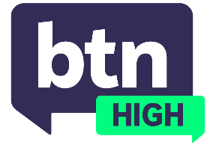
  EPISODE 28
  27th May 2026
  KEY LEARNING
  Students will discover what the Turing Test is and discuss whether it needs changing.
  CURRICULUM
  Science – Years 7 and 8 (v8.4)
  Science – Year 7 (v9.0)
  Science – Years 9 and 10 (v8.4)
  Design and Technologies – Years 7 and 8 (v8.4)
  Design and Technologies – Years 9 and 10 (v8.4)
  Design and Technologies – Years 7 and 8 (v9.0)
  Design and Technologies – Years 9 and 10 (v9.0)
  - Teacher Resource

Turing Test

Focus Questions
Discuss the BTN High story as a class and record the main points of discussion. Students will then respond to the following:
- What is the Turing Test?
- Why was it invented?
- Does it surprise you that some of today’s chatbots passed the Turing Test? Why or why not?
- What is consciousness? Why is it so difficult to test for?
- Do you think AI could become conscious?
- What would it mean for humanity if AI developed consciousness?

Activities
- Imagine you’re a writer for a tech magazine. Write an opinion piece on whether you think AI is becoming conscious or whether it could be in the future.
- Can you think of your own way to test for artificial intelligence? In small groups, brainstorm ideas for a test of your own.
- Perform your own version of the Turing Test. Either in small groups or as a class, have someone propose a question. Assign one student to collect an answer from a chatbot and another student to answer the question (without letting the questioner know which is which). See if the questioner can work out which answer is from a human and which is from AI.

