Episode 35
3rd December 2019



Aussie News 2019
- What natural disasters has Australia experienced in 2019? Give one example.
- Which town did BTN visit to find out how people were doing during the NSW and QLD bushfires?
- What extreme weather is affecting farmers?
- In which river system did millions of fish die this year?
- Complete the following sentence. Zoos Victoria stopped selling products that contain _______ oil.
- What was the first Australian city to ban single use plastics?
- Who won the 2019 Federal Election?
- Which former Australian Prime Minister died in 2019?
- In 2019 a ban was placed on climbing Uluru. True or false?
- Which Australian tennis player became number one in the world in 2019?

World News 2019
- Which rainforest experienced big fires this year?
- What was the Oxford Dictionary’s word of the year?
- Why were people in Chile and Colombia protesting this year?
- Why are people in Hong Kong protesting?
- Complete the following sentence. US President Donald Trump made history this year by visiting North _________.
- How many US Presidents have been impeached?
  - 1
  - 2
  - 3
- What is Brexit?
- What iconic Parisian building was nearly lost in a fire?
- Which country landed a lunar rover on the dark side of the Moon for the first time?
- Which world news story would you like to know more about? Why?

Kids Stories 2019
- What politician did Ashlee interview in the BTN studios this year?
- What well-known Aussie musician did young singer-songwriter Jasmin interview on BTN?
- What African country did Abdul and Samba report from?
- What language do they speak with their family?
- What is Holi?
- Hinduism is the 2nd most practised religion in the world. True or false?
- What is the holiest day of the year on the Jewish calendar?
- Who is Mr Percival?
- How has air pollution affected people in India?
- Why have kids been protesting in Australia?

Bloopers 2019
- What do you think was the funniest moment on BTN this year?
- Choose your top 5 stories from BTN this year. Briefly explain why you chose the stories.
- What topics or issues would you like to see reported on BTN next year?
- What changes would you make to BTN?
- Choose your favourite story on BTN this year and write a brief summary of what the story was about.

Check out the Year in Review resource on the Teachers page.

Teacher Resource
Episode 35
3rd December 2019

Year in Review 2019

Students will choose their favourite stories from BTN in 2019. Students will reflect on a range of events that occurred during 2019.


English – Year 6
Use comprehension strategies to interpret and analyse information and ideas, comparing content from a variety of textual sources including media and digital texts.

Compare texts including media texts that represent ideas and events in different ways, explaining the effects of the different approaches.

English – Year 7
Use a range of software, including word processing programs, to confidently create, edit and publish written and multimodal texts.

Media Arts – Year 5 & 6
Plan, produce and present media artworks for specific audiences and purposes using responsible media practice.


- What do you think was the most interesting Aussie news event this year? Give reasons for your answer.
- Which world news story would you like to know more about? Why?
- Which world news story had the biggest impact on you this year? Why?
- Which story about kids did you like the most? Why?
- What topics or issues would you like to see reported on BTN next year?
- What do you think was the funniest moment on BTN this year?
- What changes would you make to BTN?


Favourite BTN stories
Ask students to choose their top three BTN stories from 2019. They can choose stories from a range of topics, for example:

- Science
- Environment
- Animals
- Rookie reporter
- Human interest

Students will then choose their favourite and respond to the following questions:


- Why did you choose this story?
- What was the main issue/message in the story?
- Where and when did it happen?
- Who is affected by the issue?
- Why do you think kids would be interested in this story?
- Are there any updates on the story? Describe using your own words.

Kids on BTN
BTN featured kids doing amazing things in 2019. Watch these stories, choose your favourite one and then respond to the following questions:
- What is the story about?
- Why did you choose this story?
- Why do you think BTN chose to feature this kid’s story?
- Describe the main issue/message in the story.
- What makes this story interesting?

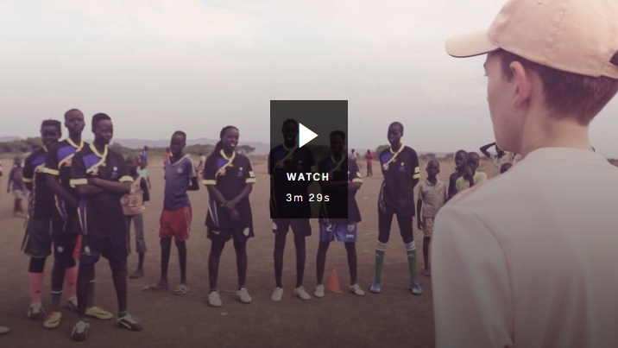  Barefoot to Boots | 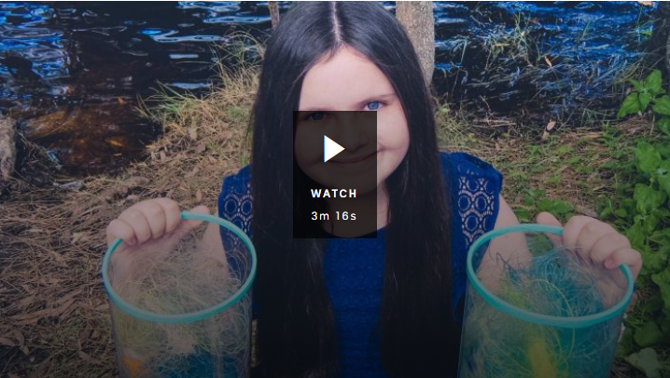  Storm Girl
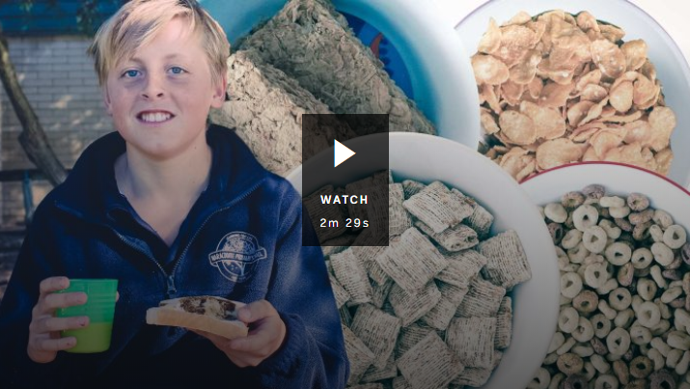  School Breakfast Club | 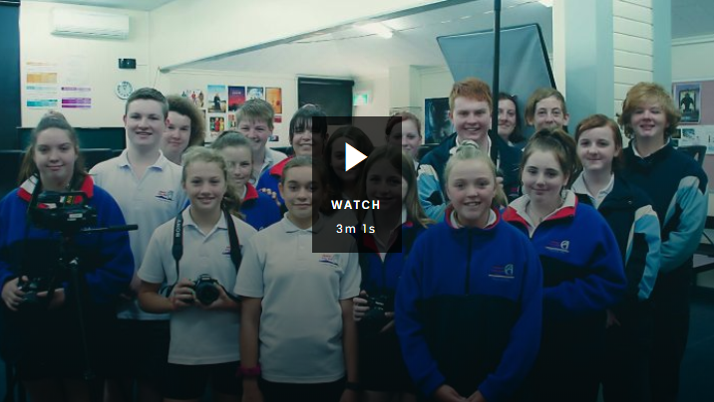  Kids’ News Service
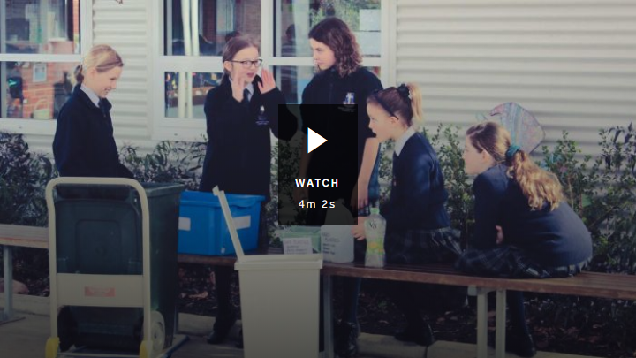  Recycling Solution | 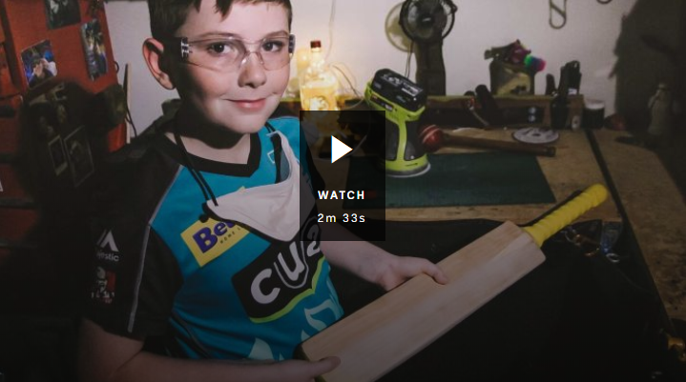  Cricket Bat Kid
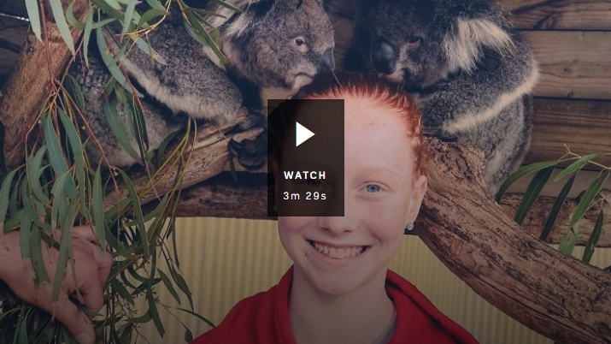  Koala Carer | 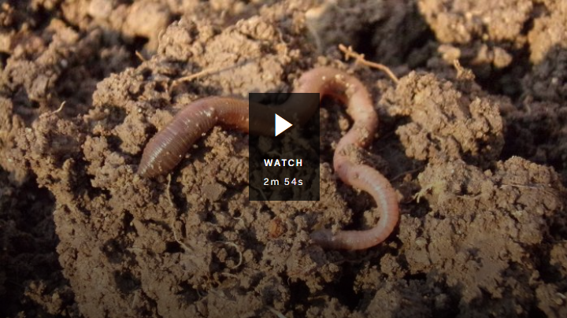  Worm Wee
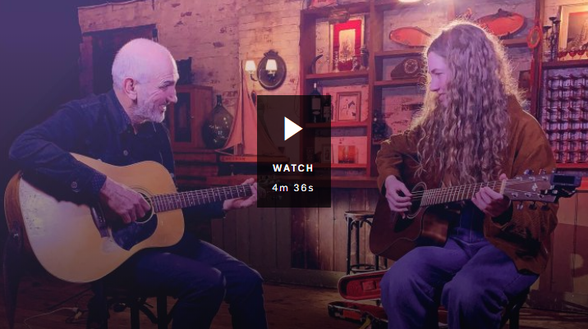  Songwriting with Paul Kelly | 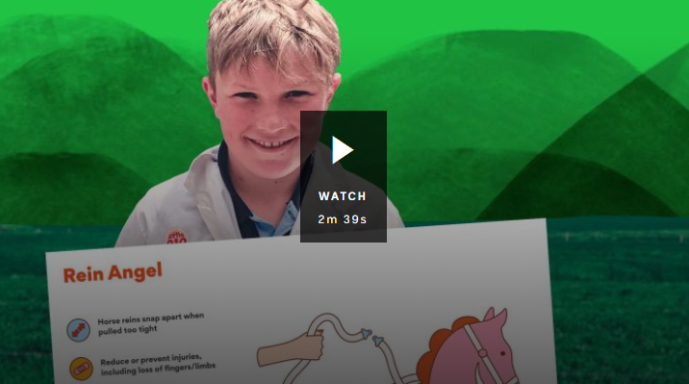  Rein Angel Inventor

BTN Kids Talk Survey
BTN held its first ever Kids Talk Survey in 2019. We wanted to know what’s going on in the lives of school kids around the country, including how they’re feeling, the issues they’re dealing with, how they feel about politics and how much time they spend on screens. Here are the results of the survey. A couple of the big issues that came out of the survey was the time kids spend on devices and the amount of sleep they get. Here are the BTN stories to explain Kids Talk – Screen time and Kids Talk - Sleep

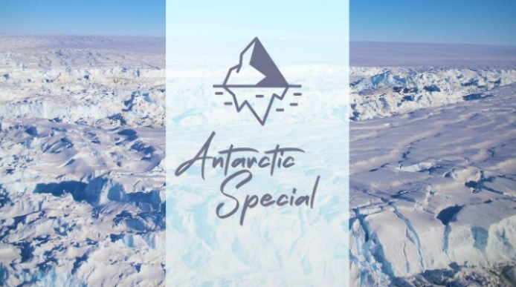
Antarctica Special
BTN reporter, Emma went on a journey to one of the world’s most remote and amazing places; Antarctica! She met the people that live and work there, discovering why the frozen continent is so important to science and spotted some of the cool animals that call it home.
Watch the special here.
Antarctic Animals teacher resource
Life in Antarctica teacher resource

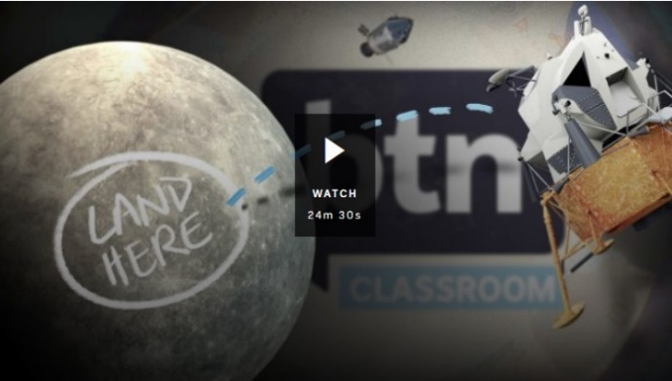
Moon Landing Special
BTN has a special episode to celebrate the 50th anniversary of the Apollo 11 mission, hosted from the CSIRO Parkes radio telescope. We look at the events leading up to the Moon landing, the Apollo 11 mission, Australia’s role in it and what the future of space exploration might hold.
Watch the special here
Moon Landing Special teacher resource

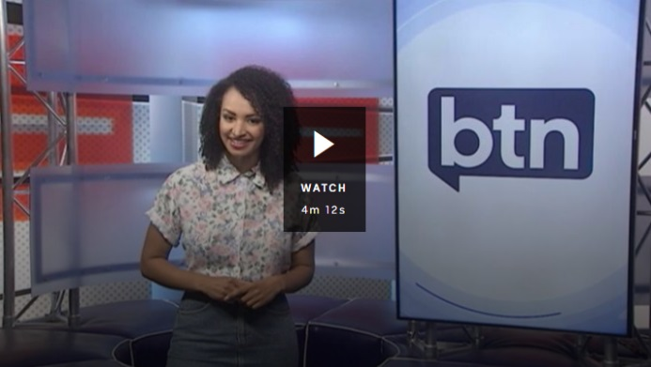
BTN – Behind the Scenes
The BTN Behind the Scenes video gives a snapshot into the making of a BTN episode. Students can watch the video then answer the following questions.

- When putting together a show, BTN looks for stories that are…
- Who decides what stories will go on BTN?
- What might happen on a BTN filming day? Give one example.
- Why do you think BTN stories involve a lot of dressing up?
- Complete this sentence. Animations on BTN are made by the __________ team.
- What is the role of an editor on BTN?
- What surprised you about the BTN Behind the Scenes video?
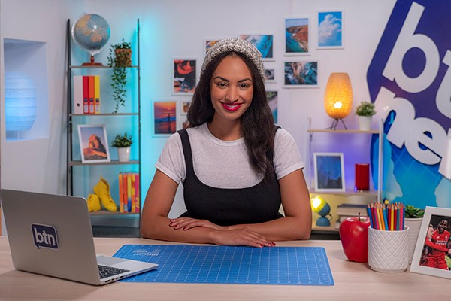
BTN Newsbreak
Watch BTN every day! Newsbreak is a great way to kick off the morning routine. You can watch Newsbreak anytime on our website or by subscribing to our YouTube channel. Head to the BTN website for all the details.


Stories - BTN
https://www.abc.net.au/btn/stories/

Super Quiz Questions

These quiz questions are to be used in conjunction with viewing BTN’s Year in Review 2019 program. Pause the video after each question to allow time for students to answer.
Aussie News
Questions | Your Answer
- Who became the new leader of the Australian Labor Party in May this year?
  - Bill Shorten
  - Anthony Albanese
  - Tanya Plibersek
- How many Prime Ministers has Australia had now?
  - 20
  - 30
  - 40
- When we interviewed Scott Morrison earlier this year we asked him what his favourite superhero was. Can you remember what his answer was?
  - Batman
  - Spiderman
  - Aquaman
- Which Australian Antarctic Research Station celebrated its 50th birthday this year?
  - Macquarie
  - Casey
  - Mawson
- We also marked the 100th anniversary of the Epic Flight from London to Sydney. Who were the Aussie pilots of the Vickers Vimy?
  - Orville and Wilbur Wright
  - Ross and Keith Smith

World Stories
Questions | Your Answer
- Ukraine got a new President this year, Volodymyr Zelensky. Why was he a bit unusual?
  - Because he was a famous cricketer
  - Because he was a reality TV star
  - Because he played the President in a TV show
- What sort of new leader did Japan get this year?
  - A new Prime Minister
  - A new King
  - A new Emperor
- Speaking of new royals, what's the name of the new British Prince born this year?
  - Archie
  - George
  - Louis
- What island did the US President say he'd like the country to buy this year?
  - Iceland
  - Greenland
  - New Zealand
- What company became the first in the world to be valued at a trillion dollars this year?
  - Facebook
  - Apple
  - Amazon
- Speaking of fortunes, what sort of animal did famous designer Karl Lagerfeld leave part of his fortune to when he died in February?
  - Cat
  - Dog
  - Turtle
- The film Avengers Endgame also made a lot of money this year! What film did it replace as the highest grossing cinema release of all time?
  - Titanic
  - Avatar
  - Star Wars: The Force Awakens

Kids News
Questions | Your Answer
- What massive esports tournament did 16-year-old Kyle Giersdorf, better known as Bugha win this year?
  - League of Legends World Championships
  - Battle.net World Champs
  - Fortnite World Cup
- Meanwhile in the UK 16-year-old Harvey Elliott made history as the youngest ever Premier League player. Which team does he play for?
  - Liverpool
  - Manchester United
  - Chelsea
- Another famous 16-year-old, Greta Thunberg, was in the news a lot this year. Which country is Greta from?
  - Norway
  - Sweden
  - Switzerland
- A Belgian boy name Laurent Simons became the youngest in the world this year to finish university. How old is he?
  - 9
  - 13
  - 16
- Meanwhile a 97-year-old American professor became the oldest ever Nobel Prize winner. What did he help to invent?
  - Electric cars
  - Lithium-ion batteries
  - Fibre optic cables

Total score
Answers

- Anthony Albanese
- 30
- Aquaman
- Casey
- Smith brothers
- Because he played the President in a TV show
- A new Emperor
- Archie
- Greenland
- Apple
- Cat
- Avatar
- Fortnite World Cup
- Liverpool
- Sweden
- 9 years-old
- Lithium-ion batteries

BTN Transcript: Episode 35 – 3/12/19

Hey, Amelia Moseley here with a very special end of year episode of BTN. Of course, it's nearly holidays, so we thought we'd get in early and come down to the beach with these guys. Want a chip? Here's what's coming up. We'll take a look back at the biggest stories we've covered this year and the awesome people we've met. We'll also give you a little peek at some of our bloopers and get ready for our traditional holiday super quiz that's coming up really soon.
Aussie News 2019
Reporter: Matt Holbrook

INTRO: But first, let's dive straight into the biggest Aussie news of 2019.

KID: Matt, you're up.
MATT: Now, it's been a big year for Australia, and a lot of news has been about the weather.

MATT HOLBROOK: Right from the beginning of 2019, we saw some extreme conditions. There were fires in Tassie.
JESSICA: My name is Jessica, and today I'm at the evacuation centre near the school in Huonville. Hundreds of people have had to come here because their homes have been under threat from the bushfires.
Floods in Queensland.
JONATHAN: Their house is underwater. I could've just left it like that, but I decided to give them a call.
And cyclones in Northern Australia. Then came the worst start to the bushfire season that we've ever had, with fires in New South Wales and Queensland and we visited Port Macquarie to find out how people there were doing.

KID: We had to leave our house because the fire got really close. It was a couple of kilometres away.

AMELIA: So do you reckon you guys would ever want to be firefighters?

KIDS: Maybe, you never know, you never know.

Before the fires was drought. It's been another tough year for farmers. Lack of water flowing through the Murray darling caused millions of fish to die.
Heading to Canberra, and it was all politics, politics, politics, as the 2019 Federal Election campaign took off. And despite being the underdog in the race, Prime Minister, Scott Morrison, held onto his seat, and led the Coalition to another term in government. Oh, and he stopped by BTN to answer some questions that you guys sent in.
AMELIA MOSELEY, REPORTER: What is your favourite part of being Prime Minister?
SCOTT MORRISON, AUSTRALIAN PRIME MINISTER: The best part is everyone wants to talk to you.
There was some sad political news, too. In 2019, we said goodbye to a former Prime Minister, Bob Hawke. And people around the country celebrated his incredible life. We looked back at Australia's important role in the Moon landing way back in 1969. The country went mad for Ooshies and Little Shops, but they were controversial.
CLARA AND ABBEY: We think Ooshies and Little Shops are sending kids the wrong message about plastic pollution
As was this, the closing of the Uluru climb, after years of campaigning from its traditional owners. Meanwhile, at Garma, there were more calls for recognition and reconciliation.

In sport, footy codes came together to close the gender pay gap, we all held an enormous Barty Party, and the AFL and NRL premierships were incredible, if your team won, and mine did. And Australia retained the ashes, thanks to an incredible return performance from Steve Smith.

You told us what mattered to you in our first ever Kids Talk survey and showed the world how much you care about fighting climate change.
Super Quiz

And now time to kick off the Super Quiz.

Who became the new leader of the Australian Labor Party in May this year? Was it:
Bill Shorten
Anthony Albanese or
Tanya Plibersek
It was Anthony Albanese. Of course, Scott Morrison became Prime Minister.

How many Prime Ministers has Australia had now?
20
30 or
40
Scott Morrison is Australia's 30th Prime Minister.

When we interviewed Scott Morrison earlier this year we asked him what his favourite superhero was. Can you remember what his answer was?
Batman
Spiderman or
Aquaman
Aquaman

Which Australian Antarctic Research Station celebrated its 50th birthday this year?
Macquarie
Casey or
Mawson
It was Casey and Emma was there to mark it.

We also marked the 100th anniversary of the Epic Flight from London to Sydney. Who were the Aussie pilots of the Vickers Vimy?
Orville and Wilbur Wright or
Ross and Keith Smith
It was the Smith Brothers.

World News 2019
Reporter: Nat Kelly

INTRO: How'd you guys go with those questions? OK? I'd do better on a Harry Potter Quiz. Now we're going to move away from Australia to look at some of the stories that happened around the world this year. Here's Nat. Oh, that’s me.

It's been a big year for our big old world. There were plenty of cheers, and a few tears. And just like here in Australia, other countries saw some pretty wild weather. There were also quite a few natural disasters this year. Earthquakes, floods and hurricanes. There were also lots of terrible fires from California to the Arctic. And of course, massive blazes in the Amazon rainforest that burned out of control for months. Some said part of the reason behind these disasters was climate change. In fact, "Climate Emergency" was the Oxford Dictionary's word of the year. And there was a big push this year from people all over the world for countries to take action. Front and centre was this now very familiar face. And in September at a UN Climate Summit, Greta had this to say to world leaders.
GRETA THUNBERG: How dare you. You have stolen my dreams and my childhood with your empty words and yet, I’m one of the lucky ones.
But it wasn't just climate change that had people taking to the streets. 2019 saw some big protests in many different countries. In Venezuela it was over their controversial leaders, while people in Chile and Colombia also protested, over inequality. Then of course there was Hong Kong. What started as peaceful marches over a proposed law, became months of violent protests that are still going today, over what many in Hong Kong are seeing as China's growing influence over the autonomous region. China also made the news because of a trade war with the US.

Of course, we saw a lot of this guy. US President Donald Trump made the news for all sorts of reasons, including a history making trip to North Korea. Then there was a phone call with another world leader, which has sparked an impeachment inquiry. Meanwhile, in the UK, everyone was still talking about Brexit. Britain's plan to exit the European Union hasn't gone smoothly. Two PMs have now stepped down because of it, leaving this guy in the top job, although there's an election coming up next week, so watch this space.
Many countries faced really big problems, like war and famine. There were terrorist attacks, including one in New Zealand. The world also came together to support Paris as a much-loved icon was nearly lost in a massive fire.
But it was also a year of celebrating achievements. Like China successfully landing a lunar rover on the dark side of the Moon for the first time ever. We also got our very first photo of a black hole. It took scientists two decades to figure out how to capture this seemingly impossible sight. But they did it. In the same year that we all celebrated the 50th anniversary of this famous small step.
Today's technology also hit the headlines, and not always for good reasons. Whether it was for helping to spread fake news, or not doing enough to protect young users. A couple of platforms copped big fines. including TikTok, which made a lot of users very cranky when it cancelled their accounts without warning. The social media companies say they're trying to do better, and many brought in new rules, or made changes to try to look after people's mental health. So overall, there was plenty to like, plenty to dislike, and plenty of reasons to use all these other emojis, as we made our way through 2019. And with only a tiny slice of it left, here's to hoping that it's a good one.
Super Quiz
Ukraine got a new President this year, Volodymyr Zelensky. Why was he a bit unusual? Was it because he was:
A famous cricketer
A reality TV star
Or he played the President in a TV show
He was an actor and comedian who played the president in a TV show.
What sort of new leader did Japan get this year?
A new Prime Minister
A new King or
A new Emperor
Emperor Akihito stepped down and passed the job to his son Emperor Naruhito.

Speaking of new royals, what's the name of the new British Prince born this year? Is it:
Archie
George or
Louis
It's Archie Harrison Mountbatten-Windsor.
What island did the US President say he'd like his country to buy this year? Was it:
Iceland
Greenland or
New Zealand
It was Greenland.

What company became the first in the world to be valued at a trillion dollars this year? Was it:
Facebook
Apple or
Amazon

It was Apple.

Speaking of fortunes, what sort of animal did famous designer Karl Lagerfeld leave part of his fortune to when he died in February? Was it his:
Cat
Dog or
Turtle
It was his beloved (and now very wealthy) cat, Choupette.

The film Avengers Endgame also made a lot of money this year. What film did it replace as the highest grossing cinema release of all time?
Titanic
Avatar or
Star Wars: The Force Awakens
It was Avatar. The Sci-Fi flick made nearly 2.8 billion dollars, but the superhero crew beat it by half a million bucks.
Kids News 2019
Reporter: Matt Holbrook

INTRO: Now some of the best stories we covered this year were about you guys. We spoke to kids all over the world about all sorts of things, from big news stories that were happening around them to the things they were doing to change the world. Let’s take a look.

ASHLEE: Hi BTN. I'm Ashlee and I'm on a mission to find out what's going on with the stuff we've been putting in here.
Yep, we met some amazing people this year who were doing some pretty impressive things. Like Ashlee, who found out about Australia's recycling problems from the PM.
ASHLEE: Get me the Prime Minister. Could you do more to encourage big businesses to create less waste in the first place?
PRIME MINISTER, SCOTT MORRISON: Yes, I think we could all do that.
Or Jasmin, who got some songwriting tips from an Aussie legend.
JASMIN: How old were you when you started song writing?
PAUL KELLY: 21, which is much later than you. When did you start?
JASMIN: I was 11.
Our rookie reporters took us to amazing places.
ABDUL: Jambo. My name is Abdul, and this is Salma and we're going to show you what it's like to live in Tanzania. It's known for its amazing environment and of course all the African wildlife in our country.
SALMA: When I am home with family, we speak Swahili.
And helped us to understand their cultures and beliefs.
AMULLYA: Hello BTN, my name is Amullya and me and my friends are going to teach you about Holi. It's a festival celebrated by Hindus like me.
JOSEPH: Hi BTN, my name is Joseph.
AFSA: And I'm Afsa.
FAISAL: I'm Faisal.
KHADIJA: And I'm Khadija.
AFSA: Today we're going to be teaching you about Ramadan and Eid.
NICOLE: Yom Kippur is the holiest day of the year on the Jewish calendar.
ASEES: Vaisakhi is celebrated by the Sikhs all around the world. That's us, we're all Sikhs. Yay.
KOBE: We welcome you to Aboriginal land where ancestors still live. I am a part of the Palawa Kani tribe, and I think it feels special, especially knowing that there's people around me who know where I'm from.
We met lots of young people who were making a difference.

SHALISE: Mr Percival and I became friends when I started coming down to the lake to empty the fishing line collection bins, I helped install around the lake. I get so sad when I see fishing lines on the shore.
JACK: Today I'm here to learn more about a major fundraiser called the World's Greatest Shave.
LIBBY: Koalas, they are my favourite animal. I just love everything about them. It's important for the younger generation to know that they can do something to help and that you don't have to say to yourself "When I grow up, I want to". You say, "I want to do this now".
And young people who helped us to understand the big stories going on around them.
KID 1: Pollution spares no one. I'm not allowed to step out of my house because I'm living in a city which is a gas chamber.
KID 1: We don't have a chance to vote so if we stand together then we are going to make a bigger impact then we would with just one voice.
KID 2: We are the future and if nothing is done about it now, then when we’re older, it's going to be absolute mayhem.
And thanks to you guys, we think the future's in pretty good hands.

Super Quiz

What massive esports tournament did 16-year-old Kyle Giersdorf, better known as Bugha win this year? Was it:
League of Legends World Championships
Battle.net World Champs or
Fortnite World Cup
It was the Fortnite World Cup and it won him 3 million US dollars.

Meanwhile in the UK 16-year-old Harvey Elliott made history as the youngest ever Premier League player. Which team was he signed to?
Liverpool
Manchester United or
Chelsea
It was Liverpool.

Another famous 16-year-old, Greta Thunberg, was in the news a lot this year. Which country is Greta from?
Norway
Sweden or
Switzerland
She’s from Sweden.

A Belgian boy name Laurent Simons became the youngest in the world this year to finish university. How old is he?
9
13 or
16
He’s nine years old.

Meanwhile a 97-year-old American professor became the oldest ever Nobel Prize winner. What did he help to invent?
Electric cars
Lithium-ion batteries or
Fibre optic cables
He invented Lithium-ion batteries back in the 70s and he says the Nobel Prize was a nice surprise.

Bloopers 2019
Reporter: Jack Evans

INTRO: Aww, how great is he. Well, we've certainly had a lot of fun this year bringing you the news. But of course, things don't always go smoothly do they Jack?
Jack: Nope. Let’s have a look at some of the times our reporting didn't quite go to plan
As BTN reporters it can sometimes be really hard working under pressure and all that pressure can often lead to some interesting arguments. When it comes to acting, we know you can say a lot with just a look and we're never shy when it comes to dressing the part. Of course, sometimes it takes a couple of takes to get it right and sometimes, well, we just can't help but laugh.
Kids Favourite Stories

So, what were your favourite stories of the year?
KID 1: I liked the history of the dogs.

LEELA: It began with wolves the ancestors of all dogs.

LEELA: Be the wolf Sookie, be the wolf.
KID 2: My favourite was the one on bigfoot.
For more than 60 years people have been on the hunt for the mysterious, probably mythical, Bigfoot, otherwise known as Sasquatch.
KID 3: I liked the one about Halloween.
JACK: Halloween, that time of year when the veil between the living and the dead is, unveiled.
KID 4: My favourite was about the Aboriginal flag.
EMMA: But while it's recognised as a one of our country's official flags, it's got some special legal rights and those have caused a few problems lately.
KID 5: My favourite has to be the one about droughts.
As you probably heard, Australia is in the middle of what's been described as one of the worst droughts in recorded history.

PARIS, BATHURST: It's shocking out there it's very dry.
KID 6: Mine was definitely the Moon landing.

NEIL ARMSTRONG, ASTRONAUT: Tranquillity base here, the Eagle has landed.

How did you feel when they landed back on Earth?
JOYCE: Oh relief, absolutely, yeah.

And also, the great feeling that I had seen a great part of history.
Closer

Well that's it for BTN this year. Thank you all so much to all of you for being a part of it. We'll be back in 2020 for a new year and a new decade of stories. In the meantime, if you’re bored during the holidays, you can always head to our website or if you're 13 or over, you can check out our YouTube channel. That’s it from me, I'm gonna go join the game. Bye.

