EPISODE 7
21st March 2023

KEY LEARNING
Students will view a range of BTN stories and use comprehension skills to respond to a series of focus questions.

CURRICULUM
English – Year 4
Use comprehension strategies to build literal and inferred meaning to expand content knowledge, integrating and linking ideas and analysing and evaluating texts.

English – Year 5
Use comprehension strategies to analyse information, integrating and linking ideas from a variety of print and digital sources.

English – Year 6
Use comprehension strategies to interpret and analyse information and ideas, comparing content from a variety of textual sources including media and digital texts.

English – Year 7
Use comprehension strategies to interpret, analyse and synthesise ideas and information, critiquing ideas and issues from a variety of textual sources.
  - Teacher Resource

Focus Questions
As a class, discuss the stories featured in the episode of BTN Classroom and record the main points of the discussion. Students will then respond to the following focus questions.

AUKUS Submarine Deal
- The AUKUS submarine alliance is between Australia and which two countries?
- The submarines are ________________ powered.
- Why does Anthony Albanese say the deal is important for Australia?
- Create a T Chart with the pros and cons of the submarine deal.
- What do you think about the AUKUS submarine deal?

Aussie Astronaut
- Who will Katherine Bennell-Pegg train with to become an astronaut? Where will she train?
- Why is Katherine excited about going to space?
- Why does Katherine think it’s important to get more young women into STEM?
- Complete the following sentence: Katherine would really like to discover life elsewhere in our solar system because…
- What was surprising about the BTN story?

Check out the teacher resource on the Archives page.

Reviving Indigenous Languages
- Kaurna Warra is the language of the First Nations people of what area?
- What has been created to help protect Kaurna language?
- What has happened to many First Nations languages since European colonisation?
- Why is it important to protect Indigenous languages?
- Find the words for `hello’ and `goodbye’ in the Indigenous language local to your area.

War Animals
- Briefly summarise the BTN War Animals story.
- What part have animals played in wars?
- What medal recognises the work of animals in war?
- Which flower is a symbol of remembrance for animals who have served in wars?
- Do you think animals should have greater recognition for the role they play in wars? Give reasons for your answer.

Check out the teacher resource on the Archives page.

Kite Surfer
- Explain the sport of kite surfing.
- What is Fynn’s favourite thing about kite surfing?
- What safety equipment does Fynn wear when he’s kite surfing?
- What advice does Fynn give to kids wanting to try kite surfing?
- How did this story make you feel?

EPISODE 7
21st March 2023

KEY LEARNING
Students will learn more about Australia’s role in space exploration. Students will investigate careers in space science.

CURRICULUM
Science – Year 5
The Earth is part of a system of planets orbiting around a star (the sun).

Scientific knowledge is used to solve problems and inform personal and community decisions.

Science – Years 5 & 6
With guidance, pose clarifying questions and make predictions about scientific investigations.

Science involves testing predictions by gathering data and using evidence to develop explanations of events and phenomena and reflects historical and cultural contributions.

Science – Year 7
Scientific knowledge has changed peoples’ understanding of the world and is refined as new evidence becomes available.

  - Teacher Resource

Aussie Astronaut

Focus Questions
Discuss the BTN story as a class and record the main points of the discussion. Students will then respond to the following:
- Who will Katherine Bennell-Pegg train with to become an astronaut? Where will she train?
- Why is Katherine excited about going to space?
- Why does Katherine think it’s important to get more young women into STEM?
- Complete the following sentence: Katherine would really like to discover life elsewhere in our solar system because…
- What was surprising about the BTN story?

Activity: What do you see, think and wonder?
After watching the BTN Aussie Astronaut story, students will respond to the following questions:
- What did you SEE in this video?
- What did you LEARN from this story?
- What do you WONDER about this story?
- What QUESTIONS do you have about this story?

Activity: Class Discussion
After watching the BTN Aussie Astronaut story, hold a class discussion using the following discussion starters.
- What role has Australia played in space exploration?
- Is it important for Australia to be involved in space exploration? Why or why not?
- How do you become an astronaut? Make a list of some of the skills required to become an astronaut.
- What questions would you like to ask an astronaut?

Activity: Glossary
Students will brainstorm a list of key words that relate to the BTN Aussie Astronaut story. Here are some words to get them started.

EXPLORATION | ASTRONAUT | SOLAR SYSTEM
MICROGRAVITY | SPACE INDUSTRY | MISSION

Ask students to write what they think is the meaning of each word (including unfamiliar words). They will swap definitions with a partner and ask them to add to or change the definition. Check these against the dictionary definition.

Further activities for students:
- Expand on your glossary and create your own glossary of astronaut jargon. Include terms like abort, command module, airlock, cosmonaut, G-force, No Go, zero gravity and uplink.
- How did this story make you feel? Make a list of words that describe how you felt after watching the BTN Aussie Astronaut story.

Activity: Questions and Answers
Are your students curious about space? Students will make a list of questions they have about space exploration. For example:
How can I become an astronaut?
- What is puffy-head bird-legs?
- How do astronauts get back to earth?
- What happens to the brain in zero gravity?
What happens to your body in space?

Students will use the internet to find answers to
their questions.
What questions do you have about space exploration?

Q&A with a space expert
All scientific discoveries start with a question! As a class, come up with some questions you think astronauts ask and solve in relation to space exploration. As a class, make a list of questions that you would like to ask a space expert. Organise the questions into common themes.

Book into one of the Australian Space Discovery Centre’s digital sessions to get an insight into what a career in space really looks like, as well as answering any questions you may have. Sessions go for 45 minutes.

Activity: Career in Space
Learn more about the space sector and pathways for a career in space. Choose one job that you would like to know more about. Investigate what the job involves and what you need to study to become one. Present the information to a small group or class. Students will think about the following during their research:
- What study do you need to do for the job?
- What skills are needed to do the job?
- What are some of the responsibilities of the job?
- What sort of research is involved once you are in this job?
- Can you interview someone who has this job to find out more?

Visit the Australian Space Agency to learn more about pathways for a career in space.
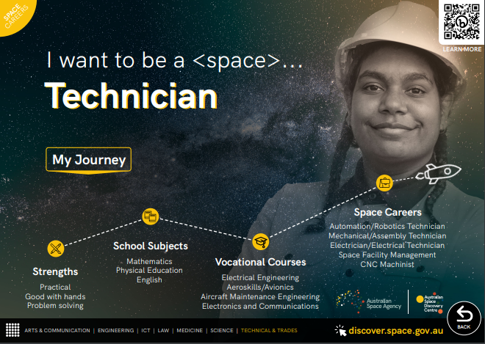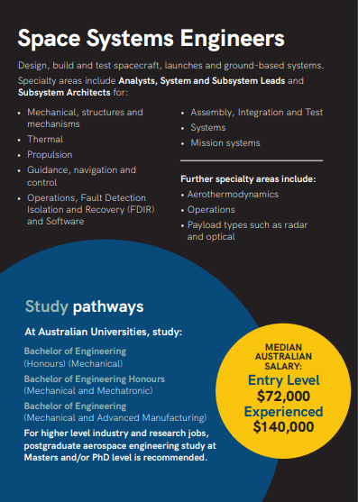
Careers in space booklet (pdf)
A space for everyone: careers in space (pdf)

Activity: Space Research
After watching and discussing the BTN Aussie Astronaut story, what questions do students have? The KWLH organiser provides students with a framework to explore their knowledge on the topic of space exploration and consider what they would like to know and learn.

What do I know? | What do I want to know? | What have I learnt? | How will I find out?

Questions to research
Students will develop their own question/s to research about space exploration. Students will collect and record information from a wide variety of sources. Students may develop their own question for inquiry or select one of the questions below.

- Who is Australia’s first female astronaut? Explore her background, experience, and training. Create a biography.
- What role has Australia played in space exploration? Research one aspect in more detail.
- What types of careers are there in space exploration? Learn more about the space sector and pathways for a career in space. Choose one to explore in more detail.
- What is the Australian Space Agency? Explore its role in space exploration.
- What STEM skills do astronomers need?
- Is space exploration important? Why or why not?
- Create a timeline showing the history of space exploration. Highlight Australian involvement on your timeline.

Activity: Fierce Girls podcast
Ruby Payne Scott – The Girl Who Listened to the Stars
In the 1940s when Ruby Payne Scott went to university, she was the only girl in her class. Back then, you could count the number of female physicists in the entire country on one hand.

Listen to the Fierce Girls Podcast to learn more about her life and her contribution to space exploration. Students will listen to the podcast and then respond to the following questions:
- What were some of Ruby Payne Scott’s challenges? List some of the roadblocks she faced.
- What course did she graduate in at university?
- What top secret job did Ruby Payne Scott do during WWII? Illustrate an aspect of her job.
- What is radio astronomy?
- What were some of Ruby Payne Scott’s achievements?

Andrea Boyd — The Girl Who Became the Voice of Space
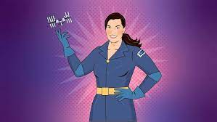
Andrea Boyd worked hard to become the International Space Station’s only Aussie flight controller, talking to the astronauts who lived in the space station as it orbited Earth. But Andrea didn't stop there — she wanted to bring space exploration to Australia. She convinced the country's leading academics, businesspeople, and the government to open the Australian Space Agency.

Listen to the Fierce Girls Podcast to learn more about her life and her contribution to space exploration. Students will listen to the podcast and then respond to the following questions:
- What is one of the best places for stargazing?
- What TV show inspired Andrea Boyd to reach to the stars?
- What is the International Space Station (ISS)? Describe.
- What is Andrea Boyd’s job for the ISS?
- What is a Soyuz?
- How would life be different without satellites?
- Summarise Andrea Boyd’s achievements in space exploration.

Activity: BTN Stories
As a class watch one or more of the following BTN stories to learn about Australia’s role in space exploration. After watching any one of the BTN videos ask students to respond to the discussion questions (to find the discussion questions and teacher resources go to the related BTN Classroom Episode and download the Episode Package).

Aussie Space Agency | 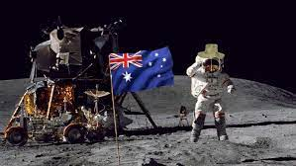  Aussie Astronauts
Parkes Telescope Anniversary | Apollo 11 and Parkes

BTN Space Science stories
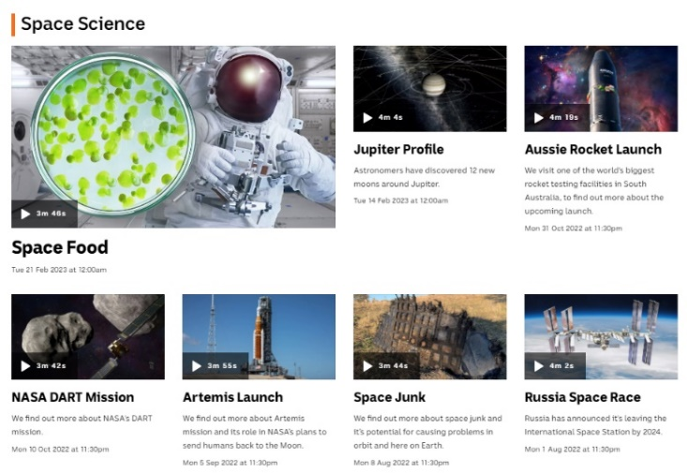
Visit BTN’s collection of stories which focus on space science and space exploration. After watching any one of the BTN videos ask students to respond to the discussion questions

To find the discussion questions and teacher resources go to the related BTN Classroom Episode and download the Episode Package.

Link to collection of BTN Space Science stories

Useful Websites
- Adelaide woman to become first female to train as astronaut under Australian flag – ABC News
- Aussie Astronauts – BTN
- Astronaut Training – BTN
- Pathways for a career in space – Australian Space Agency
- Life of an astronaut – TedEd
- Fierce Girls – ABC

EPISODE 7
21st March 2023

KEY LEARNING
Students will learn more about the role animals have played in wars.

CURRICULUM
HASS – Year 3
Days and weeks celebrated or commemorated in Australia (including Australia Day, Anzac Day, and National Sorry Day) and the importance of symbols and emblems.

HASS – Year 5 & 6
Develop appropriate questions to guide an inquiry about people, events, developments, places, systems and challenges.

Locate and collect relevant information and data from primary sources and secondary sources.

HASS – Year 7
Use historical terms and concepts.

  - Teacher Resource

War Animals

Focus Questions
Discuss the BTN story as a class and record the main points of the discussion. Students will then respond to the following:
- Briefly summarise the BTN War Animals story.
- What part have animals played in wars?
- What medal recognises the work of animals in war?
- Which flower is a symbol of remembrance for animals who have served in wars?
- Do you think animals should have greater recognition for the role they play in wars? Give reasons for your answer.

Activity: Personal Response
After watching the BTN War Animals story, ask students to finish one or more of the following incomplete sentences:
- It was interesting to learn that…
- Learning about war animals made me feel…
- BTN did a story about war animals because…

What did you learn from the story?
What questions do you have about the story?

Activity: Class Discussion
Discuss the information raised in the BTN War Animals story. Use the questions below to guide the discussion.
- What role have animals played in wars?
- What medal honours the work of animals in war?
- Should animals have greater recognition for the part they’ve played in war? Why or why not?

Activity: Glossary
Students will brainstorm a list of key words that relate to the BTN War Animals story. Here are some words to get them started.

MASCOT | DICKIN MEDAL | COMMEMORATE
TROOPS | CARRIER PIGEON | WAR PENSION

Activity: Research project
Discuss the information raised in the BTN War Animals story. What questions were raised in the discussion and what are the gaps in students’ knowledge? The following KWLH organiser provides students with a framework to explore their knowledge on this topic.

What do I know? | What do I want to know? | What have I learnt? | How will I find out?

Students will develop their own question/s to research or choose one or more of the questions below.
- Explore the pros and cons of using animals during wars.
- Why did the Anzac soldiers take animals to war with them?
- Investigate how one of the following helped soldiers during the Gallipoli campaign.
- The Imperial Camel Corps
- The 13th Australian Light Horse Regiment
Choose an animal to research in detail to learn more about the part they played in wars.
- John Simpson Kilpatrick and his donkey
- How did animals help service people during WWI and WWII?
- Not all animals were helpful during war. Investigate animals that were unwelcome such as rats and insects and the impact they had on the lives of soldiers.
- Communication is very important during wartime. How did animals help to send life-saving messages?
- Find out more about the Dickin Medal awarded to animals for bravery. Profile an animal that received the award.
- Should animals have greater recognition for the role they play in wars? Develop an argument for or or against the issue.

Activity: Visual Literacy
Below are images that relate to animals in war. Students look at the image and then respond to the following questions:

- What do you see in this image?
- What do you think is happening?
- What does the image tell you about the part animals have played in wars?
- What question/s would you like to ask about the image?
- Create a caption for each image.
Students will choose a photograph and write a short, fictional story based on the image. Students might want to tell the story of the photographer or a person in the photograph. Students will use their research to help them imagine what their characters were thinking and feeling.

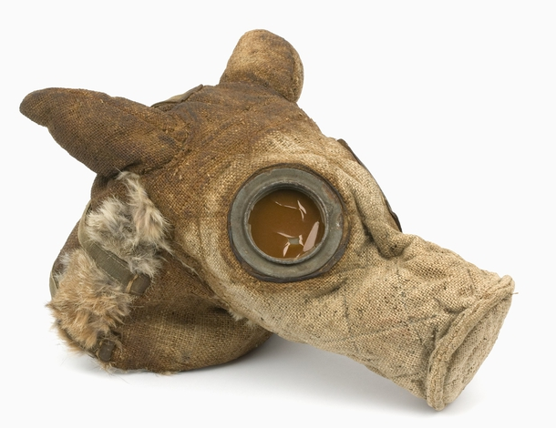

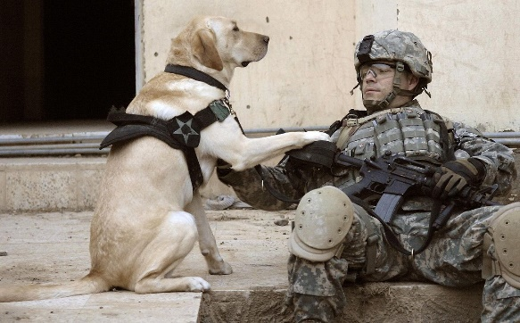

Link to image Link to image

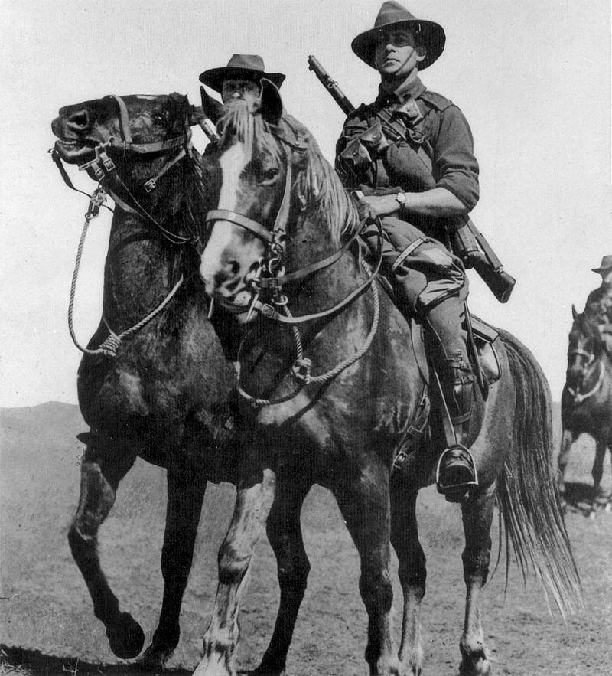
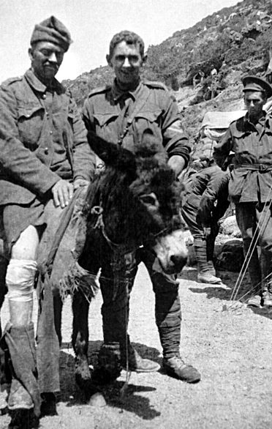

Link to image Link to image

Activity: War Animals Quiz
- What medal honours the work of animals in war?  A. Victoria Cross  B. Dickin Medal  C. Order of Australia  2. Which animal worked with Private John Simpson to bring hundreds of wounded soldiers at Gallipoli to safety?  A. Donkey  B. Horse  C. Dog  3. What was the name of the cat that received a bravery award during WWII?  A. Horrie  B. Simon  C. Duffy | 4. Which flower is a symbol of remembrance for animals who have served in wars?  A. Red rose  B. Red poppy  C. Purple poppy  5. Animals are no longer used by the defence force.  A. True  B. False

Quiz Answers: 1B, 2A, 3B, 4C, 5B

Useful Websites
- Calls for more recognition for Australia’s war animals, including pension for war dogs – ABC News
- The Animals of WWI – BTN
- War Animals – BTN
- Animals in Wartime – Australian War Memorial
- Remembrance Day – BTN

  - Teacher Resource

BTN Transcript: Episode 7- 21/3/2023

Hey, I'm Amelia Moseley and you're watching BTN. Thanks for hanging out with us again. Let’s see what's coming up on today’s show. Michelle meets the first Aussie woman to be trained as an astronaut, celebrating the achievements of Australian war animals and meet an up-and-coming kite surfer.

AUKUS Submarine Deal

Reporter: Jack Evans

INTRO: We'll get to all that soon. But, first up today, Australia has just unveiled a plan to get its hands on nuclear submarines after making a deal with the US and UK. It could cost, all up, a whopping $368 billion. But the government says it's important for the defence of our region. Jack finds out why.

JACK: AUKUS, okay. Nuclear powered submarines, huh. What’s going on?
FISHERMAN: Never fear, Jacky boy I've written a wee little sea shanty that’ll help explain the whole thing.
JACK: A sea shanty? We don't have time for a sea shanty.
Yeah, I'll just do my best and try to explain it all. Last week, our Prime Minister, Anthony Albanese, announced a big multi-billion dollar program to acquire and build nuclear powered subs. It's all part of an alliance called AUKUS, which is between Australia, the UK, and the US. Oh, AUKUS, now I get it. Part of the agreement involves Australia buying three nuclear powered subs from the US, as well as develop and build a new hybrid submarine, aptly titled the SSN AUKUS, which will combine a British submarine design with American nuclear technology.
JOE BIDEN, US PRESIDENT: The ultimate goal isn't just selling subs to Australia, it's developing something new together.
RISHI SUNAK, UK PRIME MINISTER: One of the most advanced nuclear powered subs the world has ever known.
Mr Albanese says the deal is all about strengthening Australia's military as well as boosting defence operations in the Indo-Pacific region where there have been concerns about China's growing military presence.
ANTHONY ALBANESE, AUSTRALIA PRIME MINISTER: The AUKUS agreement we confirm here in San Diego represents the biggest single investment in Australia's defence capability in all of our history. Strengthening Australia's national security and stability in our region.
The news didn't sit too well with China, and it responded by criticising the AUKUS pact, saying it's a clear attempt by the US to try and keep China under control.
WANG WENBIN, CHINESE FOREIGN MINISTRY SPOKESPERSON: China has repeatedly stressed that the AUKUS pact and the three countries’ efforts to advance co-operation on nuclear submarines and other cutting edge military technology is typical Cold War mentality. It will only spur an arms race and undermine the international non-proliferation regime and harm regional peace and stability.
Meanwhile, there has also been criticism about how much the whole thing will cost. Australia is expected to fork out a whopping $368 billion, which the Government has defended, saying that a large chunk of that bill will go towards creating more than 20,000 jobs for Aussies.
ANTHONY ALBANESE, AUSTRALIA PRIME MINISTER: Engineers, scientists, technicians, submariners, administrators, and trades people. Good jobs with good wages, working to ensure the stability and prosperity of our nations, our region and, indeed, our world.
So why nuclear powered submarines? Well, apparently, they're better than non-nuclear powered submarines. They're faster, they're quieter and they can stay underwater for longer, which seems like a thing you'd want a submarine to do.
RICHARD MARLES, DEFENCE MINISTER: Australia will now be just the seventh country to operate a nuclear-powered submarine.
The whole nuclear thing has got some people a little worried. Nuclear waste can potentially be harmful to humans and the environment. But the government says it'll be working with its AUKUS allies to make sure nuclear waste is managed and stored safely.
JOE BIDEN, US PRESIDENT: Each of our nations is making concrete commitments to one another. We're backing it up with significant investments to strengthen the industrial bases in each of our countries in order to build and support these boats.
JACK: So, there you go, and we got through the entire story without a single sea shanty.
FISHERMAN: Ohh. There once was a man who dreamt of a sub and a sub is what he dreamt. And the dreamt of the dream, the dream of the team.

News Quiz

The clock is ticking for TikTok users in the US because the app could soon be banned there. Why might TikTok be banned? Is it because of screen addiction, because it’s been bought by a rival company or because of security concerns? It’s security concerns over its Chinese ownership. US officials and legislators have raised fears that TikTok's US user data could be passed on to China's government. TikTok, which is owned by Chinese company ByteDance, has more than 100 million US users. The Chinese government says it’s all just an excuse to stop the success of a foreign-owned company.

Which of these companies have announced they won’t be using kangaroo leather in their football boots anymore? Is it Nike or Puma? Oh, it’s a trick question. It’s both. US state and federal lawmakers have tried to ban the sale of kangaroo products and with pressure from animal rights group, both companies have now opted to stop using kangaroo leather in their goods.
PERSON 1: I wish they would go somewhere else, especially in the morning when I'm trying to sleep in.

PERSON 2: I don't actually have TV much, if I do, it's all crackly.

What are these people in Western Australia complaining about? You guessed it, birds or more specifically, corellas, a species of white cockatoo that have started showing up in massive numbers.

PERSON 3: We call them flying cane toads. They're scaring all our other birds away.

Aussie Astronaut

Reporter: Michelle Wakim

INTRO: Katherine Bennell-Pegg will head to Germany next month to become the first woman to train as an astronaut under the Australian flag. Michelle had a chat with her about her training, and why she wants to inspire young Aussies to go to space.
MICHELLE: I'm here at the Australian Space Agency, and I'm about to go meet the person who could become Australia's first female astronaut. Let's do this.
MICHELLE: Hello.
KATHERINE BENNELL-PEGG, DIRECTOR OF SPACE TECHNOLOGY: Hi. I'm Katherine Bennell-Pegg. Welcome to the Australian Space Discovery Centre. Let's have a look around.
MICHELLE: Great.

Katherine has just received some pretty exciting news.

KATHERINE BENNELL-PEGG, DIRECTOR OF SPACE TECHNOLOGY: The Australian Space Agency and European Space Agency agreed to train me as Australia's first astronaut candidate, which is so great. I'm so excited.
She's heading off to Germany for about a year of training, which might mean, one day, she could go to space.
KATHERINE BENNELL-PEGG, DIRECTOR OF SPACE TECHNOLOGY: The thing that excites me the most about going to space is the fact that I'd be helping teams of scientists and engineers on Earth make new discoveries. From the eye in the sky up there, you can see all sorts of phenomena around the world. You can look at the environment, you can look at refugee movements, you can detect bushfires and floods, and help warn people about them. I'd also love to see the Earth from space. Earth looks fragile and I think that's a really important perspective to gain up there.
MICHELLE: I have a question about moonwalking.
KATHERINE BENNELL-PEGG, DIRECTOR OF SPACE TECHNOLOGY: Will they teach me how to moonwalk? As long as it's not the dance version. I’m a bit uncoordinated that way. But I think we do spacewalk training underwater and you pretend you're in space by being underwater, so you can learn how to move in zero gravity.
MICHELLE: Katherine, can you tell us a little bit about how you got here?
KATHERINE BENNELL-PEGG, DIRECTOR OF SPACE TECHNOLOGY: Well, I've always loved space. I grew up on the Northern Beaches of Sydney, which has a beautiful, bright, starry sky at night. And I used to love being out in the garden, looking at the stars. And when I realised that those stars weren't just pinpricks of light, but were planets or entire galaxies, whole new worlds waiting to be explored, I wanted to have that adventure, I wanted to be the one exploring them. You know, when we had our careers counselling sessions, they said, ‘Write down three different things you'd like to be’. And I wrote down one, astronaut, and refused to write anymore.
According to the UN, only 11 percent of astronauts have been women, and in STEM in general, women make up less than 30 percent.

KATHERINE BENNELL-PEGG, DIRECTOR OF SPACE TECHNOLOGY: So important to get more young women into STEM subjects and jobs because STEM is for everyone. We need all sorts of creativity and thought in order to solve all the problems that we need to solve through space. As a woman in the space industry, I've absolutely been in the minority for most of my career, but this hasn't held me back at all. Certainly, there's been occasions where you get small cuts or people try and bring you down a little bit. And I think that, by just doing your best and showing what you're capable of, people very quickly see that everyone's equal and everyone has ideas to contribute. Everyone's in there trying to achieve the same goals in space.

MICHELLE: I actually have one more question. Do you believe in aliens?
KATHERINE BENNELL-PEGG, DIRECTOR OF SPACE TECHNOLOGY: Oh, I absolutely believe in aliens. There's so many stars in the sky, the probability of there being life out there is so huge. They probably look like little bacteria. I'm not really sure. But I think it would be really wonderful to discover life elsewhere in our solar system, because that helps us understand how life was created on Earth.

Quiz

Who was the first Australian-born person to journey into space? Was it Neil Armstrong, Paul Scully-Power, or Andy Thomas? It was Paul Scully-Power. He flew aboard a NASA space shuttle mission in 1984. Andy Thomas was the first Australian-born professional astronaut to enter space in 1996.

Reviving Indigenous Languages

Reporter: Michelle Wakim

INTRO: A new online hub has just been launched to help people learn Kaurna, the original language of the Adelaide Plains. It's one of more than 200 First Nations languages that people and organisations around the country are working to protect. Here's Michelle.

CHOIR (Singing): Welcome everybody today, even the collared doves saying hey.
TAYLOR, KAURNA LANGUAGE LEARNING SERIES: You say, “marni’ai”. I say “niina marni”.
CROWD: Marni’ai.
TAYLOR: Niina marni.
CROWD: Marni’ai.
This is a welcome in Kaurna Warra, the language of the First Nations people of the Adelaide plains.
TAYLOR, KAURNA LANGUAGE LEARNING SERIES: In my mother's tongue I say it’s so good that you have all come here to Kaurna country.
The people here are celebrating the launch of a language website for the Kaurna people.
TAYLOR, KAURNA LANGUAGE LEARNING SERIES It's been a long time coming, this website, and it's really special to be able to combine both the, you know, modern worlds together, I suppose, and create a space that's going to offer all your, it’s going to be a one-stop shop for all your Kaurna needs from resources and history.
For years, university researchers have been putting together resources to revive Kaurna Warra. But what happened to it in the first place? Well, Kaurna Warra is one of more than 200 First Nations languages that have been spoken for tens of thousands of years. On this map, each colour represents different communities and their different languages, all over the country. There used to be even more, but since European colonisation many languages have disappeared because, well, for a long time, First Nations people were banned from speaking them and it had long-term impacts on First Nations cultures.
TEELA REID, WIRADJURI & WAILWAN LAWYER: In relation to, you know, particularly our aural history. I think that’s something that Australians generally every day don't understand that our laws are passed down aurally through ceremony, through art. You know, my ancestors were shunned, were punished, for speaking their language and I think it's so important that we speak it, and we live it and it's so much part of who we are as an identity.
Language plays a big role in storytelling and passing teachings from generation to generation, so without it, cultures could disappear as well.
TEELA REID, WIRADJURI & WAILWAN LAWYER: We need to see our languages, the many different that you know, Yorta Yorta gets spoken across the continent, be valued at the centre of who we are on a national identity.
And this is slowly happening, not just on Kaurna country, but all around Australia. Languages like Wiradjuri and Yorta Yorta, now have online dictionaries, apps, and videos for storytelling.
STUDENT: Launching the dictionary online as well will definitely help bring that back, and with us all growing up with online platforms and everything, it’s going to be extra good for the generation.
Street signs, landmarks and cities are being recognised in language a lot more, and we are hearing more music like this.

KING STINGRAY (SINGING): Milkumana. Wangany'thirri.
And more schools and universities now offer First Nations language classes.
STUDENT: It's so integral to a community, to a culture, you know. Every single community in the world has their own colloquialisms. Even if it's not just different languages. And I think that it's really, a really big identifier, and I think it's really special.
And people here are saying these changes are making a difference.
STUDENT: It's really empowering. And it makes me feel good.
STUDENT: I think it's important to show our language because it's such a beautiful language and it's a lost language. So, we hope to like, bring it back and for more people to learn it and for you know, the kids like us to learn it and schools or whatever to learn.

War Animals

Reporter: Lyeba Khan

INTRO: Horses, dogs, camels, birds. They're just some of the animals that have played important roles in supporting Australians at war. But now, some organisations are calling for more to be done to look after these animals including introducing a pension for military dogs. Lyeba explains.
Animals have been used during wars for lots of different things, like carrying soldiers' stuff, taking people who are hurt to safety, or even just cheering people up on the battlefield. One of the best known stories is of Private John Simpson and a donkey called Duffy. They helped bring hundreds of wounded soldiers to safety at Gallipoli during the First World War. But there are many more stories you might not have heard of.
DD43T139 was an Australian pigeon who flew through a cyclone to deliver a letter calling for help, which saved the ship that had sent him. He was given a Dickin Medal, which honours the work of animals in war. It's like the animal equivalent of the Victoria Cross, which is the highest bravery award for people. Simon the cat earned a medal too. He helped kill off an infestation of rats, which were eating vital supplies on a British ship that had been attacked. Horrie was a terrier who used his doggy hearing to help Australian troops in Egypt, warning them of approaching enemy aircraft long before they were seen. Horrie was a mascot for the 2/1st Machine Gun Battalion.
Kangaroos, wallabies, koalas were all taken overseas as mascots by soldiers wanting to bring a piece of home with them. But most of these animals never came back. Some died in battle, others were sold to new owners or just left overseas because of rules stopping them from bringing in animals, and a few like Horrie were sneaked back into Australia. Out of the 136,000 Aussie horses sent overseas during World War One, only one came back.
Today, animals are still a vital part of the Australian Defence Force. Military working dogs are used for all kinds of things from search and rescue, to sniffing out explosives and illegal substances. Over the years there's been greater recognition of the work animals have done and still do, including the National Day for War Animals in Australia, where there are services to commemorate the deeds and sacrifices of animals in war.

SPEAKER AT CEREMONY: They work, play, live fight and die for us.

But some organisations say more needs to be done to help animals after they come back home, including a government pension for military dogs to pay for their vet bills after service. You might have also noticed these, purple poppies. They're like the red poppies we see on Remembrance Day, but the purple represents service animals who have died and served in wars, including those who are still working and helping the Defence Force today.

Sport

The AFL season is back, and the opening game was a nail biter. Carlton led by a goal with 30 seconds to go and then.

COMMENTATOR: Scores are level.

The game ended in a draw, but it wasn't the only surprise of the round with a big comeback win from GWS over Adelaide and a heavily injured St Kilda side coming home strong against Freo.
The Sydney Kings have defended their NBL title by defeating the New Zealand Breakers 77 to 69 in a deciding game five in Sydney. They played in front of the largest NBL crowd in history with more than 18,000 people watching. Forward Xavier Cooks had his best game of the series, helping the Kings fight back from 12 points down in the first half. His good run didn't end there. Days later, he made his NBA debut for the Washington Wizards.
Aussie Sam Kerr has been named the FA Women's Super League Player of the Year at the London Football Awards. It's the second year in a row that Kerr's taken out the top gong following a massive season playing for Chelsea.
Aussie Blake Johnston has broken the record for the world's longest surf session ever.

BLAKE JOHNSTON, AUSTRALIAN SURFER: I’m good, I’m good. Just got to pace myself now. I might take this little.

He surfed continually for 40 hours, enduring two days of 30 plus temperatures to raise money for youth mental health.

BLAKE JOHNSTON, AUSTRALIAN SURFER: There’s a big reason behind it. So, using that as power to push through.

Ah, go, Blake.
Kite Surfer

Rookie Reporter: Fynn

INTRO: Now, let's meet 11-year-old Fynn from the Northern Territory. He's an up-and-coming talent in the sport of kite surfing. He's already competing against adults and hopes to one day go pro. Check it out.
FYNN: Hi, my name's Fynn, I'm an 11-year-old kite surfer, and I want to become pro. Kite surfing is a sport where you have like a big inflatable kite in the air. And you have, you can go on surfboards or any other board, wakeboards, and you go in the ocean, and just send it and be free. I can go as high as the wind and the kite lets me go. So, strong wind, I can go higher than in light wind. The more power, the more, the higher you go. My dad is one of the reasons why I got into kite surfing. He always just taught me how to get up on the board or do tricks and helped me along the way.
STEVE: Yeah, so got Fynn into kite surfing originally just from coming down watching those guys, hanging out down the beach, and then one day decided he wanted to have a go and from there started with a trainer kite, got some lessons and away he went. You could tell straight away that he definitely was talented on a board and just loves being in the water. Anything to do with water, he's loving or with board sport.
FYNN: My favourite thing is probably to just send it and see how high I go. And just hope for the best that I come down.
STEVE: So, as far as protection goes, he wears, we always make sure that he wears a helmet. He's got what we call like a little impact vest as well. So, protecting like your ribs and vital organs. And then, in the wet season, we also wear stinger suits for protection against the box jellyfish that are around.
FYNN: I'm not really that afraid of crocodiles, because I know that there's rangers going out weekly patrolling the waters. We're in what's such a nice small community, all together, all of us. If we ever see one, we'll always just tell each other and just be cautious.
STEVE: I don't really worry about him anymore. At the beginning obviously you do with any child learning a new sport, like you put a child on a new bike, you worry that they're going to fall off. But once he sort of got his training wheels off, he was away and off he goes.
FYNN: They are surprised about me competing against 18-year-olds, because they think I'm just that little boy that's only just learning. But I can go out there and they underestimate me. And I just go out and show them what I'm made of. The thing is, you have to go interstate if you want to be competing because there's no junior events up in the NT. But we'll hopefully soon have more opportunities for kids to start up. It feels nice representing the NT because there's not many young kids or anybody that goes interstate and competes. So, it feels nice to go out and say, “we actually have stuff up in the NT, we have a lot of opportunities”.
STEVE: I'd love to see Fynn going pro. Like with any child, if they've got a dream, I'm just a firm believer in follow your dream.
FYNN: My friends think it's cool. Everyone wants to start off with it. And yeah, they just all think it's super, super cool.
STEVE: So, anyone that's wanting to get into the sport, I would say that the ocean up here is a great place for learning. Most important thing is obviously you're just seeking some lessons locally for the safety side to make sure that you're actually, you are safe out there.
FYNN: My top advice if it's like scary for you or anything is to just go out and face it like anything else. It's once you're actually out there, it just goes through your head, you don't even think about it. You're just that free, you can do anything. You can do whatever you want. There's nobody to stop you what you're doing.
Closer
Great job, Fynn, keep it up. Well, that's all we have for you today. But before you go, don't forget to check out our website. You'll find heaps more stories and things to do. And while you're there, also check out BTN High and, teachers, don't forget to sign up to our newsletter to find out what's coming up each week. Have a great day and I’ll see you very soon. Bye.

