Episode 34
24th November 2020

Holiday Borders
- Discuss the BTN Holiday Borders story as a class.
- What is Prime Minister Scott Morrison’s plan for re-opening all of Australia's internal borders?
- Which state recently had a coronavirus cluster and went into lockdown?
- How did the lockdown affect Marla?
- What did Nadia do during the lockdown to keep busy?
- Why did the lockdown change from 6 days to 3 days?
- What was the first state to completely open its borders?
- What are your plans for the school holidays? Discuss with a classmate.
- How did the BTN story make you feel?
- What questions do you have about the BTN story?

Murray-Darling Wetlands
- What was the main point of the BTN story?
- What states and territories does the Murray-Darling river go through? Locate on a map.
- How may wetlands can be found along the Murray-Darling river?
- Wetlands along the Murray-Darling river are getting the water they need. True or false?
- How does flooding improve the health of wetlands?
- What has changed the natural flow of the Murray-Darling river? Give one example.
- Why did the Government create the Murray-Darling Basin Plan?
- Complete the following sentence. Part of the plan was to protect wetlands by allowing _______ into floodplains.
- Why are wetlands important?
- What questions do you have about the story?

Check out the Murray-Darling Wetlands resource on the Teachers page.

Qantas History
- Summarise the BTN Qantas History story.
- How old is Qantas?
- During which war did Hudson Fysh and Paul McGinness both fly planes?
- What does Qantas stand for?
- What year did Qantas make its first international flight?
- When did the Australian Government buy and then sell Qantas?
- What is Qantas famous for around the world?
  - its comfortable seats
  - its lack of major accidents
  - its toilets
- How has COVID-19 affected Qantas staff?
- Which airline in Australia was recently sold because it couldn’t pay its debts?
- What did you learn watching this story?

Happiness Survey 2020
- Discuss the BTN story with another student. Record the main points of your discussion.
- According to this year’s BTN Happiness Survey, how many young people said they've been worried about COVID-19 lots of the time?
- Complete the following sentence. One in five kids say __________ had an impact on their mental health.
- How has COVID-19 affected kids? Give some examples.
- Most kids agree or strongly agree with:
  - Washing your hands regularly
  - Getting tested
  - Socially distancing
  - All of the above
- How are phones or other devices affecting kids?
- Do you think your devices affect your sleep? Why or why not?
- Who should you talk to if you are feeling worried, angry or sad?
- What was surprising about the survey results?
- What things make you happy?

Check out the Happiness Survey 2020 resource on the Teachers page.

Sleek Geeks 2020
- Discuss the BTN Sleek Geeks 2020 story with another student.
- Who can enter the Sleek Geeks Science Eureka Prize?
- What was the topic for this years’ Sleek Geeks Prize?
- Complete the following sentence. Water is known as a Polar ___________.
- Why does ice float in water?
- In the BTN story what powered the hovercraft?
- What is a water molecule made up of?
  - Hydrogen and oxygen
  - Helium and oxygen
  - Hydrogen and carbon
- How do some bugs float on water?
- What scientific question do you have about water?
- What was surprising about this story?

Teacher Resource
Episode 34
24th November 2020

Murray-Darling Wetlands
Students will learn about the importance of wetlands to people, animals and the environment.

Science – Year 4
Living things depend on each other and the environment to survive.

Science knowledge helps people to understand the effect of their actions.

Science – Year 5
Living things have structural features and adaptations that help them to survive in their environment.

Science – Year 6
The growth and survival of living things are affected by physical conditions of their environment.

Science – Year 7
Interactions between organisms, including the effects of human activities can be represented by food chains and food webs.

Classification helps organise the diverse group of organisms.

- What was the main point of the BTN story?
- What states and territories does the Murray-Darling river go through? Locate on a map.
- How may wetlands can be found along the Murray-Darling river?
- Wetlands along the Murray-Darling river are getting the water they need. True or false?
- How does flooding improve the health of wetlands?
- What has changed the natural flow of the Murray-Darling river? Give one example.
- Why did the Government create the Murray-Darling Basin Plan?
- Complete the following sentence. Part of the plan was to protect wetlands by allowing _______ into floodplains.
- Why are wetlands important?
- What questions do you have about the story?

Discussion
Before watching the BTN Murray-Darling Wetlands story...
- What is a wetland? Can you think of a simple definition?
- What does a wetland look like?
- Where can you find wetlands?
- What animals can you find in a wetland? Make a list.
- What or who depends on wetlands?
- What do you know about the Murray and Darling Rivers? Brainstorm and record your thoughts as a class.

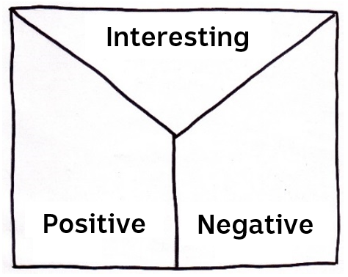Note taking
Students will practise their note-taking skills while watching the BTN Murray-Darling Wetlands story. After watching the story, ask students to reflect on and organise the information into three categories. What information in the story was...?
- Positive
- Negative or
- Interesting
Glossary
After watching the BTN Murray-Darling Wetlands story students will brainstorm a list of key words. Students may want to use pictures and diagrams to illustrate the meaning and create their own glossary. Here are some words to get them started.

Ecosystem | Biodiversity | Conservation
Water | Species | Organism
Cycle | Habitat | Irrigation

KWLH
The KWLH organiser provides students with a framework to explore their knowledge on the topic of aquaponics and consider what they would like to know and learn.

What do I know? | What do I want to know? | What have I learnt? | How will I find out?

Questions for inquiry
Students will develop their own question/s for inquiry about wetlands. Students will collect and record information from a wide variety of sources. Students may develop their own question for inquiry or select one of the questions below.

- What is a wetland? Include as many of the following terms in your explanation: ecosystem, habitat, biodiversity, absorb pollutants.
- What is the difference between a river, floodplain and wetland? Find a simple definition for each and then explain to a classmate.
- Why are wetlands important? Think about the social, cultural, economic and ecological importance of wetlands.
- About how many wetlands are there in the Murray-Darling river system? Choose one area to explore in more detail, for example the Coorong, Wonga or Macquarie marshes. What Indigenous group have a strong connection to the area? Locate the area on a map.
- How do wetlands absorb pollutants and improve water quality? Include these words in your explanation: filtering system, sediment, nutrients and pollutants.
- How can we help the wetlands? Identify some of the threats to wetlands and then suggest some ways that people can help protect our wetlands. Design a poster to raise awareness about the importance of wetlands
- There are 5 wetland ecosystem groups (arid, alpine, coastal and marine, estuarine and inland riverine wetlands). Choose one wetland system to explore in more detail. What are the characteristics of that wetland?
- Wetlands can be permanent, semi-permanent or seasonal. What does this mean?
- Why should we protect our wetlands? Write a persuasive piece of writing explaining your reasons.
Scientific exploration
Provide students with the opportunity to think and behave like biologists. As a class, plan a study trip to a wetland. Alternatively, you can visit a virtual or interactive wetland as a class, for example Catchment stories – QLD Wetland Program, Bittern Coastal Wetlands Virtual Tour or Ecolinc Discovering Wetlands.

In this activity students will be given the mission to explore the wetland, identify animals and plants in the ecosystem, and record any observations they make about the wetland. Students will work individually or in small groups and use the following as a guide.

Plan | As a class, plan a visit to a wetland. Write a list of things you may need for the exploration, for example: pen and paper for taking notes, clipboard, camera and magnifying glass, nets, buckets, containers. Predict what the wetland might look like and what you might find.
Explore | Visit the wetland and carry out an exploration of the area. Choose a spot in the environment to investigate. Look and listen for evidence that animals live in the area. Remember to respect and care for the environment, including any animals and plants, during your observations.
Collect | Collect as much data as you can about what you see and record what you find. Write notes and sketch what you see to help in your investigation. Record what you see with a stills or video camera.  - What does the wetland look like? Take photos and draw pictures.  - What animals and plants can you find? If you are not sure what they’re called take a photo and identify each species back in the classroom.  - What are the animals doing?  - Take a sample of water. Can you find any organisms in the sample?  - What interactions or interdependence do you notice?
Share | Return to the classroom and share/compare your findings.
Analyse | Analyse your findings and write a short summary of your investigation. Respond to the following questions:  - Did you find any animals during your investigation? If yes, identify, describe and classify what you found. If you didn’t see any animals did you find any evidence that animals live in the area?  - Can you create a food web including any of the species you found in the wetland? Draw a diagram.
Research | Develop your own question/s for inquiry about wetlands, for example:  - What might the wetland look like at different times of the year?  - Choose a wetlands plant or animal to research in more detail. How has it adapted over time to survive in wetland conditions.
Reflect | Reflect on the investigation by responding to one or more of the following questions:  - What did you enjoy about this investigation?  - What did you find surprising?  - What would you do differently next time?
Choose a project
Individually or in small groups, students will choose one of the following projects to work on and then present their findings to the class.
Ecosystem
What is an ecosystem? Find an ecosystem in or close to your school and teach others about it. It could be a pond, marine or forest ecosystem. You could even look at your own school as an ecosystem!
Dirty water project
Experiment with a range of materials to turn dirty water into clean water. Materials: dirt, water, rocks, cotton balls, cup, kitty litter, coffee filter and a plastic bottle cut in half. What worked well and what didn’t work so well?

True or false?
Find out as much as you can about wetlands. Create a true or false quiz and test your classmates.
Alternatively, create a word find or crossword about wetlands.
World Wetlands Day
Think of a way that your class or school can get involved and celebrate World Wetlands Day. Find a wetland expert to talk at your school.

Water from Murray-Darling Basin plan not being delivered to wetlands, Australian-first report finds – ABC News
https://www.abc.net.au/news/2020-11-17/murray-darling-missing-water-in-floodplains/12887342

Wetlands of the Murray-Darling Basin – Murry-Darling Basin Authority
https://www.mdba.gov.au/sites/default/files/pubs/Macquarie-Marshes-Poster.pdf

Murray-Darling Warning – BTN
https://www.abc.net.au/btn/classroom/murray-darling-warning/10790804

Fish Rescue – BTN
https://www.abc.net.au/btn/classroom/fish-rescue/11505940

River Kids – BTN
https://www.abc.net.au/btn/classroom/river-kids/10524662

What are wetlands? – Department of Agriculture, Water & Environment
https://www.environment.gov.au/water/wetlands/about

Teacher Resource
Episode 34
24th November 2020

Happiness Survey 2020
Students will develop a deeper understanding of things that affect their mental health.

Health and Physical Education – Years 3 and 4
Investigate how emotional responses vary in depth and strength.

Health and Physical Education - Years 5 and 6
Examine the influence of emotional responses on behaviour and relationships.
Investigate the role of preventive health in promoting and maintaining health, safety and wellbeing for individuals and their communities.
Participate in physical activities designed to enhance fitness and discuss the impact regular participation can have on health and wellbeing.

- Discuss the BTN story with another student. Record the main points of your discussion.
- According to this year’s BTN Happiness Survey, how many young people said they've been worried about COVID-19 lots of the time?
- Complete the following sentence. One in five kids say __________ had an impact on their mental health.
- How has COVID-19 affected kids? Give some examples.
- Most kids agree or strongly agree with:
  - Washing your hands regularly
  - Getting tested
  - Socially distancing
  - All of the above
- How are phones or other devices affecting kids?
- Do you think your devices affect your sleep? Why or why not?
- Who should you talk to if you are feeling worried, angry or sad?
- What was surprising about the survey results?
- What things make you happy?

Class Discussion
As a class, discuss the information raised in the Happiness Survey story and then ask students to respond to the following questions:
- What makes you happy?
- Name something that makes you worried, angry or sad.
- What can kids do if they are feeling worried, angry or sad?
- What do you do to help yourself feel calm?
- What have you found challenging in 2020?
- How have you coped with those challenges?
- Who do you talk to when you’re feeling sad, stressed or anxious?
- What are ways that you keep yourself healthy? Spend a few minutes writing down your ideas on post-it notes. Stick your post-it notes together on a board or wall in the classroom. As a class decide upon a definition of mental health.
- What questions do you have about mental health?

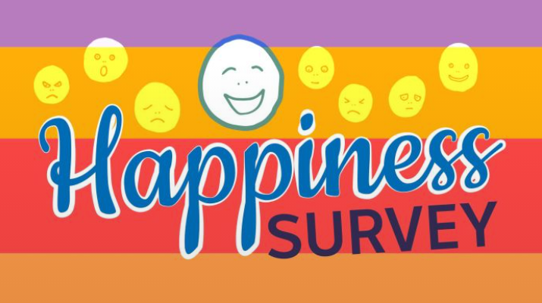
Happiness Survey
2020 has been a strange year for everyone and we want to know how it’s affected the happiness of Aussie kids. Students can complete the Happiness survey here.
As a class, talk about experiences or situations which generate particular feelings. List a range of positive and negative feelings which can be experienced at home, in the classroom and in the school playground. Organise your responses into two columns, Situation and Feelings. Below are some examples.

Situation | Feelings
You are giving a presentation to your class
Someone has asked if you would like to join in a game in the school playground
Someone in your family gets sick
Kids in the playground are joking about the clothes you are wearing
You can’t get back to sleep in the middle of the night
Someone in your class invites you to their birthday party
It’s your first day at a new school
You have just won the basketball grand final

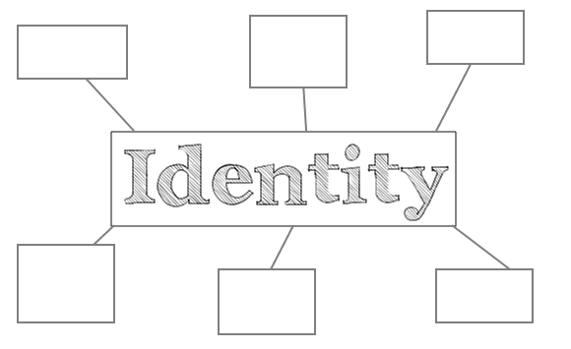Understanding Identity
Getting an idea of who you are and knowing your strengths and talents can be really useful in building confidence and self-esteem.

Identity
As a class, students will begin this activity by discussing and brainstorming what makes up your personal ‘identity’. Use a mind map to record the students’ responses about identity and then find a dictionary meaning.

Who am I?
Who am I? Students will reflect on this question through discussion, writing and art. Students will brainstorm and record how they see themselves, responding to the following reflective questions. Student will then take the information they have learnt about themselves and create a collage that illustrates who they are.
- Who are you?
- What words best describe you?
- What are you really passionate about?
- What are your most important values?
- What do you think is unique and special about you?
- What are your strengths? Check out this website for tips on figuring out your strengths.
- What are your challenges?
- How are you similar/different to other people? How do you feel about your differences?
- When do you feel most like yourself?
Choose a project
Mental Health Journal
What things affect your mental health? Keep a journal of positive and negative things you experience, think about or hope for, over one week. After a week share with a partner or the class how your journal made you feel.
.

Mental Fitness
Design a mental health guide for students at your school. Think about things like:
- Positive thinking
- A good sleep routine
- Regular physical activity
- Healthy eating
- Skills for managing stress

Heart on my Hand
Draw on your hand or on a picture of your hand all of your best characteristics. It is an opportunity for you to visually express and celebrate yourself.

Reaching Out
Create a mind map of all the support places/people/organisations you can think of that are available to help young people going through a tough time. Choose one of the categories and explain how someone might find support.

Mental health resources
Here are some resources to help children manage and look after their mental health.
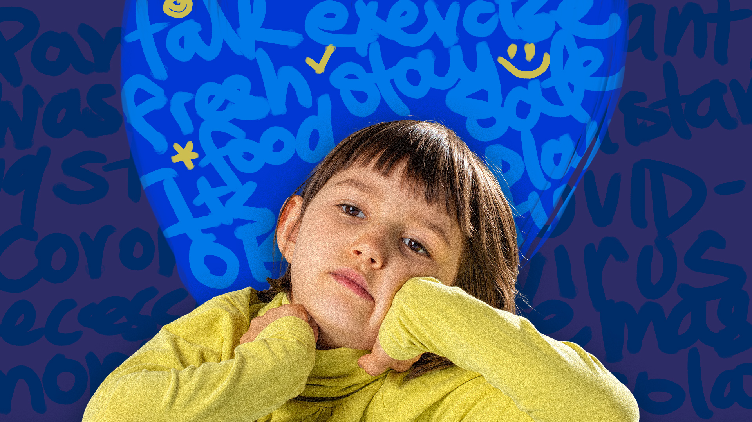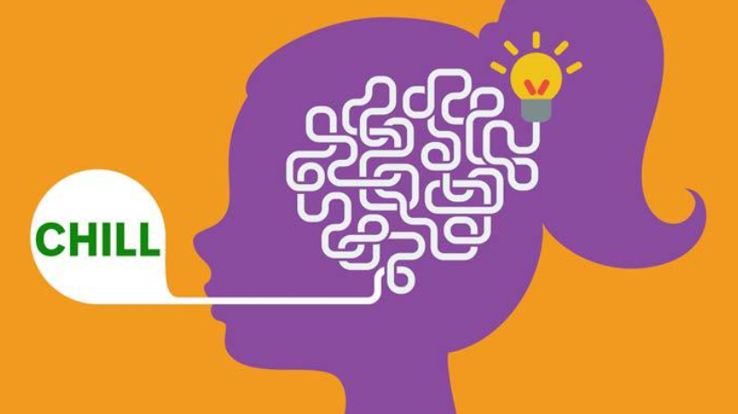

Students: How to look after your mental health BTN Coronavirus Mental Health

BTN Coping During COVID BTN Healthy Minds
Happiness Survey – BTN
https://www.abc.net.au/btn/features/happiness-survey-2020/12795914

Reach Out – Mental Fitness
http://au.reachout.com/wellbeing/mental-fitness

Behind the News – Resilience
http://www.abc.net.au/btn/story/s4067152.htm

Kids Helpline
https://kidshelpline.com.au/

Developing Minds – How teachers can help kids deal with negative emotions in the classroom
http://developingminds.net.au/teacherhelpworriedmadsadkids

Students: How to look aster your mental health – ABC Education
https://education.abc.net.au/newsandarticles/blog/-/b/3511707/students-how-to-look-after-your-mental-health

Coping During COVID – BTN
https://www.abc.net.au/btn/classroom/coping-during-covid-19/12553468

Coronavirus Mental Health – BTN
https://www.abc.net.au/btn/classroom/coronavirus-mental-health/12094046

BTN Transcript: Episode 34 – 24/11/20

Hey. I'm Amelia Moseley and you're watching BTN. Here's what's coming up. We learn more about a century of flight in Australia, find out how you're feeling in this year's Happiness Survey and meet 2020s Sleek Geeks. All that soon.

Holiday Borders

Reporter: Jack Evans

INTRO: But first, the holidays are nearly here and for many Aussies that's usually a time to catch up with family interstate or even overseas. But of course, this year is anything but usual. So today, let’s find out more about what's going on when it comes to travel and whether we'll all be home for Christmas. Take a look.
JACK: Helloooo? Mum? Dad?
People like me, with families on the other side of the country, might be feeling like these holidays will be spent home alone. Yep because of COVID a lot of us have been kept apart for a long time and now we're looking towards Christmas and wondering, when we'll all be together again? Well the Prime Minister, Scott Morrison, does have a plan for re-opening all of Australia's internal borders or at least he did have a plan.
SCOTT MORRISON, PRIME MINISTER: This is the plan, and it sets it out. It'd be very familiar, I think, to many. The reopening plan to get Australia open by Christmas of this year.
But plans can change, just ask South Australia.
MARLA: I'm Marla and I'm in Adelaide which is in lock down right now. This means no school, no going out and I can't go to my dance company rehearsals.
Yup, after months and months of no coronavirus cases a cluster popped up in Adelaide and SA began Australia's harshest lock down yet.
NADIA: To keep busy I'm going to write my own songs, play the trumpet and play with my dirty dog.
Ahh, but then the plans changed again. 6 days became 3 days when authorities found out it wasn't spreading on pizza boxes. It's a long story.
GRANT STEVENS, SA POLICE COMMISSIONER: The lie was the person claimed they'd purchased a pizza from the pizza shop. Where in fact they were working there and had been working there for several shifts. That clearly changes the circumstances and had this person been truthful to the contact tracing teams we would not have gone into a six-day lockdown.
While it was a huge relief for South Aussies, it put a bit of a glitch in the PM's open-border-reunited-for-the-holidays-plan with several states now considering SA a hotspot. Meanwhile there are stacks of Aussies still stuck overseas trying to get home. As well as Aussies who can't travel overseas to see their family.
But it's not all bad news. Borders have started to open up and people have been reunited with loved ones, both the human and the animal kind.

PERSON IN AIRPORT: I’m excited to go home, so, I’m really looking forward to seeing my family.

PERSON IN AIRPORT: It’s fantastic, much waited for, so it’s good.

On Monday New South Wales became the first state to completely open its borders and many are hoping there's still a chance we'll all be together again for Christmas.
ROSE: I'm looking forward to seeing my cousins and my Aunty and Uncle this Christmas holidays, possibly.
VICTOR AND VIVIENNE: Our cousins moved to Adelaide and we live all the way in Sydney. That's why we want to go to Adelaide. We missed them and it would be a real shame if we couldn't see them.
So, fingers crossed, but we're all getting pretty good at coping with changes this year. Even if that maybe means being home, and in some cases alone.

News Quiz

Can you name this state premier? It’s Steven Marshall, the leader of South Australia who is, of course, in the news for putting his state into Australia’s toughest (but definitely not longest) lockdown.

World leaders have met, virtually, for the G20 summit. Which of these countries is not a part of the group? Australia, Mexico or New Zealand. New Zealand isn’t in the G20. The G20, or group of 20, is made up of the world’s biggest or fastest growing economies so New Zealand doesn’t quite make the list. This year the meeting was a bit different. It was hosted by Saudi Arabia, but because of COVID-19 the actual meetings took place online, including the traditional G20 family photo.

Researchers from the University of Oxford have just done a study which found people tended to be happier if they spent hours a day playing certain video games. Which one of these games was involved in the study? Fortnite, Animal Crossing: New Horizons or Candy Crush. The researchers studied data from gamers who played Nintendo’s Animal Crossing: New Horizons and EA’s Plants versus Zombies.

Murray-Darling Wetlands

Reporter: Nat Kelly

INTRO: Now to some news about the wetlands of the Murray-Darling Basin. They're really important ecosystems which are home to lots of plants and animals, but a recent report has found they're not getting all of the water they need to stay healthy. Here's Nat.

Welcome to the Murray-Darling Basin. Spanning 4 states and 1 territory. Home to the nation's food bowl, a lot of fish, birds, boats, a bunyip? Mm. Scary. And wetlands. They're the boggy bits along the rivers that stay wet most of the time. Marshes, swamps, estuaries, billabongs, the Murray-Darling Basin has around 30,000 of them.
PROF JAMIE PITTOCK, AUSTRALIAN NATIONAL UNIVERSITY: These wetlands are really important habitats. And that's because there is so much water there, that plants can grow a lot and generate food for lots of insects and animals. It's also a refuge area, it's often a cooler kind of habitat. And so in really hot places in Australia, lots of land animals like to use the moist forests along the rivers, to shelter.
Professor Jamie Pittock is a water management expert who's been looking closely at the Murray-Darling's wetlands, and what he found wasn't great. He says a lot of them aren't getting the water they need to stay healthy. And the main reason is a lack of floods. That might sound a bit strange, but floods are actually a really important natural part of the river system.
PROF JAMIE PITTOCK: In winter and spring, when there is snow and lots of rain, there would be a lot of water come down the river in those seasons and fill up the river channel and spill out over the riverbanks and onto the wetlands, which made the plants healthy, and then the animals healthy. The dams have stopped that happening.
In the past 200 years, we've built heaps of dams and weirs along the rivers and taken out a lot of water for irrigation.
PROF JAMIE PITTOCK: Until recently, about half of the water in the rivers was being taken out for farming. But that meant that there wasn't enough water left to keep the plants and animals that depend on regular watering, alive.
It's why, back in 2012, the government came up with a plan to share the water between farmers right along the river, and make sure there was still enough left for the environment. Some of that extra water was supposed to make its way to wetlands. But Professor Pittock says it's not always getting there. He says it's mainly because governments have to negotiate with farmers before they can flood their land, and they have to make sure it doesn't damage properties, roads, or crops. That's a long and difficult process, and it means only small amounts of water are being released at a time.
PROF JAMIE PITTOCK: What that means is that while there's a lot of environmental water, about 2000 billion litres, can you imagine 2000 billion litres. Unfortunately, the governments are just being forced to let that run down the river channel, which is good for keeping the water clean and helping fish. But it's not helping the wetland ecosystems, because it's not going over the riverbank and onto the floodplain.
It's not an easy problem to fix. But experts say we need to figure out a solution quickly if we want to protect the Murray-Darling and its amazing wetlands.
Quiz

In which state is the mouth of the Murray River? New South Wales, Queensland or South Australia? It's in South Australia.

Qantas History

Reporter: Jack Evans

INTRO: Last week was a milestone in the history of flight in Australia. The country's oldest airline, Qantas, turned 100. So, today we thought we'd take a look at what flying around Australia was like in the past and how airlines are faring now. Here's Jack.
Australia is a pretty enormous place, imagine trying to get around it without a plane. Well for a long time that was a thing until these guys, Hudson Fysh and Paul McGinness, had a thought while travelling across the Queensland outback.
JACK AS FYSH & McGINNESS: Gosh Australia is a big place. Tell me about it. Hey why don't we, instead of driving, carry mail, cargo, even people by aeroplane? Gee that's a cracker of an idea.
It sure was, but back then in 1919 planes were still fairly new. In fact, most people were pretty terrified of the idea of a big hunk of metal soaring through the sky. But not Fysh and McGinness, they had both flown planes during the First World War and thought that maybe they could be used to deliver mail and people from A to B. A year later, on the 16th of November 1920, they founded the Queensland and Northern Territory Aerial Services or Qantas. There were doubters, like the postmaster at the time.
JACK AS POSTMASTER: Airmail? That'll never work.
But a few months later Qantas took off on its first ever mail and passenger flight from Charleville to Cloncurry. This guy, Alexander Kennedy, was their first ever passenger and when they were soaring through the sky yelled, be damned to the doubters. Over the next several years Qantas really started to soar. The planes got improvements including one with a toilet and they started making longer trips, not to the toilet. In 1934 Qantas teamed up with Britain's Imperial Airlines for their first international flight. 15 passengers travelled from Darwin to the UK in just 9 days with only 36 stop overs. Which apparently was impressive at the time.
After the Second World War the government bought Qantas and created a domestic airline called TAA. The other main airline was Ansett and for the next few decades if you were flying in Australia chances are, you'd either be on one or the other. In fact, they were the only two airlines allowed to fly between capital cities. And they were busy, more and more people took to the sky as flying got quicker, cheaper and safer. In fact, Qantas was famous for its lack of major accidents. In the 90s the government decided to sell Qantas and let other airlines join the mix. But the competition was too much for Ansett which shut up shop for good in 2002.
Since then the airline industry's seen its ups and downs and right now it's definitely down. COVID-19 has made it really hard for airlines to stay aloft and many workers have been stood down or lost their jobs. Earlier this year Virgin announced it couldn't pay its debts. It was sold to new owners and while it's still in business it'll have make some changes. As for Qantas while it hasn't been the best year last week was a time to celebrate and while we don't know what the future will hold the flying kangaroo has cemented it's place in Aussie aviation history.

Quiz

What's the longest non-stop flight you can take on a commercial airline? Is it Perth to London, New York to Singapore or Doha to Auckland? At the moment, it's Singapore Airlines' flights from New York to Singapore, which takes 18 and a half hours on a good day. Although Qantas could break that record if it goes ahead with flights from Sydney to New York which takes 19 hours and 16 minutes.

Happiness Survey 2020

Reporter: Amelia Moseley

INTRO: For the past few week's we've been asking you to take part in our Happiness Survey and we've already had thousands of responses. If you haven't managed to fill it out yet, don’t worry, you've still got a few weeks. But we thought we'd have an early look at the results and see how Aussie kids are feeling in 2020. Check it out.

It's been a pretty weird year and according to the results of 2020s BTN Happiness Survey so far, COVID-19 has been on the minds of a lot of Aussie kids. No surprises there. About one in three kids say they've been worried about the coronavirus lots of the time and one in five kids says it's had an impact on their mental health.
RAFAEL: The thing I worry about the most is that coronavirus will have another massive outbreak and I won't be able to go outside.
JONAH: It can be quite disturbing and worrying sometimes in case the cases build up again and more people are passing away.
IZZY: We live right next to my grandparents, I'm more worried about getting it and passing it onto my family.
Lots of kids say COVID-19 has made things like exercising and playing sport and after school activities harder. And some of you say it's made schoolwork trickier too.
POPPY: It's made it a lot harder for school and especially we've missed out on a lot of things in Grade 6.
BEN: Lots of my sports have been cancelled and lots of activities I wanted to do and basketball.
But most of you agree or strongly agree with washing your hands regularly, getting tested, socially distancing and controlling public gatherings. COVID isn't the only thing on a lot of kids minds though. More than half of you say your phone or other device is stopping you from getting enough sleep at least some nights of the week. That's a big increase from what kids told us in 2017's BTN Happiness Survey.
POPPY: When you're on your screens and then you go to sleep, you're like always thinking about them and they kind of just distract you from going to sleep.
KALINA: I think screens have a big impact on your sleep and the next day at school my abilities wouldn't be at their best.
And around a third of you say you worry a lot of the time about your bodies, your future and your family and friends.
BILLY: I worry about family getting sick and grandparents and maybe going into high school.
KALINA: When I've done something wrong and won't admit to it or if I haven't finished a task on time.
While experts say it's normal to worry or feel sad or angry sometimes like a lot of you say you do you should always talk to a family member, a teacher or a friend about it. It'll hopefully make you feel better. And speaking of feeling better there’s some good news too. Half of you told us you feel happy lots of the time or that you feel like you belong. And the things most likely to make you smile are your family and friends and home in general.
KALINA: The things that make me happy in life is doing the things that I enjoy the most like gaming, playing sports, art.
JONAH: Doing some gardening sometimes. Playing soccer and cricket on my front lawn.
BILLY: I like going to my dog cause she makes me feel happy. I also like being with my family and friends.
About three out of five of you also say you feel hopeful about your own future and the future of Australia.
BILLY: Yeah I think we'll make a vaccine and we’ll get over corona.
KALINA: Things will gradually get better which is why we all need to work together.
But these are just our early results and there's still plenty of time to get involved in this year’s BTN Happiness Survey to have your say today.
Ask a Reporter

You can join me, and Jack live on Friday for the last Ask A Reporter of the year, where you can ask us anything about BTN or the stories we've covered in 2020. Head to our website for all the details.

Sport

The Sydney Sixers Big Bash campaign has come to a bitter-sweet end. While they took victory over the top-placed Melbourne Stars by five wickets on the weekend, they just missed out on a spot in the semi-finals. Despite ending the season equal fourth on points they’re closest rivals still finished higher by net run rate.
Queenslanders are still celebrating an unexpected but very welcome State of Origin win. With 14 debutants in the series and coming off a 24-point loss in Sydney. This Queensland side was dubbed the worst in 40 years, that was until kick off. A best on ground effort from Cameron Munster and tries to Edrick Lee and Harry Grant secured a 20 to 14 win for the Maroons.
And no tow truck? No worries. These guys have just the solution. These super strong strongmen from all over Russia are carrying cars, pulling trucks and lugging 100 kilo tyres all for the title of the strongest strongman. I think I broke more of a sweat just watching. Phew.

Sleek Geeks 2020

Reporter: Nat Kelly

INTRO: Finally, today, move over Doctor Karl because you're about to meet the science communicators of the future. They're the finalists of this year's Sleek Geeks Science Eureka Prizes which ask kids to tell us all about an interesting scientific concept. Take a look.

NAT: Have you ever asked yourself, what is water? Where does it come from? What are some properties about water that make it especially watery? I know I have. A. Water is wet. B. Water comes from the tap. I think? And rain.
LEELA: What are you doing?
NAT: Oh hey, I’m just making an entry for the Sleek Geeks Eureka Prize.
LEELA: Really?
NAT: Yeah.
LEELA: Oh, a. you're too old, and b. the competition closed ages ago. They’ve already announced the finalists.
NAT: Oh.
LEELA: Yeah. OK, well, have a good day.
NAT: Well, let's take a look at some of them, shall we?
If you're a budding filmmaker, and into science, you might have heard about the Sleek Geeks Science Eureka Prize. It's a competition open to primary and secondary school students, and it's presented alongside the Australian Museum Eureka Prize. Students are asked to focus on a scientific concept, discovery or invention, or even present their own scientific hypothesis. And this year's topic was water.
NAT: This entry is from Jessica and Zachary, which explores why ice floats in water, defying the rules of chemistry. Let’s check it out.
VIDEO: Water. H2O, right? What you probably didn't know is that water is something called a Polar molecule. This is how water expands when it cools instead of contracting. The molecules aren't packed as tightly, creating more space between them and resulting in a lesser density. And that is why, despite all that we think we know, solid water floats in its liquid counterpart.
NAT: That's really interesting. I never knew that. But I guess I never really questioned why ice floats in water. Then there was this pretty cool concept.
VIDEO: Did you know that there was a type of miniature hovercraft fuelled by its own fart?
NAT: Future of transport?
VIDEO: This is caused by droplets evaporating, and steam propels them upwards. As well as propelling them upwards, the steam acts as an insulator because it conducts heat less than water. 30 times less to be exact.
NAT: While these guys opted for a bit of Claymation and interpretive dance to explain how to go about supercooling water.
VIDEO: First let's have a look at how water turns into ice. A water molecule connects two hydrogen atoms, bonded to one oxygen atom. Molecules are constantly moving, because they have energy.
NAT: Oh. This one's something I've always wondered. How can some bugs float on water?
VIDEO: As you can see here, the water bugs are just making little dimples on the surface and not sinking in. This is because the force they are putting on the water is less than the surface tension. This bonding is called cohesion and happens because the water molecules form hydrogen bonds with each other. But they can't form bonds with the air above them.
NAT: Of course, this is only a tiny snapshot of Sleek Geeks 2020. Well they were great. I wonder what next year’s topic is going to be.
LEELA: It's big. The topic is big.
NAT: Well, you heard it here first, folks. 2021. Big. Now, I got to get to work.
Closer

Well, that's it for today and that's nearly it for 2020. Next week we'll have a special episode looking back at the year and some of the awesome people that we've met along the way. And of course, we’ll have our annual end-of-year mega quiz, so get studying. In the meantime, Newsbreak will be here every weekday to keep you up to date and don't forget there's still plenty of time to take part in the 2020 Happiness Survey. Have an awesome week and I’ll see you later. Bye.

