Episode 5
12th March 2019



Kashmir Conflict
- Discuss the Kashmir Conflict story as a class and record the main points of the discussion.
- When did India become independent from Britain?
- 1847
- 1947
- 2017
- What is the name of the plan that split India into two parts?
- India became a majority ____________country and Pakistan a homeland for British India’s _________ population.
- Which area of land did India and Pakistan fight over?
- Who controls Kashmir today?
- Describe the recent conflict in Kashmir.
- Why are a lot of world leaders worried about the recent conflict?
- What do you understand more clearly since watching the BTN story?
- How did this story make you feel?

Single-use Plastic Ban
- What did the BTN Single-use Plastic Ban story explain?
- Which city has just announced a ban on single-use plastics?
- Give some examples of single-use plastics.
- Before plastic existed, what sort of materials were used?
- In which decade did plastic become a commonly used material?
- What are some advantages of plastic?
- Who will be impacted by the ban?
- Create a T chart with the pros and cons of a ban on single-use plastics.
- What was surprising about this story?
- What did you learn watching the BTN story?

Check out the Single-use Plastic Ban resource on the Teachers page.

TikTok Trouble
- In pairs, discuss the TikTok Trouble story and record the main points of the discussion.
- TikTok is an app that lets users create…
- Why has TikTok been in the news lately?
- Recently, TikTok passed the _____________users mark.
- Why was TikTok fined recently?
- How old do you have to be to set up a profile on TikTok?
- Why are there age restrictions on many social media platforms?
- What happened to the accounts of many users under 13?
- What has TikTok done to make the app safer?
- Do you think that age restrictions on social media platforms are fair? Give reasons for your answer.

Life in Antarctica
- Briefly summarise the BTN Life in Antarctica story.
- Antarctica is the coldest, driest and windiest place on Earth. True or false?
- About how many people work in Antarctica with the Australian Antarctic Division?
- Describe the clothing worn by people in Antarctica.
- What is the name of the station where Emma stayed?
- What types of jobs do people do in Antarctica?
- How do they grow veggies in Antarctica? Use words or pictures to explain.
- Why can’t they bring soil from Australia to grow plants in?
- What are some of the disadvantages of living in Antarctica?
- What questions do you have about Antarctica?

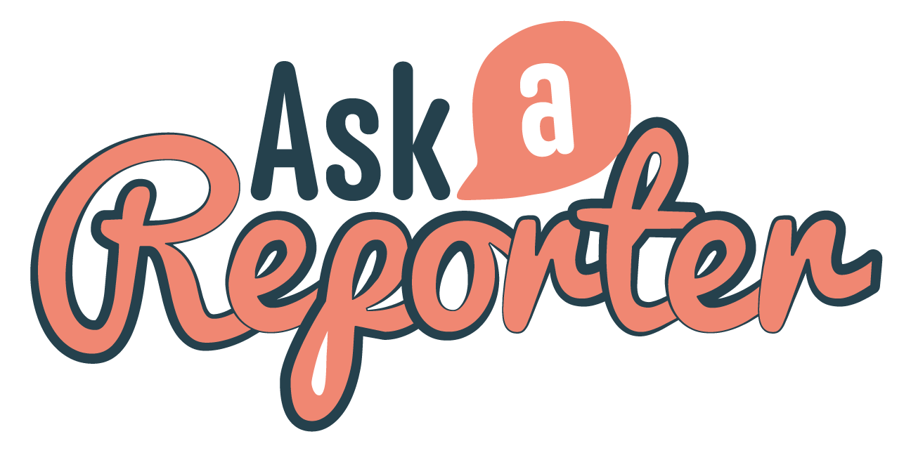
Check out the Life in Antarctica resource on the Teachers page. Get your class involved in BTN’s Ask A Reporter! This week’s topic is Life in Antarctica.

World’s Greatest Shave
- What is the aim of the World’s Greatest Shave fundraiser?
- Leukemia is a type of ________________of the blood.
- Finish the following sentence: Leukemia happens when something goes wrong with your…
- Leukemia is one of the more common cancers that kids can get but the treatments are really good. True or false?
- Retell April and Tom’s story.
- What does Jack’s dad Paul have?
- What did Paul do to raise awareness about the issue?
- What did Jack do to raise awareness for the cause?
- Name three facts you learnt watching the BTN story.
- How did this story make you feel?

Teacher Resource
Episode 5
12th March 2019

Single-use Plastic Ban

Students will investigate the impact single-use plastics have on the environment.


Geography Year 4
The use and management of natural resources and waste, and the different views on how to do this sustainably.

HASS – Year 4
Reflect on learning to propose actions in response to an issue or challenge and consider possible effects of proposed actions.
Science Year 4
Science knowledge helps people to understand the effect of their actions.
Science – Year 5 & 6
Scientific knowledge is used to solve problems and inform personal and community decisions.

- What did the BTN Single-use Plastic Ban story explain?
- Which city has just announced a ban on single-use plastics?
- Give some examples of single-use plastics.
- Before plastic existed, what sort of materials were used?
- In which decade did plastic become a commonly used material?
- What are some advantages of plastic?
- Who will be impacted by the ban?
- Create a T chart with the pros and cons of a ban on single-use plastics.
- What was surprising about this story?
- What did you learn watching the BTN story?


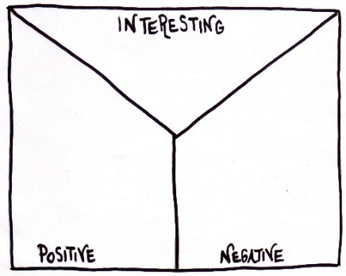
Note taking
Students will practice their note-taking while watching the BTN Single-use Plastic Ban story. After watching the story, ask students to reflect on and organise the information into three categories.

What information in the story was...?
- Positive
- Negative or
- Interesting

Class Discussion
As a class discuss the BTN Single-use Plastic Ban story using the following questions as a guide. Record the main points of the discussion on a mind map with single-use plastics at the centre. Use the following questions to guide the discussion:
- Which city has banned single-use plastics?
- What are single-use plastics? Give some examples.
- Why has the ban been introduced?
- What impact do single-use plastics have on the environment?
- What are the benefits of single-use plastics?
- What are the alternatives to single-use plastics?
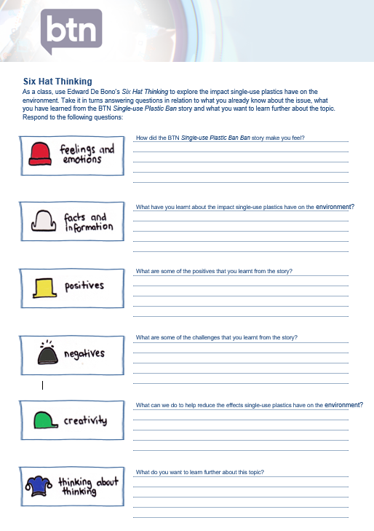
Six Hat Thinking
As a class, use Edward De Bono’s Six Hat Thinking to explore the impact of single-use plastics on the environment.

Students will take it in turns answering questions in relation to what they already know about the issue, what they have learned from the BTN Single-use Plastic Ban story and what else they want to learn about the topic.

There is a worksheet at the end of this activity for students to record their responses on.

Awareness Challenge – Single-use plastics audit
For one-week students will keep a diary to document the amount of single-use plastics they use.

Class brainstorm
Before starting this challenge, brainstorm a list of plastics that are designed to be used once. Share students’ ideas by recording their responses. For example, cling wrap, zip lock bags, plastic cutlery, plastic bags, plastic straws, water bottles, take away containers.

Audit your single-use plastics
On a daily basis, collect and record all the single-use plastics used, including the weight. At the end of the week add up how many pieces of single-use plastics you threw out and the combined weight. Plot the results on a bar graph.

Day | What single-use plastics did you throw away? | Number of items | Weight
Monday
Tuesday
Wednesday
Thursday
Friday

Analyse your results
Analyse your results and respond to the following:
- What surprised you about the results?
- Identify the best areas for improvement. How could you reduce the amount of single-use plastics you use?
- How much of the single-use plastics is able to be avoided, reused, recycled or is biodegradable?
- What are sustainable options to single-use plastics?


Reduce your waste
Do your part to make a change and challenge yourself by having a `waste-free lunch’ or `nude food’ for a day or a week.
- Think of ways that you can avoid or reduce the amount of packaging you use. For example, putting food in reusable containers instead of disposable bags, and avoiding pre-packaged food.
Make your own
REUSABLE BEESWAX
FOOD WRAPPERS.
Discuss the benefits of using beeswax wrappers instead of plastic wrap.
.

- Did you find this challenge difficult? Why or why not? Explain.
- How has this challenge impacted on your thinking?
- What can you do to take action?
  - Reduce the amount of packaging
  - Buy food that has little or no packaging (wherever possible)
  - Buy food in bulk and put into reusable containers
  - Write to food companies asking them to reduce the amount of packaging or change to environmentally friendly packaging.

Awareness raising art installation
The Natural Plasticity Art Installation was created to raise awareness about the problem of single-use plastics and to challenge people to look at waste differently. Below are some images from the installation. Ask students to respond to the images. Do they think they’re an effective way to get the message across? Why or why not? Students can then create their own awareness campaign about the issue of single-use plastics. They can create an art installation or display or any other medium of their choice to get their message across.
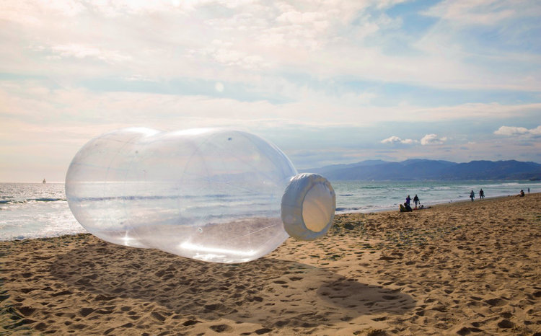
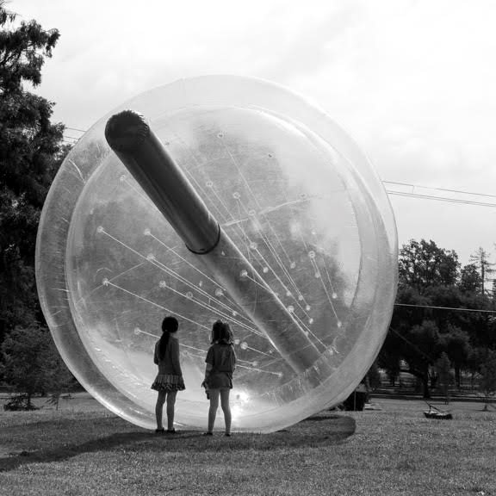

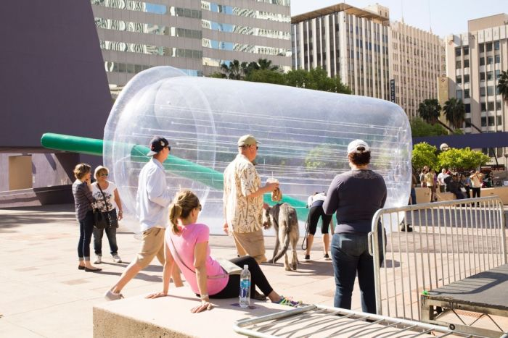

@naturalplasticity: Jana Cruder and Matthew LaPenta
Persuasive argument – Should single-use plastics be banned?
Students will develop a persuasive text for or against the following statement: `There should be a worldwide ban on single-use plastics’. Students can use the information recorded on the mind map and their own research to help develop their argument. Encourage students to use a range of sources.
Provide students with the following structure to follow when completing this activity.
Structure of a persuasive text
Introduction
- What is the point you are trying to argue? Construct an introductory paragraph which states the issue or topic.
- Introduce the arguments that will be developed in the body of the text.

Body
- Construct arguments that support your point of view.
- Each paragraph starts with a topic sentence which introduces each point.
- The rest of the paragraph gives more reasons.
- Arguments can be ordered from strongest to weakest.

Conclusion
- Restate your position on the argument.
- Construct a concluding paragraph that provides a summary of your arguments and a call to action.

Tips for writing persuasive texts
- Who is your audience? For example, are you directing your argument at kids, teachers or politicians?
- Explore how language choices can have a big impact on persuading your audience.
- Which language devices give the report credibility and authority?
- Which are designed to create an emotional response in the listener?
- Provide facts and evidence to support your argument.
- Write in the present tense.
- Check your spelling and punctuation.

Use this Read Write Think persuasion map to plan your exposition text.

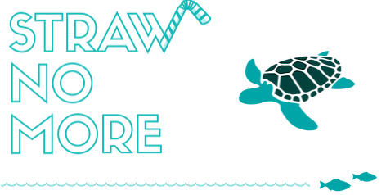
Kids making a difference
Students will investigate ways they can make a difference to the problem of plastic pollution. Working in pairs brainstorm some solutions to the problem. For example, conducting a beach clean-up or reducing the amount of plastic packaging they use.
They can take a look at kids who are making a difference on an environmental issue. Go to Molly’s Straw No More campaign website and check out her Ted Talk.

BTN has featured kids who are passionate about the issue with these stories Plastic Ocean Campaigner Plastic Bag Ban War on Waste School

Discuss ways to present the information. Some ideas include:
- Make a news report. Visit the BTN Rookie Reporter page for some ideas.
- Create a website using Wix
- Create a podcast using PodOmatic, Buzzsprout to share with the school community.


ABC News – Hobart’s single-use plastic ban
https://www.abc.net.au/news/2019-03-05/hobart-to-ban-single-use-plastic/10869790
ABC News – South Australia to consider banning single-use plastics such as straws
https://www.abc.net.au/news/2019-01-13/sa-to-consider-banning-single-use-plastics/10711906
ABC News – Rate of plastic pollution will double by 2030 as report calls for end to single-use plastics
https://www.abc.net.au/news/science/2019-03-05/single-use-plastic-ban-wwf-report/9918870
Sustainability Victoria – Single-use items
https://www.sustainability.vic.gov.au/You-and-your-home/Live-sustainably/Single-use-items
BTN – Plastic Bag Ban
http://www.abc.net.au/btn/classroom/plastic-bag-ban/10522750
BTN – War on Waste School
http://www.abc.net.au/btn/classroom/war-on-waste-school/10522784

Teacher Resource
Episode 5
12th March 2019

Life in Antarctica
Students will explore why people live and work in Antarctica.

HASS – Year 5
The environmental and human influences on the location and characteristics of a place and the management of spaces within them.
- Briefly summarise the BTN Life in Antarctica story.
- Antarctica is the coldest, driest and windiest place on Earth. True or false?
- About how many people work in Antarctica with the Australian Antarctic Division?
- Describe the clothing worn by people in Antarctica.
- What is the name of the station where Emma stayed?
- What types of jobs do people do in Antarctica?
- How do they grow veggies in Antarctica? Use words or pictures to explain.
- Why can’t they bring soil from Australia to grow plants in?
- What are some of the disadvantages of living in Antarctica?
- What questions do you have about Antarctica?

Class discussion
Before watching the BTN Life in Antarctica story students will brainstorm a list of questions they have about Antarctica, in particular what it’s like to live in Antarctica. For example:

- Why do people live in Antarctica?
- How do people get to Antarctica? What type of transport is used to get to Antarctica?
- How many people live in Antarctica?
- What type of clothes do people wear in Antarctica?
- What animals live in Antarctica?
- What type of jobs do people do in Antarctica?
- What are the conditions like in Antarctica?

Which of your class’s questions were answered by the BTN story? What questions weren’t answered that your students want to explore in more detail? Students will use the KWLH organiser below to help organise the questions raised in your class discussion and find out the gaps in their knowledge.

KWLH
The KWLH organiser provides students with a framework to explore their knowledge on this topic and consider what they would like to know and learn.

What do I know? | What do I want to know? | What have I learnt? | How will I find out?

Topic for inquiry – Living in Antarctica
Students will determine a focus for their inquiry into Antarctica (in particular living in Antarctica) and develop a key question to guide their inquiry (below are some example key questions). Students will collect and record information from a wide variety of sources (internet, books, newspaper and magazines).

- How has living and working in Antarctica changed over time? Analyse how transport, accommodation, communication and clothing has changed. Write a news article reporting on the first expedition to Antarctica and then write a news article reporting on an expedition to Antarctica today.

- What impact do people have on Antarctica? Think about some of the ways that humans might impact the environment. For example, buildings, food, energy, transport and waste. How could people reduce their impact on Antarctica?

- Who owns Antarctica? Explore which countries have territorial claims in Antarctica and draw on a map. Draw flags on your map to represent each of the countries with territorial claims in Antarctica.

- Describe Australia’s connection to Antarctica. Create a timeline showing major expeditions and discoveries made by Australians in Antarctica.

- What is the Antarctic Treaty? What is the main purpose of the Antarctic Treaty? Explore what makes Antarctica unique in relation to its rules and the way it is run. Make a poster for World Antarctica Day (1st of December), which celebrates the continent and marks the day that the Treaty was signed.

- What do you think an Antarctic winter would be like and how would it influence the people that live in Antarctica? Think about sunlight, temperature and landscape. What changes do you think you would see as the seasons change from autumn to winter and winter to spring? Watch this ABC Splash video to learn about the changes of seasons in Antarctica.

Visiting Antarctica
Students will imagine they will be visiting Antarctica to complete a mission. Below is a suggested framework for their research. Before starting this activity, students will brainstorm a list of jobs that people do while living in Antarctica and then choose one role they would like to explore in more detail.

During this activity students will visit the Australian Antarctic Division’s website on living and working in Antarctica. This website is an important reference for expeditioners before they depart for Antarctica, and anyone seeking information on the unique challenges of living and working on station and in the field.

  Prepare | Make a list of what you will need to take with you on your expedition. Consider clothing, scientific equipment and tools. What other resources will you need while in Antarctica? Estimate the amount of food, water and energy you will need daily. What can’t you take on your expedition to Antarctica?  Where will you be based in Antarctica? Will your work be based in the station, field or both? Describe the living conditions.  ‘Visit’ Antarctica via webcam to investigate the environment and weather conditions. Explore the various webcams looking at the environment from different angels, close-up or faraway. You may want to write notes and sketch what you see to help in the planning of your expedition.
  The journey | Organise your journey to Antarctica. Consider what modes of transport you will use to get there and how long it will take. Plot your journey on a map. Refer to this distance map to calculate approximately how far you need to travel. Create an itinerary for your journey. How long will you be in Antarctica?
Living in Antarctica | Respond to these questions about living in Antarctica:  - What activities will you be doing while in Antarctica?  - What are some of the challenges?  - What might you see whilst in Antarctica?  - How is living in Antarctica different or similar to living in Australia?  Write a journal entry in your diary about your experiences. Title your entry ‘A day in the life of a [insert job here] living and working in Antarctica’. Explore some real-life Antarctic experiences here.
Share | Prepare a presentation to share and compare your findings with the class.
Reflect | Reflect on the investigation by responding to one or more of the following questions:  - What did you enjoy about this investigation?  - What did you find surprising?  - What would you do differently next time?

BTN – Mawson Expedition
http://www.abc.net.au/btn/classroom/mawson-expedition/10523694

BTN – Antarctic Icebreaker
http://www.abc.net.au/btn/classroom/antarctic-icebreaker/10522910

Australian Antarctic Division – Living in Antarctica
https://classroom.antarctica.gov.au/subjects/geography/living-in-antarctica

British Antarctic Survey – Living in Antarctica Today
https://discoveringantarctica.org.uk/science-and-exploration/living-in-antarctica-today/

BTN Transcript: Episode 5 – 12/3/19

Hey there, Amelia Moseley here. Welcome to another episode of BTN. Here's what we've got for you today. A look at a future without plastic, an explanation of TikTok's privacy problems and a journey to the coldest continent.

Kashmir Conflict
Reporter: Amelia Moseley

INTRO: All that soon. But first today to a place called Kashmir. It's located between Pakistan and India and there's been some fighting there recently. Actually, it's not just recently. There's been fighting over Kashmir for the past 70 years and it's all got to do with the history of the region. Let's find out more.

If you travel to the border of India and Pakistan, you'd probably think these neighbours get along pretty well. I mean they both clearly like facial hair, funny-looking hats and have great flexibility. Just look at that high kick. But while this quirky daily tradition of closing the border is quite the spectacle. It's also a sign of a complicated history that's divided two nations. You see, a century ago there was no such thing as the country we now know as Pakistan. For hundreds of years this whole area was controlled by Britain and was known as British India. Eventually in 1947, it became independent from Britain.
BRITISH NARRATOR: August the 15th, 1947 Independence Day for India.
But instead of becoming one single country, it was quickly split into two parts in a plan that's known as The Partition. There was India, which became a majority Hindu country, and Pakistan, a homeland for British India's Muslim population. While there was celebrating for some, it meant millions of people had to leave their homes and many Muslims and Hindus who'd lived side-by-side became enemies.
A war soon broke out between the new countries over an area of land called Kashmir. It's here in the Himalayan Mountains between India, Pakistan and China. While its leader was Hindu, most of the population were Muslim and there was fighting over whether Kashmir should be part of India or Pakistan. The argument continued, and two more wars were fought. Today, Pakistan controls one side of Kashmir and India controls the other and for the past 20 years, things here have been relatively peaceful until now.
The trouble started last month with a terrorist attack which killed some Indian soldiers. India blamed Pakistani terrorists and in response, it attacked a terrorist training base in Pakistan's side of Kashmir. Pakistan was not happy and, soon afterwards, it shot at some Indian fighter jets flying over Kashmir and captured a pilot. That got a lot of world leaders worried that things could escalate, especially because Pakistan and India have big armies and nuclear weapons. Pakistan later released the Indian pilot and it says it's planning to crack down on terrorist groups. Now many are hoping the two countries will keep their cool and, just like in this border tradition, end their rivalry with a handshake.

Did You Know?

Did you know India has 22 officially recognised languages but there are actually way more than that, in fact, surveys have shown more than 1600 different languages and dialects are spoken in India.
This Week in News

Air crash investigators are trying to find out what caused a deadly plane crash in Ethiopia. The Ethiopian Airlines plane had just left Addis Ababa when it came down. It was quite similar to another deadly accident that happened in Indonesia last year involving the same model of plane. Although investigators say it's way too early to know if there's any link.

A new report says that Aussie food is seriously salty. Researchers looked at how much salt is in popular kids’ meals from fast food companies and it found the Aussie versions were often much saltier than the same meal in the UK. It also found that some kids meals had more salt in them than you're supposed to eat in a whole day. That's an issue because too much salt can cause some serious health problems.

Two NASA astronauts will soon make history, by completing the first all-woman spacewalk. Later this month Anne and Christina will walk outside the International Space Station in a seven-hour mission to upgrade its batteries. Their following in the footsteps of the first woman to spacewalk, Russian cosmonaut Svetlana Savitskaya all the way back in 1984.

And music lovers from all over the country and even the world have been partying at the Womad festival in Adelaide. It's a massive world music event featuring 500 artists from more than 30 countries. There was also an amazing art installation where kids helped build this recycled cardboard box thingy with some French artists.

Single-use Plastic Ban
Reporter: Jack Evans

INTRO: Now to plastic. It's a big part of our daily lives but, as you probably know by now, it's also causing some big problems for the environment. Last week a new report came out that recommended banning single-use plastic, something that Hobart is already planning to do. That got Jack thinking about a world where plastic was a thing of the past. Take a look.
MUSEUM GUIDE: This is our single-use collection, notice the fine craftsman ship and the motif of the colour white.
KID: What's that?
MUSEUM GUIDE: That's a plastic fork, good for one use, no wash up required just chuck it out.
KID: Wow it's in such good condition.
MUSEUM GUIDE: Well that's because plastic lasts for a really, really long time, so preservation is not a problem.
KID: But if it lasts forever, why did they throw it away?
MUSEUM GUIDE: The people of the past were a mysterious and primitive people, take this plastic lid for example.
KID: Oh wow. Was that thrown away after one use too?
MUSEUM GUIDE: Precisely, just like this plastic bag which we believe they used to hold things they bought from a place known as a supermarket. What a time.
Ok, so maybe the future won't exactly look like this. Although that is a nice hat.
MUSEUM GUIDE: Thank you.
But if you go back in time a world without plastic was very much a reality. It only became popular in the middle of the 20th century and apparently not just with humans. It was cheap to make, long lasting and a breeze to clean. And it wasn't long before we stopped bothering to clean it and made plastics items that were so cheap they could be used once and then thrown away.
Today, most of us use single-use plastics every day, from cutlery, to plates, packaging, food containers, straws, coffee cups, plastic bags, you get the point. In fact, last week a report found that since the year 2000 we've used more plastic than in all the years before. But that also means we chuck out more than ever. Nearly 300 million tonnes of plastic every year. About 40 per cent of that is stuff designed to be used just once. And according to the report that's said to double by 2030 if we don't change our single-use plastic habits.
One of the recommendations from the report was to make companies that produce plastic products accountable for where that plastic ends up and eventually ban single-use plastics all together. It's something that's already happened in parts of Europe and last week the Hobart City Council voted in favour of banning single-use plastics by 2020.
BILL HARVEY, HCC Alderman: We will be the first city in Australia to go down this path and it’s quite exciting to think that we lead the nation again.
It would mean local businesses, like take away shops, would have to swap them with things that are either decomposable or can be recycled. But it won't necessarily be easy. Eco friendly products can be more expensive, and some small businesses say the ban will have a big effect on them. The rest of the country will be watching closely because lots of other places are thinking of bringing in similar bans. So that in the future these types of forks, spoons, sporks, straws, cups etc are a thing of the past.
MUSEUM GUIDE: Don't touch that, it's an artefact.
Quiz

Which was the first state in Australia to ban single-use plastic bags? Was it

New South Wales
South Australia or
Tasmania?

It was South Australia. It brought in a ban in 2008 although way back in 2003 Coles Bay in Tasmania became the first town in Australia to ban single-use plastic bags.
TikTok Trouble
Reporter: Martin Dougan

INTRO: Now to a story that you might already know about if you're a fan of TikTok. Of course, it's a social media platform that lets you make and share short videos. And recently it got hit with a big fine when a US court found it had been illegally collecting kids’ data. Martin had a look at what happened and found out how some of you feel about it.

KID 1: Well it's a fun thing to do when you're bored. Like you get to make videos. And a lot of kids find it fun to lip sync and stuff.
KID 2: You could also communicate with your friends on it if you didn't have other things to communicate with.
KID 3: You can have different editing and all these different ways you can make your videos unique.
Of course they're talking about TikTok. Just in case you don't know about it (and I know you probably do) it's an app that lets you create and share short videos and it's pretty popular. Ok, that's a massive understatement.
MARTIN DOUGAN, REPORTER: Last week TikTok passed the 1 billion users mark.

In fact, it sits 4th place in the download rankings for non-game apps in 2018. Well then, celebrations all round, right? Nope. Last month a US court hit TikTok with a massive fine.

REPORTER: 8 million dollars to be exact. That seems like quite a lot doesn't it? Well, it's because the app failed to protect the privacy of its younger users. That's you. Let me explain in a little bit more detail.
Like many social media platforms, TikTok says that to set up a profile, you have to be at least 13. That's mainly because of a US law which makes it illegal for companies to collect information about kids online. It was put in place to protect kids' privacy, so their personal information isn't shared with advertisers and, of course, to prevent any encounters with nasty people online. Ok, but let's be honest, it's often not that difficult to fib about your age and make an account. And that's the main issue. The court found TikTok's owners knew that younger kids were using the app even though that's against the rules. As well as paying the record fine, they agreed to delete videos made by users who weren't 13 and that's upset a few TikTok fans.
KID: The comments were the first things to start deleting and then my whole account. I couldn't log back onto it.
KID: I think it was obviously they were getting worried that people under thirteen where using their site, because it can be dangerous but once again they should've done it more smartly and more respectfully.
There were also lots of reports of people losing their accounts, even though they were over the age of 13. Understandably, they weren't too pleased. So, what now? Well TikTok's brought in a bunch of new features to try to make the app safer. It's also made a bunch of videos about internet safety and there are reports it's planning to release a new version of the app that's specially designed for under 13s.
While some reckon that'll help keep kids safe, others say the changes and the fine don't go far enough and more needs to be done to make sure kids aren't being put at risk by social media apps. Then there are those who argue that the rules are unfair and outdated and that kids should be given a way to use social media as long as they're doing it safely. So, what do you think?
KID: It's good, but they should've given notice, so people could maybe save their videos if they liked them.
KID: I’d say that they should lower it, the restrictions to like 11 or so.

KID: Even if there’s an age limit in places. People are still going to go on it, even if they're too young. It’s been happening for ages.
Sport

The Aussies have earned themselves a record-breaking win in their One Day International series against India. The home side set a massive target of 359 but Australia racked up the runs with a 91 from Usman Khawaja and a century from Peter Handscomb. Newbie Ashton Turner's 84 not out finished up the win making it Australia's greatest ever run chase in an ODI.

Meanwhile the Matildas have also killed it on the international stage winning the first ever Cup of Nations. It's a friendly comp between Argentina, South Korea, New Zealand and Australia. The Aussies are now ranked 6th in the world and are looking good ahead of the World Cup in June.

And Manchester United have made an incredible comeback against French champs Paris Saint Germain to qualify for the quarter finals of the Champions League. After losing the first leg 2-nil, United came into the game needing a big win and they delivered with the deciding goal coming in the dying minutes.
Life in Antarctica
Reporter: Emma Davis

INTRO: OK. Now we're going to change things up a bit and take you to a pretty cool place. Actually, it's very cool, below freezing in fact. I'm talking about Antarctica. Our reporter Emma has been on an epic trip to find out more about life on the frozen continent and over the next few weeks she's going tell us about all the cool stuff she found out.

At the very bottom of the globe, covered in ice, lies the coldest, driest and windiest place on Earth.

REPORTER, EMMA DAVIS: And I get to go there, how cool is that. I'm heading down to Antarctica with the Australian Antarctic Division. Now, while I’m in Antarctica the weather during the day is going to be well below freezing, so I'm going to need a new wardrobe.
Every year about 500 people head to work in Antarctica with the AAD. Either by boat, actually Icebreaker to be precise or by plane. It takes around 4 and a half hours to leave Hobart, travel a few thousand kays, and arrive at the main Aussie runway in Antarctica, called Wilkins Aerodrome. It's not very often you get to land on a runway that’s carved into a moving glacier. Stepping foot on Antarctica is an awesome feeling. It's so big you feel like a little speck in the middle of nowhere. The other weird thing is that at this time of year, the sun doesn't set at all, so it can be the middle of the night and still look like day time.
REPORTER: Behind me is where I've been living, Casey Station. It's one of three Aussie stations on the Antarctic continent. It actually just celebrated its 50th birthday but the conditions I've been hanging out in are a lot different to what they were in 1969. There's a big kitchen, areas to hang out and play some games, there’s even a mini supermarket in case you leave something at home.
At the moment I'm sharing this place with around 100 other people. Not only scientists, but plumbers, electricians, mechanics, weather forecasters, oh and of course, chefs. Feeding all these people and keeping them healthy is a big job, especially when you can't dip down to the shops if you're missing an ingredient.
Jordan Smith, Chef: Obviously we have to make sure that our stocks last for the entire year, so we have to make sure that it's varied every night. So that we're not stuck with 1 thing at the end of the year.
But it's not all frozen stuff, some herbs and a small amount of veggies are actually grown here. In a very special building of course.

REPORTER: But they're not allowed to bring soil from back home to grow the plants in, in case it contaminates the environment. So, they put them in these little clay rocks which help the roots spread and absorb the nutrients.
As well as their regular job, everyone who lives here helps out in other ways. Kinda like doing your chores. Everyone works really hard to make it feel like home, because there can be downsides to living in such a remote place.
Jordan Smith, Chef: One of the hardest is being away from family and friends. I think most people would probably tell you that.
Maddie Ovens, Field Training Officer: At the moment I really miss mangoes and summer fruits and any sort of fresh delicious vegetables.
Chris Genovese, Diesel Mechanic: With basically 24 hours of sunlight I hadn't seen darkness, or natural darkness in quite some time. And when I saw a sunset after about 4 months I was just absolutely in awe. Didn't realise I'd missed it until I saw it again.
But these guys say it's all worth it to be able to live and work in one of the most amazing places in the world.
Chris Genovese, Diesel Mechanic: The best thing about being in Antarctica is definitely the wild weather. It always changes, the winds can be extreme.
Maddie Ovens, Field Training Officer: I just love being able to walk out the door in the morning and walk down the road to work and look at icebergs out of the water and you can hear penguins in the distance.
Justin Chambers, Chef: There's no downsides to being in Antarctica ever. Ever. I can't think of a downside, honestly. Nah, no downside.
Ask a Reporter

If you've got some questions about what it's like to live in Antarctica, you can ask me live on Ask a Reporter on Friday. Check out the website for details.
World’s Greatest Shave
Reporter: Jack Evans

INTRO: I can't wait to find out more about Emma's trip. Just jokes, she won’t stop talking about it. But you can find out more next week in part two of our Antarctic special when we'll learn about some of the really fascinating scientific research going on there. Now speaking of research this week we're going to find out about how lots of Aussies will be raising money for Leukemia research by shaving or colouring their hair. Our Rookie Reporter Jack found out more.

ROOKIE REPORTER, JACK: Hi, I'm Jack Kennedy and today I'm here to learn more about a major fundraiser called the World's Greatest Shave. I'm sure you've heard of it. The World's Greatest Shave involves people shaving or dying their hair to raise money for the Leukemia Foundation. But what is the Leukemia Foundation? Well that's a good place to start.
The Leukemia Foundation is a national charity that’s dedicated to supporting people with leukemia. That's a type of cancer of the blood that happens when something goes wrong with your bone marrow. It starts making abnormal blood cells and that’s when you can get really sick. People of all ages can get leukemia, but certain types are more common in different age groups. It's actually one of the more common cancers that kids can get, but the treatments are really good these days. April was diagnosed back in 2016 and went straight into intensive treatment.
JACK: How did you feel when you were diagnosed April?
APRIL: I remember being in the room. My parents were crying, and I didn't know what they meant when they said I had cancer, but I knew it was bad since everyone was upset.
JACK: What was the treatment like April? Did you stay in hospital the whole time or did you get to go home sometimes?
APRIL: Yeah like I stayed in the hospital for like two weeks occasionally even for a month the treatment made me feel like really sleepy and bad.
Tom was diagnosed last year. But luckily it was caught in the early stages and they began treatment straight away.
TOM: Well it was fast and furious, so like it was over four months and I got a couple of times to go home but I was mostly in hospital.
Both April and Tom are in remission which means they no longer have to have treatment.
JACK: So, your hair’s growing back, what are you looking to do with it now Tom?
TOM: Well I'm looking to grow a man bun because of my hero Chris Goulding he plays for Melbourne United.
Stories like Tom’s and April’s are really personal for me, because people in my family have had leukemia.
PAUL: My uncle, so your great uncle, he was one of the first people in Australia to have a bone marrow transplant. He got leukemia back in the early early 80s.
This is my dad by the way, if he looks familiar that's cause he's on ABC's News Breakfast show. He actually has a rare blood disorder which he doesn't talk about much.
PAUL: They told me it's a relative of leukemia but it's not quite leukemia.
That's why this year he's taking part in the World’s Greatest Shave. Now it's my turn, I'm going to dye my hair blue and hopefully it looks pretty cool. The main thing is we're helping out a really good cause and one day hopefully we can beat blood cancer.
Closer

Awesome work Jack and PK. Thanks so much for sharing that. Well that's all we have time for today, but we'll be back next week with more of the news you need to know. In the meantime, you can check out Newsbreak every weekday on ABC ME, on our website and on YouTube. Have a fantastic week and I'll catch you soon. Bye.

