KEY LEARNING
Students will view a range of BTN stories and use comprehension skills to respond to a series of focus questions.

CURRICULUM
English – Year 4
Use comprehension strategies to build literal and inferred meaning to expand content knowledge, integrating and linking ideas and analysing and evaluating texts.

English – Year 5
Use comprehension strategies to analyse information, integrating and linking ideas from a variety of print and digital sources.

English – Year 6
Use comprehension strategies to interpret and analyse information and ideas, comparing content from a variety of textual sources including media and digital texts.

English – Year 7
Use comprehension strategies to interpret, analyse and synthesise ideas and information, critiquing ideas and issues from a variety of textual sources.
  - Teacher Resource

Focus Questions

History of Democracy
- Summarise the History of Democracy story.
- What ancient civilisation came up with the idea of democracy?
- What does democracy mean?
- What type of government was common during the Middle Ages?
  - Democracy
  - Monarchy
  - Anarchy
- What year was the Magna Carta created?
- How did the Magna Carta impact on England’s kings and queens?
- When did America become democratic?
- What is a constitution?
- What is the role of a politician?
- What questions do you have about this story?

History of Voting
- Who were the suffragettes?
- Which state was the first to give women the right to vote?
- When did all Indigenous people get the right to vote in federal elections?
  - 1952
  - 1962
  - 1972
- It’s compulsory for everyone over the age of ________to vote.
- Do you think the right to vote is important? Give reasons for your answer.

Voting Age
- What is the minimum voting age in Australia?
- For a long time in Australia, the minimum voting age was 21. True or false?
- Which country has NOT lowered the voting age to 16?
  - Brazil
  - Austria
  - England
- Why are some people against the idea of lowering the voting age?
- Do you think the voting age should be lowered to 16 in Australia? Why or why not?

KEY LEARNING
Students will learn more about significant events in Australian democracy.

CURRICULUM
Civics and Citizenship – Year 5
The key values that underpin Australia’s democratic system of government.

Civics and Citizenship – Year 6
The key institutions of Australia’s democratic system of government and how it is based on the Westminster system.

The responsibilities of electors and representatives in Australia’s democracy.

History – Year 6
Key figures, events and ideas that led to Australia’s Federation and Constitution.

Experiences of Australian democracy and citizenship, including the status and rights of Aboriginal and Torres Strait Islander Peoples, migrants, women and children.

  - Teacher Resource

History of Democracy

Activity: Class Discussion
Discuss the BTN History of Democracy story as a class. Ask students to record what they know about democracy. What questions do they have? Use the following questions to guide discussion:
- Where does the word democracy come from?
- What is democracy? Come up with a class definition.
- Australia is a democratic society. What does this mean?
- How would our lives be different without democracy?

Activity: Glossary
Create your own glossary about democracy. Start by brainstorming words using a mind map to record your ideas. Add to your list of words by downloading the BTN History of Democracy story transcript and highlighting all the words that relate to democracy. Find definitions for each word.

DEMOCRACY | REPRESENTATIVE DEMOCRACY | MONARCHY
MAGNA CARTA | CONSTITUTIONAL DEMOCRACY | PARLIAMENT

Activity: Democracy Research
After watching and discussing the BTN History of Democracy story, what questions do students have? The following KWLH organiser provides students with a framework to explore their knowledge on this topic and consider what they would like to know and learn.

What do I know? | What do I want to know? | What have I learnt? | How will I find out?

Questions to research
Students will develop their own question/s to research about democracy. Students will collect and record information from a wide variety of sources. Students may develop their own question for inquiry or select one of the questions below.

- Compared to some parliaments around the world, Australia’s is quite young, but it is based on practices and ideals from parliaments in centuries past. Research the origins of parliament and present your findings in a timeline which highlights significant events. Find similarities and differences between ancient parliament and Australia’s parliament now.
- Magna Carta has become a powerful symbol of our rights and freedoms. Why was Magna Carta originally created? What would life be like if Magna Carta didn’t exist? This British Library video explains more.
- Investigate the key values that underpin Australia’s democratic system of government: freedom, equality, fairness and justice. What does each value mean to you? Why are these values important?
- What are the benefits of democracy? Is everyone’s experience of democracy the same?

Activity: Telling the story of Australian democracy
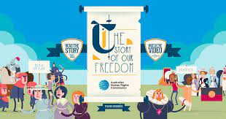
Take a look at this fun and engaging infographic, The Story of Our Freedom, to get a picture of the origins of democracy and how it has influenced our rights and freedoms today.

Students can then create their own timeline highlighting the main events that led to democracy in Australia. Research the origins of democracy and what democracy looks like in Australia today. Include three significant facts about each event. Reflect on ways in which people in ancient societies were represented and compare to Australia today.

Activity: Representative Democracy
In Australia we have something called a representative democracy. That means that unlike in ancient Greece where everyone went to meet and vote on laws, we elect a representative to do that for us. They're our politicians and they represent us in parliament. It's their responsibility to keep in touch with their voters and make sure their voices are heard on a national level.
What makes a good representative?
Ask students to think about the following question: What do you think makes a good representative? Brainstorm and list what a good representative ‘is’, ‘does’, ‘does not’ and ‘says’. Record their ideas. Here are some examples:
- honest
- good at communicating
- confident
- has a positive attitude
- commitment
- creative
- inspiring

Run your own election
Running an election for your class provides the opportunity for students to participate in the democratic process of choosing representatives for a range of purposes. Students will run their own election and investigate how the preferential voting system works.

Watch BTN’s Preferential Voting story to find out why people’s preferences matter on election day. Visit the Australian Electoral Commission’s Get Voting website. Get voting is everything you need to run a free and fair election for your class.

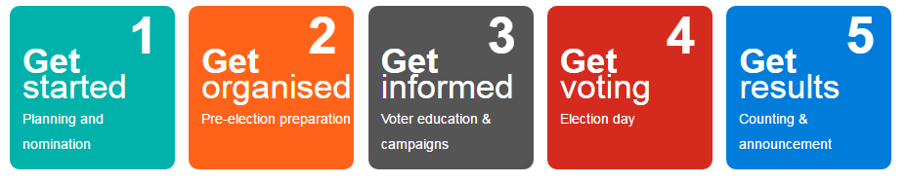

Activity: Visual literacy
In this activity students will examine, analyse and query a range of images which show significant moments in Australia’s history of democracy. Students will choose one or more of the images below and respond to the following:
- What is happening in the image? Create a caption for each image.
- How does the image make you feel?
- What does the image tell you about democracy in Australia?
- What questions do you have about what you see in the image?
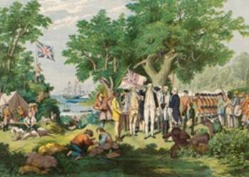  MoAD | 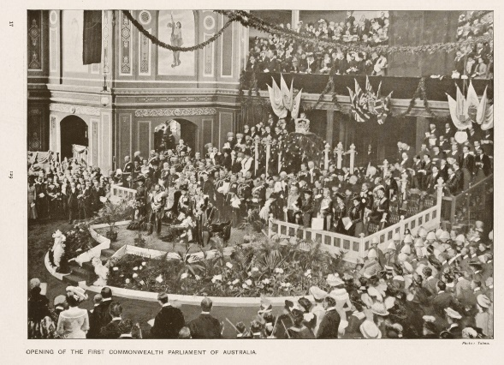  MoAD
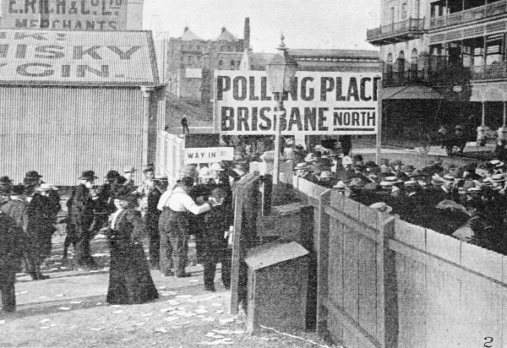  MoAD | 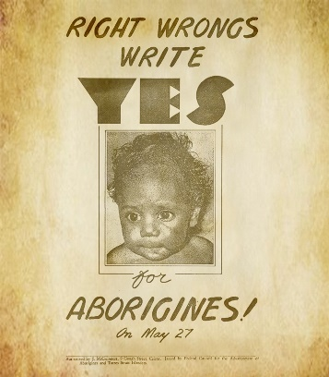  AIATSIS

Further investigation
Students can find and collect images, photographs and illustrations that represent the history of democracy in Australia. Students can organise and sequence their pictures in the form of a timeline.

Activity: Women in Politics Timeline
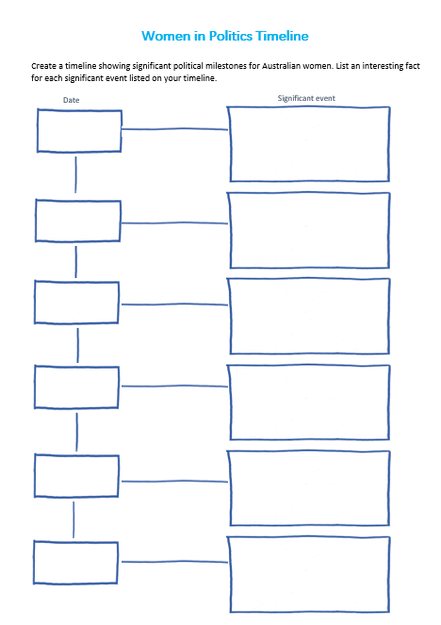
Students create a timeline showing significant political milestones for Australian women. Use the timeline template at the end of this activity to record key dates and milestones. Students can use the following questions to guide their research:

- When did women get the right to vote in Australia?
- Which state first gave women the right to vote?
- When were women first given the right to stand for Federal Parliament in Australia?
- When were Australian Aboriginal women given the right to vote?
- Who was the first woman to be elected to the House of Representatives?
- Who was the first woman to be elected in the Senate?
- Who was Australia’s first female Prime Minister?

Activity: 1967 Referendum
The BTN 1967 Referendum story explains how a majority of Australians voted to change our country’s laws to count Indigenous Australians as full citizens. Students watch the story and then respond to the following questions.

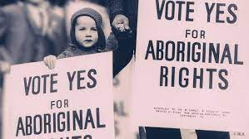
- Did Aboriginal people have equal rights to other Australians in the 1960s? Explain.
- In what year were Indigenous Australians given the right to vote in Federal Elections?
- To change the constitution there has to be a referendum. True or false?
- What is a referendum?
- In 1967 what percent of Australians voted ‘yes’ to change the constitution?
- Discuss why it is important to remember Australia’s 1967 referendum.
- How do you think being left out of the Constitution affected Aboriginal people?

Activity: Museum of Democracy Digital Excursion
The Museum of Australian Democracy’s Digital Excursions bring Old Parliament House directly into the classroom. These digital programs allow Museum Educators to connect with students in real time and guide them through the building to explore some key people and events in our democracy. Students participate in interactive activities and discussions to learn more about their role as active citizens and our democratic history. Find out more here

Activity: Democracy Quiz

- Who created the first form of democracy?  A. Ancient Greece  B. Ancient Rome  C. Ancient Egypt  - In which year did Federation  occur?  A. 1899  B. 1900  C. 1901  - In Australia, the public doesn’t  vote in a Prime Minister.  A. True  B. False  - In which city did parliament  first meet?  A. Canberra  B. Melbourne  C. Sydney  - Who does the Governor-General  represent in Australia?  A. Prime Minister  B. The people  C. The Queen | - How many levels of government  are there in Australia?  A. 1  B. 2  C. 3  - Voting in Australia is NOT  compulsory.  A. True  B. False  - At what age is it compulsory  for an Australian citizen to vote?  A. 16 years old  B. 18 years old  C. 21 years old  - When was a referendum  held to change the Constitution  so that Aboriginal and Torres Strait Islander people were counted in the census?  A. 1901  B. 1962  C. 1967  - Victoria was the first state to give women the right to vote.  A. True  B. False
Quiz Answers: 1A, 2C, 3A, 4B, 5C, 6C, 7B, 8B, 9C, 10B, South Australia was the first state to give women the vote.

Useful Websites
- Defining Democracy – Museum of Australian Democracy
- Democracy - Parliamentary Education Office
- Milestones in Australian democracy – MOAD
- What is Democracy? – BTN
- Magna Carta – BTN
- History of Voting – BTN
- Australian Women in Politics – BTN
- 1967 Referendum – BTN
- Federation – BTN
- The story of our freedom – Human Rights Commission

Women in Politics Timeline
Create a timeline showing significant political milestones for Australian women. List an interesting fact for each significant event listed on your timeline.

Date
Significant event

KEY LEARNING
Students will learn about the history of voting in Australia and analyse significant events that have shaped Australia’s system of voting.

CURRICULUM
Civics and Citizenship – Year 5
The key features of the electoral process in Australia.

Civics and Citizenship – Year 6
The responsibilities of electors and representatives in Australia’s democracy.

History – Year 6
Experiences of Australian democracy and citizenship, including the status and rights of Aboriginal and Torres Strait Islander Peoples, migrants, women and children.

  - Teacher Resource

History of Voting

Activity: Class Discussion
After watching the BTN History of Voting story, hold a class discussion using the following discussion starters.
- What is voting?
- How old do you have to be in Australia to vote?
- Is voting compulsory?
- How has people’s right to vote changed over the years?
- Have you ever voted? Think of different situations where you have been able to have your vote. For example, in the classroom with hands-up voting, at home in family decisions or at clubs voting for new members.
- Is voting important? Give reasons for your answer.

Activity: Glossary
Students will brainstorm a list of key words that relate to the BTN History of Voting story. Here are some words to get them started.
 | VOTE | ELECTION |  | PARLIAMENT
 | SUFFRAGE | SUFFRAGETTE |  | COMPULSORY

Activity: History of Voting Research
Discuss the information raised in the BTN History of Voting story. What questions were raised in the discussion and what are the gaps in students’ knowledge? The following KWLH organiser provides students with a framework to explore their knowledge on this topic.

What do I know? | What do I want to know? | What have I learnt? | How will I find out?

Students will develop their own question/s to research or choose one or more of the questions below. Encourage students to collect and record information from a wide variety of sources and present the information they find in an interesting way.
- Who were the suffragettes? Describe the suffragette movement.
- Imagine you a suffragette living in the late 1800s. Write a persuasive letter to your local government, write a newspaper article or write a petition explaining why women should be able to vote.
- When were women first given the right to vote in Australia?
- When were Indigenous women given the right to vote in Australia?
- Who was the first woman elected as a member of parliament in Australia? Create a short biography of them.
- Many women around the world still do not have the right to vote. Find out where in the world women still do not have the vote and highlight on a world map.
- How would you feel not being able to vote because of colour, race, gender or financial status? Was this fair? Was this democratic? Why do you think the right to vote has changed over time?
- What is the secret ballot system of voting? When and why was it introduced? Why is the secret ballot important to Australia’s voting system?

Activity: Timeline of voting
Students research the history of voting in Australia. Use the information they find to help match the dates to key events in Australia’s history of voting. Complete the template at the end of this activity.

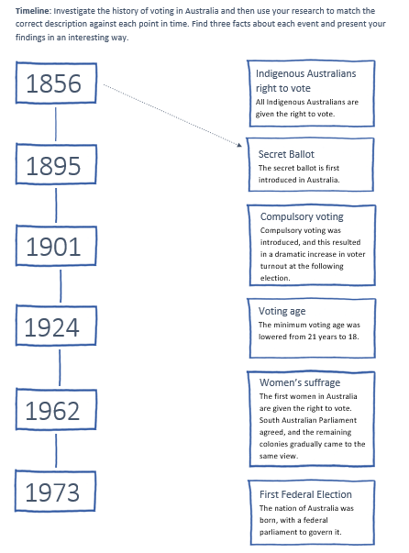
Students will then respond to one or more of the following questions:

- Find three interesting facts about each significant event.
- Imagine what it was like not being able to vote because you are a woman or because you are Indigenous. Write a diary entry explaining your lack of rights and how it feels not being able to vote. Students will use their research findings to support their writing.
- Which dates on the timeline do you think are especially significant? Why?

Activity: Visual Literacy
Below are photographs depicting significant events in Australia’s history of voting. Students look at the images below or find your own images and then respond to the following questions:
- What is happening in the image?
- Where do you think it was taken?
- How do you think they might be feeling?
- Is there a message about democracy that comes across in the image? Explain.
- What question/s would you like to ask the people in the image?
- Create a caption for each image.

After you have responded to the above questions click on the link for each image to find out what is happening and compare to your responses.

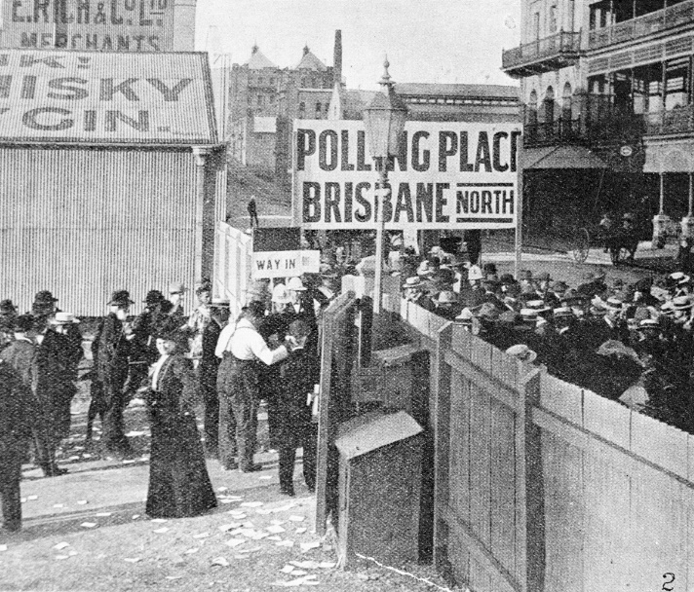
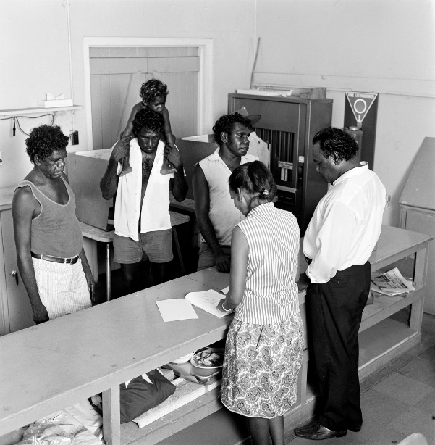

Source of image Source of image

Activity: BTN Women in Politics
Watch the BTN Australian Women in Politics story then answer the following questions:

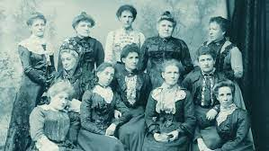
- The South Australian Government was the first in the world to give women the right to run for election. True or false?
- Who was Catherine Helen Spence?
- In what year were the first women elected to Federal Parliament?
- Who was Australia’s first female prime minister?
- Who was the first Indigenous woman to sit in parliament?
- What did you learn watching the BTN story?

Activity: Quiz
- What is the voting age in Australia?  A. 16  B. 18  C. 21  - Which state was the first to give women the vote?  A. ACT  B. New South Wales  C. South Australia  - Which state became the first to introduce compulsory voting?  A. South Australia  B. Queensland  C. Western Australia  Quiz Answers: 1B, 2C, 3B, 4B, 5B, 6A | 4.When was voting made compulsory for the Australian Parliament?  A. 1901  B. 1924  C. 1967  5. When did all Indigenous Australians get the right to vote in federal elections?  A. 1952  B. 1962  C. 1972  6. Voting in Australia is compulsory.  A. True  B. False

Useful Websites
- The Right to Vote – MOAD
- History of Voting – BTN
- Australian Women in Politics - BTN
- Australian voting history in action – AEC
- History of Voting game - AEC

Timeline: Investigate the history of voting in Australia and then use your research to match the correct description against each point in time. Find three facts about each event and present your findings in an interesting way.

Indigenous Australians right to vote
All Indigenous Australians are given the right to vote.
1856

Secret Ballot
The secret ballot is first introduced in Australia.

1895

Compulsory voting
Compulsory voting was introduced, and this resulted in a dramatic increase in voter turnout at the following election.

1901

Voting age
The minimum voting age was lowered from 21 years to 18.

1924

Women’s suffrage
The first women in Australia are given the right to vote. South Australian Parliament agreed, and the remaining colonies gradually came to the same view.

First Federal Election
The nation of Australia was born, with a federal parliament to govern it.
1973
1962

KEY LEARNING
Students will develop their understanding of the voting process. Students will develop a persuasive argument for or against lowering the voting age in Australia to 16.

CURRICULUM
HASS – Year 4
Sequence information about people’s lives, events, developments and phenomena using a variety of methods including timelines.

HASS – Year 5
The key features of the electoral process in Australia.

Sequence information about people’s lives, events, developments and phenomena using a variety of methods including timelines.

HASS – Year 6
The responsibilities of electors and representatives in Australia’s democracy.

Civics and Citizenship – Year 7
Reflect on their role as a citizen in Australia’s democracy.

  - Teacher Resource

Voting Age

Activity: Class discussion
Before watching the BTN Voting Age story record what students know about voting on a mind map. What questions do they have about voting and elections? Use the following questions to help guide discussion.
- Have you ever voted? Discuss in pairs.
- Who can vote at an election?
- How old do you have to be to vote in Australia?
- Do you think being able to vote is important? Why or why not?

After watching the BTN story ask students what they would like to know and learn about voting. Use the following framework to explore their knowledge on this topic.

What do I know? | What do I want to know? | What have I learnt? | How will I find out?

Activity: Glossary
Create your own classroom glossary about voting. Start by brainstorming words as a class using a mind map to record your responses. Add to your list of words by downloading the BTN Voting Age story transcript and highlighting all the words that relate to voting. Find definitions for each word. Here are some words to get students started.

BALLOT BOX | CAMPAIGN | ELECTORATE
POLITICAL PARTY | ELECTORAL ROLL | ELECTION

Activity: Class Vote
Ask your students if they have ever voted. Students will think of different situations where they have been able to have their vote. For example, in the classroom with hands-up voting, at home in family decisions or at clubs voting for new members. Does your school hold elections? Get Voting is everything you need to run a free and fair election for your class or school. Visit the Australian Electoral Commission to download step-by-step resources.

Further investigation
Individually or in small groups, students will choose one of the following projects to work on and then present their findings to the class.

Timeline
Research the history of voting in Australia and record significant events on a timeline. Which dates on the timeline do you think are especially significant? Why?

Quiz
Create a quiz about voting and the electoral process. Test your classmates. Alternatively, make a word search using voting and election lingo!
Flowchart
Create a flowchart which shows the steps in the voting system. You could use Australia’s federal voting system, or a voting system that your school might use.
Class Poll
Run a class poll to find out if your classmates would like to lower the voting age to 16. Alternatively, run a poll on another issue that interests you.

Activity: Opinion Poll
Students will conduct their own opinion poll on the issue of lowering the voting age. Working in groups, students will need to decide who their sample group will be and how many people will be polled.

- What method they will use to conduct the poll? (Face to face interviews or written responses).
- Ask students to graph the opinion poll results and display in the classroom. Students can reflect on how reliable they think the results were. What would they do differently next time?
- Students may want to film their interviews and then create a movie to present to other students.

Activity: Persuasive Text
Students will explore the issue of changing the voting age in Australia and develop a persuasive text for or against the following statement: The voting age should be lowered to 16. Encourage students to research the issue using a range of sources. The following may help students to structure their argument.

Tips
- Who is your audience? For example, are you directing your argument at kids, teachers, or politicians?
- Explore how language choices can have a big impact on persuading your audience.
- Which language devices give the report credibility and authority?
- Which are designed to create an emotional response in the listener?
- Provide facts and evidence to support your argument.
- Write in the present tense.
- Check your spelling and punctuation.

Use this Read Write Think persuasion map to plan your exposition text.

Introduction
- What is the point you are trying to argue? Construct an introductory paragraph which states the issue or topic.
- Introduce the arguments that will be developed in the body of the text.

Body
- Construct arguments that support your point of view.
- Each paragraph starts with a topic sentence which introduces each point.
- The rest of the paragraph gives more reasons.
- Arguments can be ordered from strongest to weakest.

Conclusion
- Restate your position on the argument.
- Construct a concluding paragraph that provides a summary of your arguments and a call to action.

Reflection
- How difficult was it to think of points to support one side of the argument?
- Do you think you would have done a better job supporting the other side of the argument?
- Was I able to convince others of my opinion?
- Did my opinion change?
- What did you learn from this activity?

Useful Websites
- History of Voting – BTN
- Voting Age – BTN
- Voting Age Experiments – BTN
- Voting Age Experiment Results – BTN
- Democracy Rules – AEC
- Practise Voting – AEC
- Why do we enrol to vote? – BTN Newsbreak

