EPISODE 21
8th August 2023

KEY LEARNING
Students will view a range of BTN stories and use comprehension skills to respond to a series of focus questions.

CURRICULUM
English – Year 4
Use comprehension strategies to build literal and inferred meaning to expand content knowledge, integrating and linking ideas and analysing and evaluating texts.

English – Year 5
Use comprehension strategies to analyse information, integrating and linking ideas from a variety of print and digital sources.

English – Year 6
Use comprehension strategies to interpret and analyse information and ideas, comparing content from a variety of textual sources including media and digital texts.

English – Year 7
Use comprehension strategies to interpret, analyse and synthesise ideas and information, critiquing ideas and issues from a variety of textual sources.
  - Teacher Resource

Focus Questions
As a class, discuss the stories featured in the episode of BTN Classroom and record the main points of the discussion. Students will then respond to the following focus questions.

Global Boiling
- What month recently was declared the hottest month in recorded history?
- The UN has warned that we are entering an era of Global…
  - Warming
  - Boiling
  - Melting
- Describe the extreme weather that people are experiencing in the Northern Hemisphere.
- On average how many degrees hotter is it than it was in the late 1800s?
- What questions do you have about the BTN story?

Reef Reprieve
- Summarise the BTN Reef Reprieve story using your own words.
- Where is the Great Barrier Reef? Find on a map.
- The Great Barrier Reef is on UNESCO's World Heritage in Danger list. True or false?
- What are some threats to the Great Barrier Reef?
- How many mass coral bleaching events have there been on the Great Barrier Reef since 2016?

Check out the teacher resource on the Archives page.

Garma Festival 2023
- Where is the Garma Festival held? Find on a map.
- Gulkula is a sacred site for the _________ people.
- What is a bunguul?
- What did the prime minister talk about at Garma?
- What questions do you have about the BTN story?

Check out the teacher resource on the Archives page.

Robo Rave
- Who participates in Robo Rave?
- What different categories are there at Robo Rave? Give one example.
- What are the robots programmed to do?
- Why was Robo Rave created?
- What did you like about the BTN story?

Emu Eggs
- What is the significance of the emus’ tracks?
- Emus are a protected species. True or false?
- How does Jareece feel when he finds emu eggs?
- Why does Jareece take the stick far away after he has collected emu eggs?
- What happens to the emu eggs once they have been collected?

EPISODE 21
8th August 2023

KEY LEARNING
Students will learn more about the Great Barrier Reef; the threat to the reef, the animals that live there and what is being done to protect it.

CURRICULUM
Science – Year 4
Living things depend on each other and the environment to survive.

Living things have life cycles.

Science – Year 5
Living things have structural features and adaptations that help them to survive in their environment.

Scientific knowledge is used to solve problems and inform personal and community decisions.

Science – Year 6
The growth and survival of living things are affected by physical conditions of their environment.
Scientific understandings, discoveries and inventions are used to solve problems that directly affect peoples' lives.

Science – Year 7
Classification helps organise the diverse group of organisms

Interactions between organisms, including the effects of human activities can be represented by food chains and food webs.
  - Teacher Resource

Reef Reprieve

Focus Questions
Discuss the BTN story as a class and record the main points of the discussion. Students will then respond to the following:
- Summarise the BTN Reef Reprieve story using your own words.
- Where is the Great Barrier Reef? Find on a map.
- The Great Barrier Reef is on UNESCO's World Heritage in Danger list. True or false?
- What are some threats to the Great Barrier Reef?
- How many mass coral bleaching events have there been on the Great Barrier Reef since 2016?

Activity: Note Taking
Students will practise their note-taking skills while watching the BTN Reef Reprieve story. After watching the story, ask students to reflect on and organise the information into three categories. What information in the story was...?
- Positive
- Negative or
- Interesting

Activity: Class Discussion
After watching the BTN Reef Reprieve story, hold a class discussion using the following discussion starters.
- Have you ever visited the Great Barrier Reef? What did you see there? Describe your experience.
- What do you know about the health of the Great Barrier Reef?
- Why is the Great Barrier Reef special?
- Why is the reef important to Australia and the rest of the world?
- What can be done to protect the Great Barrier Reef?
- What do you want to learn about the Great Barrier Reef?

Activity: Glossary
Students will brainstorm a list of key words that relate to the BTN Reef Reprieve story. Here are some words to get them started.

CORAL | ALGAE | CORAL BLEACHING
CORAL POLYPS | CLIMATE CHANGE | ECOSYSTEM

Ask students to write what they think is the meaning of each word (including unfamiliar words). They will swap definitions with a partner and ask them to add to or change the definition. Check these against the dictionary definition.

Further activities for students:
- Students will add to their glossary by downloading the transcript for the BTN Reef Reprieve story and highlight all the words that relate to the topic.
- What other words relate to this issue? Students will choose additional keywords and concepts to add to their class glossary that are tricky. For example, biodiversity, crown of thorns starfish, conservation, adaptation, bleaching, consumer, phytoplankton, zooxanthellae, and reef mosaic. Students will find a definition and add to their Great Barrier Reef glossary.
- What is the difference between soft coral and hard coral? Give some examples of each type.

Activity: Virtual Diving
Students will go on a virtual diving expedition of the Great Barrier Reef using Google Maps and Virtual Reef Diver to explore the reef’s marine life and environment. Students will navigate through different sections of the reef to get a closer look at various marine habitats, coral formations, and marine species. During the expedition students will respond to the following:
- Make detailed observations of the marine life you encounter during the virtual expedition.
- Create a journal to record your findings. Draw sketches and make notes based on what you see.
- Include a map of the area. How far does it stretch? What is the area (m2) of the reef?
- What are some of the unique features of the Great Barrier Reef?
- What type of habitats can be found in this region?
- What species live in and rely on the habitats in the Great Barrier Reef?
- Choose one species in the region to investigate in more detail and create a creature feature.
- Create a diorama illustrating one aspect of the of the region.
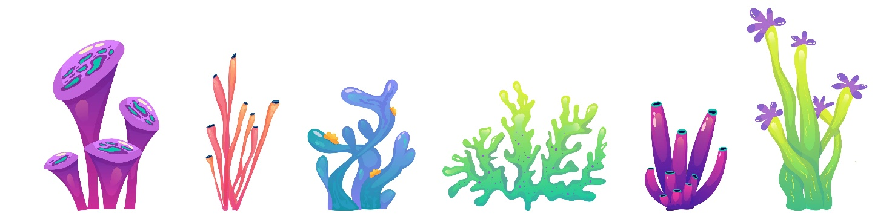

Activity: Coral Profile
Students will imagine they are coral ecologists and study one species of coral that can be found in the Great Barrier Reef. Begin the lesson by asking students what they already know about coral and write students’ responses on the board.
- What do you know about coral?
- What does coral look like? What are some if its unique characteristics?
- What does coral need to survive?
- Why do you think coral reefs are often referred to as "rainforests of the sea"?
- What do you want to learn about coral?

Students will then create a profile about one type of coral species, see below for some examples:
- Plate coral
- Brain coral
- Cabbage coral
- Finger coral
- Staghorn coral

Students will research the following and then share their research findings with the class or create a display in the classroom.
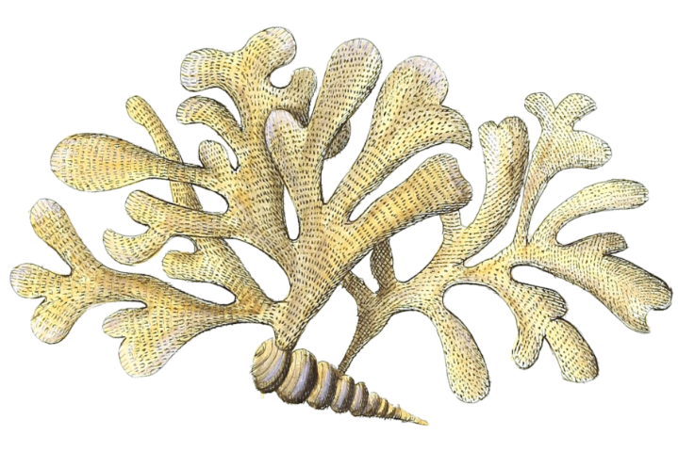
- Name (common and scientific name)
- Biological illustration or photo
- Scientific classification (class, family, genus)
- Description (size, colour, physical features)
- Is it a soft or hard coral?
- Habitat
- Lifecycle
- Diet
- Adaptations
- Threats
- Conservation status

Activity: Biological Illustration
Students will create their own biological illustration of a type of coral species. This activity encourages students to develop their observation skills and reinforce their understanding of biological concepts.

Explain to students that in their illustration they need to draw what they see (using photographs/videos they find in books and on the internet). Students will need to think about size, shape, texture, and patterns; and include as much detail as possible.

Teachers may want to show examples of scientific drawings or begin this exercise by asking students to collect a plant specimen (for example, a leaf or flower) from the school yard to practise scientific drawing.

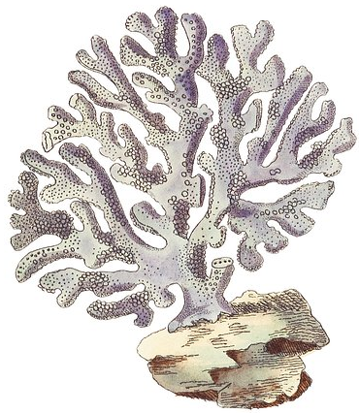
Students can use the following as a guide as they create their scientific drawing:
- Find photographs and/or videos of the species to observe. What key structures will you focus on in your drawings?
- Draw the species to scale (include a ratio on the drawing).
- Include its scientific and common name.
- Add labels – to show size, colour and texture.

For more information about scientific drawing in the classroom, visit this website Sketching for observation. Consider sending your students’ drawings into your local museum to display as an exhibition.

Activity: Reef Citizen Science
What is citizen science and what are the benefits? Students will explore one of the following citizen science projects to learn more about the Great Barrier Reef.

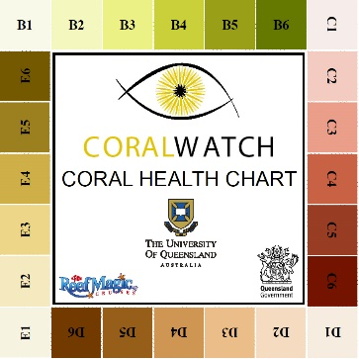  Become a CoralWatch citizen scientist Find out more. Save reefs from home Find out more. | 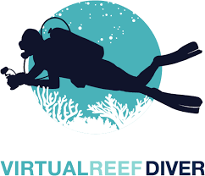  The Virtual Reef Diver project allows students to become citizen scientists, classifying underwater images of coral. Virtual Reef Diver also allows students to explore 360-degree images of the Great Barrier Reef (through the Google Play store).

Useful Websites
- Great Barrier Reef escapes 'in danger' recommendation ahead of UNESCO World Heritage decision – ABC News
- UNESCO Great Barrier Reef – BTN
- Great Barrier Reef – Australian Museum
- Reef Bleaching – BTN
- Coral Bleaching – BTN

EPISODE 21
8th August 2023

KEY LEARNING
Students will learn about the Yolngu people and the importance of the Garma Festival.

CURRICULUM
HASS – Year 5
Evaluate evidence to draw conclusions.

The influence of people, including Aboriginal and Torres Strait Islander Peoples, on the environmental characteristics of Australian places.

HASS – Year 6
Experiences of Australian democracy and citizenship, including the status and rights of Aboriginal and Torres Strait Islander Peoples, migrants, women and children.

HASS – Year 7
The importance of conserving the remains of the ancient past, including the heritage of Aboriginal and Torres Strait Islander Peoples.

The process for constitutional change through a referendum.

How groups, such as religious and cultural groups, express their particular identities; and how this influences their perceptions of others and vice versa.

  - Teacher Resource

Garma Festival 2023

Focus Questions
Discuss the BTN story as a class and record the main points of the discussion. Students will then respond to the following:
- Where is the Garma Festival held? Find on a map.
- Gulkula is a sacred site for the _________ people.
- What is a bunguul?
- What did the prime minister talk about at Garma?
- What questions do you have about the BTN story?

This document may contain the names and images of Aboriginal and Torres Strait Islander people now deceased. It also contains links to sites that may use images of Aboriginal and Torres Strait Islander people now deceased.

Activity: Class Discussion
Discuss the BTN Garma Festival 2023 story in small groups or as a class. What questions do students have? Use the following questions to help guide discussion:
- What is the Garma Festival? What does it celebrate?
- Where is the Garma Festival held? Find Gulkula on a map.
- What does the word Garma mean?
- Who goes to the Garma Festival?
- Who are the traditional owners of the land, where the Garma Festival is held?
- What special announcement did the prime minister make at Garma?
- What are some of the important issues that are talked about at the Garma Festival?

What questions do you have about the story?
What did you learn from the story?

Activity: Glossary
Students will brainstorm a list of key words that relate to the BTN Garma Festival 2023 story. The glossary will help inform students while working through the activities in this resource. Below are some words to get them started.

BUNGUUL | SACRED SITE | RECOGNITION
RIGHTS | INDIGENOUS VOICE TO PARLIAMENT | AUSTRALIA’S FIRST PEOPLES

Activity: Write a Feature Story
Students will imagine they are a journalist covering the Garma Festival 2023 and give insight into Aboriginal culture and heritage in Northeast Arnhem Land. Students will choose one aspect of the event that they are interested in writing about. Some possible topics include:
- Festival highlights including the bunguul (dance).
- What the festival showcases, including traditional miny’tji (art), manikay (song), bunggul (dance) and storytelling.
- The Prime Minister’s speech.
- A profile on the Yothu Yindi Foundation, the festival organisers.

Students can use the following to guide them throughout the research and writing process:
- Research as much as you can about the topic.
- Add visuals, such as images (including artworks, photographs, or illustrations).
- Could you interview someone, like the prime minister or someone attending the event? Write some interview questions.
- Write a feature story – find out what makes a good feature story here. Share your story.

Activity: The Yolngu
After watching the BTN Garma Festival 2023 story students will learn more about the Yolngu people, the traditional owners of Northeast Arnhem Land, including their language, culture, and traditions. Students will research and present on one of the following topics.

Yolngu Language  What is the language of the Yolngu people? Learn more about the different dialects.  Learn some common Yolngu words. What does the word Yolngu mean? | Yolngu Seasonal Calendar  Why is the cycad tree the most important tree of all for the Yolngu people?  Learn more about the Yolngu seasonal calendar, and the plants and animals that are important to the Yolngu people. | Indigenous Map of Australia  Where is Arnhem Land? Mark the approximate boundaries on a map. What are some special sites in Arnhem Land? Explore the Indigenous Map of Australia to learn more about the language, social or nation groups of Aboriginal Australia.

Yolngu Culture  In small groups students will research a specific aspect of Yolngu culture. Topics could include art and storytelling, ceremonial dances (Bunguul), traditional music (Yidaki), bush tucker, or Dreamtime stories.  Arnhem Land is the home of the yiḏaki. What is a yidaki and what is it used for? What role do termites play in the creation of a yidaki? | Important Yolngu People  Who are some well-known Yolngu leaders, artists, and performers? Choose one to explore and learn about their life and achievements. Write a profile about them.  Some well-known Yolngu people include: Galarrwuy Yunupingu, Yothu Yindi, Baker Boy, David Gulpilil, Guypunura "Janet" Munyarryun, Djalu Gurruwiwi and Geoffrey Gurrumul Yunupingu. | Land Rights  What is the Yirrkala bark petition? Use as many of these words in your explanation as possible: bauxite mine, bark petition, Gurindji people, Wave Hill, Whitlam Government and Aboriginal Land Rights act.  Learn more about the petition on the National Museum of Australia website.

Activity: Further Investigation
Students will explore the cultural diversity of Aboriginal and Torres Strait Islander peoples. Individually or in small groups, students will learn about the Indigenous group where they live and present what they have learnt to the class. Students will learn about the geographic location, language, culture, traditions, and histories. Below are some questions to help guide their research.

Geography
What is the geographic location? Find on a map. Mark important Indigenous sites on your map. What are songlines and why they are important?
Acknowledgement
Who are the traditional owners of the land on which your school stands? How can you acknowledge the traditional owners of the land?
Language
What Indigenous language/s are spoken in your area? Learn more about the dreaming stories of the area. Illustrate an aspect of the dreaming story.
Environment
What is the Indigenous word for ‘land’ in this area? Learn about the land and waters of the area. What plants and animals in the region are important to the Indigenous people?

Activity: BTN Stories
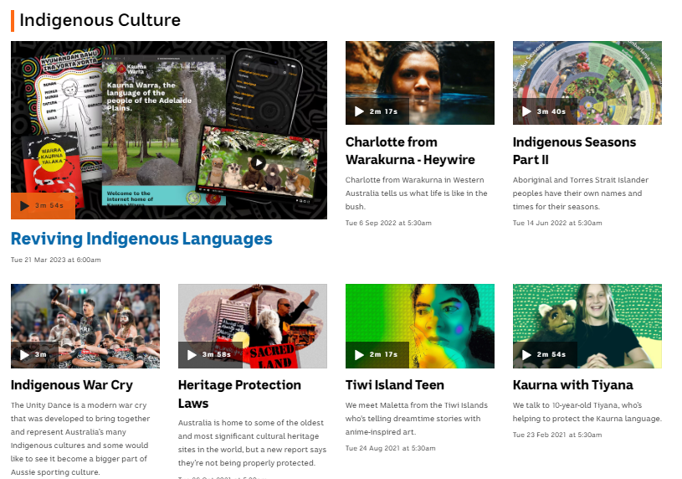
Visit BTN’s collection of stories which focus on Aboriginal and Torres Strait Islander peoples’ culture and issues.

After watching any one of the BTN videos ask students to respond to the discussion questions (to find the discussion questions and teacher resources go to the related BTN Classroom Episode and download the Episode Package).

Collection of BTN stories about Indigenous culture

Useful Websites
- 2023 Garma Festival – Newsbreak
- About Garma Festival – Yothu Yindi Foundation
- The Yolngu – National Museum Australia
- Garma Festival 2022 – BTN
- Voice to Parliament Update – BTN
- 1967 Referendum – BTN
- Prime Minister to announce Australia's first referendum in 20 years at Garma Festival. Here's what you might be asked – ABC News

  - Teacher Resource

BTN Transcript: Episode 21 – 8/8/2023

Hey, I'm Amelia Moseley and you're watching BTN. Thanks for joining us again let’s see what's coming up on today’s show. Some good news about the Great Barrier Reef, we hear from a special guest reporter at this year's Garma Festival in Arnhem Land and these robots get ready to rumble.

Global Boiling

Reporter: Michelle Wakim

INTRO: All that soon but first up today, scientists say that last month was officially the hottest month Earth has ever recorded. And the UN says we're no longer facing global warming, but something worse. Here's Michelle.

NEWS REPORTER: Confusion and fear as a Greek paradise burns.

NEWS REPORTER: Which have forced thousands of people to be evacuated.
ANTÓNIO GUTERRES, UN SECRETARY-GENERAL: The era of global warming has ended. The era of global boiling has arrived.
MICHELLE, REPORTER: Global boiling. It sounds pretty intense, but the UN says the threat the world's facing is intense.
ANTÓNIO GUTERRES, UN SECRETARY-GENERAL: The air is unbreathable, the heat is unbearable, and the level of fossil fuel profits and climate inaction is unacceptable.
Data released by the World Meteorological Organisation shows the hottest 23 days in recorded history all happened in July this year.
SARAH PERKINS-KIRKPATRICK, CLIMATE SCIENTIST: We're talking about temperatures of mid 40s or higher almost every day for parts of the heatwave over places like Italy and Greece. And that's just abhorrent. That’s really hard to cope with. It doesn't matter who you are or how fit you are.
Even Antarctica has been hotter than usual, and sea ice is running at record low levels.

MICHELLE: So, why is this happening? Part of it is something called El Nino.

It's a weather phenomena that affects water temperatures and wind currents that blow across the Pacific Ocean and can increase average global temperatures and bring more extreme weather.

MICHELLE: El Ninos happen naturally every two to seven years, but some scientists believe that they’re becoming more intense and more frequent. And on top if that, the temperature of the planet is rising, because of us.
SARAH PERKINS-KIRKPATRICK, CLIMATE SCIENTIST: Now it's likely that these heat waves probably would have occurred this summer, but they likely wouldn't have lasted as long or be as intense because of climate change.
Yep, since humans started burning fossil fuels during the Industrial Revolution, scientists say global temperatures have been rising. On average, it's now about one degree hotter than it was in the late 1800s.

MICHELLE: And while that might not seem like a lot, remember it's a global average, made up of some extreme highs and some extreme lows. And, scientists say it means trouble.
CHRIS HEWITT, WMO DIRECTOR OF CLIMATE SERVICES: We're not saying we're permanently exceeding 1.5 degrees at this point, but more than likely than not one of the next five years we'll temporarily exceed 1.5.
1.5 degrees is the temperature rise that scientists say we need to stay below, to avoid the really drastic effects of climate change. We're talking more bushfires, heatwaves, droughts, floods, cyclones and rising sea levels.

MICHELLE: Yeah, it's a lot.

And the UN says we need to take action now. That means reducing the amount of emissions we’re sending into the atmosphere, but it also means preparing for a changing in planet.
JOE BIDEN, US PRESIDENT: Today I'm announcing additional steps to help states and cities deal with consequences of extreme heat.

Over in the US the government says it's trying to find ways to keep people safe during heat waves by giving outdoor workers more rights, improving weather forecasting, and creating better access to drinking water. Experts say Australia also needs to get ready for the heatwaves, droughts, and bushfires which could be caused by El Nino in the next few years. And, after that, for the extreme weather that climate change could bring.
ANTÓNIO GUTERRES, UN SECRETARY-GENERAL: Climate change is here. It's terrifying, and it is just the beginning.

Upsetting News

Now if you're feeling worried or upset about that story, or anything you've seen in the news, make sure you talk to someone about it. Kids Helpline is always there, and you can visit our website for more tips about how to deal with upsetting news.

News Quiz

Can you tell who this is? It’s former US President Donald Trump, who’s been indicted again. That means a grand jury has decided he should be charged with breaking the law, this time for trying to interfere with the election result in the state of Georgia in 2020. It’s the third time the former president has been indicted in just four months.
The capital of which country received its heaviest rainfall in 140 years last week? It was China. Typhoon Doksuri caused deadly flooding across the country’s north, including in the capital Beijing which recorded 744 mills of rain between Saturday and Wednesday last week.
Do you know the name of this famous little spacecraft which went missing for a while last week?
Is it Investigator, Explorer or Voyager? It’s Voyager, Voyager 2 to be exact. It was one of a pair of probes sent out to explore the solar system in the 70s and now Voyager 1 and 2 are the only man-made objects in interstellar space. But voyager 2 went silent for a few days after flight controllers accidentally sent a wrong command nearly two weeks ago that tilted the unmanned spacecraft's antenna away from Earth. They managed to send a message repointing the antenna using our very own Big Dish in the ACT.

GLEN NAGLE, DEEP SPACE COMMUNICATION CENTRE: With our radio signals being sent off to the spacecraft, even at the speed of light, it takes 18 and half hours to get all the way up to Voyager 2, which is 20 billion kilometres from home, and another 18 and half hours back. So it’s 37-hour round trip time. And right at the appointed time, that signal hit the ground and we got it.

NASA is now back in full contact with the Voyager 2 probe.

Reef Reprieve

Reporter: Lyeba Khan

INTRO: Now to the Great Barrier Reef which, as you might know, has been going through a rough few years. It's faced predators, pollution, and mass coral bleaching which is why UNESCO was about to list the site as in danger. But it looks like that won't be happening after all. Here's Lyeba to tell us why.

STEVE THE CLOWNFISH: You know, Bob, sometimes I feel we don't appreciate how great it is to live in the Great Barrier Reef, you know?
BOB THE CLOWNFISH: I know, right?
TURTLE: It's so cosy.
BRAIN CORAL: And mmm yes mmm colourful.
Yup, whether you're a fish, a piece of coral or a human, you've gotta admit, the Great Barrier Reef is pretty, well, great! And, it's the biggest reef system in the world and the only living organism visible from space, and it's home to thousands of amazing species. Which is why it's on UNESCO's list of World Heritage Sites.
RAY: World Heritage Sites? What's that?
Glad you asked, my fishy friend. Well, UNESCO, or The United Nations Educational, Scientific and Cultural Organisation, has a list of places around the world that are really special because of their natural or cultural significance. The Great Barrier Reef made it on there in 1981, making all of us Aussies pretty proud.
SCHOOL OF FISH: Hooray.
But there's a problem.
SCHOOL OF FISH: Oh no.
You see, for a while now, the reef's been facing some serious threats. Pollution and overfishing have taken a toll on the underwater environment and so have outbreaks of the crown of thorn starfish, a prickly predator which munches on coral. Then there's coral bleaching. That's when the water warms up too much, causing coral to go white. And while it can recover, if the temperature stays high for too long, the coral dies. Since 2016 there have been 4 mass bleaching events, which have killed a lot of coral.
SHARK: That's scary.
OCTOPUS (squirts ink): Terrifying.
Sure is. And in 2021 things were bad enough for UNESCO's world heritage centre to recommend that the reef be listed as 'In Danger'.
OCTOPUS: 'In danger?' What does that mean?
BARRACUDA: I think it means we're in trouble.
You see, UNESCO has another list of World Heritage Sites, that are all in danger of losing the things that make them special. It's a list Australia definitely didn't want to be on. The government was worried that being on the 'In Danger' could have a big impact on reef tourism, so it set about trying to change UNESCO's mind. In 2022, experts came to the reef to see if things had got better, and they weren't happy with what they saw. They gave us another year to see if things improved, and our government put in some more effort, sending UNESCO reports to update them. And last week, we got some more good news.
ANTHONY ALBANESE, PRIME MINISTER: The draft decision cites, to quote the decision, "significant progress being made on climate change, water quality and sustainable fishing, all putting the reef on a stronger and more sustainable path."
UNESCO decided not to list the Great Barrier Reef as 'In Danger' after all.
TANYA PLIBERSEK, MINISTER FOR THE ENVIRONMENT AND WATER: I am very pleased to see this decision by UNESCO come out overnight.
BABY OCTOPUS: Phew, well that's a breath of fresh air.
BLUE FISH: We don't breathe air.
BABY OCTOPUS: It's a figure of speech.
Wait, hold your horses, that doesn't mean things are all good down at the reef. And with Australia heading into another El Nino period, many experts are worried there could be another big bleaching event on the horizon. UNESCO says it'll revisit its decision next year, which means Aussie authorities still have their work cut out for them to prove they're doing all they can to protect this natural wonder - and all of the creatures that call it home.
FISH: Yeah, like us.
FISH 2: Pretty magnificent, aren't we? Check out these fins.
FISH: Gorgeous, just gorgeous.

Did You Know?
Did you know, the Great Barrier Reef isn't just huge it's also ancient. The living corals sit on top of dead corals some of which are thought to be up to 20 million years old. It’s also home to ancient creatures like the Nautilus which has remained pretty much unchanged for 500 million years.

Garma Festival 2023

Reporter: Jack Evans

INTRO: Now to Arnhem Land, where the Garma Festival has just wrapped up. It's a celebration of First Nations cultures that takes place at Gulkula on Yolngu country every year. And this year there was a special BTN reporter there, I'm not just talking about Jack, I'm talking about the Prime Minister of Australia – check it out.
ANTHONY ALBANESE, AUSTRALIAN PRIME MINISTER: That's Anthony Albanese guest reporter for Behind the News.
Yep, you heard correct. The Prime Minister is a guest reporter for Behind the News. Uh, kinda. To find out how this happened, let's go back a bit. Every year 1000s of people head to North East Arnhem Land for the Garma Festival.

KID: It's a big festival where lots of people camp. And it's held in the Northern Territory in East Arnhem Land.
KID: Different tribes from different area come together. And probably like all Yolngu mob welcome the, like, other tribes.
KID: People coming together and showing their different cultures.
KID: Make friends, meet other families.
KID: Everybody can come together and dance and do more fun activities.
Garma has been running since 1999, and is held up at Gokula a sacred site for the Yolngu people. The festival is intense... as in, everyone sleeps in tents. There is also a heap of art, music, stunning views. And at the end of each day, everyone meets here for the Bunguul, which is a traditional dance ceremony that's been performed for 1000s of years.
But this year, I was on a mission and that was to get an exclusive with the Prime Minister for BTN. Mr. Albanese was at Garma to announce that the government will commit $6.2 million dollars to develop a Garma Institute for educating Yolngu students. The Prime Minister then took time to talk about the upcoming referendum on an indigenous voice to parliament.
ANTHONY ALBANESE: This year on referendum day, the power to reach for a better Australia is in our hands.
Mr. Albanese was actually at Garma last year, but unfortunately, he didn't have time to talk to BTN.
JACK: Mr. Prime Minister, I'm from Behind the News. No?
But this year, I had a plan. If the PM wouldn't talk to me, maybe he would talk to one of you when he visited the Youth Forum to answer questions that students had. And guess what? It worked.
KID: Will you be speaking to the BTN people today? We watch it every day in class.
ANTHONY ALBANESE: Ah, Behind the News. Ahh, I don't know, they haven't asked to speak to me today.
JACK: We asked last year. Hello.
ANTHONY ALBANESE: They’re right there… so, the answer to that is yes, 'cause they're right there.
Personally, I thought that was a great result, but Xavier thought we could do better.
XAVIER: Mr. Albanese, tell me how much you like BTN. That's a real microphone.
ANTHONY ALBANESE: That's a real microphone.

XAVIER: It’s connected to, it’s connected…

ANTHONY ALBANESE: Today, I'm a guest presenter on Behind the News. And this is young Xavier say hello.
XAVIER: Hello.
ANTHONY ALBANESE: And what would you like to say on Behind the News?
XAVIER: I like to watch it. And I like to play AFL.
ANTHONY ALBANESE: Like to play AFL. Which team do you follow?
XAVIER: Brisbane Lions.
ANTHONY ALBANESE: Brisbane Lions. Well, go the Lions. That's Anthony Albanese, guest reporter for Behind the News. Closing down now to go pay footy.
So, that's a mission accomplished for BTN. And for these guys, well, they not only got to chat with the Prime Minister, but also make new friends and memories that will last a lifetime.
KID: The highlight for me I think was last night the Bunguul, it was the first time that I've seen like proper dancing like that. And firstly, seeing like all the kids get involved. They were like insanely good.
KID: Kicking the ball and making new friends.
KID: Probably all the activities and all the freebies at the shops.
KID: How unique and varied indigenous culture is and how it's something that you kind of need to experience to understand.

Robo Rave

Reporter: Michelle Wakim

INTRO: In Queensland students have battled it out at a robotics competition in the lead up to next year's RoboRAVE World Champs. Michelle found out more about it.

At RoboRAVE, you can find everything from the weird…
Camera Person: Can you give me a smile?
To wonderful.

Who knew there could be so many ways to collect ping pong balls?

All of these robots are created by students from all around the world. Basically, these guys work with adults to design, build and program a fully autonomous robot, which means it can complete a given task all on its own. There are heaps of different categories and they include battling it out in a sumo fight, finding their way through mazes, collecting balls, following tracks, and climbing surfaces. The winners of each round progress through to the finals and battle it out. And it's all in preparation for the World Champs next year.
TIM HADWEN, ROBORAVE DIRECTOR: This year we've had a record number of competitors, volunteers, coaches here. We've had nearly 1,100 competitors over our first ever two-day event, so it's been a success. And we’re really looking forward to what comes next year with the World Championships.
This year, there was a total of 500 teams from across Queensland and the Northern Territory, as well as some international participation from China, India, Ecuador, the Philippines, and Vietnam. And while this is all quite a bit of fun, there's a bigger purpose to these competitions. Organisers created RoboRAVE so that young people have a pathway into coding and mechanics.
TIM HADWEN, ROBORAVE DIRECTOR: The skills that our students are learning here are really important because they're the skills that they need for the jobs ahead of them. With the world going more technology based, and especially with robotics, all these students are going to need some of these skills as they progress through life, get jobs, and continue into our work force.
STUDENT: I think it's a great way for younger people to be introduced to robotics.
STUDENT: It's amazing because you get to code robots, and just try and win, get prizes and have a fun time with your friends.
So, how did everybody go?
STUDENT: Very good. Much better than we expected. We were expecting to just have a bit of fun and not do anything because this is our first time here. But we think we might be in the finals. We're not sure but we're pretty sure we might be.
STUDENT: Let's just say, it took a lot of tape.
STUDENT: When it did work, it was fun.
STUDENT: It was exciting, but not too exciting, to see how you could try our best and try to get the coding wrong, and you've just got to think.
STUDENT: Also trying to fix your robot, trying to get little errors fixed and stuff. So, it's really fun.

STUDENT: I like challenges. So, I enjoyed like competing.
STUDENT: It was very fun. And there's a lot of people here and you have a good competition, and a day.
STUDENT: It doesn't matter if you're highly experienced in robotics or like, just starting out. It's really good for everyone.
Sport
Yup, the Diamonds absolutely dominated the Netball World Cup with a massive 61-45 win over the England Roses. That's their biggest win margin in a final at the tournament in 28 years and the 12th time they've taken it out. Kiera Austin claimed the MVP gong smashing 15 goals in the match.

LIZ WATSON, DIAMONDS CAPTAIN: Oh, this is unbelievable. I mean, just to come back from the way we did in the rounds. It honestly feels so surreal. This group, I'm so proud to lead them. They are an amazing group of athletes. The rotations, everyone that came on. Everyone's embracing their families now. It's so special.

The win also means Australia now holds all of netball's major titles including the Commonwealth Games gold medal and Constellation Cup trophy.
Now over to the other world cup everyone's talking about the FIFA Women's World Cup where there's been another big upset. Two-time defending champs, the USA, have been knocked out of the comp by Sweden. In a match that was a total nailbiter, neither team scored throughout the standard 90 minutes of play time or in extra time. So, it all came down to this thrilling sudden death shootout and this controversial goal giving Sweden the win.

Fan: It had everything, to the last minute, and even the last minute when we had to get the replay.
Fan: I was sad. And I wanted to beat Sweden but it was too late, I couldn't.
Fan: It was a really close match, but I'm really glad that we won.
And finally four-time US Olympic gold medallist Simone Biles is back. She took a break from gymnastics for almost two years because she was dealing with "the twisties". Nope not the chip kind. It's something that happens when an athlete loses their sense of spatial awareness while they're in the air. But now she's back and she means business taking the top spot at the U.S. Classic over the weekend.
Emu Eggs

Reporter: Jareece

INTRO: Finally, today we're going to meet Jareece who's a winner of Takeover Mildura. It's a competition that asks kids in regional areas to tell stories about their lives and things that are important to them. And for Jareece that's searching for emu eggs with his family. Take a look.

I love being with mob on country, Barkindji country. It ran not long ago. You could smell it in the air. This means the emu started mating. My mob's been coming here forever. Today, we have four generations here. You can still see where my great grandmother used to cook emu eggs. Now, Nan's passing down the culture to me.
AUNTY COLLEEN: When you see lots of coming and going tracks, you know that not far away is that nest.
Back in the days, our mob would hunt and eat emus. Now we protect them and only collect eggs.
AUNTY COLLEEN: Make sure you got your walkie talkies on. Got your backpack. And let's do this one. Let's get these eggs. Come on, we got this one. Let’s go!
We get real competitive scouting for tracks.
AUNTY COLLEEN: Not far away from ya. Any tracks?
KID: Fresh tracks here.
You feel on top of the world when you find the eggs.
KID: We got it, we got it. Quick, quick quick, we got it.
We use a stick to rake the eggs out of the nest. We always leave an egg behind. We take the stick far away as it has our scent on it. When we get back to the camp, it's time to celebrate. One egg feeds the whole mob. The rest of the eggs are taken home.

First, we blow the yolk out. I've been doing this since I was a kid. We draw an outline, then we carve in the art. We also paint our stories. It takes a week to complete. I haven't painted one yet. I want to make sure that I'm ready.

The eggs get passed down through generations. I love looking at them, holding it in my hand and thinking about the stories. It gives me strength. I'm proud to be part of the oldest living culture on earth.

Closer

Oh well, that's all for today. We'll see you next week, but if you can't wait that long, you visit our website, where you can watch literally thousands of stories. Or you check out Newsbreak right here every weeknight. I hope you have the best week and I’ll see ya soon. Bye!

