EPISODE 8
23rd March 2021

KEY LEARNING
Students will view a range of BTN stories and use comprehension skills to respond to a series of focus questions.

CURRICULUM
English – Year 4
Use comprehension strategies to build literal and inferred meaning to expand content knowledge, integrating and linking ideas and analysing and evaluating texts.

English – Year 5
Use comprehension strategies to analyse information, integrating and linking ideas from a variety of print and digital sources.

English – Year 6
Use comprehension strategies to interpret and analyse information and ideas, comparing content from a variety of textual sources including media and digital texts.

English – Year 7
Use comprehension strategies to interpret, analyse and synthesise ideas and information, critiquing ideas and issues from a variety of textual sources.
  - Teacher Resource

Focus Questions
As a class, discuss the stories featured in the episode of BTN Classroom and record the main points of the discussion. Students will then respond to the following focus questions.

Equality Protest
- In pairs, discuss the Equality Protest story. Record the main points of your discussion.
- Why were people protesting recently?
- Women make up less than a third of our elected leaders in Parliament. True or false?
- Give an example of how men and women are treated unequally.
- What changes do the kids in the BTN story want?
- How have governments started to address the problem?
- What are some education programs in schools teaching kids about?
- What can kids do to challenge stereotypes about boys and girls?
- Why is it important for people to speak up if they’re being hurt by another person?
- What questions do you have about this story?

Lockdown Anniversary
- Describe what the BTN story is about in one sentence.
- Complete the following sentence. It’s been ____________ since Australia went into COVID lockdown.
- How has life changed for you over the past year?
- Name one thing that feels normal now.
- Why has hygiene and social distancing been important?
- Describe your remote learning experience.
- What have you found challenging about the past year?
- What changes to your life have been positive?
- Name five new words you have learnt since the coronavirus.
- How did this story make you feel?

NFTs and Digital Art
- Discuss the NFTs story. What were the main points of your discussion?
- What are NFTs? Give an example.
- What does NFT stand for?
- What does non-fungible mean?
- What makes something valuable?
- Some NFTs have been selling for millions of dollars. Give an example of one.
- How much did the artwork created by Beeple sell for recently?
- Generating the code behind NFTs requires a lot of energy which can contribute to greenhouse gases. True or false?
- What do you think is the future of digital art?
- Name three things you learnt watching the BTN story.

Australian Film Boom
- What did the Australian Film Boom story explain?
- Hollywood has been making movies in Australia for decades. True or False?
- Why is Australia a great place to make films?
- What impact has COVID had on Hollywood?
- Give an example of a big blockbuster being filmed in Australia.
- What does Rising Sun Pictures do?
- What films has the studio worked on?
- Why is the film industry good for Australia’s economy?
- What has been built in Melbourne and why?
- What was surprising about this story?

Check out the Australian Film Boom resource on the Teachers page.

Harmony Day
- Briefly summarise the Harmony Day story.
- Working in pairs, come up with a definition for multiculturalism.
- What are some great things about living in a multicultural society?
- Complete the following sentence. The White Australia policy made it hard for people from _____________countries to come to Australia.
- In which decade did the government bring in laws against racial discrimination?
- It’s estimated that Australia is home to people from more than _____ different cultural backgrounds.
- What is the official Harmony Day colour?
- Give some examples of things that are shared on Harmony Day.
- How does your school celebrate diversity?
- Why do you think celebrating our differences is important?

Check out the Harmony Day resource on the Teachers page.

EPISODE 8
23rd March 2021

KEY LEARNING
Students will explore an aspect of the Australian film industry. Students will plan, produce and present their own short film.

CURRICULUM
Media Arts – Year 3 & 4
Plan, create and present media artworks for specific purposes with awareness of responsible media practice.

Use media technologies to create time and space through the manipulation of images, sounds and text to tell stories.

Media Arts – Year 5 & 6
Plan, produce and present media artworks for specific audiences and purposes using responsible media practice.

Develop skills with media technologies to shape space, time, movement and lighting within images, sounds and text.

Media Arts – Year 7 & 8
Develop and refine media production skills to shape the technical and symbolic elements of images, sounds and text for a specific purpose and meaning.

Develop media representations to show familiar or shared social and cultural values and beliefs, including those of Aboriginal and Torres Strait Islander Peoples.
  - Teacher Resource

Australian Film Boom

Focus Questions
Discuss the BTN story as a class and record the main points of the discussion. Students will then respond to the following:
- What did the Australian Film Boom story explain?
- Hollywood has been making movies in Australia for decades. True or False?
- Why is Australia a great place to make films?
- What impact has COVID had on Hollywood?
- Give an example of a big blockbuster being filmed in Australia.
- What does Rising Sun Pictures do?
- What films has the studio worked on?
- Why is the film industry good for Australia’s economy?
- What has been built in Melbourne and why?
- What was surprising about this story?

Activity: Cinematic vocabulary
Students will brainstorm a list of keywords that relate to filmmaking. Here are some words to get them started. Students will create their own class glossary of keywords and terms. Students can use illustrations and diagrams to help explain each keyword.
STORYBOARD | TRANSITION
CAMERA ANGLE | CONTINUITY
ANIMATION | DOCUMENTARY
SCRIPT | VISUAL EFFECTS

Further investigation: Tricky words
Students will choose additional keywords and terms to add to their class glossary that are tricky. For example, mise-en-scene, antagonist or the hero’s journey. Students will find a definition and explain to their classmates what the keywords mean.

Activity: KWLH
Hold a class discussion about the information raised in the BTN Australian Film Boom story. What questions were raised in the discussion about filmmaking and the film industry in Australia, and what are the gaps in their knowledge? The following KWLH organiser provides students with a framework to explore their knowledge on this topic and consider what they would like to know and learn.

What do I know? | What do I want to know? | What have I learnt? | How will I find out?

Research questions for Inquiry
- What was the first film to be made in Australia? Explore the history of the Australian film industry using a timeline to record your findings.
- Why is Australia’s film industry booming at the moment?
- What is the highest grossing film to be made in Australia? Make a list of the top 10 grossing films in Australia. Choose one of the films to explore in more detail.
- What are visual effects? Explore the different types of visual effects used in film. Using Australian films, find examples of these visual effects.
- What is the difference between visual effects and special effects? Give examples.
- Who is involved in the making of a film? Watch the closing credits of an Australian film to see who is involved in the film making process. Make a list of the different roles and their responsibilities. Choose one role to research in more detail.
- Why do filmmakers use storyboards? Choose a scene from your favourite Australian film and make a storyboard of that scene.
- What is Bollywood? Explore the Bollywood film industry and make comparisons to Australia’s film Industry. Alternatively, research the Hollywood industry and compare to Australia’s film industry.

Activity: Filming tips
Before watching BTN’s Explainer about filming tips, hold a class discussion asking students what they think are good filming tips, recording students’ responses on the class whiteboard.

After the discussion, watch this BTN Explainer to learn more about filming tips, like how to frame your shots and what the rule of thirds is. Students will then respond to the following focus questions.

Focus Questions
- What is meant by the term ‘framing’?
- Which way should you hold a smartphone when filming? Why?
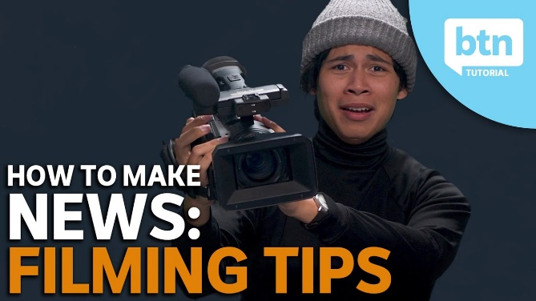
- What is the difference between ‘direct’ and ‘indirect’ interview styles?
- The direct to camera interview style is more natural. True or false?
- What does it mean to have an eye level camera angle?
- What is the rule of thirds? Draw a diagram to help explain the concept.
- What is a camera pan?
- When starting out it is safer to keep your shots still. True or false?
- What questions do you have about filming?

Activity: Making a short film
Working in small groups, students will create they own short film. Ask each group to think about ideas for their film. Each group needs to answer the following questions:

- What is your story about?
- Where is the story set?
- Who are the characters in the story?
- What are the characters going to say? (dialogue)
- What is the problem in the story?
- How is the problem solved?

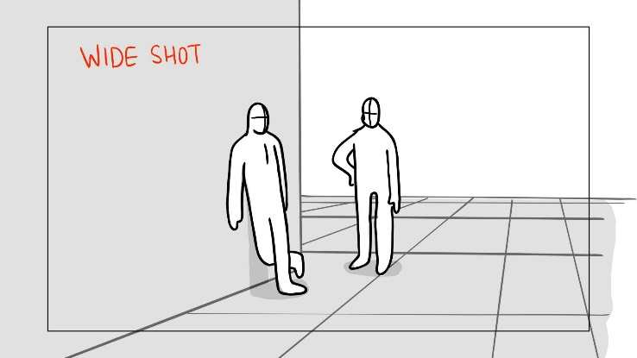
When students have worked out a basic idea for their film, they can create a storyboard. Storyboards look like comic books and have a picture for every shot in the film. Explore the ACMI website to learn about what a storyboard is and how to create your own story board.

Students can use devices such as smartphones or tablets to record their films. The Behind the News website has some tips to help students with the filming process.

Activity: Documentary making
Students will produce a short documentary about someone who’s doing something great, doing something interesting or helping others in their community. It could be a friend, family member, schoolteacher, or themselves. Alternatively, you could encourage students to research an issue that affects their local community.

- Choose someone in your community that you want to feature in your documentary. Watch some of BTN’s Rookie Reports for inspiration.
- Write your documentary – find out what makes a good feature story here. Celebrate the persons’ strengths in your writing. Share your story with the class.
- Plan your documentary – Story board your documentary on paper.
- Make your documentary – check out these interviewing tips to help with interviewing your subject. Encourage students to film and edit their own short documentary and send it in to BTN. Visit BTN’s Rookie Reporter webpage for some training videos.

Activity: Movie review
Students will choose an Australian film and write a review about it. It could be a classic Australian film, or a film made in Australia recently. Refer to Screen Australia’s list of Australian Films. Alternatively, if your students make their own short films, they can review these. Before starting their review, discuss with students the movies they like to watch. Possible questions include:
- What is your favourite movie genre?
- How do you make choices about what films you see and don’t see?
- Do you read film reviews? If so, do reviews help them decide which films they will see?
- What else influences your decision about what you will see?

Students will then begin to write their own film review. Students will respond to the following questions and then write their review using the layout below.
- What did you like or dislike about the film? Why?
- Would you recommend the film to other kids your age? Why or why not?
- What are the themes in the film?

Review layout
- Title of the film
- Audience – what is the rating who is the film aimed at?
- Synopsis (summary of the plot)
- Characters
- Special effects/sound/music
- Opinion (supported by 2-3 reasons)
- Star rating (out of 5)

Additional activities
- Include an illustration with your review. It could be a poster for the film or a sketch of one of the characters from the film.
- Hold your own class film club. Everyone will watch the same film, either individually or as a class and then discuss the film (genres, characters, plot).

Useful Websites
- Outback Films – BTN
- Silent Films – BTN
- Visual Effects – BTN
- Queensland’s film industry booms as A-listers seek a safe haven from the COVID-19 pandemic – ABC News
- Film and animation studios look to Australia as huge `game-changer’ pool gets built in Melbourne – ABC News
- Learning filmmaking Vocabulary by Making Films – Read Write Think
- World’s First Feature Film – National Museum Australia
- Hero’s Journey – Read Write Think
- So, you want to make a film? – ACMI

EPISODE 8
23rd March 2021

KEY LEARNING
Students will learn more about the history of migration in Australia and the reasons why people migrate. Students will explore individual migration stories.

CURRICULUM
History – Year 5
The reasons people migrated to Australia and the experiences and contributions of a particular migrant group within a colony.

History – Year 6
Stories of groups of people who migrated to Australia since Federation (including from ONE country of the Asia region) and reasons they migrated.

The contribution of individuals and groups to the development of Australian society since Federation.

Civics and Citizenship – Year 6
The obligations citizens may consider they have beyond their own national borders as active and informed global citizens.
Civics and Citizenship – Year 5 & 6
Identify over-generalised statements in relation to civics and citizenship topics and issues.
  - Teacher Resource

Harmony Day

Focus Questions
Discuss the BTN story as a class and record the main points of the discussion. Students will then respond to the following:
- Briefly summarise the Harmony Day story.
- Working in pairs, come up with a definition for multiculturalism.
- What are some great things about living in a multicultural society?
- Complete the following sentence. The White Australia policy made it hard for people from _____________countries to come to Australia.
- In which decade did the government bring in laws against racial discrimination?
- It’s estimated that Australia is home to people from more than _____ different cultural backgrounds.
- What is the official Harmony Day colour?
- Give some examples of things that are shared on Harmony Day.
- How does your school celebrate diversity?
- Why do you think celebrating our differences is important?

Activity: Note Taking
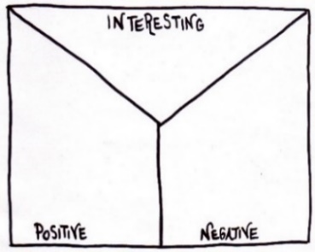
Students will practise their notetaking skills while watching the BTN Harmony Day story. Ask students to reflect on and organise the information into three categories. What information in the story was...?
- Positive
- Negative or
- Interesting

Activity: Class Discussion
After watching the BTN Harmony Day story, hold a class discussion, using the following discussion starters.
- What does harmony mean? Give some examples.
- Why is it important to celebrate Harmony Day?
- In your own words, define multiculturalism.
- How does your school celebrate diversity?

Activity: Glossary
Students will brainstorm a list of key words that relate to the BTN Harmony Day story. Here are some words to get them started.
INCLUSIVENESS | COMPASSION | RESPECT
EMPATHY | DIVERSITY | CULTURE

Activity: Inquiry Questions
After watching and discussing the BTN Harmony Day story, what questions do students have and what are the gaps in their knowledge? The following KWLH organiser provides students with a framework to explore their knowledge on this topic and consider what they would like to know and learn.

What do I know? | What do I want to know? | What have I learnt? | How will I find out?

Students will develop their own question/s to research or select one of the questions below.
- What are some of the reasons people have left their own countries to migrate to Australia?
- When and why was the White Australia Policy introduced and what impact did it have? Why did the policy end?
- Who are the traditional custodians of the land where you live and what languages do they speak?
Activity: Migration in Australia
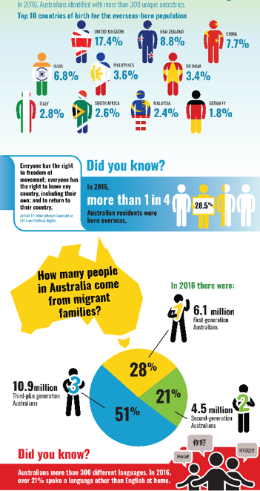
Hold a class discussion about the reasons why people emigrate to another country. Make a list of the ‘push’ and ‘pull’ factors that have contributed to people migrating to Australia. ‘Push’ factors are conditions that drive people to leave their country, for example, a natural disaster. `Pull’ factors are conditions that attract people to a new country, for example, job opportunities. Think about environmental, economic, social and political factors.

Investigate the question - Where do Australian migrants come from? Go to the ABC’s infographic to learn more about where Australian migrants come from. What surprised you about these statistics?

Create your own classroom set of statistics about migration. Survey your class to find out how many students come from migrant families. Create a graph to illustrate the results.

Activity: Migration Stories
Students will interview a family member or friend who migrated to Australia to learn about their experiences.
- Ask your interviewee open ended questions, not closed ‘yes’ or ‘no’ questions to get interesting and different kinds of answers.
- Share and compare the stories you have learned about as a class.
- How does talking to people who have experienced migration give us a different perspective on events?
- What have you learnt from this experience?

Bring in an object from home that says something about immigration and your family. Create a caption for your object and write a brief story about it explaining its significance.

Identify and explore the migration experience through the eyes of one migrant group that has come to Australia, for example:
- Chinese migrants who worked in the goldfields in the 1850s
- Italian migrants that came to Australia during the 1950s and 60s
- Vietnamese refugees who arrived in Australia after fleeing their homeland in 1975

Display your research in an interesting way and include images, text and audio. Respond to the following questions:
- Who came?
- Where did they come from?
- When did they come?
- Why did they come?
- What was life like in Australia for them?
- What contributions to Australian life did these individuals or cultural groups make?
- Write a letter from the point of view of a newly arrived person describing their experiences to a family member who remained back home.

Activity: Celebrating Diversity in Your School
As a class, discuss the diversity in backgrounds, experiences, interests and age of people in your class and school community. Broaden your discussion and talk about your local community and Australia as a whole. Explain to students that developing positive relationships can help build a sense of belonging and inclusion. Provide a range of opportunities for students to share their personal stories to create an atmosphere of cultural respect and acknowledgement of diversity.
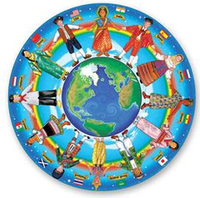
- What do you like about being part of your school community?
- What makes you feel safe in your school community?
- How do you welcome new students to your school community?
- What are some of your school’s values?
- Describe some of your school’s traditions. Why are they important?
- What are the advantages of belonging to a culturally diverse community?
- How does your school value and celebrate cultural diversity?
Harmony Day Resources
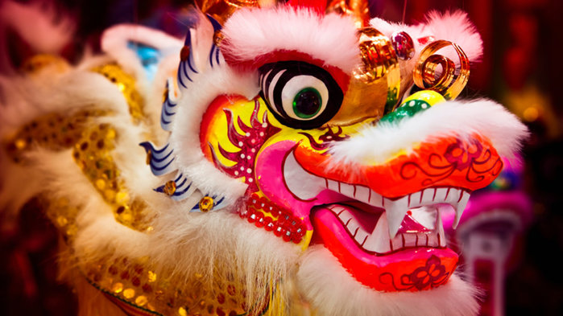
The topic Celebrations and traditions features a range of ABC educational resources related to multiculturalism and Harmony Day.

ABC Education’s Celebrations digibook explores celebrations in Australia, Asia and Europe. It considers the beliefs, rituals and foods associated with popular celebrations that show how celebrations are observed around the world.

Check out the BTN Religions and Beliefs stories

Useful Websites
- Harmony Celebrations – Australian Government
- Waves of Migration – BTN
- Celebrations and Traditions – ABC Education
- Celebrations digibook – ABC Education

  - Teacher Resource

BTN Transcript: Episode 8 - 23/3/2021

Hey, Amelia Moseley here with another episode of BTN. Check out what’s coming up. We mark one year since Australia went into lockdown, learn about the virtual artworks that are bringing in millions and find out how this massive water tank could be used by future film makers.

Equality Protest

Reporter: Amelia Moseley

INTRO: All that soon, but first to an issue we've been hearing a lot about in the news lately and that's the treatment of women and girls in schools and workplaces and even in Parliament. Last week we saw thousands of people around Australia take part in the March4Justice, calling for an end to discrimination and violence against women. Let’s find out why so many are calling for change.
PROTESTER: I think it's important for women to be treated equally.
PROTESTER: I feel like women don't get enough respect and men and boys should stand up for them a lot more.
They were scenes and words that echoed all across Australia and around the globe.
PROTESTERS: What do we want? Justice. When do we want it? Now.
As thousands of people of all ages hit the streets to demand change.
PROTESTER: I think that women should have the same respect and the same power as men do.
While the law says that men and women should be treated equally, experts say that's not always the case.
DR ANASTASIA POWELL, ASSOC. PROF. CRIMINOLOGY & JUSTICE, RMIT: Women make up less than a third of our elected leaders in Parliament, and two university graduates, a man and a woman, when they get their first job, the woman on average earns 10 per cent less, even though they've got exactly the same qualification. So, our society treats men and women differently. And it treats them as though they're worth a little bit less than men. It makes it easier for other people to hurt them. And it also makes it harder for people to ask for help if they are getting hurt.
Dr Powell says that hurt all too often comes in the form of sexual harassment or violence.
DR ANASTASIA POWELL, ASSOC. PROF. CRIMINOLOGY & JUSTICE, RMIT: So sexual violence, harassment or abuse can really be anything that makes someone feel uncomfortable, so whether it's someone touching their body or even making comments about their body or anything in a sexual way, that’s not wanted.
Surveys show that one in two women in Australia have experienced sexual harassment. One in six experienced violence by their partner and one in five have experienced some form of sexual violence since the age of 15. While men do experience these things too; it happens way more often to women. And recently, this woman came forward to say it happened to her while she was working for the government at Parliament House.
BRITTANY HIGGINS, FORMER LIBERAL STAFFER: My story was on the front page for the sole reason that it is a painful reminder to women that if it can happen in Parliament House, it can truly happen anywhere.
Her story made a lot of people angry and sparked these big March4Justice protests.
PROTESTER: We want people to be able to dress how they want; behave how they want and not have terribly unjust consequences.
PROTESTER: I want the politicians to listen to women about what's happening and for them to make changes.
Governments have started programs to try to address the problem, including ad campaigns like this.
AUSTRALIA GOVERNMENT AD: Doesn’t she know that’s just boys being boys? Yeah, I mean, I've already accepted that as I grow up, I'll probably be harassed and even abused.
And education programs in schools teaching kids about respectful relationships and recognising gender stereotypes. Experts say from the time we're really little we can start to get messages about how boys and girls should look and act.
DR ANASTASIA POWELL, ASSOC. PROF. CRIMINOLOGY & JUSTICE, RMIT: Those types of stereotypes about boys and girls or men and women, they do cause real harm, they add up to a society that doesn't treat women with respect.
AMELIA, REPORTER: So, Dr Powell, what can kids do?
DR ANASTASIA POWELL, ASSOC. PROF. CRIMINOLOGY & JUSTICE, RMIT: When someone says, oh, girls can't play sport, or boys shouldn't have long hair, or boys are just naturally loud and strong, and girls should be quieter; and we can say "hey, that's just not true”.
She also says it's really important to speak up.
DR ANASTASIA POWELL, ASSOC. PROF. CRIMINOLOGY & JUSTICE, RMIT: If someone does tell you that they're being hurt by another person, it's really important that we believe them, and that we help them to talk to someone about it. So, whether that's a trusted teacher, whether it's a parent, or even the police, everyone deserves to be safe.
That's a message that protesters say they want taken to workplaces, sports clubs, homes and even right here {parliament}, so we can all enjoy a safer and more equal future.
PROTESTER: I think women should just be able to follow their own dreams and do what they want to do and what makes them happy.
PROTESTER: I want to live in a world where all genders are equal, you know no matter if you're non-binary, man or woman. It's so important that we just move together as a generation otherwise nothing is ever going to get done and no change will happen.
News Quiz

What’s the name of the rescue organisation whose volunteers dress in orange and have been helping people in New South Wales’ floods? Is it the CFS, the SES or the RNDS? It’s the SES. Thousands of New South Wales and Queensland SES volunteers, along with rural and metropolitan fire and rescue services have been rescuing people from floodwaters and protecting property from the devastating floods, which hit communities along the east coast.

GLADYS BEREJIKLIAN, NEW SOUTH WALES PREMIER: I hate to say this again to all of our citizens of this state, but it’s not going to be an easy week for us.

KID: It’s just water and it’s going to stay here for a while.

Schools have closed and thousands of people and animals have had to evacuate as the flood water destroyed homes and even sent one floating along the Manning River.

China’s capital, Beijing was hit by its worst sandstorm in a decade last week when strong winds blew sand in from the desert. Can you name the desert this sand came from? Was it the Simpson, Sahara or Gobi? It’s the Gobi Desert which stretches across a big chunk of China and Mongolia.

What unusual Arctic animal got lost and ended up in Ireland last week? Was it a polar bear, a walrus or a penguin? It was a walrus. Experts thought it probably fell asleep on a drifting iceberg and ended up thousands of kays from its home in the Arctic Circle.

Lockdown Anniversary

Reporter: Cale Matthews

INTRO: Do you remember where you were one year ago? You might've been getting your first taste of online learning or being stuck at home because, believe it or not, it's been a whole year since Australia first went into COVID-lockdown. Let's take a look at how our lives have changed and how some once-weird stuff has become kinda normal.
It might seem hard to believe that this was a year ago.
GLADYS BEREJIKLIAN, NSW PREMIER: Please don't move around unless you absolutely have to.
DAN ANDREWS, VICTORIAN PREMIER: Stay at home, or people will die.
SCOTT MORRISON, PRIME MINISTER: 2020 will be the toughest year of our lives.
So, how has your life changed since then?
BEN: Well, a year ago, I didn't know what this was.
DIYA: What is normal for me now is wearing masks.
DAN ANDREWS, VICTORIAN PREMIER: Wear a mask, it’s not too much to ask.
While it took a bit of getting used to, these days walking around, smelling our own breath has become pretty normal and even a fashion statement. That one’s my fave.
ANASTASIA: Hand sanitiser.
DIYA: Hand sanitiser.
MICHAEL: Hand sanitiser.
BEN: I didn't even know it existed.
NADIA: When I go to the shop, I think where's the hand sanitiser?
Yeah, we've all become pretty obsessed with hygiene and staying away from each other.
ANNASTACIA PALASZCZUK, QUEENSLAND PREMIER: No, we’re not starting until you properly socially distance. Everybody.
ANASTASIA: When you're waiting in line at Woolie's like to really keep your distance.
MICHAEL: One of the biggest things I've noticed right now is basically everywhere you need to go, you need to check-in on your phone.
YIANI: You have to pre-order tickets now and then check-in and have people scan your ticket.
Oh, that reminds me, can you guys make sure you check-in to this BTN story please, come on scan the code. Thank you, back to the story. Although we didn't travel far, we've been Zooming everywhere.
BEN: Yeah, remote learning, like Zoom, WebEx, Teams, Google meets. All that stuff I didn't even know existed.
It also meant getting to enjoy people’s Zoom backgrounds and Zoom fails. We got really used to seeing our state leaders.
BEN: Waiting for them Andrew to do a press conference. Whenever he's wearing his North Face jacket means it's good news.
DAN ANDREWS, VICTORIAN PREMIER: Now is the time to open up.
BEN: And a suit and tie after 12pm means, bad news.
DAN ANDREWS, VICTORIAN PREMIER: I'm declaring a state of disaster.
MICHAEL: On the news, I hear a lot about Job Seeker, job whatever. I don't really know what they mean. But I usually hear them a lot.
Yeah, we've learned a lot of new words.
NADIA: Pandemic, quarantine, medi-hotels, AstraZeneca.
BEN: Quarantine, which is like, don't go outside, lockdown, which is also don't go outside.
GEORGIE: As for the word isolation, lockdown, restrictions. Well, we all know that can happen at the drop of a hat.

MICHAEL: I think Australia’s changed the most with travel, because obviously there's hundreds and 1000s of people who can't see their family and still trying to see their family till this day.
ANASTASIA: The borders were shutting down one day opening the next day. So that was probably very hard for some people.
Around the world the pandemic is certainly not over. More than 120 million have now been infected and at least 2.5 million have died, but with vaccines rolling out things are looking way more hopeful than a year ago.
DIYA: They're fighting to stop the Coronavirus. So, we have to stick to it and fight back.
BEN: Everyone is more kind to each other because they know they could lose them or not be able to talk to them for a while. Even though we might be physically apart, virtually we’re all connected and we’re all together. We’re all in this together. We should show everyone that we’re in this together.

NFTs and Digital Art

Reporter: Cale Matthews

INTRO: Imagine paying millions of dollars for a work of art that only exists on a computer. Weird right? Well, welcome to the world of NFTs: digital trading cards and artwork that are taking the world by storm. Cale found out how a bunch of pixels could be so valuable.
Art, it's elegant, it's quirky, it's hmm not sure. Anyway, aficionados will travel the world just to get a glimpse of a da Vinci, a Monet, or a Warhol, but imagine having millions of dollars’ worth of art stored entirely in your phone. Not like that.
Welcome to the world of NFTs. They are digital collectibles, from artworks, to trading cards and even gifs of Nyan Cat, the sound wasn't included, thankfully. NFT stands for Non-Fungible Token. Fungible basically means exchangeable, so non-fungible means they're one of a kind.
CALE: That seems weird. I mean it's just a computer file, how hard can it be to copy? See just did it.
VO: Yeah, no you didn't.
CALE: Didn't I?
VO: No, you didn't.
The non-fungible part of an NFT isn’t actually the picture. It's a bit of really, really complicated code tied to the picture that can't be copied. It's the same sort of technology that's used in cryptocurrencies like Bitcoin. And it's like a certificate of authenticity for your art, ensuring it's one of a kind, and that’s part of what makes something valuable.
CALE: Take this old gal for instance. She's pretty famous and has been copied onto posters, T-shirts, and even shower curtains. But none of these copies will ever be worth as much as the original that's hanging in the Louvre. It's one of a kind and it's why my screenshot of this NFT is basically worthless, it's just a copy. But originality is only part of what makes something valuable, there's also popularity, and right now NFTs are really popular.
People have been forking out millions of dollars to own their own digital collectible. Singer Grimes has just made seven and a half million dollars selling a bunch of NFTs, while this piece by artist Beeple, was recently auctioned off for more than 90 million, putting him in the top 3 most valuable living artists.
BEEPLE: What. Like I don’t even know, I can't even, it's like an unfathomable number, to be quite honest. It's just crazy.
And it’s not just NFTs. The National Gallery in Victoria recently bought these massive computer-generated pieces, and some artists reckon the digital movement is here to stay.
JESS LAMBIE, ARTIST: It's a different culture that's coming through now, it's an internet culture that’s coming through now, it's a different kind of person, it's a different kind of collector, it's a different kind of artist.
But not everyone’s on board. Some say it's just a passing fad, while others are concerned about its energy use. Generating the code behind NFTs requires a lot of computing power, which can contribute to greenhouse gases. But whether or not these are the Mona Lisa’s of the future, there's no doubt the art world will continue to evolve and take us to strange new artistic places.
CALE: Give it 5 years and this'll be priceless.

Ask a Reporter

Do you want to know more about NFTs? Well, you can ask me this Friday live on Ask a Reporter. Just head to our website for all of the details.

Australian Film Boom

Reporter: Amelia Moseley

INTRO: Now to the movies. There've been a few very famous faces wandering the streets of Australia recently because some big Hollywood blockbusters are being filmed right here. You see, while COVID-19 has had a big effect on production in Hollywood there's been a silver lining for Australia's film industry. Let's find out more.
Whether they make us laugh, jump or cry; there's no denying the magic of movies. But while the magical movie making land, also known as Hollywood, might seem like a world away from the comfy couches of Australia, these worlds aren't actually so far apart. In fact, a lot of what you just saw was made right on our doorstep. Hollywood's been making movies here for decades. Sometimes it's cheaper than other locations. Other times, it's just the right setting or scenery. But recently, there's been another reason, COVID. Or a lack of covid, to be precise.
America hasn't been doing too well keeping its cases down. In fact, it's the reason lots of movies that were set for release last year were delayed. One day, James Bond. One day. But here in Australia, things are much better, and some reckon that's why our movie industry is booming. In Queensland a record 39 movies have signed up to be made here since 2020. They include some big blockbusters, like Baz Luhrmann’s Elvis epic, shooting on the Gold Coast. And over in Sydney there are a bunch of Marvel movies coming up like the sequels to Black Panther and Captain Marvel and that'll mean a lot more work for these guys too. Rising Sun is a visual effects studio in Adelaide which adds the magic to lots of famous movies; sometimes literally.
DENNIS 'DJ' JONES, VFX SUPERVISOR, RISING SUN: You know Severus Snape, he'll just do his little flick. We add all the magic. There's a scene with the chestnuts getting roasted by a dragon outside the sweatshop, that was us. So, we make the dragon designer dragon, animate it.
AMELIA, REPORTER: Wow. So, have you been working on more Hollywood movies lately?
DENNIS 'DJ' JONES, VFX SUPERVISOR, RISING SUN: With COVID and the pandemic, recently, we’re pretty unaffected in Australia, we fared pretty well in the world, so we found that we didn't stop working at all.
The film industry brings in billions of dollars a year to Australia's economy and employs thousands of people, but sometimes you have to spend money to make money. And last year the government invested an extra 400 million dollars into luring Hollywood filmmakers here. Victoria's government has also put 46 million dollars towards building this in Melbourne; one of the biggest sound stages in the whole world complete with a 900 thousand litre, 4.5-metre-deep pool. Why? To film a sinking submarine, of course or an epic under water shark scene or whatever.
DANNY PEARSON, VICTORIAN CREATIVE INDUSTRIES MINISTER: All the world's a stage then it's Melbourne's turn to shine.
Of course, it won't just be Hollywood movies made here. Aussie productions are welcome too. And some say they'd like to see more money spent on those. Featuring more of our own talent and our own stories. But many are just happy to see our shores stealing scenes on the silver screen.
Sport

For a few sports, this weekend it was a wash out. Due to torrential rains and flooding in New South Wales, A-League and W-League matches between Sydney FC and Melbourne Victory had to be postponed. Meanwhile NRL matches still went ahead, with Penrith taking down Canterbury 28-nil in a game that was half rugby half swimming.
Over in the other code, the AFL season got underway with Richmond beating the Blues in their traditional opening round match up. But it was the Adelaide Crows that really stunned the league. Last year’s wooden spooners defeated last year’s grand finalists, Geelong by 12 points.

Harmony Day

Reporter: Amal Wehbe

INTRO: Last week, schools around Australia celebrated Harmony Week. It was a time to enjoy the food, the clothes, the music and the stories of all of the cultures that call Australia home. Amal went out to a school to find out why living in one of the most multicultural countries on Earth is something worth celebrating. Take a look.
KID 1: I just came to Australia one year ago, and I'm from India, Punjab.
KID 2: I am mainly from Australia, but I'm partly Finnish.
KID 3: I came from Indonesia; my family and I just came to Australia a year ago.
KID 4: I'm from Punjab, India.
KID 5: I'm mostly English, and I’m partly Scottish and partly Irish.
Yep, we Aussies come from all over the world, in fact it's estimated that this country is home to people from more than 300 different cultural backgrounds including the world's oldest continuous cultures. According to these guys all of that multicultural goodness makes for a great place to grow up.
KID 1: We can learn and understand other cultures, and make our communities become unique.
KID 2: Everyone accepts all the cultures, and they all have harmony together.
KID 3: We get to learn about all different cultures and share their food, and we get to celebrate who they are.
It wasn't always this way. While people have come from all over the world ever since colonisation, for a lot of the last century, governments tried to assimilate people to a single, white Australian culture.
British official: As there is no language barrier to overcome these British children can adapt themselves immediately.
The White Australia policy made it hard for people from non-European countries to come to Australia. But eventually that changed. In the 70s the government brought in laws against racial discrimination. And began to adopt multiculturalism, the idea that different cultures existing side by side could make the country better. It was a policy embraced by both of the big political parties and one that continues today.
DANIELLE ROCHE, CHAIR OF NATIONAL AUSTRALIA DAY COUNCIL: Our nation is made of many people from hundreds of countries. We speak many languages and follow many faiths.
And that's what Harmony Day is all about.
KID 1: Harmony Day is a day for everyone in the world to come together and create peace with all the countries.
KID 2: Harmony Day is a day where we all come together and celebrate each other.
KID 3: Harmony Day is about celebrating different cultures and delivering the message that everyone belongs.
It's a day of sharing music, stories, cultural clothing and food.
AMAL, REPORTER: Many schools like Richmond Primary School here a parade where you can dress up in your traditional clothes of culture or you can choose to wear orange which is the official Harmony Day colour.
KIDS: Happy Harmony Day.
Harmony Day also coincides with the UN's International Day for the Elimination of Racial Discrimination and for many it’s a great reminder that our differences are made to be celebrated.
KID 1: Because no one should be left out and we should respect and tolerate people to the other people who come from different culture.
KID 2: Because we should judge people by the kindness in their heart, other than where they come from or what they look like.
KID 3: It’s important to include everyone so no one feels left out or sad and then we can all be happy together.
KID 4: Because it doesn’t matter from what country they are or what state they are or what religion they are. Because we're all people and we have the same hearts.

Closer

Well, that's it for us today, but we'll be back with our last episode of the term next week. In the meantime, you can jump online to check out more stories and quizzes and specials and keep up to date with Newsbreak every weeknight. Oh, and if you're 13 or over, you can also subscribe to our YouTube channel. Have an awesome week and I’ll catch you soon.

