EPISODE 6
8th March 2022

KEY LEARNING
Students will view a range of BTN stories and use comprehension skills to respond to a series of focus questions.

CURRICULUM
English – Year 4
Use comprehension strategies to build literal and inferred meaning to expand content knowledge, integrating and linking ideas and analysing and evaluating texts.

English – Year 5
Use comprehension strategies to analyse information, integrating and linking ideas from a variety of print and digital sources.

English – Year 6
Use comprehension strategies to interpret and analyse information and ideas, comparing content from a variety of textual sources including media and digital texts.

English – Year 7
Use comprehension strategies to interpret, analyse and synthesise ideas and information, critiquing ideas and issues from a variety of textual sources.
  - Teacher Resource

Focus Questions
As a class, discuss the stories featured in the episode of BTN Classroom and record the main points of the discussion. Students will then respond to the following focus questions.

East Coast Floods
- In your own words, describe the damage the flood caused to the northern NSW town of Lismore.
- What other places along the east coast have been affected by floods?
- Who has been helping out during the floods?
- What is the name of the weather event that brings wet weather to the east coast of Australia?
  - El Niño
  - La Niña
- Brisbane received more than half of its average annual rainfall in just a week. True or false?

Ukraine Refugees
- About how many people are fleeing Ukraine right now?
- Which countries are Ukrainian people going to?
- What are teenagers Carrie and Adriana doing to help Ukrainians?
- How are governments and aid agencies around the world helping Ukrainian people?
- How did this story make you feel?

Women’s History Month: Faith Bandler
- What inspired Faith Bandler to become a rights activist?
- What did Faith and her friend’s campaign to change?
- What impact did the 1967 Referendum have on Indigenous people’s lives?
- What will Faith Bandler be remembered for?
- If you could meet Faith Bandler and ask her a question, what would it be?

Check out the teacher resource on the Teachers page.

Humpback Whale Comeback
- What was the main point of the BTN story?
- Every year, humpback whales migrate to Australia from where?
- What impact did whaling have on whale populations?
- The Australian government has taken humpback whales off what list?
- What threats do humpback whales still face?

Check out the teacher resource on the Teachers page.

Women’s History Month: Edith Cowan
- Which Australian bank note does Edith Cowan feature on?
- Describe Edith Cowan’s life growing up.
- Complete the following sentence. Edith Cowan was the first Australian woman to serve as a member of ________________.
- What impact did Edith have on women’s lives today?
- What did you learn watching this story?

EPISODE 6
8th March 2022

KEY LEARNING
Students will choose a significant Australian woman to investigate in depth and create a biography.

CURRICULUM
HASS – Year 3 and 4
Pose questions to investigate people, events, places and issues.

Locate and collect information and data from different sources, including observations.

HASS – Year 5 and 6
Develop appropriate questions to guide an inquiry about people, events, developments, places, systems and challenges.

Locate and collect relevant information and data from primary sources and secondary sources.

History – Year 6
The contribution of individuals and groups to the development of Australian society since Federation.

HASS – Year 7
Construct significant questions and propositions to guide investigations about people, events, developments, places, systems and challenges.

Aboriginal and Torres Strait Islander readers please note that this document contains images of deceased Indigenous people.

  - Teacher Resource

Women’s History Month

Focus Questions
Discuss the BTN Women’s History Month stories as a class and record the main points of the discussion.
Respond to the following questions about Faith Bandler:
- What inspired Faith Bandler to become a rights activist?
- What did Faith and her friend’s campaign to change?
- What impact did the 1967 Referendum have on Indigenous people’s lives?
- What will Faith Bandler be remembered for?
- If you could meet Faith Bandler and ask her a question, what would it be?

Respond to the following questions about Edith Cowan:
- Which Australian bank note does Edith Cowan feature on?
- Describe Edith Cowan’s life growing up.
- Complete the following sentence. Edith Cowan was the first Australian woman to serve as a member of ________________.
- What impact did Edith have on women’s lives today?
- What did you learn watching this story?

Activity: Brainstorming
Before watching this story, students will brainstorm a list of significant Australian women. This activity can be done as a class or in smaller groups. The list can include famous Australian women or there might be an important woman in the students’ lives that has achieved something significant.

Activity: Personal Response
Discuss the BTN Women’s History Month stories (Faith Bandler and Edith Cowan) as a class. Students will then choose a woman featured in one of the stories and complete one or more of the following incomplete sentences:
- [insert name] was an important Australian because…
- It was interesting to learn…
- These are five words that I would use to describe…
- This story made me feel…
- It is important to remember [insert name] because …
What surprised you about this story?

Activity: Biography
Students will choose a well-known Australian woman to research and write a biography about. They can choose one of the women featured in the BTN Women’s History Month stories (see images below) or another significant Australian woman else. Before students begin to construct their biographies, hold a class discussion to find out what they already know about biographical writing.

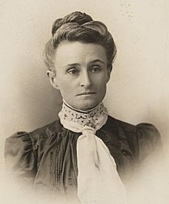  Edith Cowan, Source of image | 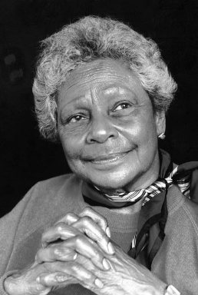  Faith Bandler, source of image

Use the questions below to get a class discussion started with your students about biographical writing.
- What does a biography tell us about a person?
- Where can you look to find information for your biographical writing? It could include the internet, newspaper articles, magazine articles and interviews, other biographies, historical books or television interviews. Why is it important to use more than one source of information?
- What makes a biography interesting? For example, key information and facts, a timeline of events, photographs, illustrations and quotes.

Using the biography worksheet at the end of this activity, students will research and record information about one significant Australian woman. Some possible areas of research include:

- When and where were they born? Describe their family life growing up.
- What are some of their achievements? Choose one to explore in more detail.
- What inspired/motivated them?
- What were their challenges?
- How do we recognise their achievements?
- How have they made an impact on people’s lives?
- What do you admire about them?
Further investigation
- Create a timeline of significant events in their life.
- What are some of the key events in their life? Write a summary for one key event, which answers the 5 W’s – Who, What, Where, When and Why?
- How do primary sources (for example photos, letters, diaries and official documents) help us understand what might have happened at a place in time? Find 1 or 2 primary sources that help you learn more about the person’s life.
- Imagine you could sit down and talk to them. What questions would you ask about their life and achievements?
- Write a letter thanking them for their achievements and how they have changed the world.
- Create a portrait.
- Make a Did You Know for other students.

Activity: International Women’s Day
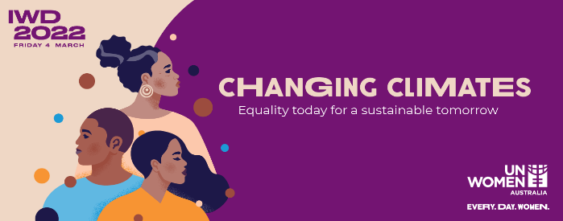
International Women's Day is a global day celebrating the economic, political and social achievements of women past, present and future. How does your school honour and celebrate the achievements of women all around the world? Go to the UN International Women’s Day website for more information.

Useful Websites
- Women in History Special – BTN
- NAIDOC Indigenous Women – BTN
- Women’s History Month – BTN
- Australian Women in Politics – BTN
- Women’s History Month – Royal Australian Historical Society

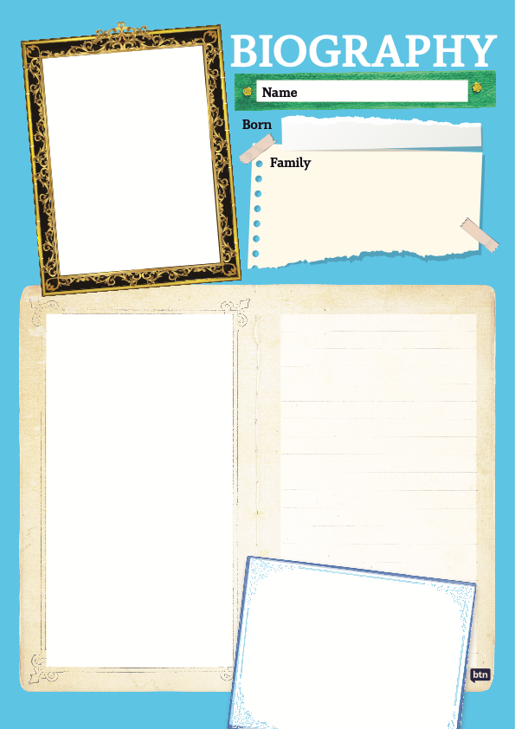

EPISODE 6
8th March 2022

KEY LEARNING
Students will learn more about the humpback whale and the impact whaling had on the species.

CURRICULUM
Science – Year 4
Living things depend on each other and the environment to survive.

Science knowledge helps people to understand the effect of their actions.

Science – Year 5
Living things have structural features and adaptations that help them to survive in their environment.

Science – Year 5 & 6
Scientific knowledge is used to solve problems and inform personal and community decisions.

Science – Year 6
The growth and survival of living things are affected by physical conditions of their environment.

Science – Year 7
Classification helps organise the diverse group of organisms.

Scientific knowledge has changed peoples’ understanding of the world and is refined as new evidence becomes available.

Interactions between organisms, including the effects of human activities can be represented by food chains and food webs.

  - Teacher Resource

Humpback Whale Comeback

Focus Questions
Discuss the BTN story as a class and record the main points of the discussion. Students will then respond to the following:
- What was the main point of the BTN story?
- Every year, humpback whales migrate to Australia from where?
- What impact did whaling have on whale populations?
- The Australian government has taken humpback whales off what list?
- What threats do humpback whales still face?

Activity: Note taking
Students will practise their note-taking skills while watching the BTN Humpback Whale Comeback story. After watching the story, ask students to reflect on and organise the information into three categories. What information in the story was...?
- Positive
- Negative or
- Interesting

Activity: Class Discussion
Discuss the BTN story as a class. Create a class mind map with WHALES in the middle. Ask students to record what they know about whales. What questions do they have? In small groups, ask students to brainstorm responses to the following questions:
- What do you know about whales?
- Why is it important to protect the species?
- What is the conservation status of humpback whales now?
- Why do some conservationists believe that humpback whales are still in danger?
- What has happened to whale populations over the years?

Activity: Glossary
Students will brainstorm a list of key words that relate to the BTN Humpback Whale Comeback story. Here are some words to get them started.

MIGRATE | BALEEN | WHALING
SPECIES | CETACEAN | CONSERVATION

Activity: Whale Research
The KWLH organiser provides students with a framework to explore their knowledge on the topic of whales and consider what they would like to know and learn.

What do I know? | What do I want to know? | What have I learnt? | How will I find out?

Questions to research
Students will develop their own question/s to research about whales. Students will collect and record information from a wide variety of sources. Students may develop their own question for inquiry or select one of the questions below.

- What are some unique features of whales?
- What are the different species of whales found in Australian waters?
- Why do whales migrate? Where can they be seen throughout the year?
- How do whales communicate with each other?
- How did Aboriginal people use whales differently to European settlers?
- How have people around the world used whales in the past? How is this different today? Why do you think it changed?
- When and why did whaling in Australia start to decline?
- Do you think that people’s attitudes to whaling have changed over the years? Why?
- What is causing species loss? Explore issues such as habitat loss, introduced species, pollution, population growth and overharvesting/hunting.
- What happens when an animal becomes extinct? If one species in the food chain becomes extinct, how would it affect the rest of the chain?

Activity –Visual Literacy
Below is a collection of photographs and artworks of whaling in Australia. Look at the image and then respond to the following questions:

- What is happening in the image? Describe what you can see.
- When do you think the image was created? Why?
- If there are people in the image, who do you think they are? How do you think they might be feeling?
- What question/s would you like to ask the people in the image?
- What does the image tell you about whaling?
- How does the image make you feel?
- Create a caption for the image

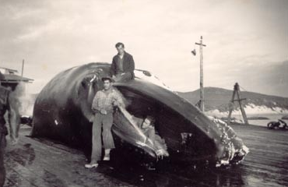
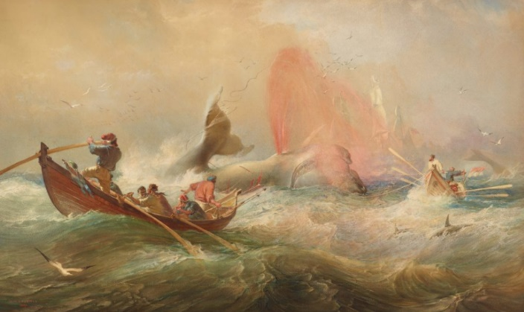

Link to image Link to image

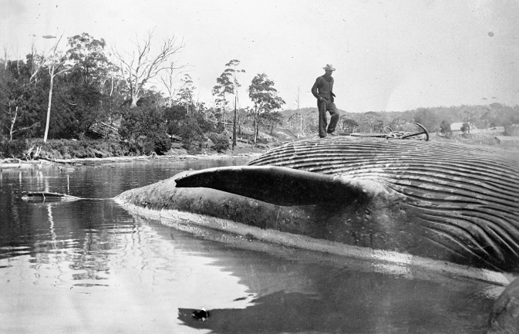
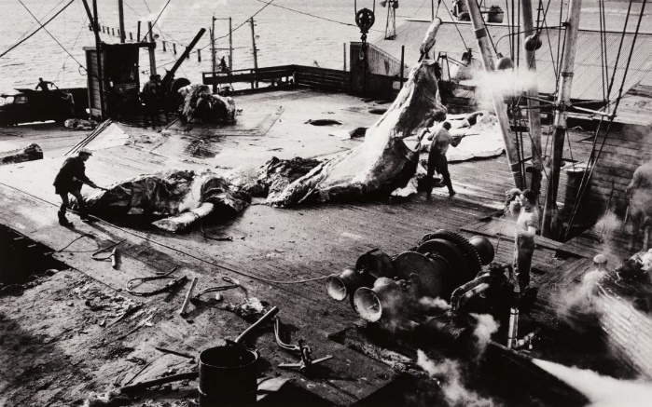

Link to image Link to image

Activity: Whale Profile
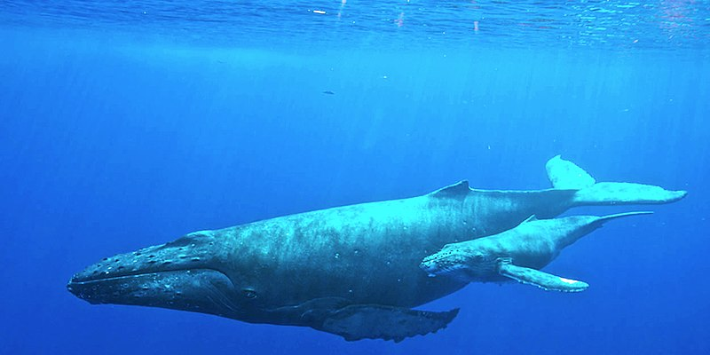
Students will explore in depth a species of whale and create a profile about them. Below are some examples.

- Humpback whale
- Southern Right whale
- Blue whale
- Minke whale
- Killer whale

Humpback whale

Students will research the following and then share their research findings with the class or create a display in the classroom. Students can use the Animal Profile at the end of this activity.
- Illustration or photo
- Name (common and scientific name)
- Appearance
- Adaptations
- Habitat
- Threats
- Unique features
- Conservation status

Further Investigation
Students can choose a species of animal that has been taken off Australia’s Threatened Species List and investigate why the animal was threatened and what was done to protect it.

Useful Websites
- Humpback whales no longer listed as endangered after major recovery – ABC News
- Humpback Whale – Australian Museum
- Why do Whales Sing? TedEd
- Humpback Whaling – BTN
- Start of Whaling – National Museum Australia

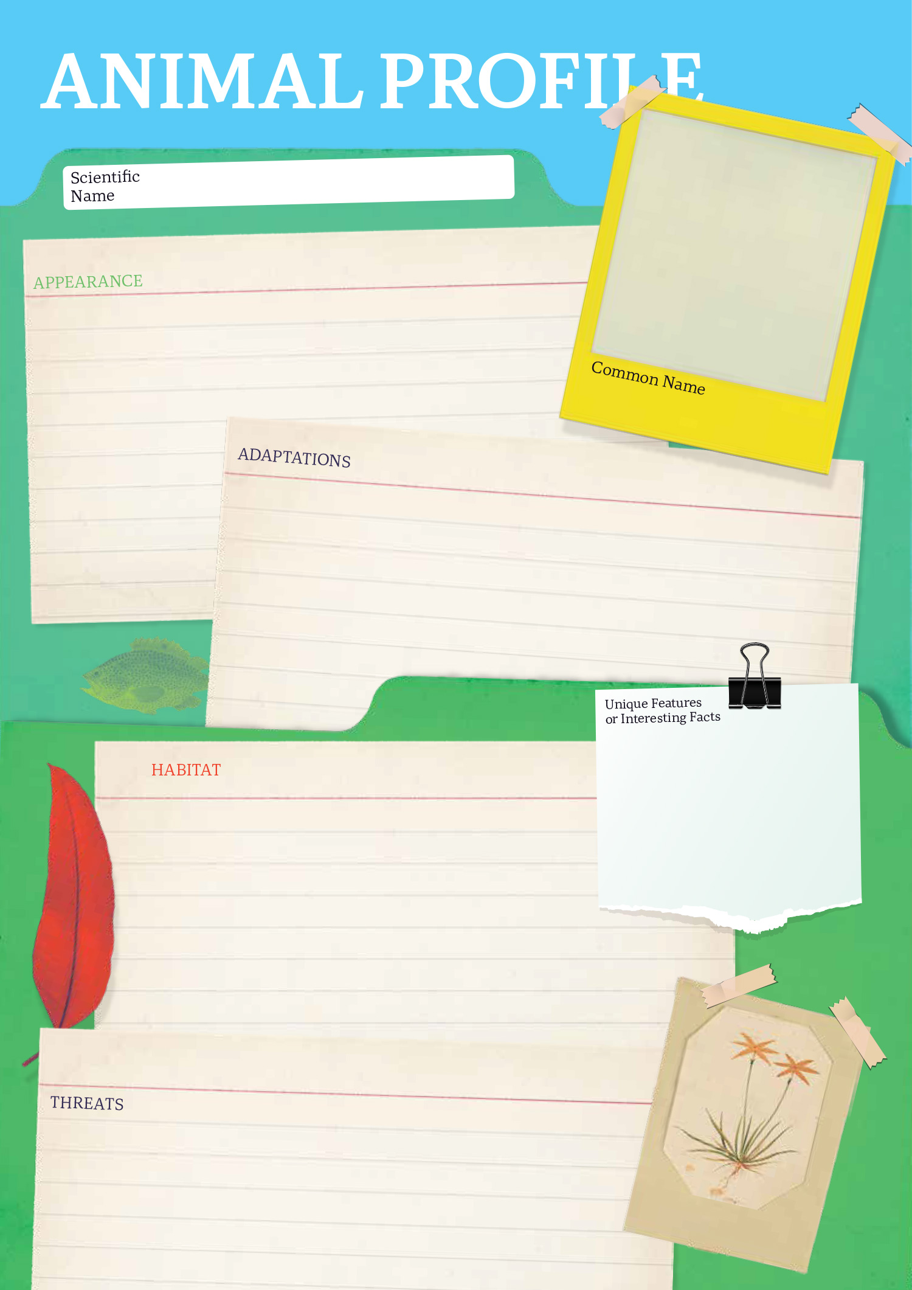

  - Teacher Resource

BTN Transcript: Episode 6 - 8/3/2022

Hey everyone, Amelia Moseley here and you’re watching BTN. Thanks for hanging out with us again. Let’s see what’s coming up. Australia says goodbye to a cricket icon, humpback whales make a comeback, and we celebrate Women's History Month by telling you about some famous Aussie women with the help of our rookie reporters.

East Coast Floods

Reporter: Cale Matthews

INTRO: We’ll have a couple of those in today's show so keep an eye out. But first today to the deadly floods which have hit Australia's east coast. Thousands of homes as well as schools and businesses have been damaged and many are now facing a long and difficult clean-up. Let’s find out what happened and meet some kids who've been affected.
This isn't a river. It's the town of Lismore in Northern New South Wales. Last week it was hit by the region's worst flood on record. People died and hundreds of homes were submerged, as boats became the only way around town.
KID: It was crazy. Some people couldn't even leave their house. My school has been filled all the way to the top. It’s really sad.
KID: My dad works at the evac centre in Lismore, and he has to handle how everything works, all the donations and all the lovely things people bring, and he just gets very stressed from that so that’s affected my family as well.
KID: Right now, I'm living at a friend’s house with my family and another family is staying there as well. Our house that was in the floods is pretty wrecked, really muddy. We've started cleaning it out, but it still has a long way to go.
It’s been a similar story across much of Australia's east coast.
KID: If you fall asleep you could wake up with water in your room so it’s a bit scary.
KID: Seeing a flood for the first time is kind of crazy, especially when your whole school is underwater. It’s mad.
The rain began a couple of weeks ago, filling up rivers and dams until they overflowed. Brisbane and the Gold Coast were the first to flood then the rain made its way down to Sydney, inundating towns in between.
KID: My school was closed because all of the water was like a big river in the middle.
BENJI: Our driveway has been flooded and it was that deep that we could go boat racing.
People prepared for the floods as best as they could, using sandbags which can help to keep out water and mud and even temporary levees like this one in Maryborough, which saved the main street from flooding. Hundreds of thousands of people were told to leave their homes throughout New South Wales. But for some the water rose too quickly. SES and other volunteers rescued hundreds of people and even pets.
FLOOD VICTIM: We've lost everything, and I just had to rescue the goat.
FLOOD VICTIM: I've got a surf lifesaving background and I was like OK I gotta get out here and help.
FLOOD VICTIM: This lad needed a bitta help so, you know, I towed him out, and then I’m gonna keep doing the same thing for hopefully the rest of the day.
So, what's going on? Well, the Bureau of Meteorology says it’s because we've had two big La Nina events in a row. La Nina is a weather pattern that brings more wet weather to the east coast of Australia and last year it filled up catchments which meant dams and rivers were already full when this huge batch of rain arrived. And it was huge. In fact, Brisbane received more than half of its average annual rainfall in just a week.
Scientists say that these sorts of events are becoming much harder to predict because of climate change so it can be really hard to evacuate people in time. While wet weather is continuing to cause problems in some places flood waters are slowly going down revealing all the damage that's been done and these towns say they are going to need a lot more help to clean up.
KID: It's going to take a long time for us to even get back the slightest bit of normality.
KID: We've all just jumped at whatever opportunity to help each other. Help clean our houses. My school’s community has donated so many things and they’ve cooked meals for everyone. It’s just really sweet.
KID: Everybody is stepping into action and helping each other, and we’re all just working together to try and get our community to thrive again.
Some things can’t be replaced, but people are working together and supporting each other as the clean-up begins.

Ukraine Refugees

Reporter: Amelia Moseley

INTRO: Now to Ukraine. Since fighting started there more than a million people have left their homes to try to find safety and the UN says in the next few weeks and months millions more could join them. Let's hear from some Ukrainian people and see what's being done to help them.

Imagine having to leave your home as quickly as possible because it's no longer safe. You might get in your car, or on a bus, or a train and leave your town, city or even country behind.
UKRAINIAN REFUGEE: We heard first explosions and we were devasted. So, we started to plan, and we still don't have clear plan what we should do or where we should go.
It's the situation for more than a million people fleeing Ukraine right now because of the war with Russia.
UKRIANIAN REFUGEE: There's a lot of people in train stations. I even heard just today that a woman just gave birth in a station, and a lot of people, a lot of kids, everybody, you can see the real suffering of the people there.
The Ukrainian government says Ukrainian men aged 18 to 60 shouldn't leave the country in case they have to fight. It's something many Ukrainians, men and women, say they're willing to do. But it means lots of families are having to separate to find safety.
UKRAINIAN REFUGEE: We left dad in Kyiv, and he'll be selling things and helping our heroes, our army. He might even fight.
Most people are heading to safer parts of Ukraine, while others are going to neighbouring European countries, especially Poland. It's already home to more than a million Ukrainians. But with so many people trying to leave, it can be a long wait. In Western Ukraine, teenagers Carrie and Adriana are volunteering in this shelter and collecting donations, especially warm clothes, for those who have left their homes on the other side of the country.
ADRIANA, UKRAINIAN VOLUNTEER: We want to help people from our country who don't have their houses now, they need us.
CARRIE, UKRAINIAN VOLUNTEER: We are sending messages with words that we are not alone, and we can help each other.
Those who do leave Ukraine are being greeted with open arms. Volunteers at borders are handing out food and water and supplies, even toys for kids. And they're being given a place to rest. But it's not just humans, pets are welcome too. Romania, Hungary and Poland usually have strict rules about bringing animals across borders, but their governments are making an exception.
TATYANA AND PET PUG, KYIV RESIDENT: We are going to, with my dog, we will try to go to west side of Ukraine and may be after to Romania and let's see. It is going to be a long trip.
The European Union says Ukrainians can stay and work in EU countries for up to three years, but it'll take some time to get so many people settled and the UN says millions more could be on their way. Governments and aid agencies around the world say they're ready to help by sending supplies and giving refugees a new home. But many Ukrainians say they like their old home and are hoping the war will end soon.
UKRAINIAN REFUGEE: I want back to Ukraine and study maths, physics, I want study in university.
UKRAINIAN VOLUNTEER: I think helping other countries is very important for us.

UKRAINIAN VOLUNTEER: Thank you so much everyone, who is trying to change the world because of what happened and pray for Ukraine.

News Quiz

Can you figure out who this is? It’s the Prime Minister, Scott Morrison, who’s been in isolation after testing positive for COVID-19.

SCOTT MORRISON, PRIME MINISTER OF AUSTRALIA: First of all, can I just thank everybody for their very kind wishes after I confirmed last night that I tested positive to COVID.

He’s not the only world leader who’s come down with the virus. Which of these famous Brits has been in isolation recently? It’s the Queen. The good news is she was back to giving virtual audiences last week so seems to be feeling better.

The US President made a very important speech to his country last week, often called the S.O.T.U. Do you know what that stands for? It’s the State of the Union, a speech each US president gives once a year. Joe Biden began his first by showing support for Ukraine.

JOE BIDEN, US PRESIDENT: Together with our Allies we’re providing support to the Ukrainians in our fight for freedom.

Something crashed into the moon last week. What was it? An asteroid, an alien spacecraft or a rocket? It was a rocket, well part of one anyway. Scientists have been tracking the 2700 kilogram hunk of space junk for months and on Friday it crashed into the far side of the moon. Probably creating a new crater and sending space dust everywhere but, because it’s on the other side of the moon, it’ll take a while to find out for sure.

Which Aussie state did these happy travellers enter last week? Western Australia. On Wednesday the state opened its borders to all vaccinated travellers for the first time in a long time.

And can you name the colourful parade that took over the SCG on the weekend? It’s the Gay and Lesbian Mardi Gras.

Shane Warne

Reporter: Leela Varghese

INTRO: People around the world have been paying tribute to Shane Warne who died suddenly on the weekend. Warnie was known as probably one of the best cricketers of all time and was loved and admired by players and fans. Let’s find out more about him and his lasting impact on the game.

PAT CUMMINS, AUSTRALIAN CRICKETER: We all grew up watching Warnie idolising him. The showmanship, the charisma, his tactics.

SCOTT MORRISON, PRIME MINISTER OF AUSTRALIA: Shane Warne is one of the greatest cricketers of all time, and he was ours. 100 percent Australian and we were so proud of him.

Here in Australia and all around the world, people are remembering the Aussie icon.

ARJUNA RANATUNGA, FORMER SRI LANKAN CRICKETER: He was one of the toughest cricketers I’ve ever played against. He had a lovely heart, big heart for people here.

MICHAEL VAUGHN, ENGLISH CRICKETER: He’s going to be hugely missed over here.
Shane Keith Warne or Warnie as many called him, was a leg spinner who went on to become one of the greatest ever. He first played for Australia in 1992 but became a lot more well-known after this, a delivery that people called The Ball of the Century. Throughout his career, Warne also drew attention for what he did off the field.
In 2006, just before he retired, he became the first ever bowler to claim 700 test wickets. The cricketer will be farewelled at a State Funeral and the MCG has already announced it’s renaming the Great Southern Stand the SK Warne stand in his honour.

SHANNE WARNE: Well, obviously I had a gift, which I could spin the ball. But I worked pretty hard to try to be the best version of myself I could be, but I think, I think I got there.

Women’s History Month: Faith Bandler

Rookie Reporter: Devon

This is Faith Bandler. She was born in a little town in Northern New South Wales in 1918. Her Mum was born in Australia too. But her dad was born on one of the islands now known as Vanuatu. When he was 13, he was kidnapped and taken to the east coast of Australia to be a slave on a sugar plantation. It's something that happened to tens of thousands of South Sea Islander people at the time. Faith's dad died when she was only five, but his experiences stuck with her as she grew up and became a famous rights activist.
PRESENTER: Ladies and gentlemen Mrs Faith Bandler.
FAITH BANDLER: Today in Australia we cannot say we have so much as one doctor of Aboriginal descent. Neither have we a lawyer. Nor an engineer and so it goes on.
Faith saw that Aboriginal and Torres Strait Islander people faced terrible discrimination. They weren't even counted as citizens of their own country. So, she and her activist friends spent ten years campaigning to change Australia's constitution.
FAITH: I feel that the time has come when Australia can no longer tolerate legal racial discrimination against its Indigenous people.
In 1967, Faith's hard work paid off and Australia's government finally held a national vote. It ended up being the biggest 'yes' vote in our nation's history.
NEWSREADER: The result of the referendum on the Aboriginal quest is a resounding triumph for the Aboriginal cause. Australia recorded a yes vote of nearly 91 per cent.
It gave Indigenous Aussies more legal rights and protections and helped pave the way for Indigenous Land Rights. But Faith didn't stop there. She knew from her own experiences that the kids and grandkids and great grandkids of South Sea Islander slaves like her dad were still facing discrimination in Australia. So, she spent decades fighting for their rights too.
FAITH BANDLER: If I stay here any longer, I'll shed tears because it's a great day for Islanders to rejoice.
Faith Bandler died in 2015, but she'll always be remembered as a pioneering icon that helped change the lives of so many Australians.

Humpback Whale Comeback

Reporter: Joe Baronio

INTRO: Now to some big news about a very big animal. Recently the Australian government decided to take humpback whales off its list of endangered species. Here's Joe with the story of the humpback and it's great comeback.

OLD FISHERMAN: Oh. Hello there. Today I have the tale of a whale. A whale of a tale. A whale tale. But will the whale in this tale prevail?
The not so humble humpback whale is a pretty impressive creature. They grow up to 17 metres long and weigh around 36 tonnes. About the same as two buses, or 514 of me. Whichever you like. Every year, they migrate up and down the east coast of Australia from Antarctica, much to the delight of whale watchers.
OLD FISHERMAN: Unfortunately, for nearly 200 years in Australia, they were hunted and killed.
The first whaling to happen in Australian waters was way back in 1791. After the third fleet had delivered its convict passengers from England, the ships went out whaling. See, back then whales were prized for their oil, which was made by melting down their blubber or fat and it was used as lubricant for machinery and fuel for lamps.
OLD FISHERMAN: Which there were a lot of because electricity wasn't a thing yet.
Whale bones were also used for making things like corsets and umbrellas, and the meat was used for food. As the years rolled on, things got worse for the whales. When whaling was at its peak in 1962, there was estimated to only be about 1500 humpbacks left.
OLD FISHERMAN: But, a year later, everything changed for the better.
In 1963, Australia stopped hunting humpbacks. By 1978, Australia's whaling industry had wrapped up all together, and we became a world leader in whale protection. Now, almost 60 years on, the humpback population has bounced back to around 40,000. Which is enough for the Australian government to finally take them off the threatened species list.
OLD FISHERMAN: And so, the humble humpback lived happily ever after.
JOE: Or did they?
Yeah, these guys aren't entirely in the clear yet.
DR VANESSA PIROTTA: Humpback whales, like all whales around the world, unfortunately still do face a number of threats. These include entanglement in fishing gear, ship strike, acoustic pollution, where us as humans create too much noise in the ocean, reducing the availability for them to talk to each other, as well as climate change.
See, humpbacks mainly eat these tiny crustaceans called krill. They live and breed under the Antarctic ice, but as climate change melts the ice, the krill population drops. Still, whale experts like Vanessa say that the news is mostly good.
DR VANESSA PIROTTA: Removing humpback whales from the threatened species list is a true conservation story, but now what we can do is we can not only celebrate their recovery success, but we can focus our conservation dollars into conserving animals more in need of our help, like the southern right whale.
And there's still plenty of simple things that we, the public, can do to help too.
DR VANESSA PIROTTA: Humans can always do more to help humpback whales and other animals in the ocean, for example, you can put your rubbish in the bin, and don't litter at the beach.
So, hopefully the story of these majestic giants will go on long into the future.

Quiz

Which of these whales is the biggest? The southern right whale, the minke whale, the blue whale or the humpback? Blue whales are the biggest, followed by southern rights, then humpbacks, then minkes.

Sport

Sydney FC have won a second consecutive A-League Women's premiership. They finished top of the ladder after beating Adelaide United 1-nil with Paige Satchell scoring the only goal. Sydney FC's now got top seeding for the finals series and will host second-placed City next week.
The Winter Paralympics are here. The opening ceremony took place in Beijing at the weekend and the Ukrainian team was met with a particularly warm welcome. With the IPC president making a call for peace in his speech. All up, more than 500 athletes across 46 countries will compete over the nine days of the games.
It's time for the sled dog race to end all sled dog races, Iditarod. The competition in Alaska forces competitors to journey 1500 kilometres through fierce mountains, frozen rivers and thick forests with their canine companions. It's the event's 50th year and 49 teams are taking part.

Women’s History Month: Edith Cowan

Rookie Reporter: Liv

Meet Edith Cowan. You might recognise her from our $50 note. But how did she get here? Well, Edith's story starts in 1861. She was born in Western Australia and had a really tough childhood. When she was just six years old her mum died and when she was a teenager, she also lost her dad. He was sentenced to death for the crime of murder. Tough times. But Edith took these bad experiences and steered herself towards a career helping women and children. She married a guy called James Cowan, who was a lawyer. But instead of being left at home all day like many other wives she knew; Edith decided to go and watch his court cases.

But she couldn't believe what she was seeing day in and day out. Many men appearing before the court charged with hurting women and children and often justice wasn't being served. She decided to do something about it. She joined and created a bunch of clubs and societies to support women and children. She encouraged them to think about their rights. Edith even helped create what we know today as the Children's Court. But she figured to really make changes in Australia, she had to become a politician.
It wasn't easy. But in 1921 she was elected to WA's parliament making Edith the first woman ever to be elected to parliament in Australia and only the second woman to be elected to parliament in the entire British Empire. If it wasn't for her hard work, Australian women might not even be lawyers today or even have equal legal rights as men. She's one of the many women who've helped make Australia and the world a better place. Go Edith.

Closer

Well, that's it for today. I hope you've enjoyed the show. We'll be back with more next week and in the meantime, Newsbreak will be right here every weeknight to keep you up to date. There's also heaps to see and do on our website, and you can check out our YouTube channel if you're 13 or over. Look after each other, stay safe and I'll see you soon. Bye.

