

Egyptian Cat Mummies
- Retell the BTN Egyptian Cat Mummies story using your own words.
- Why was mummification important to ancient Egyptians?
- What did embalmers use to treat the bodies ready for mummification?
- Which internal organ wasn’t removed during the process? Why?
- What is a sarcophagus?
- Why were cats mummified during ancient Egyptian times?
- What was the name of the goddess of cats?
- What animals other than cats have been found in ancient Egyptian tombs?
- Illustrate and aspect of the Egyptian Cat Mummies story.
- What did you learn watching the BTN story?

Egypt Exploration
- Summarise the Egypt Exploration story.
- How long ago were the pyramids built?
- Why were the pyramids built?
- What valuable objects were kept inside the pyramids?
- Describe the inside of a pyramid.
- What are researchers using to find out more about the pyramids?
- What are they hoping to discover?
- The great pyramid of Giza is made up of more than ______million blocks.
- Illustrate an aspect of the Egyptian Exploration story.
- What was surprising about this story?

Tutankhamun Exhibition
- Discuss the BTN story as a class. What points were raised in the discussion?
- Finish the following sentence: King Tutankhamun was an Egyptian ____________.
- About how many years ago did King Tut live?
- How old was he when he became king?
- What happened to King Tut’s body when he died?
- Where was the tomb of King Tut found?
- Who discovered the tomb?
- What was surprising about this story?
- Name three facts you learnt watching the BTN story.
- Illustrate an aspect of the BTN story.

Teacher Resource

Ancient Egypt



Students will develop a deeper understanding about how and why ancient Egyptians mummified people and animals.


HASS – Year 7
How historians and archaeologists investigate history, including excavation and archival research.

Significant beliefs, values and practices of the ancient Egyptians, with a particular emphasis on ONE of the following areas: everyday life, warfare, or death and funerary customs.

The importance of conserving the remains of the ancient past, including the heritage of Aboriginal and Torres Strait Islander Peoples.

- Retell the BTN Egyptian Cat Mummies story using your own words.
- Why was mummification important to ancient Egyptians?
- What did embalmers use to treat the bodies ready for mummification?
- Which internal organ wasn’t removed during the process? Why?
- What is a sarcophagus?
- Why were cats mummified during ancient Egyptian times?
- What was the name of the goddess of cats?
- What animals other than cats have been found in ancient Egyptian tombs?
- Illustrate and aspect of the Egyptian Cat Mummies story.
- What did you learn watching the BTN story?


Class Discussion
Hold a class duscussion asking the following:

- What do you THINK about what you saw in the story? What does this video make you WONDER?
- Think of three questions you have about the BTN story.
- What did you learn watching the BTN story?

Glossary of key terms
Students will develop a glossary of historical terms and concepts that relate to ancient Egypt. Below are some key terms and concepts to get you started:

Pharaoh | Tomb | Mummified
Afterlife | Archaeology | Sarcophagus

Ancient Egypt Research

Define: What do I want to know?
Key questions to research
Students can choose one or more of the following questions or come up with their own:
- How do we know about the ancient past?
- What are some characteristics of Egypt’s ancient societies?
- Why is it important to conserve the remains of the ancient past in Egypt?
- What were the roles of key people in ancient Egyptian society (such as the nobility, bureaucracy, women and slaves)?
- Why were the pyramids built? Consider the significant beliefs, values and practices of the ancient Egyptians.
- Why were some people in ancient Egypt mummified?
- What did ancient Egyptians believe about death and the afterlife?
Locate: Where do I find the information?
What resources will help answer my questions? (Internet, people, resource centre, organisations, print). Discuss with students what a reliable source is.
Select: What information is important for the investigation?
Students may need support to sort through and select relevant information.
Organise: How do I make sense of the information?
Students can organise their research by creating main headings from their questions. Write each heading on a separate piece of paper. Record the information found for each question.
Present: How do we let others know about this information?
Each group needs to discuss then decide on the best way to present the information. Possibilities could include:
- A ‘Did You Know’ Facts sheet
- Infographic
- Oral presentation
- Prezi presentation
- Create an infographic using Canva
- Create a website using Wix
Evaluate: What have we learnt?
Each group reflects on what they have learnt about ancient Egypt during their investigation. Students will reflect on their learning and respond to the following.
- What I learned...
- What I found surprising...
- What I would do differently next time…

Mummification
Students will investigate the influence in ancient Egypt of religious ideas and beliefs about an afterlife. They will explore the significance of the afterlife to ancient Egyptians by investigating mummification.

Here are some possible questions for students to research:
- Who was mummified in ancient Egypt?
- Why were they mummified?
- Why is the mummification process important?
- What was the embalming process?
- What did the dead person take to the afterlife and why?
- Why were mummies and sarcophagi’s important to ancient Egyptians?

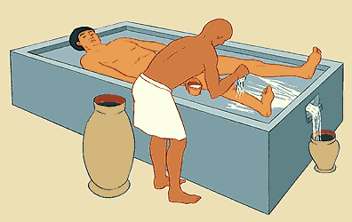
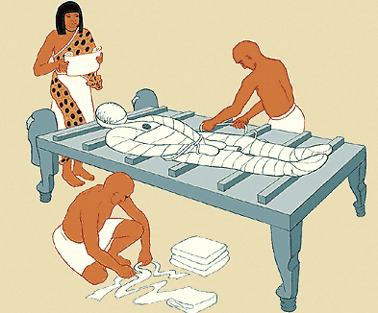

Students can find out more about the embalming, wrapping and burial of the body here
The Clickable Mummy interactive gives students a peak under the wrapping of a mummy.

Egyptian Goddess Bastet
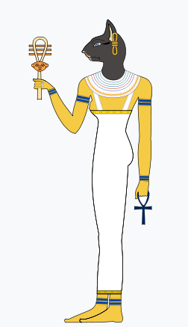
Students will learn more about the Egyptian goddess Bastet who took the form of a cat. Ask them to research the answers to the following questions:

- Who was Bastet?

- Who was Bastet’s father?
- In ancient Egyptian mythology, what powers did Bastet have?

- Why were cats important in ancient Egypt?

- What characteristics do you think a cat goddess would have?

- What was Bastet’s name in Hieroglyphics?

The following videos will help students to learn more about ancient Egypt.

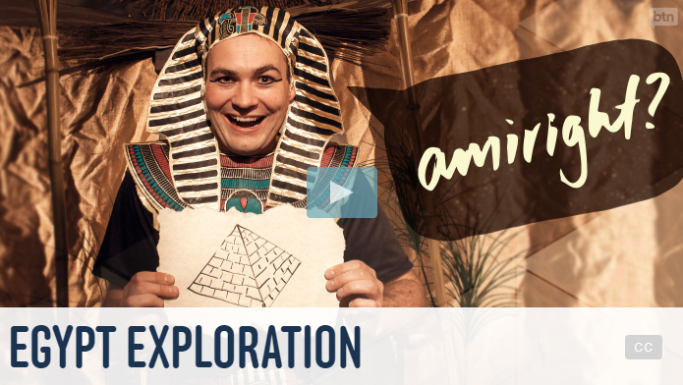  Egypt Exploration video | 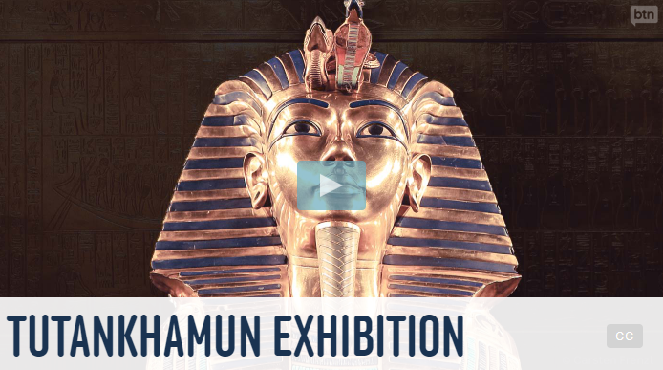  Tutankhamun Exhibition video
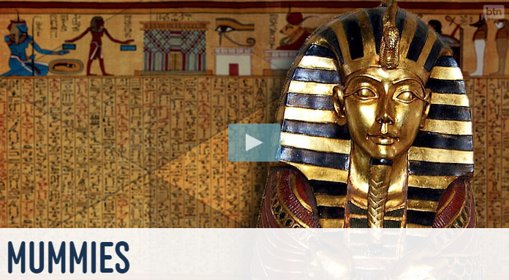  Mummies video | 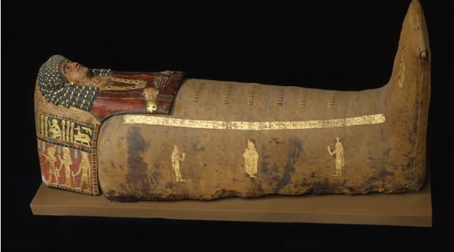  How were Mummies made in Ancient Egypt?


ABC News – Egyptian archaeologist uncover ‘unique’ beetle, cat mummies, sealed Fifth Dynasty tomb
https://www.abc.net.au/news/2018-11-11/egyptian-archaeologists-uncover-cat-mummies-in-newly-discovered/10485974
BTN – Mummies
http://www.abc.net.au/btn/story/s2661729.htm
BTN – Tutankhamun Exhibition
http://www.abc.net.au/btn/story/s4856436.htm
BTN – Egypt Exploration
http://www.abc.net.au/btn/story/s4345716.htm
Akhet – Interactive mummy
http://www.akhet.co.uk/clikmumm.htm
ABC Education – Wonders of Ancient Egypt
http://education.abc.net.au/home#!/digibook/1505264/the-wonders-of-ancient-egypt

Teacher Resource
Egypt Exploration

Students will develop their historical knowledge and understanding of ancient Egypt. Students will identify a range of questions about the past to inform a historical inquiry on ancient Egypt.

History – Year 7
The evidence for the emergence and establishment of ancient societies (including art, iconography, writing tools and pottery)

Key features of ancient societies (farming, trade, social classes, religion, rule of law)

The Mediterranean world
Physical features of ancient Egypt (such as the River Nile) and how they influenced the civilisation that developed there

Roles of key groups in ancient Egyptian society (such as the nobility, bureaucracy, women, slaves), including the influence of law and religion

Significant beliefs, values and practices of the ancient Egyptians, with a particular emphasis on ONE of the following areas: everyday life, warfare, or death and funerary customs

- Summarise the Egypt Exploration story.
- How long ago were the pyramids built?
- Why were the pyramids built?
- What valuable objects were kept inside the pyramids?
- Describe the inside of a pyramid.
- What are researchers using to find out more about the pyramids?
- What are they hoping to discover?
- The great pyramid of Giza is made up of more than ______million blocks.
- Illustrate an aspect of the Egyptian Exploration story.
- What was surprising about this story?

How do we know about the ancient past?
Finding out about the ancient past can be difficult. Some ancient peoples and civilisations have left behind evidence of the past which help us learn about how they lived. But often our knowledge and understanding of the ancient past is incomplete.

How do we know about the ancient past? Brainstorm ideas as a class.
- Scientists make discoveries, like finding ruins which help us understand how people used to live.
- Scientists use new technologies and new methods to investigate ancient structures like the pyramids.
- We can look at artefacts in museums, libraries and art galleries (primary sources).
- We can look at documents, like reports and newspapers, which can be found in the library or on the internet (secondary sources).

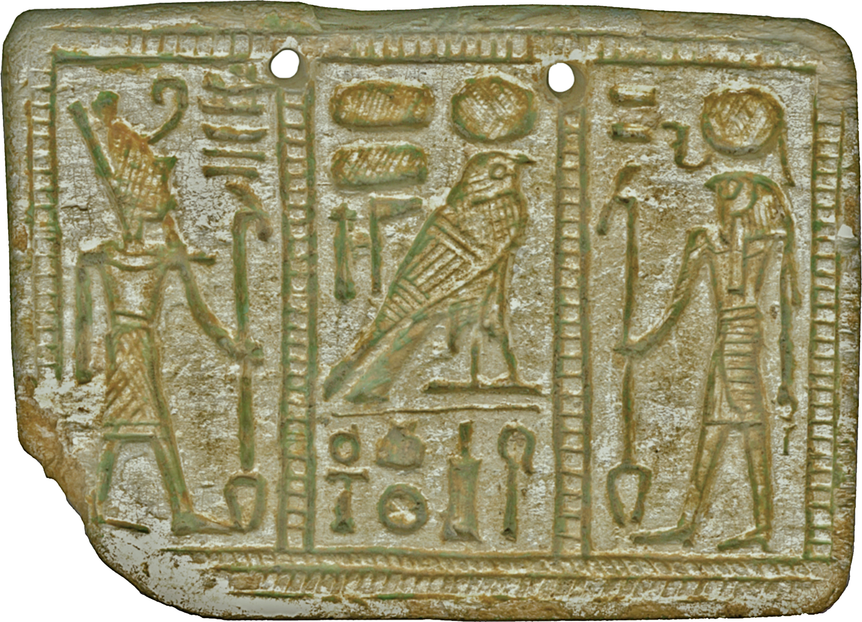
Other than the Great Pyramids of Egypt, think of some examples of evidence or places which help us understand the ancient past. For example:
- Aboriginal rock art in Australia
- Discovery of the remains of Mungo Man at Lake Mungo
- Giant moai statues on Easter Island
- Stonehenge in England


Unlock the mystery of the Egyptian pyramids
The Pyramids of Giza is the only remaining Wonder of the Ancient World. Why do you think the pyramids are listed as one of the seven wonders of the ancient world? Brainstorm in pairs and then share your ideas as a class.
- it is a mystery how they were built
- it has amazing architecture
- it is something that must be seen
- it was built during the ancient times
- it is the oldest and largest of all the pyramids in Egypt

Profile
Create a profile of the Ancient Pyramids of Egypt using a range of sources of information.

The Ancient Pyramids of Egypt
Where is it? Locate using Google Maps
What civilisation built it?
How was it built?
What did it look like when it was built?
What does it look like now?
What was it used for?
Is it damaged? How and why was it damaged?
Should it be conserved?
Picture (photo or sketch)
Now and then.

Historical inquiry – In-depth research

- Begin this activity by developing a glossary of ancient Egypt terms and words. Download the BtN Pyramids story transcript to get your started. Start by brainstorming words as a class using a mind map to record your responses and then find definitions for each word. Consider using pictures and diagrams to illustrate meanings.

Archaeologist | Hieroglyphs | Egyptology | Afterlife
Chamber | Mummy | Great Pyramid of Giza | Pharaoh
Artefact | Nile River | Tomb | Evidence
BCE | era | Excavation | Ancient

- Students will determine a focus for their inquiry into ancient Egypt and develop a key question to guide their historical inquiry (below are some example key questions).

- What does the term “ancient times” mean? Find a definition.
- What is technology? Look at technology invented and used in Egyptian ancient times compared to now. How is it similar or different?
- What inventions (tools and equipment) were used to build the Egyptian pyramids? What evidence do we have?
- How were the pyramids at Giza built (what do historians know/believe)? Is there a definitive answer? Why or why not? Why is it a mystery? Make up an alternative explanation for the building of the pyramids at Giza.

- Students will collect and record information from a wide variety of primary and secondary sources and present the information they find in an interesting way.

- Primary sources – Through using primary sources, that is a document like a diary, paintings or a physical object such as stone tools, that was written or created at a particular time, we can gain an understanding of what might have happened at a place in time.

- Secondary sources – Secondary sources are documents written after an event has occurred, providing “second-hand” accounts of that event, person, or topic. Unlike primary sources, which provide first-hand accounts, secondary sources offer different perspectives, analysis, and conclusions of those accounts.

As part of their research, students will need to:
- Use historical terms and concepts in their presentation and refer to evidence and sources.
- Write down the name of the source of the information.
- Look for facts and opinions that answer their inquiry question/s.
- Write down using their own words facts and opinions from the source.

ABC News – New bid to find hidden chambers, unravel `secrets’ of Egypt’s pyramids
http://www.abc.net.au/news/2015-10-26/experts-in-new-bid-to-unravel-secrets-of-egypt-pyramids/6883862

ABC News – Egypt’s Queen Nefertiti may lie concealed in Tutankhamun's tomb, says archaeologist
http://www.abc.net.au/news/2015-10-01/queen-nefertiti-may-lie-concealed-in-king-tutankhamum-tomb/6821738

Behind the News – Mummies
http://www.abc.net.au/btn/story/s2661729.htm

Akhet – Clickable Mummy
http://www.akhet.co.uk/clikmumm.htm

Ancient Egypt – The Mummification Process
http://www.ancientegypt.co.uk/mummies/story/page2.html

Australian Museum – How were ancient Egyptian mummified?
http://australianmuseum.net.au/how-were-ancient-egyptians-mummified

ABC Education – The Wonders of Ancient Egypt
http://splash.abc.net.au/home#!/digibook/1505264/the-wonders-of-ancient-egypt

BBC History – Egyptians
http://www.bbc.co.uk/history/ancient/egyptians/

Behind the News – Egypt Trouble (resource)
http://www.abc.net.au/btn/resources/teacher/episode/20130806-egypttrouble.pdf

ABC Education – Enigma of the Pyramids
http://splash.abc.net.au/home#!/media/1479393/enigma-of-the-pyramids

Teacher Resource
Tutankhamun Exhibition
Students will develop their historical knowledge and understanding of ancient Egypt. Students will identify a range of questions about the past to inform a historical inquiry on ancient Egypt.

HASS – Year 7
The role of a significant individual in ancient Egyptian, Greek or Roman history.

How historians and archaeologists investigate history, including excavation and archival research.

Key features of ancient societies (farming, trade, social classes, religion, rule of law).

The importance of conserving the remains of the ancient past, including the heritage of Aboriginal and Torres Strait Islander Peoples.

The physical features of ancient Greece, Egypt or Rome and how they influenced the civilisation that developed there.

The significant beliefs, values and practices of ancient Greece, Egypt or Rome, with a particular emphasis on ONE of the following areas: everyday life, warfare, or death and funerary customs.

- Discuss the BTN story as a class. What points were raised in the discussion?
- Finish the following sentence: King Tutankhamun was an Egyptian ____________.
- About how many years ago did King Tut live?
- How old was he when he became king?
- What happened to King Tut’s body when he died?
- Where was the tomb of King Tut found?
- Who discovered the tomb?
- What was surprising about this story?
- Name three facts you learnt watching the BTN story.
- Illustrate an aspect of the BTN story.

Class Discussion
Hold a class duscussion asking the following:
- What do you THINK about what you saw in the Tutankhamun Exhibition story? What does this video make you WONDER?
- Think of three questions you have about the BTN story.
- What did you learn watching the BTN story? Leave your comment on the BTN Tutankhamun Exhibition story page.
- Why is it important to research ancient history?

Glossary of key terms
Students will develop a glossary of historical terms and concepts that relate to ancient Egypt. Below are some key terms and concepts to get you started:

Pharaoh | Tomb | Mummified
Valley of the Kings | Archaeology | Sarcophagus

Students will add definitions to the glossary as they come across unfamiliar words throughout the BTN Tutankhamun Exhibition story. Students will demonstrate their understanding by writing their own sentences using historical terms and concepts from the glossary.

How do we know about the ancient past?
Finding out about the ancient past can be difficult. Some ancient peoples and civilisations have left behind evidence of the past which help us learn about how they lived. But often our knowledge and understanding of the ancient past is incomplete.

How do we know about the ancient past? Brainstorm ideas as a class.
- Scientists make discoveries, like finding ruins or artefacts which help us understand how people used to live.
- Scientists use new technologies and new methods to investigate ancient structures.
- We can look at artefacts in museums, libraries and art galleries (primary sources).
- We can look at documents, like reports and newspapers, which can be found in the library or on the internet (secondary sources).

Students will then complete one or more of the following activities to learn more about the discovery of Tutankhamun’s tomb in Egypt.
- Create a timeline to show significant events in ancient Egypt. Include events like the development of hieroglyphic writing, first pyramid built, first writing on papyrus, mummification first used and King Tut buried in the Valley of the Kings.
- Where is Tutankhamun’s tomb? Find using Google Maps. When and how did archaeologist Howard Carter discover Tutankhamun’s tomb?
- What technologies did scientists use during the discovery of Tutankhamun’s tomb?
- What were scientists able to find out about Tutankhamun by studying his tomb and the artefacts in his tomb?
- Write a news report as if you were covering the discovery of Tutankhamun’s tomb by Howard Carter.
- What do artefacts tell us about ancient history? Choose an artefact from King Tut’s tomb that interests you. Conduct a mini historical investigation to find out more about it.

What objects do you think you would find inside the tomb of a great pharaoh from Egypt? As a class read and discuss the “Top 10 things you might find in a Pharaohs tomb – in pictures”. Students will then respond to the following:
- What important objects were found in King Tutankhamun's tomb? What might this tell us about beliefs and society during Ancient Egyptian times? Learn more about Tutankhamun’s treasures here.
- What things are important to you and your culture? Make a list of important items you would include in your tomb. Give reasons for your choices.
- Design and illustrate your own comic strip explaining your top 10 items.

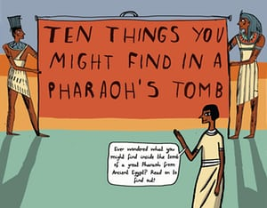 | 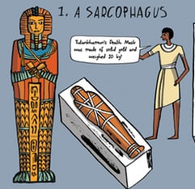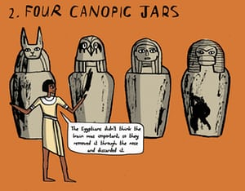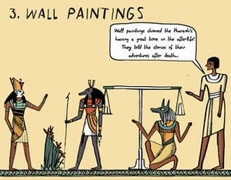
 | 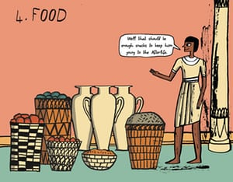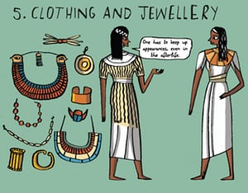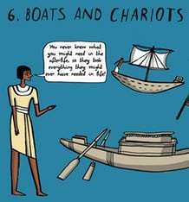

Latin meaning of hieroglyph
As a class, discuss the origin of the word ‘Hieroglyph’. Did you know that the word hieroglyph comes from the Greek hiero ‘holy’ and glypho ‘writing’? In the ancient Egyptian language, hieroglyphs were called medu netjer, ‘the gods’ words’ as it was believed that writing was an invention of the gods.

Deciphering hieroglyphs
Visit an Egyptian exhibit at your local museum, or use the internet to find a photograph of an ancient Egyptian artefact (Example – Australian Museum). You will most likely discover that hieroglyphs can be seen on many ancient Egyptian artefacts. Choose one ancient Egyptian artefact with hieroglyphs and use this document to help decipher the messages you discover.
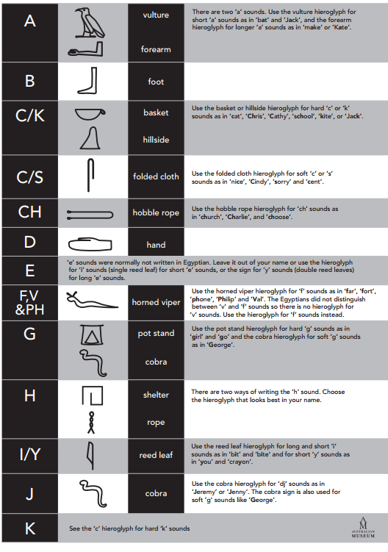  Egyptian hieroglyphs, Australian Museum | 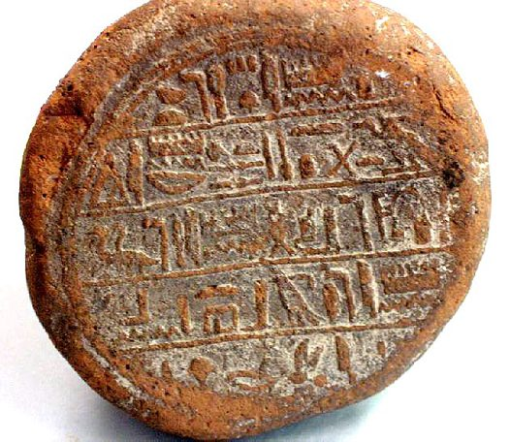  Ancient Egyptian funerary cone, Australian Museum

Using hieroglyphs
Students will use Egyptian hieroglyphs to write their name and then display their artworks around the classroom. Alternatively, students can use Egyptian hieroglyphs to write a secret message, which can then be deciphered by a classmate.

ABC News – Sydney lands King Tutankhamun exhibition before it heads back to Egypt for good
http://www.abc.net.au/news/2018-06-11/king-tutankhamun-treasures-are-sydney-bound/9857448

National Geographic Kids – Tutankhamun Facts
https://www.natgeokids.com/au/discover/history/egypt/tutankhamun-facts/

BTN – Egypt Exploration
http://www.abc.net.au/btn/story/s4345716.htm

Australian Museum – How were ancient Egyptians mummified?
https://australianmuseum.net.au/how-were-ancient-egyptians-mummified

ABC Education – The wonders of Ancient Egypt
http://education.abc.net.au/home#!/digibook/1505264/the-wonders-of-ancient-egypt

BBC – Egyptians
http://www.bbc.co.uk/history/ancient/egyptians/

