

History of Portraits
- Before watching the BTN story, record what know about portraits.
- What is the name of Australia’s portrait competition?
- The most famous painting in the world is a portrait. True or false?
- Retell the story of how portraiture first began.
- During what century did portraiture become popular?
- What does the word ‘portrait’ mean?
- Name a well-known artist during the Renaissance period.
- How did portraiture change when photography was invented?
- Can a selfie also be called a self-portrait?
- What did you learn watching the BTN History of Portraits story?

Songwriting with Paul Kelly
- Retell the BTN Songwriting with Paul Kelly story using your own words.
- How old is Jasmin?
- How old was Jasmin when she first started playing the guitar?
- Where did Jasmin get the inspiration to write her first song?
- How old was Paul Kelly when he first started writing songs?
- How did Paul Kelly feel when he heard his song on the radio for the first time?
- Where does Paul Kelly get his ideas for songs from?
- Who is Paul Kelly’s favourite writer?
- Which of these isn’t a Paul Kelly Song?
  - From Little Things Big Things Grow
  - How to Make Gravy
  - My Happiness
- What did you like about the BTN story?

Spinifex Gum
- Briefly summarise the BTN Spinifex Gum Choir story.
- Where in Australia is the choir from? Find using Google Maps.
- What musicians are working with the choir?
  - Cat Stevens
  - Cat Empire
  - Stray Cats
- What issues does the choir sing about?
- Where has the choir performed?
- What is the purpose of their song ‘Dream Baby Dream’?
- How did the story make you feel? Discuss in pairs.
- What questions would you like to ask the singers in the choir?

Beatboxing
- Briefly summarise the BTN Beatboxing story.
- Why is the beatboxing performance called Frankenstein?
- Where are the performers in the BTN story from? Find using Google Maps.
- Complete the following sentence. The Beat Box Academy started ___ years ago.
- What decade did beatboxing start?
  - 1970s
  - 1980s
  - 1990s
- What is beatboxing?
- How did beatboxing begin?
- What do the kids in the story like about beatboxing?
- Describe beatboxing using 3 words.
- What did you like about this story?

Teacher Resource
History of Portraits



Students will explore the history of portraiture. They will explore their own identity through discussion, writing and art. Students will create a self-portrait and hold a class exhibition.

Visual Arts – Years 3 & 4
Explore ideas and artworks from different cultures and times, including artwork by Aboriginal and Torres Strait Islander artists, to use as inspiration for their own representations.

Use materials, techniques and processes to explore visual conventions when making artworks.

Visual Arts – Years 5 & 6
Explore ideas and practices used by artists, including practices of Aboriginal and Torres Strait Islander artists, to represent different views, beliefs and opinions.

Develop and apply techniques and processes when making their artworks.

Plan the display of artworks to enhance their meaning for an audience.

Visual Arts – Years 7 & 8
Experiment with visual arts conventions and techniques, including exploration of techniques used by Aboriginal and Torres Strait Islander artists, to represent a theme, concept or idea in their artwork.

Present artwork demonstrating consideration of how the artwork is displayed to enhance the artist’s intention to an audience.

- Before watching the BTN story, discuss in pairs what you already know about portraits.
- What is the name of Australia’s portrait competition?
- The most famous painting in the world is a portrait. True or false?
- Retell the story of how portraiture first began.
- During what century did portraiture become popular?
- What does the word ‘portrait’ mean?
- Name a well-known artist during the Renaissance period.
- How did portraiture change when photography was invented?
- Can a selfie also be called a self-portrait?
- What did you learn watching the BTN History of Portraits story?


Class Discussion
Before watching the BTN History of Portraits story, ask students what they already know about portraits. Here are some discussion starters:


- What is a portrait? What is a self-portrait?
- Why do we create portraits?
- Where can you see portraits?
- What do portraits tell us about a person?
- What makes a portrait interesting?
- What is the difference between a selfie and a self-portrait? What are the similarities?

Mind map
Ask students to think of words they associate with the word portrait. Record students’ ideas on a mind map with the word PORTRAIT in the middle. Below are some suggested words.

Background | Colour | Composition | Contemporary
Expression | Focus | Foreground | Form
Gesture | Identity | Individuality | Objects
Portraiture | Pose or posture | Profile | Self-portrait
Shape | Style | Technique | Texture

Ask students to clarify their understanding of the key words by writing down what they think the word means. Swap definitions with a partner and ask them to add to or change the definition. Check them using a dictionary or other source.

KWLH
Watch the BTN History of Portraits story and discuss as a class. What questions were raised in the discussion and what are the gaps in their knowledge. The following KWLH organiser provides students with a framework to explore their knowledge on this topic and consider what they would like to know and learn.

What do I know? | What do I want to know? | What have I learnt? | How will I find out?

Students will develop their own question/s for inquiry, collecting and recording information from a wide variety of sources. Students may develop their own question for inquiry or select one or more of the questions below.

- How has portraiture changed over history? Compare the beginnings of portraiture to modern portraiture that you see now. Illustrate using a timeline.
- How did painters like Vincent Van Gogh and Paul Gaugin challenge traditional portraiture?
- What different techniques can be used to create portraits? Give examples.
- How is the medium used in a portrait important in portraying someone’s identity?
- What do portraits tell us about a person? Give examples.

Exploration
Students will choose a well-known portrait or self-portrait (it may be a sculpture, painting, drawing, mixed medium, photograph or film). Students will respond to the questions below to help guide their exploration. Students will then create their own portrait inspired by the artist’s style and technique. Below is a range of well-known portraits/self-portraits your students may be interested in exploring further.

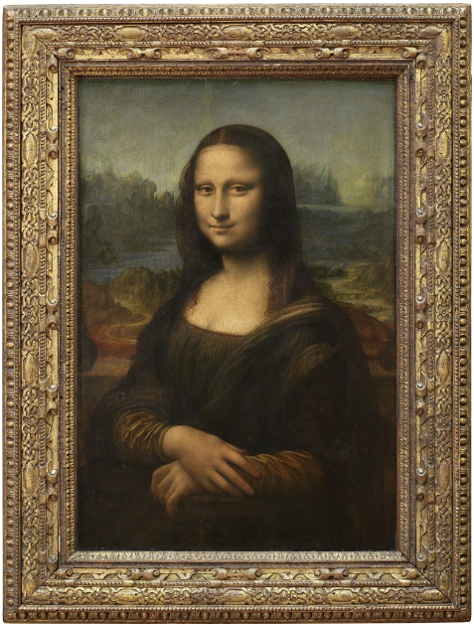  Mona Lisa Leonardo Da Vinci 1503-06 | 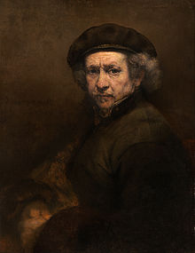  Self-Portrait Rembrant Harmenszoon van Rijn 1659 | 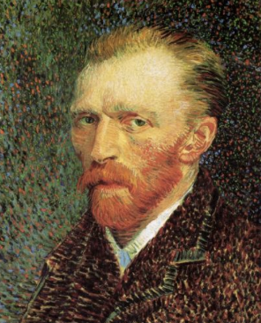  Self-Portrait Vincent Van Gogh 1887
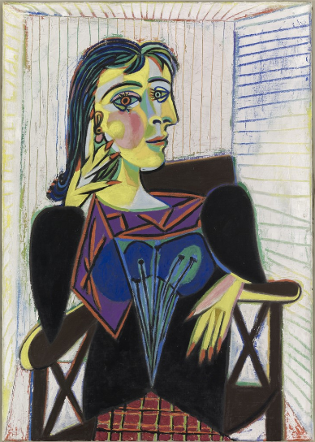  Portrait de Dora Maar Pablo Picasso 1937 | 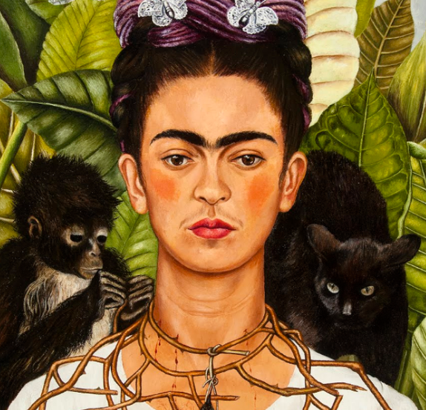  Self-Portrait with Thorn Necklace and Hummingbird Frida Kahlo 1940 | 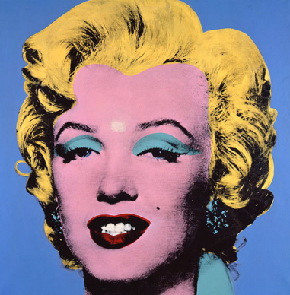  Marilyn Monroe Andy Warhol 1967

Questions to help guide students’ exploration:
- Record as much information as you can about the portrait/self-portrait in 15 minutes. Record everything you see. The longer you look the more you will see. Consider looking at it from different angles, up close and far away.
- Who do you think the portrait is of? What can you tell about their personality? What are they doing? Where are they from? Describe their facial expression and posture.
- Is it a painting, print, sculpture or another type of artwork? What materials were used to make it?
- Do you notice any background objects in the portrait? How do these objects represent the subject’s identity or individuality?
- How does the portrait make you feel? What do you like about this portrait/self-portrait? Why did you choose it?

Who are you?
Who are you? Students will reflect on this question and explore their own identity through discussion, writing and art. Students will brainstorm and record how they see themselves, responding to the following reflective questions. Students will then take the information they have learnt about themselves and create a self-portrait.

- Who are you? (How do you see yourself?)
- What words best describe you?
- What are some objects, events, people or occasions that are important to you?
- What are you really passionate about?
- What are your most important values?
- What do you think is unique and special about you?
- What are your strengths?
- What are your challenges?
- How are you similar/different to other people? How do you feel about your differences?
- When do you feel most like yourself?
- How do you want people to see you?
- Why is it so important to be yourself?

Create a self-portrait
Students will create a self-portrait which represents how they see themselves on the inside. Looking at a mirror, students will experiment with poses, costumes and props and produce a self-portrait. Initially students can do some quick, detailed sketches of different features and then use these sketches to help create a final self-portrait. Students will write an artist's statement to go with it. Curate a class exhibition of your students’ self-portraits and choose a title for the exhibition.

Below are some guidelines for students as they create their own self-portrait:
- Use colours that you feel reflect your mood or feelings.
- What style will you use to create your self-portrait? How will it help portray your identity?
- Where are you going to sit? Think about the background of your self-portrait. Is it real or imaginary?


BTN – Young Archie 2018
http://www.abc.net.au/btn/story/s4841038.htm

BTN – Archibald Prize
http://www.abc.net.au/btn/story/s2508253.htm

Art Gallery NSW – Young Archie 2018
https://www.artgallery.nsw.gov.au/prizes/young-archie/2018/

Art Gallery NSW – Archibald Prize
https://www.artgallery.nsw.gov.au/prizes/archibald/

National Portrait Gallery
https://www.portrait.gov.au/

Teacher Resource
Beatboxing

Students will explore what beatboxing is and learn the three basic sounds of beatboxing.

Music – Years 3 & 4
Develop aural skills by exploring, imitating and recognising elements of music including dynamics, pitch and rhythm patterns.

Practise singing, playing instruments and improvising music, using elements of music including rhythm, pitch, dynamics and form in a range of pieces, including in music from the local community.

Music – Years 5 & 6
Explore dynamics and expression, using aural skills to identify and perform rhythm and pitch patterns.

- Briefly summarise the BTN Beatboxing story.
- Why is the beatboxing performance called Frankenstein?
- Where are the performers in the BTN story from? Find using Google Maps.
- Complete the following sentence. The Beat Box Academy started ___ years ago.
- What decade did beatboxing start?
  - 1970s
  - 1980s
  - 1990s
- What is beatboxing?
- How did beatboxing begin?
- What do the kids in the story like about beatboxing?
- Describe beatboxing using 3 words.
- What did you like about this story?
What do you see, think and wonder?
After watching the BTN Beatboxing story, students will respond to the following questions:

- What did you SEE in this video?
- What do you THINK about what you saw in this video?
- What did you LEARN from this story?
- What was SURPRISING about this story?
- What QUESTIONS do you have about this story?
Learning to beatbox
Students will be exploring what beatboxing is and learn to make the three basic sounds of beat boxing. Begin with a brainstorm asking students to write down what they know about beatboxing then record any questions they have or information they would like to know more about.
Ask students to research the following:
- What is human beatboxing? Write a short description.
- Investigate the history of beatboxing. Who were some of the pioneers of beat boxing?
- Where did the term beatboxing come from?
- Beatboxing is mainly associated with hip hop and is often referred to as the 5th element of hip hop. What are the other elements of hip hop?
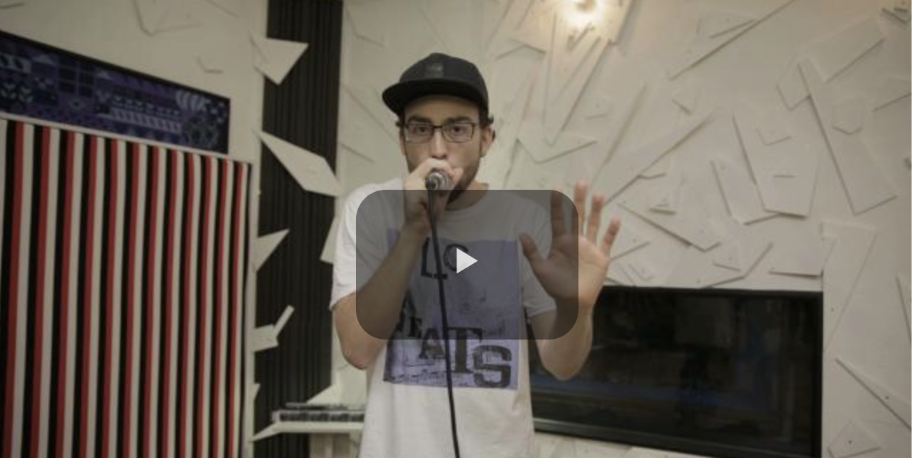
Students can learn how to perform three basic beatboxing sounds: a kick drum, a hi-hat and a snare. Watch this ABC Education video to find out more.
When students have practised making the basic sounds, they can have a go at combining the sounds into a simple 8-beat rhythm.
Start slowly and build up speed later.
If students feel confident, they can record their beatboxing (either video or audio).

Watch the BTN Beatbox video to find out more about beatboxer Tom Thum then answer the following questions:
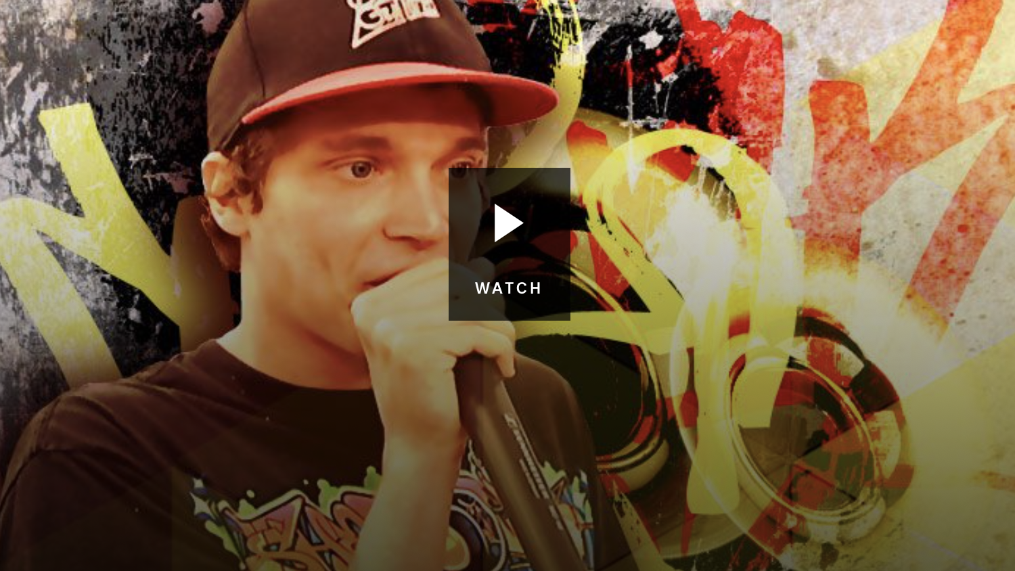
- In which decade did beatboxing become popular?
- In your own words, describe what beatboxing is.
- What does Tom Thum use loop machines for?
- What instrument sounds did you hear Tom Thum make?
- What did he teach the kids at the school he visited?
- What advice did Tom give to people interested in becoming a beatboxer?
- What skills do you think beatboxers need?
- Finish the following sentence: `Tom says being a good beatboxer means…’
- Teach yourself one of the sounds Tom teaches to the students. Explain how easy or difficult it was to make the sound.
Beatbox – BTN
https://www.abc.net.au/btn/classroom/beat-box/10532996
Learn to Beatbox – ABC Education
https://education.abc.net.au/home#!/media/2641928/learn-to-beatbox-.htm

