
KEY LEARNING
Students will view a range of BTN stories and use comprehension skills to respond to a series of focus questions.

CURRICULUM
English – Year 4
Use comprehension strategies to build literal and inferred meaning to expand content knowledge, integrating and linking ideas and analysing and evaluating texts.

English – Year 5
Use comprehension strategies to analyse information, integrating and linking ideas from a variety of print and digital sources.

English – Year 6
Use comprehension strategies to interpret and analyse information and ideas, comparing content from a variety of textual sources including media and digital texts.

English – Year 7
Use comprehension strategies to interpret, analyse and synthesise ideas and information, critiquing ideas and issues from a variety of textual sources.
  - Teacher Resource

Focus Questions

Native Title
- What was the main point of the Native Title story?
- When is Mabo Day?
- Why is it known as Mabo Day?
- What is Mabo Day the anniversary of?
- Where are the Torres Strait Islands in relation to Australia? Locate using Google maps.
- Dwayne says ‘We have a strong connection to the land. It gives us life’. Explain why land is so important to Aboriginal and Torres Strait Islander people.
- What does Terra Nullius mean?
- What effect did European settlement have on Aboriginal and Torres Strait Islander people?
- How long have Aboriginal and Torres Strait Islander people lived in Australia?
- When was Australia first settled by the British?

Indigenous Place Names
- Summarise the BTN Indigenous Place Names story.
- Newcastle was named after a coal port in which country?
  - England
  - Scotland
  - Ireland
- How did the Flinders Ranges get its name?
- What place got its name from the Dharawal word woolyungah, which means five islands?
- Where does the name Canberra come from and what does it mean?
- What iconic landmark became the first in the Northern Territory to get two official names?
- Which Australian city is considering renaming many of its landmarks?
- What do they want to rename Franklin square as?
- Complete this sentence. The council says it would be a great step towards ______________.
- Find out more about your town’s name.

Welcome to Country
- Retell the BTN Welcome to Country story to another student.
- What is the language of Tiyana’s family and people?
- What is a Welcome to Country?
- Complete the following sentence. When Indigenous people cross into another groups country they would need to request ____________.
- Describe how Tiyana does a Welcome to Country.
- What does Tiyana wear during a Welcome to Country?
- What is an Acknowledgement of Country?
- How does Tiyana feel when she performs a Welcome to Country?
- Have you ever seen a Welcome to Country ceremony? Describe the ceremony in your own words.
- How do you say welcome in the Indigenous language local to your area?

KEY LEARNING
Students will learn about Eddie Mabo and create a biography about him.
CURRICULUM
History – Year 3
Days and weeks celebrated or commemorated in Australia (including Australia Day, Anzac Day, and National Sorry Day) and the importance of symbols and emblems.

The importance of Country/Place to Aboriginal and/or Torres Strait Islander Peoples who belong to a local area.

Civics & Citizenship – Year 4
The differences between ‘rules’ and ‘laws’, why laws are important and how they affect the lives of people, including experiences of Aboriginal and Torres Strait Islander Peoples.

History - Year 6
Experiences of Australian democracy and citizenship, including the status and rights of Aboriginal and Torres Strait Islander Peoples, migrants, women and children.

  - Teacher Resource

Native Title

Focus Questions
Discuss the BTN story as a class and record the main points of the discussion. Students will then respond to the following:

- What was the main point of the Land Rights story?
- When is Mabo Day?
- Why is it known as Mabo Day?
- What is Mabo Day the anniversary of?
- Where are the Torres Strait Islands in relation to Australia? Locate using Google maps.
- Dwayne says ‘We have a strong connection to the land. It gives us life’. Explain why land is so important to Aboriginal and Torres Strait Islander people.
- What does Terra Nullius mean?
- What effect did white settlement have on Aboriginal and Torres Strait Islander people?
- How long have Aboriginal and Torres Strait Islander people lived in Australia?
- When was Australia first settled by the British?

Activity: Class Discussion
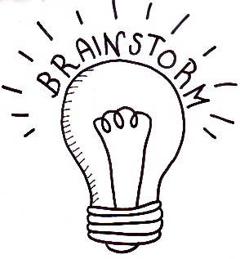
After watching the BTN Native Title story hold a class discussion. Here are some discussion starters:
- Who was Eddie Mabo?
- Where was Eddie Mabo from?
- What is native title?
- Why was the Mabo decision important?
- What was Eddie Mabo fighting for?

Activity: Glossary
Students will brainstorm a list of key words that relate to the BTN Native Title story. Below are some words to get them started.
NATIVE TITLE | EUROPEAN SETTLERS | TERRA NULLIUS
MABO DAY | TORRES STRAIT ISLANDS | EDDIE MABO

Activity: Murray Island
Using Google Maps find Murray Island (known by the local Torres Strait Islanders as Mer Island) in the Torres Strait region and display in your classroom. As a class look at the features of Murray Island and compare these to Eddie Mabo‘s drawings.
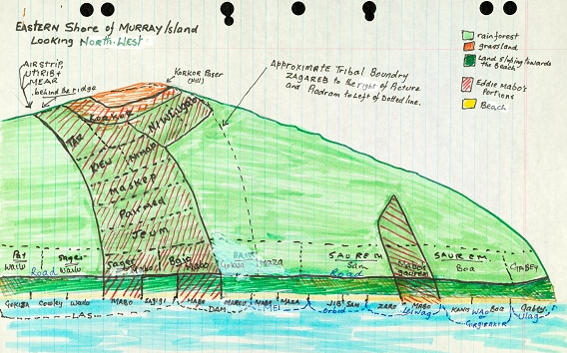
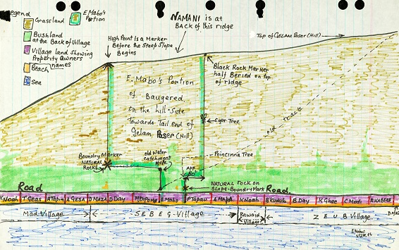

Students will learn more about Murray Island choosing 1 or 2 of the following questions to research.
- Where is Murray Island located?
- What is the land size of Murray Island?
- Describe the landscape of the island. Refer to the legend on Eddie Mabo’s maps to identify rainforest, grassland and beach areas.
- What language do the people of Murray Island speak?
- Draw the Torres Strait Island flag. What do the flags symbols and colours represent?

Ask students to draw a map of Northern Australia including the Torres Strait region and the Papua New Guinea mainland. Mark, name and colour Murray Island and at least two other islands in the same area.

- On their maps students will use geographical terminology and include the following:
  - Border
  - Title
  - Identify scale
  - Orientation; identify direction
  - Identify physical features
  - Legend (key)

Activity: Eddie Mabo Biography
Before students begin to construct their biographies, hold a class discussion to find out what they already know about biographical writing. Below are some discussion starters:

- What does a biography tell us about a person?
- Where can you look to find information for your biographical writing? It could include the internet, newspaper articles, magazine articles and interviews, other biographies, historical books or television interviews. Why is it important to use more than one source of information?
- What makes a biography interesting? For example, key information and facts, a timeline of events, photographs, illustrations and quotes.

Using the biography worksheet at the end of this activity, students will find and record information about Eddie Mabo. Some possible areas of research include:

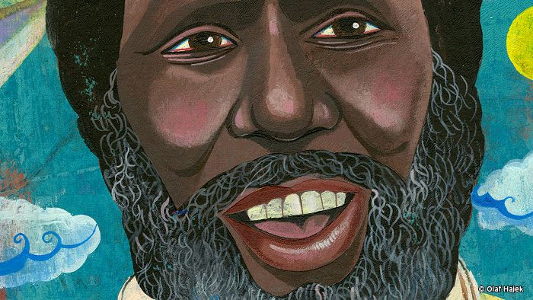
- Where was Eddie Mabo from? Locate using Google Maps.
- When was he born? Describe his family life growing up.
- What were some of Eddie Mabo’s achievements? Choose one to explore in more detail.
- How do we recognise his achievements?
- What were some of the challenges he faced?
- How has Eddie Mabo made an impact on people’s lives?
- What do you admire about Eddie Mabo?

Further investigation
- Imagine you could sit down and talk to Eddie Mabo. What questions would you ask about his life and achievements?
- Create a portrait of Eddie Mabo. Explore and experiment with different techniques and media to produce a portrait.

Useful Websites
- Mabo Day - BTN
- Native Title – Australian Museum
- Reconciliation Australia – Eddie Koiki Mabo


Biography – Eddie Mabo

Born
Full name

Family

Portrait of Eddie

Interesting things about Eddie…
Important contributions Eddie made…

Eddie’s achievements

KEY LEARNING
Students will learn more about Welcome to Country ceremonies and the traditional custodians of the land where students live.

CURRICULUM
History – Year 3
The importance of Country/Place to Aboriginal and/or Torres Strait Islander Peoples who belong to a local area.

History - Year 6
Experiences of Australian democracy and citizenship, including the status and rights of Aboriginal and Torres Strait Islander Peoples, migrants, women and children.

  - Teacher Resource

Welcome to Country

Focus Questions
Discuss the BTN story as a class and record the main points of the discussion. Students will then respond to the following:
- Retell the BTN Welcome to Country story to another student.
- What is the language of Tiyana’s family and people?
- What is a Welcome to Country?
- Complete the following sentence. When Indigenous people cross into another groups country they would need to request ____________.
- Describe how Tiyana does a Welcome to Country.
- What does Tiyana wear during a Welcome to Country?
- What is an Acknowledgement of Country?
- How does Tiyana feel when she performs a Welcome to Country?
- Have you ever seen a Welcome to Country ceremony? Describe the ceremony in your own words.
- How do you say welcome in the Indigenous language local to your area?

Activity: See, think and wonder
After watching the BTN Welcome to Country story hold a class discussion, using the following as discussion starters:
- What do you THINK about what you saw in the BTN Welcome to Country story?
- What does this video make you WONDER?
- Think of three QUESTIONS you have about the story.
- What did you LEARN from the BTN story?

Activity: Local Indigenous Languages
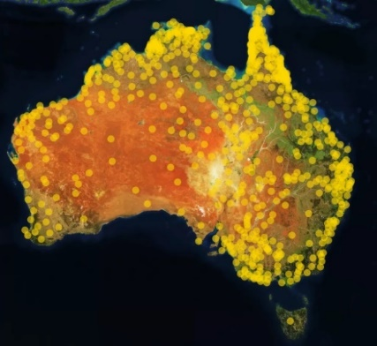
Who are the traditional custodians of the land where you live and what languages do they speak?
Students will learn more about their local Indigenous languages by exploring the Gambay – First Languages Map. Enter the place they live to find out the Indigenous languages in their area. Many of the Indigenous languages have videos or resources to support students to learn more about the language.
Learn words in your local Indigenous language! The 50 Words Project provides words in Indigenous languages. Use the map to search the local language and learn 50 words. All words have audio recordings provided by language speakers.
Further Learning
Invite an Indigenous language speaker to your school to learn more about the local languages.

Activity: Learn First Languages through song

The Marrin Gamu song was created to introduce people to the diversity of Australia’s first languages. The song incorporates words from several different Indigenous language groups within Australia. Follow the instructions to get involved in creating and sharing your song.
- Watch the song and translate it into your local Indigenous language.
- Learn the song in your local language.
- Record a film clip of your song.
- Upload the video.

Activity: Learning our First Words on Country

Listen to the diverse languages, stories and Countries of Indigenous Australia in these Little Yarns audio resources. Teachers can check out the educators notes for ideas to get the most out of the Little Yarns podcast series.

Activity: This Place
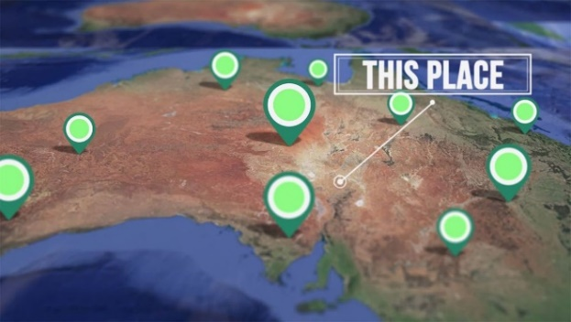
Around Australia, many places are known by their Aboriginal and Torres Strait Islander names. Indigenous communities share the stories behind place names of their country in the This Place series. Do you know the meaning of the place names where you live?

Students can explore the place names where they live using the Gambay interactive map.
Check out ABC Education’s English resources that explore Aboriginal and Torres Strait Islander culture. Learn about language conventions while discovering various Australian Indigenous languages and cultures.

Activity: Recognise and Celebrate Indigenous Culture
Discuss with students, ways they could recognise and celebrate Aboriginal and Torres Strait Islander culture in their class or school. Some ideas are:
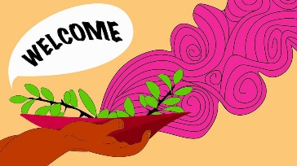
Have you held a Welcome to or Acknowledgement of Country at your school? Find out what the difference is between the two and why they are important in showing respect to and understanding First Nations people. Visit Reconciliation Australia for more info. Read this ABC article to find out why an Acknowledgement of Country is important (and advice on how to give one).

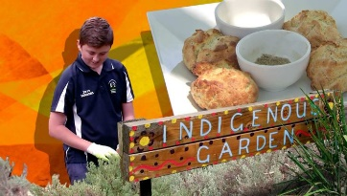
Create a bush food trail/indigenous garden in your school. Find out if you have an indigenous food trail near your school that you could visit for inspiration and to learn about indigenous plants local to your area. Meet some kids in BTN’s Bush Tucker Garden story to learn about growing traditional Aussie foods and cooking them as well.

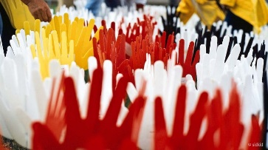
Create a remembrance wall for the Anniversary of the National Apology. Use words to represent feelings, memories or write messages of commemoration for the Stolen Generations. Your artwork could be done in conjunction with an Indigenous artist in residence. Watch this BTN Apology 10th Anniversary story to learn more.

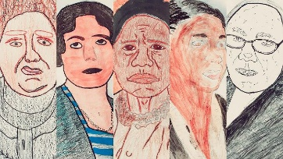
Celebrate Aboriginal and Torres Strait Islander women who've made a difference and inspired others. Choose an Indigenous woman who inspires you and research in more detail. Share your findings with the class. Watch this BTN NAIDOC Indigenous Women story to learn more.

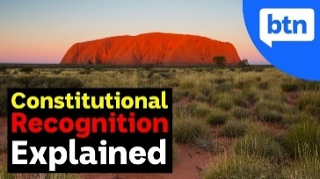
Recognition can make you feel valued, respected and that you belong. What does recognition mean to you? Create a presentation explaining what it means to you to be ‘recognised’. Constitutional recognition is something a lot of Indigenous people in Australia have been campaigning for, for a long time. But what exactly is it and why is it such a big deal? Watch BTN’s Explainer on Constitutional Recognition to learn more.


Learn more about the dreaming trails in your local area. Use the internet to find out if there are any dreaming trails in your area that explain the creation theories of the traditional owners of the land. Meet Rookie Reporter Tyrone in this BTN story to tell you what the river means to his people - the Ngarrindjeri.

Useful Websites
- Welcome to and Acknowledgement of Country – Reconciliation Australia
- Gambay – First Languages Map - First Languages Australia
- 50 Words Project – University of Melbourne
- Little Yarns – ABC Listen
- Marrin Gamu – First Languages Song

