EPISODE 2
14th February 2023

KEY LEARNING
Students will view a range of BTN stories and use comprehension skills to respond to a series of focus questions.

CURRICULUM
English – Year 4
Use comprehension strategies to build literal and inferred meaning to expand content knowledge, integrating and linking ideas and analysing and evaluating texts.

English – Year 5
Use comprehension strategies to analyse information, integrating and linking ideas from a variety of print and digital sources.

English – Year 6
Use comprehension strategies to interpret and analyse information and ideas, comparing content from a variety of textual sources including media and digital texts.

English – Year 7
Use comprehension strategies to interpret, analyse and synthesise ideas and information, critiquing ideas and issues from a variety of textual sources.

PLEASE NOTE: Talking about the earthquakes may be upsetting for some children and may cause some discomfort, distress and/or anxiety. BTN has a short video about the Important Things to Remember about Upsetting News.

  - Teacher Resource

Focus Questions
As a class, discuss the stories featured in the episode of BTN Classroom and record the main points of the discussion. Students will then respond to the following focus questions.

Türkiye and Syria Earthquakes
- Find the town of Gaziantep, Türkiye on a world map.
- What countries neighbouring Türkiye felt the earthquakes?
- What are tectonic plates?
- What impact have the earthquakes had on Türkiye?
- How did this story make you feel. Discuss as a class.

Voice to Parliament
- Where did Indigenous delegates meet in 2017 to talk about a way to change Australia's constitution so it reflects the original owners of this country?
  - Cave Hill
  - Garma Festival
  - Uluru
- What is the Indigenous Voice to Parliament?
- What has Prime Minister, Anthony Albanese, promised to hold later this year in relation to the Voice to Parliament?
- Complete the following sentence. A referendum is needed if you want to change Australia’s __________.
- What do you need for a successful referendum?

Egyptian Mummy Recipe
- Where is Cairo, Egypt? Find on a world map.
- Why were pharaohs mummified in ancient Egypt?
- What is natron and how was it used in the mummification process?
- What parts of the body were placed in jars during the mummification process?
- What ingredients did scientists discover were used during mummification? Give 1 or 2 examples.

Check out the teacher resource on the Archives page.

Jupiter Profile
- How many moons does Jupiter have?
  - 72
  - 82
  - 92
- Astrophysicists try to answer big questions like…
- How does the size of Jupiter compare to Earth?
- Name three facts you learnt about Jupiter.
- What questions do you have about the story?

Check out the teacher resource on the Archives page.

Super Bowl Ads
- What is the Super Bowl?
- How many people watch the Super Bowl on TV?
- How much does a 30 second Super Bowl advertisement cost?
- Why do businesses advertise during the Super Bowl?
- What ads featured in the 2023 Super Bowl?

EPISODE 2
14th February 2023

KEY LEARNING
Students will explore the process of mummification and learn why it was important in ancient Egypt.

CURRICULUM
HASS – Year 3-4
Pose questions to investigate people, events, places and issues.

HASS – Year 5-6
Develop appropriate questions to guide an inquiry about people, events, developments, places, systems and challenges.

HASS – Year 7
The methods and sources used to investigate at least ONE historical controversy or mystery that has challenged historians or archaeologists, such as in the analysis of unidentified human remains.

The significant beliefs, values and practices of ancient Greece, Egypt or Rome, with a particular emphasis on ONE of the following areas: everyday life, warfare, or death and funerary customs.

Key features of ancient societies (farming, trade, social classes, religion, rule of law).

The evidence for the emergence and establishment of ancient societies (including art, iconography, writing tools and pottery).

The role of a significant individual in ancient Egyptian, Greek or Roman history.
  - Teacher Resource

Egyptian Mummy Recipe

Focus Questions
Discuss the BTN story as a class and record the main points of the discussion. Students will then respond to the following:
- Where is Cairo, Egypt? Find on a world map.
- Why were pharaohs mummified in ancient Egypt?
- What is natron and how was it used in the mummification process?
- What parts of the body were placed in jars during the mummification process?
- What ingredients did scientists discover were used during mummification? Give 1 or 2 examples.

Activity: Class Discussion
Discuss the BTN Egyptian Mummy Recipe story as a class. Ask students what they learnt about mummification and ancient Egypt, recording their responses on a mind map. In small groups, ask students to brainstorm responses to the following questions:
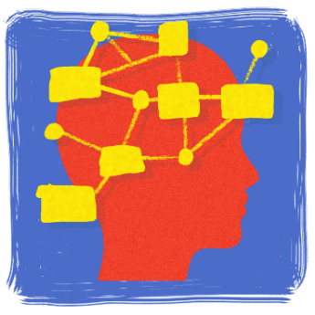
- What did you learn?
- What was surprising about the story?
- What do you wonder?
- What questions do you have about the BTN story?

Activity: Questions and Answers
All scientific discoveries start with a question! As a class, come up with some questions you think scientists ask and solve in relation to the ancient past and how people lived. As a class, make a list of questions that you would like to ask an Egyptologist. Organise the questions into common themes. Use the internet to find answers to your class questions.
What questions do you have?

Activity: Glossary
Students will brainstorm a list of key words that relate to the BTN Egyptian Mummy Recipe story. Here are some words to get them started.

PHAROAH | AFTERLIFE | MUMMIFICATION
EGYPTOLOGIST | SARCOPHAGUS | TOMB

Ask students to write what they think is the meaning of each word (including unfamiliar words). They will swap definitions with a partner and ask them to add to or change the definition. Check these against the dictionary definition.

Further activities for students:
- Visit the Australian Museum for a glossary on ancient Egyptian terms. Choose some words to add to and enhance your classroom glossary on ancient Egypt.
- Learn more about the process of mummification including embalming, wrapping and burial of the body here. What were the following items used for in the embalming and wrapping process: palm wine, natron, linen, canopic jars, amulet, and papyrus scroll.
- Find out if your local museum has an ancient Egyptian collection and plan a visit to learn more mummification and the afterlife. Alternatively, find a virtual museum like this 360 museum tour, to visit and explore ancient Egypt from your classroom.

Activity: Explore a mystery
After watching the BTN Egyptian Mummy Recipe story ask students to think about what they found interesting, or what they are curious about. In pairs, students will work together to try and uncover more about the mystery of mummification in ancient Egypt.

Students can use the steps below to guide them as they uncover the mystery of mummification. Alternatively, students can choose another mystery of ancient Egypt that interests them.
- What are you curious about? Write down all the questions you have about the mystery.
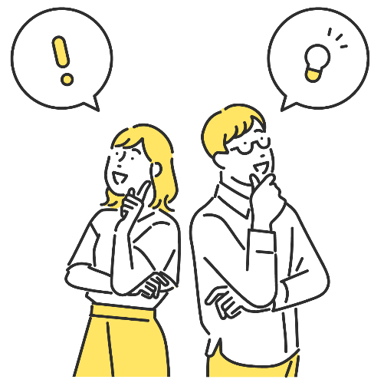
- Do as much research as you can to help answer some of your questions. ‘Visit’ a range of different places during your research phase, collecting as many clues as you can along the way. Possible places for research could include the library, a museum (real or virtual), or the internet.
- Choose 1 or 2 significant pieces of evidence that you have collected during your research. Try and choose one primary source and one secondary source of information. Write a summary about each piece of information which answers the 5 W’s – Who, What, Where, When and Why?
- Consider interviewing an expert to learn more and take your research further.

Activity: Further Investigation
Individually or in small groups, students will choose one of the following projects to work on and then present their findings to the class.

Experiment
Experiment with the process of mummification in your classroom by mummifying an orange. Use these step-by-step instructions. Predict what you think will happen.

True or False?
Create a true or false quiz about mummification in ancient Egypt and test your classmates. Alternatively, create a word find or crossword.

Instructions
Explore the process of mummification in ancient Egypt. Write your own instructions which include the embalming, wrapping and burial process. Include as many words as you can from this glossary of ancient Egyptian terms.
Design
Explore the amulets found in the tombs of ancient Egyptian pharaohs. What did they mean? Design and make your own amulet. What does the shape and colour of your amulet symbolise?

Activity: Pharoah profile
Students will research and write a profile about an ancient Egyptian pharaoh. Students can use the biography worksheet at the end of this activity to record their findings. Encourage students to use a range of sources to find their information.

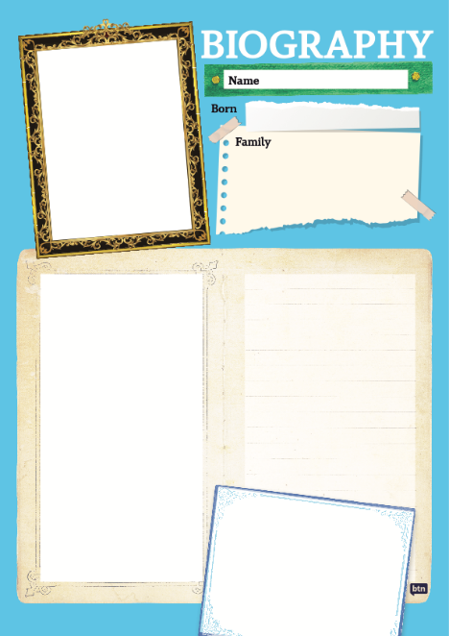
Students will choose an ancient Egyptian pharaoh to research and create a biography.
- Pharaoh’s name
- How is the pharaoh depicted in Egyptian art? Include an illustration.
- When were they born and when did they die?
- When did they reign?
- What were some of their achievements?
- Where is their tomb (if it has been found)? What was found in their tomb? Describe.
- Interesting facts

Useful Websites
- Ancient Egypt Special – BTN
- Ancient Egypt: Ingredients used to embalm mummies identified – Newsround
- Ancient Egyptian Discovery – BTN
- Investigating Ancient Egypt – ABC Education
- How were ancient Egyptians mummified? – Australian Museum
- Investigating Ancient Egypt – ABC Education

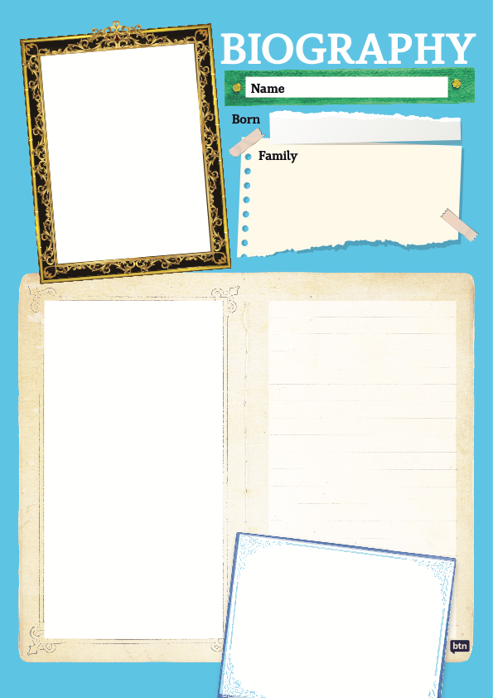

EPISODE 2
14th February 2023

KEY LEARNING
Students will learn more about Jupiter and create a profile of the planet.

CURRICULUM
Science – Year 5
The Earth is part of a system of planets orbiting around a star (the sun).

Scientific knowledge is used to solve problems and inform personal and community decisions.

Science – Years 5 & 6
With guidance, pose clarifying questions and make predictions about scientific investigations.

Science involves testing predictions by gathering data and using evidence to develop explanations of events and phenomena and reflects historical and cultural contributions.

  - Teacher Resource

Jupiter Profile

Focus Questions
Discuss the BTN story as a class and record the main points of the discussion. Students will then respond to the following:
- How many moons does Jupiter have?
  - 72
  - 82
  - 92
- Astrophysicists try to answer big questions like…
- How does the size of Jupiter compare to Earth?
- Name three facts you learnt about Jupiter.
- What questions do you have about the story?

Activity: See, Think and Wonder
After watching the BTN Jupiter Profile story, students will respond to the following questions:
- What did you SEE in this video?
- What did you LEARN from this story?
- What do you WONDER about this story?
- What QUESTIONS do you have about this story?

Activity: Class Discussion
Discuss the BTN Jupiter Profile story as a class. Ask students to record what they know about the planet. What questions do they have? Use the following questions to help guide discussion:
- Make a list of all the things you know about Jupiter.
- What did astronomers recently discover about Jupiter?
- Why does Jupiter look different to other planets?
- What is the weather like on the surface of Jupiter?
- Can humans survive on Jupiter? Why or why not?

Activity: Glossary
Students will brainstorm a list of key words that relate to the BTN Jupiter Profile story. Here are some words to get them started.

PLANET | SOLAR SYSTEM | GAS GIANT
MOON | GALAXY | GRAVITY

Activity: Profile of Jupiter
Create a profile of Jupiter using a range of sources of information. The following questions will help guide students’ research:

- Who discovered Jupiter and when was it discovered?
- How was it named?
- Where is Jupiter in the solar system?
- What is Jupiter’s distance from the sun (kms)?
- Jupiter is a gas giant. What does that mean?
- What does Jupiter look like? Describe the surface of the planet using words and pictures.
- Describe Jupiter’s atmosphere.
- How long is a day on Jupiter?
- How long is a year on Jupiter?
- Describe the weather on Jupiter.
- List 10 interesting facts about Jupiter.

Activity: Venn diagram
Use a Venn diagram to compare and contrast Jupiter with Earth. Compare and contrast the size of the planets, the distance from the sun and its physical features.

Earth
Jupiter

Activity: Make a model of our solar system
Students will make a scale model of the planets in our solar system. In small groups, students will represent the size of the Sun and the planets in our solar system as accurately as possible. Students need to agree on an approximate scale for their model. The model should begin with the Sun and show planets in order. Use this calculator to help determine size and scale.

Students will respond to the following:
- What scale will you use to model the solar system?
- What materials or found objects will you use to represent the Sun and each of the planets?
- What surprised you about you about this activity?

Following this activity, students will agree on a scale to represent the distance of the planets from the Sun. Calculate and record the distances using a spreadsheet. Consider modelling your findings on your school oval. In this BTN story we demonstrate the scale of our solar system, using a bowling ball, a pin, a peppercorn, a pecan, a hazelnut and a peanut, on a racecourse!

BTN Space Science stories
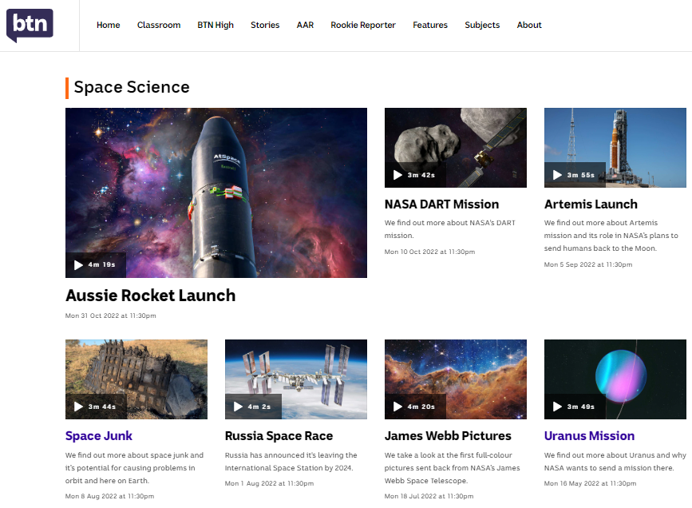
Visit BTN’s collection of stories which focus on space science and space exploration. After watching any one of the BTN videos ask students to respond to the discussion questions (to find the discussion questions and teacher resources go to the related BTN Classroom Episode and download the Episode Package).
Link to collection of BTN Space Science stories

Useful Websites
- Jupiter’s moon count jumps to 92, breaking Saturn’s Solar System Record – ABC News
- Jupiter now has the most moons in the solar system, say astronomers – Newsround
- Jupiter Moons – NASA
- Jupiter Overview – NASA
- Jupiter – NASA

Activity: Jupiter Quiz
- Which is the biggest planet in the solar system?  A. Saturn  B. Jupiter  C. Uranus  2. Jupiter is the closest planet to the Sun.  A. True  B. False  3. One year on Jupiter is equivalent to how many years on Earth?  A. 2  B. 6  C. 12 | 4. How many moons does Jupiter have?  A. 72  B. 82  C. 92  5. What is Dr Sara Webb’s job?  A. Archaeologist  B. Astrophysicist  C. Astronaut  - All of Jupiter’s moons have names.  A. True  B. False
Quiz Answers: 1B, 2B, 3C, 4C, 5B, 6B

  - Teacher Resource

BTN Transcript: Episode 2- 14/2/2023

Hey, what's up? Amelia Moseley here and you're watching BTN. Thanks for hanging out with us again. Let's see what's coming up. We find out more about the Voice to Parliament, how ancient Egyptians made mummies and the world's most expensive ads.

Türkiye and Syria Earthquakes

Reporter: Jack Evans

INTRO: We'll get to all that soon. But first to Türkiye and Syria where a massive deadly earthquake struck last week. It affected hundreds of thousands of people and now countries around the world have started lending support. Jack can tell you more.

On February 6th, at about 4 in the morning, a massive earthquake hit just outside the town of Gaziantep in southern Türkiye. It was so big it was felt in neighbouring countries Syria, Lebanon, Cyprus, and Iraq. Then about 9 hours later another earthquake hit. It’s been devastating for the people who live here and while earthquakes are pretty common in this area, these are the worst in decades.
You see Türkiye sits on top of something called the Anatolian Fault System, which is where several tectonic plates meet. Tectonic plates are a bit like jigsaw pieces that make up the Earth's crust, they sort of float on molten rock which means they're constantly moving. We typically don't feel that movement because it happens so slowly. But sometimes the plates slip or fall and crash into one another and that can cause an earthquake.
When an earthquake happens, it sends out huge waves of energy, they're known as seismic waves or shock waves. Scientists measure the size of these waves using a scale called the moment magnitude scale, which determines how big an earthquake is and how much damage it has caused. The first earthquake reached 7.8 and the second 7.5, which is pretty rare but incredibly destructive.
So far, the earthquakes have killed tens of thousands of people, thousands more have been injured and many have been left stranded without anywhere to go.

TÜRKIYE RESIDENT: We have no water, no food. We have nothing.

There have also been massive rescue efforts to reach people stuck in the rubble, which emergency workers have had to do in wet and freezing winter temperatures.
HOMBELINE DULIÈRE, CAFOD EMERGENCY PROGRAM: It's a race against time because the weather is so, so cold. It's been raining. It's been snowing.
The earthquakes have destroyed a lot of buildings and while some newer ones in places like Istanbul have been designed to withstand earthquakes. A lot of older buildings in the south and in neighbouring countries haven't and so thousands of buildings have collapsed including some ancient landmarks. Meanwhile, many countries including Australia have offered to help out where they can.
ANTHONY ALBANESE, AUSTRALIAN PRIME MINISTER: The Australian Government will provide an initial 10-million dollars in humanitarian assistance to those affected through our Red Cross and Red Crescent partners and through humanitarian agencies.
TAYYIP ERDOGAN, PRESIDENT Türkiye: We have received several calls for international aid to our country. Offers of assistance from 45 countries, including NATO and the European Union have reached us.
Amongst the devastation there have been some positive stories of people and animals being rescued. Meanwhile, firefighters from New South Wales have headed over to help out and around Australia mosques have been fundraising and collecting donations for victims in affected areas.
DR ASSEM AL ALWANI, AUSTRALIANS FOR SYRIA SA: It's going to be a long way to recovery here and we start at the very beginning at the moment and the community is very concerned and they are basically trying to do as best to help their relatives.
Now if you're feeling worried or upset about that story or anything else you've seen in the news, make sure you talk to someone about it. You can also call Kids Helpline on 1800 55 1800 or check out our website, we've got some resources up there on how to deal with upsetting news.
News Quiz

Australia Post says it’s getting way more expensive to deliver, what? Is it letters, parcels or food deliveries? It’s letters. Fewer Aussies are sending them. On average we now receive a little more than a letter a week and at the moment the cost of delivery is more than the price we pay to send them.

Who is this? It’s famous composer Burt Bacharach. He died aged 94 and is the man behind some very famous hit songs. During his career, he won six Grammys and three Oscars.

There’s some big news about Donald Trump on social media. What is it? Has he, announced he won’t run for President, shut down his personal website or had his accounts restored on Facebook and Instagram? Donald Trump’s accounts are back online. The former President was banned from the social media platforms after the Capitol riots in 2021. But Meta, the platforms parent company, has overturned the ban.

Voice to Parliament

Reporter: Michelle Wakim

INTRO: This year, Australians will vote on whether to change the Constitution to include an Indigenous Voice to Parliament. But how exactly will the Voice work? Well, there's been a lot of discussion about it, and Michelle found out more.

LIDIA THORPE, INDEPENDENT POLITICIAN: We don't need a referendum, we need a sovereign treaty.
THOMAS MAYOR, ULURU PARTICIPANT: The most powerful thing you can do is have a voice in the centre of decision making.
PAT TURNER, COALITION OF PEAKS: Everyone's hearing about the Voice and people are saying, ‘well what does that mean?’.
It's a topic lots of people are passionate about, but to understand more about it we need to go back a few years. In 2017, 250 Indigenous delegates met at Uluru to talk about a way to change Australia's Constitution, so it reflects the original owners of this country. The Constitution is a really important legal document. It kind of acts like the country's rule book. But Aboriginal and Torres Strait Islander people aren't recognised in this document. So, the delegates at Uluru came up with this. The Uluru Statement from the Heart, which outlined a number of changes they wanted to see. The Voice was one of these changes. It would be a new group in federal parliament called a First Nations Body. Their job would be to give advice to the government, on laws and policies which impact First Nations people.
DEAN PARKIN, FROM THE HEART: It's about elevating those voices of our mob who haven't been heard before. It's not like they've been silent. They've been out there talking; they’ve been out there advocating; they’ve been out there striving for change, year after year, after year. And the one thing that's not been happening is that their voices have been ignored. And that's what this voice is all about.
Prime Minister Anthony Albanese supports the Voice and promised to hold a referendum on it this year. A referendum is basically a big public vote, and you need to have one if you want to change the Constitution. Voters will be asked to answer this question: "do you support an alteration to the Constitution that establishes an Aboriginal and Torres Strait Islander Voice?". More than half of the population as well as more than half of the states have to vote ‘Yes’ to make the referendum successful. But so far, not everyone is on board with it.
LIDIA THORPE, INDEPENDENT POLITICIAN: Bring everyone together to a sovereign treaty.
DEAN PARKIN, FROM THE HEART: There must be difference of opinion. We’ve got to have a contest of ideas, so it's natural that there are people in our communities that are going to have an opposing view.
You see, some advocates believe that a Voice, which is a group that just gives advice, isn't enough and instead, Australia needs to form a treaty between First Nations people and the Commonwealth.
LIDIA THORPE, INDEPENDENT POLITICIAN: I think we need we need to stop tinkering around the edges and talking about advisory bodies, which we know we've had over decades. They've all failed. Treaty is the answer to the issues our people face in this country, because treaty will give us self determination to decide our own destiny and our own future.
A treaty could mean that First Nations people make policies for themselves and have more power in government and over traditional land. Countries like New Zealand, Canada, the US, Japan, Norway, and others, all have treaties with their First Nations people. This isn't the only argument against the Voice. Some politicians don't think there's enough information on how it will work.
PETER DUTTON, LEADER OF THE OPPOSITION: I've written to the Prime Minister asking 15 pretty basic questions on behalf of millions of Australians and I want to understand what his response is.
But the PM says a referendum is a simple 'yes' or 'no' question, and it’s parliament's job after to work out the details.
ANTHONY ALBANESE, PRIME MINISTER: The mechanics of the Voice won't be written into the Constitution because that's not how it works. The Constitution contains the power and then parliament uses its democratic authority to build the institution and, importantly, renovate it as needed.

Egyptian Mummy Recipe

Reporter: Lyeba Khan

INTRO: Okay let's head to Egypt now, where scientists have just discovered the ingredients to embalming mummies. They’ve done it by testing jars that were used thousands of years ago. Here's Lyeba.

GAME SHOW HOST: Hello and welcome back to another episode of ‘Can You Make a Mummy?’.

LYEBA: No?

GAME SHOW HOST: Here's your recipe. Good luck.

LYEBA: So sorry. Um, right. So, first thing we need is some Antiu. I don’t even know what that is.

Well, archaeologists never knew for sure, either until the recent discovery of this ancient workshop in Saqqara, near Cairo. They looked closely at 31 ceramic pots that were used to help mummify bodies. You've probably heard of mummies before, mostly in connection to these. Pharaohs. Egyptian kings who ruled in Egypt thousands of years ago. People there believed that when you died you took a lot of your wealth with you.

They built elaborate monuments for their dead royals and stuffed them with treasure. They also went to a lot of effort to preserve their bodies through mummification. This was because they believed their body would carry their soul into the afterlife, so they needed it to stay intact. But even though these mummies have lasted until now the exact art of mummification didn't. Although we do have a few ancient texts telling us about the complicated process. A priest would take out the organs and place them in jars. Including the brain which was mushed up through the nose.

LYEBA: Yeeeeeah, I'm not doing that.

Then they'd cover the body in a special salt called natron for about 40 days until everything was nice and dry and then stuff the body with spices, rags, and plants. And finally, wrapping it in linen bandages and placing it in a beautifully decorated coffin. If it was done well, it meant bodies could remain intact for thousands of years and it's one of the reasons why we now know so much about ancient Egyptians and their way of life and death. These texts even have the names of each ingredient used.

LYEBA: But what on earth is Kepu or Hat en Ash or Snetjer?

For a long time, experts didn't exactly know that, either.

LYEBA: Hey, there are labels on here. Snetjer.

But inside the jars they found something special. Tiny leftover bits which they scientifically tested. Many of these substances were already known to be used in mummification, but some were new.

RAMADAN HUSSEIN, ARCHAEOLOGIST, TÜBINGEN UNIVERSITY: We have measuring cups of oils and substance that were used in the mummification and they were actually labelled with the names of these oils. So, we are about to discover exactly what is those chemical compositions.

They found stuff like.

LYEBA: Pistachio, resin, and castor oil, for the head. Elemi and animal fat, to make the odour pleasant.

The jars also contained instructions for how to use each thing and what it was for.

LYEBA: For making beautiful the skin, for embalming or bandaging with it, to put on the head.

So, for something we already knew surprisingly a lot about, there are still more secrets to uncover about this ancient practice.

LYEBA: Alright, we got this.

Jupiter Profile

Reporter: Michelle Wakim

INTRO: Astronomers have discovered 12 new moons around Jupiter. In fact, all up it's got 92 of them. It's a pretty interesting planet really, so we sent Michelle on a mission to find out more about it.

MICHELLE: Down here on earth, we look up and see one, bright, glorious moon. You could say it's impressive, and we're pretty lucky right? Well, Jupiter, a couple of planets down, puts us and every other planet to shame.
DR SARA WEBB, ASTROPHYSICIST: Jupiter has surprised us yet again, by delivering us some more moons and I know this sounds crazy, because it has a lot of them.
A lot is an understatement. Scientists have discovered 12 new moons, taking Jupiter's moon-count to 92. But, back to the expert.
DR SARA WEBB, ASTROPHYSICIST: Hi BTN. My name is Dr. Sarah Webb, and I am your friendly astrophysicist. So, astrophysicists try to answer big questions. How many galaxies are there in the universe? Are there other planets? And even how many moons does Jupiter have? So, that is my job. Jupiter is probably doing a couple of different things. So, it will be collecting new moons, constantly.
MICHELLE: Okay, collecting moons, I like that idea.
DR SARA WEBB, ASTROPHYSICIST: Yeah, it's a little hoarder. Most of them will be very, very tiny because Jupiter is very large, and has lots of gravity, so if something comes close, it can get caught in orbit a little bit easier than say it could around Earth. And then there's all these other moons that have probably been there for a long time, we just haven't discovered them or seen them until this day. Stars are very bright. Jupiter's very bright in our night sky. But the moons are not. The moons can only shine when Jupiter's reflected light or the sunlight hits them. So, we need very big telescopes and very sensitive instruments to help us track them down. And thankfully it has, so Jupiter could break the record for the most moons in the solar system.
MICHELLE: And I've read some cool stuff about them being named. So, the really small ones might not get named, and the really big ones get named. How does that work?
DR SARA WEBB, ASTROPHYSICIST: It wasn't always like that. Up until before 2005, any type of object we found in the solar system would get a name. And then all of a sudden, our technology grew, and we had better cameras, we had quicker cameras, so we were collecting more data. We started to find so many moons around Jupiter and Saturn, many, many, too many to name all of them. But that doesn't stop you from coming up with names for your favourite moon of Jupiter.
MICHELLE: I think I'm going to have to start like putting a list together: John, Larry, Sally, Lucy.
MICHELLE: I'd like to know a bit more about Jupiter itself, as a planet and what makes it special?
DR SARA WEBB, ASTROPHYSICIST: It's the biggest planet in our solar system.
MICHELLE: Yes, Jupiter is very, very big. It’s radius, so the distance from the middle of the planet to the edge, is about 70,000 kilometres. For comparison, Earth’s is 6,371 kilometres. Yep, it’s just huge.
DR SARA WEBB, ASTROPHYSICIST: It looks very different to any of the other planets, and part of that is because of all of the different gases that it has. So, we see those beautiful stripy colours, and the little storm spots on it, because we've got different gases all mixing together. Jupiter is actually pretty chaotic. If you were to go down and look closer to its surface, there's lots of storms, big wind, lots of things happening. And we think that our solar system might look different if we didn't have Jupiter. So, Jupiter kind of helps with stabilising different orbits because it is so big. So, if Jupiter had been in a slightly different place, slightly further away, slightly closer, different planets might not be what they are today.

Sport

The Kansas City Chiefs and Philadelphia Eagles have battled it out in the 57th Super Bowl. It's the biggest day of the year for America's National Football League with the winner of the game taking home the championship. And for the first time there were two Australians playing. Jordan Mailata and Arryn Sippos suited up for the Philly Eagles. But, even with all that Aussie superpower, it was Kansas City who got the win in the final moments, 38 to 35 for their second NFL title in four years.
This is the moment LeBron James made NBA history as the league's all-time leading point scorer.
LEBRON: Thank you guys so much for allowing me to be a part of something I've always dreamed about.
Last week LeBron surpassed Karim Abdul-Jabbar's scoring record by bagging a total of 38,390 points throughout his career so far.
JAY-Z: Wow, wow beautiful.
Abdul-Jabbar's record stood for more than 38 years, so reaching that milestone is a huge deal.
Super Bowl Ads

Reporter: Jack Evans

INTRO: As you just heard, people around the world tuned in for this year's Super Bowl and while it's a huge sporting event, it isn't just about what happens on the field. A big part of the spectacle is, well, the spectacle around it. Including the millions of dollars spent on advertising. Here’s Jack.
JACK: Get the ball, get the ball, get the ball, get the ball. Get a goal, get a goal, get a goal, get a goal. Not a goal, not a goal. Oh yes, go team. Okay, as convincing as that just was, I'm not actually here to talk about football. I'm here to talk about Rihanna. Okay, I'm not here to talk about Rihanna either. I'm actually here to talk about Super Bowl ads. Why are we talking about Super Bowl ads?
The Super Bowl is one of the biggest sporting events on the US's calendar. It's the final play off of their National Football League and it's watched by roughly 100 million people. Who, for many businesses and companies, are potential customers which means ads. But you'd be mistaken if you thought these were your average run of the mill everyday ads.

JACK: No. These are Super Bowl ads which means they're, ugh, what was the word again? Oh, super.
And what's more super than a bunch of super stars.
JACK: It's quite clever really, taking advantage of the massive audience tuning in by using huge celebrities to promote their products. It would be like if I got say Rihanna.
JOE: I'm not Rihanna.
JACK: Shh if I got Rihanna to promote my new line of bowls. They're not your average bowl, they're your super bowl. I know that a lot of people will be watching this so there's a good chance that some of you might go out and buy one. But don't worry I wouldn't advertise in this story.
While that might not have cost me anything, Super Bowl commercials will cost you an arm and a leg.
JACK: Not literally of course, that would be weird.
Anyway, the first 30 second Super Bowl ad spots were sold for roughly 40,000 dollars. As the years went on, they only got more expensive. By the end of the 90s an ad spot would set you back about 2 million dollars and today companies can fork out more than 10 million dollars for a 30 second spot. While there are plenty who see that as a good business investment, there are some who think the whole thing is a super waste of money and that Super Bowl ads don't make much of a difference to a business’s sales.
JACK: But at the end of the day, Super Bowl commercials aren’t just about making people wanna buy their products. I mean they mostly are. But they also have a reputation to uphold.
For some people the ads are the best part of the Super Bowl. They make us laugh, and cry, and say things like wow, aww and huh? They often reflect pop culture moments, are made to be shareable and go viral, and ever since this 1984 Apple ad came out Super Bowl Commercials have had a bit of a block buster feel to them.
DEREK RUCKER: Most consumers are excited about the commercials. They want to talk about the commercials. So, as a marketer, you're paying for massive reach coupled with consumers who are interested in discussing and watching the ads.
And this year’s round up of ads has been no exception.
JACK: Wait, you're really going to finish this story and not show more Rihanna.

Alright.

JACK: Thank you.
Closer
Well, that's all for today. Thanks everyone for watching. As always there's plenty more to see and do on our website, including BTN High. You can check out new videos every week, exclusively for highschoolers and they're designed for teachers to use in the classroom too. Have a great week and I’ll see you soon. Bye.

