EPISODE 33
15th November 2022

KEY LEARNING
Students will view a range of BTN stories and use comprehension skills to respond to a series of focus questions.

CURRICULUM
English – Year 4
Use comprehension strategies to build literal and inferred meaning to expand content knowledge, integrating and linking ideas and analysing and evaluating texts.

English – Year 5
Use comprehension strategies to analyse information, integrating and linking ideas from a variety of print and digital sources.

English – Year 6
Use comprehension strategies to interpret and analyse information and ideas, comparing content from a variety of textual sources including media and digital texts.

English – Year 7
Use comprehension strategies to interpret, analyse and synthesise ideas and information, critiquing ideas and issues from a variety of textual sources.
  - Teacher Resource

Focus Questions
As a class, discuss the stories featured in the episode of BTN Classroom and record the main points of the discussion. Students will then respond to the following focus questions.

COP27
- What was the main point of the COP27 story?
- Where is Yessie and his son Genia from? Find on a map of the world.
- What does COP stand for?
- What natural disasters are becoming more common because of climate change?
- What questions do you have about this story?

Online Scams
- How many Aussies have been affected by scams this year?
- What type of scam is it is when a scammer pretends to be somebody they're not until they gain your trust, and then they ask for money.
  - Romance scam
  - Investment scam
  - Tech support scam
- Scammers aren’t always after money. True or false?
- What is identity theft?
- Name one Aussie company which has been targeted by online hackers.

World Cup Controversy
- In pairs, discuss the World Cup Controversy story and record the main points of your discussion.
- Where is Qatar? Find on a map.
- Why do some people think the FIFA World Cup shouldn’t be held in Qatar? Give one example.
- Qatar has been criticised for its treatment of migrant workers. True or false?
- What concerns do the Socceroos have about the World Cup being held in Qatar?

Food Safety Week
- Why is handwashing important when handling food?
- Which of these is a bacteria that causes food poisoning?
  - Salmonella
  - E-coli
  - Listeria
  - All of the above
- Why is it important to use different chopping boards when preparing raw meat and vegetables?
- What are some symptoms of food poisoning?
- What did you learn watching the BTN Food Safety Week story?

Check out the teacher resource on the Teachers page.

Christmas Island Crabs
- Where is Christmas Island? Find on a map.
- Why do red crabs migrate?
- When do red crabs migrate?
- How do people on Christmas Island adjust their lives during the red crab migration season?
- Name three things you learnt watching the BTN story.

Check out the teacher resource on the Teachers page.

EPISODE 33
15th November 2022

KEY LEARNING
Students will investigate the safe storage and preparation of food.

CURRICULUM
Health – Year 3-4
Identify and practise strategies to promote health, safety and wellbeing.

Discuss and interpret health information and messages in the media and internet.

Health – Year 5-6
Plan and practise strategies to promote health, safety and wellbeing.

Investigate the role of preventive health in promoting and maintaining health, safety and wellbeing for individuals and their communities.

Health – Year 7-8
Investigate and select strategies to promote health, safety and wellbeing.

Plan and use health practices, behaviours and resources to enhance health, safety and wellbeing of their communities.

  - Teacher Resource

Food Safety Week

Focus Questions
Discuss the BTN story as a class and record the main points of the discussion. Students will then respond to the following:
- Why is handwashing important when handling food?
- Which of these is a bacteria that causes food poisoning?
  - Salmonella
  - E-coli
  - Listeria
  - All of the above
- Why is it important to use different chopping boards when preparing raw meat and vegetables?
- What are some symptoms of food poisoning?
- What did you learn watching the BTN Food Safety Week story?

Activity: Class Discussion
Before watching
Before watching the BTN Food Safety Week story students will discuss in small groups what they already know about how to prepare and store food safely.
What do you know about food safety?

After watching
Students will respond to one or more of the following questions after watching the BTN story:
- What did you learn from the BTN story?
- What do you think about what you saw in the BTN Food Safety story?
- What was surprising about this story?
- Think of three questions you have about the story.

Activity: Glossary
Students will brainstorm a list of key words that relate to the BTN Food Safety Week story. Here are some words to get them started.

HYGIENE | BACTERIA | CONTAMINATION
FOOD POISONING | CROSS CONTAMINATION | GERMS

Ask students to write what they think is the meaning of each word (including unfamiliar words). They will swap definitions with a partner and ask them to add to or change the definition. Check these against the dictionary definition.

Further activities for students:
- Write your own sentences using the key words.
- Use the following words to write a summary about food safety: hygiene, bacteria, contamination.
- Investigate how food safety practices have changed over time. How was food stored or preserved so that it was safe to eat? Students could talk to parents or grandparents about how food storage has changed over time.

Activity: Public education campaign
Students will design a public education campaign to raise awareness about how to prepare and store food safely. Students will think about their campaign’s aim, target audience, and the value of raising awareness at their school and/or the wider community.

To create a school awareness campaign, students will need to identify the following:
- Why is it important to prepare and store food safely?
- How can not following safe food practices make us sick?
- Why is it important for everyone to learn more about food safety?
- How can you teach other kids about the importance of food safety? Think of creative ways you can teach kids your message about the topic.

Some questions to consider when designing your campaign:
- What is the campaign’s main aim?
- What are your goals? What do you want to achieve?
- Do you have a slogan or message? What is it?
- Who is your target audience?
- What is the best way to communicate the message?

Discuss with students how they will get their message out there to help raise public awareness. Some possibilities include:
- Short film or animation
- Community service announcement (for print, television or radio).
- Press release (create posters to be put up around the school or pamphlets to give to all students).
- Use Canva to design a poster to put up around their school and the wider community.

Activity: Choose a project
Individually or in small groups, students will choose one of the following projects to work on and then present their findings to the class.

Myth Busting
What are some common food poisoning myths that can be busted?
More about bacteria!
Not all bacteria are bad. Watch this video to find out more about good and bad bacteria. Present the information to other students.

Food Safe Recipe
Choose a recipe and add steps to the recipe to improve food safety. E.g., wash hands with soap and water, wash vegetables under running water, wash utensils after touching raw meat.
Food Safety Poster
Create a poster that outlines the important things to remember about food safety. Include information about handwashing, cross contamination, cooking food to the proper temperatures and refrigerating food.

Activity: BTN Handwashing story
Washing your hands before handling food and after handling raw meat or poultry will decrease the possibility of food poisoning and other disease. Watch the BTN Handwashing story and answer the following questions:
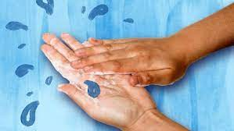
- What did the BTN Handwashing story explain?
- What year did Dr Semmelweis realise that handwashing was important for our health?
  - 1746
  - 1846
  - 1946
- What famous nurse supported Dr Semmelweis’ views about handwashing?
- What is another word for germs?
- What did the experiment in the BTN story show?
- How many seconds should you wash your hands for?
- What are good handwashing practices? Write step-by-step instructions.
- What did you learn from the BTN Handwashing story?

Useful Websites
- Food Safety Week – Food Safety Information Council
- Food Safety Basics – Food Safety Information Council
- Food Safety Week – BTN
- Handwashing – BTN

EPISODE 33
15th November 2022

KEY LEARNING
Students will learn about Christmas Island red crabs and their annual migration.

CURRICULUM
Science – Year 4
Living things have life cycles.

Living things depend on each other and the environment to survive.

Science knowledge helps people to understand the effect of their actions.

Living things have structural features and adaptations that help them to survive in their environment.

Science – Year 5
Living things have structural features and adaptations that help them to survive in their environment.

Science – Year 6
The growth and survival of living things are affected by physical conditions of their environment.

Science – Year 7
Classification helps organise the diverse group of organisms.

Geography – Year 5
The influence of people, including Aboriginal and Torres Strait Islander Peoples, on the environmental characteristics of Australian places.

The environmental and human influences on the location and characteristics of a place and the management of spaces within them.

  - Teacher Resource

Christmas Island Crabs

Focus Questions
Discuss the BTN story as a class and record the main points of the discussion. Students will then respond to the following:
- Where is Christmas Island? Find on a map.
- Why do red crabs migrate?
- When do red crabs migrate?
- How do people on Christmas Island adjust their lives during the red crab migration season?
- Name three things you learnt watching the BTN story.

Activity: Class Discussion
Discuss the BTN story as a class. Ask students what they learnt about Christmas Island red crabs, recording their responses on a mind map. In small groups, ask students to brainstorm responses to the following questions:
- What did you learn?
- What was surprising about the story?
- What do you wonder?
- What questions do you have about the BTN story?

Activity: Questions and Answers
All scientific discoveries start with a question! As a class, come up with some questions you think scientists ask and solve in relation to animals and what they need to survive. As a class, make a list of questions that you would like to ask a scientist. Organise the questions into common themes. Use the internet to find answers to your class questions.
What scientific questions do you have?

Activity: Glossary
Students will brainstorm a list of key words that relate to the BTN Christmas Island Crabs story. Here are some words to get them started.

ECOSYSTEM | WET SEASON | POPULATION
INVERTEBRATE | CRAB MIGRATION | HABITAT

Activity: Inquiry Research
The KWLH organiser provides students with a framework to explore their knowledge on the topic of Christmas Island red crabs and consider what they would like to know and learn.

What do I know? | What do I want to know? | What have I learnt? | How will I find out?

Questions to research
Students will collect and record information from a wide variety of sources. Students may develop their own question for inquiry or select one of the questions below.
- Where do Christmas Island red crabs live? Explore their habitat and mark where they live on a map.
- What are some unique features of Christmas Island red crabs? Explore its features and write a detailed description.
- What is the scientific name for red crabs? Explore the taxonomy of Christmas Island red crabs and categorise the information you find using the classification system.
- Why do red crabs migrate?
- When does the migration of red crabs occur? Investigate when the migration starts and ends.
- How far do red crabs migrate? Investigate the journey of the red crab in more detail. Highlight your findings on a map.
- How does the migration of red crabs affect the people that live on Christmas Island?
- What features does the Christmas Island red crab have to help it to adapt and survive in the wild?
- What does a Christmas Island red crab habitat look like? Study the habitat of the Christmas Island red crab and create a diorama of its habitat.
- Where is Christmas Island? Mark where it is on a world map. What are Christmas Island’s closest neighbours? What country does Christmas Island belong to?

Activity: Red crab profile
Students will research and write a profile about the Christmas Island red crab. Students can use the animal profile worksheet at the end of this activity to record their findings. Encourage students to use a range of sources to find their information.

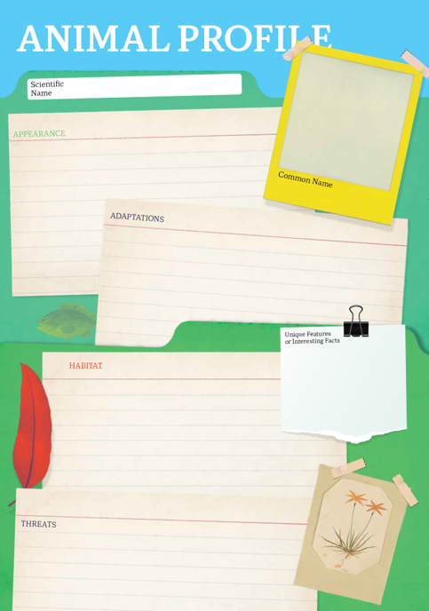
Research
Students will research the Christmas Island red crab and create a profile. Students can use the Animal Profile at the end of this activity.
- Illustration or photo
- Scientific and common name
- Classification (class, family, genus)
- Appearance
- Habitat
- Where is it found?
- Feeding and diet
- Behaviours and adaptations
- Predators
- Conservation status
- Interesting facts

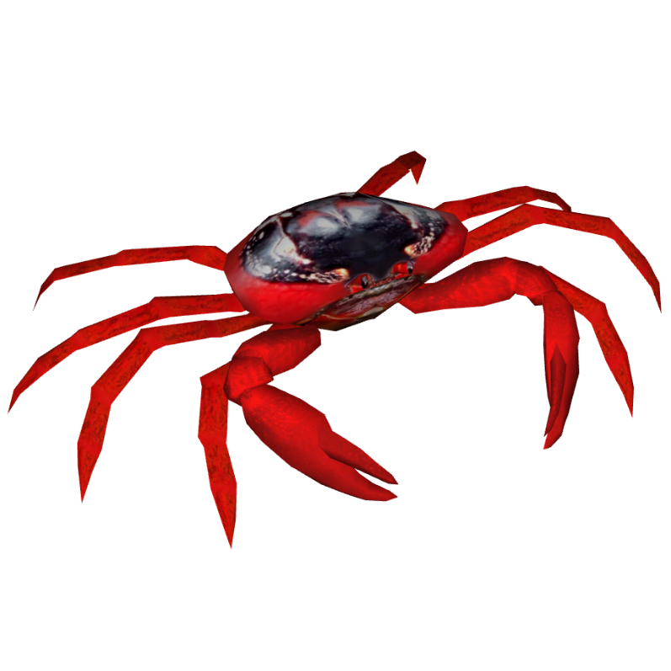
Students will then choose one of the following activities to complete:
- Model – Create a 3D model of a Christmas Island red crab or another animal native to Christmas Island using recycled materials. Display your model in your school.
- True or false? – Find out as much as you can about Christmas Island red crabs. Create a true or false quiz and test your classmates. Alternatively, create a word find or crossword.
- Children’s book or comic – Write and illustrate either a children’s book or comic which tells the story of the migration of Christmas Island red crabs.
- Geography – Where in the world do Christmas Island red crabs live? Plot on a map.
- Brochure - Make a brochure about Christmas Island that is informative and eye-catching. Include a list of attractions including the migration of the red crabs.

Activity: Quiz

- What type of animal is a Christmas Island red crab?  A. Invertebrate  B. Vertebrate  - When do Christmas Island red crabs start their migration?  A. The beginning of the dry season  B. The beginning of the wet season  - Approximately how many red crabs are on Christmas Island?  A. 5,000  B. 500,000  C. 50 million  - What direction can red crabs walk?  A. Sideways only  B. Forwards and backwards only  C. All directions  - Red crabs are native to Christmas Island.  A. True  B. False  - How many legs do red crabs have?  A. 8  B. 10  C. 12  Quiz Answers:  1A, 2B, 3C, 4C, 5A, 6B, 7C, 8B, 9A, 10A | - How many eggs can a female red crab release at once?  A. Up to 20  B. Up to 200  C. Up to 2,000  - Where do red crabs migrate?  A. From the sea to the forest  B. From the forest to the sea  C. From Christmas Island to Australia  - What type of climate does Christmas Island have?  A. Tropical  B. Dry  C. Temperate  - Which country does Christmas Island belong to?  A. Australia  B. Indonesia  C. Malaysia

Useful Websites
- Red Crab Migration – Parks Australia
- Christmas Island Red Crab – National Geographic Kids
- Red Land Crab – Australian Museum
- Christmas Island's red crabs scuttle from rainforest to coast in their millions as annual migration begins – ABC News
- Christmas Island National Park – Parks Australia

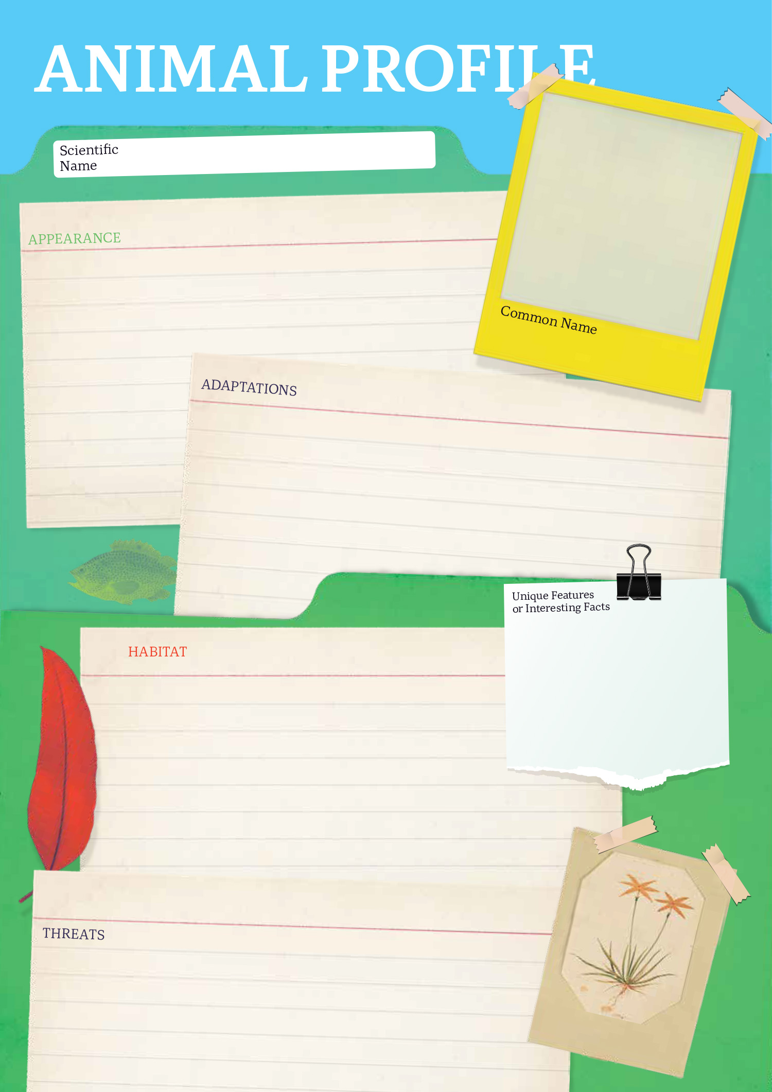

  - Teacher Resource

BTN Transcript: Episode 33- 15/11/2022

Hey, I'm Amelia Moseley and you're watching BTN. Welcome back, I hope you had a really good week. Here's what's coming up in today's show. We're going to get the low-down on safe cooking for food safety week, learn how to avoid some common online scams and meet some kids from Christmas Island who'll tell us all about crab migration.

COP27

Reporter: Jack Evans

INTRO: We’ll get to that soon, but first today to a big event that just took place in Egypt. It was called COP27, and it was a big international meeting about climate change. Jack found out who was there, what happened and why it matters.
YESSIE MOSBY: As the time is ticking, and our home is being washed away, the greediness of this world that hungry for money shows it’s neglecting a very ancient race of people. We appeal to the leaders of the world to have remorse and save what you can.
This is Yessie Mosby talking about his home, Masig Island in the Torres Strait, and how it's been affected by climate change.
YESSIE MOSBY: What we see every day is ridiculous, it's sad. A lot of the marine life, coral bleaching, a lot of the birds which flies do the navigational travel from Australia to Papua you don't see most of the birds now. It's a fight against time and the time is ticking as we all know our home is being eaten away.
GENIA: My Island is sinking. It feels sad.
Yessie and his son Genia have travelled to Sharm El Sheikh in Egypt to have their message heard at COP27, which stands for Conference of the Parties. The 27 just means this is the 27th one that's been held. Anyway, it’s a big annual meeting organised by the UN where people from across the globe, including world leaders, discuss what experts are calling the biggest challenge of our time.
ANTONIO GUTERRES, SECRETARY GENERAL UN: We are on a highway to climate hell, with our foot still on the accelerator.
You don't have to look hard to see what UN head, Antonio Guterres, is talking about. This year alone we've seen massive wildfires, flooding, droughts, heat waves, disappearing ice caps, eroding coast lines and super storms. Scientists say all these things are becoming more common because of climate change.
ANTONIO GUTERRES, SECRETARY GENERAL UN: We need to move from tipping points to turning points for hope.
That's what COP is supposed to be all about. At last year’s meeting, which was in Glasgow, many countries made some big promises to cut their carbon emissions to try to keep global temperatures from rising above 1.5 degrees. This year was a chance to check in and see how those plans were coming along but, ah, well, it hasn't been great.
ALOK SHARMA, PRESIDENT FOR COP 26: Friends, we are not currently on a pathway that keeps 1.5 in reach.
Many say wealthy countries who contribute the most to climate change, need to do way more to fix it and to help poorer countries who are going to feel the impacts the most.
WAVEL RAMKALAWAN, PRESIDENT OF SEYCHELLES: Our contribution in the destruction of the planet is minimal, yet we suffer the most. Our islands are disappearing, and our coasts are being destroyed.
PATIENCE: Every day all my life I've been experiencing floods firsthand. I'm a victim of floods, and very many other impacts of climate change that are happening in my country.
REPORTER: Patience is from Uganda in Africa which is one of the smallest contributors of carbon emissions in the world. She's one of many young people who have come to COP to tell leaders of richer nations how climate change is impacting them.
PATIENCE: We are here to demand to the end to fossil fuel extraction and investments.
REPORTER: It's not just countries copping criticism. A UN group has promised to come down hard on big companies that pretend to be more environmentally friendly than they actually are.
CATHERINE McKENNA: If you say you're a net zero, "I'm high ambition on climate", you can't be continuing to invest in new sources of fossil fuel supply, which is the problem.
It's a message that protestors around the world are echoing and as for people like Yessie and Genia, they hope that COP will help solve the problem now before it's too late.
GENIA: I got a message from my elders keep fossil fuel under the ground.
YESSIE: We're one of the oldest surviving cultures on Earth, over 60,000 years to date back to and to be refugees in our own countries. You know, we cannot practice our culture on another man's land.
News Quiz

It’s been another weekend of wild weather with storms and floods causing damage in New South Wales, Victoria, and South Australia.

KID: A lot of storms and lightning and thunder and we’ve had two trees come down on my street.

Can you name the weather system that’s been contributing to this very wet spring? Is it La Nina or El Nino? It’s La Nina. Along with a negative Indian Ocean Dipole which both bring wetter than usual weather to this part of the world.

SES SPOKESPERSON: We are in our 60th consecutive day of this particular weather event and there’s no end in sight at this point in time.

Customers of which health insurance company have had their private information published online after a massive hack. It was Medibank. Cyber criminals stole the personal info of millions of Medibank customers then demanded a 10-million-dollar ransom. When Medibank didn’t pay up, they started publishing people’s personal medical info on the dark web.

ANTHONY ALBANESE, AUSTRALIAN PRIME MINISTER: This is really tough for people. I’m a Medibank Private customer as well.

CLARE O’NEIL, HOME AFFAIRS MINISTER: I cannot articulate the disgust I have for the scumbags who are at the heart of this criminal act.

Which of these products got a lot harder to recycle in Australia last week? Soft plastics, glass, or e-waste? It was soft plastics. Australia’s biggest soft-plastic recycling program, REDCycle, paused its collection program because it couldn’t find anyone to actually recycle the plastics.

Can you name the tech company represented by this logo? It’s Meta, and last week wasn’t a great week for the company. Boss, Mark Zuckerberg, confirmed 11-thousand people have lost their jobs because of a drop in company profits.

Online Scams

Reporter: Nat Kelly

INTRO: As you just heard, there've been some big cybercrimes in Australia recently and now experts are warning it could lead to more people being exposed to scams. In fact, a recent report found Aussies are set to lose billions of dollars to scammers this year alone. So, how can you spot a scam? Here's Nat.
NAT, REPORTER: 424.8 million dollars. That's a lot of money. You could buy a lot of tins of baked beans with that. Or like, you know, cars, or whatever takes your fancy. Or, if you were the entire population of Australia, you could lose this amount of money to online scammers in the space of about 9 months. Wait, where are you taking that? No, don’t.
Yep, according to the ACCC, which looks after consumers rights in Australia, more than 160,000 Aussies have been scammed this year, and they reckon by the end of the year the losses could end up in the billions.

NAT, REPORTER: Scams come in all different shapes and sizes. Let's take a look at some of the biggest culprits from this year. At the top of the list, investment scams.
JOE: What you wanna do is invest in SillyCoin.

That's when cyber criminals con people out of their money by promising to make them super rich. Next up, romance scams, which is when scammers pretend to be somebody they're not until they gain your trust, and then they ask for money.
ALEX: Are you really Amelia Moseley from BTN?
CALE: Yes, I am really Amelia Moseley. Xo, xo, xo.
ALEX: Yes, I knew it.
CALE: By the way can you send me 500 dollars please I really need it like right now.
ALEX: Oh, sure.
Then there’s remote access or "tech support" scams. Where criminals take over your computer by pretending to be IT workers.
MICHELLE: Oh, wonderful.
NAT, REPORTER: They're not the only ways scammers can try to trick you out of your dollarydoos. In fact, if you spend any amount of time online you might’ve come across some common scams.

Like sketchy ads for products that don't even exist, emails or dm's telling you you've won a competition. And even fake social media accounts making you think your friends and family are asking you for money.

NAT, REPORTER: But scammers aren't always after money, at first. Sometimes, your personal data is enough. And you might be thinking, "well, what do they want with that?". Well, your personal data can be pretty valuable stuff.

When it ends up in the wrong hands, scammers can use it to pretend to be you online, and even in the real world. That's called identity theft and it lets scammers do some pretty sketchy things like, more scams. Speaking of which, experts are worried even more Aussies will be exposed to scams, thanks to some big data leaks that we've seen recently. Several huge Aussie companies have been targeted by hackers in some of the biggest cybercrimes the country's ever seen. And millions of customers have had their personal info, including email addresses, phone numbers, driver's licenses, and even personal medical information, stolen and shared online.

NAT, REPORTER: It's a big deal.

Which is why the federal governments just announced it's fighting back by creating a new task force made up of 100 people from the Federal Police and the cyber spy agency, ASD.
CLARE O’NEIL, CYBER SECURITY MINISTER: The smartest and toughest people in our country are gonna hack the hackers.
But what can we do to stay safe online? Well, we can start by doing a few things. Make sure you know who you're really talking to. If you've just accepted your nan's new friend request, for example, you could try giving her a phone call.
JUSTINA: Hello, nan?
CALE: Yes sweetie. It's me, your grandma. I just got a bit of a sore throat.
If you have a social media account, experts recommend you turn on multi-factor authentication. That means that even if hackers get a hold of your information, they'll have a much harder time trying to crack into your account. Whenever you're asked for personal details online, check with an adult you trust first, and be really careful about what you share with other people.
CALE: Ow. That never works.
World Cup Controversy

Reporter: Michelle Wakim

INTRO: As all you soccer fans probably know, there are only a few days to go until the World Cup. It's one of the world's biggest sporting events and for the first time ever, it'll be held in Qatar in the Middle East. But the choice of host nation has been really controversial. Michelle found out why.
These are the streets of Doha in 2010, after Qatar was announced as the host nation of the 2022 FIFA World Cup. It's the first time the massive sporting event would be held in the Middle East.
CHAIRMAN OF QATAR 2022 BID COMMITTEE: Thank you for believing in change. Thank you for believing in expanding the game. Thank you for giving Qatar a chance, and we will not let you down.
And for soccer-loving locals it was pretty exciting. But there was a long and controversial road ahead. To begin with, Qatar is very small. Tasmania is almost six times bigger than the entire country. 1.2 million people are expected to travel there for the World Cup, and there's not a lot of space to put them all. So, Qatar needed to build new state of the art stadiums and infrastructure. Then there's the weather. It's not just a little bit hot. Temperatures can reach more than 45 degrees. So, the tournament was pushed back from its normal start date in June to November, to make it bearable for players to take the field.
But for many, the most serious problem was Qatar's human rights record. You see, women in Qatar don't have as many rights as they do in countries like Australia and have to get permission to do, well, most things like get married, study, travel and work. There are also laws that discriminate against LGBTIQ+ people and same-sex relationships are still illegal. Qatar has also been criticised for its treatment of migrant workers.
To build all the stadiums, roads and accommodation needed for the World Cup, Qatar employed hundreds of thousands of workers from overseas, mainly from India, Nepal, and Bangladesh. Some of these migrants were either underpaid or not paid at all and made to work in extreme heat and unsafe conditions. A Guardian newspaper report found 6,500 migrant workers had died since 2010 although Qatar’s government says most of these deaths weren’t related to the World Cup and that's why as the Cup approaches, we've seen things like this.
SOCCEROOS: There are universal values that should define football. Values such as respect, dignity, trust, and courage.
SOCCEROOS: It is for these reasons we must speak about the situation in Qatar.
Recently, Australia's Socceroos made this video highlighting their concerns about Qatar.
SOCCEROOS: We have learnt that the decision to host the World Cup in Qatar has resulted in the suffering and the harm of countless of our fellow workers.
SOCCEROOS: As players, we fully support the rights of the LGBTQI+ people.
Germany also campaigned during the qualification rounds, and Denmark's uniform provider, Hummel, unveiled a plain design black kit to hide their logo as a protest. Last week FIFA's former president even said giving the Cup to Qatar was a mistake. But he said it was because the country was too small to host the Cup. There have been some serious questions raised about how and why that decision was made. But FIFA has stood by the host nation.
FIFA PRESIDENT: Human rights and protection of human rights at an international level is a top priority for FIFA. When it comes to the situation in Qatar, in particular, I think we need to be fair there as well and admit that a lot of progress has happened.
Qatar has made some big changes to protect workers, like introducing a minimum wage and laws around working in extreme heat. And it's promised that female and LGBTQI+ fans will be safe and welcomed. For many people in Qatar, including these migrant workers, the Cup is something to celebrate.
WORKER: Building infrastructure for the World Cup and being part of the process is very, very good, and I’m very, very proud to be a part of it.
And while things are far from perfect, many are hoping that this will be a step forward for Qatar.

Sport

England have beaten Pakistan to take out the T20 World Cup at the MCG. The Brits got off to a flying start keeping Pakistan to just 137. Pakistan's explosive bowling kept them in it, but England's Ben Stokes got his team over the line with an unbeaten 52.
It was a glorious day for Mercedes driver George Russell at the Sao Paulo Grand Prix in Brazil. He led the pack from start to finish taking home his first ever F1 win. Behind him though there was plenty of chaos including from Daniel Ricciardo who, out in the very first lap.
The Wheelchair Rugby League World Cup has come to an end for the Aussies. In the semi-finals Australia couldn't hold back the reigning champs France going down 84 to 40 at the final whistle. France will face England in the final on Saturday.
Food Safety Week

Reporter: Michelle Wakim

INTRO: Now, this next story might put you off your lunch. It's all about how food can make us sick if we aren't careful in the kitchen. You see, this week is Food Safety Week and Michelle found out why it's something we should all think about. Check it out.

MICHELLE: So, I'm really excited to have Chef Alex coming in and take a look at my kitchen. I'm pretty proud of it and what I do here.
CHEF ALEX: So, Michelle, what have we got here?
MICHELLE: Well, I have just cut some chicken and I’m going to set it aside for later.
CHEF ALEX: Okay, Michelle, we’ve just got to be careful, this is raw chicken. It is raw. This is risky business.
MICHELLE: Well, how about we just move on to some vegetables then?
CHEF ALEX: No Michelle, what are you doing, this is horrible.
MICHELLE: These will be fine right?
CHEF ALEX: No, Michelle.

MICHELLE: I think we can just.

CHEF ALEX: Michelle, Michelle if this continues Michelle, someone could get hurt.

Yep, Alex, or Chef Alex, is right. If you do the wrong thing in the kitchen, it can be a bit of a nightmare. You see, our food can be like a magnet for bacteria and some of those microscopic critters, like salmonella, e-coli, and listeria, can make us really sick. Each year, more than 4 million Aussies suffer from food poisoning, which can mean nausea, vomiting, and diarrhea and sometimes it can be really serious. But never fear, there are plenty of ways to avoid it. It's clear I've got a bit to learn about kitchen safety, so I've come to visit these guys at Kilkenny Primary. They have their very own kitchen where they make food for their classmates and it's not just about learning how to cook, it's also about learning how to be safe.
MICHELLE: Okay. Can I jump in and help?
STUDENT: Yep, we'll get your hands washed and then we’ll get your apron on.
MICHELLE: Great, alright.

Washing hands happens a lot here.
STUDENT: Then we’d wash our hands.
STUDENT: We would wash our hands again.
STUDENT: Then wash your hands.
MICHELLE: Wash my hands, okay.
And it's one of the easiest things you can do to prevent food poisoning.
STUDENT: Soap first.
MICHELLE: Soap first.
STUDENT: Water.
MICHELLE: Water, okay.
It's not just our hands we have to keep clean. It's the food and the equipment we use.
STUDENT: So, we would wash our knives before we moved onto different foods.
MICHELLE: So, if we were going from meat to vegetables, we’d have to do a big clean.

STUDENTS: Yes. Even clean the chopping boards.
MICHELLE: Even the chopping boards. Great, alright. Good to know. What happens if we don't like wash vegetables and wipe down chopping boards and keep food fresh?
STUDENT: We could get food poisoning and salmonella could grow on it, so yeah. Not good.
How we store our food also matters.
STUDENT: So, we usually keep our nice and fresh vegetables in the fridge.
MICHELLE: What about meat? What do we need to do with that?
STUDENT: Keep that in the fridge as well. If it gets too hot it can get rotten maybe.
Meat that hasn’t been handled correctly is actually the most common cause of food poisoning. So, it's really important to keep it covered and separate from other types of food.
MICHELLE: So, if I was to drop maybe a little parsley on the floor, could I just go by the five second rule?
STUDENT: No. You would pick it up off the floor and put it in the compost and then wash your hands.
MICHELLE: So, we got to throw it out?
STUDENT: Yes.
Well, these guys have taught me a lot and hopefully I can turn my bad kitchen habits around.

Quiz

Which of these is a bacteria that commonly causes food poisoning? Is it salmonella, spirillum, or streptococcus? It's salmonella.

Christmas Island Crabs
Reporter: Nat Kelly

INTRO: Finally, today let’s head to Christmas Island which has been taken over by crabs. Every year millions of the little red crustaceans scuttle their way from the forest to the beach. It's a pretty amazing sight that totally transforms life on the island. So, we asked some kids there to tell us what it's like and why it happens.

ROOKIE REPORTER: Hi BTN, I live on Christmas Island. Which is an Australian Territory. But if you look at the map, it's actually a lot more closer to Indonesia.
One of the things that Christmas Island is most famous for is the red crab migration which starts around this time each year.

With the crab migration coming at the start of wet season because we only have two seasons, wet and dry, you see a lot more crabs around.
Life on Christmas Island changes when the crab migration happens.

When tourists come to Christmas Island, it affects a lot of things like how crowded the beaches are. And more. But really, it affects crabs the most because they keep on poking them and touching them which is quite annoying for them.
The crab migration does affect the way to get to school because roads are closed, cars stop and rake. And it takes a slow process to get to school because some people live down the hill. And it's hard for them to get up to school.

We keep the crabs safe by raking them off the roads and we always have to dodge them.

And they also built the crab bridge, so the crabs can climb onto the crab bridges and not get ran over. Same as crab barriers.
Once the migration begins it will continue for around three weeks. The actual date for the migration varies each year, but they usually occur sometime in October or November.

An interesting fact about the red crabs is that they walk sideways. They have stiff joints and legs; their legs are attached to the side of their body. Red crabs migrate because they have to reproduce. If they don't reproduce, they could go into extinction.

It’s a really exciting time of year for us and taking care of the crabs is really important.

That's all from us. Bye BTN.
Closer
Well, that's it for today, but we'll be back with more for you next week. Until then you can head to our website and check out our socials if you're 13 or over. Plus, Newsbreak will be right here in the studio every weeknight with all the news you need to know. Take care of yourselves and I’ll catch you next week. Bye.

