Episode 13
21st May 2019



PM Profile
- Discuss the PM Profile story as a class and record the main points of the discussion.
- Who is the newly-elected Prime Minister of Australia?
- Which former Prime Minister lost his seat of Warringah?
- The leader of the Labor Party, Bill _________, has stepped down as opposition leader.
- Who is interested in becoming the new leader of the Labor Party?
- What is Scott Morrison’s nickname?
- How many children does he have?
- What number Prime Minster is Scott Morrison?
- What job did he have in government before becoming Prime Minister?
- What questions do you have after watching the BTN story?

Check out the PM Profile resource on the Teachers page.

Bob Hawke Remembered
- Summarise the BTN Bob Hawke Remembered story.
- During what decade was Bob Hawke the Prime Minister of Australia?
- How many years was Bob Hawke the Prime Minister of Australia?
- What political party did he represent?
- Where was Bob Hawke born?
- What is the name of the health care system that Bob Hawke set up?
- What other achievements did Bob Hawke make while he was PM? Name one.
- Describe Bob Hawke’s character.
- Complete this sentence. In 1991 Bob Hawke was replaced as PM by the treasurer Paul ___________.
- Name three facts that you learnt watching the BTN story.

Digital Footprint
- Before watching the BTN story discuss what you know about digital footprints.
- What is a digital footprint?
- Why might a potential boss look at your digital footprint?
- Is your digital footprint permanent? Why or why not?
- Who was recently in the media for things they posted online?
- What can you do to build a good digital footprint?
- Why do experts say digital footprints can be dangerous?
- How can you stay safe online?
- What do you understand more clearly since watching the Digital Footprint story?
- How did this story make you feel?

Check out the Digital Footprint resource on the Teachers page.
Get your class involved in BTN’s Ask A Reporter! This week’s topic is digital footprint.

Vesak Festival
- Summarise the BTN Vesak Festival story using your own words
- Buddhism is a religion that started in which country? Find using Google Maps.
- Approximately how many Buddhists are there around the world today?
- What is the main idea of Buddhism?
- What is one of the precepts that Buddhists follow?
- What does Vesak celebrate?
- What is the main aim of meditation?
- What do the kids give to friends and relatives on Vesak Day?
- What is the significance of the lanterns during Vesak?
- What other religious festivals are there around the world? Discuss as a class.

Gibb Challenge Kids
- Retell the BTN Gibb Challenge Kids story using your own words.
- What type of training do the kids do leading up to the challenge?
- How many kilometres is the Gibb Challenge?
- Which state is the challenge held? Locate Gibb River Road using Google Maps.
- The Gibb Challenge is only on bitumen roads. True or false?
- How much money do teams have to raise to enter the race?
- What does RFDS stand for?
- Explain what happened to Wyatt when he broke his arm in 2017.
- Complete this sentence. If the brothers finish the course, they'll be the _________ team ever to do it.
- What did you like about the BTN story?

Teacher Resource
Episode 13
21st May 2019

PM Profile

Students will learn more about Australia’s Prime Minister Scott Morrison and create a profile about them.


Civics and Citizenship – Year 6
The responsibilities of electors and representatives in Australia’s democracy.

Civics and Citizenship – Year 7
Use democratic processes to reach consensus on a course of action relating to a civics or citizenship issue and plan for that action.

The key features of government under the Australian Constitution with a focus on: the separation of powers, the roles of the Executive, the Houses of Parliament, and the division of powers.

- Discuss the PM Profile story as a class and record the main points of the discussion.
- Who is the newly-elected Prime Minister of Australia?
- Which former Prime Minister lost his seat of Warringah?
- The leader of the Labor Party, Bill _________, has stepped down as opposition leader.
- Who is interested in becoming the new leader of the Labor Party?
- What is Scott Morrison’s nickname?
- How many children does he have?
- What number Prime Minster is Scott Morrison?
- What job did Scott Morrison have in government before becoming Prime Minister?
- What questions do you have after watching the BTN story?


After watching the BTN PM Profile story, ask students to respond to the following questions:
- What did you SEE in this video?
- What do you THINK about what you saw in this video?
- What did you LEARN from this story?
- What was SURPRISING about this story?
- What QUESTIONS do you have about this story?
- A good Prime Minister…
- If I were Prime Minister I would…

Discuss the story as a class. What questions were raised in the discussion (what are the gaps in their knowledge)? The following KWLH organiser provides students with a framework to explore their knowledge on this topic and consider what they would like to know and learn.

What do I know? | What do I want to know? | What have I learnt? | How will I find out?

Glossary
Students will develop a glossary of words and terms that relate to the Prime Minister. Below are some words to get them started. Students can check out BTN’s Election words you might not know to help develop their glossary.

Prime Minister | House of Representatives | Member of Parliament | Federal Election
Minister | Cabinet | Parliament | Senate

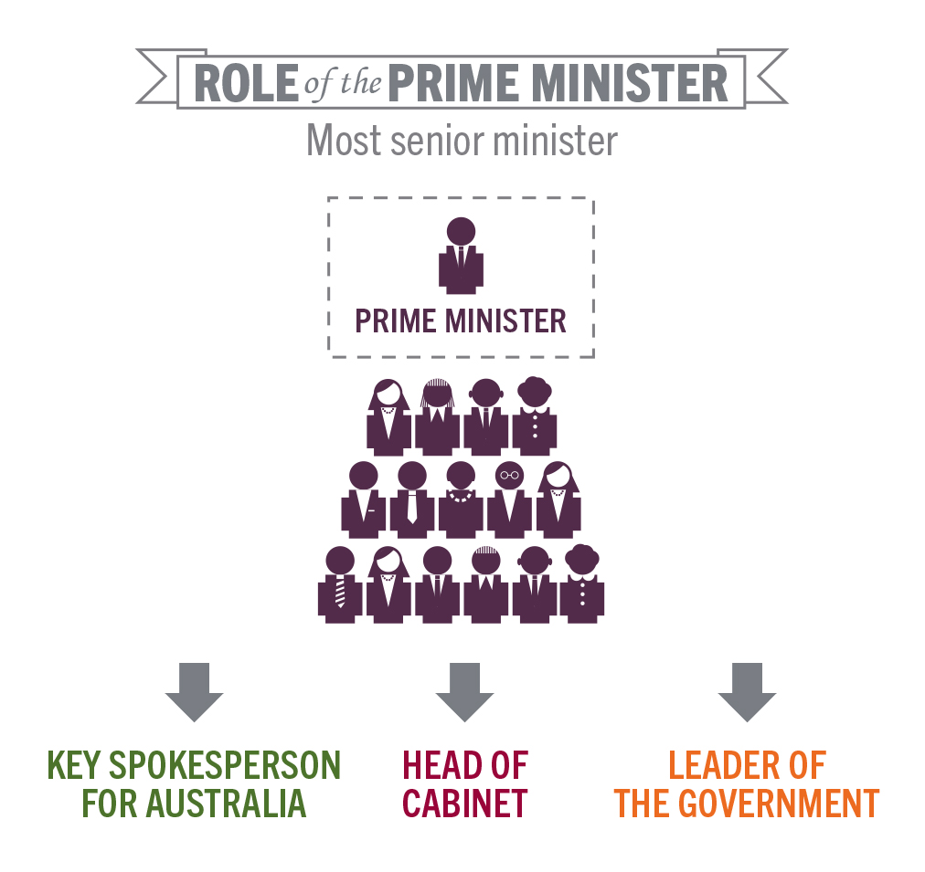
The role of Prime Minister
Students will find out more about the role of the Prime Minister.
- Who is Australia’s Prime Minister?
- How is the Prime Minister chosen?
- What is their role? Make a list of tasks.
- Is the Prime Minister a member of the House of Representatives or the Senate?
- What political party does the Prime Minister represent?
- Where are the official residences of the Prime Minister? Find using Google Maps.

To learn more about the role of the Prime Minister visit the PEO for facts and diagrams.
Source: PEO link

Profile of Australia’s Prime Minister
Students will find out more about our Prime Minister Scott Morrison and create a profile on him using a range of sources. Students can use the template at the end of this activity to record their findings. Information to research can include:
- Political party they represent
- Interesting facts
- Achievements
- About their electorate
- Issues important to them

Interview the Prime Minister
Students will imagine they are given the opportunity to interview Prime Minister Scott Morrison on behalf of their school. Their task is to write a list of interview questions that they would like to ask the Prime Minister. Students need to remember to write open-ended questions. Open-ended questions have no right or wrong answer and can’t be answered with a ‘yes’ or ‘no’. Before writing their questions, students will need to think about the following:

- What do you want to find out about the Prime Minister?
- What issues would you like to ask about?
- Choose a topic that is important to you and your school community. What do you want the Prime Minister to do about it?
Interview your local Member of Parliament
Students will focus on learning more about their local Member of Parliament (MP) that represents them in parliament. They can go to the Australian Electoral Commission website to find their electorate. They can also find out who their member of parliament is. Their task is then to imagine if they were given the opportunity to interview their local MP. Write a list of interview questions that they would like to ask them. Remember to write open-ended questions. Open-ended questions have no right or wrong answer and can’t be answered with a ‘yes’ or ‘no’. Before writing their questions, they will need to think about the following:

- What do you want to find out about your local Member of Parliament?
- What issues would you like to ask about? Here are some suggestions:
  - Families
  - Asylum seekers
  - Climate change
  - Education
  - Employment
  - Environment policies
  - Health
  - Housing
- Choose a topic that is important to you or your school community. What do you want your Member of Parliament to do about it?

What makes a good leader?
What do you think makes a great leader? Brainstorm and list as many qualities that you can think of, recording your ideas on the class whiteboard. For example:
- honest
- good at communicating
- confident
- has a positive attitude
- commitment
- creative
- inspiring

What are some examples of good leaders? They may be world leaders or leaders at your school. They can be leaders from a range of different areas, like science, fashion, politics or sport.


Parliamentary Education Office – Prime Minister
https://www.peo.gov.au/learning/fact-sheets/prime-minister.html

National Archives Australia – Scott Morrison
http://primeministers.naa.gov.au/primeministers/morrison/

BTN – PM Scott Morrison
http://primeministers.naa.gov.au/primeministers/morrison/

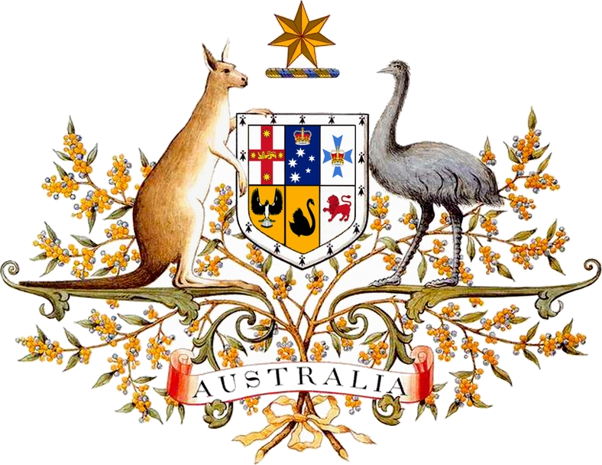
PRIME MINISTER OF AUSTRALIA
Profile
Name:
Born:
My Family:

What political party do I represent?

Interesting facts:
(portrait, illustration or photo)
My achievements:

About my electorate:

Issues important to me:

Teacher Resource
Episode 13
21st May 2019

Digital Footprint
Students will develop a deeper understanding about what a digital footprint is and how it can impact on them now and in the future.

Digital Technologies – Years 5 & 6
Plan, create and communicate ideas and information, including collaboratively online, applying agreed ethical, social and technical protocols.

Digital Technologies – Years 7 & 8
Plan and manage projects that create and communicate ideas and information collaboratively online, taking safety and social contexts into account.


- Before watching the BTN story discuss what you know about digital footprints.
- What is a digital footprint?
- Why might a potential boss look at your digital footprint?
- Is your digital footprint permanent? Why or why not?
- Who was recently in the media for things they posted online?
- What can you do to build a good digital footprint?
- Why do experts say digital footprints can be dangerous?
- How can you stay safe online?
- What do you understand more clearly since watching the Digital Footprint story?
- How did this story make you feel?



Class Discussion
After watching the BTN Digital Footprint story, hold a class discussion about the information raised in story. Record the main points on a mind map with `Digital Footprint’ at the centre. Use the following questions to guide the discussion.

- What is a digital footprint? Write your own definition and compare with your classmates.
- What does a good digital footprint look like?
- What does a bad digital footprint look like?
- How can you build a strong digital footprint?
- Is your digital footprint permanent?
- Can you erase your digital footprint?
- Does everyone have a digital footprint?


Digital Footprint Research

Define: What do I want to know?
Key questions to research
Students can choose one or more of the following questions or come up with their own:
- How is your digital footprint created?
- How can people see my digital footprint?
- Why is it important to care about your digital footprint?
- How can privacy settings on social media sites help protect my digital reputation?
- How difficult is it to remove information once it’s online?
- What are the pros and cons of digital life?

Further research
- Analyse your own digital footprint. What sort of digital footprint are you leaving? What information about you is online and how is the information protected? How could the information be made more secure?
Locate: Where do I find the information?
What resources will help answer my questions? (Internet, people, resource centre, organisations, print). Discuss with students what a reliable source is.
Select: What information is important for the investigation?
Students may need support to sort through and select relevant information.
Organise: How do I make sense of the information?
Students can organise their research by creating main headings from their questions. Write each heading on a separate piece of paper. Record the information found for each question.
Present: How do we let others know about this information?
Each group needs to discuss then decide on the best way to present the information. Possibilities could include:
- A ‘Did You Know’ Facts sheet
- Infographic
- Oral presentation
- Prezi presentation
- Create an infographic using Canva
Evaluate: What have we learnt?
Each group reflects on what they have learnt about digital footprints during their investigation. Students will reflect on their learning and respond to the following.
- What I learned...
- What I found surprising...
- What I would do differently next time…

BTN story – Internet Safety
Have you ever wondered why many internet sites and services are banned for kids under 13? To mark Safer Internet Day on the 6th of February, BTN finds out about that and some of the other rules designed to keep you safe online. Watch BTN’s Internet Safety story and then students will respond to the following questions.

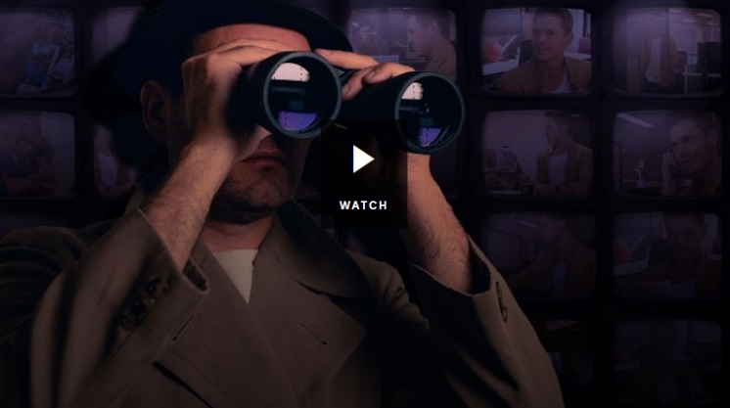
- Discuss the Internet Safety story in pairs. What points were raised in the discussion?
- What are terms and conditions?
- Accepting Facebook’s terms and conditions gives Facebook the permission to collect and use your personal data. True or false?
- Why are kids under the age of 13 banned from most social media sites?
- What do companies do with personal information they collect and store?
- Give an example of how you can stay safe and private online.
- Do you use social media? If so, which ones?
- Do you think kids under 13 should be allowed to use social media? Give reasons for your answer.
- What surprised you about this story? Discuss in pairs.
- What did you learn while watching the Internet Safety story?


BTN – Digital Footprint
https://www.abc.net.au/btn/classroom/digital-footprint/10534346

eSafety Commissioner – Digital footprint
https://www.esafety.gov.au/education-resources/classroom-resources/be-deadly-online/issues/digital-footprint

BTN Transcript: Episode 13 – 21/5/19

Hey, Amelia Moseley here and you're watching BTN. Here's what's coming up. Australia says goodbye to a past PM, we find out why it's important to watch your digital footprint and we meet some young cyclists taking on an epic outback race.

PM Profile
Reporter: Matt Holbrook

INTRO: But first to our lead story and I bet you can guess what that is. Yep, the election. After weeks of campaigning Aussies went to the polls and decided to keep Prime Minister Scott Morrison in the top job. Let’s find out a bit more about what happened.
SCOTT MORRISON, PRIME MINISTER: I have always believed in miracles.
Yeah. ScoMo is back. For his first full term as Prime Minister, and another shot at leading the country. And by the sounds of it, even he was a little surprised.
SCOTT MORRISON, PRIME MINISTER: And tonight, we've been delivered another one.
In the lead up to the election, Labor, and Bill Shorten, were favourites and polls had been pointing to a runaway, jog away win.
REPORTER: Happy election day Bill, how ya feeling?
BILL SHORTEN, OPPOSITION LEADER: Pumped.
But as the votes came in, it was the Coalition celebrating. Votes are still being counted, but we do know it'll be a Coalition government. And While the PM says he's keen to get on with things, there will have to be a few changes. Former PM, Tony Abbott, lost his seat of Warringah, a position he'd held for 25 years, to Independent Zali Steggall. And a few members of parliament, like Christopher Pyne, have retired.
So once the dust and the democracy sausages have settled, we'll see some new ministers in cabinet. And there's set to be a shake up for the Labor Party, with Bill Shorten announcing he'll step down as opposition leader. But let's get back to the PM, Scott Morrison. We told you a bit about him when he became Prime Minister last year.
BTN, 2018: He's 50 years old, 182cm tall and father to Abbey and Lily. He's known as 'Sco-Mo' to people that don't actually know him, and he was once a child actor. He was Australia's Treasurer and before that Immigration Minister and now he's the 30th Prime Minister of Australia. For those playing at home he's also our 5th PM in 5 years.
Thanks for that, 2018 Amelia. Since then, he's promised to get and keep Australia's budget in surplus. Bigger tax cuts for small businesses and families, and to help first home buyers with their deposit. So that's the plan. Now we wait while this new government gets to work.

Bob Hawke
Reporter: Jack Evans

INTRO: While Australia was getting ready to vote for our next government, we were also saying goodbye to a much-loved former leader. Bob Hawke was the longest serving Labor Prime Minister in Australia's history and he was responsible for some big political firsts and some very memorable moments. Let’s find out more about him.

If you were in Australia in the 80s you might have been grooving to tunes like this or watching TV shows like this. One thing's for sure, you would have seen a lot of this guy. Bob Hawke was Prime Minister for 8 years, longer than any other leader of the Labor Party. And he's remembered as one of the most colourful and celebrated political figures in Aussie history.
Bob Hawke was born in a small country town in South Australia. His mum was a teacher and his dad was a church minister. But right from the beginning he was pretty confident in his own abilities and apparently he even boasted to his school mates that he'd one day be prime minister. After getting a scholarship to study at Oxford University in the UK he started working with the Australian Council of Trade Unions, a group that represents workers where he fought for better pay and conditions.
In 1980 he moved into politics. He was a popular member of the Labor Party and in 1983 he became its leader, taking the party to a huge election victory. As Prime Minister he made some big changes to the way Australia traded and the way the economy worked. He set up Medicare, a system we still rely on today to provide us with health care when we need it. Hawke also brought in a law making it illegal for companies to discriminate against women and he did a lot for the environment. He passed a law which protected our world heritage sites, stopped the damming of the Franklin River in Tasmania and banned uranium mining at Jabiluka in Arnhem Land. He even spoke to BTN at the time about how kids could help to protect rainforests.
BOB HAWKE: Because I like to see the kids of Australia being concerned with what’s becoming an increasingly important issue for all of us, but particularly for them. That’s what the future of this planet is going to be.
Bob Hawke was the Prime Minister who officially made Advance Australia Fair our national anthem and proclaimed our national colours, green and gold. He was a big sports lover so much so that he famously called for a day off when Australia won the America’s Cup yacht race.
BOB HAWKE: I tell ya what, any boss that sacks their employee for not showing up to work today is a bum.
He was also known for having a bit of a temper and sometimes using well naughty words. In 1991 he was replaced as PM by the Treasurer Paul Keating. After politics he became a successful businessman. And continued to play a role in public life, speaking up for issues he believed in. While he was a loyal Labor Party member he was respected by politicians from both sides and after his death on Thursday Aussies came together to pay tribute to him, including these kids from Bordertown, where Bob Hawke was born.

KID 1: I reckon it’s cool that he just lived not that far away, and when you think of Prime Minister’s, you think that they come from the city.

KID 2: I reckon he was just funny. A bit of a cool person.

KID 3: I reckon he made a good Prime Minister.

KID 4: It’s pretty cool to see him come from a local little town to the big city and be the Prime Minister of Australia.

Quiz

Bob Hawke was Australia's 23rd Prime Minister, so who was Australia's 24th? Was it…
John Howard
Malcolm Fraser
or Paul Keating?
It was Paul Keating. He was also the Treasurer when Bob Hawke was PM.

This Week in News

The world’s biggest election has just wrapped up in India. There are more than 900 million voters there
and their election takes more than a month. While there's still a lot of counting to do, it looks like the current PM Narendra Modi is on track to keep the top job.

The other big vote on the weekend was Eurovision and, as we've come to expect, there was plenty of glitz, glam and gravity defying performances. It was the 5th time Australia's got to compete in the song contest which was traditionally just for European countries. And Kate Miller-Heidke did us proud, making it into the top ten of the grand final which was held in Tel Aviv. It wasn't enough for the win though. This year the Netherlands took home first prize for the first time in 30 years with the song Arcade by Duncan Lawrence.

An American explorer has made history with the deepest dive ever by a human in a submarine. Victor Vescovo went an impressive 11 kays down to the bottom of an area known as the Mariana Trench. The expedition uncovered some amazing species, like Arrowtooth Eels, Cusk Eels which seem to have see- through heads and this ghostly looking blob thought to be a new species, never before seen by humans. Unfortunately, the team also made an unwanted discovery, rubbish. Which means humans are having an impact even down here.

And the world has said goodbye to grumpy cat who died over the weekend. Her signature scowl made her an internet sensation, inspiring memes since 2012. Grumpy Cat also has her own coffee range, grumpuccinos, and has even starred in her very own film. Grumpy Cat's owner says she will be sadly missed but her legacy is sure to live on.
Digital Footprint
Reporter: Ruby Cornish

INTRO: Now to a story about digital footprints. They're basically what we leave online, all of our social media posts and comments and photos, and during the election they got a few politicians and would be politicians into quite a bit of trouble. Ruby found out more

RUBY: Good morning. Ruby Cornish.
MATT: Hello. Would you like a cone with ice cream in it?
RUBY: Actually, I'm here for a job interview.
MATT: Oh. Would you like to step into my office?
RUBY: Yep. Yeah sure.
Getting a job might be something that's a fair way off for you. But one day, you'll be in the hot-seat, facing some tough interview questions.
MATT: So, tell me, why exactly do you want to work at Behind the Scoop?
RUBY: Well, firstly. I love ice cream. I love it. Secondly, I have a year’s worth of customer service experience, and thirdly, I am a responsible, hard-working employee who always shows up on time.
MATT: Wow, okay. Thank you. We'll have you come by tomorrow.
But making a good impression involves more than nailing an interview. There's a good chance your potential bosses will also wanna take a look at your digital footprint. That's the information about you that exists in the online world. It includes stuff you've posted, commented on or liked on social media, interactions you've had on forums, and stuff that other people might have posted about you too. And this info doesn't necessarily disappear just because you decide to delete it. It's very easy for other people to record it or download it before it's gone.
MATT: Okay miss Ruby Cornish, what do we have on you?
RUBY: I mean, think about it. Ice cream is just like cold milk with flavouring.
MATT: Well, well, well.
Digital footprints are a relatively new thing. Before the days of social media, the past generally stayed in the past. But that's certainly not the case anymore, and some high-profile peeps have been finding that out the hard way.
Recently, in the lead-up to the federal election, a whole bunch of politicians and wannabe politicians were ditched from their parties because of stuff they posted online. These posts were mainly jokes, like memes, that they'd shared with their friends a long time ago, but a lot of people found them sexist, racist or inappropriate in other ways. Experts say that should be a lesson for the rest us, who are growing up sharing our lives online.
So, how do you avoid being brought down by your bad posts of the past? Well there is one pretty easy way. Don't make bad posts in the first place. When you do go to post or comment or share, ask yourself: Is this true? Is it nice? Would I say this to someone's face? Am I being reasonable and respectful? If you think there's any chance what you're saying could offend someone or make them think you're a few cents short of a dollar.
RUBY: Hey guys I just got to 10 thousand subscribers on YouTube so I'm gonna down this entire bottle of extra-hot mega death chilli sauce.

MATT: What?
Just don't do it. It's not just about good impressions, experts say digital footprints can be dangerous because they can be traced by people with not-so-good intentions. They say it's important that stuff like your full name, age, address, phone number and school, stays off the web, and that you only let people you actually know add you or follow you.

MATT: I wanted to hire you, but I just couldn’t.

Of course, it doesn't mean you can't have a life online, just that you should be careful.
MATT: You don’t even like ice cream.
So, your digital footprint doesn't come back to bite you.
MATT: But worst of all, this. The anti-cold desserts rally from 2013.
RUBY: Yeah. I guess I should be more careful.
MATT: But you know what, everyone deserves ice cream. Mango sorbet?
RUBY: Ha ha, you just got coned. Instagram's gonna love this. Laters.
MATT: It's not even mango.
Ask a Reporter

Do you have a question about digital footprints? Ask us live this Friday on Ask a Reporter. Just head to our website for the details.

Vesak Festival
Reporter: Jack Evans

INTRO: On Sunday millions of people around the world celebrated a big religious festival. It’s called Vesak and it’s really important to a lot of Buddhist people. We asked some kids to tell us all about it.

SANDARU: Hi BTN my name is Sandaru.
THARINSA: And my name is Tharinsa.
DINEL: I'm Dinel.
THISALI: I'm Thisali.
YENULI: I'm Yenuli.
METHULI: And I'm Methuli.
ALL: And we're going to teach you about Vesak.
DINEL: We are at the Buddhist temple which is where most people come to pray and we hold the Vesak festivities.
METHULI: Vesak is a festival that is celebrated by Buddhists all over the world.
DINEL: Buddhism is a religion that started in India and has spread around Asia. These days, Buddhists are right around the world. There are more than 500 million Buddhists around today.
SANDARU: The main idea of Buddhism is to become free from suffering and the Buddha preached how to do this is to control the mind.
YENULI: So, the easiest way to follow Buddhism is by the 5 precepts. They are: I will not kill; I will not steal; I will always be good; I will not lie; and I will not drink alcohol.
DINEL: The Vesak is about celebrating the birth, the enlightenment and the passing away of the Buddha.
YENULI: Before the Lord Buddha was Buddha he was a prince.
DINEL: When he was born he was brought up with everything he ever wanted. But one day when he was about the age of 20 he ventured outside the kingdom. He saw four things.
YENULI: An old man, a sick man, a dead man and a monk.
DANIL: When he saw these, he realised that not everything in life is happy and that there is lots of suffering.
SANDARU: Prince Siddhartha became the Buddha by becoming enlightened. For the first six years he was on fasting and then he finally realised that this was not the way, and then he started to mediate.
DINEL: The way to achieve enlightenment is to get rid of craving. So, in life whenever you want something and then when you get it you are going to get it again and then it’s going to keep happening. If you don't get it, you're going to be somewhat sad. So, the Buddha taught us to get rid of our cravings and to be happy with what we have and he teaches us in turn to be enlightened by controlling the mind, speech and thought. Before we start learning about Buddhism we meditate. When you meditate your final goal is try and keep your mind on one thing. As a child it’s really hard to keep your mind on one thing and focus.
SANDARU: Vesak is a very happy and peaceful day for us
DINEL: On Vesak day we normally give out cards to our relatives or friends. It's sort of like a birthday card and we are celebrating the Buddha and what he has done.
METHULI: We make lanterns, observe Sil. Sil means you worship the Lord Buddha and like pray.
THISALI: My favourite part is seeing the Vesak lanterns. The lanterns mean that you are enlightened and that you get rid of darkness.
THARINSAI: I actually like the pandols because they are really colourful, and they usually show the Buddha’s previous life.
METHULI: Thanks for letting us speak about Vesak.

Quiz

What does the name Buddha mean? Is it
The father
Powerful One
or Enlightened One?

Buddha means Enlightened One.

Sport

Sydney FC has won a record 4th A-league championship after knocking off Perth Glory in the Grand Final.
Sydney went the entire match without a shot on goal. Well, except for this one which was incorrectly ruled out for offside. After 2 hours of play and no goals, the game went to penalties. A bit of creative dancing from Sydney's keeper helped psych out the Perth players
Retiring Perth striker Brendon Santalab tried to get a bit too tricky with his penalty and failed pretty miserably handing Sydney a win against the favourites.

Cooper Cronk has announced his retirement from the NRL. The 35-year-old Sydney Roosters halfback and two-time Dally M medallist says he'll hang up his boots at the end of the 2019 season. Cronk has played 357 matches all up, 323 of them with the Melbourne Storm where he spent 14 seasons and won two premierships.

And if you're going to run a marathon well this is a pretty impressive place to do it. Around 1,500 runners have taken part in a 42-kilometre race through the clouds along the Great Wall of China. The track is one of the toughest around. Which could have something to do with the 5,164 steps that you have to get up and down. Feelings of regret coming, now. Yep, there it is. And guess who won? An Aussie. Douglas Wilson finished in three hours, 25 minutes and 25 seconds. Well done Dougie.

Gibb Challenge Kids
Reporter: Matt Holbrook

INTRO: Finally, to a story that kinda makes me feel a bit lazy to be honest. It's about some kids who have been training to take part in the an epic 600-kay bike race which started this weekend in the Kimberley. Let’s check it out.

The sun's not even up yet, but these guys are already hitting the track to train.
WYATT: We do the stairs every Monday, then we do the hills every Thursday. Most Sundays we have, we do like a big ride, like a 20 or 30 kay one.
SAFI: Lots of early morning starts, so they're a bit annoying, but other than that, it's been good.
Meet the Gibb Groms. They love riding, and they've spent the past few months getting ready for possibly the biggest adventure of their lives: The Gibb Challenge. It's a 660 kilometre course along the Gibb River Road in WA.
SAFI: It's got lots of hills and is bitumen sometimes and rocky the rest of the time. It's a mix of every road type I guess.
It's all for a good cause. To enter the race, teams have to raise 1,000 dollars for the Royal Flying Doctor Service. The RFDS helps hundreds of thousands of Australians every year by sending planes, as sort of air ambulances, to collect people in medical emergencies, and by setting up clinics in remote areas so locals can see doctors on a regular basis.
SAFI: So if you're going off grid and you injure yourself, they can get to you easily and take you to hospital.
It's already played a big part in the lives of the Gibb Groms.
WYATT: I broke my arm in 2017. I got flown up from One Armed Point, the community down there, then I was flown to Perth from Broome. I was driving in a buggy and we flipped it. When my arm broke, it cut off the blood flow from my arm. My arm would have been amputated if they didn’t bring me up.
Cayden and Keats are brothers and doing the challenge together.
CAYDEN: Most of our families have flown with them. My brother got burnt on a property on Queensland, he got flown to Brisbane's burns unit.
KEATS: It was really bad, and I was in bandages for a long time.

So, doing the ride means a lot to them.

The event is a relay, so someone rides while the others follow in a car.
SAFI: I think we'll ride two or one at a time, and we'll ride for 15-20 minutes, and then we'll swap over and it's just continuous.
WYATT: It's going to be hard and they think I won't survive it, but I said I will.
If they finish the course, they'll be the youngest team ever to do it. And while they know it's hard work, they say if it helps the RFDS it'll be worth it .
WYATT: It can save your life. Most people think they don't need it, but sometimes they just don't know.

Closer

They’re going to need a good rest after that. Take care guys. Well that’s it from us today but of course we’ll be back as usual next week and if you miss us in the meantime, there’s plenty to see and do on our website. And don’t forget, you can check out BTN Newsbreak every week night. Bye for now.

