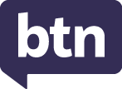
EPISODE 35
2 December 2025

KEY LEARNING
Students will learn more about the social media ban and write a persuasive text, hold a class debate or conduct an opinion poll about the ban.

CURRICULUM
Health & Physical Education – Years 5 & 6
Practise skills to establish and maintain relationships. Plan and practise strategies to promote health, safety and wellbeing.

Digital Technologies – Years 5 & 6
Plan, create and communicate ideas and information, including collaboratively online, applying agreed ethical, social and technical protocols.

English – Year 5
Plan, create, edit and publish written and multimodal texts whose purpose may be imaginative, informative and persuasive, developing ideas using visual features, text structure appropriate to the topic and purpose, text connectives, expanded noun groups, specialist and technical vocabulary, and punctuation including dialogue punctuation.

  - Teacher Resource

Social Media Ban

Focus Questions
As a class, discuss the stories featured in the episode of BTN Classroom and record the main points of the discussion. Students will then respond to the following focus questions.

Social Media Survey Results
- What percentage of people that did the BTN survey use social media?
  - 8%
  - 18%
  - 80%
- What age does the social media ban apply to?
- What social media platforms have been included in the ban? Give 2 examples.
- According to the BTN survey, what is the most popular platform used by kids?
- When does the social media ban start?
- Do you think the social media ban is a good idea? Give reasons.

PM Press Conference
- How much will social media companies be fined if they breach the new social media laws?
- Who is responsible for Australia’s online safety?
- Social media companies will know if you fake your age. True or false?
- What is the purpose of the Youth Advisory Council?
- What questions do you have about the social media ban?

International Reactions
- Australia has some of the toughest social media laws in the world. True or false?
- Which countries have announced plans to ban under-15s from social media next year?
  - Denmark and Malaysia
  - Norway and Sweden
  - Italy and Germany
- What is the UK's new law for social media called?
- What do the kids in the BTN story think about banning social media?
- What was surprising about the BTN story?

Quitting Social Media
- What type of phone does Nick use?
- How has Patrick set up his phone to make it less addictive?
- Why don’t Patrick and Nick like social media? Give 2 examples.
- What is the name of the group in the US who have given up social media?
- What are some benefits of not using social media or smartphones?
- What are some ways that you can interact with friends that doesn’t involve using social media?

Activity: Class Discussion
Discuss the BTN Social Media Ban special with students. Record the main points of the discussion on a mind map. Here are some questions to guide the discussion:
- What is social media? Come up with a class definition.
- What are the pros and cons of social media?
- What do you know about the social media ban being introduced?

- Why is the government introducing the ban?
- Which social media platforms/apps are included in the ban?
- Do you think the ban is a good idea? Will it work? Why or why not?
- Do you have any concerns about the ban?
- How do your friends/classmates feel about it?
- How can kids prepare for the ban?
- How can kids still stay connected with their friends or community once the ban is introduced?
- What questions do you have about the social media ban?

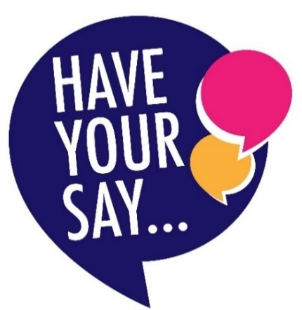
Activity: Class Poll
Hold a poll in your class. Students will conduct their own opinion poll on the issue of whether there should be a ban on kids under 16 using social media.

Working in groups, students will need to decide who their sample group will be and how many people will be polled.

What method will they use to conduct the poll? (Face to face interviews or written responses). Ask students to graph the opinion poll results and then reflect on the results.

Activity: Persuasive Text
Students will explore the issues raised in the BTN Social Media Ban special and develop a persuasive text for or against the following statement: `Kids under 16 should be banned from using social media’. Before starting the activity, discuss with students the pros and cons of the social media ban. Refer to the mind map for ideas.

Persuasive writing
Students need to weigh up the pros and cons of the issue then write a short persuasive argument using the following as a guide.

Tips
- Who is your audience? For example, are you directing your argument at kids, teachers, or politicians?
- Explore how language choices can have a big impact on persuading your audience.
- Which language devices give the report credibility and authority?
- Which are designed to create an emotional response in the listener?
- Provide facts and evidence to support your argument.
- Write in the present tense.
- Check your spelling and punctuation.

Use this Read Write Think persuasion map to plan your exposition text.
Introduction
- What is the point you are trying to argue? Construct an introductory paragraph which states the issue or topic.
- Introduce the arguments that will be developed in the body of the text.

Body
- Construct arguments that support your point of view.
- Each paragraph starts with a topic sentence which introduces each point.
- The rest of the paragraph gives more reasons.
- Arguments can be ordered from strongest to weakest.

Conclusion
- Restate your position on the argument.
- Construct a concluding paragraph that provides a summary of your arguments and a call to action.

Reflection
- How difficult was it to think of points to support one side of the argument?
- Do you think you would have done a better job supporting the other side of the argument?
- Was I able to convince others of my opinion?
- What did you learn from this activity?

Activity: Class Debate
Debating is an activity that helps students improve a range of skills including public speaking, communication skills, research skills, persuasion, confidence, teamwork and critical thinking. Use the following guide to help plan a classroom debate.

Brainstorm
As a class, brainstorm a list of arguments for and against banning social media for under 16s, using a T-chart to record student’s responses. Refer back to the mind map for ideas.
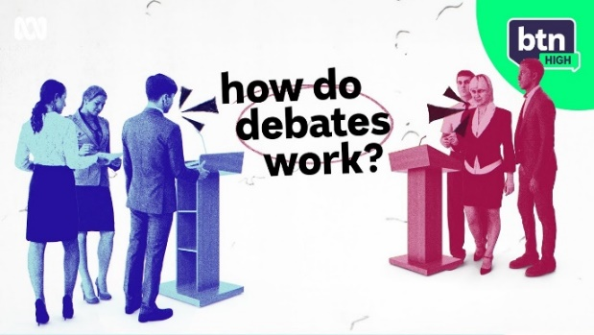
Classroom Debate – Should people under 16 be banned from social media?
Divide your class into groups of 6. Each group will then be divided into 2 teams, one representing the affirmative and the other the negative. The team arguing for the topic is called the affirmative and the team arguing against is called the negative, and the team that's judged to make the best argument wins!
To learn more about how debates work watch the BTN High School Debating story.
For each team there is a 1st speaker, 2nd speaker and 3rd speaker, each with a special role. Each speaker will prepare a 1–2-minute speech. Working together as a team students will choose their 3 best points to argue during the debate, work out their roles and what points each speaker will cover.

Activity: Interview the Prime Minister
Some students in the BTN Social Media Special were given the opportunity to ask the Prime Minister questions about the social media ban at a press conference.

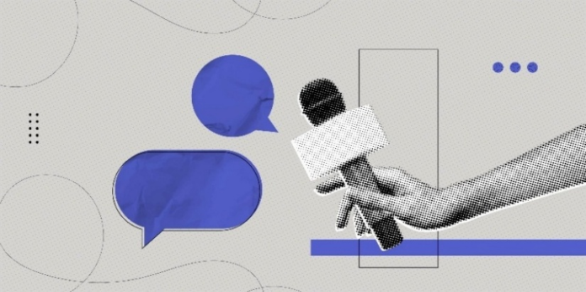
Ask students - If they had the chance to interview Anthony Albanese about the social media ban, what would they ask him?

Students write a list of interview questions, remembering to make them open-ended (can’t be answered with a ‘yes’ or ‘no’).

Activity: BTN Social Media Stories
Watch these BTN videos to help students understand more about the issues associated with social media.

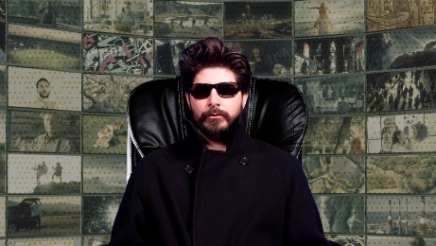  BTN Algorithms Explained | 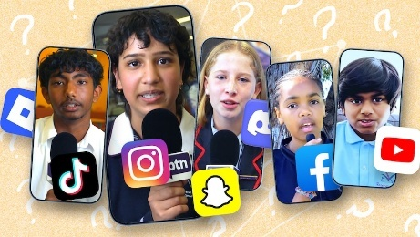  BTN Social Media Ban Q&A | 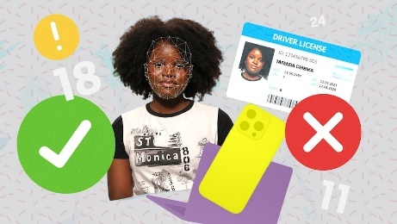  BTN Age Verification Rules
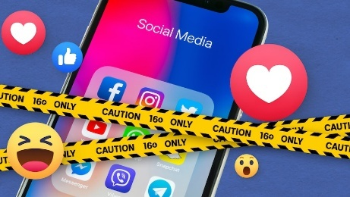  BTN Social Media Age | 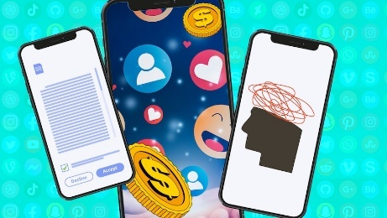  BTN Social Media Ban | 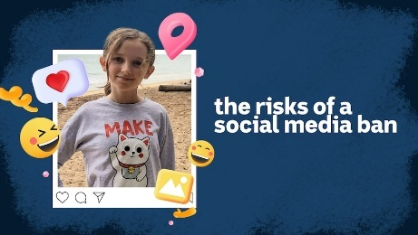  BTN High - Social Media Isolation
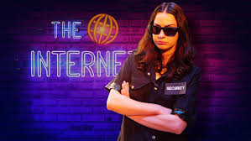  BTN Age Verification Trial | 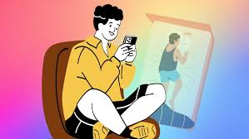  BTN Kids Smartphone Age | 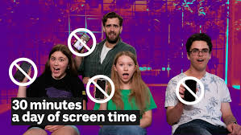  BTN Phone Detox

Useful Websites
- Safer Internet Day – BTN
- Safer Internet Day 2026 – eSafety Commissioner
- eSafety Young People – eSafety Commissioner
- Classroom resources – eSafety Commissioner
- Social Media Ban, Resources for Schools – Kids Helpline
- Social Media Ban – UNICEF Australia
- Social Media Ban – BTN
- Social Media Age – BTN
- Social Media Ban Q&A – BTN

  - Teacher Resource

BTN Transcript: Episode 35 – 2/12/2025

Yaama. I'm Jack Evans and you're watching BTN. But this isn't just any episode of BTN. It's our final episode of the year and we've got a special program all about the social media ban. Here's what's coming up. A group of students head to Parliament House to quiz the Prime Minister, we find out how the rest of the world is reacting to the ban and learn about some kids who have already given up social media.

Social Media Survey Results

Reporter: Joe Baronio

INTRO: But first, we're going to find out what you think about the ban. Over the past couple of months thousands of Aussies aged under 16 took part in BTN's Social Media Ban survey. Here's Joe to give us a run-down of all the results.

IPSITA: I feel like the ban has to happen at some point because it's not regulated at all, and people that have access to, like, so many different things that they probably shouldn't have access to.
NOAH: I think that it does have a lot of pros cause a lot of people are immature.
ANDREANA: I don't think it'll change much because people will fake their age to get into social media.
BEAU: Why? Why'd you do this to us? Why?
ELIZABATH: I would, I would never give up social media until the day I die, no, just no.
JOE BARONIO, REPORTER: Since the social media ban was announced you guys have had a lot to say. More than seventeen thousand young people have taken part in BTN's Social Media Ban Survey. About 80 per cent of you say that you use social media and 75 per cent of you have your own accounts.
ANDREANA: Some kids will probably go insane because they can't live without social media.
CHELSEA: Yeah.
LAYLA: Yeah, I use. I don't use much, but I do scroll a lot.
ELIZABETH: Get up, get ready, use it until I go to school. In the car, use it again, and then at night using it and then Saturday and Sunday, I might have plans. But if I don't just social media.
There have been a lot of questions around which social media platforms will be included in the ban and there isn't actually a list. What there is, is a legal definition of what a social media platform is and there's still some debate about which platforms fit that definition. According to the eSafety Commissioner, it does include the obvious ones like Facebook, Instagram and X but those platforms are actually some of the least used by you. The most popular platform is YouTube followed by Roblox, TikTok and Snapchat.
KATRINA: I'm mostly on like TikTok and Instagram, maybe Twitter.
JEFFERSON: I just use YouTube and Snapchat.
ELIZABETH: TikTok, Snapchat, Instagram, Facebook, Threads, YouTube, Roblox basically anyone you can think of, I use.
A common complaint about the ban is the impact it will have on young creators.
ASHER AYER, MUSICIAN: Record labels nowadays, they're not looking just for talent, they're looking for people who have some sort of success on social media that's the main way I'm advertising myself. It's definitely gonna hurt who I can work with.
27% of you told us that you use social media to make stuff.
RUBY: Young people who are already content creators, like how are they gonna take that away from them, especially since it's bringing in revenue for them?
JACINTA: I do think a downfall is for those people that do want to go into creating content themselves and they won't have access to that.
Even though it's being called a "ban" we've been told it's actually a restriction, or delay, on young people making their own accounts until they're 16 years old. That means you'll still be able to view some social media pages and videos without logging in. 75% of you told us that you don't plan to give up your account when the ban starts on the 10th of December.
ANDREANA: I'm not gonna stop using social media because…
CHELSEA: I'll just use my parents.
KATRINA: I would just like stay on social media or find any way I could.
While the government says it won't be punishing kids for side-stepping the ban it will punish social media companies so, we'll have to wait and see what happens next.
HARRISON: I don't think that would impact them much because they're multibillion dollar companies.
So, ultimately do you think the ban is a good idea and will it work? Well, while 30% of you say yes, or you're not sure the majority of you say you think it's not a good idea and it won't work.
RUBY: I don't think it will have much of an impact apart from young people thinking negatively about it.
ANDREANA: It gets people off the devices and out connecting with nature, connecting with their friends. And that's a really good thing.
NOAH: I do not think that anyone is going to obey it under 16. My YouTube account thinks I'm born in 2000.
JEFFERSON: I don't know how social media is really going to like block people that are under 16 from using it, so it'll be interesting to see how they do that.
LONDON: I think people are used to using social media as like it's how they connect with others now and once it gets taken away they might struggle with keeping in touch with people outside of school and stuff.
ELIZABETH: Please don't really enforce this bam, because I feel like we get you and we get what you're trying to do, however, this is not the way to go.
BEAU: You cannot stop the kids; they will find a way.

Quiz

What year did the first social media site launch? 1994, 1997 or 2000? It was 1997 and it was a site called SixDegrees.com. It allowed users to create profiles, list friends and send messages. Features that are used by majority of social media today.

PM Press Conference

Rookie Reporters

INTRO: The social media ban begins next week but many young Aussies still have a lot of questions about it, so, who better to ask than the Prime Minister. Last week we sent a group of students to Parliament House in Canberra for a special press conference with the PM and the Communications Minister. Check it out.

Student: So, we're gonna be doing a press conference with the Prime Minister talking about the social media ban.
Student: I feel definitely very excited, but nervous.
Student: And privileged, I think you don't get to do this very often.
Student: It's important to ask the Prime Minister these questions. So, like everyone knows what's gonna happen, how it's gonna happen.
Student: I guess we're all kind of thinking the same thing.
Student: If we ask the questions, they're also asking the questions, and we all have similar thinking around it.
Student: I'm really excited because I'm meeting the Prime Minister and I'm a bit nervous at the same time. And I'm going first out of everyone. But it's gonna be a great experience, I reckon.
Anthony Albanese, Prime Minister: Good morning.
StudentS: Morning.
Anthony Albanese: Oh, come on, you can do better than that. Good morning.
StudentS: Good morning.
Anika Wells, Communications Minister: Morning PM.
Anthony Albanese: Anika Wells is the Minister for Communication, and I'm the Prime Minister, and welcome to Parliament House.
Student: Good morning, Prime Minister. My name is Shashank. How will this delay be upheld? And what measures are in place to prevent people from bypassing the security systems and creating fake accounts?
Anthony Albanese: The responsibility is on the social media companies, and if they don't do their best endeavours. Then there'll be considerable fines, up to almost $50 million for breaches, and already what we've seen is a range of social media companies announced that they're getting even ahead of December 10 in advance. So, we're confident that this will work.
Student: My name is Charlotte. Bullying is bigger than social media. What measures are in place to protect those being bullied on games, messages or WhatsApp or even face-to-face?
Anthony Albanese: Our Education Minister, Jason Claire, is really implementing a national plan to address bullying, and we have an anti-bullying rapid review and that recommends that schools need to respond within two school days to a complaint or incident which is there. So, if we're going to properly tackle bullying, we need to have a really comprehensive approach and nip it in the bud early.
Student: Hello, my name is Ahmed, and my question for you today is what processes were used to gather the perspectives of young people under 16 before developing this policy?
Anika Wells: The eSafety Commission, which you might have, you know, come across so far in your time at school. It was the world first for Australia to have an independent eSafety Commission and they have a Youth Advisory Council and that's existed well before this policy. That Youth Advisory Council does things like help with policy design, gives feedback on how that experience might play out, you know, in your world. The Council has people from the ages of 13 to 24. They come from all different parts of the country, all different backgrounds and experiences, so they will continue to advise the eSafety Commissioner on program design, and we've also got a two-year survey that we're gonna track from 10 December about how this has rolled out, so we know what we need to do to make it better.
Student: Hello, my name is Sean. Many young people heavily rely on online spaces to escape bullying or unsafe home environments. How does the government plan to ensure continued access to online mental health communities and support networks?
Anika Wells: We've been doing a bit of work with four major mental health peak bodies. We being the eSafety Commission, they've informed this work, and then a couple of weeks ago, along with the Assistant Minister for Mental Health, we held a round table of 20 different mental health groups, advocacy bodies who look after young people, particularly in their mental health, and we talked through what the changes are, what they're gonna look like and how everyone's preparing their spaces, their platforms. There's apps that exist that you can go on instead of social media come 10 December, to help you with this, and they've all gone away and done their homework about how they can make this as easy as possible for you to transition, and we'll absolutely be looking at that as part of our two-year survey.
Student: Good morning. My name is Mia Rusan. Our careers in 10 years will look very different to those of our parents, and with the delay of social media, will this impact young children wanting our career in the digital industry or those who are ready online entrepreneurs?
Anthony Albanese: You certainly aren't going to be disadvantaged. The evidence is actually the opposite: that by stopping the negative impact of social media, people will be much more comfortable engaging in digital activity as well, because it will be doing it in a way that is safer, and so it won't stop you engaging in a whole range of research. It certainly won't stop you doing in school the sort of digital education that will enable you to have a career in the new economy as well.
Student: Hi, my name's Jayden. There are obviously those that disagree with this decision and feel their agency has been taken away. What messages would you give to provide reassurance to those that feel this way?
Anthony Albanese: Two points I would make: one is this has support across the Parliament, which is very good. Often in this building, people don't always agree with each other, you might have noticed. Second point is this hasn't come from us. This isn't our idea. It's actually come from young people, it's come from parents, it's come from the grassroots who've had campaigns on this, and they've really got organised. And as a result, we've listened, and my job as Prime Minister is to listen and act, and that is what we are doing. And I'm sure that when people look back on December 10, they're going to say, "Gee, that was the right thing to do, and we're glad that it happened." I think it'll be really positive, and it'll be really a proud moment for Australia to show that Australia is showing leadership.

Quiz

How many hours of video is uploaded to YouTube every minute? Is it 50 hours, 500 hours or 5,000 hours? It's 500 hours, give or take, which is quite a lot really.
International Reactions

Reporter: Justina Ward

INTRO: The social media ban isn't just causing a stir here in Australia, it's a world-first law that has a lot of other countries paying attention. Justina found what kids around the world think of the ban and how some countries have responded.

NEWS REPORTER: To Australia now where lawmakers have approved a world first law.
NEWS REPORTER: That country will ban children under 16 from using social media.
NEWS REPORTER: It's one of the toughest measures of its kind anywhere.
NEWS REPORTER: How effective will Australia's law be? Should Europe follow suit?
JUSTINA WARD, REPORTER: Yep. Australia's social media ban is getting a lot of attention. It's going to change the way young people communicate, and kids everywhere seem to have pretty strong opinions about it.
STUDENT, CANADA: The ban is not a good thing because some people use social media to get rid of stress.
STUDENT, SOUTH AFRICA: It's really good because a lot of bullying goes on like social media.
STUDENT, UNITED KINGDOM: There's a lot of people who just spend hours scrolling and getting rid of it will make people be more productive.
STUDENT, DENMARK: I would think it was a bit annoying. I would like to see what's going on around.
STUDENT, SWEDEN: Kids can see stuff on social media they are not supposed to, so it may be better to wait until you are older.
Some kids are worried about things like cyber bullying.
STUDENT, CANADA: People get cyber bullied online, and it can make people feel left out and not good about themselves.
STUDENT, SWEDEN: I don't think kids should really be on social media because of how many bad things have happened on it.
Others reckon it’s an important way to stay connected.
STUDENT, NORWAY: You can stay updated on world events and talk to new people and create new relations.
STUDENT, NORWAY: I can call someone if I need help or tell my parents what´s going on or ask friends to come over.
While social media rules around the world vary, Australia's not the only country making changes. Malaysia and Denmark have announced plans to ban under-15s from social media as early as next year.
CAROLINE STAGE OLSEN, DANISH MINISTER FOR DIGITAL AFFAIRS: What we're trying to make sure is that the tech platforms that create most harm is the ones that are kept away from the children.
STUDENT, DENMARK: I think it's a bit of a bad idea because it's a pretty high age limit.
STUDENT, DENMARK: I think they're doing it so that we can have better interaction with other people.
The UK's also considering a ban for under 16s and earlier this year introduced the 'Online Safety Act', which requires platforms to set age restrictions and make sure kids only see content appropriate for their age.
STUDENT, UNITED KINGDOM: There should be restrictive rules and on social media because of cyber bullying and trolling.
STUDENT, UNITED KINGDOM: Personally I don't think there should be any stricter rules on social media in the UK because I just think if we if we're taught how to navigate and things then that could be prevented.
Whether or not other countries will see a social media ban like here in Australia, many are still split on the idea.
STUDENT, SOUTH AFRICA: If that were to happen in South Africa it would be really good as well because bullying is really bad in South Africa.
STUDENT, SWEDEN: I really couldn't have it because I spend most of my time just on my phone.
STUDENT, DENMARK: An age limit of, say, 13 would probably work better.
STUDENT, CANADA: I wouldn't be that happy if Canada banned social media because my friends live far away from me.
STUDENT, SOUTH AFRICA: I would be affected, but I wouldn't be affected enough to go crazy.
STUDENT, NORWAY: It´s a bit stupid because then all the young kids won´t be able to see what is happening online. But it is also good because then we make sure everyone is safe.

Quiz

Which YouTube video holds the record for most viewed video of all time? Is it Baby Shark, Gangnam Style or Despacito? It's Baby Shark. It currently has more than 15.8 billion views and is now stuck in my head.

Quitting Social Media

Reporter: Wren Gillett

INTRO: Finally today, we're going to find out what life could look like for young Aussies after the ban begins on December 10th. Wren caught up with some students in Adelaide who have already given up social media.
PATRICK: Hi, I'm Patrick. I'm 15-years-old and I hate social media. I don't want it.
NICK: I'm Nick and this is my phone. Which has no social media on it.
Patrick and Nick have pretty strong opinions about social media.
PATRICK: I've never really been interested in social media. You see the kids. They're walking along with their phones when they could be talking to their friends and you're just like, I don't want to be like that.
NICK: My mum would always say to me, you know, it's not healthy and it's going to affect you greatly. So, well, you can get social media if you want, but I recommend that you don't, and you can get a normal phone if you want, but I would recommend you get a flip phone. So, I got a flip phone.
Nick says this decision made him look at his phone a lot less. Partly because you can't download any social media apps, or any apps at all. And it takes a lot longer for him to text.
NICK: It's very slow, it's a slow process, but you develop a skill over time, how to text. And you know, I'm able to just like, do like that you know.
This flip phone used to be Patrick's. But he left it in his pocket, and it went through the washing machine. Whoopsie. Now, this is his phone. To make it less addictive he's turned off most notifications, switched on 'grey scale', a feature that turns all your phone's colours grey. And has purposefully decided not to fix the cracks.
PATRICK: I'm just trying to make myself not get hooked really.
And it's not just Patrick and Nick who are concerned about getting addicted to their phones. These are some of their friends, who kindly let me crash their day off.
PATRICK: Take a seat.
WREN GILLETT, REPORTER: Why thank you very much.
And I learned that none of them use social media much either.
LENARD: Nowadays it's become too eager to get your attention, I feel. It's like, it's so hard to look away from it, and it's hard to pay attention to other things when you get into it too much.
WREN: When you guys do hang out are cards normally on the cards?
PATRICK: Yeah, cards are on the cards.
LENARD: I'd say table but.
Switch is also on the cards.
WREN: Some people might find it interesting that you are so against social media, but you really do love technology and that when you guys hang out, you do, you know, hop on the Switch. Can you sort of maybe, I don't know, speak to that a little bit?
PATRICK: I'd say, like technology is great. Love technology. I use it all the time I play games, I learn, I do schoolwork on technology. I hate social media because of the way it exploits technology to get you addicted, to steal your money, to steal your attention, to steal your data. That's it's whole thing. It's an attention industry and I'm playing again. No, I'm not.
LENARD: I feel much closer with these friends when I'm hanging out with them in real life, compared to just messaging over an app.
Beyond Patrick and Nick's friends, there are also many groups of young people around the world following a similar trend. Like this group in the US, called the Luddites. They don't have social media, and many of them have ditched smartphones, for dumbphones, like Nick's.
NICK: How cool would it be if flip phones came back into fashion? That would be epic. Not gonna lie.
WREN: So, guys, how do you think your life is different?
NICK: Okay I'll go first. It certainly has affected my life. It certainly saved me a bunch of time in my life having no social media and having a flip phone.
PATRICK: I'm not stuck scrolling; I'm not addicted to my phone. I'm not like losing valuable time. How much life do I have? How much of that do I want to spend watching other people's lives? That's sad.
Yeah look, it's probably not surprising they support the social media ban.
PATRICK: My response was along the lines of, yeah! I'm pretty happy about it, right? Like people don't seem to have the self-control to stay off of social media themselves. So, this is how we start getting that self-control before you fully mature, right?
NICK: I see it as like an excellent step towards a future ban, but it's not going to solve things. It's just putting a band aid over a bullet wound.
While these guys have strong views on the social media ban, and social media in general, and have made bold choices they're proud of, it hasn't all been easy.
NICK: Everybody has it, and they're able to like make jokes in reference to what they saw on social media. And I feel left out by that you know.
And after three years of having a flip phone, Nick does now have a smart phone, and uses some social media to connect with people, something a lot of Aussie teens do. But for people like Patrick and Nick, the positives of not having social media outweigh the negatives.
NICK: You don't have to use things like Snapchat and Instagram to communicate, no. You can use text messages. Yeah, guys, they're still a thing. Text messages are still a thing.
PATRICK: SMS.
NICK: SMS.
WREN: You heard it here first.
PATRICK: We did it before it was cool.
Closer

Well, that's all we have for you today and for this year. Don't worry though, we'll be doing it all again next year and if you miss us in the meantime, you can always jump on our website there is plenty to see and do. From everyone at BTN, thanks so much for tuning in, have a safe and happy holidays, and we'll see you in 2026. Bye.

