EPISODE 5
5th March 2024

KEY LEARNING
Students will view a range of BTN stories and use comprehension skills to respond to a series of focus questions.

CURRICULUM
English – Year 4
Use comprehension strategies to build literal and inferred meaning to expand content knowledge, integrating and linking ideas and analysing and evaluating texts.

English – Year 5
Use comprehension strategies to analyse information, integrating and linking ideas from a variety of print and digital sources.

English – Year 6
Use comprehension strategies to interpret and analyse information and ideas, comparing content from a variety of textual sources including media and digital texts.

English – Year 7
Use comprehension strategies to interpret, analyse and synthesise ideas and information, critiquing ideas and issues from a variety of textual sources.
  - Teacher Resource

Focus Questions
As a class, discuss the stories featured in the episode of BTN Classroom and record the main points of the discussion. Students will then respond to the following focus questions.

University Changes
- In which century did higher education start in Australia?
  - 19th
  - 20th
  - 21st
- How are TAFE’s and universities funded?
- The government says that in the future, we need _____% of our work force to have gone to uni or TAFE.
- What support do students need to help them complete higher education?
- What did you learn watching this story?

Climate Disaster Impacts
- What was the main point of the BTN story?
- According to a recent report, about how many Australian children experience extreme weather every year?
  - 1 million
  - 1.4 million
  - 2.4 million
- What impact can natural disasters have on kids?
- What changes does UNICEF want to see to help children affected by natural disasters?
- Have you or someone you know been affected by a natural disaster or extreme weather event? What impact did it have?

Skinfluencers
- At what age did Grace become obsessed with skincare?
- Why can some skincare products damage a teenager’s skin?
- Where are young people seeing a lot of the skincare messages?
- What advice does Dr Michelle Wong give for young people and their skincare routine?
- What was surprising about the BTN story?

Whale Songs
- What did scientists recently discover about whales?
- Which part of the whale’s body did they study?
- Why do whales make sounds?
- What is a baleen whale?
  - A whale with teeth
  - A whale without teeth
  - A whale found only in Antarctica.
- What impact can underwater noise have on whales?

Check out the teacher resource on the Archives page.

Elizabeth Kenny – Women’s History Month
- What started Elizabeth Kenny’s interest in the human body?
- How did Elizabeth treat patients with polio?
- In which country did the `Kenny method’ take off and voted her the most admired woman?
- Why do you think Elizabeth Kenny is an important Australian?
- What did you like about the BTN story?

Check out the teacher resource on the Archives page.

EPISODE 5
5th March 2024

KEY LEARNING
Students will learn more about a species of whale and create a profile of them. They will also investigate how whales communicate.

CURRICULUM
Science – Year 4
Living things depend on each other and the environment to survive.

Science knowledge helps people to understand the effect of their actions.

Science – Year 5
Living things have structural features and adaptations that help them to survive in their environment.

Science – Year 6
The growth and survival of living things are affected by physical conditions of their environment.

  - Teacher Resource

Whale Songs

Focus Questions
Discuss the BTN story as a class and record the main points of the discussion. Students will then respond to the following:
- What did scientists recently discover about whales?
- Which part of the whale’s body did they study?
- Why do whales make sounds?
- What is a baleen whale?
  - A whale with teeth
  - A whale without teeth
  - A whale found only in Antarctica.
- What impact can underwater noise have on whales?

Activity: See, Think and Wonder
After watching the BTN Whale Songs story, students will respond to the following questions:
- What did you SEE in this video?
- What did you LEARN from this story?
- What do you WONDER about this story?
- What QUESTIONS do you have about this story?

Activity: Class Discussion
After watching the BTN story, hold a class discussion using the following discussion starters.
- What do you know about whales? Make a list.
- What did scientists recently discover about whales?
- What are baleen whales?
- How do they communicate?
- Why is sound important to whales?

Activity: Glossary
Students will brainstorm a list of key words that relate to the BTN Whale Songs story. Below are some words to get students started.

MAMMAL | VOICE BOX | NOISE POLLUTION
SPECIES | BALEEN | MARINE

Ask students to write what they think is the meaning of each word (including unfamiliar words). They will swap definitions with a partner and ask them to add to or change the definition. Check these against the dictionary definition.

Activity: Whale profile
Students will research and write a profile featuring a species of whale. Students can use the animal profile worksheet at the end of this activity to record their findings. Encourage students to use a range of sources to find their information. Whale species to choose from include:
- Humpback whale
- Blue whale
- Sperm whale
- Southern Right whale
- Sei whale

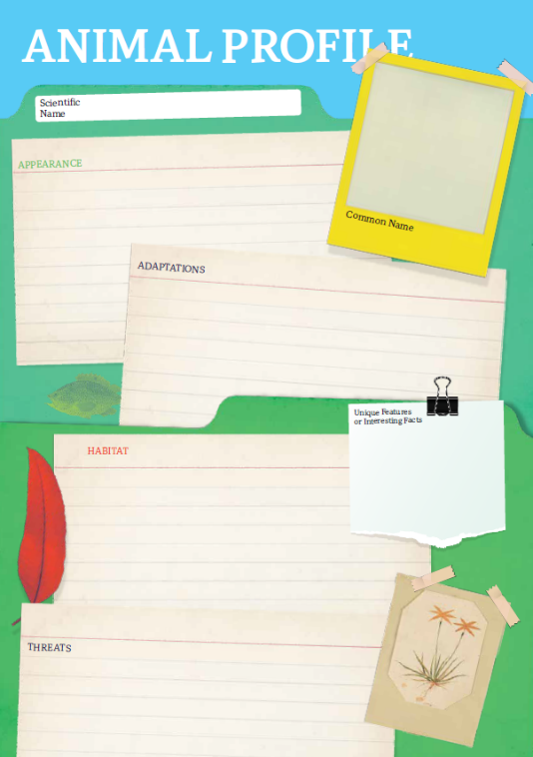
Research
Students will research the following and then share their research findings with the class or create a display in the classroom. Students can use the Animal Profile at the end of this activity.
- Illustration or photo
- Name (common and scientific name)
- Conservation status – What is being done to protect the species?
- Appearance
- Adaptations
- Habitat
- Threats
- Unique features

Further Investigation – Why do whales sing?
Whale songs are one of the most sophisticated communication systems in the animal kingdom. Watch this Ted Ed video and answer the following questions:
- Which species of whale are known to sing?
Did You Know?
The loudest whale sounds are made by blue whales and are louder than a jet plane!
- What do toothed whales use to communicate?
- How do whales generate sound? Give a brief explanation.
- How long can whales sing for?
- Why do they sing?
- What do scientists use to record underwater sounds?
- What impact can noise pollution have on the whales?
- Name three interesting facts you learnt watching the video

To learn more about why whales sound different, watch this Australian Museum video.

Listen to whale songs…
- Blue whale song
- Fin whale song
- Humpback whale song
- Dwarf minke whale song

Activity: Who am I?
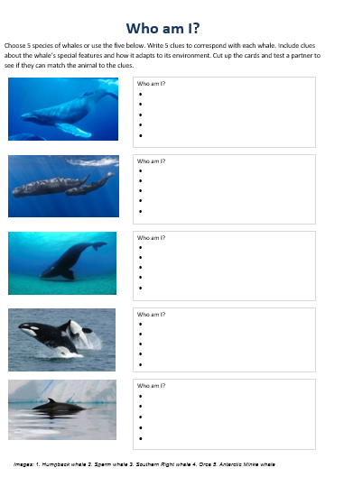
Students will make their own Who am I? game to learn more about whale species.

- Students will research and write 5 clues to correspond with each species of whale in the Who am I? worksheet at the end of this activity, with the first clue being the hardest and the last clue being the easiest.
- Include clues about special features, appearance, adaptations and any threats.
- Students will test their game on a partner.

Useful Websites
- How do whales sing? Scientists point to a specialised voice box that other animals don’t have – ABC News
- Why do whales sing? – TedEd
- Why do whales make sounds? – National Ocean Service
- How do whales communicate? – Newsround
Who am I?
Choose 5 species of whales or use the five below. Write 5 clues to correspond with each whale. Include clues about the whale’s special features and how it adapts to its environment. Cut up the cards and test a partner to see if they can match the animal to the clues.

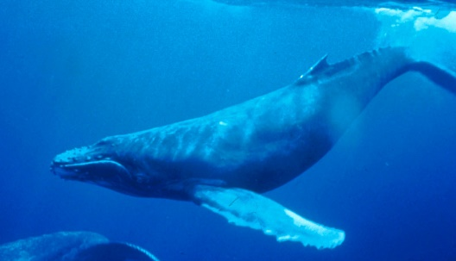 |  | Who am I?
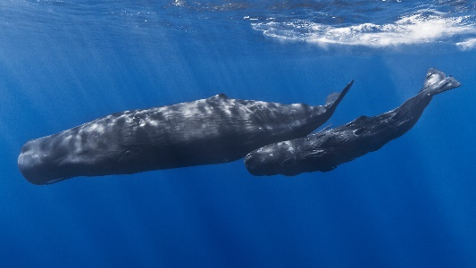 |  | Who am I?
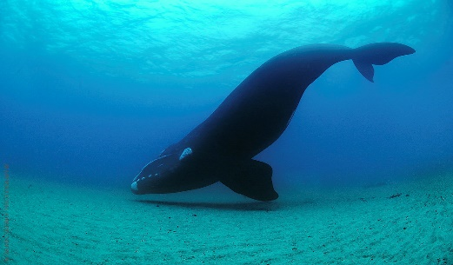 |  | Who am I?
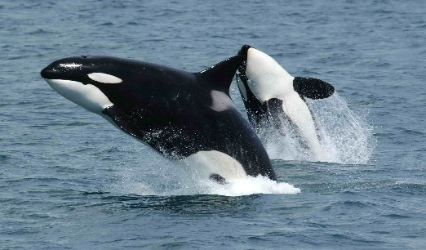 |  | Who am I?
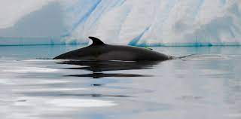 |  | Who am I?  Images: 1. Humpback whale 2. Sperm whale 3. Southern Right whale 4. Orca 5. Antarctic Minke whale

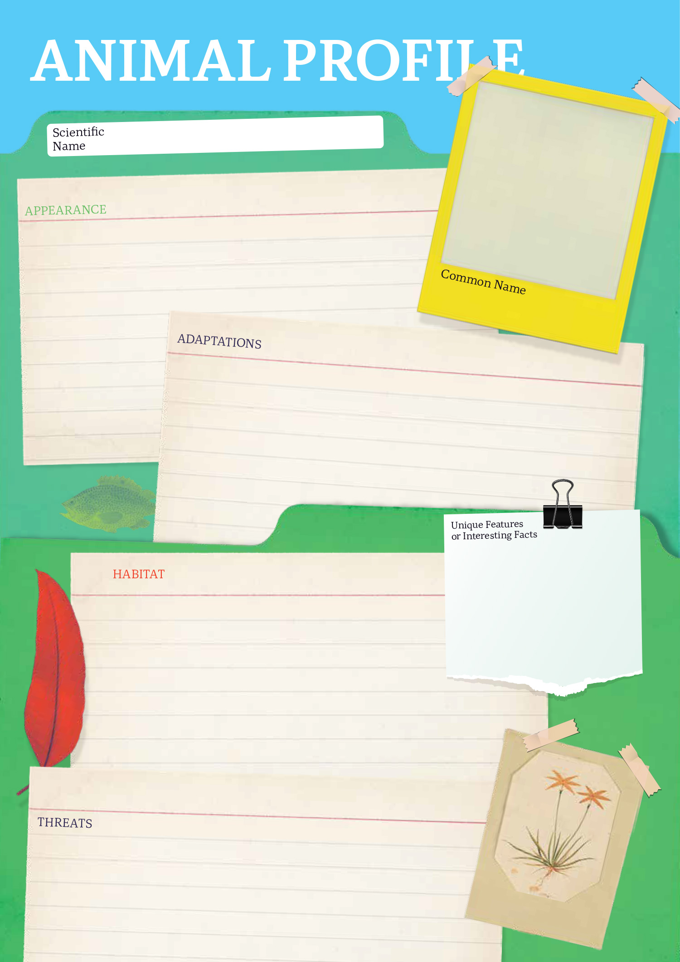

EPISODE 5
5th March 2024

KEY LEARNING
Students will recognise and celebrate Australian women who have made significant positive changes in society.

CURRICULUM
HASS – Year 3 and 4
Pose questions to investigate people, events, places and issues.

Locate and collect information and data from different sources, including observations.

HASS – Year 5 and 6
Develop appropriate questions to guide an inquiry about people, events, developments, places, systems and challenges.

Locate and collect relevant information and data from primary sources and secondary sources.

History – Year 6
The contribution of individuals and groups to the development of Australian society since Federation.

HASS – Year 7
Construct significant questions and propositions to guide investigations about people, events, developments, places, systems and challenges.

  - Teacher Resource

Elizabeth Kenny - Women’s History Month

Focus Questions
Discuss the BTN story as a class and record the main points of the discussion. Students will then respond to the following:
- What started Elizabeth Kenny’s interest in the human body?
- How did Elizabeth treat patients with polio?
- In which country did the `Kenny method’ take off and voted her the most admired woman?
- Why do you think Elizabeth Kenny is an important Australian?
- What did you like about the BTN story?

Activity: Personal Response
Respond to the BTN Elizabeth Kenny story as a class. Students will complete one or more of the following incomplete sentences:

- Elizabeth Kenny was an important Australian because…
- It was interesting to learn…
- These are five words that I would use to describe Elizabeth Kenny…
- This story made me feel…
- It is important to remember Elizabeth Kenny because…

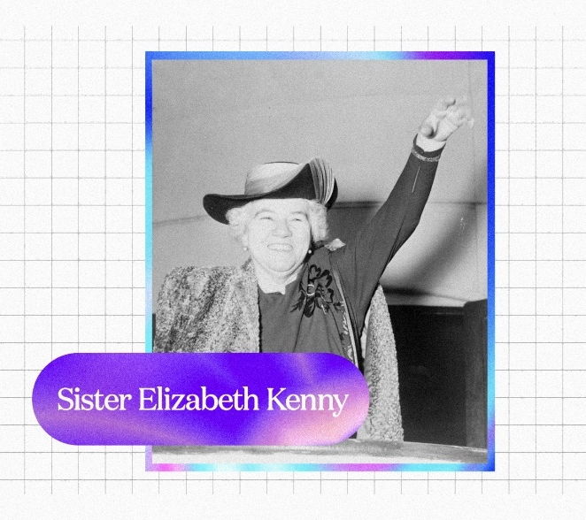

Activity: Step back in time…
Students will explore the life of Elizabeth Kenny to not only get an insight into her life, but to also gain a better understanding of what the times were like - including details about particular social, cultural, and historical perspectives.

Students will step back in time and imagine what life was like for Elizabeth Kenny. Students will find out as much as they can about Elizabeth, including her childhood, major events in her life, and learn more about her achievements and challenges.

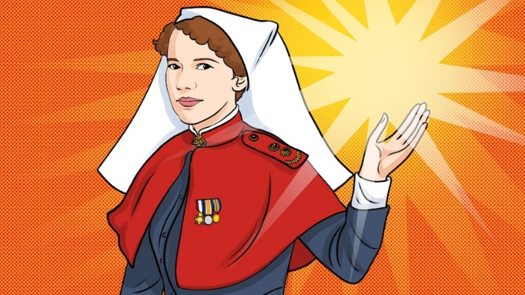
Listening
Start this activity by listening to the ABC Fierce Girls podcast about Elizabeth Kenny as a class. After listening to the podcast discuss what your student’s reactions are to the story and how it made them feel.
- What is your initial response to Elizabeth Kenny’s story?
- How did the stories about her life make you feel?
- What method did Elizabeth Kenny use to treat polio?
ABC Fierce Girls podcast – Elizabeth Kenny
- What opposition did she face from the medical profession?

Writing
Students will then choose a point in time in Elzabeth Kenny’s life, focussing on a particular event or moment in time. Students will then complete one of the following activities:
- Imagine you are Elizabeth Kenny. Write a letter from her perspective to either a friend or family member explaining how she feels and what she is going through.
- Imagine you are a patient with polio and being treated by Elizabeth Kenny. Write a letter to Elizabeth Kenny expressing your thanks for the treatment you received.
- One of Elizabeth Kenny’s significant quotes was “It is better to be a lion for a day, than a sheep all your life”. What do you think she meant by this? Think of a time when Elizabeth Kenny symbolised this and explain using your own words.

Further Investigation
Students will choose one of the following activities to complete individually or in pairs:
- Identify aspects of Elizabeth Kenny’s everyday life (from the past) that are similar and/or different from yours. How can you show that the present is different from or similar to the past?
- Find historical sources of information, for example, personal journals/diaries/memoirs, letters, newspaper and magazine articles, movies, music, photographs, artefacts. Examine each piece of information and identify if it is a primary or secondary source of information. Create a virtual excursion about Elizabeth Kenny using the historical information you find.

Activity: Who inspires you?
Class Discussion
Start the lesson by asking students which women past or present inspire them. It could be women they know in their family, the wider community or someone well-known.

- Which woman in your life do you look up to? Why?
- Which woman in your life inspires you?
- Think about a time a woman in your life helped you solve a problem. What was the problem, and how did she help you solve it?
- Think of a list of women trailblazers.
- What have people that are trailblazers got in common? Think of a list of traits.

Confident
Adventurous
Changemakers
Innovative
Strong
Powerful
Bold
Brave

Activity: Research Project
In this activity students will recognise and celebrate Australian women who have made significant positive changes in society and understand the importance of their contributions. Ask students to brainstorm and list the names of individuals they know or have heard of who have made significant positive changes in society. Encourage them to think about different areas such as civil rights, environmental conservation, science, and more.

Start a class discussion using the following questions:
- Can you think of women, past or present, who have made a positive change in society? Think of people that inspire you or are your role models.
- What qualities make this person special?
- How did their actions make a difference?
- What are some common characteristics and actions of people that are changemakers?
- Who inspires you? Why?

Direct your students to the BTN website to find stories of trailblazing Australian women who’ve made an extraordinary contribution to society, including:
- Nancy Bird Walton – Aviation pioneer
- Dorothy Hill – Scientist
- Edith Cowan – Social reformer and politician
- Faith Bandler – Civil rights activist
- Evonne Goolagong Cawley – Tennis legend

Or visit the ABC Fierce Girls website to learn more about Australian women who dare to do things differently. From athletes to aviators, scientists to spies. From the deep blue sea to the dark, black skies.
Students will choose one trailblazing Australian woman they find inspiring and research and record information about the person. Some possible areas of research include:
- When and where were they born? Describe their family life growing up.
- What are some of their achievements? Choose one to explore in more detail.
- What inspired or motivated them?
- What are some of their values?
- What were some challenges they faced?
- How did they make an impact on people’s lives?
- What do you admire about them?

Students will use a range of primary and secondary sources during their research including biographies, articles, letters, speeches, artworks, photographs, and news stories. To extend learning in this activity students will choose one of the following projects to complete.

Biography
Create a biography about the person, which includes a timeline of important events in their life.

What are some of the key events in their life? Write a summary for one key event, which answers the 5 W’s – Who, What, Where, When and Why?
Creative Writing
Who inspires you?

Write an original story (approx. 500-800 words) about an Australian girl, boy, woman or man you admire most.

They could be someone famous already, or someone you think the world should know more about!

Do you have questions?

Portrait
Plan and create a portrait of the person or group. Think about the expressions, symbolism, and colours that reflect the person, their values, and their impact. Explore and experiment with different techniques and mediums to produce a portrait.

Present your portrait to the class, introducing who the person is, the impact they had and then explain your portrait and what each of the elements in the portrait mean. Organise a class exhibition of your artworks to share with the school and local community.

Podcast
Write stories about people doing inspirational things in your community. Create a podcast using PodOmatic, Buzzsprout to share your stories with the school community.

Activity: International Women’s Day
International Women's Day is a global day celebrating the economic, political, and social achievements of women past, present and future. How does your school honour and celebrate the achievements of women all around the world? Go to the UN International Women’s Day website for more information.

Useful Websites
- Women’s History Month 2024 – BTN Newsbreak
- Women in History Special 2020 – BTN
- NAIDOC Indigenous Women – BTN
- Women’s History Month 2020 – BTN
- Australian Women in Politics – BTN
- Women’s History Month – Royal Australian Historical Society
- Fierce Girls – ABC

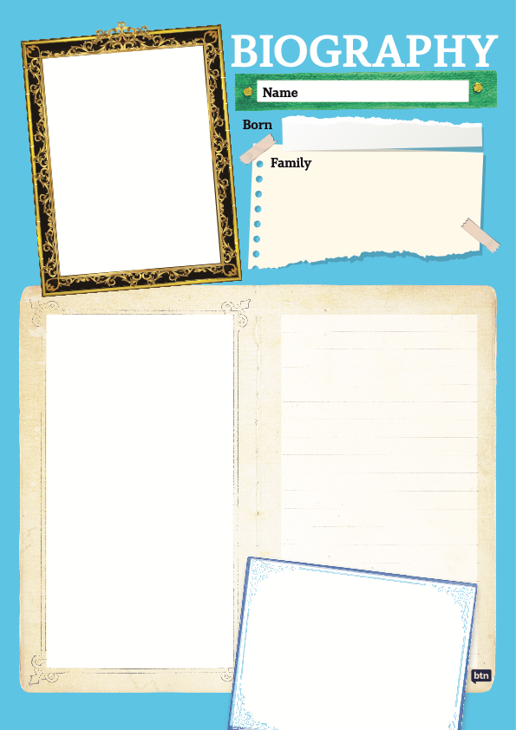

  - Teacher Resource

BTN Transcript: Episode 5 - 5/3/2024

Hey. I'm Amelia Moseley and you're watching BTN. Thanks for hanging out with us again. Let’s see what’s on today’s show. We find out how climate change is changing Aussie childhood, learn why some expensive skincare products might be doing you harm and discover the secrets behind the songs of whales.

University Changes

Reporter: Michelle Wakim

INTRO: But first today, to university. I know, it's probably a few years off for most of you, but when school's over you might be thinking of going to uni or TAFE and a report that was released last week has recommended some changes to make it easier for young Aussies to access higher education. Here's Michelle.

STUDENT: I want to be an architect when I grow up.
STUDENT: I want to be an artist.
STUDENT: I want to be a dermatologist.
STUDENT: I want to be a doctor.
STUDENT: I want to be a racing driver.
STUDENT: I want to be a geologist.
MICHELLE WAKIM, REPORTER: Depending on what you're interested in, university could become a pretty important part of life after school. In fact, it has been for about 50 per cent of Australians.
The idea of a place where adults can keep learning has been around for hundreds of years. The first true university opened way back in 1088. It was the University of Bologna in Italy and it's still going today, and so are Oxford and Cambridge in England, which opened not too long after that.
Fast forward to the 19th century and places of higher education were appearing in Australia. The first were technical colleges where people would learn trades. The Sydney Technical College opened in 1835 and would later become known as TAFE. In 1850, the University of Sydney opened its doors. At the time, you could only study science, maths, politics, French or German, so not quite as much choice as we have today.
By the time the first World War broke out, every state had its own uni, and women were becoming common sight on campus. After World War 2, there was a big university boom around Australia as the economy grew and more industries called for people with training. Unis started to become really important places for research, as well as education and the government invested more money into them. For a time in Australia, university was actually free, which encouraged a lot of people to join.
Now, Australia has 41 universities, and more than 1.4 million people go to them. TAFE is also in every state and territory and has more than 500,000 students. TAFEs and most unis are owned by the government. They're funded partly by tax, and partly by fees which can vary a lot from free to tens of thousands of dollars. Aussie students can apply for HELP, which stands for the Higher Education Loan Program, which lets you pay off your fees when you start work. But for a lot of people, paying to go to uni, is pretty tough and that's something that's been highlighted in this report. It’s the biggest review that's been done into Aussie universities in more than a decade.
PROFESSOR MARK SCOTT, UNIVERSITY OF SYDNEY: I think what it really reveals is that higher education in Australia has been chronically underfunded now for decades.
MICHELLE: The report highlighted just how important university and TAFE is, both for training and for research, and says if we want Australian society to succeed in the future we need to invest in higher education and encourage more kids to keep studying after school.
JASON CLARE, MINISTER FOR EDUCATION: In the decades ahead, we need 80% of our work force not just to have finished school, but to have gone to uni or to TAFE.
MICHELLE: To do that, the report says there needs to be more financial support for people who have to move to the city for uni and more funding, so courses are cheaper, and students end up with less debt.
JASON CLARE, MINISTER FOR EDUCATION: We've got to smash down any visible barrier that stops a lot of kids from poor families and our outer suburbs and the regions from getting a crack at university in the first place.
MICHELLE: So, perhaps by the time you’re ready, it will be easier to keep learning after school.
STUDENT: If there’s are more university people, there's more people to help out with things that need to have university training, such as doctors, law.
STUDENT: I think it's way important for kids to go to university.
STUDENT: So, they can learn about what they want to be when they grow up.
News Quiz

Do you know the name of the Aussie spy organisation that this man is in charge of? Is it MI5, ASIO or the CIA? It’s ASIO, the Australian Security Intelligence Organisation. Last week it’s Director General, Mike Burgess, caused a stir when he revealed a former politician had been recruited by foreign spies.

MIKE BURGESS: This politician sold out their country, party, former colleagues to advance the interests of a foreign regime.

He didn’t reveal who the former politician was, but it’s made a lot of people angry.

Last week some people celebrated the rarest birthday that anyone can have. What date is that? It’s February 29th. It’s rare because we only get it once every four years, on a leap year.

PERSON: 21 today and I haven’t caught a cray.

And can you name the famous colourful parade which was held in Sydney on the weekend? It’s the Gay and Lesbian Mardi Gras. It’s one of the biggest LGBTQI+ pride events in the world and it’s been going since 1978.

PERSON: It's a special place walking down here. It's amazing.

Climate Disaster Kids

Reporter: Thomas Midena

INTRO: If you've ever been through a natural disaster, you'll know it can have a huge impact on your life.
And now a new report by UNICEF has looked at exactly how Aussie kids can be affected by extreme weather events and what that's costing the country in the long run. Here's Thomas.

KID: All this water's coming in from the damn, which is normally never full, but it's really full right now.
KID: When smoke was flooding our property, we knew it was time to go.
KID: It was raining a lot, and it flooded. And there was a lot and a lot of wind.
KID: The river was really high, and really close to land. And it rained like every day.

KID: It was just me and my mum there. And, yeah, we were pretty scared because I'd never seen wind
that strong in my life before.
THOMAS MIDENA, REPORTER: Whether it's a flood, bushfire, cyclone, or a drought, there are lots of Aussie kids who know what it's like to live through a disaster.
In fact, according to a new report, 1.4 million Australian children and young people experience extreme weather each year. That's 1 in 6 kids. And researchers say that because of climate change, that number is on the rise.
OSCAR: So yesterday marked two years since we lived through a major flood. Just colossal amounts of rain poured down on us for days. And then the water rose right up in the middle of the night and just took over our town.
ROSE: The day of the bushfire was really, really smoky. You couldn’t see anything at all, and the sun was completely blocked out for weeks on end.
OPI: Even though I'm only 12, I've already been through two natural disasters. So, I'm worried that when I grow older, I'll have to deal with more and more natural disasters.
NISHADH REGO, UNICEF: We know now that with climate change, these events are going to be more frequent, they're going to be more severe, they're going to be a bigger part of our lives.
Nishadh Rego is from UNICEF, the United Nations Children's Fund. And he says natural disasters can have a lasting impact on kids.
KID: My house, we don't think we're gonna be able to move anywhere again. It's really unstable.
Kids can suffer from mental health problems like anxiety and stress.

KID: Even today, people still don't have houses. And people might still have houses, but they still have that trauma. Like, it's pretty life-changing event.

And disasters can have a big impact on their education.
NISHADH: A school might be damaged, the roads leading to a school might be damaged, and if they miss out on enough school, or if their school is destroyed for a period of time, they are less likely to finish year 12. And this has all kinds of consequences for them later in life.
UNICEF says this sort of thing isn't just bad for kids, it's bad for the economy.
NISHADH: We know through this report that disasters are very expensive, and that they cost Australia roughly $3 billion a year on average and up to $6.2 billion in a year where there are many disasters.
Which is why UNICEF is calling on the government to invest more into helping young people who have been affected by climate disasters.
NISHADH: So for example, when a disaster strikes, we need safe play areas, learning areas, areas for children to engage with each other and just relax in the context of an emergency.
They also want young people to have more of a say in government policy.

NISHADH: Children and young people are experts in their own lives. They have lots to say. And they have good things to say.

They say we can learn a lot from young people's experiences and how they got through some of the tough times.
OPI: I know this isn't going to be the last natural disaster that my community is going to witness, so I feel like people need to have better knowledge on how to prepare.
OSCAR: This mob's very resilient. So, the whole community got in and rescued people off of their rooves in tinnies and even after the flood with all the mess that was about, everyone helped each other to clean it all up.
Skinfluencers

Reporter: Cale Matthews

INTRO: Now to a trend that's got some experts worried. They say a lot of young people are watching so-called skinfluencers on social media and that's encouraging them to buy expensive beauty products that might actually be doing more harm than good. Cale looked into it.

Grace was 10 when she first became obsessed with skincare.
GRACE: I just saw some people online and I was interested and want to try it out. I know I've spent a lot on moisturizers and like skincare, like $90 for like maybe like one thing.
There's been a huge rise in kids, mostly girls, getting into the world of beauty products well before their teens. And Grace says there's a big reason why.
GRACE: Well there’s a lot of influencers like that just promote skincare and that's very popular. And they start trying it out and see how they like it. Yeah.
SKINFLUENCER: We're going to do my full make-up with only pink packaging.
SKINFLUENCER: You only have five minutes to get ready.
SKINFLUENCER: This is a 24-carat gold face serum. It's $220, so it's expensive.

The problem is, sometimes these products can do more harm than good if they're not the right product or not used properly.
GRACE: Once I bought this thing and burned my skin my friends wouldn't read. And they've got all these little bumps all over my face the next day. I was like crying at one stage because it was so painful.
MICHELLE WONG: The problem with these is that they will increase your skin sensitivity to the sun. So, in other words, you'll go into the sun, and you'll get burned more easily.
Dr Michelle Wong is a chemist who debunks a lot of skincare myths via her online persona Lab Muffin Beauty Science.
MICHELLE WONG IN VIDEO: That is actually unscientific.
She says kids’ skin is very different to adults.
MICHELLE WONG: So, our skin really kind of reaches its peak in terms of things like collagen, which is one of the proteins in your skin that keeps it smooth and bouncy. About your mid-20s. So, if you are, say, younger than that significantly younger than that, like 10 then there's just no real need for these sorts of products and they can actually cause damage to your skin.
The problem is some of these products can contain chemicals not suited to young skin. Things like glycolic and lactic acid and retinoids. These chemicals can make our skin more sensitive to the sun as well as irritate and break down our skin barrier.
MICHELLE WONG: If you're getting acne, then that's probably around the time when you can start getting benefits from it. But if you're younger, then there's no real point to it. At best, it's a waste of money. At worst, it could potentially make your skin really sensitive.
MICHELLE WONG: Back in the day, maybe 10 years ago, when people were looking at these sorts of skincare messages when they were looking at anti-aging skincare ads, a lot of the time that was on other places, like on TV, and it would be in the middle of say, a TV show that was aimed at older people. But these days, because everything is so online, then a lot of this sort of age targeting isn't quite right.
According to Dr Wong, beauty filters and filters that show what you will look like when you're older have created an obsession with aging.
MICHELLE WONG: You kind of just lose sense of what real skin actually looks like, and how closely anyone is actually looking at your skin.
There's nothing wrong with wanting to look after your skin and having a simple routine that's suited to you can be good.
DR MICHELLE WONG: I think it's okay for kids to start looking after their skin, especially in Australia. So, one of the things that is really important is sunscreen.
If your skin is dry then oils and hydrating ingredients are both good. If your skin is on the oily side, you want to look for a lighter formula that has a lot of hydration. Grace, whos' now 13, says she's a bit more careful with the products she uses.
GRACE: So, I try to stick to like more natural skincare now. All these like acids and things are just damaging my skin, and all the money I'm spending, not very good. I try to use as little as I can, just things I think I should be using.

Whale Songs

Reporter: Wren Gillett

INTRO: Now to a whale of a mystery that may have just been solved by researchers. For the first time, they've managed to get an idea of how baleen whales produce the songs that have fascinated sailors and scientists for centuries. Here's Wren.

DOCUMENTARY NARRATOR: Humpbacks sing day and night, about 50 feet below the surface.

WHALE TEACHER: Alright class now let's see how much you've learnt. Now…
CLASS: Meeeee aww meeeeeee.
WREN GILLETT, REPORTER: Yep, the language of whales is something that's fascinated human beings for centuries. Many years ago, sailors would hear these mysterious whoops and rumbles, and think they were being made by ghosts. But eventually, we figured out it was whales, using sound to navigate the vast open ocean and find the loves of their life.
CLASS: aaaaawwwww meeeeeee.
WHALE TEACHER: Yes, very good, lovely. Now let's hear from an expert.
VANESSA PIROTTA, WHALE SCIENTIST: Whoop whoop whoop whoop – that’s whale for Hello, I'm Dr. Vanessa Parotta. And I'm a whale scientist. I have heard whales make a lot of different sounds, but these are some of my favorites. So, this is the disco whale, it sounds a bit like this: “Whoop whoop whoop whoop". And then there was one whale that heard that was sounding like this: “mmmmmmMMMMMMmmmmmm”.
And some whales, like the male humpback, even sing songs with distinct patterns which can change from year to year.
VANESSA PIROTTA, WHALE SCIENTIST: So they will sing songs, kind of like the coolest tune of the year, which is similar to the hottest 100, which means that they might be singing a song this year, which is then not cool next year, if you know what I mean. But what's really interesting, because sound can travel, the top 100 songs that happened in Australian waters this year could become the hottest 100 next year in another wild population.
But while humans have been studying whale songs for years and years, we've never fully understood how they actually sing. Until now. By studying the voice boxes of whales that had died naturally, scientists have been able to paint a clearer picture of how they make those amazing noises.
WHALE TEACHER: And this is what they found. Unlike humans, baleen whales don't have vocal cords. Instead, they have a U-shaped tissue they a huge push a huge amount air through that vibrates this big "cushion" of fat and muscle, which produces sound. Baleen whales can repeat this process over and over again using the same breath of air.
VANESSA PIROTTA, WHALE SCIENTIST: And they can sing for a long time, in the case of a humpback whale, up to 20 minutes or so.
WHALE TEACHER: You hear that guys. Stamina. Alright let's see how long we can hold this ok.
CLASS: Meeeeee aaaaaawwwwwwwwwww
But as loud as whales are, they can still be interrupted by us.
VANESSA PIROTTA, WHALE SCIENTIST: Now that we know that whales make sound to talk to each other across long distances, we need to be careful as humans because we also produce sound in the ocean, like the sound of shipping noises. We also might have underwater constructions. Sonar, what we need to be mindful of is to make sure that we don't make too much noise so we reduce the opportunity for whales to talk to each other.
While we know a lot more about whale songs, there's still a lot more to learn, including what these sounds actually mean.
VANESSA PIROTTA, WHALE SCIENTIST: As humans, we don't yet 100% understand what whales are trying to say.
STUDENT: So, what, you don't actually know how to speak whale?
WHALE TEACHER: Well uh not really. But it's been fun hasn't it. Can I get a WHHOOOPP WHOOOOOP.
CLASS: WHHOOOPP WHOOOOOP.
Quiz

What is a baleen whale? A whale with teeth, a whale without teeth or a whale found only in Antarctica?
It's a whale without teeth. Instead, they have brush like fibres in their mouth which they use as a kind of sieve to collect the plankton that they eat.

Sport

The Matildas are going to the Olympics. Yup, the Tillies booked their giant novelty sized ticket to Paris last week after winning their second qualifying match against Uzbekistan.
Speaking of overseas trips, the NRL season kicked off this weekend in Las Vegas. It’s the first time premiership games have ever been played on US soil in an effort to crack the US market and it was pretty successful. More than 40,000 people packed Allegiant Stadium to watch the Sydney Roosters beat the Brisbane Broncos 20 to 10.

COMMENTATOR: And Radley scores the try!

And the Manly Sea Eagles smash the South Sydney Rabbitohs 36 to 24.
And the Aussies have won their first test against New Zealand in the Trans-Tasman series. Nathan Lyon and Cameron Green were absolute superstars leading the team to a 172-run victory.

COMMENTATOR: And Australia have won it quite convincingly in the end.

The teams will meet again on Friday for the final test of the series.

Elizabeth Kenny – Women’s History Month
Rookie Reporter: Nina

INTRO: And finally, today, March is Women's History Month. So, we're going to be bringing you the stories of some famous and influential Aussie women, over the next few episodes, with the help of our rookie reporters. This week we'll find out about the remarkable life and work of Elizabeth Kenny. Take a look.

NINA, ROOKIE REPORTER: Meet Sister Elizabeth Kenny. Elizabeth was born in 1880 in Warialda, in country New South Wales. She loved being outside, riding her horse and exploring, and wasn't so interested in behaving the way girls were expected to behave at the time.
When she was 17, she was out on a ride, fell off her horse and broke her arm. And this started her interest in the human body. While she was recovering from her injury, Elizabeth passed the time by reading her doctor's medical books and learning the names of every bone in the body. When she got home, she kept studying and even built a model skeleton out of stuff she collected.
Eventually, she was ready to use her knowledge to help others and became a bush nurse riding her horse to patient's houses for home visits. She did everything from delivering babies to bandaging broken bones, and she often saw cases of polio.
Polio doesn't exist in Australia anymore thanks to vaccines, but for a long time it was really common, especially in children. It causes terrible muscle pains and spasms and breathing problems, and doctors used to treat it by putting patient's limbs in casts and not letting them move. But Elizabeth knew from treating other patients that the best thing for aches was often hot cloths, exercise, and lots of stretching, or what we now know as physiotherapy. So, she tried it on polio patients, and it worked. Of the 20 children who caught polio in her area, the 6 she treated completely recovered.
She wanted to share her method, which became known as the Kenny Method, with doctors, but because she was a woman, most of them didn't take her seriously.
In 1932, there was a big polio epidemic across Australia. Word started to spread about the Kenny Method. Within four years, four Kenny Clinics were open, treating hundreds of patients. And then Elizabeth went to the US where there was also a polio outbreak.
Doctors over there were way more supportive of her method. In 1942 the Sister Kenny Institute opened to train therapists and in 1952, she was voted the most admired woman in the US. She was a bit of a celebrity over there and a Hollywood movie was even made about her life.

FILM – SISTER KENNY, 1946: This is going to feel hot, but it won’t burn you.
NINA: Today, the Kenny Method is still used in countries where people get polio, and it's all thanks to Sister Elizabeth Kenny for thinking outside the box whether people liked it or not. After all, her motto was: “It's better to be a lion for a day than a sheep all your life”.

Closer

Well, that's it for this week. I hope you've enjoyed the show and maybe learned a thing or two. We'll be back with more next week, of course. And in the meantime, you can check out Newsbreak right here in the studio every weekday or if you're in high school there's BTN High to keep you up to date. Have the best week and I’ll see you soon. Bye.

