Episode 26
8th September 2020

Victoria COVID Roadmap
- Discuss the BTN Victoria COVID Roadmap story as a class and record the main points of the discussion.
- How many weeks has Melbourne’s stage 4 restrictions been extended?
- What is the curfew in Melbourne?
- How many hours a day can people exercise outdoors?
- What is COVID normal?
- How does the roadmap affect regional Victoria?
- How do people feel about the new COVID roadmap in Victoria?
- How have the restrictions affected businesses in Victoria?
- How did this story make you feel?
- What questions do you have about this story?

Social Media News
- What is the main point of the BTN Social Media News story?
- Complete the following sentence. Facebook has announced it may stop Australians from posting and sharing ______ on its apps.
- What company might start charging Australians to use its search engine?
- Where do people get their news? Give an example.
- How do many traditional news outlets make their money?
- What law does the Australian Government want to introduce in relation to online news?
- What might Google and Facebook do if the law goes through?
- Where do you get your news?
- Do you think people will want to pay for online news? Why or why not?
- What do you understand more clearly since watching this story?

Threatened Flora
- Discuss the BTN Threatened Flora story in pairs. Record the main points of the discussion.
- Where in Australia can you find the Woods Well Spyridium? Find using Google Maps.
- What factors are threatening the survival of some Australian flora?
- How many different species of plants are there in Australia?
- What percent of plants are listed as threatened in Australia?
- What things depend on plant species? Give one example.
- How do botanic gardens help protect plants?
- What is a seed bank?
- How are the kids in the BTN story helping protect Australia’s plants?
- If we lose a plant species it is lost forever. True or false?

Check out the Threatened Flora resource on the Teachers page.

Flying Cars
- Briefly summarise the BTN Flying Cars story.
- What does the flying car look like? Describe.
- Who built the car?
- How high did the flying car hover above the ground?
- How long did the flying car stay up in the air?
- When do they predict we will be using flying cars?
  - 2023
  - 2033
  - 2053
- When was the first flying car to successfully take flight built?
- What challenges are there in building a flying car? Give two examples.
- What are some advantages of having flying cars?
- Do you think having flying cars is a good idea? Give reasons for your answer.

Check out the Flying Cars resource on the Teachers page.

Teacher Resource
Episode 26
8th September 2020

Threatened Flora
Students will learn more about the importance of preserving native plants and research a threatened native plant in detail.

Science - Year 4
Living things have life cycles.

Living things, including plants and animals, depend on each other and the environment to survive.

Science – Year 5
Living things have structural features and adaptations that help them to survive in their environment.

Scientific knowledge is used to inform personal and community decisions.

Science – Year 6
The growth and survival of living things are affected by the physical conditions of their environment.

- Discuss the BTN Threatened Flora story in pairs. Record the main points of the discussion.
- Where in Australia can you find the Woods Well Spyridium? Find using Google Maps.
- What factors are threatening the survival of some Australian flora?
- How many different species of plants are there in Australia?
- What percent of plants are listed as threatened in Australia?
- What things depend on plant species? Give one example.
- How do botanic gardens help protect plants?
- What is a seed bank?
- How are the kids in the BTN story helping protect Australia’s plants?
- If we lose a plant species it is lost forever. True or false?

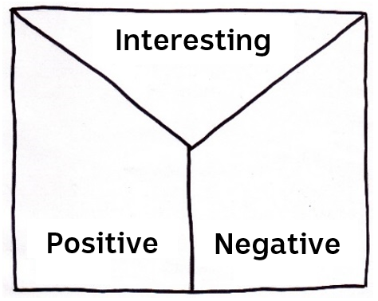Note taking
Students will practise their note-taking skills while watching the BTN Threatened Flora story. After watching the story, ask students to reflect on and organise the information into three categories. What information in the story was...?
- Positive
- Negative or
- Interesting

Class Discussion
Discuss the BTN Threatened Flora story as a class, using the following questions to guide the discussion. Record responses on a mind map. Clarify students’ understanding of the following terms: Flora, introduced species, native, conservation and biodiversity.
- Why do we need plants?
- What native plants do you know? Make a list.
- What things are threatening our native plants?
- Name an animal or insect that relies on native plants.
- Why is it important that we protect and conserve living things?

Match these terms to their definitions

Term | Definition
Threatened species | This species is facing a high risk of extinction in the wild in the medium-term
Extinct | There is no immediate threat to the survival of this species
Least concern | This species is facing a very high risk of extinction in the wild in the near future
Vulnerable species | This species may be considered threatened in the near future
Endangered | This species is no longer in existence

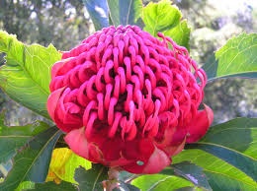Get to know the plants in your area
Students choose a plant in their school grounds, backyard or local park. Then respond to the following:
- Describe the plant they have chosen using words and an illustration. Include the different parts of the plant and any interesting features.
- Identify what type of plant it is. Find its botanical name. Is it a native or introduced species?
- Describe any insects or wildlife on or near the plant.
- Find out the conservation status of the plant.

Further investigation
Does your local botanic garden have a program similar to the one in the BTN story? Students can investigate working with their local botanic garden to collect and propagate seeds from endangered plants.
Improve the biodiversity in your school yard
Students will work together to plant and care for native plants in their school yard. Ask them to consider the following:
- What kind of native plants will you plant and where will you plant them? Which plants are native to your area?
- Where will the plants get the sun or shade they need?
- Where will it be most appreciated?
- What materials and tools are needed?
- Predict and record the growth rate, for the first days/weeks/months, and see whose predictions are most accurate.
- Include an information label next to the plant for other students to learn more about it and the biodiversity of your school yard. Include the botanical name, when it was planted and some basic information.
- Make a map of your school yard which highlights important plants in your school yard.
Students will choose a threatened Australian plant to learn more about (they may want to choose one that is local to their area). The Threatened Australian Plants fact sheet may help students select a plant to investigate. Use the template below to help guide their research.

Research project – Threatened Australian Plant
Scientific and common name
Describe its appearance
What does it look like (shape, size, colour, special features)?

Locate where this species can be found using Google Maps

Conservation Status

Threats

Recovery Action (what is being done to protect the species)

Interesting facts
- What is your favourite thing about this species?
- What surprised you about your research?

Photograph or Illustration

BTN stories
These BTN stories explore different ways in which threatened plants are being protected.
Endangered Seeds
- How many plant species in WA are threatened with extinction?
- 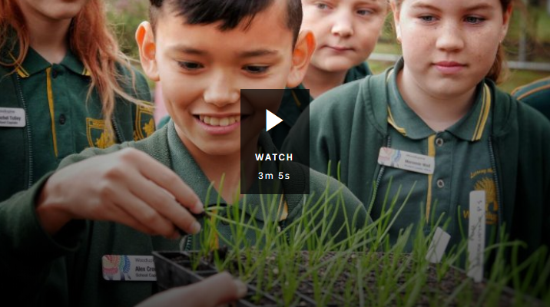What is a seed bank?
- Where is the biggest seed bank in the world located? Find using Google Maps.
- How many different types of seeds does it hold?
- What type of plants does the seed bank in WA focus on?
- What are the kids in the BTN story doing?
- What is the name of the plant they are looking after?
- How do the kids know when to harvest the seeds from the plant?
- Why is it important to collect seeds?

Plant Bank
- What is another word for plants?
- How many species of plants can be found in Australia?
- 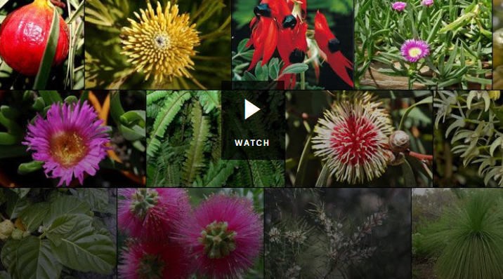Since European settlers arrived in Australia how many different types of plants have disappeared?
- Someone that studies plants is called a...
- The idea of seed banks is a completely new idea. True or false?
- List a reason why scientists store seeds?
- Where in the world is the ‘doomsday vault’? Locate using Google Maps.
- Why is it important that we look after our plants?
- How are seeds prepared for the seed bank? Illustrate using a flow chart.

Doomsday vault
- Describe what the seed bank and its surroundings looks like.
- 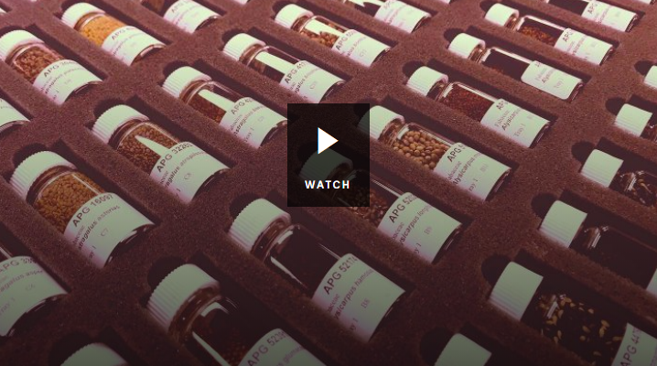Why was the seed bank created?
- Why is the seed bank also called the Doomsday Seed Vault?
- How many different types of seeds are stored in the bank?
- List some of the types of seeds that are stored in the seed bank.
- Australia is about to make its biggest deposit to the seed bank. True or false?
- How old is the Doomsday Seed Vault?
- What did you learn while watching the BTN story?
Threatened Australian plants – Department of Environment and Heritage
https://www.environment.gov.au/system/files/resources/d947f8ec-dd8b-4e7f-bd3b-8246e0702547/files/plants.pdf

Plant Bank – BTN
https://www.abc.net.au/btn/classroom/plant-bank/10529572

Endangered Seeds - BTN
https://www.abc.net.au/btn/classroom/endangered-seeds/11229492

National Herbarium of New South Wales – The Royal Botanic Garden Sydney
https://www.rbgsyd.nsw.gov.au/Science/National-Herbarium-of-New-South-Wales

Teacher Resource
Episode 26
8th September 2020
Flying Cars
Students will generate and communicate design ideas for a car of the future. Students will design a car that has minimal impact on the environment.

Design and Technologies – Years 3 and 4
Recognise the role of people in design and technologies occupations and explore factors, including sustainability that impact on the design of products, services and environments to meet community needs.

Generate, develop, and communicate design ideas and decisions using appropriate technical terms and graphical representation techniques.

Design and Technologies – Years 5 and 6
Examine how people in design and technologies occupations address competing considerations, including sustainability in the design of products, services, and environments for current and future use.

Generate, develop and communicate design ideas and processes for audiences using appropriate technical terms and graphical representation techniques

Design and Technologies – Years 7 and 8
Generate, develop, test and communicate design ideas, plans and processes for various audiences using appropriate technical terms and technologies including graphical representation techniques.
- Briefly summarise the BTN Flying Cars story.
- What does the flying car look like? Describe.
- Who built the car?
- How high did the flying car hover above the ground?
- How long did the flying car stay up in the air?
- When do they predict we will be using flying cars?
- When was the first flying car to successfully take flight built?
- What challenges are there in building a flying car? Give two examples.
- What are some advantages of having flying cars?
- Do you think having flying cars is a good idea? Give reasons for your answer.

Class discussion
Students will discuss the BTN Flying Cars story in pairs and then share their thoughts with the class.
- What do you THINK about what you saw in this video?
- What does this video make you WONDER?
- What do you think cars of the future will look like?
- Think of three questions you would like to ask the engineers of the car featured in the BTN Flying Cars story.
- These are five words that I would use to describe the flying car …

KWLH
Hold a class discussion after watching the BTN Flying Cars story. What questions were raised in the discussion (what are the gaps in their knowledge)? The following KWLH organiser provides students with a framework to explore their knowledge on this topic and consider what they would like to know and learn.

What do I know? | What do I want to know? | What have I learnt? | How will I find out?
Questions for inquiry
Students will develop their own question/s for inquiry, collecting and recording information from a wide variety of sources. Students may develop their own question for inquiry or select one or more of the questions below.

- Why do people want flying cars? Investigate the pros and cons for flying cars and use a T-chart to record your findings.
- How have cars changed since their invention? Explore the history of cars in more detail and create a timeline of significant events. Alternatively, choose another mode of transport to explore in more detail and plot your findings on a historical timeline.
- Why don’t we have flying cars yet? List all the reasons you can think of. Write a persuasive text either for or against flying cars.
- What energy sources are used to power cars? Explore in more detail and rate them from least to most environmentally friendly.
- Who is involved in the design and manufacturing of cars? Make a list of the different roles and their responsibilities.
- Make a prediction about how cars will change in the future. Illustrate your predictions.

Students can present the information in one of the followng ways:
- Prezi presentation
- An infographic using Canva

Car of the future
Before starting this activity, hold a class discussion, asking students what sort of car they think they will be driving in 50 years’ time? Think about safety, environmental impact, sustainability, power sources and innovation.

In small groups, students will imagine they are engineers and design a car of the future or make a modification to a car (to improve the design or function of a car). Ask students to respond to the following:

- How can cars be improved? For example, they could be more environmentally friendly, or they could be safer. What’s the problem and what are some solutions to the problem?
- Write a brief for your design, using these headings as a guide: Background, Criteria, Your Challenge, Constraints.
- Sketch a drawing of the car with labels to show its features. Use terms like chassis, wheels and axles.
- Choose a body size, engine size, fuel type and accessories.
- What is the source of power for your car?
- What speed will your car travel?
- What safety features does your car have?
- What materials will be used to make your car? Are they environmentally friendly?
- What are the interior and exterior features?
- What new technologies will you incorporate in your design?
- How will the car benefit people?
- How will the car benefit the environment?
- Why is your design the best one for your community?
- What is unique about the design?
- What inspired you to create your invention?

Choose a project
Individually or in small groups, students will choose one of the following projects to work on and then present their findings to the class.
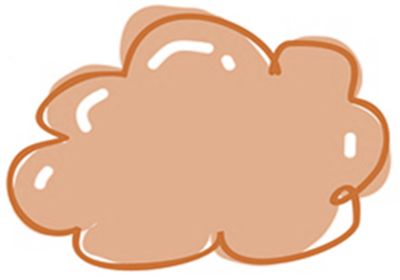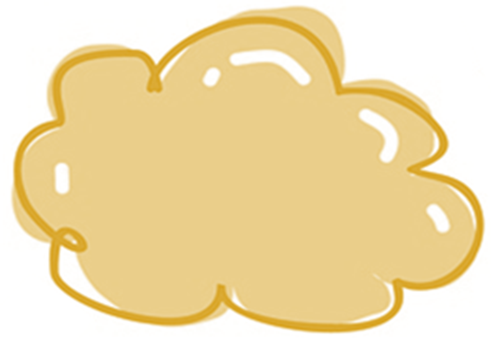
Air powered car
Do you think you could build a car powered by nothing but air? What materials would you need? Hint: a balloon! Experiment with a range of materials and test which design travels the fastest and furthest.
Car review
What are the pros and cons of electric cars? Use a T-chart to record your findings. Choose an eco-friendly car to research and write a review on it.

Rubber band car
Do you think you could build a car powered by a rubber band? Experiment with a range of materials including rubber bands as your source of power. What will you use for the wheels, axles and chassis? Race against your classmates!
Solar powered car
What are the pros and cons of solar powered cars? Become an engineer and build your own solar powered car. There are inexpensive solar car kits available online!

Electric Car Future – BTN
https://www.abc.net.au/btn/classroom/electric-car-future/10970808

When was the first car made? – BTN
https://www.abc.net.au/btn/classroom/when-was-the-first-car-made/10488924

Driverless Cars – BTN
https://www.abc.net.au/btn/classroom/driverless-cars/10522100

Electric Cars – BTN
https://www.abc.net.au/btn/classroom/electric-cars/10528362

Japan wants flying cars in its skies in three years. Here's how they plan to pull it off – ABC News
https://www.abc.net.au/news/2020-08-29/flying-cars-could-be-a-reality-in-japan-in-three-years/12599544

BTN Transcript: Episode 26 – 8/9/20

Hey there. Amelia here with another episode of BTN. Here's what's coming up. We hear about some Melbourne kids' lives in lockdown, learn more about Australia's diverse and delicate flora and take a ride to the future of flying cars.

Victoria’s COVID Roadmap

Reporter: Amelia Moseley

INTRO: All that and more soon. But first today to Victoria. As you know, the state's been going through a tough time with a big spike in COVID-19 cases and a strict lockdown to try to bring it under control. While there has been some progress, it's not over yet. On the weekend the state’s premier announced his roadmap out of restrictions. Here's Charlotte.
For Victorians, it's been a long and bumpy ride with lockdowns, curfews and border closures that have kept families apart and the premier says that the road ahead won't be a short one.
DAN ANDREWS, VICTORIAN PREMIER: There is no choice but to do this in a safe a steady way.
On the weekend he released Victoria's roadmap for reopening. It actually looks like this, but it’s a good metaphor. First up for the state's capital, there's a bit of a roadblock. Melbourne stage 4 restrictions, that were supposed to end next week, have now been extended for an extra two weeks.
DAN ANDREWS, VICTORIAN PREMIER: We cannot open up at this time if we were then we would lose control very very quickly.
But there will be a couple of changes. The city's curfew, which is when people have to be inside, will be extended to 9pm instead of 8. People will also be allowed to exercise outside for up to two hours a day rather than just one. And people who live alone will be able to have one visitor. If the city reaches an average daily case rate of 30 to 50 over those two weeks, it will move to step two.

In step 2, groups of five people will be allowed to gather outside and VCE students and prep to grade 2 students can start going back to the classroom. If things are still smooth sailing or driving and cases keep going down, it'll be time for a stop off at step 3. That will mean no curfew and retail stores and dine-in restaurants will be allowed to re-open. It'll also be when year’s 3 to 10 might start heading back to school.
After there are no new cases in the state for two weeks, it'll be time to hit the road again for the last step. Up to 50 people will be able to gather outside and all sports will start back up. After no new cases for 28 days, Victoria will arrive at its final destination also known as COVID normal. Most stuff will be back to normal with students back at school and no limits on outdoor gatherings or visitors to the home.
Regional Victoria, which has been under stage three lockdown, has its own roadmap out of restrictions. And from next week some rules will be relaxed. People from two households will be able to gather in groups of 5, outdoor playgrounds and outdoor pools will be allowed to open, and schools will reopen in term four with extra safety measures. But a lot of other restrictions will stay in place until COVID cases get right down to less than 5 a day for two weeks. Yup, it's a long journey ahead. Too long according to some people, who say the roadmap will come at too high a cost to businesses and people's lives.

MICHAEL O’BRIEN, VICTORIAN OPPOSITION LEADER: Today was supposed to be the day the Premier gave Victorians hope, instead he has cruelly taken away that hope and many Victorians are more despairing than ever before.

But the Premier says it's important to take things slowly to make sure the road ahead for Victorians is as safe as possible.

Lockdown Diaries

Rookie Reporters

INTRO: That announcement’s been really tough news for people in Melbourne who've been pretty much stuck at home for the past six weeks. Some of them have been keeping a video diary for us to document their highs and lows and tell us what life’s been like in lockdown. Check it out.

MATAYA: Coronavirus, coronavirus. The word to me scares me, not just about myself. I'm more worried about my family. Family in Canada that I might not see again. Family in Perth, and my close family, I worry about them too.
ROSIE: My mother works in a hospital as a midwife and it's scary sometimes watching her leave for work when she could possibly come home with this dangerous virus that everyone's talking about. She has to do this really strange routine when she gets home where she has to shower and wash all her clothes straight away and wipe down the keys and the passes before we can even give her a hug. It just seems like another world.
STEFANI: I was looking forward to enjoying my last year of primary school. Instead, I'm at home doing remote learning. I haven't been able to see my friends.
BONNIE: I learnt from the last lockdown that it's a lot better when you facetime your friends and do schoolwork. 'Cause last lockdown I didn't really facetime them that much and it was a bit dull.
LEVI: I've got a lot of anxiety going back to school because, you know, I've learnt from home a lot and I'll just be very use to being at home and I won't be use to coming back to school.
MATAYA: I am really moody like at one moment I'll be cranky and then I'll be sad and I'll be cranky again and then I'll be happy.
ROSIE: I think that my family isn't the only family who have had members that have learnt new words. My brothers picked up a few words from my parents. When they've been frustrated with job keeper, job seeker and tax invoice and boring things like that. Yeah, it was funny.
MEEKA: We had to really adjust to lockdown during COVID-19. No school, no soccer matches, no swimming and we have hardly seen our family and friends. But the upside is we have lots and lots of free time. We are very lucky that Melbourne Victory has posted online sessions on YouTube for us to train in the backyard.
BONNIE: During lockdown, I've had a lot more spare time. So, I've been doing some different activities and one of the things I've been doing is skateboarding. And it's really fun because I go outside and I just skate up and down my streets for like 45 minutes roughly every day, and I get to learn a new skill.
MATAYA: Sport may be cancelled but music definitely isn't. I still have my music lessons but over Zoom.
STEFANI: I've been trying to enjoy this lockdown as much as I can. The most enjoyable thing I've done is spend time with my family.
RAPHAEL: We thought we should do something special this weekend and we said why don't we have a movie night.
ROSIE: My family has been the thing that's gotten me through this lockdown. My little brother is hilarious. He invented this thing called the Geoffrey virus. It goes in through your ear and infects your brain and makes you laugh. The only way to stop it is with tomatoes.
STEFANI: I feel a little bit of uncertainty for the future because I'm afraid there'll be more viruses and pandemics like COVID-19. It's not easy living with these restrictions. But if we need to do this to slow the spread of COVID-19, then I'm willing to do it.
ROSIE: I think that our lives will never be the same. Everyone's going to be different when we go back. Whether that's a good thing or a bad thing we're yet to find out but our lives, they've been changed by this event. I call it BC an AC instead of before Christ, it's before COVID and after COVID. I'm hoping AC will come soon.
News Quiz

The government’s announced Australia is in a recession after the biggest drop in the economy since the Great Depression. When was the Great Depression? In the 1990s, the 1970s or the 1930s? It was in the 1930s. It started after a big stock-market crash in 1929 and lasted for a decade.
People around the world have paid tribute to US actor Chadwick Boseman who died of cancer recently. What superhero was he famous for playing? He played Black Panther.
Do you know what’s special about this new dollar coin that’s just been minted, other than the fact it’s green of course? It’s designed to be given away. It’s the world’s first donation dollar, and while you can still use it to buy stuff, the mint’s hoping people will pass them on to charities.
What unusual flying object was spotted by pilots at Los Angeles Airport? A flying saucer, a flying car or a person in a jetpack? Yep, it was a person in a jetpack. Sadly, we don’t have a picture, but I imagine it looked something like this.

Social Media News

Reporter: Amelia Moseley

INTRO: Now to a bit of an argument that's going on at the moment between the Australian Government and two of the world's biggest tech companies. Google and Facebook aren't happy with a plan to make them pay for the news they share online, and it could mean some big changes for Aussies. Check it out.
They say no news is good news, but whoever they are they maybe didn't think that through, because without news you'd probably feel pretty out of the loop. That's why some recent news about how Australians might not be able to get their news is, well, big news. And no, not just for BTN reporters.
Facebook has announced it may stop Australians from posting and sharing news on its apps, including Instagram, and Google says it might start charging Aussies to use its search engine and YouTube; all because of news. So, what's going on? Well, it really comes down to where we get our news from. Sure newspapers, TV and radio news are still a thing, but more Aussies than ever are getting their news online, particularly from social media.
But that's been bad news for a lot of traditional news organisations, because many rely on ads to make money. You see, if you're getting your news from an Instagram post or YouTube video and not clicking through to the news organisation's own website then that ad money is probably going to the social media company instead.

Many news organisations say that means they're not getting paid for the work they do, and now the Australian Government says it wants to change that. In a world first, it's working on new laws which would force tech companies to pay for the news they publish, but that hasn't gone down so well with two of the world's biggest tech companies, Google and Facebook. That's why you might've seen messages like this pop up lately.
Facebook says news content doesn't actually make it that much money and, instead, it's the media companies that benefit from having more people see their stuff. And Google says if the laws go through, they could have a big impact on search results giving powerful media organisations an unfair advantage over the little guys. So, they've both hit back saying they may have to make changes to how they do business, like scrapping news on their platforms for all Australians or charging Aussies to use them. Of course, even if the government follows through with its new laws, and Google and Facebook follow through with their threats, it wouldn't be the end of news.
But experts say it would mean some big changes; ones that could cause other problems like the spread of more fake news because legit news outlets wouldn't be popping up everywhere to spread the real news. Plus, a news-less newsfeed would probably be more boring and, in my case, have even more cats on it (not that I'm complaining) and, for a lot of people, it would make keeping up with the news a bit trickier than before.

Threatened Flora

Reporter: Ella Germein

INTRO: Monday September 7th was Threatened Species Day, which is all about making us more aware of all of the living things we could lose to extinction and while you might know about some of Australia’s threatened animals, there are also heaps of plant species that are in trouble. Ella found out more about Australia's threatened flora and what's being done to help it.
This little flower might not seem to out of the ordinary. It's bushy and kinda pretty but it's like any plant in your school garden, right? Not quite. These garden beds hold some of the world's last Woods Well Spyridium.
STUDENT: It's down from the Coorong at the end of the Murray River. There’s only eleven left in the wild. So, we really want to help save this endangered species and repopulate it in the wild as well as through our school.
Wilderness school in Adelaide is working with their local botanic garden to collect and propagate seeds from endangered plants like this one.
STUDENT: The results we have seen are quite positive, we've been planting the viable seeds and we're getting some good baby little spirillums that once they're big enough to look after themselves we can put out into the wild.
Australia is home to hundreds of thousands of amazing plants from Triassic trees to teeny tiny orchids.
But like our amazing animal species a lot of our flora is in trouble. Things like weeds, feral animals, land clearing for housing and farms and fires have had a big impact.
DR MARCO DURETTO, BOTANTIST: In Australia there are over 1,300 plants listed as threatened. Three times as many plants are listed as animals. Australia has about 25,000 different species of plant. So that's about 6%.
Marco is a botanist who works for Sydney Botanic Gardens and he says plants are way more important than many of us realise.
DR MARCO DURETTO: Every time we lose a plant species we also lose all those species of fungi, insects and other things that depend on those species. And that's millions of years of evolution just lost, which we will never get back. So that in itself is a reason to preserve everything.
It's why around the country, botanic gardens are working to protect plants. They do that in many ways, by doing research out in the wild and nurturing specimens in the garden. They also act as botanical museums keeping records of all the different species that we have, and many have plant banks, where seeds and cuttings are deposited for safe keeping and withdrawn for research, or for restoring populations. That's what these girls are doing.
STUDENT: Essentially the Botanic Gardens have entrusted us with these endangered species. We study them, we plant them, we grow them and soon we hope to take them out into the wild again so they can thrive.
They say it feels great to have such an active role in protecting the environment.

STUDENT: I've loved working with threatened species because it lets make a big difference to the environment around us.

STUDENT: If a plant or animal goes extinct more likely than not it will lead to the extinction of another creature so being able to protect these plants means that we are able to protect other creatures from extinction.

And thanks to these heroic horticulturists and others like them, future Aussies have a better chance of enjoying Australia's beautiful botanic biodiversity.

Did You Know?

Did you know Australia's Wollemi pine is one of the oldest and rarest tree species in the world? They belong to a 200 million-year-old plant family that was presumed to be extinct until a bushwalker stumbled across a living one in 1994.
Ask A Reporter

Do you have a question about threatened plants? Well you can ask me live this Friday on Ask a Reporter. Just head to our website for all the details.

Sport

It's official the AFL Grand Final is headed for Brisbane. It'll be the first time in the AFL's 124-year history that the big game will be held outside of Victoria. But, of course, this year that can't happen because of COVID-19. South Australia and Western Australia also put in bids to host the match, but Queensland won, with a bit of help from these kids who starred in their state's pitch video.

KID: It’s just like a really special moment, it was really fun to be a part of it and I’m glad that we finally got the grand final.

And a moment of carelessness has cost Novak Djokovic his place at the US Open. He slung a ball behind him in frustration after having his serve broken by Pablo Busta. The Grand Slam rulebook says the punishment for intentionally hitting a ball recklessly and injuring the line umpire is to be defaulted, which means Djokovic lost all ranking points and prize money earned at the 2020 US Open. He apologised to the line judge and made a sorry Insta post too and while some reckon the disqualification is a bit harsh, others say that rules are rules.

Flying Cars

Reporter: Jack Evans

INTRO: Now let’s take a drive or flight, maybe into the future. For generations, people have been dreaming of getting about in flying cars and while, sadly, that's not a reality yet, it could be closer than you think. Here's Jack with more.
JACK: Alrighty, where to today? New York it is.
Imagine being able to get in the car, buckle up and fly wherever you want to go. Well experts reckon flying cars will be part of our everyday lives in the not so distant future. Although I dare say international travel would probably be a little more complicated than this.
JACK: Wait, should I have gone through customs or something?
This is a real-life flying car, the SD-03, hmmm catchy. Yeah, I know it doesn’t have wheels yet. But the team that built it says they wanted to make sure it could fly before it could drive. Recently they conducted the first successful flight with a person behind the, uh wheel? Joy stick? I'm not quite sure. Anyway, the Quad Propeller Vehicle managed a vertical take-off and then hovered six and a half feet off the ground for 4 minutes. OK so 4 minutes might not sound that long but it's still pretty impressive. And SkyDrive reckons we could be flying them as soon as 2023.
Now I know what you're thinking, About time, right? I mean we’ve been seeing flying cars in movies for decades. There have also been quite a few attempts to build them in real life. In the late 1940s engineer Molt Taylor built the Aerocar. The first plane car thingy to successfully take flight. It was tested and approved for mass production, but it never quite took off. Because as a plane it was too heavy to stay up for long enough and as a car well it wasn't as powerful or comfortable as other road vehicles.
They're the sorts of problems that a lot of would-be-flying-car manufacturers have faced. Building a flying car that's comfortable, fuel efficient, quiet, light, cheap and most importantly safe, isn’t easy. Plus there are a bunch of other things to consider. Like would people need a pilot’s licence as well as a driver’s licence? And how would you make sure all those flying cars don't crash? Would you need air traffic controller, or some sort of a skyway like in Back to the Future?
These are all big questions that are actually being thought about by authorities around the world as more companies show off their plans for a flying future. Last week New Hampshire in the US became the first place in the world to make it legal to drive a flying car on the road, although you'd still have to take off and land from an airport. But flying cars definitely have their advantages. Traffic congestion wouldn't be nearly such a problem if you could spread it out or rather up into the sky. Plus, you know, who wouldn't want a flying car? They seem pretty cool, right? But while we wait for the future to catch up with our imaginations we'll be stuck on the ground for a little while longer.
JACK: The ground, but that’s so boring.
Closer

Well that's all we've got for today. I hope you've enjoyed the show. We'll be back next week with more but, in the meantime, you can jump on our website whenever you like to check out more stories and specials and other fun stuff. And don't forget you can keep up to date with BTN Newsbreak every weeknight. Thanks for watching and I’ll catch you soon. Bye.

