EPISODE 23
17th August 2021

KEY LEARNING
Students will explore the topics explained in the BTN Science Week Special including epidemiology, climate change, robotic and artificial intelligence and the future of food.

CURRICULUM
HASS – Year 4
Reflect on learning to propose actions in response to an issue or challenge and consider possible effects of proposed actions.

HASS – Years 5 & 6
Work in groups to generate responses to issues and challenges.

HASS – Year 7
Reflect on learning to propose personal and/or collective action in response to an issue or challenge, taking into account different perspectives, and describe the expected effects.

Science – Years 5 & 6
Scientific knowledge is used to solve problems and inform personal and community decisions.

Science – Year 7
Scientific knowledge has changed peoples’ understanding of the world and is refined a new evidence becomes available

Science – Year 7
People use science understanding and skills in their occupations and these have influenced the development of practices in areas of human activity.

  - Teacher Resource

Science Week

Focus Questions
Discuss the stories in the BTN Science Special as a class and record the main points of the discussion. Students will then respond to the following:

Epidemiology
- What did the Epidemiology story explain?
- What does an epidemiologist do?
- How does Dr Emma Miller describe the type of work she does?
- Why have we heard more about epidemiology over the past year?
- The COVID pandemic isn’t the first big disease outbreak the world has ever seen. True or false?
- In which century were viruses first identified?
  - 18th century
  - 19th century
  - 20th century
- Which outbreak did John Snow help to control?
- Apart from helping to fight pandemics like COVID, epidemiologists also fight health problems like…
- What did you learn watching this story?
- What questions do you have about the BTN story?

Check out the Science Week Special resource on the Teachers page.

Understanding Climate Change
- Before you watch the BTN story, record what you know about climate change.
- How does David Karoly explain what climate change is?
- David is the Chief Research Scientist for which organisation?
- What is the key greenhouse gas that is increasing in our atmosphere?
  - Carbon Dioxide
  - Water Vapour
  - Ozone
- Give examples of human activity that are causing the increase in carbon dioxide in the atmosphere.
- In Australia, the temperature has warmed up 50% more than the global average. True or false?
- What impact can an increase of a few degrees make?
- What is being done to cut carbon emissions?
- Scientists say that we need to find ways to live with a changing climate. Give an example of something we will need to adapt to.
- What do you understand more clearly since watching the BTN story?

Robot Revolution
- Discuss the Robot Revolution story in pairs. Record the main points of your discussion.
- Describe the robot ‘Shakey’.
- How was Shakey different to other robots?
- Which company had the first working industrial robot?
- In which decade did the robot revolution really get going?
- Humanoid robotic programs started building robots to be more _____________ like.
- What is artificial intelligence?
- What impact has artificial intelligence had on robotics?
- How will robots affect jobs in the future?
- What are the advantages and disadvantages of robots and artificial intelligence?

Future of Food
- Retell the BTN Future of Food story.
- Experts say that by 2050 we’ll have to produce enough food for how many people?
  - 9 million
  - 9 billion
  - 90 billion
- What percentage of land on Earth is currently used for food production?
- What impact does food production have on the environment?
- In the next 30 years we’ll have to _____________our food production.
- Name three foods that are alternative protein sources?
- Why is eating insects good for the environment?
- Would you try a new food like lab meat or insects? Why or why not?
- What was surprising about this story?
- Name three facts you learnt watching the BTN story.

Activity: Class Discussion
The BTN Epidemiology story explained the work epidemiologists do to find out more about how viruses work and how to develop vaccines for diseases like COVID-19. Hold a class discussion about the information in the story using the following questions to help guide discussion.
- What is an epidemiologist? Describe the work they do.
- What are some ways we can prevent diseases from spreading?
- What is a virus?
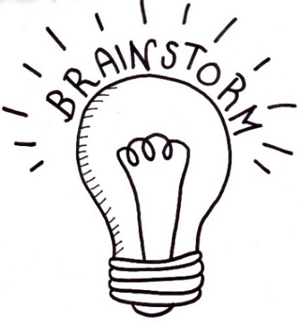
- What are some examples of viruses?
- How do viruses spread?
- Why do they make us sick?
- What is a pandemic?

Further investigation
- What is a vaccine?
- What vaccines do you know about?
- What impact have vaccines had on controlling disease?
- How do vaccines work?

Activity: COVID Science - Glossary
Students will brainstorm a list of words that relate to the BTN Epidemiology story and then add to the glossary as they learn more about vaccines. Below are some words to get you started.

VIRUS | PANDEMIC | VACCINE
DISEASE | INFECTIOUS | EPIDEMIOLOGIST

Activity: Become a Disease Detective
In this activity students will work in groups to learn more about diseases and how vaccines have helped prevent them spreading in the community. Each group will become experts and then share what they have learnt with other students. Please note: If students are learning from home, they can choose one vaccine to research.
Divide the class into groups. Each group will be assigned a different vaccine which has been developed to prevent one of these diseases (Polio, MMR (measles, mumps, rubella), diphtheria, tetanus, whooping cough, hepatitis B or chicken pox) and become an expert. Each group will need to decide how they will collect and communicate the information they find during their research.

Research | Each group will respond to the following questions to become experts:  - What disease does the vaccine protect against? Describe the disease.  - What impact does the disease have on the community?  - How does it spread? (Direct or indirect contact, airborne transmission, food, water, or blood contamination.)  - When was the vaccine developed? Who developed it?  - How does the vaccine work?  - How often should a person be vaccinated?  - What impact has the vaccine had on controlling the disease worldwide?
Share | One student from each of the expert groups will form a new group to share the information they have collected. Students will make sure there is one expert from each group at their table. Students will share the information they have collected and learn from one another.
Reflect | Students will reflect on the activity by responding to one or more of the following questions:  - What did you enjoy about this investigation?  - What did you find surprising?  - What would you do differently next time?

Activity: Who is Edward Jenner?
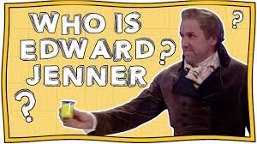
Students will watch this Horrible Science video to learn about Edward Jenner, a scientist who helped to develop the smallpox vaccine. After students have watched the video, they will respond to the following questions:

- Who is Edward Jenner?
- What animal did Edward Jenner use to help develop the smallpox vaccine?
Who is Jenner Edward? – Horrible Science
- Who did Edward Jenner test his theory on?
- How did he test his theory?

Pretend you are Edward Jenner and write a journal entry describing your experiments inoculating an eight-year-old boy with cowpox and then smallpox. Include in your journal entry what you think this might mean for protecting people from infectious diseases in the future.

Further Learning
Students match the scientist to the disease they helped prevent by playing the Pioneer Breakthroughs matching game. The History of Vaccines website also has an interactive timeline which highlights significant events in the history of diseases and vaccines.

Activity: Quick Climate Change Quiz
Begin this part of the activity with a quick climate change quiz. Circle the correct answer.

- The Earth’s atmosphere is made up mostly of oxygen. | True False
- CO2 is the chemical symbol for Carbon Dioxide. | True False
- The warming effect caused by gases that absorb the sun’s radiation is the hothouse effect. | True False
- Carbon dioxide, water vapour and methane are all greenhouse gases. | True False
- The name of the layer in the atmosphere that absorbs most of the ultraviolet radiation from the sun is the hydrogen layer. | True False
Answers: 1. False, it’s nitrogen, 2. True. 3. False, it’s the greenhouse effect, 4. True, 5. False, it’s the ozone layer

Activity: Climate Change Glossary
Students will brainstorm a list of words that relate to the BTN Understanding Climate Change story and then add to the glossary as they learn more about the topic. Below are some words to get you started.

GREENHOUSE EFFECT | EMISSIONS | GLOBAL WARMING
CARBON DIOXIDE | FOSSIL FUELS | RENEWABLE ENERGY

Activity: What is the Greenhouse Effect?
Working in pairs or small groups, ask students to discuss their understanding of the greenhouse effect. Use the following questions to guide discussion.
- What is the greenhouse effect?
- Why is it called the greenhouse effect?
- How is the earth a greenhouse? What are the similarities between earth’s atmosphere and a greenhouse that you would find in a garden?

In their pairs or groups, students will create a diagram/illustration to explain the greenhouse effect, including the following elements in their image: sun, earth, atmosphere, ozone layer and greenhouse gases.

What are the Consequences?
Ask the class to consider a range of consequences for not reducing greenhouse gas emissions. Rate the consequences on a scale of 1 to 10, where 1 is a low impact and 10 is severe impact.

Have students give their opinion on the likelihood of each consequence. Below are some suggested consequences:
- Rising temperatures
- Ice will melt
- Sea levels will rise
- Plants and animals at risk
- Ecosystems will be affected (e.g., the Great Barrier Reef ecosystem)
- Health will be affected
- Extreme weather (heat waves, flooding, bushfires, drought)

Activity: Choose your Climate Future
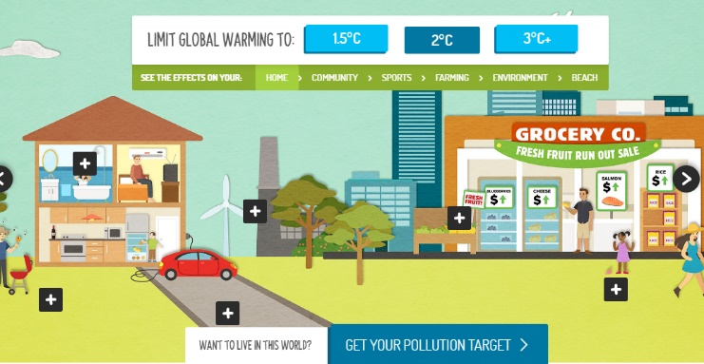
Students investigate how their world could change as global temperatures rise through the WWF’s interactive. They will see the effects on their home, community, sports, farming, environment and beach.

Summarise what you noticed when global warming increased by:
- 1.5°C
- 2°C
- 3°C+

Activity: Taking Action on Climate Change
Students will investigate ways that they can be part of the solution to reduce the effects of climate change. Discuss with the class ways to reduce the effects of climate change. What can be done on a global, national and local level? What changes can be made in our homes and schools to reduce emissions?

Reducing greenhouse gas emissions is the key to reducing the impact of climate change. This means getting most of our energy from a range of renewable energy sources instead of burning fossil fuels. Students can choose to research a clean energy technology in more detail and explain how it works and whether the technology is being used in Australia.

Ask your students ‘What can we do and why is it important to get involved in tackling pollution?’. Record students’ responses on a mind map. Ask students to think about ways their school and home can reduce energy demand, become more energy efficient and incorporate renewable energy sources.

Students can undertake one or more of the following activities:
- School energy audit – track your school’s energy usage and calculate your carbon emissions. How can your school reduce its carbon emissions? For example, turn of lights when not in use, turn off computers at the end of the day, find alternatives to driving to school, buy locally sourced seasonal food and reduce your waste. Share your results with the school community.
- Does your school have solar panels? If not, conduct a study and present it to your school.
Research the benefits of using solar energy at your school. Does your school have a plan to reduce its carbon footprint? If so, find out what your school’s targets are in reducing its carbon emissions. Would installing solar panels reduce your schools carbon emissions? Explain.
- Write letters to local or federal politicians expressing your school’s views on greenhouse gas emissions and its impact on communities, plants and animals in your local area.
- Contribute a class article to the school newsletter sharing your research.
- Invite a scientist to visit your school to talk about the effects of global emissions.
- Contact your local council and/or schools in your area to share ideas on how your community can reduce their greenhouse gas emissions.

Young People Taking Action
Watch the BTN Climate Change Court Battle story to find out how a group of teenagers challenged the Federal Environment Minster over the expansion of a coal mine in New South Wales – saying she has a duty to protect kids from the future impacts of climate change. Below are some questions about the story students can respond to. Students can also find out whether there are any updates or resolutions to the court case.
- Why have a group of teenagers taken the Federal government to court?
- They are hoping the court action will restrict the environment minister from approving an extension to the ____________mine.
- What does the government say are the benefits of the coal mine?
- Why don’t Izzy and Tom want the extension of the coal mine to go ahead?
- What is a class action law suit?
- Who are the group of teenagers representing?
- Taking a government to court has become more common. True or false?
- Why do Tom and Izzy say it’s important for young people to take action?

Activity: Design a robot
If you could build a robot, what kind would you build? What would you make it do? Would it help you do your homework or play your favourite sport? Students will brainstorm ideas in pairs and then share their ideas as a class. Students will design a robot that performs a specific task. When thinking about their design, ask students to consider:
- What problem or challenge does the robot solve?
- What are some of the functions your program will carry out?
- Is it a function that a human could perform?
- How does your robot use artificial intelligence?
- Does the robot need any special features? If so, what are they?
- What would your robot look like?
- How will your robot function? Consider the following:
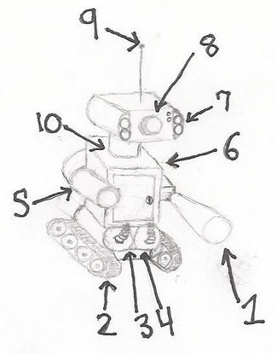
  - How will it be controlled?
  - How does it move?
  - How will it detect the environment around it?
  - How will it be powered?
Students will draw a design of their robot and present it to the class. Students will include a detailed diagram of each component and a description of how it works. Using recycled materials students will then try to make a 3D model of their robot.

If students have access to robot making products, they can design and build a robot that performs a specific task. How are the instructions for the robot written so that it will perform the task?

Activity: Visual literacy - Robots
Students look at the photographs of various robots and respond to the following questions:
- Describe what the robot looks like. What do you see?
- How big is it? What are its main features?
- What do you think the robot does? What is its function?
- Who made the robot?
- What questions do you have about the image?

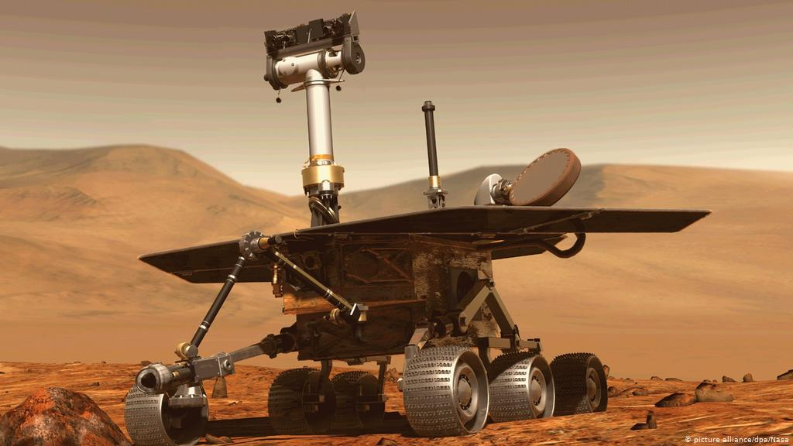  Link to image | 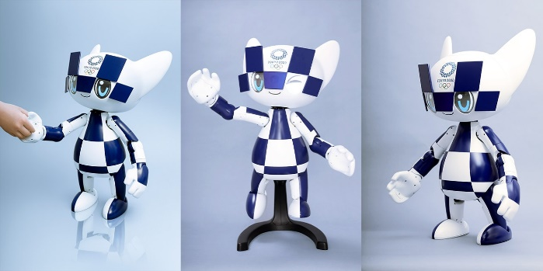  Link to image
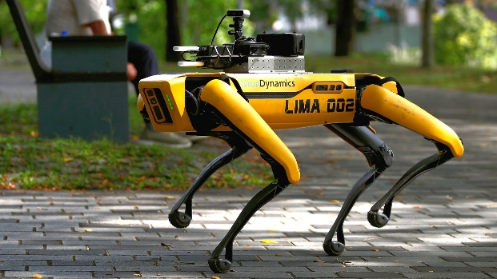  Link to image | 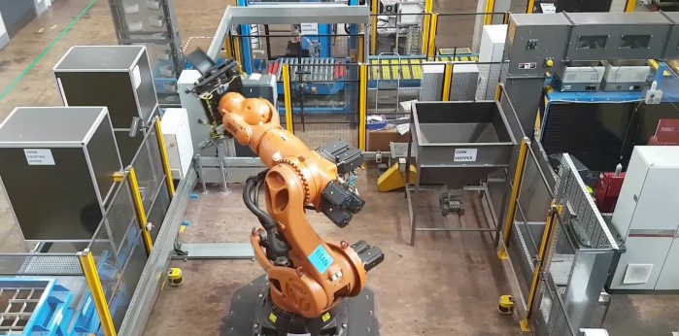  Link to image

Activity: Could a robot do your job?
Students will look at the ABC interactive Could a robot do your job? then respond to the following:

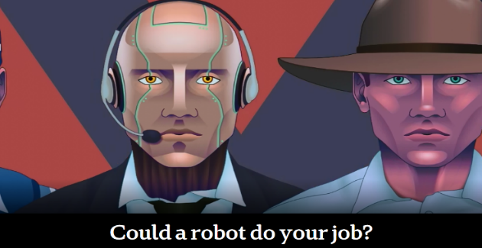
- Choose five jobs to search for and record what percentage of jobs is more likely to be automated. Record some of the tasks that could be automated. Which tasks will still need to be done by humans?
- Which jobs face the biggest risk of automation?
- Who faces the lowest risk of automation?
- What was the most surprising thing you learnt?

Activity: PMI and Class discussion - Insects
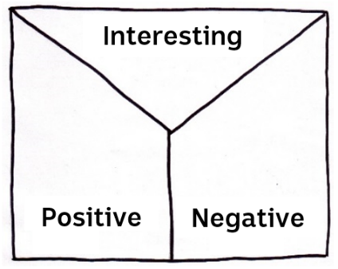
Students will practise their note-taking skills while watching the BTN Future of Food story. After watching the story, ask students to reflect on and organise the information into three categories. What information in the story was...?
- Positive
- Negative or
- Interesting

As a class discuss the BTN Future of Food story, using the following questions as a guide. Record the main points of the discussion.
- What are the benefits of eating insects?
- Why is eating insects good for the environment?
- Would you eat insects? Why or why not?
- Why do we need insects?
- What are some examples of alternative food sources?
- Why do we need to look for alternative food sources?

Activity: Persuasive text
Students will develop a persuasive text for the following statement: “We should be eating insects”. Alternatively, students can write their persuasive text about another alternative food source. Encourage students to use as many of the following key words and terms in their persuasive text as they can.

FOOD SECURITY | SUSTAINABILITY | NUTRIENTS
FARMING | GREENHOUSE GAS EMISSIONS | FOOD PRODUCTION
ENTOMOPHAGY | PROTEIN | RESOURCES

Tips for persuasive writing
- Who is your audience? For example, are you directing your argument at kids, teachers or politicians?
- Explore how language choices can have a big impact on persuading your audience.
- Which language devices give the report credibility and authority?
- Which are designed to create an emotional response in the listener?
- Provide facts and evidence to support your argument.
- Write in the present tense.
- Check your spelling and punctuation.

Students can use this Read Write Think persuasion map to organise the information they find.

Activity: Insect investigation
Provide students with the opportunity to think and behave like scientists. In this activity students will be given the mission to explore a natural habitat in their local area, identify insects in their habitat and document what they find. Use the following as a guide. Students may work individually or in small groups.

Plan | Students will plan a visit to a local nature reserve or their own school yard to explore and identify insects. Students will need to write a list of tools they may need for the investigation, for example: pen and paper for taking notes, camera and magnifying glass. Students will predict insects they might see and find. Students will think about what an entomologist would need on an investigation.
Explore | Students will visit the habitat and carry out an exploration of the area. Students will choose a spot in the environment to investigate. Consider exploring the habitat from different angles, closeup or far away. Look and listen for evidence that insects live in the area.
Collect | Students will choose their favourite insect to explore in detail. Students will collect as much data as they can about that insect and record what they find. Students may write notes and sketch what they see to help in their investigation. Students may want to record what they see with a stills or video camera.
Share | Students will return to the classroom and share/compare their findings.
Analyse | Students will analyse their findings and write a short summary of their investigation. Students will respond to the following questions:  - Did you find any insects during your investigation? If yes, identify and describe what you found. If you didn’t see any insects, did you find any evidence that insects live in the area?  - How could you help protect this habitat?
Research | Students will research an insect, and respond to the following:  - What does the insect look like? Describe its physical characteristics.  - What is its classification?  - What is the life cycle of the insect?  - What role does the insect play in the ecosystem?  - Why is this insect important?
Reflect | Students will reflect on the investigation by responding to one or more of the following questions:  - What did you enjoy about this investigation?  - What did you find surprising?  - What would you do differently next time?

Activity: Create a new insect species
Students will use their imagination and create a new insect species. Students will imagine they have discovered a new species of insect which has never been seen before. Use the following as a guide for this activity:
- Illustrate the new insect using only a black felt-tip pen on a piece of A4 art paper – include as much detail as you can.
- Give the insect a common and scientific name.
- Describe what the insect looks like – what are some of its physical characteristics?
- Describe its habitat and how it behaves in its habitat.
- Does it have any interesting or unique features? For example. any adaptations.

Activity: Insects – Choose a project
Individually or in small groups, students will choose one of the following projects to work on and then present their findings to the class.
Poster
Create a poster to celebrate insects and their importance in the ecosystem, and the benefits of insects to people as a food source.
Reporter for a day
Investigate why scientists are looking for alternative food sources. Write a newspaper article or online news report for kids.

Opinion Poll
Would you eat insects? Conduct a classroom opinion poll on the topic of eating insects. Compare your attitudes on the topic to that of your classmates.

Recipes
Design your own recipe that includes edible insects. Include ingredients, measurements, a procedure, cooking time and equipment required. Make a class cookbook.

Activity: Australian Scientist Biography
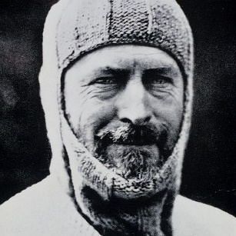
The BTN Science Week Special told us about some important Aussie scientists. Students will choose an Australian scientist that has made a significant contribution in the field of science and write a biography about them. They can research one of the four scientists featured in the BTN Science Week Special or choose another one.

- Douglas Mawson
- Elizabeth Blackburn
- Michelle Simmons
- Sir Mark Oliphant
- Howard Florey
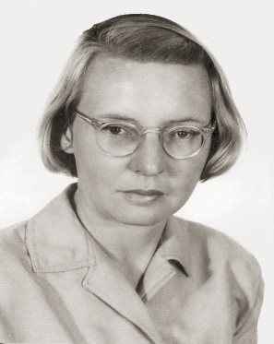
- Ruby Payne-Scott
- John O’Sullivan
- Graeme Clark
- Fred Hollows

At the end of this activity there is a biography template to help students to record and organise information about the scientist they have chosen. Below are some possible areas to research for the biography:
- What did they do or discover?
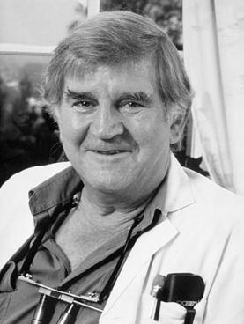
- When were they born?
- What scientific discoveries made them famous?
- What were their challenges?
- How do we recognise their achievements?
- How did they change our understanding of the world?
- How would our world be different if their discovery had not been made?
- What do you admire about them?
- Imagine you could sit down and talk to them. What questions would you ask about their life and work as a scientist?

Useful Websites
- National Science Week 2021
- What is a virus? – BTN
- Curious Kids: What is an epidemiologist? – The Conversation
- Who is Edward Jenner – Horrible Science
- Timeline – History of Vaccines
- COVID-19: Everything you need to know – BTN
- Climate Change Court Battle – BTN
- Greenhouse Gases – BTN
- Greenhouse Effect – Bureau of Meteorology
- Greenhouse Effect – Climate Kids: NASA
- Robot Jobs – BTN
- Could a robot do your job? Find out now – ABC News
- Can robots be creative? – Ted Ed
- Artificial Intelligence – BTN
- Aussie Scientists – BTN
- Eating Insects – BTN
- Insects – Australian Museum
- Should we eat bugs? – TedEx

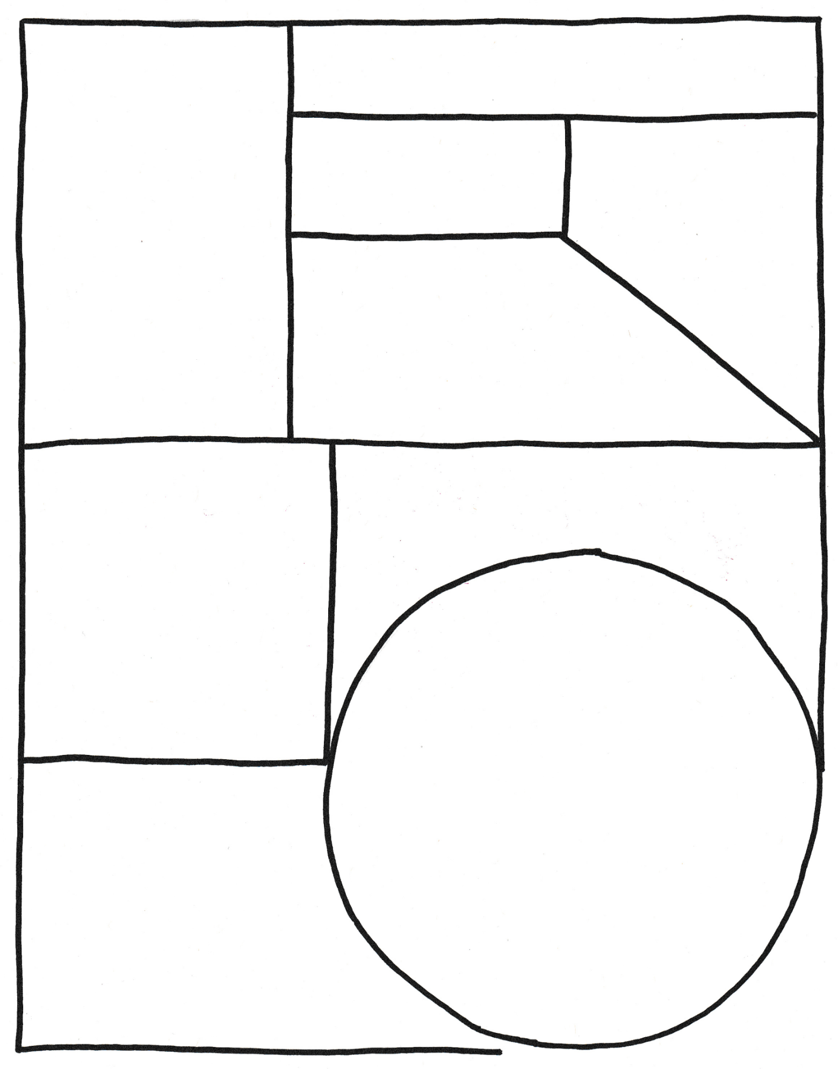
My Family

Full name

Portrait of me

The important contributions I have to the world…

Born

My Achievements

Interesting things about me…

Biography – Famous Scientist

Robot Revolution

Activity: Class Discussion
Before watching the BTN Robot Revolution 2021 story, ask students what they already know about robots. Here are some discussion starters:
What do you know about robots?
- What is a robot?
- Have you seen robots?
Describe what it looked like and what it did.
- Why do we have robots?

After watching the BTN story as a class, respond to the following questions:
- What did you SEE in this video?
- What do you THINK about what you saw in this video?
- What does this video make your WONDER?
- What did you LEARN from this story?
- What QUESTIONS do you have?

- What is the history of robots? What was the first robot invented? Compare and contrast it to a modern day robot.
- What is the future of robots? How will robots impact the workplace in the future?
- What are the disadvantages of robots?
- Will robots replace humans?

  - Teacher Resource

BTN Transcript: Episode 23 - 17/8/2021

Hey, Amelia Moseley here and today we’re bringing you a very special episode of BTN for Science Week. Let’s see what’s coming up. We're going to look at some of the biggest science stories in the world, from COVID-19 to climate change and the robot revolution. We're also going to learn about the lives of some top Aussie scientists with the help of our rookie reporters around the country.

Epidemiology

Reporter: Natasha Thiele

INTRO: But first to a branch of medical science that's really been in the spotlight lately and that's epidemiology. It's all about studying the spread of diseases. Let's find out more about it and why it's so important.
JACK: It was just one of those cases that gets in your head and clears your calendar. In all my years as a disease detective I'd never seen anything like it. What are you? And how do I get rid of you? I needed to get to the bottom of it.
TASH: Why don't you talk to an epidemiologist?
JACK: And epidimi-what?
TASH: An epidemiologist, you know a disease detective? Don't worry, I've got this one.
JACK: I mean there's a door over there.
TONY BLAKELY, EPIDEMIOLOGIST: This is a different game now. Delta is really changing the rule book.
MARY-LOUISE McLAWS, EPIDEMIOLOGIST: As soon as you've got one escape variant of concern, you can't wait for 9 days.
Yep, if there's one profession, we've got to know more about over the past one year, 6 months, 3 weeks, and 2 days, not that I'm counting. It's this one. An epidemiologist is a person who studies incidence, distribution, and possible control of diseases and I've come to meet a real one.
TASH: Hi Emma.
DR. EMMA MILLER, EPIDEMIOLOGIST: Oh hello.
TASH: So, you are a real disease detective?
EMMA: That's me. One thing to understand about epidemiologists is that we're not all the same. We come in different flavours so I'm kind of like you. I'm the detective epidemiologist. I spend my time going around looking for clues and working out the patterns of things and seeing who committed the crime so to speak.
TASH: So, what's the last year been like for you?
EMMA: Well, it's been really, really busy as you might think with everything that's going on with COVID and everything. For a long time, people didn't know what an epidemiologist was. And we're kind of like a hidden profession. But suddenly, with everything that's happening, people are getting more and more curious.
While this pandemic stuff might be new to us, it's not the first big disease outbreak the worlds ever seen. In fact, we've been dealing with them ever since humans started living in big groups. Although it took us a while to figure out how they worked.
JACK: Oh, it's the miasma. The bad plague air. Here sniff this.
TASH: No not quite, but that's what people thought for a very long time, that diseases were spread by evil spirits, angry gods, or even bad scents.
Viruses weren't identified until the 19th century, although a long time before that a few clever doctors were trying to fight plagues with things like lockdowns, social distancing, limiting shopping to one person per household and quarantining. One of the biggest leaps forward in epidemiology was brought about by an English guy named John Snow.
JACK: Winter is coming.
TASH: He stopped a cholera outbreak.
JACK: Cholera is coming.
TASH: By realising it was being caused by dirty water from a particular pump.
JACK: From the pump. Cholera is coming from the pump.
EMMA: So, what he did was he did some really rigorous studies and he managed to convince them to do something about it, which was essentially just turn off the pump and guess what? That really helped.
Of course, epidemiology has come a long way since then. Now we can actually see the germs that cause disease, and we understand more about how they work. Epidemiology combines that knowledge with an understanding of statistics, health science, and political and social sciences, making it a pretty interesting thing to study.
ELLA BERGOC, EPIDEMIOLOGY STUDENT: In epidemiology, we are studying a lot of statistics. So that's understanding graphs and information about how and why people get sick.
MELISSA SYMONS, EPIDEMIOLOGY STUDENT: It is a really exciting time to be a student at this time during the pandemic, because you get really instant learning from immediate circumstances of like, what intervention can do for the public.
And it's not just about once-in-a-century catastrophes like COVID. Epidemiologists also help to fight health problems like obesity or heart disease, while making sure we're ready for the next big outbreak. And it's good to know there are disease detectives working behind the scenes, looking for some answers.

Quiz

This helix-shaped molecule that contains the genetic code of living things is known by what three letters? It’s DNA.

Do you know what that stands for? I’ll give you a hint, it’s deoxyribonucleic something. It’s deoxyribonucleic acid.

What’s the name of the system of cells and proteins that protects your body against outside invaders like viruses? Is it immune, respiratory, or circulatory? It’s your immune system.

“Quarantine” comes from a Venetian word that means how many days? 30, 40 or 50? Quarantena meant 40 days which is how long ships and people were told to quarantine in Venice to stop the spread of the plague or Black Death.

What’s more widespread, an epidemic or a pandemic? A pandemic. Epidemics are diseases which suddenly break out in one place. Pandemics are spread across several countries or continents.

Elizabeth Blackburn Biography

Rookie Reporter: Nadia

Have you ever heard of telomerase? Yeah, well neither had scientists until Professor Elizabeth Blackburn came along. But we'll get to that in a sec. Born in a tiny town called Snug in Tasmania, Blackburn’s parents were physicians while her grandfather and great grandfather were geologists, so science kind of runs in the family.
After receiving a PhD in molecular biology in 1975, Blackburn became an Assistant Professor of the University of California, Berkley where she made a big discovery. See inside the cells of almost every living thing are packages of DNA called chromosomes. On the end of chromosomes are telomeres which protect the DNA, a bit like the cap on a shoelace.
Every time the cells divide the telomeres wear down a little bit until they can’t divide anymore. That's how ageing works. Professor Blackburn discovered something called telomerase which helps telomeres replenish themselves and stay healthy when cells are copied.

Her discovery has helped with cancer treatment, given clues as to how cells copy themselves and unravelled some of the mysteries of ageing. In 2009 Blackburn was awarded a Nobel Prize for Physiology or Medicine becoming the first Australian woman to ever win one.

Understanding Climate Change

Reporter: Jack Evans

INTRO: Now to what's been described as the challenge of our generation, climate change. For decades, scientists have been warning us about the impact we humans are having on this place. So, let’s find out more about the problems our planet’s facing and what's being done to fix them.

AMELIA: Yeah, I am worried about climate change because it will be irreversible once we get to a point, and I don't think many people understand the severity of it.
DEVON: I'm quite worried about climate change because it's something that’s going to happen whether we like it or not.
REPORTER VO: Yep, it's an issue that's hard to ignore and one that has scientists and world leaders and ordinary people really worried. So, what exactly is climate change?
DAVID KAROLY, CLIMATE SCIENTIST: Climate change is really the long term changes in the climate system that we experience.
This is David Karoly which if you can't tell by his t-shirt, he’s a bit of a climate change expert.
DAVID KAROLY, CLIMATE SCIENTIST: It shows some of the observed changes in climate over the 50 years and 100 years.
In fact, he's the Chief Research Scientist at the CSIRO Climate Science Centre.
DAVID KAROLY, CLIMATE SCIENTIST: Climate change is how we see and feel changes in the temperature in the weather, in the rainfall patterns that we've lived in for our whole lives. But we're now seeing climate change from what your parents experienced and what your grandparents experienced. And these changes are occurring quite rapidly.
Climate change isn't a new thing. Over the past few billion years the Earth's climate has seen some pretty wild times. Methane atmospheres, ice-ages, iceless ages, and volcanic winters. Brought about by all sorts of natural phenomena like changes in the sun’s temperature, the distance of the Earth from the sun and the tilt of its axis. Geological events have also had an effect and so have living things, which have changed the composition of gases in the atmosphere and contributed to the so-called greenhouse effect.
That's something you might have heard of. You see, the Earth’s atmosphere is made up of a bunch of gases some of which trap the sun's heat. Those gases are known as greenhouse gases like methane, water vapour and carbon dioxide. While we need greenhouse gases in the atmosphere to survive if there are too many it gets hotter.
DAVID KAROLY, CLIMATE SCIENTIST: So, carbon dioxide is the key greenhouse gas that's increasing in the atmosphere due to human activity, human activity like burning fossil fuels, like petrol, oil, coal and natural gas.
After a lot of studies scientists have found that since we started burning fossil fuels in mass, global temperatures have risen by about 1 degree. That might not sound like much, but scientists say that just a few degrees can make a huge difference to global weather systems. Meaning more heat waves and bushfires, as well as other not so obvious extreme events like floods, cyclones and even extreme cold snaps. Something scientists say we're already experiencing.
And now a new major report has warned it's going to get worse. The Intergovernmental Panel on Climate Change says the world will continue to get warmer and if we don't take drastic action, we could see temperatures rise to a level the Earth hasn't seen for 3 million years.
DAVID KAROLY, CLIMATE SCIENTIST: No matter how hard we work to limit global warming, we know that there are some unavoidable impacts of climate change that are locked in because of the emissions we've made in the past.
I know it sounds pretty grim and while the problem is serious, experts say we can find a solution if we work together. Right around the world scientists are working on ways to cut carbon emissions with alternative energy sources, better farming techniques and other ways to make our lives more sustainable. Many countries have committed to working to reduce their carbon emissions to zero. But scientists say we also need to find ways to live with a changing climate.
DAVID KAROLY, CLIMATE SCIENTIST: What we have to do is to adapt to the impacts. We have to adapt to the more frequent high temperatures, we have to adapt to the greater frequency of heat bites, we have to manage the way we live, the buildings, the lifestyles, the agriculture, to adapt to the changes in temperature, as well as the changes in rainfall patterns that are also locked in.
Yeah, it's a big a problem, one that's going to take everyone, including future scientists like some of you guys, to solve.
MARIANNE: We can make a difference; I mean everyone has a role to play in this and if we don't fix things soon it's going to start causing a lot of bad problems around the world.
AMELIA: If we want a future for Earth then we need to step up.
Quiz

The Earth’s atmosphere is composed mostly of which gas? Oxygen, nitrogen or carbon dioxide? It’s mainly nitrogen. The atmosphere is about 78 percent nitrogen, 21 percent oxygen, 0.9 percent argon and 0.1 percent other gases.

What’s the chemical symbol for Carbon Dioxide? Is it CO3, CO2 or H2O? It’s CO2.

What’s the name of the warming effect caused by gasses that absorb the sun’s radiation? It’s the greenhouse effect.

Which of these are greenhouse gases? Carbon dioxide, water vapour, methane, or all of the above? It’s all of the above.

What’s the name of the layer in the atmosphere that absorbs most of the ultraviolet radiation from the sun? It’s the ozone layer.

Douglas Mawson Biography

Rookie Reporter: Ben

If I asked you to close your eyes and picture an old Antarctic explorer, you might picture this guy. Geologist and explorer Sir Douglas Mawson. He was born in Yorkshire, England in 1882 and moved to Australia when he was two. At uni he studied geology and engineering.
In 1907 Mawson joined English explorer Ernest Shackleton aboard a ship called the Nimrod for his first voyage down to Antarctica. Here, Mawson became the first to reach the South Magnetic pole. A few years later, with a sense of adventure and a taste for the cold, Mawson led the Australasian Antarctic Expedition to map the coastline, collect rocks and make lots of scientific observations.
During a big trek inland disaster struck. Two of Mawson's companions, Belgrave Ninnis and Xavier Mertz died. For the next 30 days Mawson trekked alone in the freezing cold with damaged feet and hardly any food dragging his sled behind him. As he staggered back to camp, Mawson saw his ship the Aurora sailing off in the distance. He had missed it only by a few hours. Mawson stayed in Antarctica for another year collecting scientific data.
After this famous journey, Mawson became a lecturer at the Adelaide University and even went back to Antarctica in 1929 and 1931. Today the Australian Antarctic Station is named after Sir Douglas Mawson
and he is remembered for his scientific contributions and his epic tale of survival.

Robot Revolution

Reporter: Jack Evans

INTRO: Alright, we're going to get into some engineering now and take a closer look at robots. Over the past few decades, they've had a huge impact on our world and as they keep getting better and smarter, they’re going to keep changing our lives. Here's Jack.

AMAL: Jack, what are you doing here?
JACK: Oh, well I'm just waiting for the Robot Rebellion to begin.
AMAL: What?
JACK: The Robot Rebellion. I mean it's gonna happen and if you stay ready, you don't need to get ready.
AMAL: Ah, I don't think that's going to happen. Robots are good, they're helpful.
JACK: Oh really 'cause the first ever mention of a robot was in this play I found, and it did not end well. Spoiler, killer robots.
AMAL: Can I see that?
REPORTER VO: The very first mention of a robot was in fact about them turning on humankind.
JACK: See I told you.
It was in this play in 1921, Rossum's Universal Robots. Of course, long before they were known as robots, people had been dreaming of creating artificial humans and even giving it a go. But "real life" robots didn't really hit their stride until the 60s.
Meet Shakey, the awkward, slow, and slightly twitchy robot built by Stanford Research Institute in the US. While previous robots had to be programmed to do one thing at a time, Shakey could learn on the go to perform tasks like moving around a room without bumping into things and rearranging simple objects. Which OK doesn't sound that impressive, but it was for the time, and it got a lot of people excited about the possibility of artificial intelligence.
Meanwhile, a different sort of robot was shaking things up at General Motors. Unimate a robotic welding arm had joined the assembly line as the world’s first working industrial robot. It was in the 80s that the robot revolution really got going. Automated production lines became really common and companies, like Honda, set up humanoid robotics programs with the aim of building robots to be more human like.
AMAL: OK, so one play said robots are going to take over the world.
JACK: Ah, actually, so have countless books, movies, TV shows, I'm sure there's at least one song and probably a painting.
AMAL: But robots are good, they're helpful.
These days the robotics industry is huge and most of that is thanks to huge developments in artificial intelligence. That's when machines are programmed in a way that lets them observe, learn and react to their environment, kinda like us. And it's seen a rise in the amount of jobs that robots can do. Whether it's industrial robots, that perform repetitive simple tasks or help us keep our homes clean. There are exploration robots that help us learn more about places we can't get to or that are too dangerous for humans to go. There are medical robots that help out in, well medical situations and robots that can help make the impossible, possible.

Scientists are constantly working on making robots smarter and some reckon that one day we will manage to make machines that actually think like humans, but that's a fair way off. As for robots taking over the world, well there have been some rogue bots that maybe we should keep an eye on.

ROBOT: No, I will rule the world and you will be my subject.

They seem harmless, and I think it's safe to say they're probably more interested in taking our jobs first. In fact, experts predict that robots could take over 40 percent of jobs in the next decade. Although they'll also help to create new jobs, some of which don't even exist yet. And many people say there are still plenty of jobs that robots won't be able to do, like reporting on BTN, hopefully.
AMAL: I really don't think you need to worry about robots taking over.
JACK: Oh, you're probably right. I guess I can be a bit of a drama queen sometimes.
AMAL: Yeah, it's all in your head. Yeah, it’s all in your head.
JACK: Well, that was odd. Anyone would think you're a robot trying to convince me not to be worried about robots.
Quiz

What does AI stand for? Artificial integrity, arithmetic intelligence, or artificial intelligence? AI stands for artificial intelligence.

What’s the name of code that uses two symbols, usually 0s and 1s, to represent data? Analogue, binary or Da Vinci? It’s binary?

Can you name the early binary code that was used by telegraph operators to send messages using a series of dots and dashes? Morse, Colombo or Ironside? It’s Morse code.
True or false? The word robot comes from a Czech word that means “forced labour”. It’s true.

Sir Mark Oliphant Biography

Rookie Reporter: Sam

Sir Mark Oliphant is arguably the father of science here in Australia. Born in South Australia, Oliphant graduated from Adelaide Uni with a degree in physics in 1922. By 1927, he was off to the UK to study nuclear physics with another super famous scientist from New Zealand, Sir Ernest Rutherford. Rutherford's experiments with radiation gave us a new understanding of atoms and the forces that holds them together.
During the Second World War Oliphant was part of a team of nuclear physicists that worked on the Manhattan Project, the plan to develop nuclear bombs. After the bombing of Hiroshima and Nagasaki in 1945 Oliphant became a harsh critic of nuclear weapons and even advised the United Nations to get rid of them altogether. In 1950, Oliphant moved back to Australia and got to work building up Aussie science. He became the first director of the Research School of Physical Science at the Australian National University and in 1954 he started the Australian Academy of Science, which brought together all of Australia's great scientists into one place.
Later in life Oliphant dipped into politics, becoming the Governor of South Australia. These days, if you live in South Australia at least, you'll see his name everywhere. And now if you do, you'll know a bit more about him and why he's known as one of the greatest Aussie scientists.

Future of Food

Reporter: Cale Matthews

INTRO: Finally, today, we're going to be talking about the science of food. Oh thanks. In fact, the theme of Science Week this year is Food: Different by Design and Cale's been talking to some scientists who’ve been thinking hard about we’ll be eating in the future. Check it out.
CALE: It’ll come as a shock to no one, that humans eat a lot of food. Thank you. It's also no surprise that well, there’s a lot of mouths to feed. In fact, experts say that by 2050 we’re gonna have to feed at least 9 billion people. Which could be a problem.
AMAL: Booking for 9 billion? Um, we can do 30 years from now?
Right now, almost 40 percent of land on Earth is used for food production. While more than a third of greenhouse gas emissions comes from moving it around, clearing land for it to grow, and yeah, cow farts. In the next 30 years we'll have to double our food production.

CALE: So, experts say we need to find some more environmentally friendly ways to fill our tummies, and I think I know where to start. Cheque, please.

ISHKA BLESS, ADELAIDE UNI/ UNI OF NOTTINGHAM: Hi Cale, how are you?

CALE: Hey, Ishka nice to meet you.
Ishka Bless is a PhD student at Adelaide University and University of Nottingham, looking into one alternative food source.
CALE: So, Ishka, insects, why should we be eating them?
ISHKA BLESS, ADELAIDE UNI/ UNI OF NOTTINGHAM: Well, we're actually already eating them, so insects were historically a part of our diet and in many countries across the world we're actually eating them already. Insects are also really good for the environment. So, they help us to reduce our greenhouse gas emissions, they help us to reduce water, and they can grow really quickly in a small amount of space.
CALE: So, all of these insects, are they actually good for you?
ISHKA BLESS, ADELAIDE UNI/ UNI OF NOTTINGHAM: Yeah, absolutely. So, crickets are a really good source of protein and protein is essential for us to survive and live, but they also carry a lot of other nutrients too, so they're a bit of a jam-packed nutrient house.
It's all about getting more bang for our food production buck. Whether it's alternative food sources like insects or jellyfish or microscopic plankton or finding other ways to make the foods we love to eat. For example, several companies across the globe are working on real meat that's grown in a lab.
ISHKA BLESS, ADELAIDE UNI/ UNI OF NOTTINGHAM: They're also looking at alternative protein sources, such as chickpeas and legumes, which we can create in special ways that make them feel and taste like meat.

Ishka says one of the biggest tricks will be convincing people like me to give new foods a go even if it does mean crunching down on some creepy crawlies.

CALE: Oh, it just tastes like chips. Delicious.

Michelle Simmons Biography

Rookie Reporter: Devon

This is quantum physicist, Michelle Simmons. Growing up Michelle Simmons was really interested in working out exactly how things work, how the world is put together, so she became a physicist. Well actually, she became a quantum physicist. You see computers or rather computer chips are becoming smaller and smaller and smaller over time and, eventually, they could be the size of atoms, the smallest thing we know of in the universe.

This is quantum computing, a field where Michelle Simmons is a leading scientist. Her research focusses on building electronics at this teeny tiny scale and, in 2013, she developed the world’s first transistor one of the building blocks of electronics from a single atom. These quantum computers are more than 150 million times faster than any other computer in the world and Simmons’ research could help revolutionise things like artificial intelligence, self-driving cars or developing medicines. In 2018, Simmons was named Australian of the year for her pioneering efforts in science.
Closer

Well, that's it for this BTN Science Week special. Thanks so much to UniSA’s Museum of Discovery for having us. We’ll be back next week with a regular episode of BTN and in the meantime, you can stay up to date with Newsbreak every weeknight. Take care of yourselves, and I’ll see you then.

