EPISODE 10
26th April 2022

KEY LEARNING
Students will view a range of BTN stories and use comprehension skills to respond to a series of focus questions.

CURRICULUM
English – Year 4
Use comprehension strategies to build literal and inferred meaning to expand content knowledge, integrating and linking ideas and analysing and evaluating texts.

English – Year 5
Use comprehension strategies to analyse information, integrating and linking ideas from a variety of print and digital sources.

English – Year 6
Use comprehension strategies to interpret and analyse information and ideas, comparing content from a variety of textual sources including media and digital texts.

English – Year 7
Use comprehension strategies to interpret, analyse and synthesise ideas and information, critiquing ideas and issues from a variety of textual sources.
  - Teacher Resource

Focus Questions
As a class, discuss the stories featured in the episode of BTN Classroom and record the main points of the discussion. Students will then respond to the following focus questions.

Anzac Day
- In pairs, discuss the main points of the Anzac Day story.
- Where did most of the fighting in World War One take place?
- What plan did Britain come up with to defeat Germany?
- Where in Turkey were Australian and New Zealand soldiers sent in?
- What does Anzac Day mean to you?

Check out the teacher resource on the Teachers page.

History of Voting
- Who were the suffragettes?
- Which state was the first to give women the right to vote?
- When did all Indigenous people get the right to vote in federal elections?
  - 1952
  - 1962
  - 1972
- It’s compulsory for everyone over the age of ________to vote.
- Do you think the right to vote is important? Give reasons for your answer.

Check out the teacher resource on the Teachers page.

Election Lingo - Electorates
- What is an electorate?
- Each electorate is represented by a __________________.
- The House of Representatives is also known as what?
- How many federal electorates are there in Australia?
  - 51
  - 151
  - 251
- Which is the largest electorate in Australia? How many square kilometres does it cover?
Female Statues
- Explain the campaign Malia started in Queensland.
- Malia found that there were only ______ official statues of women in Brisbane.
- What percentage of statues around the world are female?
  - 5%
  - 15%
  - 50%
- What did Malia do about getting more female statues in Queensland?
- Which statues would Malila like to see in the future? Which statues of females would you like to see?

Ramadan
- Why do Muslim people fast during Ramadan?
- What is Suhoor and why is it important?
- What do Muslim people do at the end of the day to break their fast?
- What is the festival at the end of Ramadan called?
  - Eid Al-Fitr
  - Suhoor
  - Iftar
- What do the kids in the BTN story like about Ramadan?

EPISODE 10
26th April 2022

KEY LEARNING
Students will gain a deeper understanding of World War One and Anzac Day. Students will explore ideas relating to commemoration and remembrance.

CURRICULUM
HASS – Year 3
Days and weeks celebrated or commemorated in Australia (including Australia Day, Anzac Day and National Sorry Day) and the importance of symbols and emblems.

HASS – Years 4, 5 & 6
Locate and collect relevant information and data from primary sources and secondary sources.

HASS – Year 5 & 6
Sequence information about people’s lives, events, developments and phenomena using a variety of methods including timelines.

HASS – Year 7
Apply a methodology to locate and collect relevant information and data from a range of primary sources and secondary sources.

History – Year 9
Students investigate key aspects of World War I and the Australian experience of the war, including the nature and significance of the war in world and Australian history.
  - Teacher Resource

Anzac Day

Focus Questions
Discuss the BTN story as a class and record the main points of the discussion. Students will then respond to the following:
- In pairs, discuss the main points of the Anzac Day story.
- Where did most of the fighting in World War One take place?
- What plan did Britain come up with to defeat Germany?
- Where in Turkey were Australian and New Zealand soldiers sent in?
- What does Anzac Day mean to you?

Activity: See, think and wonder
After watching the BTN Anzac Day story, students will respond to the following questions:
- What did you SEE in this video?
- What does this video make you WONDER?
- What did you LEARN from this story?
- What QUESTIONS do you have about this story?

Students will write a personal response to the BTN Anzac Day story. Ask students to finish one or more of the following incomplete sentences:
- This story made me feel….
- It’s important to commemorate Anzac Day because…
- Five words that I would use to describe Anzacs…

Activity: Discussion
Discuss the BTN Anzac Day story in small groups or as a class. Ask students to record what they know about Anzac Day. What questions do they have? Use the following questions to help guide discussion:
- What do the letters in Anzac stand for?
- How is Anzac Day commemorated in Australia?
- What are some Anzac Day symbols?
- What does the Anzac Day dawn service mean to Australians?

Activity: Glossary
Students will brainstorm a list of key words that relate to the BTN Anzac Day story. Here are some words to get them started.

ANZAC | COMMEMORATION | GALLIPOLI
ALLIES | MEMORIAL | VETERAN

Further investigation
Students will find meanings for the following words to add to their glossary: Central Powers, Western Front, Anzac Cove, veteran, Gallipoli campaign, British Empire and armistice.

Activity: Act like a historian
Provide your students with the opportunity to act as historians. After watching the BTN Anzac Day story students will write down a list of key events, they think defined World War One. Students will use additional sources to help in their research. Students will use the following as a guide or alternatively they can develop their own inquiry question/s to research:

- Make a list of 5 key events that you think shaped World War One.
- Record each event on a timeline. Include a title, date, and description for each event, which is added with a dot on the timeline.
- Write a summary for each key event, which answers the 5 W’s – Who, What, Where, When and Why?
- Analyse each of the events on your list. What caused each event? What effect did it have?
- Compare your list of key events with that of another classmate. How are your list of events similar or different? Collaborate to create a class timeline which includes each students’ key events. Can you add any more detail to your class timeline?

Further investigation
After watching the BTN Anzac Day story, students will choose one of the following projects to work on (in pairs or individually) and then present their findings to the class.
- Imagine you are a reporter for an Australian newspaper. Write a news article dated 25th April 1915, which reports on the landing of Australian troops at Anzac Cove. Alternatively, choose another key event to write a report about.
- Imagine you are a reporter; the war has just ended, and you have been given the opportunity to interview an Australian that served during World War I. Who will you interview? Think about the questions you would like to ask. Write a list of questions and then try to find answers to your questions.
- Imagine you are an Australian that served during World War I. Write a journal entry in your diary about your experiences before, during or after World War I.
- Choose a map which documents an aspect of World War One. What does the map tell us about World War One? Choose a map from this website.

Activity: Collect objects from WWI
In this activity, students will explore how objects can help tell the story of war. Students will use the internet to ‘collect’ a range of items and categorise them into primary and secondary sources. Students will reflect on each item by responding to a range of questions. Before starting this activity analyse the Australian War Memorials World War I Memorial Box as a class. Then, individually or in pairs, students will use the following as a guide as they create their own memorial box:

- ‘Collect’ 6 items to create your own World War I memorial box. Use the internet to find your memorial box items, including equipment, objects, works of art, photographs, letters, diaries or souvenirs. Alternatively, you may have family member or friend that can share items they have from WWI.
- Include an illustration/photo and a description of each object. Why did you include each object in your memorial box? Are there any stories related to the object?
- Categorise the objects into two columns, is it a primary source or secondary source?

Activity: Your community during WWI
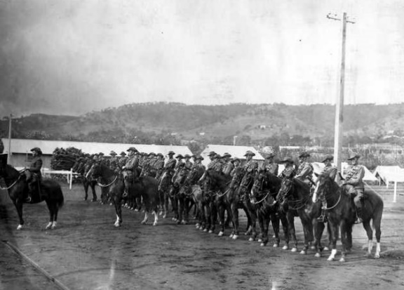
The students in the BTN Remembrance Day Research story investigated the history of their neighbourhood during World War I. As a class, discuss what the students discovered about their community during the war. Students will then research the history of their community during WWI.

Working in small groups, students research the following:
- What do you know about your community during WWI? How can you find the information? (Consider local historical societies, RSLs, State Libraries, Trove).
Source: State Library SA
- Does your local community have a World War I or II memorial or honour board? Where are they located?
- How does your local community commemorate Remembrance Day?

Discuss ways for students to display their findings. For example, they could create an exhibition of the information they’ve found and display it in their classroom, a space in the school or in their local community (library, community centre).
Further Investigation
If possible, arrange an excursion to your local war memorial. Some students may be able to trace members of their families on local memorials. Encourage students to describe what they can see (e.g., lists of names, dates and symbols). Ask questions during the excursion:
- Why are there lists of names?
- When was the memorial built?
- What do the symbols mean?
- Why did people want to build a war memorial?

Activity: Visual literacy
In this activity students will examine, analyse and query a range of images which show Anzac Day commemorations and traditions. Students will choose one or more of the photographs below (alternatively, students can find an image themselves to analyse). Students will then respond to the following:

- Write a short paragraph describing what you see in this image.
- When and where was the photo taken?
- What do you think is happening?
- How does this image make you feel? Describe your emotions.
- Write a caption for each image using your own words.
- What question/s would you like to ask about the image? Choose one of your questions to investigate in more detail.

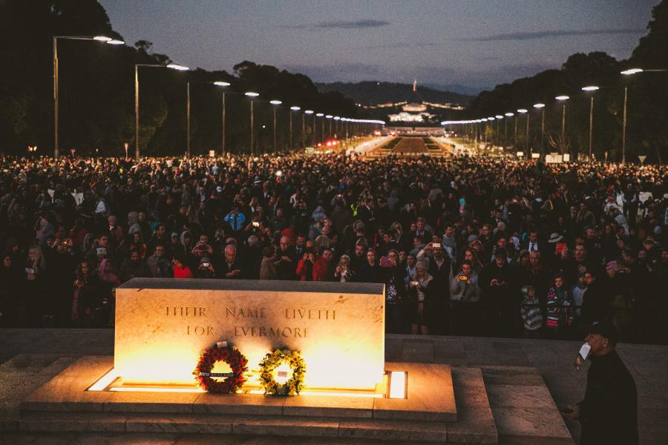  Australian War Memorial | 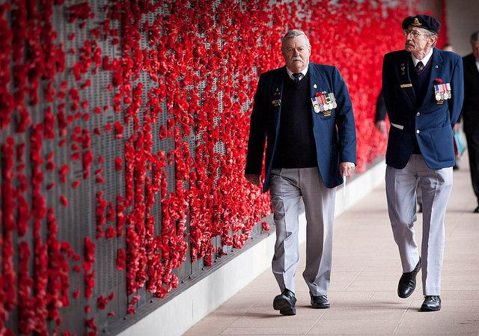  Australian War Memorial
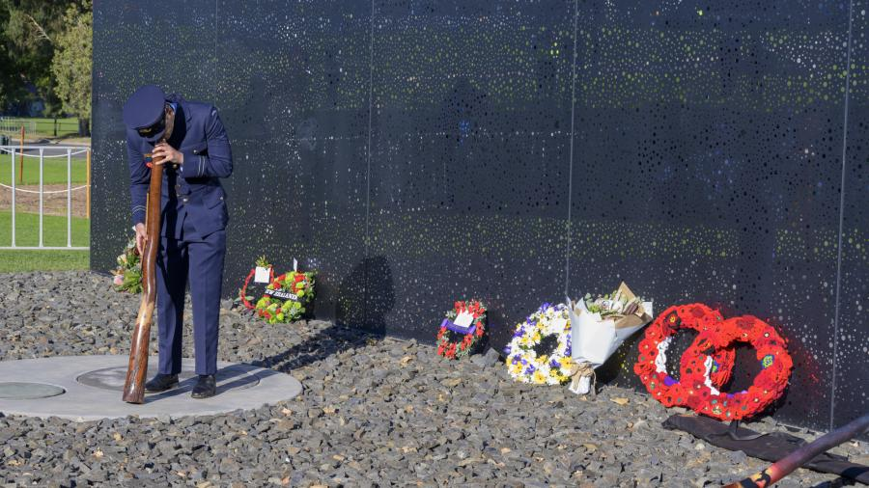  Australian War Memorial | 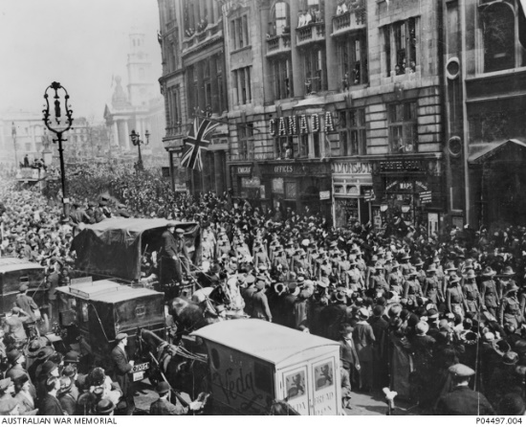  Australian War Memorial

Activity: Reflections on WWI
Provide your students with the opportunity to reflect on the anniversary of the Anzac landing at Gallipoli. After watching the BTN Anzac Day story ask your class to brainstorm a list of words to describe World War I (E.g., solemn, warfare, destructive, conflict). Record students’ responses on a mind map. Students will then choose one of the following activities to work on as they reflect on World War I:

- Design your own class World War I Memorial exhibiting your research. Visit Australia’s virtual war memorial for ideas.
- Choose one of the Australians at War stories on the Anzac Portal. Read and analyse the story. Illustrate an aspect of the story. Discuss unknown words and concepts with your teacher. How did the story make you feel? Imagine you could write a letter back, what would you say?
- Use the internet to find a letter from World War I. It could be a letter from a soldier to his family, or a letter of address from the Prime Minister. Analyse the letter and answer these questions: How did you feel after reading the letter? How do letters help us understand World War I? What is the purpose of the letter? How is the language used in the letter similar or different to language used today?

Activity: Choose a project
Individually or in small groups, students will choose one of the following projects to work on and then present their findings to the class.

Artwork
Create an artwork which celebrates Anzac Day. Include a range of symbols of commemoration used during Anzac Day services.

Quiz
Create a quiz about World War One and Anzac Day and test your classmates.
Poetry
Read the In Flanders Fields poem as a class. Write your own short poem (perhaps a haiku poem) to commemorate Anzac Day. Make a classroom poetry book using all of your poems.
Make a poppy
Follow BTN’s poppy making tutorial, create a poppy and then create an installation in your school. How to make a poppy tutorial

Useful Websites
- History of WWI – BTN
- What is Anzac Day? – BTN
- Anzac Day Special – BTN
- Stories from the World War One Collection – State Library of NSW
- Life in the Trenches – BTN
- The Gallipoli Story – BTN
- WWI Centenary – BTN
- First World War 1914-18 – Australian War Memorial
- Australia’s involvement in World War I – Civics and Citizenship Education
EPISODE 10
26th April 2022

KEY LEARNING
Students will learn about the history of voting in Australia and analyse significant events that have shaped Australia’s system of voting.

CURRICULUM
Civics and Citizenship – Year 5
The key features of the electoral process in Australia.

Civics and Citizenship – Year 6
The responsibilities of electors and representatives in Australia’s democracy.

History – Year 6
Experiences of Australian democracy and citizenship, including the status and rights of Aboriginal and Torres Strait Islander Peoples, migrants, women and children.

  - Teacher Resource

History of Voting

Focus Questions
Discuss the BTN story as a class and record the main points of the discussion. Students will then respond to the following:
- Who were the suffragettes?
- Which state was the first to give women the right to vote?
- When did all Indigenous people get the right to vote in federal elections?
  - 1952
  - 1962
  - 1972
- It’s compulsory for everyone over the age of ________to vote.
- Do you think the right to vote is important? Give reasons for your answer.

Activity: Class Discussion
After watching the BTN History of Voting story, hold a class discussion using the following discussion starters.
- What is voting?
- How old do you have to be in Australia to vote?
- Is voting compulsory?
- How has people’s right to vote changed over the years?
- Have you ever voted? Think of different situations where you have been able to have your vote. For example, in the classroom with hands-up voting, at home in family decisions or at clubs voting for new members.
- Is voting important? Give reasons for your answer.

Activity: Glossary
Students will brainstorm a list of key words that relate to the BTN History of Voting story. Here are some words to get them started.
 | VOTE | ELECTION |  | PARLIAMENT
 | SUFFRAGE | SUFFRAGETTE |  | COMPULSORY

Activity: History of Voting Research
Discuss the information raised in the BTN History of Voting story. What questions were raised in the discussion and what are the gaps in students’ knowledge? The following KWLH organiser provides students with a framework to explore their knowledge on this topic.

What do I know? | What do I want to know? | What have I learnt? | How will I find out?

Students will develop their own question/s to research or choose one or more of the questions below. Encourage students to collect and record information from a wide variety of sources and present the information they find in an interesting way.
- Who were the suffragettes? Describe the suffragette movement.
- Imagine you a suffragette living in the late 1800s. Write a persuasive letter to your local government, write a newspaper article or write a petition explaining why women should be able to vote.
- When were women first given the right to vote in Australia?
- When were Indigenous women given the right to vote in Australia?
- Who was the first woman elected as a member of parliament in Australia? Create a short biography of them.
- Many women around the world still do not have the right to vote. Find out where in the world women still do not have the vote and highlight on a world map.
- How would you feel not being able to vote because of colour, race, gender or financial status? Was this fair? Was this democratic? Why do you think the right to vote has changed over time?
- What is the secret ballot system of voting? When and why was it introduced? Why is the secret ballot important to Australia’s voting system?

Activity: Timeline of voting
Students research the history of voting in Australia. Use the information they find to help match the dates to key events in Australia’s history of voting. Complete the template at the end of this activity.

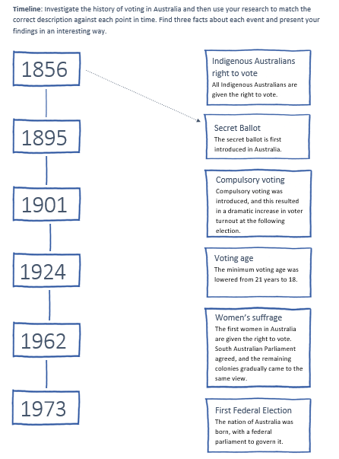
Students will then respond to one or more of the following questions:

- Find three interesting facts about each significant event.
- Imagine what it was like not being able to vote because you are a woman or because you are Indigenous. Write a diary entry explaining your lack of rights and how it feels not being able to vote. Students will use their research findings to support their writing.
- Which dates on the timeline do you think are especially significant? Why?

Activity: Visual Literacy
Below are photographs depicting significant events in Australia’s history of voting. Students look at the images below or find your own images and then respond to the following questions:
- What is happening in the image?
- Where do you think it was taken?
- How do you think they might be feeling?
- Is there a message about democracy that comes across in the image? Explain.
- What question/s would you like to ask the people in the image?
- Create a caption for each image.

After you have responded to the above questions click on the link for each image to find out what is happening and compare to your responses.

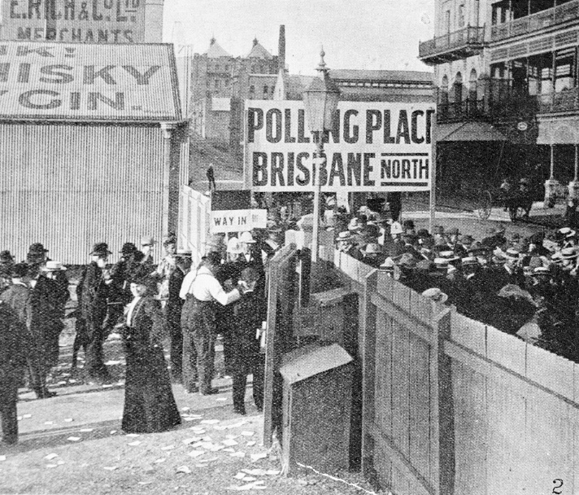
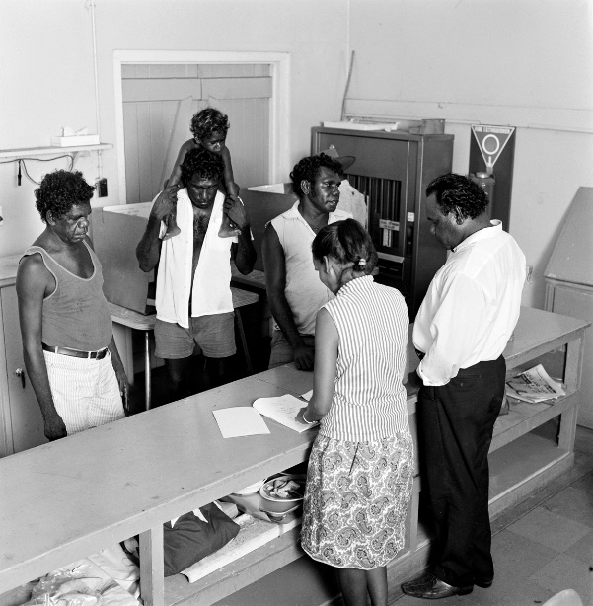

Source of image Source of image

Activity: BTN Women in Politics
Watch the BTN Australian Women in Politics story then answer the following questions:

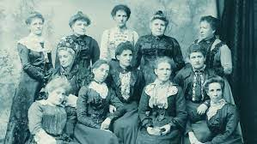
- The South Australian Government was the first in the world to give women the right to run for election. True or false?
- Who was Catherine Helen Spence?
- In what year were the first women elected to Federal Parliament?
- Who was Australia’s first female prime minister?
- Who was the first Indigenous woman to sit in parliament?
- What did you learn watching the BTN story?

Activity: Quiz
- What is the voting age in Australia?  A. 16  B. 18  C. 21  - Which state was the first to give women the vote?  A. ACT  B. New South Wales  C. South Australia  - Which state became the first to introduce compulsory voting?  A. South Australia  B. Queensland  C. Western Australia  Quiz Answers: 1B, 2C, 3B, 4B, 5B, 6A | 4.When was voting made compulsory for the Australian Parliament?  A. 1901  B. 1924  C. 1967  5. When did all Indigenous Australians get the right to vote in federal elections?  A. 1952  B. 1962  C. 1972  6. Voting in Australia is compulsory.  A. True  B. False

Useful Websites
- The Right to Vote – MOAD
- History of Voting – BTN
- Australian Women in Politics - BTN
- Australian voting history in action – AEC
- History of Voting game - AEC

Timeline: Investigate the history of voting in Australia and then use your research to match the correct description against each point in time. Find three facts about each event and present your findings in an interesting way.

Indigenous Australians right to vote
All Indigenous Australians are given the right to vote.
1856

Secret Ballot
The secret ballot is first introduced in Australia.

1895

Compulsory voting
Compulsory voting was introduced, and this resulted in a dramatic increase in voter turnout at the following election.

1901

Voting age
The minimum voting age was lowered from 21 years to 18.

1924

Women’s suffrage
The first women in Australia are given the right to vote. South Australian Parliament agreed, and the remaining colonies gradually came to the same view.

First Federal Election
The nation of Australia was born, with a federal parliament to govern it.
1973
1962

  - Teacher Resource

BTN Transcript: Episode 10 - 26/4/2022

Hey, I'm Amelia Moseley and welcome back to a whole new term of BTN. Hope you had a great holiday. Let's take a look at what's coming up on today’s show. We meet a 10-year-old who's been leading a charge to get more female statues, find out how some young Aussies have been marking Ramadan and we learn about the history of voting.

Anzac Day

Reporter: Amelia Moseley

INTRO: We'll also be explaining some of those tricky election words you're going to be hearing over the next few weeks, with the help of our rookie reporters, so keep an eye out for that. But first to Anzac Day. There've been services and marches around the country to commemorate Australians and New Zealanders who served and died in wars and conflicts. But why is this national day of remembrance held on the 25th of April? Let's find out.
In the year 1914, the world went to war for the first time. The Allies, including countries like Britain, France and Russia were fighting the Central Powers, including Germany, Austria-Hungary, and the Ottoman Empire. Over in Australia, we hadn't even officially been a country for that long. We were still part of the British Empire, so when there was a call out for soldiers many young Aussies who had never fought before, saw it as a chance to sign up and serve their country alongside the other allies.
BASIL HOLMES, GALLIPOLI VETERAN, ABC ARCHIVE VISION 1988: I was keen, 100 percent keen, like we all were in those days.
While there's no one alive anymore who fought in the war, we can learn what it was like from old interviews and from historians like Mel at the Australian War Memorial.
Dr Meleah Hampton, Australian War Memorial: There’s lots and lots and lots of letters from the First World War available so we can really get into these guys heads in ways we couldn't from wars before. One of the things that they talk about a lot is they wonder what their first experience of combat will be like, and many men actually write the same sort of thing. They say the first hour is really strange and weird, and they might have the shakes, or they might feel a bit out of their body or a bit unable to think properly, and then it clicks in and they're able to just carry on.
Most of the fighting in World War One took place in France on the Western Front. But months in, neither side was winning. So, Britain came up with a plan to defeat Germany by attacking its allies. The aim was to capture the capital of the Ottoman Empire, Constantinople (now known as Istanbul in Turkey) by opening up this area so the Allied navies could get through. Many of the tens of thousands of troops involved were actually British and French. Aussies and Kiwis made up just one of the three ground landings.
NEWSREADER, 1915: An immense enthusiasm ran among them. They were out to prove themselves to themselves and to the world. Their destination? A place called Gallipoli.
Early on the morning of the 25th of April 1915, they landed at a beach now known as Anzac Cove in Gallipoli. But what they'd hoped would be a pretty easy win ended up being a long and deadly stand-off fought from trenches dug by both sides. After eight months, the Allies gave up on taking Gallipoli and decided to evacuate the troops instead.
BASIL HOLMES, GALLIPOLI VETERAN, ABC ARCHIVE VISION 1988: We thought we'd be very lucky if we got away.
But most did and the Gallipoli campaign was finally over, although there were thousands of casualties.
FRANK PARKER, GALLIPOLI VETERAN, ABC ARCHIVE VISION 1988: 8,700 graves we left on Gallipoli. That's a lot of people.
Gallipoli was seen as the first real battle we took part in as a nation, but the Anzacs went on to fight many important and deadly battles over the next three years, eventually helping to win the war in 1918.
Amelia, Reporter: What sort of an impact do you think it had on Australia as a whole as a pretty young country at the time?
Dr Meleah Hampton, Australian War Memorial: It was really important to Australia's sense of identity. It was something Australians held a great deal of pride, in ways that is hard for us to understand now, knowing how terrible war is and how terrible that war was. And at the same time everybody in Australia was missing a face. It might be a son or a cousin or a nephew who had been killed or it might be your teacher’s son or a boy from the butchers or, you know everyone was missing someone from their regular life, the causalities were so high. So, it's a source of pride and it's a source of very deep sorrow.
The very first Anzac Day was commemorated a year after the landing at Gallipoli on April 25th, 1916, and in the 1920s it became a national holiday. But then came another world war, and other significant conflicts that Australians played a part in, so over the years Anzac Day has become a time for people to remember and honour those who fought and died; not just in World War One, but in every conflict since.

Quiz

Which flower became a symbol of World War One? It was the poppy. They grew on the battlefields of France and Belgium and now they're a symbol of remembrance worn by many on Anzac Day.

News Quiz

Leaders in hi-vis, faces on poles, it can only mean one thing. There’s an election coming up. Do you know what the date of the federal election will be? It’ll be held on May 21st which means Australia’s politicians only have a few more weeks to convince people to vote for them.

Speaking of elections, which country has just re-elected this man as its president? It’s France. Over there presidents serve for 5 years, and Emanual Macron is the first person in 20 years to get the job twice.

Which major tennis tournament has banned players from Russia and Belarus? The US Open, the French Open or Wimbledon? It’s Wimbledon. The ban is a response to Russia's invasion of Ukraine and as a Russian ally, Belarus was included too. While some have praised organisers for taking a stand others say it’s not fair to punish athletes for something they had no control over.

Which artist broke the world record last week for the most streamed song on Spotify in 24 hours? It was Harry Styles’ latest banger “As It Was”. It racked up 16 million streams in its first day.

History of Voting

Reporter: Amal Wehbe

INTRO: As you just heard, pretty soon Aussies will head the polls and vote for who they want to run the country. It's something everyone over the age of 18 has to do. But, did you know, it hasn't always been that way. There was a time when not everyone had the right to vote. Here's Amal to tell you more.

AMAL: Ugh, I can't believe I have to spend my Saturday waiting in line to vote. Alright let's get this over and done with. Oh, what's up with that booth?
POLLING BOOTH: Hey you.
AMAL: Have I got 2 voices in my head?
POLLING BOOTH: No down here.
AMAL: Is this real?
POLLING BOOTH: Yes, and I see people like you all the time. Just don't appreciate voting. Well, I'm going to show you why you’re wrong.
AMAL: Oh, and um, how are you gonna do that?
POLICE OFFICER: What are you doing here?
AMAL: Uh, I'm here to vote?
POLICE OFFICER: Vote? Vote?
Yep, back in the late 1700s Australia was a British penal colony and the convicts had very few legal rights.
CONVICT: Too right.
And certainly weren't able to vote.
POLICE OFFICER: No. Wait. What did you do then?
POLLING BOOTH: So, here we are, a few decades later.
AMAL: Hey. You got out. Do you get to vote now?
FREE SETTLER: What?
No Amal, even though there were a lot more free settlers by this stage most of them still couldn't vote. In 1840 South Australia became the first colony to give men the right to vote. But you had to be a wealthy landowner. A lot of people thought that wasn't fair. In fact, it caused quite a bit of drama here in Victoria's goldfield in 1854.
POLLING BOOTH: The diggers got sick of paying authorities for the right to mine when they weren't given any say on government.
GOLD DIGGER: Too right.
POLLING BOOTH: So, they decided to rebel.
GOLD DIGGER: Yeah. We should rebel.
The Eureka Rebellion was a big deal. And it helped put pressure on the colonies to allow all men who were British citizens and over the age of 21 to vote.
AMAL: Whoa, we can vote now?
VOTING CENTRE WORKER: Well, you see, he can, you cannot.

AMAL: Why not?

VOTING CENTRE WORKER: I’m sorry, I don't make the rules, I just enforce them.
That's right Amal while male British citizens over the age of 21 could all vote by the end of the century women weren't allowed. A lot of women fought really hard for the right to vote. They were known as the suffragettes.
POLLING BOOTH: Suffrage means the right to vote.
And it paid off. In 1894 South Australia's government became the second in the world to give women the right to vote. And one year after federation women were allowed to vote for the new Australian government.
AMAL: Wow. We're really getting somewhere. Go Australia.
POLLING BOOTH: Well, hmm we're still not there yet.
Not all men and women could vote. The same law that gave the right to women, actually stopped Indigenous Australians from voting along with many other non-white people unless they were already registered at state level. In fact, it wasn't until 1962 that the government finally made a law guaranteeing all Indigenous Australians the right to vote in federal elections.
AMAL: Whoa, what a journey.
BOOTH: It sure was. Of course, now it's compulsory for you and every other Australian over the age of 18 to vote. And you know, it's something you should be grateful for.
AMAL: You know what? Too right magic voting booth. Oh um, that voting booth, it's a bit. You'll see. It’s fine.

Election Lingo - Electorates

Rookie Reporter: Alice

We all know the street we live in, the suburb, the town or the city and the state. But do you know your electorate? Everyone lives in an electorate, a state electorate and a federal electorate. And each electorate is represented by a politician who has a seat in the House of Representatives or the lower house.
There are 151 federal electorates in Australia. And as you can see, they come in all different shapes and sizes. That's because they're based on the number of people who live there. Which means that some are really small, like Grayndler in Sydney. And some are enormous, like Durack in Western Australia, which is 1,629,858 square kays, which is bigger than most countries.
Electorates can be very different places and someone who lives in an electorate here might want very different things from their government to someone who lives here. So, by voting for a local representative the idea is that all Aussies get an equal say no matter which electorate they live in.
Female Statues

Reporter: Amal Wehbe

INTRO: Now it's time to meet 10-year-old Malia. For the past 2 years, she's been on a mission to get more statues honoring women in her home state of Queensland and, she's succeeded. Check it out.

What do these statues have in common? There are sporting stars, scientists, musicians and monarchs. Any guesses? They're all statues of men. Yep, while there are all sorts of statues, of all sorts of people around Australia, most of them are men. It's something that really bothered 10-year-old Malia. So, she started a campaign in her home state of Queensland to try to change things.
MALIA: I started this campaign so there could be more statues, pictures and plaques of women in Brisbane and Australia, so that young girls like me can look up to them and know what they wanna be when they grow up.
Malia began researching and found out that there were actually only 3 official statues of women in Brisbane. In fact, you're more likely to find statues of an animal than of a woman and it's not just Brisbane that is under represented. Right across the country and the world, statues of women make up a very small percentage, like less than 5 percent. And most of the time they're of a Queen or a fictional character. Many reckon that’s because a lot of history we know has been mostly written by men about men. Malia decided that wasn't good enough and got to work.
Over the past two years she's collected more than 800 signatures for a petition to parliament as well as raise $22,645 to help pay for a new statue, of a woman of course. And her hard work seems to have paid off. Earlier this month the government announced that a new bronze statue will be placed outside the Brisbane Planetarium of Dr Abigail Allwood. She is the first woman and Australian to be a principal investigator on a mission to Mars.
MALIA: I'm very excited because the Brisbane Planetarium there are zero statues, pictures and plaques of women in the Planetarium and it's very exciting that there's finally going to be a statue of a woman.
It's a big win for Malia and her campaign. But she's hoping this is just the beginning and that we'll be seeing even more statues of inspiring Aussie women in the future.
MALIA: I'd like to see Ash Barty next, because she is an amazing tennis player. And I always look up to her and she inspires me. Also, Auntie Michelle Daly, who was the first Aboriginal female train driver, and Jessica Watson, who was a 16-year-old girl who travelled around the world.
Malia reckons it's really important to have statues of women around for young girls, like herself, to look up to.
MALIA: I think they're gonna feel happy that there's now, there's a statue of a woman instead of just men everywhere. And they can kind of see themselves.

Ramadan

Rookie Reporters

INTRO: This week is the last week of Ramadan. It's a religious event observed by more than a billion Muslim people around the world including lots of Aussies. Let's meet some kids to tell you what Ramadan is all about and why it's important to them.
DANNY AND JACOB: Hi BTN, I'm Jacob and I'm Danny.
AAIRA: Hi BTN, I'm Aaira.
GABRIEL: Hello, my name is Gabriel.
MAHEEN: Hi BTN, my name's Maheen.
DANNY AND JACOB: And we're gonna tell you about our lives during Ramadan.
JACOB: What is Ramadan?
DANNY: Ramadan is a month on the Islamic calendar which is the lunar calendar. It's a time when we fast from dawn till dusk which means we don't eat or drink anything. It's a time when all the good deeds we do are multiplied. So, lots of people do extra good deeds and prayer, and extra prayers to get some of those good deeds in the bank.
AAIRA: This period of time is when Muslims are deepening their spiritual connection with their religion and with Allah.
GABRIEL: By fasting, people learn how hard it is not drinking or eating.
DANNY: But Jacob, you're not fasting, are you?
JACOB: No.
DANNY: Because you only have to fast once you reach puberty, so I don't have to fast but I'm trying to do it as practice for when I have to.
DANNY: It's now 4am and we're eating Suhoor. Suhoor is the predawn meal that we eat before we start fasting.
AAIRA: It acts kind of like a breakfast and is the most important meal. The most important thing during Suhoor is to drink enough water to last you throughout the day.
DANNY: So, I've finished eating now, it's 4:50am so about 10 minutes until I have to stop eating.
AAIRA: After Suhoor we recite the day's first prayer called Fajr. Fajr marks the start of the day's fast. If it’s a school day, I’ll go to school and I’ll do whatever I do at school. The only thing that's different is that I'm not eating or drinking and then I'm, and then I'm focusing more on strengthening my spiritual connection with my beliefs.
JACOB: But you must feel really hungry.
DANNY: Well, you think you are, but it actually doesn't take that much to fill you up. You feel like you can eat a horse, but your stomach is actually shrinking while you're fasting.
AAIRA: The setting of the sun signals the end of the day’s fast which is called Iftar. During Iftar a large meal is prepared for you to break your fast with. The meal consists of anything that you want. But many people break their fast with a date.
AAIRA: Something I really like about Ramadan, is celebrating it with your family and friends and creating a deeper connection with your community.
MAHEEN: My favourite thing about Ramadan is waking up really early with your family you know getting ready to like set the table, you know help them out, it’s just like family time I guess.
AAIRA: At the end of Ramadan, a festival called Eid Al-Fitr is held to celebrate the end of another successful Ramadan. During this time, we decorate our houses, wear special clothes and cook special meals to share with our friends and family.
MAHEEN: Normally we would have gatherings, like you go see your family and maybe you get money.
AAIRA: Even if you're not Muslim and you don't know much about Ramadan or Eid celebrations, you're welcome to join us.
Sport

History was made this weekend in the Super W Grand Final. Fijiana Drua beat the New South Wales Waratahs to win the club's first ever championship in its first ever season. Fijiana Drua are the only international team in Australia's top rugby union women's league and it's safe to say they have definitely taken the competition by storm.
Lauren Jackson is back. After 6 years of retirement one of the biggest legends in Aussie basketball history has made her return to the sport playing for NBL1 team Albury Wodonga. She’s played two games over the weekend and has proved she's still got it clocking 36 points yesterday and 21 on Saturday. What a comeback.
The most famous streak in Aussie sport is over. For the first time in more than 35 years the Perth Wildcats will miss the NBL finals after a tight loss against the Phoenix. It's tough news for Perth but great news for the Tassie JackJumpers. Perth's loss means the JackJumpers get the remaining finals spot, a huge achievement in the team's first season. Here’s the guys as they found out the good news.
Vignesha’s National Anthems

Rookie Reporter: Vignesha

INTRO: Finally, today, we’re going to meet Vignesha who’s one of the winners of the Takeover Melbourne competition. It asks young Melburnians to share something about themselves, their lives and the things their passionate about and, as you’ll see, Vignesha’s got quite a passion for national anthems. Check it out.

Since I was eight, I have been teaching myself to sing the world's national anthems in their original languages. You might think it's a strange hobby. But I love how each anthem gives you a window into the culture, people and history of a country. I’ve learned 38 anthems so far with the aim to learn them all. The way I teach myself an anthem in a foreign language is by mimicking YouTube clips and watching pronunciation videos over and over. Once I learned the lyrics, then I dive into the research, working out what everything means connecting with their culture, and then I usually run out to tell Mum and Dad.

VIGNESHA: Did you know that the Dutch anthem is written in first person and pledges loyalty to the King of Spain? Whilst the Spanish anthem has no lyrics as they couldn’t get a consensus on the words, and the Japanese anthem is the shortest anthem with only 15 words?

VIGNESHA’S MUM AND DAD: What? Where do you get all these facts from?

One day, I want to visit all these countries. I look forward to continuing this journey of learning every national anthem, only about 150 more to go.

Closer

Well, that's all we have for today. I hope you've enjoyed the show. We'll be back with more next week and in the meantime, Newsbreak will be right here every weekday to keep you up to date with the news. There's also heaps to see and do on our website and if you're 13 or over you can subscribe to our YouTube channel where there's even more content. Have a great week and I will see you very soon. Bye.

