

Teaching Finance
- Before you watch the BTN story, predict what you think it’s about.
- Discuss as a class the information raised in the Teaching Finance story.
- How has the way we use money changed over the years?
- What did a recent survey find about teenagers understanding of money?
- What is interest?
- Explain what interest rates are.
- In your own words, explain how credit cards work.
- What are the students in the BTN story learning about?
- Name three things you learnt watching the Finance Kids story.
- Do you think kids should be taught more about money? Give reasons for your answer.

Teenage Boss
- Discuss the BTN story with another student.
- What is the new ABC TV show called where kids are put in charge of their family’s budget?
- How long do they have to manage the family budget?
- Who is Eddie Woo?
- How much money does Vasanth give himself for supermarket shopping?
- Recent studies have found that kids aren’t as financially literate as they were in the past. True or false?
- Was Vasanth successful in managing his family’s budget? Explain.
- How would you feel if you had to look after your family’s budget?
- What skills do you think you would need to manage a budget?
- What questions do you have after watching the BTN story?

Business of Shares
- Discuss the BTN story with another student.
- What are shares? Describe using your own words.
- Complete this sentence. A share market can also be referred to as the __________ market.
- What are some of the biggest companies listed on Australia’s stock market? Name two.
- What is a shareholder?
- Complete this sentence. The value of shares can go up and down depending on how _____________ they are.
- What other things can affect the price of shares?
- Facebook’s shares recently increased in value. True or false?
- Who is the boss of Facebook?
- What questions do you have after watching the BTN story?

Teacher Resource

Teaching Finance



Students will investigate and calculate interest using percentages and decimals. Students will explore the difference between cash and digital money.


Maths – Year 4
Solve problems involving purchases and the calculation of change to the nearest five cents with and without digital technologies

Maths – Year 5
Create simple financial plans

Maths – Year 6
Investigate and calculate percentage discounts of 10%, 25% and 50% on sale items, with and without digital technologies Year 6

Maths – Year 7
Investigate and calculate 'best buys', with and without digital technologies Year 7

- Before you watch the BTN story, predict what you think it’s about.
- Discuss as a class the information raised in the Teaching Finance story.
- How has the way we use money changed over the years?
- What did a recent survey find about teenagers understanding of money?
- What is interest?
- Explain what interest rates are.
- In your own words, explain how credit cards work.
- What are the students in the BTN story learning about?
- Name three things you learnt watching the Finance Kids story.
- Do you think kids should be taught more about money? Give reasons for your answer.


Discussion
Before watching the BTN Finance Kids story, ask students to make some predictions about what the story might be about. Students will compare and contrast their predictions with other classmates after viewing the story.

After watching the BTN Finance Kids story, hold a class discussion, using the following discussion starters. Brainstorm ideas in small groups and then students will report their group’s responses to the class.

- Think of as many words as you can that relate to finance and managing your money.
- What do you already know about credit cards, interest and loans? Describe using your own words.
- Think of 5 reasons why kids should learn more about managing their money. Share and compare your ideas with the class.
- How well do you manage your money?
- Why do you think BTN covered this topic?

Glossary
Develop a glossary of words and terms that relate to the story. Below are some words to get students started. Add words and meanings to the glossary as you come across unfamiliar words throughout your research. Consider using pictures and diagrams to illustrate meanings.

- Savings
- Bank
- Money (notes and coins)
- Budget
- Interest rate
- Credit
- Digital money
- Cash
- Loan
- Debt

What questions do you have about interest rates, credit cards and managing money? Consider visiting your local bank to ask an expert your questions.

Managing money
Introduce students to the concept of managing money, including ways to pay for things, borrowing money and budgeting. Have a class discussion to explore and investigate these concepts further, using the following questions to get the discussion started:

- What are some of the different ways you can pay for things? Give examples.
- What is the difference between cash and digital money?
- What is the difference between a credit card and a loan?
- Have you ever saved up your own money to buy something? How did you reach your savings goal?
- Have you ever had to budget for something (e.g. party or school event)? Explain.
- Have you ever borrowed money from someone?
- How did you pay the money back? What sort of agreement did you have to pay the money back? Were you able to pay the money back in time?
- Alternatively, have you ever lent money to someone else? How did they pay you back and did you have an agreement to make sure the loan was paid back in time?

Working with percentages
- In pairs, students will think about how they use maths in everyday life. Do you use ratios, percentages, sums or integers?
- As a class discuss the concept of interest and how it relates to credit and loans. What sort of maths would you need to use to calculate interest?
- Explain to students how to calculate interest on a loan using percentages and decimals. For example, calculate how much interest would need to be paid on a $500 loan with a 15% interest rate.

15% = = 0.15
0.15 x $500 = $75 interest

Classroom budget
Working in small groups, students will prepare to run a stall selling hotdogs at the school fundraising fair. Students will create a simple budget to run the stall and work out how many sausages, bread and sauce they will need to buy within their budget.

Create a table to record information about the budget. Below is an example:

Item | Individual cost | Size of item | Number of items | Total Cost
Sausages | $7.50 | 2kg (20 servings) | 10 x packages | $75.00
Bread | $2.00 | 1 loaf (20 slices) | 10 x loaves | $20.00
Sauce | $4.50 | 500mL | 4 x bottles | $18.00
 |  |  |  | $113.00

Students will address the following:
- Set a realistic budget
- How many people will want to buy a hotdog?
- Compare prices for the sausages, bread and sauce (visit more than one online shopping website, or collect more than one grocery brochure to find and compare prices).
- Select which products you will buy for your stall. Why have you chosen these products?
- What quantities of food will you need?
- What will the food cost?
- What is your total income and total expenditure?
- Do you have enough income to cover your expenses?
- Can savings be made or can more be afforded on the food?


Further challenge:
- Calculate the GST on the items you have purchased.
- How much will you charge students to buy a hotdog?
- How much will you raise from the fundraising stall?

Students will swap their budget with another group and check the following:
- Is there enough food for the number of students attending the fundraising fair?
- Do the calculations balance?
- Is it under or over budget?


BTN – Cashless Society
http://www.abc.net.au/btn/story/s4645349.htm

ABC News – Test your own financial literacy against teenagers
http://www.abc.net.au/news/2017-08-17/financial-literacy-survey-quiz-test-yourself/8815272

ABC Splash – Money and Finance
http://splash.abc.net.au/home#!/topic/495578/money-and-finance

BTN – Interest Rates
http://www.abc.net.au/btn/story/s3354552.htm

ABC Splash – How banks make money
http://splash.abc.net.au/home#!/media/29709/calculating-percentage-and-simple-interest-banking

ASIC’s Money Smart – Credit Cards
https://www.moneysmart.gov.au/borrowing-and-credit/credit-cards

Teacher Resource
Teenage Boss

Students will explore the concept of managing money, including ways to pay for things, borrowing money and budgeting. Students will investigate differences and similarities between cash and digital money.

Mathematics – Year 5
Create simple financial plans.

Mathematics – Year 7
Investigate and calculate 'best buys', with and without digital technologies.

Economics and Business – Year 7
Why and how individuals and businesses plan to achieve short-term and long-term personal, organisational and financial objectives.

- Discuss the BTN story with another student.
- What is the new ABC TV show called where kids are put in charge of their family’s budget?
- How long do they have to manage the family budget?
- Who is Eddie Woo?
- How much money does Vasanth give himself for supermarket shopping?
- Recent studies have found that kids aren’t as financially literate as they were in the past. True or false?
- Was Vasanth successful in managing his family’s budget? Explain.
- How would you feel if you had to look after your family’s budget?
- What skills do you think you would need to manage a budget?
- What questions do you have after watching the BTN story?

Class discussion

After watching the BTN Teenage Boss story, hold a class discussion, using the following discussion starters. Brainstorm ideas in small groups and then students will report their group’s responses to the class.

- Do you think you parents would let you take over the family finances? Why or why not?
- Do you think it is a big responsibility to look after the family budget? Give reasons.
- How would you feel if you had to look after your family budget?
- What skills do you need to look after a budget?

Managing money

Introduce students to the concept of managing money, including ways to pay for things, borrowing money and budgeting. Have a class discussion to explore and investigate these concepts further, using the following questions to get the discussion started.
Do you have any good financial tips and hints? Share and compare your ideas with the class.

What are some of the different ways you can pay for things?

Have you ever had to budget for something? Explain what you did.

Have you ever saved up your own money to buy something? How did you reach your savings goal?

Think of 3 reasons why kids should learn more about managing money.

Have you ever borrowed money from someone? How did you pay the money back? What sort of agreement did you have to pay the money back?

Cash versus digital money
Find similarities and differences between ‘digital money and the ‘cash money. Use the questions below to start a class discussion. Use a Venn diagram to help organise your information.

- What are the differences and similarities between cash and digital money?
- When would you use physical money (coins and notes) to buy or pay for something?
- How and where can you access cash money?
- When would you use a prepaid card, debit card or credit card to buy or pay for something?
digital money

cash money

- What is meant by the term ‘cashless society’? Explain using your own words.
- Where does the money come from when you use digital money?
- Why is digital money sometimes called ‘invisible’ money?
- What does tap and pay mean?
- What can an ATM do?

Budget helpline
Students will use what they have learnt about budgeting, spending and saving money and give what they think is the best advice in the following scenarios. Students will share and compare their responses with other students in the class. Students will make a book of financial tips and advice for their class.

Before starting this activity brainstorm a list of tips for managing money (how to budget, save and spend money) and other financial skills kids might need as they grow up. Make a list of good choices that you make when using managing money. Use the scenario worksheet at the end of this activity.

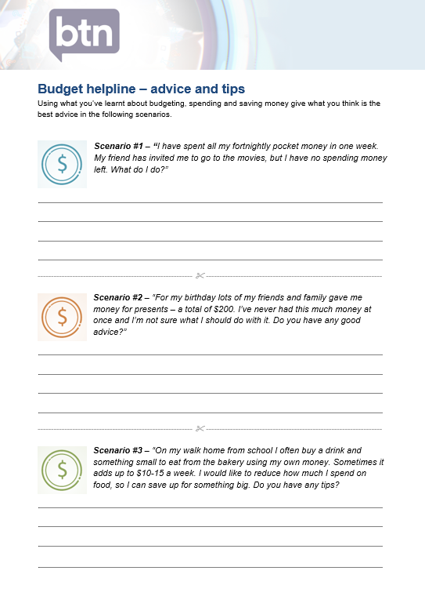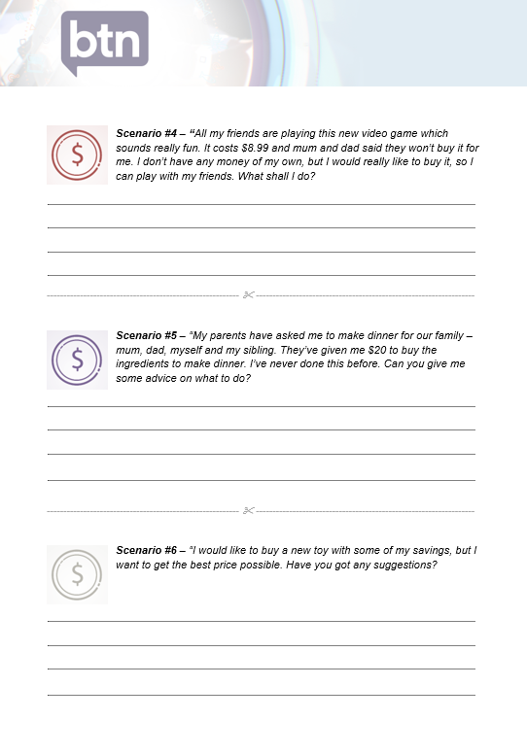

ABC iView – Teenage Boss
https://iview.abc.net.au/show/teenage-boss

Screen Australia – Teenagers take charge of family budgets in new ABC Me doco
https://www.screenaustralia.gov.au/sa/media-centre/news/2017/11-15-teenagers-take-charge-budgets-in-new-doco

ASIC – Moneysmart Teaching Resources
https://www.moneysmart.gov.au/teaching/teaching-resources

Budget helpline – advice and tips
Using what you’ve learnt about budgeting, spending and saving money give what you think is the best advice in the following scenarios.


Scenario #1 – “I have spent all my fortnightly pocket money in one week. My friend has invited me to go to the movies, but I have no spending money left. What do I do?”

----------------------------------------------------------  ------------------------------------------------------------------


Scenario #2 – “For my birthday lots of my friends and family gave me money for presents – a total of $200. I’ve never had this much money at once and I’m not sure what I should do with it. Do you have any good advice?”

----------------------------------------------------------  ------------------------------------------------------------------


Scenario #3 – “On my walk home from school I often buy a drink and something small to eat from the bakery using my own money. Sometimes it adds up to $10-15 a week. I would like to reduce how much I spend on food, so I can save up for something big. Do you have any tips?


Scenario #4 – “All my friends are playing this new video game which sounds really fun. It costs $8.99 and mum and dad said they won’t buy it for me. I don’t have any money of my own, but I would really like to buy it, so I can play with my friends. What shall I do?

----------------------------------------------------------  ------------------------------------------------------------------


Scenario #5 – “My parents have asked me to make dinner for our family – mum, dad, myself and my sibling. They’ve given me $20 to buy the ingredients to make dinner. I’ve never done this before. Can you give me some advice on what to do?

----------------------------------------------------------  ------------------------------------------------------------------


Scenario #6 – “I would like to buy a new toy with some of my savings, but I want to get the best price possible. Have you got any suggestions?

