EPISODE 3
15th February 2022

KEY LEARNING
Students will view a range of BTN stories and use comprehension skills to respond to a series of focus questions.

CURRICULUM
English – Year 4
Use comprehension strategies to build literal and inferred meaning to expand content knowledge, integrating and linking ideas and analysing and evaluating texts.

English – Year 5
Use comprehension strategies to analyse information, integrating and linking ideas from a variety of print and digital sources.

English – Year 6
Use comprehension strategies to interpret and analyse information and ideas, comparing content from a variety of textual sources including media and digital texts.

English – Year 7
Use comprehension strategies to interpret, analyse and synthesise ideas and information, critiquing ideas and issues from a variety of textual sources.
  - Teacher Resource

Focus Questions
As a class, discuss the stories featured in the episode of BTN Classroom and record the main points of the discussion. Students will then respond to the following focus questions.

School Hours Change
- Which state is proposing a change to school hours?
- Briefly explain how the 9am to 3pm school day came about.
- What are some advantages of changing the school start and finish times?
- Give an example of another country’s school hours.
- Do you think the school hours should change? Give reasons for your answer.

Indigenous War Cry
- What is the name of the war cry that the Indigenous rugby players did?
- Why is the war cry important to the Indigenous players?
- What is the name of the war dance performed by New Zealand’s sports teams before they play?
- How did they make sure all Indigenous nations were represented in the dance?
- What did you learn watching this story?

Peanut Allergy Treatment
- How old was Declan when he discovered he was allergic to peanuts?
- How many Aussie kids have a peanut allergy?
  - 3 in 100
  - 10 in 100
  - 15 in 100
- What are some symptoms of an allergic reaction?
- What is the treatment for anaphylaxis?
- Explain the trial treatment that Declan was involved in. What was the result?

Check out the teacher resource on the Teachers page.

ISS Crash Plan
- Which two superpowers worked together to launch the International Space Station?
- The ISS is modular. What does that mean?
- What is the purpose of the ISS?
- Why is NASA planning to retire the ISS?
- When and how will it be retired?

Check out the teacher resource on the Teachers page.

Why do we have names?
- Many historians think names probably came around the same time as _____________ languages.
- Why were people given names?
- Give an example of a name, what it means and where it came from.
- How did surnames come to be?
- What does your name mean?

EPISODE 3
15th February 2022

KEY LEARNING
Students will learn more about what food allergies are and the signs and symptoms of allergic reactions.

CURRICULUM
Health and Physical Education – Year 3 and 4
Identify and practise strategies to promote health, safety and wellbeing.
Describe strategies to make the classroom and playground healthy, safe and active places.
Health and Physical Education – Year 5 and 6
Plan and practise strategies to promote health, safety and wellbeing.
Health and Physical Education – Year 7 and 8
Practise and apply strategies to seek help for themselves or others.
Investigate and select strategies to promote health, safety and wellbeing.
Evaluate health information and communicate their own and others’ health concerns.
Plan and use health practices, behaviours and resources to enhance health, safety and wellbeing of their communities.

  - Teacher Resource

Peanut Allergy Treatment

Focus Questions
Discuss the BTN Peanut Allergy Treatment story as a class and record the main points of the discussion. Students will then respond to the following:
- How old was Declan when he discovered he was allergic to peanuts?
- How many Aussie kids have a peanut allergy?
  - 3 in 100
  - 10 in 100
  - 15 in 100
- What are some symptoms of an allergic reaction?
- What is the treatment for anaphylaxis?
- Explain the trial treatment that Declan was involved in. What was the result?

Activity: Class Discussion
Before watching
Before watching the BTN Peanut Allergy Treatment story students will discuss in small groups what they already know about food allergies and how they impact people.
What do you know about allergies?

After watching
Students will respond to one or more of the following questions after watching the BTN story:
- What did you learn from the BTN story?
- What do you THINK about what you saw in the BTN Peanut Allergy Treatment story?
- How do you know if you have a peanut allergy?
- What are some of the signs and symptoms of a peanut allergy?
- Think of three questions you have about the story.

Activity: Glossary
Students will brainstorm a list of key words that relate to the BTN Peanut Allergy Treatment story. Students may want to use pictures and diagrams to illustrate the meaning and create their own glossary. Here are some words to get students started.

ALLERGEN | ANAPHYLAXIS | IMMUNE SYSTEMS
ANTIBODIES | SYMPTOMS | ALLERGIC REACTION

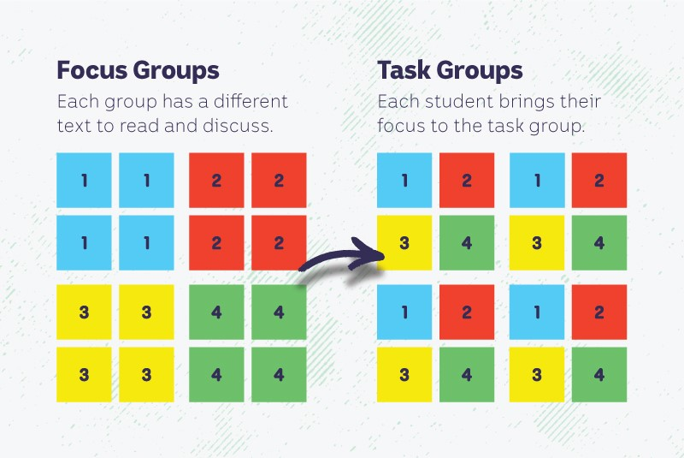
Activity: Jigsaw learning activity
In this activity students will work cooperatively to learn more about allergies, how they affect people and how they can be prevented. Each group will become experts and then share what they have learnt with other students. Please note: If students are learning from home, they can choose one type of allergy to research and become an expert.

Form groups | Divide the class into 4 x Focus Groups. Each Focus Group will be assigned a different type of allergy (pollen allergy, food allergy, insect allergy and pet allergy) to investigate and become experts. Each group will need to decide how they will collect and communicate the information they find during their research.
Research | Each Focus Group will respond to the following questions to become experts:  - Describe the allergy.  - How does the allergy affect the body? Use the following scientific words in your description: symptom, allergens, immune system and antibodies.  - What are the signs and symptoms of the allergy?  - How can you prevent the allergy from developing? How can it be treated?  - What can you do if you see someone having an allergic reaction?  - What are some challenges for people with the allergy?  - Investigate what students can do to help those with the allergy to avoid their triggers. What can students with the allergy do to avoid triggers?
Share | Mix the Focus Groups to form Task Groups (Tasks Groups include one student from each of the Focus Groups) to share the information they have collected. Students will share the information they have collected and learn from one another.
Reflect | Students will reflect on the activity by responding to one or more of the following questions:  - What did you enjoy about this investigation?  - What did you find surprising?

Activity: Public education campaign
Students will design a public education campaign to raise awareness about food allergies and how they can be treated and prevented. Students will think about their campaign’s aim, target audience, and the value of raising awareness at their school.

To create a school awareness campaign, students will need to identify the following:
- What is a food allergy?
- How do food allergies affect people?
- Why is it important for everyone to learn more about food allergies?
- What does it mean to be ‘nut aware’ or allergy aware at school?
- How can you teach other kids about the importance of being allergy aware? Think of creative ways you can teach kids your message about the topic.

Some questions to consider when designing your campaign:
- What is the campaign’s main aim?
- What are your goals? What do you want to achieve?
- Do you have a slogan or message? What is it?
- Who is your target audience?
- What is the best way to communicate the message?

Discuss with students how they will get their message out there to help raise public awareness. Some possibilities include:
- Short film or animation
- Community service announcement (for print, television or radio).
- Press release (create posters to be put up around the school or pamphlets to give to all students).
- Use Canva to design a poster to put up around their school and the wider community.

Useful Websites
- Food Allergy Week – BTN
- Food Allergies – BTN
- Food Allergy Guidelines – BTN
- Food Allergies in Children – Healthdirect
- Food Allergies in Children and Teenagers – Raising Children
- Food allergies: Important information every child should know – BBC Newsround

EPISODE 3
15th February 2022

KEY LEARNING
Students will learn what the International Space Station is and what it does.

CURRICULUM
Science – Year 5
The Earth is part of a system of planets orbiting around a start (the sun).

Science – Years 5 & 6
Scientific knowledge is used to solve problems and inform personal and community decisions.

Science – Year 7
Scientific knowledge has changed peoples’ understanding of the world and is refined as new evidence becomes available.

  - Teacher Resource

International Space Station

Focus Questions
Discuss the BTN International Space Station story as a class and record the main points of the discussion. Students will then respond to the following:
- Which two superpowers worked together to launch the International Space Station?
- The ISS is modular. What does that mean?
- What is the purpose of the ISS?
- Why is NASA planning to retire the ISS?
- When and how will it be retired?

Activity: Class Discussion
Discuss the BTN International Space Station story as a class. What do students know about the ISS? What questions do they have? In small groups, ask students to brainstorm responses to the following questions:
- Why do humans explore space?
- What is the International Space Station?
- What is the purpose of the ISS?
- Give examples of what astronauts on the ISS do.
- What questions do you have about the ISS?

Activity: Glossary
Students will brainstorm a list of key words that relate to the BTN International Space Station story. Here are some words to get them started.

INTERNATIONAL SPACE STATION | ASTRONAUT | MICROGRAVITY
ORBIT | EXPLORATION | EXPEDITION

Activity: History of space exploration
Students will investigate the history of space exploration and present their research as a timeline, infographic or a presentation. Below are some key events in the history of space exploration
1969
Apollo 11 Moon landing

1957
Sputnik, first artificial satellite launched.

1998
Launch of the International Space Station.

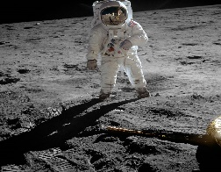
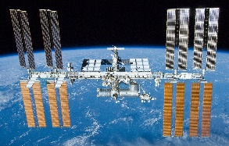
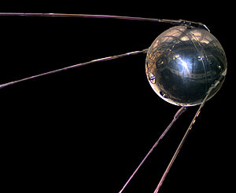

- 1957 – Sputnik, first artificial satellite launched into space
- 1961 – Yuri Gagarin, first person to enter space
- 1969 – Apollo 11, Moon landing
- 1990 – Launch of Hubble Space Telescope
- 1998 – Launch of International Space Station
- 2011 – Curiosity launches to Mars
- 2019 – First image of black hole released
- 2020 – Perseverance launches to Mars

Activity: ISS Research
Discuss the information raised in the BTN International Space Station story. What questions were raised in the discussion and what are the gaps in students’ knowledge? The following KWLH organiser provides students with a framework to explore their knowledge on this topic.

What do I know? | What do I want to know? | What have I learnt? | How will I find out?

Students will develop their own question/s to research or choose one or more of the questions below.

- What is the ISS? Why do we have an International Space Station?
- What do astronauts do on the ISS?
- How long do they stay on the ISS?
- What is it like living in microgravity? Eating, sleeping, having a shower, going to the toilet.
- What impact does microgravity have on the human body? Bones and muscles, sense of taste.
- What do you think the challenges of living in space would be?
- How does the work carried out by the ISS astronauts contribute to science and affect life on Earth?
- How has technology used in space exploration changed over time?
- How will the International Space Station be decommissioned safely?

Activity: Get to know the ISS
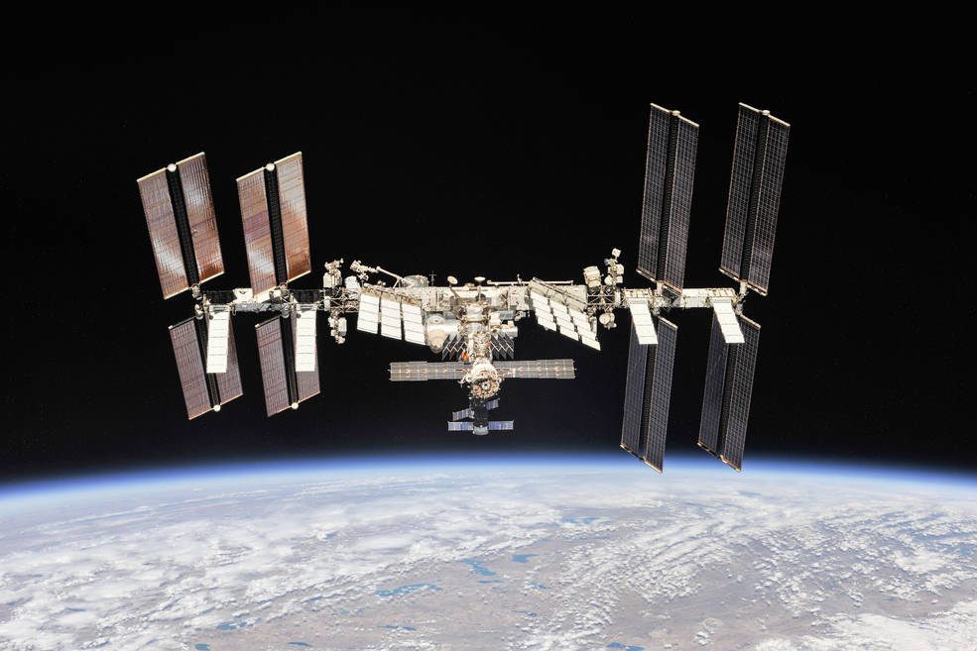
Who’s on the ISS – Meet the Expedition 66 crew. Choose an astronaut and write a short biography about them.

Learn more about the Spacewalks at the Station

Find out what the astronauts are up to on the ISS and the research what they are doing by checking out the Space Station blog update

Spot the International Space Station. Watch the ISS pass overhead from locations all around the world. It is the third brightest object in the sky and easy to spot if you know when to look. Enter your location to find out when you can see it.

Activity: How do astronauts live in space?
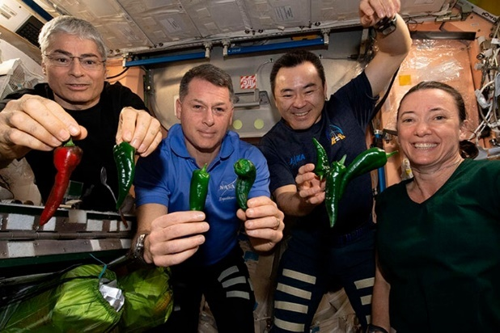
Students will learn more about what life is like on the International Space Station. These videos provide a snapshot of what living on the ISS is like.
Everything about living in space
Life inside the ISS

Students will describe a day in the life of an astronaut on the ISS, including information about sleeping, eating, personal hygiene, exercising and carrying out work on the ISS. What do astronauts do in their spare time?

As a class, watch the Eating in Space video for an in-depth look at how and what astronauts eat to stay healthy. Students will then respond to the following questions:
- What food do astronauts eat?
- Is there any food they can’t eat?
- Does food need any special preparation before it can be eaten?
- Why is nutrition important for astronauts?
- If you lived in space, what foods would you miss the most? Why?

Watch the Exercising in Space video and explain why it’s important for astronauts on the ISS to exercise.

Activity: Space Mission
Students will choose a space mission to explore in detail. Students can choose one of the space missions below or choose another mission.
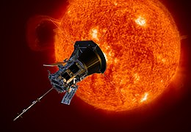
- International Space Station
- Perseverance Rover
- Hubble Space Telescope
- Parker Solar Probe

Students can use the following questions to guide their research.
- Briefly summarise the mission.
- When did the mission take place?
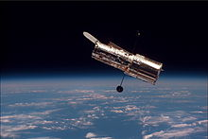
- What was the purpose of the mission?
- Who was the crew? What were their roles?
- What did the mission discover?
- Which countries were involved in the mission?
- How has the mission helped us understand space?
- What were some challenges of the mission?
- Include photographs and diagrams in your research project.

Useful Websites
- The International Space Station will meet its end in 2031. Where will it crash and what will take its place? – ABC News
- 23 facts about the ISS – Newsround
- The 20 most amazing moments of the ISS – Newsround
- Life in Space – BTN
- How do astronauts go to the bathroom in space? – Curious Kids
- A day in the life aboard the International Space Station – NASA

  - Teacher Resource

BTN Transcript: Episode 3 - 15/2/2022

Hey, I'm Amelia Moseley and you're watching BTN. Hope you had a good week, let’s see what’s coming up. We find out why some people want to see more of this in the NRL, learn about NASA's plan to crash the ISS into the ocean and Jack investigates why we have names.

School Hours Change

Reporter: Amelia Moseley

INTRO: But first today to the school day. For most of you, that starts at around 9am, right? And finishes just after 3. But is that the right way of doing things? Some people say no, including the New South Wales Premier, who wants to shake up when we go to school. Check it out.
For a long time, one thing's been pretty constant in the lives of most Aussie kids and that's the school day. But imagine if it could change?
SCHOOLKID 1: I feel like school hours should start at 8.30 and end at 4 o'clock.
SCHOOLKID 2: I think school should start at 12.30 and then at 6 o'clock because students need to rest in the night, and they might not like waking up early like me.
Yeah, I'm with that kid. But this isn't imaginary, it's a real possibility at least in New South Wales. The state's premier Dominic Perrottet says he'd like to see school hours change to match up better with modern families.
DOMINIC PERROTTET, NSW PREMIER: The school hours are 9 ‘til 3. That was set up at a very very different time in life.
Well that's true. In fact, it dates back to the late 1800s before this country was even officially a country.
AMELIA: It was at this time that different colonies, starting with Victoria, brought in new laws to make education free, compulsory and non-religious. This would go on to become Australia's public education system. And when New South Wales created their own education laws in 1880, they also set out a timetable for how the school day would run. Now, does anybody know what that is? Anyone? Dorothy?
DOROTHY, 1800s SCHOOLKID: 9 to 3.30.
AMELIA: Well done Dorothy. No cane for you today. Ha ha. Different times.
But Mr Perrottet isn't the first to suggest school hours should change with the times. Some reckon it could make it easier for parents to juggle their work commitments, or help with traffic jams in the morning rush, or maybe even help you do better at school because you could get more sleep in the morning or have more time to do your homework in the afternoon. Well, that's the idea, anyway.
In fact, some countries have already switched things up. In Finland school goes from 8 or 9 to 2pm. In Brazil, kids are in class from 7am to midday so they can head home for lunch with their families. Oh, that's nice. And in China, school usually goes from 7.30 all the way to 5pm but, with a two hour break in the middle of the day. And back in Australia some schools have also already chosen to change their hours in different ways.
Of course, not everyone thinks a change to the school day will work for every family. In fact, it could make it trickier for some. And education experts say the most important thing is, well, education and any changes should be about what helps you learn best. There is set to be a trial in New South Wales later this year and schools can apply to take part. And while the government hasn't confirmed which times will be tested out, it's thought a 7am to 1pm school day or a longer day is on the cards. So, what do you think?
ALICE: Waking up to get to school at 7 I feel like is crazy, I wake up early enough trying to get to school at 8.45.
TOM: I guess I'm just lucky that I have an amazing teacher because if I didn't then I wouldn't really want extra hours.
LIV: I think that 9 to 3 the way it is currently is good and it's stayed the same for so long because it is good and I don't really see any purpose in changing it now.

News Quiz

An anti-vaccine protest led by truck drivers is causing chaos in Canada’s capital. Do you know the name of the city? It’s Ottawa. And for weeks it’s been brought to a standstill by the protests.

OTTAWA POLICE: No officers are on days off. Everyone has been working. We are stretched to the limit, but we are 100 percent committed to using everything we have to end this demonstration.

These furry little Aussie icons were officially declared endangered last week, but only in parts of Australia. In which three states or territories are they in trouble. Koalas have been officially declared endangered in New South Wales, Queensland and the ACT. Their populations are healthier in Victoria and SA, and they’re not found at all here. While an endangered listing sounds bad, it’s actually something conservationists have been calling for because it means they’ll have more protection.

MINISTER FOR THE ENVIRONMENT, SUSSAN LEY MP: This listing adds priority when it comes to conservation of the koala coming out of the black summer fires.

And which animated film wasn’t nominated for an Academy Award this year? Luca, Encanto, Raya and the Last Dragon or Soul? The answer is Soul but only because it won last year. All the others are up for an award, but we’ll have to wait until March to find out who wins.

Indigenous War Cry

Reporter: Jack Evans

INTRO: If you're a rugby fan you might've watched the big match on the weekend between the Indigenous All Stars and the Māori’s. But this next story's not about the game, it's about what happened beforehand. Jack found out more about the Indigenous Unity Dance which some people want to see play a bigger role in the NRL.

This is the Unity Dance, a war cry designed to show the pride and power of Australia's best Indigenous rugby players as they prepared to take on their Māori rivals.
DEAN WIDDERS: A war cry is a pre-game sort of cultural dance that we do, before we play, to show respect to our culture and our ancestors, and also to unify our group.
Dean Widders is an Anaiwan man who played NRL for a bunch of different teams and he's one of the people behind the Unity Dance.
DEAN WIDDERS: As the oldest nation in the Pacific, we are really proud of our culture, and we want to represent that when we play.
Of course, you probably already know about this dance which was also performed on the weekend. The Haka is a ceremonial war dance or challenge that New Zealand's sports teams perform before they play. There are lots of different Haka and they've always been an important part of Māori culture. But now they've become important to all New Zealanders and are performed in all sorts of situations to show pride, strength and unity. Some Aussies would like to see a similar celebration of Australian Indigenous cultures in sport. You might have even seen a few different examples. But finding a way to represent all of Australia's Indigenous nations isn't easy.
DEAN WIDDERS: It's hard for Indigenous Australia to come up with one dance, you know, we are so diverse. We represent so many different nations, all across this country and so, we got all the players in with some people who gave us advice on dance and dance experts from cultural experts. And we workshopped and came up with a dance from the players that represents all of those nations across the country, as these players they come from those nations. It represents everyone. It doesn't belong to just anyone and we find it easy then that everyone's able to build, it’s universal across them.
Now, Dean is pushing for the Unity Dance to be performed by all Aussie NRL teams, Indigenous and non-Indigenous and the Players Association has agreed.
DEAN WIDDERS: It belongs on the footy field, it's not a traditional dance, it's not law, or any historical culture. It's a football dance made up of players that they perform to prepare for a game and showcase their culture. So, you know, the players want to give this as a gift to the Australian teams and hopefully the Australian teams will learn about this dance and performance. And we feel that we can empower the team, you know, and bring people together, which is the big thing that we want to do is unite people and make everyone proud of Indigenous culture.

Did You Know?

Did you know the Ka Mate Haka isn't a war dance, but a celebration of life over death? It was composed by famous Māori leader Te Rauparaha after he had a lucky escape from his enemies.

Peanut Allergy Treatment

Reporter: Amelia Moseley

INTRO: Remember if you want your school to be featured in a shoutout you can jump on our website and find out how. Now there may be some good news for all of you out there who have peanut allergies. Aussie researchers have been testing out a type of treatment and it's had some really good results. Take a look.

Peanuts. They're the nasty little nuts that lurk in heaps of stuff we eat, and they can be really dangerous, even deadly.
JACK: Hey. Why'd you do that?
AMELIA: It has peanuts in it.
JACK: So, what? It’s not like I’m allergic. I love peanuts.
AMELIA: Ohhhh. Maybe let's start this again.
Peanuts. They're the nice little nuts that pop up in heaps of stuff we eat. And they're only dangerous if someone's allergic. Otherwise, they're, like, just nuts. This is Declan and, unlike Jack, Declan was definitely allergic. When he was four, he learnt the hard way after having a serious reaction to peanut butter.
DECLAN, CLINICAL TRIAL PARTICIPANT: Would have to ask what was in the foods to see if it had peanuts. I couldn't have things that had traces of it either.
And he's not the only one. About 3 in a hundred kids in Australia have a peanut allergy where sometimes even tiny amounts of peanut, or touching a surface where peanuts were, can set them off and most of the time their allergy never goes away. It all comes down to their immune system; the barrier that normally protects against germs and diseases. It mistakenly thinks the nuts are harmful and tries to get rid of the invaders by sparking a reaction. Sometimes it can be really serious and can lead to something called anaphylaxis which can cause symptoms like a rash, nausea, vomiting and difficulty breathing. It can be life-threatening and if it happens, the person might need an adrenaline injection or EpiPen, which helps reverse the symptoms.
But wait, Declan. That's got peanuts in it. No. Oh, oh no that's right. Declan's one of 201 kids who have just taken part in the trial of a new treatment in Melbourne. Researchers wanted to see if Declan and the other kids could become desensitised to peanuts, which means teaching their immune system that they aren't so bad and not to react. The main part of the treatment gave each kid a tiny amount of peanut, less than 100th of a nut, in powder form, and over four years they were slowly given more until they got to 8 whole peanuts. For a peanut allergy sufferer that's amazing. Now, 18 months on Declan can eat nuts whenever he wants.
DECLAN, CLINICAL TRIAL PARTICIPANT: I don't like them at all.
Oh, fair enough. About half of the kids in the trial stopped having an allergic reaction to peanuts altogether while a quarter of the kids became less sensitive to them.
PROFESSOR MIMI TANG, ALLERGY SPECIALIST: What it means for the patient is that they can stop treatment and introduce peanut into their diet, as and when they like.
Researchers say the treatment could be life changing for many more kids. Although it's important to remember, the trial was done under strict medical supervision over a long period of time, so definitely don’t try this one at home, OK?
JACK: Hey. What did you do that for? I told you I wasn’t allergic.
AMELIA: No, I know, I just hate chocolate chip. Gross.

ISS Crash Plan

Reporter: Amal Wehbe

INTRO: Now to some dramatic news about the ISS. Recently NASA announced that in 2030 it will retire the ageing space station and then crash it into the ocean. Here’s Amal to explain.
AMAL: Well, we're all gathered here today to mark the loss of our dear friend, the International Space Station. So, um I think let's start at the beginning.
I guess that's way back here when humans first figured out how to put things into orbit, sparking a race between the US and the Soviet Union to get things and then people into space. In 1971, the USSR successfully launched the first space station. And NASA wasn't far behind with its own home away from home. Then there was Russia’s Mir Station, which stayed in orbit from 1986 to 2001. But in the 90s, the two space superpowers decided to end the space race and work together on something even bigger and in 1998 Russia launched the first part of the International Space Station. Over the years it kept growing and more countries got involved. Now it's the biggest object we've ever put in space. In fact, if you look up at the right time you can see it with the naked eye as it whizzes by at 28 thousand kilometres an hour.
AMAL: But friends the ISS wasn’t just there to look good. It was also a space laboratory that helped us learn more about our world.
In fact discoveries made up here that get used on Earth are known as 'spinoffs'. And there have been quite a few of them. From air and water recycling systems to new ways of growing food. And looking at the Earth from up here has given us a unique perspective on things like weather, climate change, and volcanic activity. It also had a pretty big effect on the 244 people who've been lucky enough to visit.
AMAL: But nothing lasts forever especially when you stick it up in a big cold radioactive void and now, we come to the end.
Yep, after a couple of decades in space the ISS is well wearing out. And maintaining it costs about 4 billion dollars a year. So, NASA is planning to retire the station. And when I say retire, I mean send it plummeting into the ocean in a fiery ball. I know this might sound dramatic, but experts say it's the best option. Otherwise, if you leave it up there it becomes space junk, which is already a massive problem. And they don't want it falling back to Earth in an uncontrolled way.
AMAL: Now friends the question is without the ISS, what does the future hold for humans in space?
Well the ISS isn't the only station up there. China's Tiangong is growing, and it's already had crews onboard. And NASA's given grants to three private companies to build their own space stations. And they could use the ISS to help them get there. It'll also be used to help get us ready for our next big space adventure getting people to Mars.
AMAL: So, let’s not see this as the end but a beginning as we look forward to another eight years of amazing science from our giant friend in the sky.
NAT: Wait what? We've got another eight more years?
AMAL: Yeah, they're not crashing it until 2031.
JACK: What? Well, then why are you having a funeral now? You made us all so sad.

Sport

As you heard earlier, the NRL got off to an impressive start on the weekend with Australia’s Indigenous All Stars facing off New Zealand's Māori’s in the Annual All Star weekend. First up, the women’s game and after a devastating loss last year, the Aussies came back for the win. Winger Jaime Chapman got the first two tries and the team kept up the lead the whole game to take out a 18 to 8 win.
It wasn't such good news for the Aussie Men though. The Indigenous All Stars started with the lead but by the third quarter the Māori side were up 16 against 6. Tyrell Sloan helped out with an impressive four pointer, but it wasn't enough.
Meanwhile the US has celebrated its biggest football game of the year. This year the Los Angeles Rams beat the Cincinnati Bengals 23 t o20 to take out their second Superbowl title. The game went down to the wire with the Rams scoring a touchdown in the last 40 seconds.
And finally, in Beijing, Jaclyn Narracott made Australian Olympic history claiming our first ever medal in a sliding sport. She got a silver which brings our medal tally to 4, the most we've ever got in the Winter Olympics.

Why do we have names?

Reporter: Jack Evans

INTRO: Now it's time for BTN Investigates, a segment where we take questions sent in by you and we do our best to answer them. This week, Alex from Queensland had an interesting one for Jack about why we have names. Check it out.

PERSON 1: Hey you.
PERSON 2: Me?
PERSON 1: No, not you, you.
PERSON 3: Me?
PERSON 1: No, you.
PERSON 4: Me?
PERSON 1: No, the other you.
PERSON 2: Me?
PERSON 1: No, I already said I wasn't talking to you.
PERSON 2: Then who are you talking to?
Yeah, it would be pretty annoying to live in a world where we didn't have names.
PERSON 1: Right, nobody move, and I'll point to the person that I’m trying to talk to, alright? You.
Thankfully we actually live in a world where people have first names, middle names, last names, nicknames, names of all kinds. But who exactly decided that we needed names? Well, the truth is, we don't actually know. As far back as the history books go people have always had names. Many historians reckon they probably came around the same time as spoken languages, as a way to help distinguish one person from another, obviously.
As for the types of names that people were given, well that was different from culture to culture. Some names came from nouns, like Ava, which is Latin for life. Others come from adjectives, like Sophia which is Greek for wise. Some names are compound phrases, which is two words put together, like the Hebrew name Benjamin meaning son of my right hand. And in some cultures, names came from gods and deities, like the Greek goddess Diana.
PERSON 1: OK, right this is too confusing. So, from now on you can all refer to me as Jack, which FYI means God is gracious.
PERSON 2: Ooh I like it. Can I have one too?
PERSON 1: Of course.
PERSON 2: OK, what about Jack?
PERSON 1: But that's my name.
PERSON 2: Yeah, well now it's mine too.
PERSON 3: I like Jack. I'll also be Jack.
PERSON 4: Of, me too. I'll also be Jack.
As you can imagine, it became pretty difficult when you had a bunch of Jacks in the one town and as populations grew the need to distinguish one Jack from the other became pretty important. That's where surnames or last names or family names come in. Again, they're different from culture to culture.
There are religious last names, like in Islam, Abdullah means Servant of God. Or Sikhs who take the last name Singh or Kaur. In some cases, last names refer to your father or mother. Like the ancient Chinese who would adopt their mothers name followed by their given name. Although, that was eventually replaced with the father’s name. In parts of UK, it was also common to take their father’s name and add son to the end of it. Which is where we get names like Williamson and Samson. During the Middle Ages it was also pretty common for people to be given a last name based on a character trait, the place they were born or even just their occupation.
PERSON 1: Fine alright, well, what if you’re Jack the shoulder, ‘cause you do that shoulder dance.
PERSON 2: Oh, this one?
PERSON 1: Yeah, that's the one and you can be Jack of all trades 'cause you're good at everything.
PERSON 3: Who me?
PERSON 1: And what will we call you?
PERSON 4: Ummm, Jack the other one?
PERSON 1: Sure.
Today we continue to use names that have been around for thousands of years. Although there are a lot of unique names out there now that are, well, unique. Anyway, whatever your name is, the reason why we have one is still the same as it was thousands of years ago.
PERSON 1: Great, OK, now that we all have names I can address the person that I was trying to talk to.
PERSON 2: And who was that?
PERSON 1: Oh, um, it was, um oh know, I seem to have forgotten their name. It was Jack the something.

Closer

Well, I hope that clears things up a bit. And just for the record Alex comes from Alexander which means "defender of mankind" so there you go Alex. Well, that's it for this week, thanks for hanging out with us. We'll be back next week with more, but until then you can keep up with Newsbreak every weeknight. Plus, you can check out extra stuff on our website and, if you're 13 or over, make sure you head to our YouTube channel. Have an awesome week everyone and I'll see you soon. Bye.

