EPISODE 1
6th February 2024

KEY LEARNING
Students will view a range of BTN stories and use comprehension skills to respond to a series of focus questions.

CURRICULUM
English – Year 4
Use comprehension strategies to build literal and inferred meaning to expand content knowledge, integrating and linking ideas and analysing and evaluating texts.

English – Year 5
Use comprehension strategies to analyse information, integrating and linking ideas from a variety of print and digital sources.

English – Year 6
Use comprehension strategies to interpret and analyse information and ideas, comparing content from a variety of textual sources including media and digital texts.

English – Year 7
Use comprehension strategies to interpret, analyse and synthesise ideas and information, critiquing ideas and issues from a variety of textual sources.
  - Teacher Resource

Focus Questions
As a class, discuss the stories featured in the episode of BTN Classroom and record the main points of the discussion. Students will then respond to the following focus questions.

Income Tax Changes
- Who collects tax?
- What is tax used to pay for? Give 2 examples.
- Which type of tax brings in the most money in Australia?
  - Income tax
  - Payroll tax
  - Property tax
- The more money you earn the higher percentage of income tax you pay. True or false?
- How will the stage 3 tax cuts affect people with higher incomes?

Queensland Wild Weather
- What sort of weather has Queensland been experiencing recently? Describe.
- Complete the missing gaps. Heavy rainfall in parts of Queensland has caused both flash__________ and riverine____________.
- What is the name of the recent cyclone in Queensland?
- How has the weather in Queensland impacted people?
- What kind of weather does Queensland have?
  - Hot desert
  - Mediterranean
  - Tropical

Check out the teacher resource on the Archives page.

Young Political Journalist
- Which state in the United States is Quinn from? Find on a map.
- What age did Quinn become interested in politics?
- What are the three branches of government in the United States?
- What are the two main political parties in the United States?
- It is compulsory to vote in the United States. True or false?

Beach Safety
- How many beach rescues were made along the Australian coastline in 2023?
  - 60
  - 600
  - 6,000
- What two colours do life savers wear?
- Where along the beach should you swim so life savers can see you and keep you safe?
- What is a rip?
- Rips are hard to spot. True or false?

Check out the teacher resource on the Archives page.

Finding Confidence in Performing
- Summarise the BTN story.
- What true story is The Sapphires musical based on?
- What role did Katiana play in the musical?
- How did performing in the musical make Katiana feel?
- What did you like about the BTN story?

EPISODE 1
6th February 2024

KEY LEARNING
Students will investigate the impact of floods and cyclones on people and communities.

CURRICULUM
Geography – Year 5
The impact of bushfires or floods on environments and communities, and how people can respond.

HASS – Year 5
The impact of bushfires or floods on environments and communities, and how people can respond.

Science – Year 6
Sudden geological changes and extreme weather events can affect Earth’s surface.

Geography – Year 7
Causes, impacts and responses to an atmospheric or hydrological hazard.
  - Teacher Resource

Queensland Wild Weather

Focus Questions
Discuss the BTN story as a class and record the main points of the discussion. Students will then respond to the following:
- What sort of weather has Queensland been experiencing recently? Describe.
- Complete the missing gaps. Heavy rainfall in parts of Queensland has caused both flash__________ and riverine____________.
- What is the name of the recent cyclone in Queensland?
- How has the weather in Queensland impacted people?
- What kind of weather does Queensland have?
  - Hot desert
  - Mediterranean
  - Tropical

Activity: Class Discussion
Discuss the BTN Queensland Wild Weather story as a class. Ask students what they know about cyclones and floods. Use the following questions to guide discussion:
- What do you know about the recent cyclones and floods in Queensland?
- What causes flooding?
- What do you know about cyclones?
- What impact have the cyclones and floods had on people and communities?
- What questions do you have?

Activity: Note taking
Students will practise their note-taking skills while watching the BTN Queensland Wild Weather story. After watching the story, ask students to reflect on and organise the information into three categories. What information in the story was positive, negative, or interesting?

Activity: Glossary
Students will brainstorm a list of key words that relate to the BTN Queensland Wild Weather story. Below are some words to get students started.
FLOOD | CYCLONE | RAINFALL
TROPICAL | CLIMATE | SEVERE WEATHER

Activity: Cyclone & Flood Research
Discuss the information raised in the BTN Queensland Wild Weather story. What questions were raised in the discussion and what are the gaps in students’ knowledge? Students will develop their own question/s to research or choose one or more of the questions below. Encourage students to collect and record information from a wide variety of sources and present the information they find in an interesting way.
- What are floods? Investigate what flash floods and riverine floods are and what causes them. Compare and contrast flash floods and riverine floods.
- What damage can floods cause? In your own words, describe the damage floods can cause.
- How do floods affect people? Divide your response into the following categories: houses, services, and emotions. What are the immediate and long-term needs of people?
- What can people do before a flood to stay safe?
- Which areas in Australia do you think would be most at risk of flooding? Find a map of your local area and identify waterways near where you live and highlight the areas that would be most at risk of flooding.
- How do tropical cyclones form? Use a diagram to show how a cyclone forms.
- What tools help scientists to detect and categorise cyclones?
- How are cyclones tracked and measured? Describe and compare old and new discoveries.
- How do cyclone warnings help people prepare for a catastrophic natural disaster? Why is the early detection of cyclones important? Investigate how people can prepare for a cyclone.
- Why and how are cyclone names chosen? Watch this ABC Education video How to name a cyclone to learn more.
- Where in Australia do cyclones occur? Why? Create a map to show the regions in Australia affected by cyclones.

Further investigation
Find out more about Cyclone Jasper and Cyclone Kirrily and answer the following questions.
- Where did the cyclone form?
- Where did it travel? On a map mark where the cyclone travelled.
- What wind speed did the cyclone reach?
- What category was this cyclone?
- What damage did it cause inland?

Cyclone in a Bottle
In this experiment, students will learn how air moves during a cyclone. They will identify the similarities and differences between the formation and features of cyclones and follow these instructions to create a ‘cyclone in a bottle’.

Activity: Understanding rainfall
Students will start to think like a meteorologist and analyse this map produced by the Bureau of Meteorology. Students will then respond to the following questions:
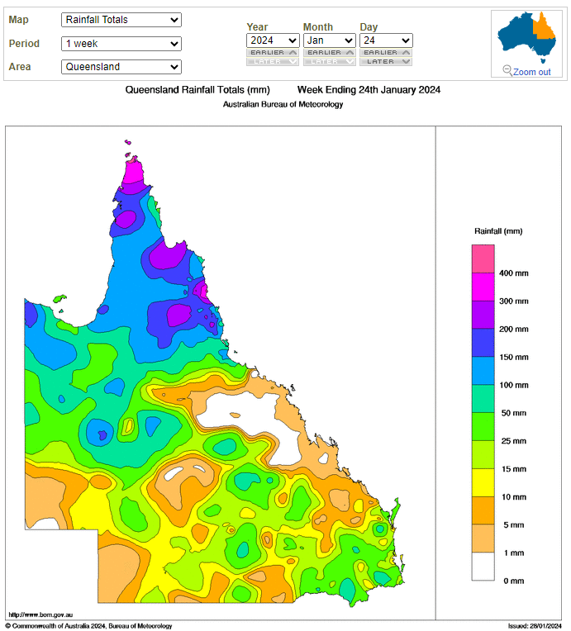
- What features do you see on this map? Make a list.
- What does the map tell us?
- What does it measure?
- What area does it cover?
- What period of time does this map cover?
- What is the purpose of this map?
- Find a map which shows the total rainfall for Queensland a week prior, and a week later and then compare. What are your findings?

Further investigation
- What is rainfall?
- How is rainfall measured? What instruments are used to measure rainfall?
- Who measures rainfall? BoM
- What is a rain gauge? Investigate and then create
your own school rain gauge. Record the daily rainfall and calculate the average daily rainfall.

Visual Literacy
In this activity students will analyse a range of images which show the damage caused by the cyclones and floods in Queensland recently. Students will choose one or more of the images below and respond to the following:
- What is happening in the image? Create a caption for each image.
- How does the image make you feel?
- What does the image tell you about the impact floods and cyclones have on a community?
- What questions do you have about what you see in the image?

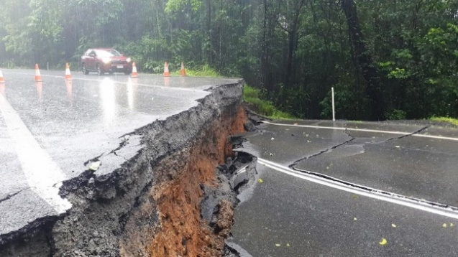  ABC News | 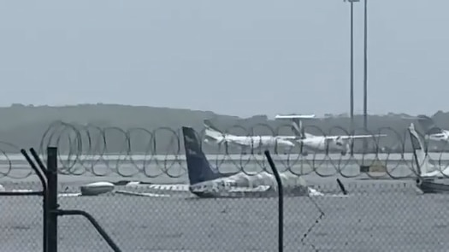  ABC News
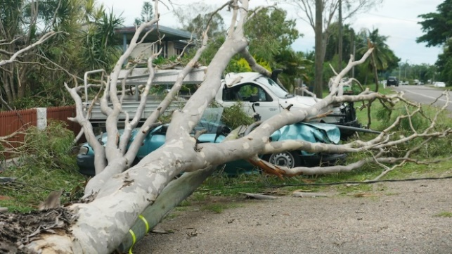  ABC News | 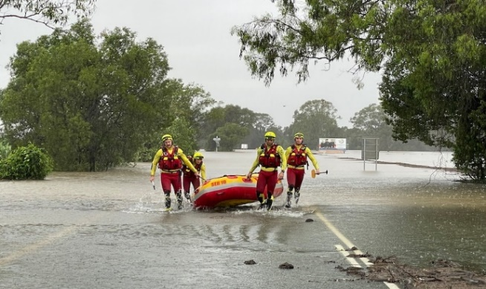  ABC News

Useful Websites
- Cyclone Kirrily Aftermath – BTN Newsbreak
- Understanding Floods – Bureau of Meteorology
- Floods – Geoscience Australia
- Things you can do before a flood – NSW SES
- Cyclones Explained - BTN
- Cyclones: What you should do if disaster threatens – ABC Emergency
- Here’s everything you need to know about cyclones - ABC News
- Tropical cyclone categories explained - ABC News
- Bureau of Meteorology – Cyclones FAQ

EPISODE 1
6th February 2024

KEY LEARNING
Students will develop a deeper understanding of beach safety including how to spot a rip.

CURRICULUM
Health and Physical Education – Year 3 & 4
Identify and practise strategies to promote health, safety and wellbeing.

Health and Physical Education – Year 5 & 6
Plan and practise strategies to promote health, safety and wellbeing.

Investigate the role of preventive health in promoting and maintaining health, safety and wellbeing for individuals and their communities.

Investigate community resources and ways to seek help about health, safety and wellbeing.

Health and Physical Education – Year 7 & 8
Investigate and select strategies to promote health, safety and wellbeing.

  - Teacher Resource

Beach Safety

Focus Questions
Discuss the BTN story as a class and record the main points of the discussion. Students will then respond to the following:
- How many beach rescues were made along the Australian coastline in 2023?
  - 60
  - 600
  - 6,000
- What two colours do life savers wear?
- Where along the beach should you swim so life savers can see you and keep you safe?
- What is a rip?
- Rips are hard to spot. True or false?

Activity: Class Discussion
Before watching the BTN Beach Safety story begin with a discussion to find out what your students already know about beach safety. In pairs, students will respond to the following questions, recording their ideas on a mind map. Ask some volunteers in the class to share their mind maps.
- What do you like about swimming at the beach?
- What are some of the dangers when swimming at the beach?
- What is a rip current? Explain what you know about rips.
- What do you do to be safe around water?

After watching the BTN story students will respond to one or more of the following questions:
- What did you learn from the BTN story?
- What do you THINK about what you saw in the BTN story?
- Have you ever experienced a rip current? Describe what it was like.
Activity: Research Project
Discuss the information raised in the BTN Beach Safety story. What questions were raised in the discussion and what are the gaps in students’ knowledge? The following KWLH organiser provides students with a framework to explore their knowledge on this topic.

What do I know? | What do I want to know? | What have I learnt? | How will I find out?

Students will develop their own question/s to research or select one of the questions below.
- What is a rip current and how do you spot them?
- Why is it important to swim between the red and yellow flags at the beach? Investigate the different flags and signs which help us to be water safe. Think of a creative way to teach kids in your class about what the flags and signs mean and why they are important.
- Why is it important for kids to learn water safety skills? Write a persuasive piece of writing for the following statement: “All kids need to learn beach safety skills”.
- What are some hazards when swimming in the beach? For example: rip currents, dangerous marine creatures, large waves, rock fishing or diving off a jetty. Choose one to investigate in more detail. Identify the hazard, tips for avoiding the hazard, and give advice to help people if they encounter the hazard. Use images, diagrams, videos and/or photos to help explain your answers.
- What is the role of a lifesaver? How do you become a lifesaver? What is the difference between lifesavers and lifeguards? Write some questions you would like to ask a lifesaver. As a class organise to meet and interview a lifesaver to learn more about beach safety.
- When did surf lifesaving start in Australia? Research the history of surf lifesaving in Australia and record your findings on a timeline.

Activity – Jigsaw learning
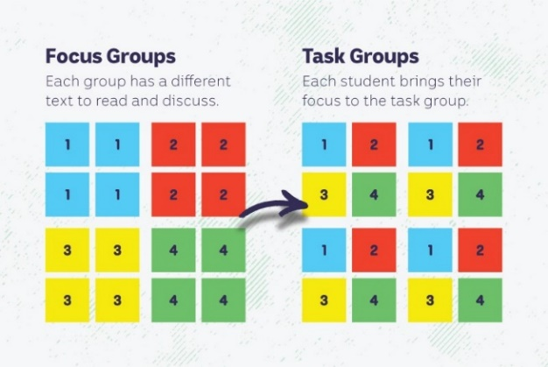
In this activity students will work cooperatively to understand the importance of water safety and how to stay safe when swimming at the beach, in a river, lake or a pool. Each group will become experts and then share what they have learnt with other students.

Form Groups
Divide the class into 4 x Focus Groups. Each Focus Group will be assigned one of the following to study: beach, pool, river, and lake. Each group will need to decide how they will collect and communicate the information they find during their research.

Research
Students can search for news articles and other publications to help with their research. Each Focus Group will respond to one or more of the following questions to become experts:
- What are some of the hazards when swimming in this area? Highlight the obvious dangers and some of the hidden dangers.
- Is the area patrolled? If so, give a description.
- How can people be water safe in and around the area? Give some safety tips.
- Are there any safety devices that people can use to stay safe in the water?
- What can we do if we are in danger? How can we help others that are in danger? Think of a real life scenario and explain the steps to get out of danger.

Share
Mix the Focus Groups to form Task Groups (Tasks Groups include one student from each of the Focus Groups) to share the information they have collected. Students will share the information they have collected and learn from one another.

Reflect
Students will reflect on the activity by responding to one or more of the following questions:
- What did you enjoy about this investigation?
- What did you find surprising?

Activity: Flags, Signs and Notices
Students will research Australia’s beach safety flags. They can use the worksheet at the end of this activity to record their findings.

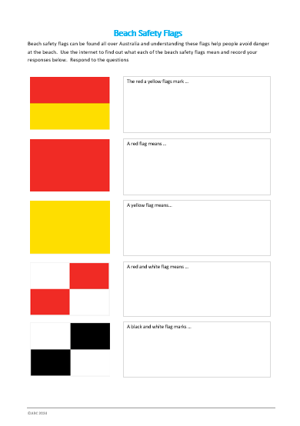
Research
Students can use the worksheet at the end of this activity and respond to the following.
- What do each of the different beach safety flags mean?
- Why do we have beach safety flags?
- What is the most important flag?
- What does it mean if there are no red and yellow flags on the beach?

Further research
Beach safety signs are different shapes and colours. They tell you about the beach and the conditions. Find out more about these signs and present your information to the class.

Activity: Can you spot a rip current?
Rip currents are the number one hazard at Australia's beaches, but they can be difficult to spot. Challenge your students by asking them to spot the rip currents in the following photos. Students will analyse each of the photos and mark with a highlighter where the rip current is in the water. Watch this Surf Life Saving Australia YouTube video to learn more about spotting rips at the beach.

Students will then respond to one or more of the following questions:
- What is a rip current? What are the things to look for when spotting a rip?
- Why are rip currents dangerous?
- What is the best way to avoid swimming in a rip?
- What should you do if you get caught in a rip?
- Rip currents are easy to spot. True or false?
- What are some myths about rip currents? Explain why they are myths.
- How are rips formed?
- What questions do you have about rip currents?

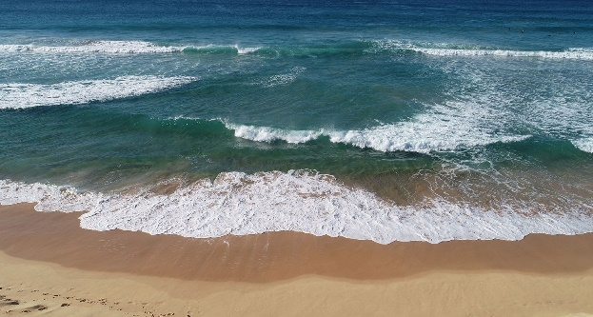  Image link | 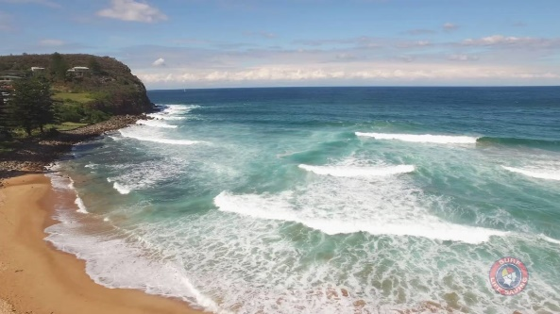  Image link
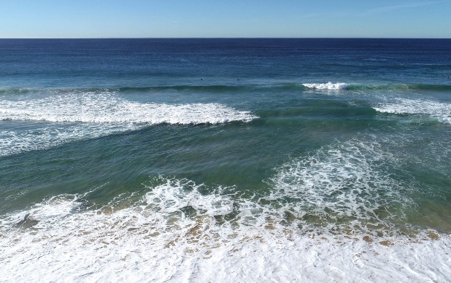  Image link | 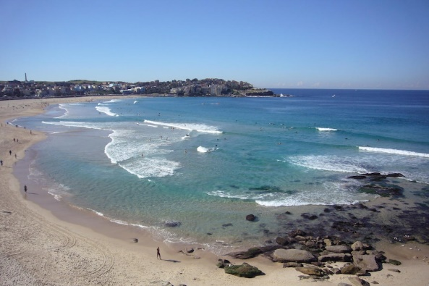  Image link
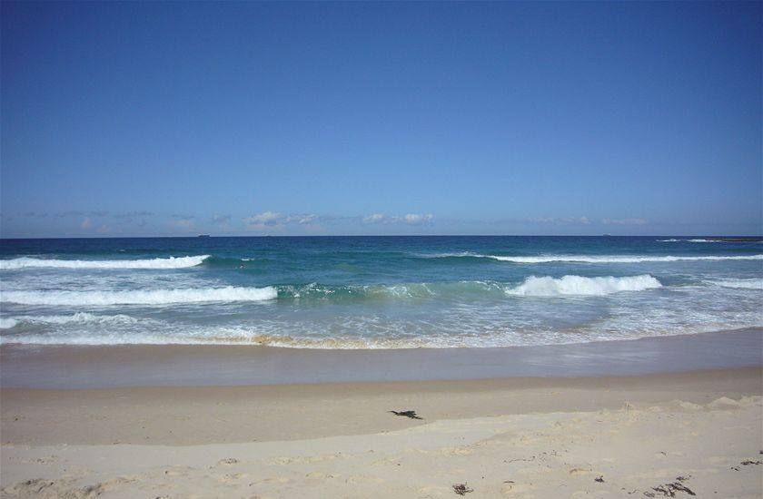  Image link | 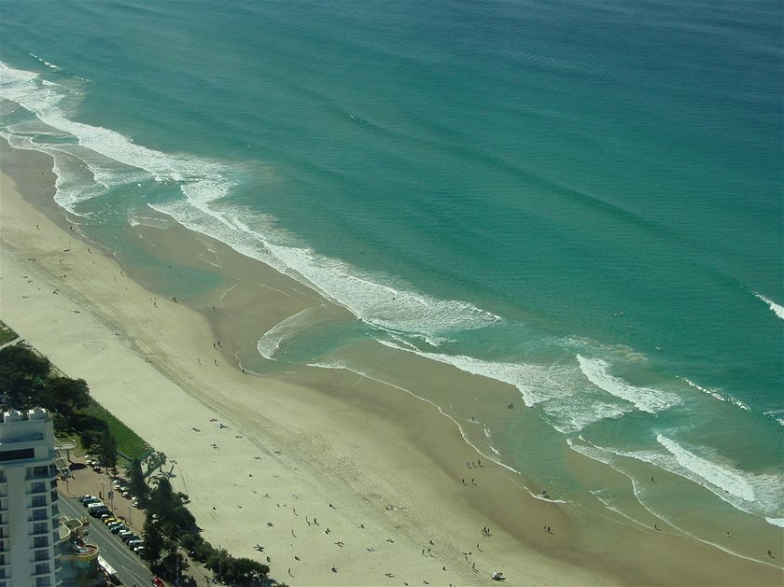  Image link

Activity – Choose a project
Individually or in small groups, students will choose one of the following projects to work on and then present their findings to the class.

Design a Poster
Create a poster which promotes beach safety. Think about how your poster will communicate the message to Australians and visitors to Australian beaches.
Tips and advice
Make a list of tips and advice all about beach safety. Think of a creative way to present your information.
Summary
Write a summary of the story. What was the story about? Why did BTN cover this story?
Quiz
Create a true or false quiz to test your classmate’s knowledge about rip currents.

Useful Websites
- Swim and Survive Program – BTN
- Beach Safety – Royal Life Saving Australia
- Rip Currents – Surf Life Saving NSW
- Beach Safety – Healthdirect
- Flags and Signs – Royal Life Saving QLD
- How to spot a rip current – Surf Life Saving Australia (YouTube)

Beach Safety Flags
Every beach has hazards that you will need to look out for. Lifesaving services use safety flags to help show these hazards. The flags also show you safe areas to swim in. Understanding these flags help people avoid danger at the beach. Use the internet to find out what each of the beach safety flags mean and record your responses below.

 |  | The red a yellow flags mark …
 |  | A red flag means …
 |  | A yellow flag means…
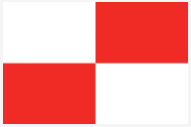 |  | A red and white flag means …
 |  | A black and white flag marks …

  - Teacher Resource

BTN Transcript: Episode 1 - 6/2/2024

Hey, I'm Amelia Moseley and you're watching BTN's first episode for 2024. Hope you had the best holidays. Let's jump into it and see what's coming up. We find out more about Queensland's wild weather, a young journalist gives us a lesson in US politics, and Kushi learns what to do if you're caught in a rip.

Income Tax Changes

Reporter: Jack Evans

INTRO: We'll have all that and more soon. But first today to a story about tax. It's been big in the news since the PM announced he was making some changes to some planned tax changes. So, what's going on? And what is tax, anyway? Jack is here to explain.

TOWN CRIER: Hear ye, hear ye, the King is here, ye.
KING: Hello pitiful peasant tis I, your king.
PEASANT: Oh, I didn't know we had a king?
KING: I'm to make a few changes around here to help spruce things up a little.
PEASANT: Oh yeah, like what?
KING: Roads. I'm going to be building roads.
PEASANT: Roads?
KING: And to help pay for these roads I'm going to require everybody to pay 3 bucks of their weekly income.
PEASANT: *scoffs*
KING: I'm calling it, tax. I'll be back tomorrow for collection.
PEASANT: What is this tax?
REPORTER VO: Well tax is...
PEASANT: Whoa, who said that? are you also a king?
No, I'm a reporter.
PEASANT: Oh, Oh well go on then.
Thank you, like this peasant just found out, taxes are a way the government, or king, can collect money from its citizens, business and other entities to pay for things people need like roads, health care, education, defence, the list goes on. Here in Australia, there are few types of taxes, but the one that brings in the most money is income tax.
KING: Hello pitiful peasants, tis I, your king.
PEASANT: Yes, yes, yes we get it.
KING: I'm here to collect the tax I spoke of yesterday.
PEASANT: Oh yeah, about that… old mate over there just got a fancy schmancy new job with a pay rise and a company cart. So, why should I have to pay the same as him when he earns way more than I do?
KING: You do have a point there. Well, to make things fairer those earn more will pay more and those who earn less will pay less. I'll call it, income tax.
PEASANT: Income tax?
Yes income tax.
KING: Who said that, is that another king?
PEASANT: Oh no, that's a reporter.
KING: Oooooh.
Like this village, the amount of income tax you pay is determined by how much money you make. The more money you earn, the higher percentage of income tax you'll end up paying. It's designed to make sure people are only paying what they can afford. But it's a delicate balance to get it right. You see if you tax people too much they don't have as much money to spend and that can affect the economy.
OTHER PEASANT: I need six eggs, that's too expensive.
But if you tax too little the government doesn't have as much to spend on things like, well, roads.
PEASANT: Oh yeah, where are those roads and what are roads again?
Back in 2018 the government announced a 3 stage plan to change the income tax system. The first and second stages lowered taxes for people who earn the lowest and middle incomes, and the 3rd stage would have seen tax cuts for people with higher incomes to make sure that if peoples pay went up, they weren't losing too much of it to tax. But things have changed.
ANTHONY ALBANESE, PRIME MINISTER: When economic circumstances change, the right thing to do is to change economic policy.
As you might have heard there is a cost of living crisis going on and a lot of people are struggling. So, the Prime Minister has announced that he's changing the tax changes so that people on lower and middle incomes will get an extra tax cut. While the higher income earners won't get so much back.
JIM CHALMERS, TREASURER: It's better for women and workforce participation, it's better for nurses and truckies and teachers and it's better for the economy.
It's been pretty controversial, mostly because the prime minister said before the election, he wasn't going to touch the tax changes.
PETER DUTTON, LEADER OF THE OPPOSITION: Well, I think it's just a major break of trust, it's a betrayal and the prime minister promised this on over a hundred occasions.
SUSSAN LEY, DEPUTY LEADER OF THE OPPOSITION: We will fight this legislation through both the House of Representatives and the Senate. We are not prepared to give up on this.
The changes still have to go through the Senate and the Opposition haven't said if they'll support it. So sorry everyone, there's probably going to be a lot more tax talk to come.
PEASANT: Oh ah, your ah majesty. I've been thinking about this whole tax thing, and I think we could make it even fairer. I've come up with a 3 stage plan.
KING: Oh, you know, got to go. Very busy and all that ah kingly duties...
PEASANT: Oh, well no, I’ve put it in a Word document.
News Quiz

Can you name this famous painting? It’s the Mona Lisa and it was in the news last week when protesters threw soup at it. They say they were trying to raise awareness about food security but of course security at the Louvre in Paris weren’t too impressed. Da Vinci’s famous painting wasn’t damaged thanks to a protective glass shield. She even looks a bit amused.

Japan’s first moon lander is up and roaming the lunar surface. It landed on January 20th but it had to take a nap for a week until it’s solar panels managed to catch enough rays to power up. How many countries have now landed rovers on the moon now? 3, 5 or 7? It’s five. The US, Russia, India, China and now Japan.

And the world got its first Australian-born queen over the holidays when King Frederick and his wife Queen Mary took over the throne of which country? The Netherlands, Denmark or Greece? It’s Denmark. Mary is originally from Tasmania but married the Crown Prince of Denmark back in 2004 and became the Queen Consort when Frederck’s mother abdicated earlier this month.

Queensland Wild Weather

Reporter: Justina Ward

INTRO: Now to the weather which, for people in parts of Queensland, has been wild, windy and very, very wet. They've had weeks of devastating floods and storms and Justina caught up with some kids to find out what it's been like. Take a look.
Yeah, for lots of kids in Queensland the holidays were full of wild weather.
Kobe: It was very windy and it was nonstop rain.
Madeleine: All the grass had turned from grass to mud.
You see the state's south-east has been hit with a lot of rain. Last week, some areas got up to 300 millimetres in just a few hours. Which is about a third of what Brisbane usually gets in a whole year.
Angus Hines, BOM: That's really heavy rainfall, that's enough to cause both flash flooding but also contribute to riverine flooding.
The rapid rise of water levels caught a lot of people off guard, giving emergency services and the public not a lot of time to prepare.
Gemma: It was really scary. Everyone, my neighbours had to evacuate, and screaming.
The rain came on the heels of ex-tropical cyclone Kirrily, which hit the coast a few weeks ago bringing gusts of up to 170 kilometres per hour - tearing roofs off buildings, ripping up trees and powerlines and decimating crops.
Lilly: Everything was all over the place. Things were flying away, tumbling over. It was crazy.
Taylor: We had to take shelter because it was really windy.
Daniel: We had quite a lot of flooding. I remember when we are driving into town, the road was closed, because there was so much water, so we had to find different ways to go.
Kirrily struck barely a month after Tropical Cyclone Jasper, which made its windy way across Queensland and the NT, bringing record rainfall, damaging winds, and isolating floods, not to mention some unwanted guests, just in time for the holiday season.
Madeleine: And then we saw someone's Christmas decorations flowing above, they were really, really high in the sky.
KOBE: During and after Cyclone Jasper, the river down there was 4.2 metres under, which is our only way to get resources.
TAYLOR: The water came up that sign.
Of course, if you live up here, you'll know this weather isn't anything new.

Man: Welcome to the Wet Season.

Yep. In the tropics the familiar seasons of summer, autumn. winter and spring don't apply. Instead, it's all about the wet, and the dry. That's because our tropical regions are close to the equator, which means they're closer to the sun. That heat creates a kind of natural sauna, bringing hot and humid weather, along with rain, thunderstorms, floods, and tropical cyclones. While this sort of thing is nothing new. Some are worried that climate change is making these events more intense and frequent. So, is more wet weather on the way? Well, quite possibly.
Angus Hines, BOM: Well it is a little bit early to say for sure but there is a bit of an elevated risk of that we will see La Nina conditions developing across Australia this year.

That’s the weather pattern that brings more cool wet weather to the east.
Meanwhile, many people are still waiting for floodwaters to go down.
Madeleine: If you're stranded, you should call for help. But you should not go in it. Because there might be… there could be… you don't know how deep it is.
And for others, there'll be a long clean up ahead.
Daniel: So, there's been a lot of cleanup. The community is really coming together helping everybody.
Lilly: It's just it really puts it into perspective how one thing can really change so much.

TAYLOR: Thanks for Watching BTN!
Quiz

The wind system that brings rain to the tropics every year is known as a what? It's a monsoon.

Young Political Journalist

Reporter: Justina Ward

INTRO: As you might know, the US is having an election this year, which means we're probably gonna be hearing a fair bit about American politics and one person who knows a lot about that is Quinn Mitchell. At 15 he's got his own podcast and website and spends his time asking big questions of powerful people. Justina caught up with him to find out about his passion for politics.
NBC Anchor: 15 year old, Quinn Mitchell.
NCC ANCHOR: Who's been asking tough questions.
QUINN: A lot of people are excited about meeting, you know, their, their favorite YouTuber or their, you know, favorite social media star, whatever. You know, I like meeting politicians.
JOE BIDEN, 46TH U.S. PRESIDENT: How old are you? Eleven.
QUINN: Do you believe that Trump violated the peaceful transfer of power?
RON DESANTIS, GOVERNOR OF FLORIDA: Are you in high school?
QUINN: Uh, yeah.
JUSTINA: So, tell us a little bit about yourself.
QUINN: So, I'm a 15 year old political enthusiast from New Hampshire. It's one of the 50 states in the United States.
QUINN: I got involved in politics and history, when I was five years old. From a young age, I was able to have conversations with adults in my life, about political issues that, you know, really enlightened me on what was happening in our world. And I slowly progressed, I slowly just built up my questions. And, you know, that's how I got you know, where I am today.
JUSTINA: Can you explain how politics work in the US?
QUINN: Big question. All right. So obviously there's the US government at a federal level, specifically the three branches. There's the Constitution, which is basically the framework of our country. We have the fundamentals, you know, the right to a free press, which is enshrined in our Constitution, which I love that part, specifically for myself. The two big parties in the United States are the Republicans and the Democrats. A lot of people just fall into those two, because those are the only two, we have. It's not mandatory to vote in the United States. I think, like a third of our citizens don't vote, so it's something around that. The US political system is very hard to explain in a couple of minutes. But what I will tell you is that you get the opportunity to question politicians, especially in New Hampshire, because we have the right to, and I mean, they're gonna represent us, you know, if they get elected.
JUSTINA: And what's happening is US politics at the moment?
QUINN: Our Former President Donald Trump is under four indictments. We are currently going through the presidential primary, where the two political parties elect a nominee, then there will be two nominees who will go against each other in the general election, which is in November of 2024. So, we're kind of all gearing up for that right now. A lot of it is around Donald Trump, I have to say.
JUSTINA: Can you tell us a little bit about what events you go to?
QUINN: I go to the presidential primary events in New Hampshire, which are mainly town hall meetings, where you get the opportunity to ask questions and I feel a responsibility, you know, as a citizen to to ask them.
JUSTINA: So, what do you like about journalism?
QUINN: I like the idea of holding the people we elect to serve accountable on their actions or whatever promises they made. And, you know, what I found is, you know, hard questions matter. Without journalism citizens become easily more prone to, you know, disinformation or being ignorant about certain political issues.
JUSTINA: And how do you look for news?
QUINN: I have several morning newsletters sent to me, look at you know, a lot of perspectives across the political spectrum, you know, because if you're only looking at one, you're getting probably extreme bias. I listen to a lot of conservative and liberal commentary. One of my favourite things to listen to is debates. They're the most entertaining thing in my opinion to watch.
JUSTINA: What are some of your most memorable moments?
QUINN: I got a challenge coin; I don't know if you know what it is it's usually for military. And basically, if you have the challenge going when you meet somebody, they have to buy you a drink, but if you don't have it the person has to buy them a drink. So, Biden gave me one of those June of 2019. And he said, okay, I guess I owe you a drink. And he stepped away from all the press, and then we went over to grab a drink together. And then another time was random campaign rally he just pulled a Coca Cola out of his pocket. I'm not kidding. It was in his pocket. You know, I've thought about this for four years. You know, this is an extreme mystery for me. For four years I pondered, you know, what could have happened? Conclusion is, I think, is the campaign staffers, they saw me, you know, they knew I had a challenge coin, they slipped him a Coca Cola, you know, nobody really has a Coca Cola in their pocket.
JUSTINA: Nup, that’s the most hilarious story, I love it so much. So why do you think it's important for young kids to be involved in politics?
QUINN: We live in such a consequential, a momentous time period, where the politicians, you know, we elect to serve, and the decisions they make are going to impact us drastically, whether it's in you know, 30 or 50 years. So, you know, if there's a time to be involved, it's definitely right now. Be involved in what you believe in because try and make a change because you’ll find your voice matters more than you think it is.

Quiz

Which of these animals is used to represent the US Democratic Party? Democrats are donkeys, republicans are elephants.
Beach Safety

Reporter: Kushi Venkatesh

INTRO: Now, let's head to the beach. It's where a lot of us like to spend our holidays but it can also be dangerous, and lifesavers say we need to do more to protect ourselves. So, Kushi went to get some tips for staying safe in the water.
KUSHI VENKATESH, REPORTER: Yep, over the holidays you've probably spent some time here. Building sandcastles, playing with your friends, eating ice cream, and most importantly, swimming.

But while cooling off in the water is a lot of fun, it can also be a pretty dangerous place. Last year there were 6,000 rescues made along the Australian coastline and 281 people died. Which is why Surf Life Savers are on a mission to keep people safe. They're the people you've probably seen wearing red and yellow and, well, saving lives. They say one of the most important things you can do at the beach is to make sure they can see you.

SEAN FAULKNER, LIFESAVING & EMERGENCY OPERATIONS MANAGER: Biggest tip is to swim between the flags because that's where we've got extra sets of eyes keeping you safe and make sure you're swimming with someone else.

Sean says while any sort of water can be dangerous, the ocean has its own hazards.

SEAN FAULKNER, LIFESAVING & EMERGENCY OPERATIONS MANAGER: The biggest thing we're really worried about is rips.

Rips are very strong and narrow currents that run perpendicular to the beach and quickly pull swimmers away from the shore and out to sea.

SEAN FAULKNER: Cause if you find yourself in a rip, what’s actually happening is the wave energy is trying to get away from the shoreline, and it takes the quickest path out. And often our swimmers get trapped in them.

Here, life savers have used coloured dye to show a rip in action but without it they can be really hard to spot even for experts.

SEAN FAULKNER, LIFESAVING & EMERGENCY OPERATIONS MANAGER: The biggest indication is often that the waves get a knock flat by the returning energy. And often you'll see a streak of sand being carried out through the back.

Other things to look out for include deep dark patches of water, fewer breaking waves, or foamy discoloured water beyond the waves.

So, what do you do if you get caught in a rip? The most important thing to remember is to stay calm. Sean says that you should never try and swim against a rip. Even Olympic swimmers aren't fast enough for that, so you'll probably just wear yourself out.

SEAN FAULKNER, LIFESAVING & EMERGENCY OPERATIONS MANAGER: And that's why people get in trouble. They think they should just try and take the shortest path back to the beach and try and swim back the way they've come.

Instead, flip onto your back and float with the rip. Next signal out to shore.

SEAN FAULKNER, LIFESAVING & EMERGENCY OPERATIONS MANAGER: Put your hand up to wave for assistance and you'll often find one of our lifesavers. If you're at a patrol beach, we'll come out and help. Or maybe someone standing by will actually help you get back in.

If you are a strong swimmer, you can try swimming parallel to the shore to escape the currents pull, in other words just swim left or right. Just remember that if you do see someone else stuck in a rip it’s super important that you don't jump in to save them.

SEAN FAULKNER, LIFESAVING & EMERGENCY OPERATIONS MANAGER: So, in Australia, we've got a problem with bystander rescues which is when people are trying to help other people ending up getting in trouble themselves.

Instead try and alert a lifeguard nearby. If there aren't any on sight throw in something that floats for them to grab onto, like a surfboard.

KUSHI VENKATESH, REPORTER: So, we've covered rips, what else should we be looking for in the water?

SEAN FAULKNER, LIFESAVING & EMERGENCY OPERATIONS MANAGER: First of all, it's about understanding your own capabilities. The surf at the moment today is nice and flat and calm so it's good for everyone to go in. But even then, you don't know what happens with the sand as you move further out.

Sean says waves can be really dangerous whether you're in the water or next to it. And you should also be aware of what other people are doing around you. But one of the best things we can all do to stay safe is to learn to swim.

SEAN FAULKNER, LIFESAVING & EMERGENCY OPERATIONS MANAGER: There's a so many Learn to Swim programs around the country. Surf offers some of them. Make sure you can swim, so you can enjoy the beach.

Sport

Australia has won its One Day International Series against the West Indies.

COMMENTATOR 1: The world champions continue their dominance.

The Aussies looked like they were in trouble when the West Indies had them at 4 to 89 by the 16th over. But Sean Abbott got things back on track with the best score of his international career making 69 runs off 63 balls.

COMMENTATOR 2: That’s big, it’s very big!

Helping the Aussies to an 83 run win.
Aussie mogul superstar Jakara Anthony is now Australia's most successful moguls skier ever after claiming another World Cup gold medal. She just took out the dual moguls crown on the Champion Run which was her 11th win of the season and her 18th overall.
And over to the World Aquatics Championships in Doha where a 13-year-old called Huang Jianjie and his team mate Zhang Jiaqi have won gold for China in synchronised diving.

COMMENTATOR: Ha Ha Ha, once again, what a great performance for them so far.

They claimed the top spot for the mixed 10-metre dive category and yeah, they look pretty synced up to me.

Finding Confidence in Performing
Rookie Reporter: Katiana

INTRO: Finally today, we're going to introduce you to one of the winners of the Takeover Melbourne competition which asks young people to write stories about things that are important to them. Katiana is going to tell us how her school-life changed thanks to a famous Aussie musical. Take a look.

I didn't have the best childhood. I was dealing with trauma and anger. I was struggling to cope and thought my story would end there and then. But mum had other plans. She sent me to Worawa Aboriginal College, a boarding school for girls, east of Melbourne. I felt isolated and alone, and I thought the other girls would pick on me because of my light skin.

KATIANA: One day a teacher announced there’s going to be auditions held for a musical production of The Sapphires.

The Sapphires is based on a true story about four deadly Aboriginal women who form a music group in the 60s. First it was a play, then it was turned into a film, and get this, one of the real life Sapphires, Aunty Lois, was the school principal of Worawa. A week after I auditioned, they announced the roles.

TEACHER: So… playing Aunty Lois' character K… can I have a big drum roll please… isssss Katiana. Whooo hooo.

KATIANA: Oh. my. gosh. I was so excited because singing, acting, and dancing are huge passions of mine. Our performance of The Sapphires was to be filmed and screened. Rehearsals were so much fun. I started making friends with the cast and crew. That's when I noticed a change. I realised I was happy.
The night of the screening was very emotional. I remember crying when Aunty Lois told us how proud she was. That year I ended up winning three school awards for my talent and effort. I now know what makes me truly happy and at peace, and that is expressing myself through cultural dance and performing on stage. I am a proud Wadawurrung woman.

Closer

Naww, awesome work Katiana. Well, that's it for week one of BTN. I'll be here next week same time, same place, different stories. Until then, you can jump on our website or keep up to date with Newsbreak and BTN High. I’ll catch you soon. Bye.

