Episode 16
9th June 2020



US Race Relations
- Discuss the BTN story as a class. What issues were raised in the discussion?
- What does the US Declaration of Independence say about how people should be treated?
- What did the kids in the BTN story say about racism in the United States?
- What was the slave trade?
- Give some examples of segregation that occurred in the United States.
- What did people like Rosa Parks and Martin Luther King fight for?
- Are black people in America treated equally to white people? Explain your answer.
- Why have people been protesting in the US?
- How have people reflected on the treatment of Indigenous people in Australia?
- What do you understand more clearly since watching the BTN story?

Charles Dickens
- Who was Charles Dickens?
- Where and when was Dickens born?
- Describe what Dickens’ life was like growing up.
- What influenced Dickens’ writing?
- Finish the following sentence: Charles Dickens worked as a newspaper reporter but preferred writing…
- Complete the following sentence. Dickens wrote funny short stories under the name of ________.
- Describe the success of Dickens’ novels.
- What did he want to educate his upper-class readers about?
- Name one of Dickens’ books.
- What influence has his writing had on other authors and films?

Check out the Charles Dickens resource on the Teachers page.

History of Newspapers
- What did the BTN story explain?
- Which organisation recently announced that it was closing newspapers around Australia?
- How have newspapers changed over the years?
- How do newspapers make money?
- Which two companies own most of Australia’s newspapers?
- Why did the internet have a big impact on newspapers?
- How many newspapers will close at the end of this month?
- How will the newspaper closures impact communities?
- What do you think is the future of newspapers?
- What did you learn watching the BTN story?

Check out the History of Newspapers resource on the Teachers page.

Glacial Music
- Briefly summarise the Glacial Music story.
- Where is Iceland? Find using Google Maps.
- Where did Charles get the idea for the Iceland project?
- Why is it described as ‘extreme music making’?
- What technique does Charles use for drumming on the ice?
- Why did Charles make the sounds he recorded available online?
- What issue did Charles want to raise through his music?
- What is happening to Iceland’s glaciers?
- What does Charles like about sampling environmental sounds?
- What was surprising about this story?

Teacher Resource
Episode 16
9th June 2020

History of Newspapers

Students will explore the role newspapers have played over the years and make predictions about the future of newspapers.


English – Year 5
Plan, draft and publish imaginative, informative and persuasive print and multimodal texts, choosing text structures, language features, images and sound appropriate to purpose and audience.

English – Year 6
Plan, draft and publish imaginative, informative and persuasive texts, choosing and experimenting with text structures, language features, images and digital resources appropriate to purpose and audience.

Plan, rehearse and deliver presentations, selecting and sequencing appropriate content and multimodal elements for defined audiences and purposes, making appropriate choices for modality and emphasis.

Compare texts including media texts that represent ideas and events in different ways, explaining the effects of the different approaches.

English – Year 7
Analyse and explain the effect of technological innovations on texts, particularly media texts.

- What did the BTN story explain?
- Which organisation recently announced that it was closing newspapers around Australia?
- How have newspapers changed over the years?
- How do newspapers make money?
- Which two companies own most of Australia’s newspapers?
- Why did the internet have a big impact on newspapers?
- How many newspapers will close at the end of this month?
- How will the newspaper closures impact communities?
- What do you think is the future of newspapers?
- What did you learn watching the BTN story?


Class Discussion
Discuss the BTN History of Newspapers story as a class, using the following questions to guide the discussion. Record the main points on a mind map with ‘Newspapers’ at the centre.

- Where do you get your news from? (print, online, TV, radio, social media)
- What part have newspapers played in history?
- How do newspapers make money?
- What role do newspapers play in communities?
- How has the internet changed the way we get news?
- What do you think is the future of newspapers?

Glossary
Students will brainstorm a list of key words and terms that relate to the BTN History of Newspapers story. Here are some words to get your students started.
Publish | Press | Broadsheet
Tabloid | Printing press | Journalist

Compare and contrast
Students will find similarities and differences between newspapers and online news. Use the questions below to start a class discussion. Use a Venn diagram to help organise the information.

- What are the differences and similarities between newspapers and online news? For example, once a print newspaper is published the content is fixed. Online news can be updated and changed throughout the day.
Newspapers

Online news

- When would you read a newspaper?
- When would you read news online?
- What are the pros and cons of each?

Inquiry Questions
Students will explore newspapers in more detail. After watching and discussing the BTN History of Newspapers story, what questions do students have and what are the gaps in their knowledge? Students can complete the following KWLH organiser to explore their knowledge and consider what they would like to know and learn.
What do I know? | What do I want to know? | What have I learnt? | How will I find out?
Here are some possible questions for students to research:
- How has technology changed the way that news and information from major newspaper publishers is produced, sold and accessed?
- Choose an event that is in the news. Find reports about it from a range of media sources: newspaper, radio, television and online. Compare and contrast how the event is presented in each source. How does it affect the way that readers/viewers/listeners get information about the news event?
- Research your local newspaper. When was it first published? Give examples of stories that are published. What groups in the community rely on the newspaper?
- Will newspapers survive? Can they compete for an audience with other media sources? Give reasons for your answer.
- Investigate the history of newspapers in Australia. What is the oldest newspaper? What is the longest running newspaper? Display the information on a timeline.

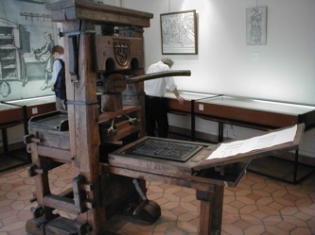
Printing Press
Students will research the history of the printing press using the following questions to help guide their research.
- What is the printing press?
- Who invented it?
- When was it invented?
- How did it change the way information was distributed?
- How has the printing press changed over time?

Mini Debate or Persuasive text
Students will develop a mini debate or a persuasive text for or against the following statement: ‘Newspapers are still relevant today.’ Alternatively, students can develop their own statement. Students can use the information recorded on the mind map and their own research to help develop their argument.

Mini debate
- Working in pairs, students will prepare a 1-2-minute speech for a mini debate on the topic of the future of newspapers.
- One person will speak for the affirmative and the other will speak for the negative.
- Before students begin to construct their argument, ask them to record what they already know about the topic and what they would like to find out. Students then research the topic to gain a greater understanding of the issue.
- Ask students to list their arguments in point form on paper (without their partner seeing them). When they have done this, ask them to choose the five best points that will form the basis for their debate.
- Students will write in point form, their debate on cards that fit into the palm of their hand. Their debate needs to have an introduction (introducing the topic), middle (three main points) and a conclusion (restating their position). Students practise their speech and then present the mini debate to other students.

Structure
Introduction
- What is the point you are trying to argue? Construct an introductory paragraph which states the issue or topic.
- Introduce the arguments that will be developed in the body of the text.

Body
- Construct arguments that support your point of view.
- Each paragraph starts with a topic sentence which introduces each point.
- The rest of the paragraph gives more reasons.
- Arguments can be ordered from strongest to weakest.

Conclusion
- Restate your position on the argument.
- Construct a concluding paragraph that provides a summary of your arguments and a call to action.
Tips
- Who is your audience? For example, are you directing your argument at kids, teachers or politicians?
- Explore how language choices can have a big impact on persuading your audience.
- Which language devices give the report credibility and authority?
- Which are designed to create an emotional response in the listener?
- Provide facts and evidence to support your argument.
- Write in the present tense.
- Check your spelling and punctuation.

Use this Read Write Think persuasion map to plan your exposition text.

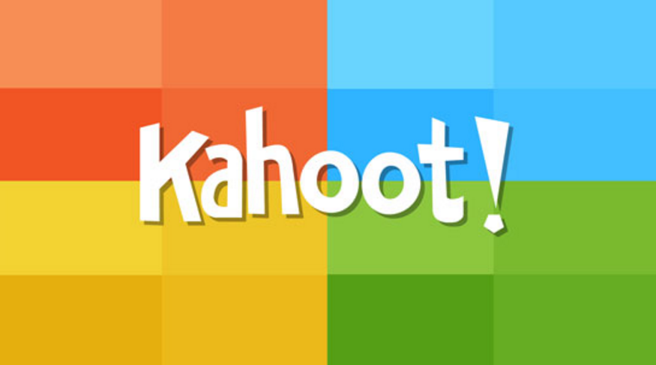
Create a Kahoot Quiz
Use Kahoot. to test students’ knowledge about the history of newspapers. Quizzes can be created to recap learning or test personal knowledge. There is also the option to connect with classrooms around the world and play kahoot in real time.


Old News - BTN
https://www.abc.net.au/btn/classroom/old-news/10532328

Net News - BTN
https://www.abc.net.au/btn/classroom/net-news/10538278

News Corp to cut jobs in restructure towards digital-only community and regional newspapers – ABC News
https://www.abc.net.au/news/2020-05-28/news-corp-to-cut-jobs-in-restructure-towards-digital-newspapers/12294970

History of Australian Newspapers – National Library of Australia
https://www.nla.gov.au/australian-newspaper-plan/for-researchers/history-of-australian-newspapers

Teacher Resource
Episode 16
9th June 2020

Charles Dickens
Students will learn more about the life and work of Charles Dickens.
Students will experiment with shared story writing. Students will develop storylines, characters and settings in their writing.

English – Year 4
Create literary texts by developing storylines, characters and settings.

English – Year 5
Create literary texts using realistic and fantasy settings and characters that draw on the worlds represented in texts students have experienced.

Create literary texts that experiment with structures, ideas and stylistic features of selected authors.

English – Year 6
Create literary texts that adapt or combine aspects of texts students have experienced in innovative ways.

English – Year 6
Analyse how text structures and language features work together to meet the purpose of a text.

Plan, draft and publish imaginative, informative and persuasive texts, choosing and experimenting with text structures, language features, images and digital resources appropriate to purpose and audience.
- Who was Charles Dickens?
- Where and when was Dickens born?
- Describe what Dickens’ life was like growing up.
- What influenced Dickens’ writing?
- Finish the following sentence: Charles Dickens worked as a newspaper reporter but preferred writing…
- Complete the following sentence. Dickens wrote funny short stories under the name of ________.
- Describe the success of Dickens’ novels.
- What did he want to educate his upper-class readers about?
- Name one of Dickens’ books.
- What influence has his writing had on other authors and films?


Class Discussion
After watching the BTN Charles Dickens story hold a class discussion, using the following as discussion starters:
- What do you THINK about what you saw in the BTN Charles Dickens story?
- What does this video make you WONDER?
- Think of three QUESTIONS you have about the Charles Dickens story.
- What did you LEARN from the BTN story? Leave your comment on the BTN Charles Dickens story page.

Personal Response
Students will write a personal response to the BTN Charles Dickens story. Ask students to finish one or more of the following incomplete sentences:
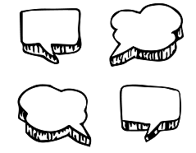
- Charles Dickens is an important writer because…
- It was interesting to learn…
- These are five words that I would use to describe Charles Dickens’ writing …
- It is important to remember Charles Dickens because…

Create a biography
Students will research and write a biography on Charles Dickens. Before students begin to construct their biographies, hold a class discussion to find out what they already know about biographical writing. Discuss what type of information is included in a biography and what they tell us about a person. The Civics and Citizenship website has some examples of biographies for students to look at.

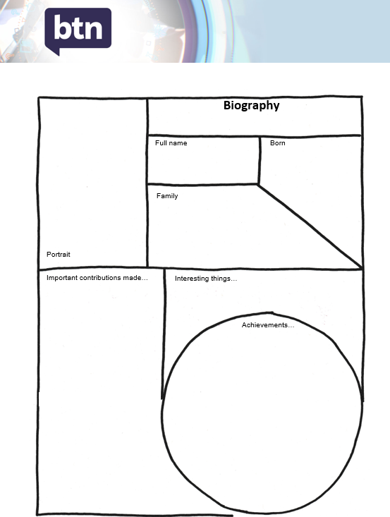
Below are some discussion starters:
- What does a biography tell us about a person?
- Where can you look to find information for your biographical writing? It could include the internet, newspaper articles, magazine articles and interviews, other biographies, historical books or television interviews. Why is it important to use more than one source of information?
- What makes a biography interesting? For example, key information and facts, a timeline of events, photographs, illustrations and quotes.

Using the biography organiser template at the end of this activity, students will find and record information about Charles Dickens.

Some possible areas of research include:
- Where and when was Charles Dickens born? Locate using Google Maps.
- Describe his family life growing up.
- What are some of his achievements? Choose one to explore in more detail.
- What inspired/motivated him in his writing?
- What were some of the challenges he faced?
- What do you admire about him?
- Sketch a portrait of Charles Dickens. Explore and experiment with different techniques and media to produce a portrait.

Further investigation
- Imagine you could sit down and talk to Charles Dickens. What questions would you ask him about his life and achievements?

Present your findings in an interesting way.
- Give a presentation on their achievements.
- Make a “Did you know?” for other students.
- Write a letter thanking them for their achievements.
- Create a timeline highlighting significant events.

Glossary
Students will brainstorm a list of key words that relate to the story writing process. Students may want to use pictures and diagrams to illustrate the meaning and create their own glossary. Here are some words to get you started.

Episodic | Narrative | Theme
Character | Comedic | Series

Further investigation
Students will choose one of the words from their glossary to explore in more detail and develop a key question to guide their inquiry. Alternatively, students will respond to one or more of the following:
- What common themes did Charles Dickens explore in his writing?
- What was London like during Victorian England? Find images. How was Charles Dickens’ writing influenced by the Victorian Era?
- Rewrite the ending of a Charles Dickens book (or your favourite book). Explain why you chose to end it the way you did.
- What is episodic writing? Give an example of episodic writing in Charles Dickens’ work. Can you give any other examples of episodic storytelling? How are they similar or different to Charles Dickens’ writing?
- Find 5 images that relate to a book by your favourite author and explain why you chose the images.
- Write a letter to the author of your favourite book explaining your views on the book and asking any questions you have about the book.


Writing activity – Exquisite Corpse
Exquisite corpse is the most famous of all the surrealist games and was invented by Andre Breton and the surrealists in the 1920s. The surrealists were a group of artists and poets who loved breaking the rules of art and finding new ways to look at the world.

Exquisite corpse is a method by which a collection of words or images is collectively assembled. Each collaborator adds to a composition in sequence, either by following a rule, or by being allowed to see only the end of what the previous person contributed.
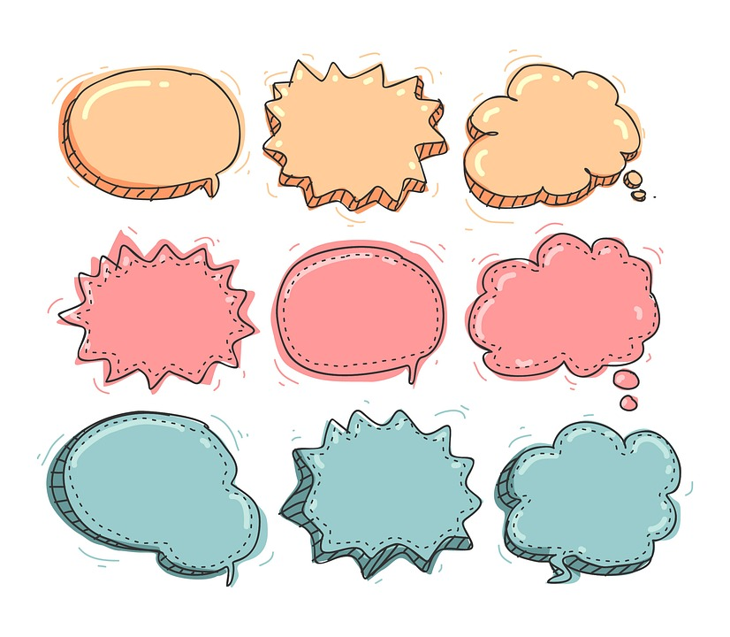

Exquisite (adjective)
Early 15c., "carefully selected," from Latin exquisitus "choice," literally "carefully sought out"

Corpse (noun)
Late 13century “body”, from Old French cors “body; person; corpse; life

Drawing your Exquisite Corpse
Students will work in groups of three to create their exquisite corpse drawing, using the following steps.

  How to: | - Fold an A4 piece of paper into three equal parts.  - The first person begins the drawing at the top of the paper. Using a black tip pen, draw the head and neck of any creature – real or imagined. When finished, make sure you can see two marks from your drawing down to the middle fold. This will help the next person know where to start their drawing.  - Fold the paper to make sure the next person can’t see what you have drawn – pass it on to the next person.  - The second person draws a body – any kind of body – in the middle section of the paper. When finished, the second person puts two marks down to the bottom fold – remembering to fold the paper so the next person can’t see what has been drawn and pass it on to the next person.  - The third person draws the legs.  - NOW – SHARE.  TIP – use a black tip pen for drawing.
Folding Story based on the Exquisite Corpse
The instruction provides outline details for writing a narrative, but it could also be used for writing a poem. If writing a narrative, students will write a beginning, middle (with a complication) and an ending (with a resolution). Students will work in groups of three to create their folding story, using the following steps.

How to: | - Fold an A4 piece of paper into three equal parts.  - The first person begins writing the beginning of the story on the first section of the paper. The last word they are going to write should be written onto the next section.  - The second person uses the word that is written as the start of the second section (middle) of the story – it should include a complication. The last word they are going to write should be written onto the next section.  - The third person uses the word that is written as the start of the third section (ending) of the story – it should include a resolution for the story.  - NOW – SHARE.
Reflect | Reflect on the activity by responding to the following questions:  - What did you enjoy about this investigation?  - What did you find surprising?

Dickens Museum
https://dickensmuseum.com/

Charles Dickens – BBC History
http://www.bbc.co.uk/history/historic_figures/dickens_charles.shtml

Charles Dickens – Australian Dictionary of Biography
http://adb.anu.edu.au/biography/dickens-charles-3409

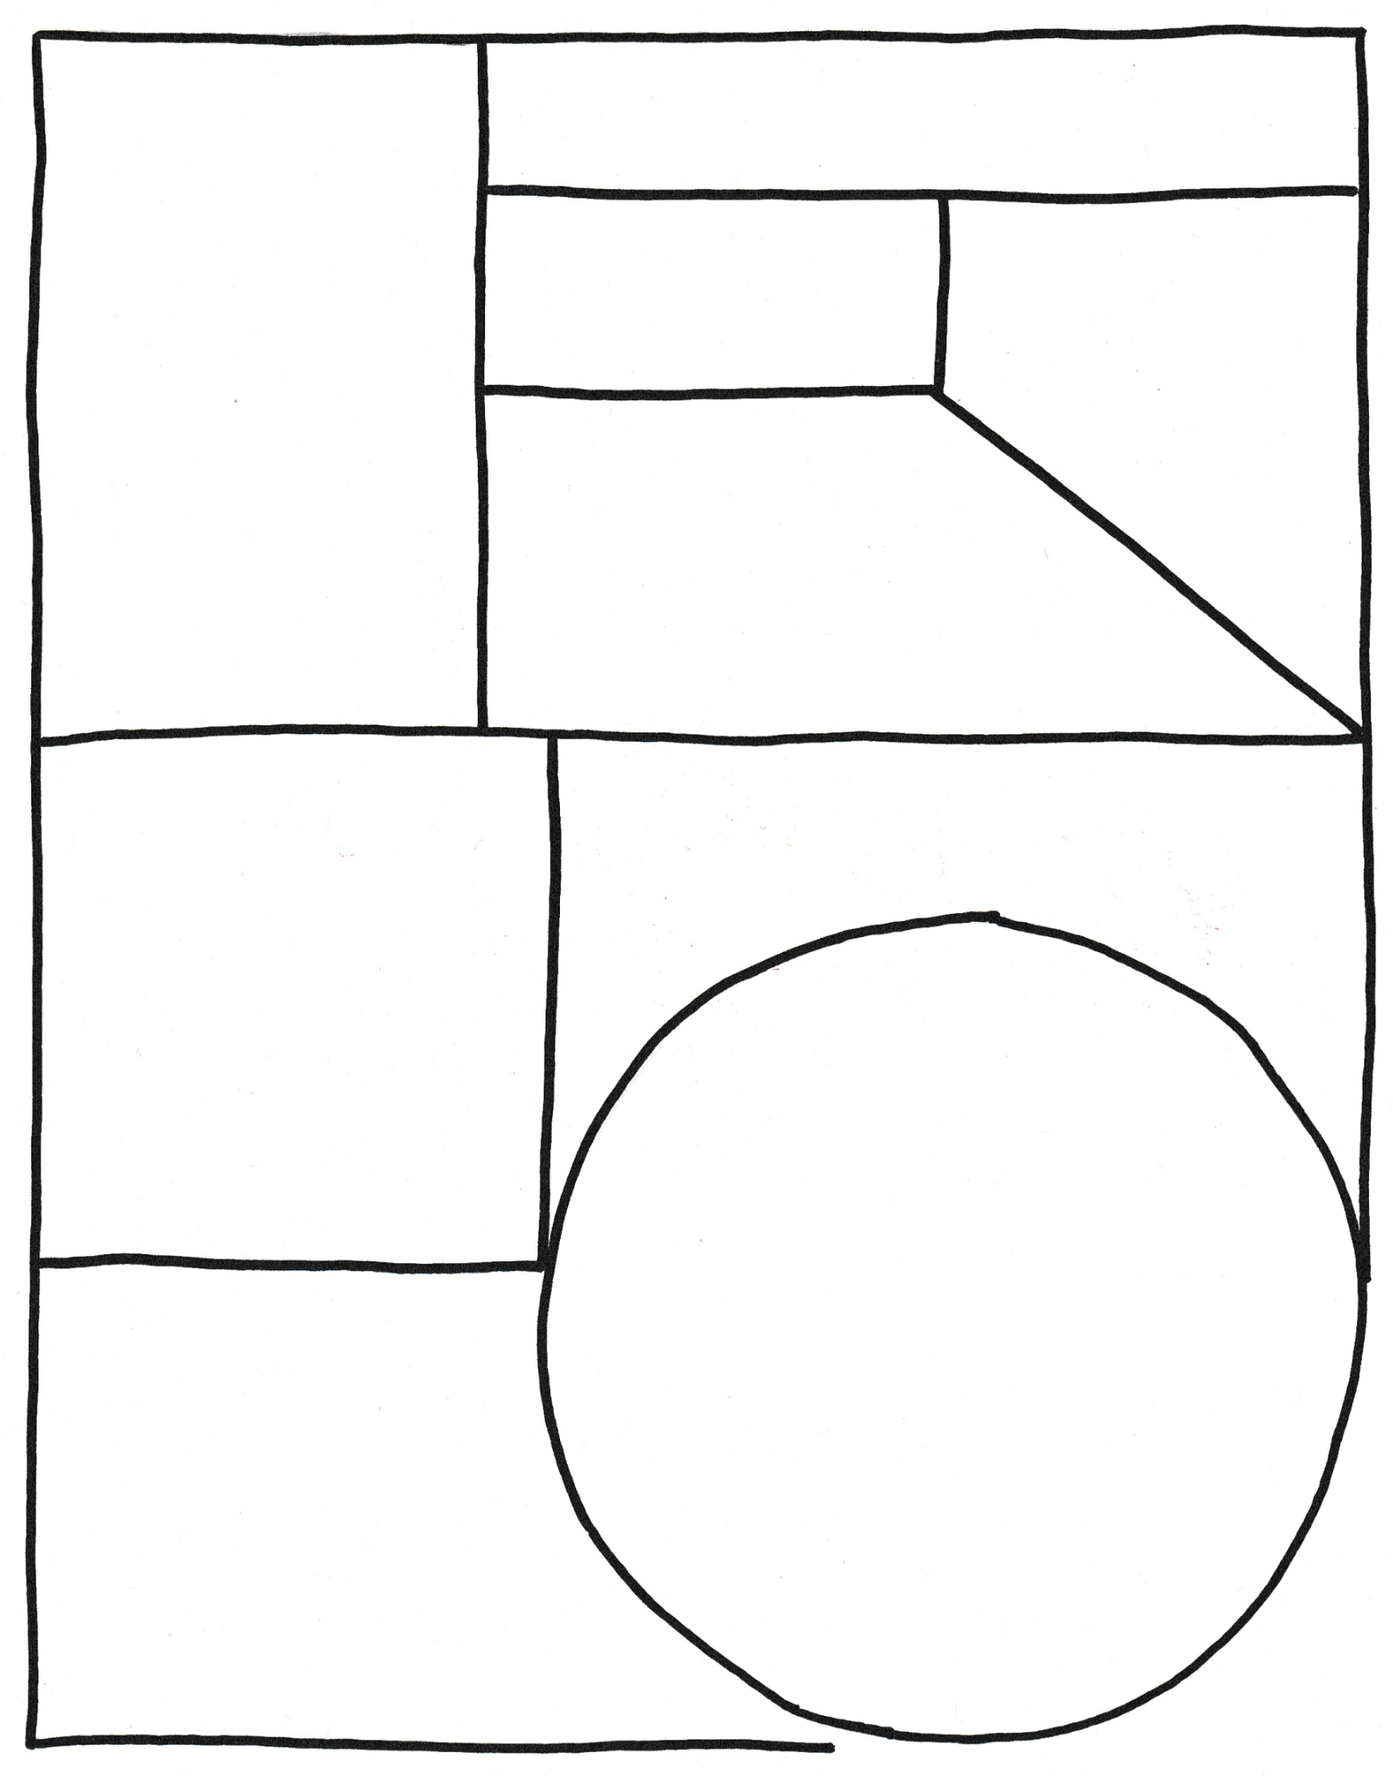
Family
Full name
Portrait
Important contributions made…
Born
Achievements…
Interesting things…
Biography

BTN Transcript: Episode 16 – 9/6/20

Yaama, I'm Jack and you're watching BTN. Here's what's coming up. We celebrate the life and literature of Charles Dickens, find out more about the history and the future of newspapers and meet a man who makes music out of ice.

US Race Relations

Reporter: Cale Matthews

INTRO: There've been protests all week in the US and around the world following the death of George Floyd. He was a black man from Minnesota who was killed by police. And while the officers involved have been arrested, many protesters say they're taking a stand against racism. And as Cale found out, that's an issue that's divided America for a long time.

VOICE-OVER GIRL’S VOICE: “We hold these truths to be self-evident that all men are created equal. That they are endowed by their creator with certain unalienable rights. That among these are life liberty and the pursuit of happiness”.

America's declaration of independence famously says everyone is equal, but there are a lot of people who say that doesn't always feel true.

GIRL: Racism is definitely still a problem in America and an example of this is what’s going on with George Floyd’s case today. Even though the civil rights movement ended over 50 years ago we are still marching today to get our basic rights.

About 15% of the US population is black and many can trace their family history to the slave trade. Between 1619 and 1865, more than 450,000 men, women and children were kidnapped from West Africa and taken to the US where they were bought and sold as property and forced to work with no pay and no rights.
There were many Americans, black and white, who fought against slavery, and by 1804 all of the northern states had abolished it. But the south didn't. In fact, tensions over slavery were one of the main reasons why the North and South fought against each other in the American Civil War. The North won the war, and slavery was abolished.
But while black Americans were now free, they weren't always treated equally. Particularly in some Southern states, which had laws keeping black Americans separate from white; in bathrooms, schools, and even public transport. There were also laws preventing many black Americans from voting. Over the years there were many people who fought for change, like Rosa Parks, who was arrested in 1955 for refusing to give up her bus seat to a white man and Dr Martin Luther King Jr who encouraged and led peaceful protests.

VOICE OF DR MARTIN LUTHER KING JR: I have a dream that my poor little children will one day live in a nation where they will not be judged by the colour of their skin but by the content of their character.

I have a dream.
There was also violence, as frustration at injustice boiled over. Over the years, American life became desegregated. Black Americans got equal rights and broke down a lot of barriers. In 2008, the US elected its first black president
Today there are many laws against racism, but has it really gone away? On average black Americans earn less than white Americans, are less likely to finish high school, and more likely to be put in prison. They are also 2.5 times more likely to be killed by the police, and that's what these protests are all about. The protests have gained support all over the world, including here in Australia, where many see what's happening in the US as a reflection of the many injustices Indigenous Australians face.
Many people have condemned violence and looting in the US, but say the protestors have a message that needs to be heard, and there's hope in the US, and around the world, that everyone is marching toward equality.

News Quiz

Which Aussie state had a ban on protests overturned at the last minute on the weekend? Was it South Australia, Victoria or New South Wales? It was New South Wales. The Sydney protest had been banned because of COVID-19 restrictions but on Saturday the Court of Appeals said it could go ahead. It was just one of the many marches around the country where tens of thousands of people called for an end to Indigenous deaths in custody.

Meanwhile in Hong Kong, people have defied a government ban to mark the 31st anniversary of the Tiananmen Square massacre. Where is Tiananmen Square? Is it in Hong Kong, Shanghai or Beijing? It’s in Beijing in mainland China. In 1989 the Chinese government sent in tanks and soldiers against unarmed protesters and many people were killed. Hong Kong has held a vigil every year since but this year the Chinese government said it wasn’t allowing it because of COVID-19 restrictions.

Back in Australia there’s been some bad news for the economy. Overall, it’s been shrinking for nearly 6 months and the government says we’re now in a what? A depression, a recession or a procession? It’s a recession. It’s the first time Australia’s had a recession in 29 years and the governments says it’s because of the bushfires and COVID-19.

Can you name this famous Aussie who fought for Indigenous land rights? It’s Eddie Mabo. He was a Meriam man from the Torres Strait who went to the High Court to prove his people had legal rights to their land. Now he’s honoured every year on June 3rd which is Mabo Day. And this year, because of COVID-19 the celebrations were mostly online.

ONLINE TRIBUTE: I really hope all Australians understand the significance of this day and acknowledge it by celebrating this day. So, I’d like to ask all non-Indigenous Australians to please help celebrate and educate others on just how significant this day was in the history of our country.
And this Italian landmark was reopened last week for the first time in three months. What’s its name? Is it the Pantheon, the Tower of Pisa or the Colosseum? It’s the Colosseum. one of Rome’s most famous buildings where ancient Romans would put on deadly fights for fun. Nice.

History of Newspapers

Reporter: Leela Varghese

INTRO: Ok, now to some news about newspapers. Recently, News Corp announced it was going to stop printing 112 Aussie community papers. Some of them have been around for more than a century and many locals say they'll be missed. So, let’s find out what’s going on and why Newspapers are becoming old news.

LEELA VARGHESE, REPORTER: There was a time when newspapers ruled the news kingdom.
If you wanted info about what was happening in the world you got it from the paper. And some of the biggest stories ever told were told in print. Australia's first newspaper was printed way back in 1803 on an old school printing press which actually came over on the First Fleet. Though it took a decade for people to figure out how to use it. From there newspapers took off all over the place. At first they were just pages of text but eventually they had photos and even much loved extras like crossword puzzles.
The newspaper kingdom grew vast with national, state and local newspapers. And it was a rich kingdom - thanks to advertising.
LEELA: You see people would pay to put their ad in the paper knowing it would get to thousands.
That sweet, sweet ad money helped to build media empires like Fairfax and News Corp which now own nearly all Australian newspapers. But over the years there have been some rivals to the newspaper throne. First there was radio, then TV. But the toughest foe has turned out to be, the internet. Unlike newspapers info here can be updated instantly, you can search for what you want to read and there are no printing cost. Site like these have soaked up a lot of the advertising money that would once have gone to newspapers. Of course, they have websites too, but many are struggling to make money. So they're finding ways to cut costs. Recently News Corp announced it was shutting down 112 of its Australian community and regional papers at the end of this month.
MATT DEIGHTON, EDITOR THE ADVERTISER: That that's the changing times. You go on a tram now you don't see a bunch of guys with hats reading newspapers you see a lot of kids on phones.
Matt Deighton works for Newscorp. He's spent many years writing for community papers, and he says they cover stories other news outlets don't.
MATT: I think I've covered everything from an AFL game to the local under eleven lacrosse team. Those stories might matter to a small group of people, but it matters a lot to that group of people.
News Corp says it’s still going to employ journalists to cover community stories, but they'll go into big city papers and online.
MATT: The loss of papers in not a loss of journalism.
But while News Corp is keeping 76 of its community papers online, 36 will be gone for good. And some people say that's a huge problem because there'll be parts of Australia where new just isn't covered. Some have pointed out that News Corp is big global company that's actually making heaps of money at the moment from other types of media so it could afford to keep their papers going. Plus, many think there is still a demand for your good old-fashioned newspaper.
PERSON ONE: I prefer a physical paper.
PERSON TWO: I'll have nothing to read in the morning now.
In fact, here in Naracoorte in SA one local has recently launched his own newspaper and he says it's selling really well.
MICHAEL WAITE, THE NARACOORTE COMMUNITY NEWS: It's making people talk to each other again and that's not my words that's what I'm hearing as we're out.
However we get our news many say a health democracy depends on everyone having access to quality reporting from a variety of sources. And while the reign of printed newspapers seems to be coming to an end. Many are hoping it doesn't mean the end of quality journalism.

Ask a Reporter

If you want to know more about newspapers, you can ask me live on Friday. Check out our website for details.

Did You Know?

Did you know that Ancient Romans had their own sort of newspaper although it wasn't paper? The daily news was carved into stone or metal and displayed in public places.

Charles Dickens

Reporter: Jack Evans

INTRO: This week marks 150 years since the death of one of the English language's most famous authors - Charles Dickens. He was the guy who gave us famous characters like Ebenezer Scrooge and Oliver Twist, and he had a pretty big influence on the way we tell stories today. Take a look.

JENNA: Why do I have to read this anyway? It's so old. What does Bah Humbug even mean? Who are you?
GHOST 1: I'm a ghost. Boo.
JENNA: Let me guess the ghost of telling me why Charles Dickens is actually really great?
GHOST: Yeah actually I am and I'm also the ghost of telling you to drop the 'tude scrooge.
JENNA: Bah humbug.
Ghosts and bad moods aside, Charles Dickens was actually one pretty cool fella. In fact he's probably one of the most famous authors in, well, the history of authors and even if you've never read one of his books you probably know his work.
JENNA: And who are you?
GHOST 2: I'm the Ghost of Charles Dickens' past.
JENNA: Ok.
GHOST 2: Look, look it's Charles Dickens.
Charles Dickens was born in the UK in 1812. Growing up his parents didn't have much money and were in a lot of debt. When Charles was 12, he got a job at a boot polish factory where he earned a measly 6 shillings a week.
GHOST 2: And you think your life is hard.
JENNA: Well... I...
This was the reality for many people living in the UK at the time. It was during the Industrial Revolution when factories first became a thing. A lot of people moved to the city to work in them and earn well not very much, while the factory owners got rich. And that would end up being a big influence on Dickens' writing.
JENNA: When are we going to get to the part when he actually becomes interesting? Oh, great another ghost and who are you?
GHOST 3: Well I'm the ghost of Charles Dickens' life as a young adult.
Dickens started out as a newspaper reporter but he actually preferred writing made up stories. So he asked his newspaper buddies to published a handful of short comedy stories under the name Boz.
JENNA: Hey this is pretty funny.
CHARLES: Thank you.
GHOST 3: On ya Boz.
Shortly after he published his first proper book, this time under his real name and it went viral - or whatever the 19th century equivalent is.
VICTORIAN READER: This is Lit... erature at its finest.
Dickens went on to publish 14 more novels including Oliver Twist and Great Expectations and of course A Christmas Carol. And as well as entertaining people, Dickens wanted to influence his readers who were mostly upper-class with stories that exposed inequality and taught them what it was like to be poor.
VICTORIAN RICH LADY: Poor. The only poor I know is porcelain.
JENNA: Well yeah that's great for back then but it doesn't mean it's relevant or important today.
GHOST 4: Oh really?
JENNA: And who are you?
GHOST 4: I'm the Ghost of... the... uh...legacy that was left behind by Charles Dickens. Yep look the names aren't great but Dickens was and still is.
Today his books are read and adored by people right around the world. His writing has also had a big influence on other authors and later on film. Many film makers credit Dickens for coming up with things like the parallel montage where two storylines run alongside each other.
GHOST 1: Well...
JENNA: Well what?
GHOST 1: Dickens, he's pretty cool right?
JENNA: Yeah, I actually already knew that. I've read A Christmas Carol like 5 times.
GHOST 1: What.? What was all that before?
JENNA: I don't know? I just get caught up in the story and the Scrooge really takes over.
GHOST 1: You mean I put on my best chains - I made all those props and sets and costumes. I even hired actors - to prove a point you already knew.?
JENNA: Uh oh, look who's the scrooge now.

Did You Know?

Did you know that we can thank Dickens for introducing the world to hundreds of words and phrases that we still use today like "fluffiness", "whiz-bang" "the creeps" and, of course, bah humbug.

Sport

Welcome to another week of sports news with some actual sport. In the NRL, Gold Coast Titans snapped a year-long losing streak. It wasn't such good news for the Broncos though who couldn't manage a score against the Roosters. Maybe some real fans will help. Yep next week the NRL is going to swap some of these fan photos for real life people. The NSW government has decided to let limited crowds watch the games from corporate boxes.
Meanwhile, fans of the other code are counting down the days till the AFL kicks off again. The first match will take place this Thursday when Collingwood take on Richmond. Although for now, there will be no crowds. Sorry.
Now, if you love Disney and you love Basketball well, I've got good news. The NBA has officially locked in a league re-start at a temporary home in Disney World Florida. It's an idea that's been discussed for a while and now NBA bosses say it'll begin on the 31st of July.
And a teenage basketballer from China has become an internet sensation after showing off some incredible dribbling skills. 13-year-old Zhang Jiacheng has more than 35 million views for this vid, and Steph Curry is a bit of a fan.
STEPH CURRY: What’s up Jiacheng, it's Stephen Curry man, I just wanna say you are an inspiration.
Zhang lost his arm when he was 5. He's been playing basketball for 2 years now and says it's his passion.
Zhang Jiacheng: I've become happier and more confident. When I touch the basketball, I don't want to put it down.

Glacial Music

Reporter: Leela Varghese

INTRO: Finally, today, have you ever wondered what a glacier sounds like? Ok, you've probably never wondered that but you're about to find out. Recently, Leela caught up with a very adventurous musician who's been to Iceland to capture the sounds of its disappearing ice rivers. Check it out.
LEELA VARGHESE, REPORTER: This is the Vatnajökull glacier in Iceland. It's pretty spectacular, right? But you know, it sounds pretty funky too. Yep. What you're listening to is glacier music as performed by Charles Van Kirk.
LEELA: So, thanks heaps for chatting with us. Can you tell us about this very cool project?
CHARLES VAN KIRK, MUSICIAN: So, this Iceland project got started actually from a video that my mother sent me of some folks in Siberia playing sheets of ice as hand percussion instruments. I was so captivated by the sounds of these ice sheets that made all sorts of different pitches, high and low that I thought well I want to go record some ice.
And what better place to record ice than Iceland.

CHARLES: The Vatnajökull glacier is where we ended up going which is the largest glacier in Europe.
We had an awareness after doing a bit of reading that we would need professional help to actually hike up onto the glacier safely.
LEELA: This is kind of like extreme sports but like extreme music making.
CHARLES: A friend said to me afterwards that you know if you're wearing a helmet while you're recording, something cool is probably happening.
And some very cool things were happening.

LEELA: Is there a trick is there a skill to drumming on ice?

CHARLES: I think the main technique is to listen to what the ice wants to say and find where its resonating in interesting ways or making interesting sounds. I found this tabletop that I could really play like a traditional percussion instrument.
LEELA: Did your hands get cold?
CHARLES: One thing that I did, was to take the shorter more percussive sounds and map them out to my drum set. I played the main beat of the song on my drum set but I wasn't playing acoustic drums I was playing the ice sounds. I wanted to have some things that very clearly sounded like they could be pieces of ice and then some that were really processed and transformed.
He also made the sounds he recorded available online so that other people can make their own music. And Charles says that the music comes with an important message
CHARLES: One of the big motivations for this project was to use it as a vehicle to discuss climate change.
You see Iceland's glaciers are melting. In fact, one of them’s already lost its status as a glacier. The country even had a funeral for it last year. Charles is hoping that his music helps to keep this place alive in people's minds.
CHARLES: One thing that I love about sampling and about environmental sounds is the ability to just close my eyes listen to the sound of a big piece of ice falling off of the glacier and echoing through the valley and remember that moment. It's amazing what you'll hear when you stop and listen.

Quiz

Roughly what percentage of Iceland is covered in ice?
11 per cent
51 per cent
or 81 per cent
It's 11 per cent. Despite its name, Iceland isn't really that icy. Unlike Greenland, which is 80 percent ice - Confusing, right? In fact, while it's probably a myth, some people think Vikings deliberately gave islands misleading names to put off possible invaders.

Closer
That's it for this week but we'll be back before you know it. If you miss us in the meantime, there's heaps to see and do on the website. You can also stay up to date with Newsbreak every weeknight and if you're over 13 you can subscribe to our YouTube channel. I'll catch you next week.

