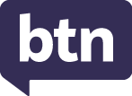
EPISODE 35
30th November 2021

KEY LEARNING
Students will view a range of BTN stories and use comprehension skills to respond to a series of focus questions.

CURRICULUM
English – Year 4
Use comprehension strategies to build literal and inferred meaning to expand content knowledge, integrating and linking ideas and analysing and evaluating texts.

English – Year 5
Use comprehension strategies to analyse information, integrating and linking ideas from a variety of print and digital sources.

English – Year 6
Use comprehension strategies to interpret and analyse information and ideas, comparing content from a variety of textual sources including media and digital texts.

English – Year 7
Use comprehension strategies to interpret, analyse and synthesise ideas and information, critiquing ideas and issues from a variety of textual sources.
  - Teacher Resource

Focus Questions

COVID Kids Wrap
- What have the kids in the BTN story found difficult this year?
- What were the best moments of 2021 for them?
- What helped them cope during COVID?
- Name at least three things that helped you during COVID.
- What message do you have to kids in Australia?

Check out the End of Year resource on the Teachers page.

World News 2021
- Who became the new President of the United States of America in 2021?
- In what country was there a military coup?
- What major world sporting event took place in 2021?
- Many kids around the world took part in protests in 2021. Why were they protesting? Give an example.
- What millionaire took tourists into space in 2021?

Good News 2021
- A vaccine for malaria was developed in 2021. True or false?
- What did scientists discover about the Tyrannosaurus rex in 2021?
- What social media company is now called Meta?
- What animal won Bird of the Year in New Zealand?
- What was your favourite good news story this year? Give reasons for your choice.

BTN Bloopers 2021
- What do you think was the funniest moment on BTN this year?
- Choose your top 5 stories from BTN this year. Briefly explain why you chose the stories.
- What topics or issues would you like to see reported on BTN next year?
- What changes would you make to BTN?
- Choose your favourite story on BTN this year and write a brief summary of what the story was about.

EPISODE 35
30th November 2021

KEY LEARNING
Students will choose their favourite stories from BTN in 2021. Students will explore what news values are and why they are important.

CURRICULUM
English – Year 6
Use comprehension strategies to interpret and analyse information and ideas, comparing content from a variety of textual sources including media and digital texts.

Compare texts including media texts that represent ideas and events in different ways, explaining the effects of the different approaches.

English – Year 7
Analyse and explain the ways text structures and language features shape meaning and vary according to audience and purpose.

Compare the text structures and language features of multimodal texts, explaining how they combine to influence audiences.

Media Arts – Years 5 & 6
Plan, produce and present media artworks for specific audiences and purposes using responsible media practice.
  - Teacher Resource

2021 in Review
Activity: The News in 2021
What was your best memory of a news event in 2021? Students can have a look through the BTN archives to remind them of the stories BTN covered this year. Choose your five favourite stories from BTN this year. They can choose stories from a range of topics, for example Science, Health, Environment, the Arts, Sport and Human Interest.

Once students have chosen their favourite stories from 2021, answer the following questions and then share with the class:

- Why did you choose these stories?
- Why do you think kids would be interested in these stories?
- Why do you think BTN ran this story?

Activity: What makes something ‘news’?
Events happen in the world every day. Some of these events become news stories that appear in the daily news. Students will investigate what makes an event newsworthy. Before starting this activity, brainstorm some ideas as a class.

Watch BTN’s News Values video, which explores what makes news, news. In this video we look at the news values that determine which stories we see and hear about and which ones we don't and how those news values can subtly shape the way we see the world.

Make your own news story
Students will then put together their own news program. Students will need to include a good balance of stories across different topics. Respond to the following questions for each news story.
- Why did you choose this story?
- Summarise the main issue/message.
- Is the news story about a current local issue or an issue from the past?
- Where and when did it happen?
- What new information have you found about it?
- Who is affected by the issue?
- How are they affected by the issue?
- Why is it important for people to know about the issue?
- Why will people be interested in watching the news story?

Activity: Make your own news report
Have you ever dreamt of being a news reporter? Students will produce a short video about someone who’s doing something great, doing something interesting or helping others in their community. It could be a friend, family member, schoolteacher, or themselves. Alternatively, you could encourage students to research an issue that affects their local community.

- Choose someone in your community that you want to feature in your news report. Watch some of BTN’s Rookie Reports for inspiration.
- Write your story – Find out what makes a good feature story here. Celebrate the persons’ strengths in your writing. Share your story with the class.
- Plan your report – Story board your news report on paper.
- Make your news report – Check out the videos below for a range of tips on how to make a news report. Visit BTN’s Rookie Reporter webpage for more training videos.

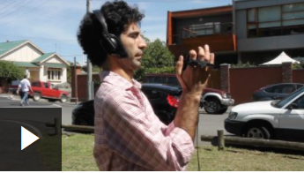  Recording great audio | 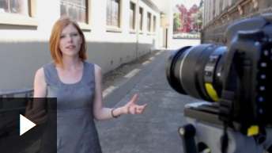  Shooting the story | 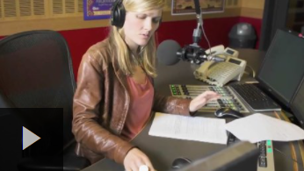  Conducting interviews

Activity: Filming tips
Before watching BTN’s Explainer on How to Make News, hold a class discussion asking students what they think are good filming tips when making a news report, recording students’ responses on the class whiteboard. After the discussion, watch this BTN Explainer to learn more about filming tips, like how to frame your shots and what the rule of thirds is. Students will then respond to the following focus questions.

Focus Questions
- What is meant by the term ‘framing’?
- Which way should you hold a smartphone when filming? Why?
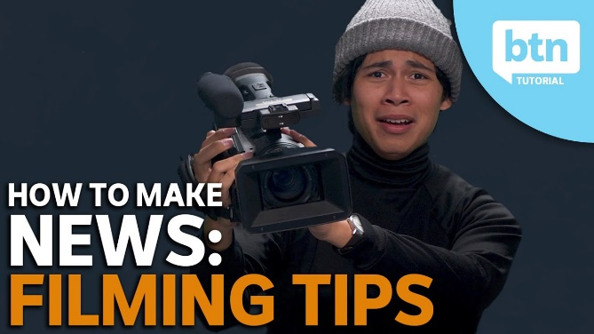
- What is the difference between ‘direct’ and ‘indirect’ interview styles?
- The direct to camera interview style is more natural. True or false?
- What does it mean to have an eye level camera angle?
- What is the rule of thirds? Draw a diagram to help explain the concept.
- What is a camera pan?
- When starting out it is safer to keep your shots still. True or false?
- What questions do you have about filming?

Activity: Good News Stories
BTN featured lots of good news stories in 2021, many of them showing kids doing amazing things. Choose one of your favourite stories below or visit BTN’s website to see more. Respond to the following questions:
- What is the story about?
- Why did you choose this story?
- Why do you think BTN chose to feature this story?
- Describe the main issue/message in the story.
- What makes this story interesting?
- What questions do you have about the story?

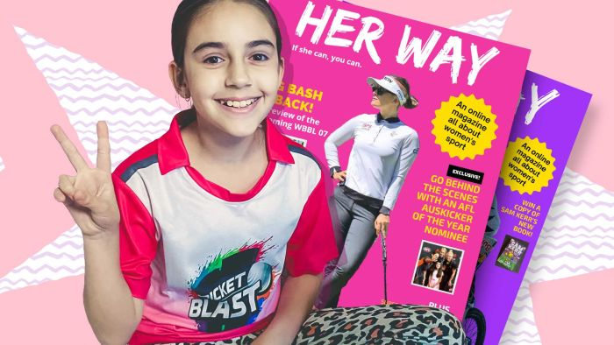  Her Way Sports Magazine | 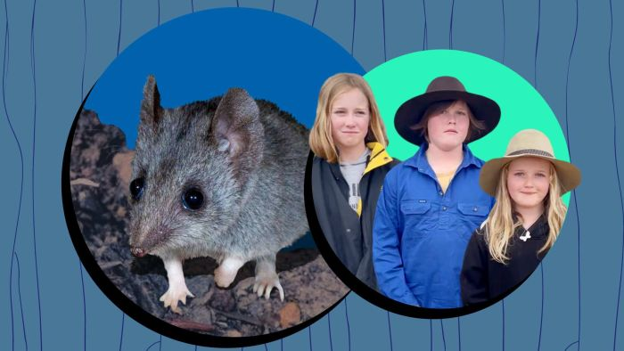  Kangaroo Island Dunnarts
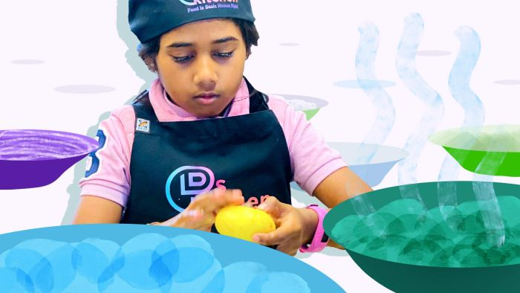  Cooking with Kindness | 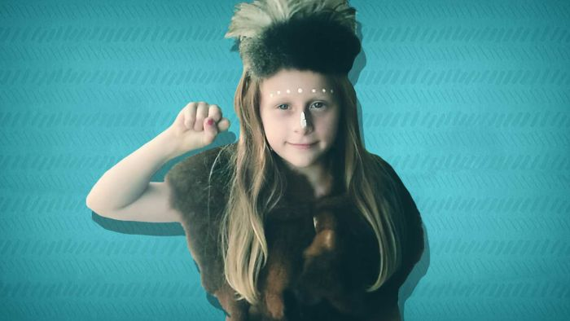  Welcome to Country
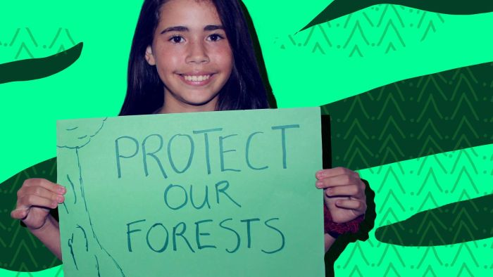  Fantastic Forests | 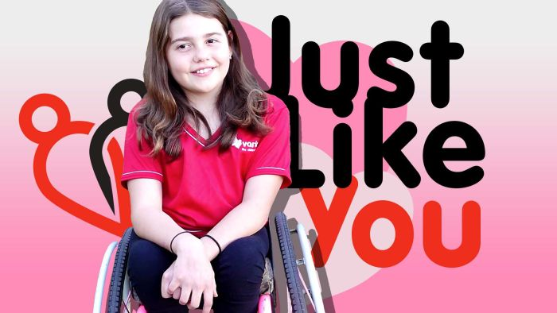  Just Like You

Activity: BTN Science Week Special
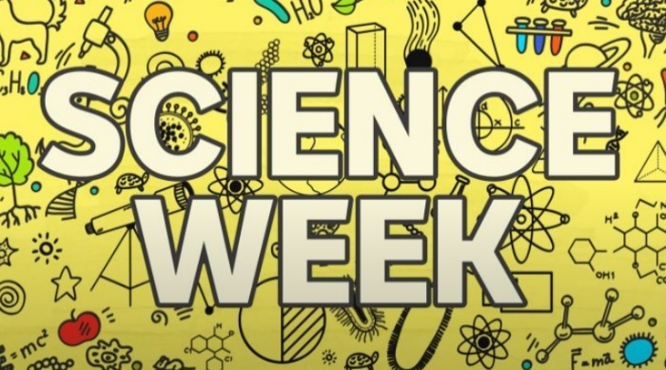
In this BTN Science Week special, we learn more about the work epidemiologists have been doing to understand and fight COVID-19 outbreaks. We take a closer look at what climate change is and what scientists around the world are doing to try to save us from its effects. We look at the positive and negative aspects of the robot revolution and the ways robots will continue to change our lives in the future and look into what the future of food might look like.
Video | Teacher Resource

Activity: Competitions
What competitions did you see in 2021 and wish you had entered with your students? Make a list of competitions that might interest students in your class and get planning for 2022. Below is a list of competitions that BTN featured in 2021 and 2020.

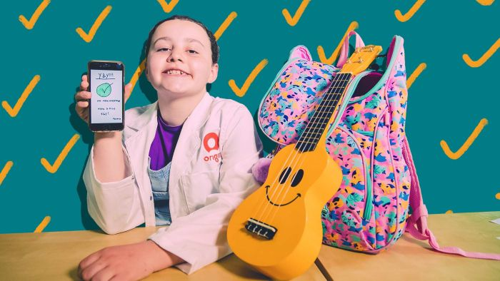  BTN - Little Big Idea Winner  Competition details here | 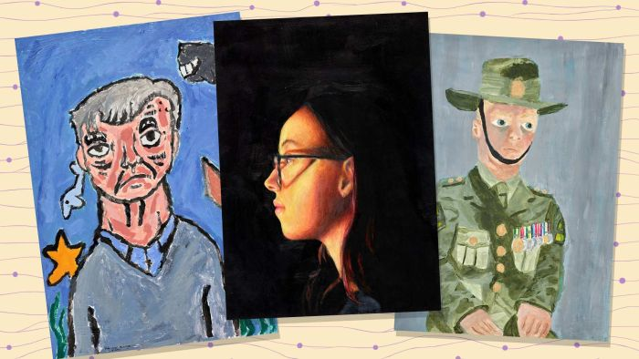  BTN - Young Archie 2021  Competition details here
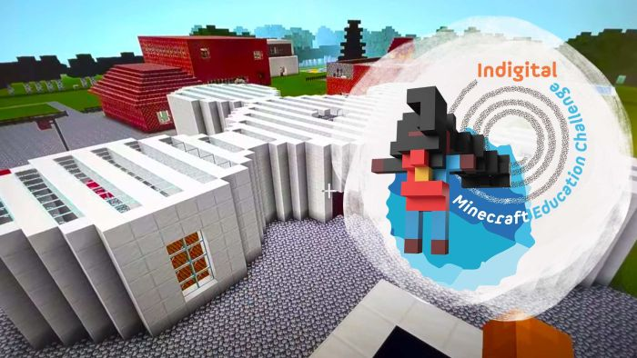  BTN - Minecraft Education Challenge  Competition details here | 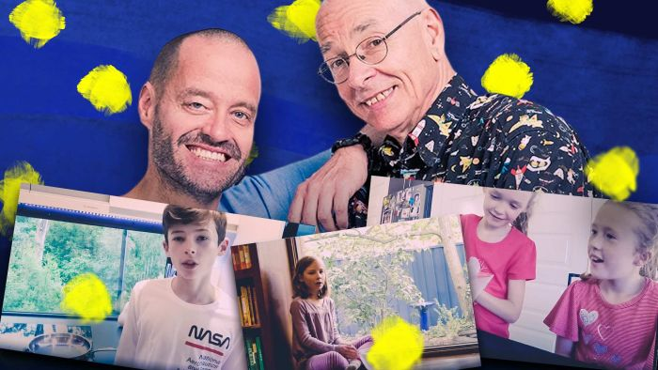  BTN - Sleek Geeks 2020  Competition details here

More competitions…
- My Place competition – ABC Education and the Australian Children’s Television Foundation (ACTF)
- Indigenous Language Art competition – ABC Education
- Heywire competition – ABC
- Books That Made Us: Youth Fiction Prize – ABC Education
Activity: Create your own Super Quiz
After completing the BTN 2021 Super Quiz, students will create their own news quiz. Students can use the following as a guide.

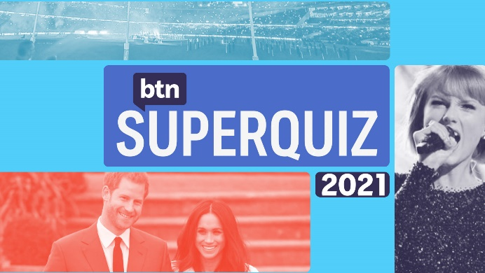
- Make a list of news stories from 2021 that were important to you.
- Write a structure for your quiz. Include a quiz title, target audience, time frame in which quiz needs to be completed and news themes.
- Write and design your quiz. Consider including multiple choice, true or false and picture quiz. It is important that your questions are based on news stories from 2021. Make it fun, engaging and educational.
- Give your quiz to a classmate to complete. Provide your classmate with a score and correct answers.

Activity: Get your news daily
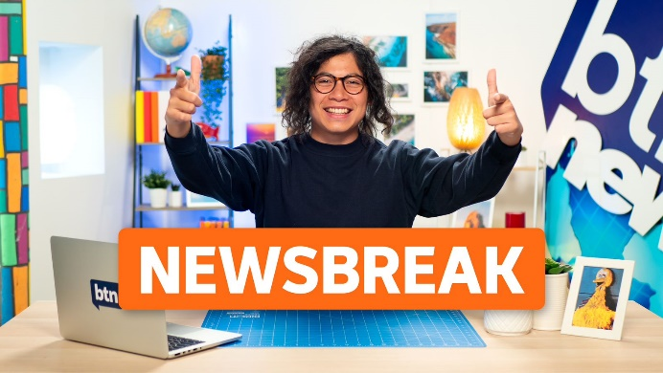
Watch BTN every day! BTN Newsbreak is a great way to kick off the morning routine. You can watch Newsbreak anytime on our website or by subscribing to our YouTube channel. Head to the BTN website for all the details.

Useful Websites
- BTN Classroom Stories – BTN
- Newsbreak Stories – BTN
- How to Make News: Filming, Framing & The Rule of Thirds – BTN YouTube
- What Makes News, News? – BTN Media Literacy

  - Teacher Resource

Super Quiz Questions

These quiz questions are to be used in conjunction with viewing BTN’s Year in Review 2021 program. Pause the video after each question to allow time for students to answer.

QUESTIONS | Your answers
- In August 2021, a third COVID-19 vaccine was made available in Australia. Which company makes it?
A. Pfizer
B. Johnson & Johnson
C. Moderna

- What was the name of the COVID-19 variant that was first detected in India late last year?
A. The Alpha variant
B. The Delta variant
C. The Omega variant

- Which country declared Freedom Day on the 19th of July, scrapping laws for mask wearing and social distancing?
- What was the Oxford Language’s Word of the Year in 2021?
- Which famous Australian landmark escaped an “in danger” listing by the UNESCO World Heritage committee this year?
- Can you name this Caribbean country that was hit by a devastating earthquake in August?
- In the US the government released the results of an investigation into sightings of UFOs, or, as the military calls them, UAPs. Do you know what that stands for?
A. Unidentified Alien Phenomena
B. Unreal Astral Projection
C. Unidentified Aerial Phenomena

- What’s going on in the video?
A. It’s a special effect from the new Indiana Jones movie
B. It’s a fire caused by a leaking underwater gas pipe
C. It’s an underwater volcano

- Can you name this US celebrity who became the oldest person to blast into space?
- Can you name this pop star?
- Prince Harry and Meghan Markle celebrated the birth of their second child this year, Lillibet, who was named in honour of which royal relative?
- In much sadder news we said goodbye to this famous royal, the Queen’s husband, Prince Philip. He was also known as the duke of what?
- Which film won best animated feature at the Oscars this year?
TOTAL SCORE:

Answers

- Moderna
- Delta variant
- UK
- Vax
- The Great Barrier Reef
- Haiti
- Unidentified Aerial Phenomena
- It’s a fire caused by a leaking underwater gas pipe
- William Shatner
- Britney Spears
- The Queen
- Duke of Edinburgh
- Soul

  - Teacher Resource

BTN Transcript: Episode 35 - 30/11/2021

Hi everyone, I'm Amelia Moseley …
KIDS: And you're watching BTN.
Hey, that's my line. As you can see today, I'm not in the studio, I'm at Kilkenny Primary School bringing you the very special last episode of BTN for 2021. Today we'll be having a look back at some of the biggest stories of the year. We'll find out how you guys dealt with another difficult year of lockdowns and home learning and remember some of the stories that made us smile. We'll also give you a look behind the scenes at the times when thing didn't go quite right on BTN, and we'll be testing your knowledge with our end-of-year super quiz.

COVID Kids Wrap

Reporter: Amelia Moseley

AMELIA, REPORTER: All that soon, but first, let’s talk about the pandemic. Do you remember when we thought we'd be putting COVID-19 behind us in 2021?
KIDS: Yes.
AMELIA: Ugh, that didn't really happen, did it?

KIDS: Nah.

AMELIA: There were still lockdowns and closed borders and plenty of hand sanitiser. And a lot of you spent the year learning from home. So, we thought we'd check in with BTN's regular rookie reporters to find out how they were affected and what their hopes are for 2022.
FRANKIE, VIC: This year has been pretty rough, COVID wise, we have been the most locked down city in the world, and it's been hard.
DANIEL ANDREWS, VICTORIAN PREMIER: I'm declaring a state of disaster across Victoria.
PROFESSOR TONY BLAKELY, VIRUS SPECIALIST: This is a different game now. Delta is really changing the rulebook.
GLADYS BEREJIKLIAN, FORMER NSW PREMIER: From 6pm today all of Greater Sydney, the Blue Mountains, the Central Coast and Wollongong will go into a lockdown.
AMELIA NSW: New South Wales went into lockdown in different stages. I live in an area where it wasn't a hotspot area, but we were still in lockdown for months and months.
LIV, NSW: Over here it's been tough. We've spent months in lockdown and even longer in remote learning and I also lived in an LGA of concern which meant we had tougher restrictions than the rest of the state.
OLIVER, VIC: The thing that sucked the most about lockdown, probably just not being able to go to school, having to do online learning, all that kind of stuff.
ALICE, NSW: Definitely being stuck at home for the holidays. Because me and my family normally go to other places for the holidays, but because of COVID restrictions we couldn't go.
BEN, VIC: Well, the worst thing probably has to be all these protestors like anti-vax like we don't believe in the vaccine, it’s kinda bad. Well, the good things, which there aren’t many of, the vaccine rollout, us being nearly 90 percent vaccinated and starting from one of the slowest people to get the vaccine to one of the highest, so that's pretty good.
SCOTT MORRISON, AUSTRALIAN PRIME MINISTER: Australia gets vaccinated. Australia is able to live differently.
FRANKIE: The best part about 2021 was being able to spend more time with the family and going bike riding and doing some cooking.
AMELIA: It was also great to sleep in and exercise with my friends.
ALICE: I just enjoyed the break from school and the pressures of just being so new to high school and having to try and work everything out.
LIV: I actually created better and stronger friendships. My friends and I spoke a lot online, and I think that if we didn't have that way to connect and we weren't at home talking to each other so much our friendship and our group wouldn't be as strong as it is now.
LIV: Right now, New South Wales lockdown is over for fully vaccinated people, we're back at school and borders are reopening.
ALICE: It's slowly getting better. We still have to wear masks outside, not many people do, but we still have to wear them. As more and more people are getting the vaccine, the restrictions are eased more and more.
DOMINIC PERROTTET, NSW PREMIER: Vaccination has been key to us being able to open up. There's obviously a lot of excitement, but it certainly has to be tempered by making sure we continue to look out for each other.
BEN: Well, in Victoria, we've got 90 percent vaccinated, that means we can pretty much do most things. We don't need masks in most situations, the theatres are open. Yay.
DANIEL ANDREWS, VICTORIAN PREMIER: I simply cannot tell you how proud I am of every single Victorian who has persevered, shown great courage and character, but also shown amazing kindness towards each other.
LIV: I've got mixed feelings about the borders reopening. The case numbers will inevitably rise, and also new variants could come into the country. But also, it's a great thing. You can travel interstate and internationally to visit friends and family or just go on a holiday. And we haven't been able to do that for nearly two years.
FRANKIE: I hope that 2022 includes no lockdowns and we get to go and do all the fun things and more restrictions will ease.
OLIVER: I just want there to be no more lockdowns, just free and do whatever we want. We can go to America, go to India, go to England, go wherever cause the borders will be open and we can go anywhere, and the world will be free of COVID.
ALICE: Honestly anything better than the last two years would be great.
BEN: Well, I hope there'll be less protestors and COVID will be a thing of the past and I can tell stories to my grandchildren like back in my day there was a thing called COVID-19, it was very bad. Luckily, I was one of the survivors.

Super Quiz (part 1)

Alright, get ready. Question one. In August a third COVID-19 vaccine was made available in Australia. Which company makes it? Is it Pfizer, Johnson & Johnson or Moderna? It’s Moderna.

What was the name of the variant of COVID-19 that was first detected in India late last year and caused outbreaks around the world in 2021? Was it the Alpha variant, the Delta variant or the Omega variant? It was the Delta variant or Delta strain, a more contagious version of the virus that causes COVID-19.

SCOTT MORRISON, AUSTRALIAN PRIME MINISTER: The reality is, we’re living this year in a pandemic that’s worse than last year.

Which country declared Freedom Day on the 19th of July, scrapping laws for mask wearing and social distancing. It was the UK. At that stage about 68 percent of adults were fully vaccinated and the government decided to open things up again.

And do you know what the Oxford Language’s Word of the Year was in 2021? It was vax, makes sense.

World News 2021

Reporter: Amelia Moseley
AMELIA, REPORTER: So, how has the pandemic affected you guys?
KID: Learning from home was very hard during the pandemic for me.

KID: My football career, my training and games have been cancelled, so yeah.

AMELIA, REPORTER: What about you guys?

I haven’t been able to see my friends like I usually do on the weekends.

KID: Well, it’s been not too bad for me, well, I play guitar and I can practise a lot and I’ve got a really good family that I can hang out with and support me through my life.

KID: The sad thing is, sometimes you get sick of your family, especially when you have siblings.

AMELIA, REPORTER: Yeah, I bet I can imagine. Although watch out they might be watching.
Now, it might seem like most of this year's news was COVID related, but let’s not forget a whole bunch of other significant stuff happened in Australia and around the world this year. So, let's take a look back at some of the biggest news stories of 2021.
As always, Mother Nature wasn't pulling any punches in 2021. From spectacular volcanic eruptions, to floods and heatwaves. And let's not forget the occasional Aussie tornado, a troublesome mouse plague. Oh, and an earthquake that no one in Melbourne was prepared for.
In the tricky world of politics, there were also a few big shakeups. Of course, not everyone agreed with how things turned out and in the US a crowd of protestors stormed The Capitol. World leaders got together, well, mostly online. But even in person things didn't always go smoothly. For people in some places, life took a real turn. There was a military coup in Myanmar. Intense fighting between Israelis and Palestinians and the Taliban's takeover of Afghanistan.
AUSTRALIAN KID: I hope that there's no more wars, there's no bombing, there's no shooting, there's no killing, there’s no anything there. It's just going to the shops, and just getting whatever, you need and just coming home safe.
In Australia, we sometimes found it tough to keep up with news, but when the Olympics were finally on you couldn't drag us away from our screens. Eh, even if it was just to see Jack show us this.
This royal walked away from the job he was born into and thousands of Aussies walked together to demand equality, and to once again call for action on climate change. It's a topic this activist had plenty to say about, and so did world leaders as they tried to work out how to save our planet. Meanwhile, others focused their attention on leaving Earth. Two billionaires took tourists into space for a view they'll never forget. And a few countries set their sights on somewhere much, much further away. And with that let's say goodbye to another year of big news.

Super Quiz (part 2)

Which famous Australian landmark escaped an “in danger” listing by the UNESCO world heritage committee this year? It was the Great Barrier Reef. UNESCO had recommended Reef be placed on the “in danger” list after three mass bleaching events, but the World Heritage Committee decided not to do it yet. It has asked to send a team to visit the reef next year to check it out.

Can you name this Caribbean country that was hit by a devastating earthquake in August? It’s Haiti. The earthquake killed more than 2,000 people and left many more homeless.

In the US, the government released the results of an investigation into sightings of UFOs or, as the military calls them, UAPs. Do you know what that stands for? Is it Unidentified Alien Phenomena, Unreal Astral Projection or Unidentified Aerial Phenomena? It’s c, Unidentified Aerial Phenomena. The report didn’t actually manage to identify many of them, although officials say they could be foreign technology, or sensor errors, probably not aliens, but maybe? Right?

What’s going on in this video? Is it a special effect from the new Indiana Jones movie? Is it a fire caused by an underwater gas leak or is it an underwater volcano? It’s a fire, in the Gulf of Mexico which was caused by a leaking underwater gas pipe, and it took five hours to put it out.

Can you name this US celebrity who became the oldest person to blast into space? It’s William Shatner, best known for his role as Captain Kirk of the Starship Enterprise and he was pretty impressed with his real life trip to the final frontier.
Good News 2021

Reporter: Amal Wehbe

INTRO: While it might have felt like there was lots of bad news in 2021, there was also plenty of stuff to celebrate, like scientific breakthroughs, exciting announcements, and, of course, amazing kids doing amazing things. So, here's Amal to bring you the good news stories of 2021.

Yep, even in the midst of a global pandemic there were reasons to cheer in 2021. Reasons to dance, well eventually, anyway. And reasons to be thankful. We saw some medical wonders, not just COVID vaccines but a world first jab for Malaria.
PROFESSOR JAMES BEESON, MONASH UNIVERSITY: It's been one of the biggest killers of humanity for thousands of years.
DR TEDROS ADHANOM GHEBREYESUS, WHO DIRECTOR-GENERAL: This vaccine is a gift to the world.
Scientists helped us to learn more about the universe and more about our home. They named a new ocean and Australia got a brand new ice-breaker to unlock its mysteries. There were also discoveries about the ancient Earth and the creatures that used to live here. We learned how T-Rex’s moved, met a new human ancestor and learned more about ancient civilisations. Meanwhile art got futuristic. We watched as NFTs made some people rich. A struggling video game store became the hottest stock in town. Meanwhile, this big name announced a new name.
MARK ZUCKERBERG, CEO OF META PLATFORMS INC.: Starting today our company is now Meta.
And we all learnt more about the future of metaverse. There was plenty to marvel at back in the real world. We followed the flight of trillions of cicadas that only come out every 17 years.
MICHAEL RAUPP, ENTEMOLOGIST: This is just a spectacular event. I mean, there's nothing else like this on the entire planet Earth, even in the entire universe.
And we followed the journey of a herd of elephants across China. Meanwhile, New Zealand voted in an unusual bird of the year, a bat.
PETER WILLS, PEKAPEKA CAMPAIGN MANAGER: We've really ruffled some feathers having them in the competition this year. But the nice thing is, every single investment that we do to protect our natural environment does a good job at supporting all species.
We were inspired by people who fought to make the world a better place. And those who fought for their place in history. Our sporting legends gave us plenty to cheer about. But for us the biggest legends of 2021 were you guys. The kids who inspired us with your big ideas. And big campaigns. You taught us new things. And showed us new places. You impressed us with your amazing skill and your big hearts. So, thank you for helping to make 2021 a year to smile about.
Super Quiz (part 3)

Can you name this pop star? It’s Britney Spears and this year she made the news for fighting and winning a legal battle to end something called a conservatorship, which gave her father the power to make a lot of decisions about her life.

Prince Harry and Meghan Markle celebrated the birth of their second child this year, Lillibet, who was named in honour of which royal relative? It was Harry’s grandmother, the Queen. Lillibet is a nickname used by the Queen’s father when she was a baby and couldn’t pronounce her own name properly.

In much sadder news we said goodbye to this famous royal, the Queen’s husband, Prince Philip. He was also known as the duke of what? He was the Duke of Edinburgh.

Which film won best animated feature at the Oscars this year? It was Pixar’s Soul.

BTN Bloopers 2021

Reporter: Jack Evans

AMELIA, REPORTER: As always, we've had a lot of fun bringing you BTN this year, but you know, things don’t always go according to plan. So, before we go, how about we have a look at some BTN bloopers. What do you reckon? Do you want to see?

KIDS: Yeah.

AMELIA, REPORTER: Yeah, I thought you would say that.

Welcome to the BTN academy of over acting. Here you'll be taught all the tricks of the trade. To be able to pull off this and this and, yes, even this. You'll learn how to get into character.
JACK: Release the hackers. I don't know why I'm talking like this.
And how a costume can really help your character come alive. There's specialised subjects, like the subtle art of eating on camera.
JACK: Oooh it's good. That's enough though.
CALE: In fact, experts say that by 2050 we need to feed at least 9 billion people.
And how to work with a scene partner.
CALE: Is dinner ready?
CALE CLONES: We're working on it.
JACK: This one’s made of chocolate. Not bad, want some?
We'll give you tips on how to learn all your lines.
LIV: Sorry. These rep, oh no. Sorry, these rep, oh no I did it again.
JACK: Oh I love them. They're round, they're flat, is that my line? Oh, it is, it just sounds really stupid.
And as for those pre-show nerves, don't worry, it's OK to make a mistake.
CAMO: OK Action.
LEELA: Good catch.
JOE: Hey mate how's it going?
NAT: Hey, how you going? Yeah good. Oh, sorry just do that again.
AMELIA: But if you have just one. But if you eat just one orange, you'll only have. Sorry I keep messing that up. I started laughing.
MATT: Ah huh genius. Oh, that was weird, let’s do another one.
NIC: Yeah, well as long as you don't have some bloke talking through the whole thing. I've come all the way from 1910 to watch this weird movie about a train and then suddenly there's a bloke with cotton wool in his mouth and he's wearing a suit and he's talking in Italian about gullible this and whatever I don't know man, and what's this, ah yeah, OK.
AMELIA: But in, I went too far didn't I. Anyway, back to it.
And by the end of the course, you'll realise that acting is no laughing matter.
JACK: Fly, fly. Ooh a fly.
CAMO: OK, shall we do this?
JACK: Yeah, what are we doing?
JOE: Excuse me, um, I'd like to report some crimes against the environment.
LIV: Alright, what's the nature of the crime. Hah, get it? Nature.

So, enrol today, to the BTN academy of over-acting.

Closer

Well, that brings us to the end of the show and the end of the year. Thanks so much to Kilkenny Primary School for having us. We'll be back with more news for you in 2022 but don’t worry if you miss us in the meantime you can head to our website or if you're 13 or over you can check out our YouTube channel. Take care of each other, stay safe, enjoy your holidays and I'll see you next year. Bye.

