EPISODE 29
19th October 2021

KEY LEARNING
Students will view a range of BTN stories and use comprehension skills to respond to a series of focus questions.

CURRICULUM
English – Year 4
Use comprehension strategies to build literal and inferred meaning to expand content knowledge, integrating and linking ideas and analysing and evaluating texts.

English – Year 5
Use comprehension strategies to analyse information, integrating and linking ideas from a variety of print and digital sources.

English – Year 6
Use comprehension strategies to interpret and analyse information and ideas, comparing content from a variety of textual sources including media and digital texts.

English – Year 7
Use comprehension strategies to interpret, analyse and synthesise ideas and information, critiquing ideas and issues from a variety of textual sources.
  - Teacher Resource

Focus Questions

School Strike 4 Climate
- What did the School Strike 4 Climate story explain?
- What happens at the UN Conference of the Parties (COP)?
- Why are some people describing this year’s COP meeting as the most significant climate event ever?
- What do many countries want to achieve by 2050?
- What message do you have for world leaders attending this year’s COP meeting?

Malaria Vaccine
- How is malaria transmitted?
- What type of disease is malaria?
  - Viral
  - Bacterial
  - Parasitic
- What areas in the world are most affected by malaria?
- What are some ways that malaria is prevented or treated?
- How many doses of the new malaria vaccine need to be taken?

Check out the Malaria Vaccine resource on the Teachers page.

Food Allergy Guidelines
- Summarise the Food Allergy Guidelines story.
- What types of foods cause allergies? Give 3 examples.
- What are some common symptoms of an allergic reaction?
- What does it mean when a school is ‘nut aware’?
- What do new national guidelines recommend for schools and their ‘no nut’ policies?

Check out the Food Allergy Guidelines resource on the Teachers page.

Why is the Earth a sphere?
- What force gives Earth a spherical shape?
- What is an ellipsoid?
- Who was the first person to say the Earth is round?
- How did Aristotle prove that the Earth is round?
- How did Eratosthenes measure the Earth?

Cooking with Kindness
- Retell the BTN story using your own words.
- How would you describe Diya’s organisation?
- When did Diya start DD’s Kitchen?
- What does mise-en-place mean in cooking?
- How did this story make you feel?

EPISODE 29
19th October 2021

KEY LEARNING
Students will learn more about vaccines and how they have helped prevent disease in the community.

CURRICULUM
Science – Years 5 & 6
Scientific knowledge is used to solve problems and inform personal and community decisions.

Communicate ideas, explanations and processes using scientific representations in a variety of ways, including multi-modal texts.
Science – Year 7
Solutions to contemporary issues that are found using science and technology, may impact on other areas of society and may involve ethical considerations.

  - Teacher Resource

Malaria Vaccine

Focus Questions
Discuss the BTN story as a class and record the main points of the discussion. Students will then respond to the following:
- How is malaria transmitted?
- What type of disease is malaria?
  - Viral
  - Bacterial
  - Parasitic
- What areas in the world are most affected by malaria?
- What are some ways that malaria is prevented or treated?
- How many doses of the new malaria vaccine need to be taken?

Activity: Class discussion
Discuss the information raised in the BTN Malaria Vaccine story. Ask students to record what they learnt about malaria and the vaccine on a mind map. What questions do students have? Use the following to guide the discussion:

- What did you learn about malaria?
- What does this story make you wonder?
- How did this story make you feel?
- It was interesting to learn that…
- Why do you think it is important to hear about this topic?
- What questions do you have about this story?

What do you know about malaria?

Activity: Glossary
Students will brainstorm a list of key words that relate to the BTN Malaria Vaccine story. Students may want to use pictures and diagrams to illustrate the meaning and create their own glossary. Students will use the words to write their own sentences about malaria and vaccines. Here are some words to get them started.

MOSQUITO | VACCINE | IMMUNITY
DISEASE | INFECTION | PARASITE
INFECTIOUS | IMMUNISATION | MALARIA ENDEMIC

Further investigation: Tricky words
Students will choose additional keywords and terms to add to their class glossary that are tricky. For example, anopheles, antigen or epidemiology. Students will find a definition and explain to their classmates what the keywords mean.

Activity: Research
After watching and discussing the BTN Malaria Vaccine story, what questions do students have? The following KWLH organiser provides students with a framework to explore their knowledge on this topic and consider what they would like to know and learn.
What do I know? | What do I want to know? | What have I learnt? | How will I find out?

Students will develop their own question/s to research or select one or more of the questions below.
- When was malaria first discovered and by whom?
- Why is malaria called malaria? Investigate the origin of the word.
- How does a person become infected with malaria?
- Where geographically is malaria found? On a world map highlight where malaria is most prevalent.
- Before a vaccine was created, what was the main way of fighting malaria? Give 2 examples.
- Why was it important to find a vaccine for malaria?
- How do vaccines work? Choose one to explore in more detail and explain how it works.
- What is the history of vaccination? Research the history of vaccination and present your findings in a timeline which highlights significant events.
- What impact have vaccines had on controlling disease? Choose one vaccine to explore in more detail and share your findings with the class.
- What’s the difference between a virus, bacteria, and a parasite? Find meanings for each and then compare and contrast.
- What’s the difference between vaccination and immunisation?

Activity: Jigsaw learning
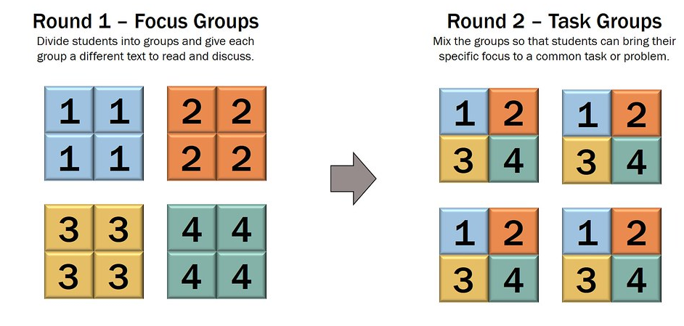
In this activity students will work cooperatively to learn more about vaccines and how they have helped prevent disease in the community. Each group will become experts and then share what they have learnt with other students.

Form groups | Divide the class into groups. Each group will be assigned a different vaccine which has been developed to prevent one of these diseases (rotavirus, hepatitis a, chicken pox, influenza, Covid-19, polio and mumps) and become an expert. Each group will need to decide how they will collect and communicate the information they find during their research.
Research | Each group will respond to the following questions to become experts:  - What disease is the vaccine for? Describe the disease.  - When was the vaccine developed? Who developed the vaccine?  - How does the vaccine work?  - How often should a person be vaccinated?  - What impact has the vaccine had on controlling the disease worldwide?  - What are some interesting facts about the vaccine?
Share | One student from each of the expert groups will form a new group to share the information they have collected. Students will make sure there is one expert from each group at their table. Students will share the information they have collected and learn from one another.
Reflect | Students will reflect on the activity by responding to one or more of the following questions:  - What did you enjoy about this investigation?  - What did you find surprising?  - What would you do differently next time?

Activity: Visual literacy
In this activity students will examine, analyse and query a range of posters which were designed to educate the public about malaria and its risk to the community. Students will choose one or more of the posters below (alternatively, students can find another campaign poster online) and then respond to the following questions:
- Write a short paragraph describing what you see in this poster. Think about the colours, shapes, images, font and symbols.
- What year do you think the poster was created?
- Who is the intended audience?
- What is the key message?
- What is the purpose of the poster?
- How does the poster make you feel? Describe your emotions.
- What question/s would you like to ask about the poster?

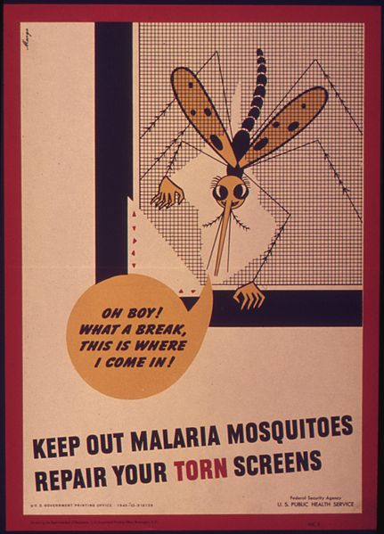  Wikipedia | 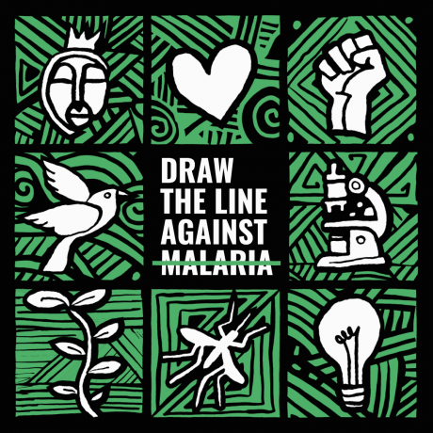  Zero Malaria Starts with Me
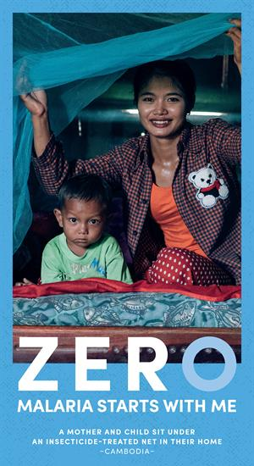  World Health Organisation | 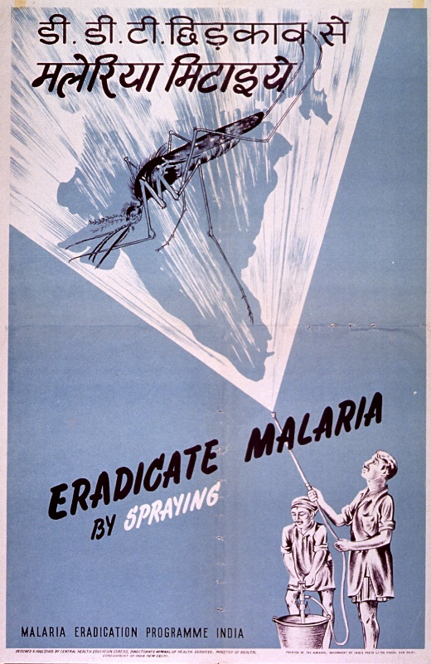  US National Library of Medicine

Activity: Public education campaign
Students will design a public education campaign to raise awareness of malaria and vaccination against the disease. Students will think about their campaign’s aim, target audience, and the value of raising awareness at their school. Visit the World Health Organisation’s website to learn more about raising awareness of malaria.

To create a school awareness campaign, students will need to identify the following:
- What is malaria?
- How is it transmitted?
- Where geographically is malaria found? Highlight on a map.
- How can malaria be prevented?
- Why is it important to find a vaccine against malaria?
- How can you teach other kids about the importance of vaccination? Think of creative ways you can teach kids your message about the topic.

Some questions to consider when designing your campaign:
- What is the campaign’s main aim?
- Do you have a slogan or message? What is it?
- Who is your target audience?
- What is the best way to communicate the message?
- When is the best time to communicate your message? (e.g., World Malaria Day)

Discuss with students how they will get their message out there to help raise public awareness. Some possibilities include:
- Short film or animation
- Community service announcement (for print, television or radio).
- Press release (create posters to be put up around the school or pamphlets to give to all students).

Useful Websites
- Immunisation for Children – Department of Health, Australian Government
- Pioneer Breakthroughs – History of Vaccines
- Timeline – History of Vaccines
- Malaria Vaccine Approved – BTN Newsbreak
- Malaria: Children across Africa to get `historic’ vaccine - Newsround
- World Health Organization endorses first malaria vaccine, Mosquirix, for children in Africa – ABC News
- World Malaria Day: What is malaria and why is it such a big problem? – Newsround

  - Teacher Resource
EPISODE 29
19th October 2021

KEY LEARNING
Students will learn more about what allergies are and the signs and symptoms of allergic reactions.

CURRICULUM
Health and Physical Education – Year 3 and 4
Identify and practise strategies to promote health, safety and wellbeing.
Describe strategies to make the classroom and playground healthy, safe and active places.
Health and Physical Education – Year 5 and 6
Plan and practise strategies to promote health, safety and wellbeing.
Health and Physical Education – Year 7 and 8
Practise and apply strategies to seek help for themselves or others.
Investigate and select strategies to promote health, safety and wellbeing.
Evaluate health information and communicate their own and others’ health concerns.
Plan and use health practices, behaviours and resources to enhance health, safety and wellbeing of their communities.

Food Allergy Guidelines

Focus Questions
- Summarise the Food Allergy Guidelines story.
- What types of foods cause allergies? Give 3 examples.
- What are some common symptoms of an allergic reaction?
- What does it mean when a school is ‘nut aware’?
- What do new national guidelines recommend for schools and their ‘no nut’ policies?

Activity: Class Discussion
Before watching the BTN story students will write down as much as they can about food allergies. Do they have a food allergy? Do they know of anyone with a food allergy?

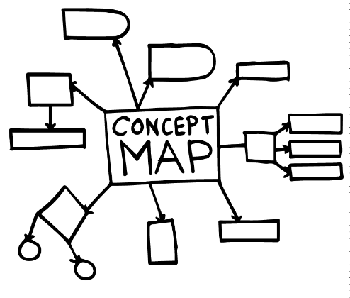
After watching the BTN story hold a class discussion about food allergies using the questions below as a guide. Record the main points of discussion on a mind map.

- What is an allergy?
- What sorts of allergies can people have?
- What do you know about food allergies?
- Give examples of food that people can be allergic to.
- What is an allergen? Give examples.
- What are the signs and symptoms of a mild to moderate allergic reaction?
- What are the signs and symptoms of a severe allergic reaction?
- How is a severe allergic reaction treated?
- Which foods cause 90% of food allergies?
- What do you do if you see someone at school having an allergic reaction?

Activity: Glossary
Students will brainstorm a list of key words that relate to the BTN Food Allergy Guidelines story. Students may want to use pictures and diagrams to illustrate the meaning and create their own glossary. Here are some words to get you started.

ALLERGY | SYMPTOM | ALLERGIC REACTION
ANAPHYLAXIS | IMMUNE SYSTEM | ALLERGEN
ANTIBODIES | AWARENESS | SEVERE

Activity: Six Hat Thinking
As a class, use Edward De Bono’s Six Hat Thinking to explore the issues raised in the BTN Food Allergy Guidelines story. Make your own coloured hat cut-outs and place on the floor. Students will take it in turns answering questions in relation to what they already know about the topic, what they have learned from the story and what they want to learn further about the issue.

Reflection
After this activity, ask students to reflect on what they have learnt. Students can include details about how their thinking on this issue has changed.

How did the Food Allergy Guidelines story make you feel?

What do you know about the topic?
What have you learnt from the story?
Were there any positives from the story? If so, what were they?
What are some of the negatives or challenges that you learnt from the story?
Why is it important to find out more about the topic?
What questions were raised during this activity?
What do you want to learn further about this topic?

Activity: Research
Define: What do I want to know?
Key questions to research
Students can choose one or more of the following questions or come up with their own:
- How do allergies affect the body? Use the following scientific words in your description: symptom, allergens, immune system and antibodies.
- What is the difference between a food allergy and a food intolerance?
- What are the signs and symptoms of a severe allergic reaction (anaphylaxis)? How can it be prevented? How can it be treated?
- What can I do if I see someone having an allergic reaction?
- Investigate what students can do to help those with food allergies avoid their triggers. What can students with food allergies do to avoid triggers?

Locate: Where do I find the information?
What resources will help answer my questions? (Internet, people, resource centre, organisations, print). Discuss with students what a reliable source is.

Select: What information is important for the investigation?
Students may need support to sort through and select relevant information.

Organise: How do I make sense of the information?
Students can organise their research by creating main headings from their questions. Write each heading on a separate piece of paper. Record the information found for each question.

Present: How do we let others know about this information?
Each group needs to discuss then decide on the best way to present the information. Possibilities could include:
- A `Did You Know’ Facts sheet
- Oral presentation
- Prezi presentation
- Create a poster using Canva

Evaluate: What have we learnt?
Each group reflects on what they have learnt about food allergies during their investigation. Students will reflect on their learning and respond to the following.
- What I learned...
- What I found surprising...
- What I would do differently next time…

Activity: Food allergies and product labelling
Students will learn more about the foods that trigger most allergic reactions and why product labelling is important to people with a food allergy. Below is a list of the foods that cause 90% of food allergies. Discuss with students why product labelling is important to people with a food allergy. Explain that foods on products may have different names. Ask students to match the other names below to the most common allergens. Some foods may have more than one name. To extend the activity, students can give examples of products that contain the food allergens.

Albumin | Anchovy | Egg solids | Macadamia
Almond paste | Tuna | Hydrolysed whey | Lactose
Triticale | Casein | Walnut | Tahini
Ground nuts | Tofu | Gluten | Crab

Egg  Other names food may be called on ingredients list: | Fish  Other names food may be called on ingredients list: | Soy  Other names food may be called on ingredients list:
Wheat  Other names food may be called on ingredients list: | Tree nut  Other names food may be called on ingredients list: | Peanut  Other names food may be called on ingredients list:
Shellfish  Other names food may be called on ingredients list: | Milk  Other names food may be called on ingredients list: | Sesame  Other names food may be called on ingredients list:

Activity: Food Allergies Quiz

- An allergen is…  A. A substance that triggers an allergic reaction  B. Medicine used to treat an allergy  C. A symptom of an allergic reaction  - Anaphylaxis is a severe allergic  reaction.  A. True  B. False  - An EpiPen, which is used to treat  anaphylaxis, contains…  A. Adrenaline  B. Insulin  C. Cortisol  - If someone is allergic to gluten,  then they should avoid…  A. Tree nuts  B. Casein  C. Wheat  - A macadamia isn’t a tree nut.  A. True  B. False | - Hummus contains tahini which  is...  A. Chickpea paste  B. Almond paste  C. Sesame paste  - If a person is allergic to albumin,  they should avoid food containing…  A. Soy  B. Shellfish  C. Eggs  - What are peanuts sometimes called on food labels?  A. Pistachios  B. Pine nuts  C. Ground nuts  - About what proportion of kids have a food allergy?  A. 1 in 10  B. 1 in 20  C. 1 in 50  - There is no cure for food allergies.  A. True  B. False
Quiz Answers: 1A, 2A, 3A, 4C, 5B, 6C, 7C, 8C, 9B, 10A.

Useful Websites
- New national food allergy guidelines recommend education instead of bans – ABC News
- Food Allergy Week – BTN
- Food Allergies – BTN

  - Teacher Resource

BTN Transcript: Episode 29 - 19/10/2021

Hey, I’m Amelia Moseley and you’re watching BTN. Here’s what’s coming up. We find out why these are the world's deadliest creatures, learn why nut bans might become a thing of the past and investigate the shape of the planet.

School Strike 4 Climate

Reporter: Jack Evans

INTRO: All that soon, but first, kids around Australia walked out of the classroom on Friday to protest for action on climate change. The schools strike for climate is a world-wide movement that's been going on for a few years now and organisers say this protest was particularly important because of a big global climate meeting that's happening really soon. Here's Jack.

KID 1: This is about the climate change protests because we want more action on climate change, and we want a better future.
KID 3: We're the ones in the long term who are going to be affected by it, and we’re the ones who are going to see the fallout of it.
Over the last few years marches like this have become a familiar sight around the world, as kids take to the streets to demand a better future. It all started back in 2018 with this now famous school girl who decided to stage her own protest outside of the Swedish parliament. What started as a small protest turned into a global movement involving millions of kids and their supporters.
KID 2: So, our demands as School Strike 4 Climate are no new investment in fossil fuel projects, 100 percent renewable energy by 2030 and adjust transition for fossil fuel workers, and especially in the lead up to COP26 we're really calling on the government to set a target for net zero emissions.
If you haven't heard of COP26, well you will be pretty soon. In just a couple of weeks leaders from all over the world will meet in Glasgow in the UK for the UN Conference of the Parties. It's part of a series of meetings that have been going since 1995 to try to fix the problem of climate change and yes there have been 26 of them now, hence the name. People have described this year’s meeting as the most important ever. We now know that the planet has already warmed and that's going to get worse unless global emissions go down this decade. It's why many countries have already signed up to a zero net emissions target by 2050.
Of course, getting to net zero won’t be easy, especially for a country like Australia where lots of jobs rely on the fossil fuel industry. But a lot of people say it will be worth it, including many businesses here in Australia and all of the states and territories. But the federal government is yet to announce a national policy. Many are hoping that will change at COP26. Although some were worried that the Prime Minister, Scott Morrison, wasn't actually going to be there.
INTERVIEWER: Scott Morrison the Australian PM isn't even certain that he can make it to the meeting in Glasgow.
PRINCE CHARLES: Is that what he says, is it?
INTERVIEWER: He did say that, yeah.
PRINCE CHARLES: The point being, that this is our last chance saloon. Literally, because if we don't really take the decisions that are vital now, it's going to be almost impossible to catch up.
KID 3: Like Scott Morrison really needs to be attending these things, because he's the one who has the say, and he's the one who has the power to be able to change our lives for the better.
Well, the PM was listening.

SCOTT MORRISON, PRIME MINISTER OF AUSTRALIA: So overnight, I confirm my attendance at the Glasgow summit.

He says, addressing climate change is something we need to do together, and he’ll be working with other members of government to finalise a policy that he will take to COP and a lot of people are going to be watching closely to see how Australia will react to what’s being called the challenge of our generation.
News Quiz

Which Aussie state ended up in a short, sharp lockdown last week when a traveller breached quarantine? It was Tasmania. Things opened up again on Monday evening. The ACT has also ended its lockdown and lots of Melburnians are looking forward to restrictions easing this week.
What natural disaster hit the town of Armidale in northern New South Wales last week? Was it an earthquake, a cyclone or a tornado? It was a tornado. It was part of an evening of wild weather that ripped across the state bringing wind, rain and hail stones as big as golf balls.

Aussie scientists are building a robotic rover which will be sent where? To the Moon, to Mars or to the North Pole? It’ll be sent to the Moon. The Australian government has made a deal with NASA to build a rover that could be sent to the Moon as soon as 2026, to collect lunar soil and find out more about how humans could live up there.

Can you name this US actor who became the oldest person to go to space last week? It’s William Shatner, best known for playing Captain Kirk in the original Star Trek TV series. He said his real-life trip to the final frontier was a profound experience.

And can you name the mysterious British street artist behind this, um slightly shredded painting that sold last week for $29 million dollars? It’s Banksy. The artist secretly built a shredder into the frame, then when it went up for sale the first time, he did this. Turns out it actually increased the value of the art, go figure.

Malaria Vaccine

Reporter: Amelia Moseley
INTRO: Next up, to some good news about the global rollout of an important vaccine. But no, this story's not about COVID it's about malaria. It's a disease that affects hundreds of millions of people every year, especially kids, and experts say this new vaccine will save lives. Let's find out more.
What's the most dangerous animal in the world? Is it a lion? Is it a crocodile? Or a spider? Maybe a snake? Nope, think way smaller. The most dangerous animal is a mozzie. Seriously.
AMELIA, REPORTER: That was truly terrifying.
Most of the time, these little blood suckers are just a bit irritating, especially if you always get bitten like I do.
AMELIA: But some types can cause a lot more harm than just an itchy red lump. And not because they're ten times bigger or have giant teeth or anything like that but because of the diseases they can carry, in particular malaria.
It's a parasitic disease which means it's a teeny tiny bug that survives by living off other living things. It spreads through an infected mozzie's saliva when it bites someone. The parasite then multiplies and infects their liver and red blood cells making them really sick. And it can be deadly.
PROFESSOR JAMES BEESON, MONASH UNIVERSITY: It's been one of the biggest killers of humanity for thousands of years. You know malaria kills several hundred thousand people a year, causes a couple hundred million cases of illness a year and it mostly affects young children.
Luckily, we don't have Malaria in mainland Australia, but it's a huge problem in many tropical countries, especially in parts of Africa where 94 percent of cases are recorded. Up until now, the main way of fighting the disease was by avoiding mozzie bites using things like nets and insect repellent, or by preventing or treating the disease using medicine. But it's not always effective and can't be used long term. Plus, all those things can be hard to come by in developing countries. So, for generations scientists have been working on a better solution, a vaccine to protect people. And now after 30 years of research and trials, a malaria vax has finally been approved.
PROFESSOR DYANN WIRTH, WHO MALARIA POLICY ADVISORY GROUP CHAIR: This is the first ever vaccine for a human parasite and demonstrates that a vaccine is possible for this challenging infection.
Dr Tedros Adhanom Ghebreyesus, WHO Director-General: This vaccine is a gift to the world, but it's value will be felt most in Africa.
The World Health Organisation says kids in high risk African countries will be the first to get the vax. It has to be taken in at least four doses and trials have shown it could prevent 4 in 10 cases of malaria. While that isn't perfect, experts say it's a huge scientific breakthrough that could help save literally hundreds of thousands of young lives every year.
DR MATSHIDISO MOETI, WHO REGIONAL DIRECTOR FOR AFRICA: We expect many more African children will be protected from malaria and grow into healthy and productive adults.
Researchers say they'll keep working on even more effective vaccines to protect people. But for now, it's a big win against a very tiny, but very dangerous enemy.
Food Allergy Guidelines

Reporter: Amal Wehbe

INTRO: Food allergies affect a lot of Aussies, and they can be really serious, which is why some schools ban foods like nuts which can cause bad reactions. But some new national guidelines have just come out saying that banning foods might not actually be the best way to go. Amal found out why.
AMAL: Alright guys, what's for lunch today?
JACKSON: I have a banana and a salad wrap.
RUBY: I have a ham and cheese toastie with a banana.
JACK: I have a sandwich and yoghurt.
DANIEL: And I have a salad and a pear.

AMAL: Looks so good.
You might not think a lot about what's in your lunch box, but for some kids, what's in here, here, or here can be pretty serious.
DANIEL: I have a peanut allergy, and if I eat peanuts, I get hives on my face and I can't breathe as well as I normally can, and I also vomit.
JACK: I can't eat peanuts and sunflower seeds.
It's thought up to 1 in 20 school-aged children in Australia like Daniel and Jack have food allergies. People can be allergic to all sorts of food, but the most common ones are nuts, milk, eggs, seafood, sesame, soy and wheat. Food allergies happen when someone's immune system, the barrier that normally protects against germs and diseases, mistakenly thinks a type of food they're eating is harmful and tries to get rid of the invaders by sparking a reaction. Sometimes that reaction can be really serious, and cause something called anaphylaxis, which can cause a rash, nausea, vomiting and difficulty breathing. It can be life-threatening, and if it happens, the person might need an adrenaline injection or EpiPen.
DANIEL: It has like a medicine in a needle that you stick into your hip, then I would have to go to the hospital.
As you can imagine, schools take food allergies pretty seriously. And some have 'no nut' policies that ban kids from bringing in anything containing nuts.
AMAL: This school is 'nut aware' which means students can bring nuts to school, as long as they’re careful.
LAM: You can bring nuts to school, but you have to be careful not to share it. Otherwise, you know, if you share it to a friend, they can have an allergic reaction.
RUBY: If you possibly didn’t know that they have a nut allergy, and you give them nuts they could have to possibly go to hospital.
Now some new national guidelines have come out recommending that other schools take a similar approach. They say banning things like nuts from school actually isn't the best way to go. That's because nuts can be hidden in all sorts of things and bans can lead to teachers, parents and students feeling more relaxed about allergies in school.
DR PREETI JOSHI, NATIONAL ALLERGY STRATEGY: I can guarantee you, that that allergen, no matter what the school says is there, and is often served unknowingly to particular allergic children who then will think that they’re safe.
Instead the guidelines say schools should make sure teachers and students are educated about allergies and know how to react if someone has an allergic reaction. They also recommend having special zones in schools where food is prepared, not letting students share food, and having adrenaline injectors in places that are easy for teachers to find.
DR KATIE ALLEN, FEDERAL MEMBER FOR HIGGINS: These are important guidelines. And they’re guidelines that are standardised so that they can be nationally rolled out, and that everyone is on the same page.
And hopefully we can all feel safe while we enjoy lunch.
AMAL: Mmm, that looks really good. Can I have some?
JACKSON: Isn’t that against the guidelines?
AMAL: Yeah, it is.

BTN Investigates: Why is the Earth a Sphere?

Reporter: Jack Evans

INTRO: Now it's time for BTN Investigates, a segment where we answer questions sent in by you guys. And today we're going to look into a question from Evie who wants to know more about the shape of our planet. Check it out.

EVIE: Hey BTN it’s Evie and I’m wondering why is the world round? Also, big fan, love you guys.

Somewhere a long time ago, like more than 4.5 billion years, a committee was meeting to decide the shape of our planet.
ONE: I don't know, I still think a cube is the right shape.
TWO: What about a pyramid? Then we can hide treasures inside it.
ONE: For the last time we're not going with a pyramid. But once we've decided on the shape of Earth you can put as many pyramids on it as you like.
TWO: I can't wait. I love pyramids. They're straight to the point.
THREE: It could always be flat?
FOUR: How about a sphere?
ONE: A sphere.
FOUR: Yeah, a round sphere.
ONE: Hmm, I like it.
And that my dear BTN viewers is not the reason why the Earth is round.
THREE: Yeah, cause it's flat.
ONE: Shhh.
The real reason why the Earth is round is a lot less science-fiction and a lot more science-faction or scientific. It's all to do with gravity. You know that force that attracts everything to everything else. The force of Earth’s gravity pulls equally from all sides. Which is why people on the other side of the planet don't fall off. All of us and all the stuff the Earth's made of are being pulled towards the centre of the planet with equal force. Which gives you a sphere shape. The same thing is happening to all the other planets in our solar system, which is why they're also round, well kinda. Technically the Earth and other planets are more of an.
ONE: Irregularly shaped ellipsoid…
FOUR: What?
ONE: I think Earth should be an irregularly shaped ellipsoid. You know not exactly a sphere but close enough so that everyone thinks it is.
You see when objects like planets spin and spin and spin, things on the outer edge have to move faster than things on the inside to keep up and that causes a sort of bulge along the equator. Now, today we know the Earth is round because of, well duh, technology and like we've been to space so we can see it and go "yeah it's round". But before that many thought it was…
THREE: Flat. I still think it makes sense for it to be flat.
ONE: Sure, sure, sure and what happens when you reach the edge? Do you just fall off?
THREE: I don't know, something magical?
Yeah, that was pretty much what most people thought for a long time. But not this guy, Pythagoras, who you might know as the guy who invented Pythagoras' Theorem. Anyway, in the 6th century BC he reasoned that if the moon was round then the Earth must be too. OK so not exactly a scientific breakthrough, but a pretty good theory.
A couple of hundred years later this guy, Aristotle, also declared that the Earth was round. But this time he backed it up with observations he made based on which constellations he could see in the sky as he travelled further and further away from the equator.
And then in 240BC this guy, Eratosthenes, actually measured the Earth. Not with a measuring tape. Instead, he did some calculations based on the position of the sun at certain times and locations and worked out that…
ERATOSTHENES: The Earths circumference is 39,375 kilometres.
Ooh so close it's actually 40,075 kilometres. But, like, working that out without the tech we have today, impressive.
ERATOSTHENES: Thank you.
Still, the whole round Earth idea didn't really catch on until people started to sail right around it and not fall off.
ONE: Which is probably the main reason why I've decided the Earth will be…
TWO: A pyramid.
ONE: Round. Round, we're going with round, OK people.
Quiz

Can you name this famous British mathematician who came up with the theory of gravity in the 1600s? It's Sir Isaac Newton. The idea came to him when he saw an apple fall from a tree. No, it didn't hit him on the head, but it did make him wonder why things fall straight down.

Sport
This is Chloe McCardel and she's got 44 reasons to feel amazing. She's now broken the world record for most swims across the English Channel. That's a 33 kay stretch of ocean between Southern England and Northern France and while a lot of people have swum across it, no one has done it 44 times.

CHLOE MCCARDEL: Oh, I’m buzzing right now. I feel like I could go again and swim the Channel tomorrow, that’s not a very good idea.
For you cricket lovers, good news. The Women's Big Bash League has hit off. Alyssa Healy from the Sydney Sixers started the season strong helping her team defeat the Melbourne Stars, whacking 57 from 27 deliveries and then things got tense when Perth and Brisbane ended up tied at the end of the match. Brisbane managed just 12 runs from their over which Perth chased down, thanks to this massive 6 from Beth Mooney.

Now this looks like the least enjoyable race ever. Athletes in Kazakhstan have clambered up this 400 metre ski slope. People say it's the toughest 400 metre run on the planet, but I think the term "run" is a bit of a stretch.
Cooking with Kindness

Rookie Reporter: Diya

INTRO: Finally, today we're going to check in with our rookie reporter Diya. Over the holidays she was busy helping her dad prepare meals for people in need. Over to you Diya.
DIYA: Hi I'm Diya and I'm 9 years old and I live in Melbourne. I help my dad run DDs Kitchen. DD stands for dad and daughter, Damon and Diya. It's a non-for-profit charity organisation that we help people who are in need of healthy food on their table. When the COVID-19 striked back like last year in March and all the people went in lockdown and was struggling to get healthy food on their table, then we started cooking three times a week from our home kitchen.
I usually help my dad to do the preparation but in cooking language it's called mise-en-place. Cooking, cleaning and packing up in containers, writing food labels and sticking them onto the containers then I put them into bags and help him in delivering door-to-door. We cook fresh and healthy food like lasagna, pavlova which are really delicious. We also donate fresh veggies, fresh breads, rice and ready-to-eat meals.

DIYA: We got 3,200 kilos of rice. Can you believe it? Not only rice, we’ve even got some bread to take to the Shepparton community, so now let’s take it over there to get ready to go to Shepparton. Come on.

During the week we cook about 500 meals at home, and we drop at people's doorsteps who are in need. We do it very, very carefully. We follow our health COVID rules making sure everyone's wearing masks, they maintain social distancing. They are always very appreciating and grateful of what we do. They always smile and say thank you and when the people are not in lockdown, we get heaps and heaps and heaps of hugs.

In my opinion all kids of my age should do some kind of volunteering as it teaches us the value of things. Sometimes we take it for granted and also, we learn the pleasure of sharing and caring for our community.
It makes me feel very, very, very, very, very happy and also, I feel humbled and privileged that I am able to share my meals to others who are in need. In this difficult time, we make sure we share our meals with nice respect and sharing. I also love volunteering because I meet new people and learn from their experiences because it's always good to learn new things.

Closer

Way to go Diya. Well, that's the news for this week but we'll be back before you know it, and in the meantime, you can jump online whenever you want to watch stories or new episodes of Newsbreak. And don't forget we have a YouTube channel with even more content for anyone who's 13-and-over. Stay safe, look after each other and I’ll see you soon. Bye.

