EPISODE 5
1st March 2022

KEY LEARNING
Students will view a range of BTN stories and use comprehension skills to respond to a series of focus questions.

CURRICULUM
English – Year 4
Use comprehension strategies to build literal and inferred meaning to expand content knowledge, integrating and linking ideas and analysing and evaluating texts.

English – Year 5
Use comprehension strategies to analyse information, integrating and linking ideas from a variety of print and digital sources.

English – Year 6
Use comprehension strategies to interpret and analyse information and ideas, comparing content from a variety of textual sources including media and digital texts.

English – Year 7
Use comprehension strategies to interpret, analyse and synthesise ideas and information, critiquing ideas and issues from a variety of textual sources.
  - Teacher Resource

Focus Questions
As a class, discuss the stories featured in the episode of BTN Classroom and record the main points of the discussion. Students will then respond to the following focus questions.

Russia Sanctions
- Where are Ukraine and Russia located? Find on a map of the world.
- Ukraine’s president has declared martial law. What does that mean?
- What is a sanction? Give an example.
- What is it hoped sanctions will achieve?
- How has Australia offered to help Ukraine?

Ukrainian Australians
- How long have Sofia and Andrew been living in Australia?
- Where is Sofia and Andrew’s grandfather travelling to from Ukraine?
- How are they feeling about the situation in Ukraine?
- What did you learn about Ukraine watching the BTN?
- What message of support would you send to Ukrainian people?

Australian Antarctic
- How many countries signed the Antarctica Treaty in 1959?
- What percentage of Antarctica does Australia claim?
  - 4%
  - 42%
  - 84%
- What sort of research does Australia do in Antarctica?
- Why is the government using drones in Antarctica?
- What questions do you have about the BTN story?

Underwater Sounds
- Explain the BTN story to another student.
- How does Dr Miles Parsons describe the sound a Mulloway makes?
- Why do marine animals make sounds?
- How will the library of marine sounds help researchers?
- What was surprising about this story?

Check out the teacher resource on the Teachers page.

Clean Up Australia Day
- Briefly summarise the BTN story.
- Why has the pandemic made the waste problem worse?
- Explain the citizen science project Clean Up Australia are running.
- About how long does it take for a disposable mask to break down?
- What changes will you make to help reduce waste?

Check out the teacher resource on the Teachers page.

EPISODE 5
1st March 2022

KEY LEARNING
Students will explore why sound is important to marine animals.

CURRICULUM
Science – Year 4
Living things depend on each other and the environment to survive.

Science knowledge helps people to understand the effect of their actions.

Science – Year 5
Living things have structural features and adaptations that help them to survive in their environment.

Science – Year 5 & 6
Scientific knowledge is used to solve problems and inform personal and community decisions.

Science – Year 6
The growth and survival of living things are affected by physical conditions of their environment.

Science – Year 7
Classification helps organise the diverse group of organisms.

Scientific knowledge has changed peoples’ understanding of the world and is refined as new evidence becomes available.

Interactions between organisms, including the effects of human activities can be represented by food chains and food webs.

  - Teacher Resource

Underwater Sounds

Focus Questions
Discuss the BTN story as a class and record the main points of the discussion. Students will then respond to the following:
- Explain the BTN story to another student.
- How does Dr Miles Parsons describe the sound a Mulloway makes?
- Why do marine animals make sounds?
- How will the library of marine sounds help researchers?
- What was surprising about this story?

Activity: Class Discussion
Discuss the BTN Underwater Sounds story as a class, using the following questions to guide the discussion. Record responses on a mind map. Clarify students’ understanding of the following terms: animal populations, marine scientist, marine species, and underwater biological sounds.

- What is meant by the term ‘biological sound’?
- Why are scientists collecting underwater sounds?
- Why is it important to collect these sounds?
- Name a marine species that uses sound to survive.
- What questions would you like to ask the scientists in the BTN story?

What questions do you have?
What surprised you about this story?

Activity: Glossary
Students will brainstorm a list of keywords that relate to the BTN Underwater Sounds story. Here are some words to get them started. Students will create their own class glossary of keywords and terms. Students can use illustrations and diagrams to help explain each keyword.

MARINE SCIENTIST | UNDERWATER BIOLOGICAL SOUNDS | ANIMAL POPULATION
MARINE ECOSYSTEMS | ADAPTATION | SPECIES

Further investigation: Tricky words
Students will choose an additional keyword to add to their class glossary that is tricky. Students will find a definition and explain to their classmates what the keyword means.

Activity: Inquiry based-learning
The KWLH organiser provides students with a framework to explore their knowledge on the topic of marine sounds and consider what they would like to know and learn.

What do I know? | What do I want to know? | What have I learnt? | How will I find out?

Questions for inquiry
Students will develop their own question/s for inquiry about marine sounds. Students will collect and record information from a wide variety of sources. Students may develop their own question for inquiry or select one of the questions below.

- Why are scientists collecting underwater biological sounds?
- Why is sound important to marine animals? Give examples.
- What marine animals use sound to survive? Choose one marine species to explore in more detail. Create a 3D model of the animal and display in the classroom. Think of a way to include a sound file to illustrate the sound the animal makes.
- What is the difference between whales and dolphins? Explore the taxonomy of the animals and categorise the information you find using the classification system. Compare the sounds they make.

Activity: Species profile
Students will choose one marine animal that relies on sound for its survival and create a profile about the animal. Below are some examples of marine animals that use sound.
- Paddle crab
- Streaked gurnard
- Bocon toadfish
- Dwarf minke whale
- American eel
- Red piranha

Students will research the following and then share their research findings with the class or create a display in the classroom. Students can use the Animal Profile at the end of this activity.
- Biological illustration or photo
- Name (common and scientific name)
- Appearance
- Adaptations
- Habitat
- Threats
- Unique features
- Classification (class, family, genus)

Students will then choose one of the following activities to complete:

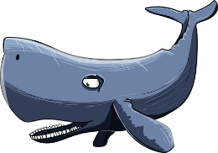
Bingo
Play bingo in your classroom using marine animal sounds! Make your own bingo boards and collect a range of marine animal sounds to play.
True or false?
Find out as much as you can about the marine species. Create a true or false quiz and test your classmates. Alternatively, create a word find or crossword.
Comic
Write and illustrate comic which tells the story of a marine animal and the sounds it makes.
3D Model
Create a model of the marine animal using recycled materials. Display your model in the classroom. Find a sound recording online to illustrate the sounds that the animal makes.

Activity: Who am I
Play this Who Am I guessing game with your students to get them thinking about marine animals and their classification properties. This game can be played with 2-6 players. To make the game write down the names of marine animals on individual pieces of card (about the size of playing cards). You will need pieces of elastic to make head bands for each player to put around the top of their head.

How to play the game:
- Place the cards face down on a table.
- Each player will choose 1 card and tuck it into their headband (No peeking. However, the other players can see yours).
- Take it in turns to guess what animal is written on your card. You can only ask ‘yes’ or ‘no’ questions. When asking questions players can use the classification properties or more specific properties, for example its colour, size, where it lives and how it moves, to help identify the animal.
- When you have enough specific information, you may try to guess the animal’s identity.
- The first player to guess their animal wins.
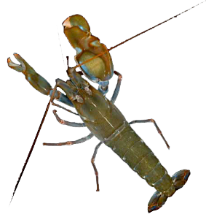
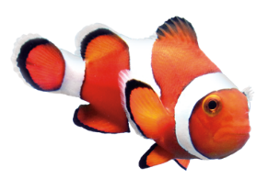
Clownfish
Smooth claw snapping shrimp

Sea Urchin

Activity: Scientific exploration
Get to know the biological sounds in your area
As a class, plan a visit to your local park or simply visit your school yard. Students will write a list of things they may need for the exploration, for example: pen and paper for taking notes, clipboard, and a device to record sound. Students will predict what they think they will hear during their exploration. Students will then respond to the following:
- Describe – describe what you hear in the environment. Record and describe as many biological sounds as you can hear. Can you see the animal? Do you notice any behaviours displayed by the animal? If you can’t hear any animals, what other sounds can you hear?
- Identify - can you identify the animal that belongs to the sound? Identify and classify what you found.
- Research - learn more about the species. Why do they make these sounds? Is it a native or introduced species?
- Share - report your findings to the class. Compare and contrast your findings. Create a library listing all the biological sounds your class detected.
- Citizen science - find a citizen science project where you can share what you’ve found in your local area. Here are some example citizen science projects: FrogID, Hoot Detective or Virtual Reef Diver.

Activity: Why do whales sing?
Whale songs are one of the most sophisticated communication systems in the animal kingdom.

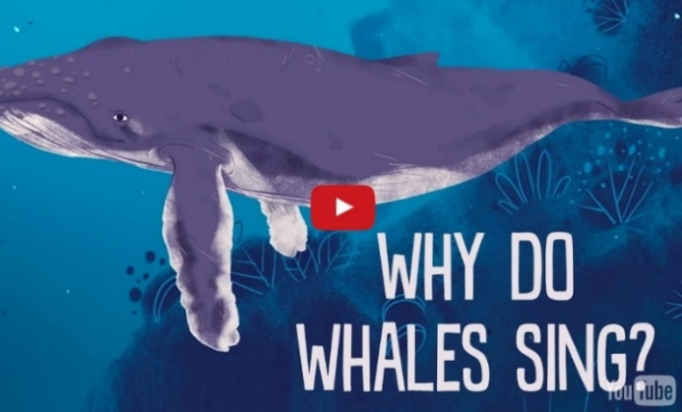
Students will watch this TedEd video Why do whales sing? to learn more and then answer the following questions.
- Which species of whale are known to sing?
- How long can whales sing for?
- Why do they sing?
- What impact can noise pollution have on whales?
- Write down three interesting facts you learnt watching the video.

Useful Websites
- Whales, Dolphins and Sound – Department of Agriculture, Water and Environment
- Audio Gallery Marine Mammals – University of Rhode Island
- Underwater Research – BTN
- Underwater Explorer – BTN
- Deep Sea Exploration – BTN
- Ocean Noise Pollution – BTN
- Regent Honeyeater Song – BTN
- Investigating Sound and Hearing – Victoria State Government
- Worlds’ first library of underwater biological sounds to monitor changing marine life – Australian Institute of Marine Science

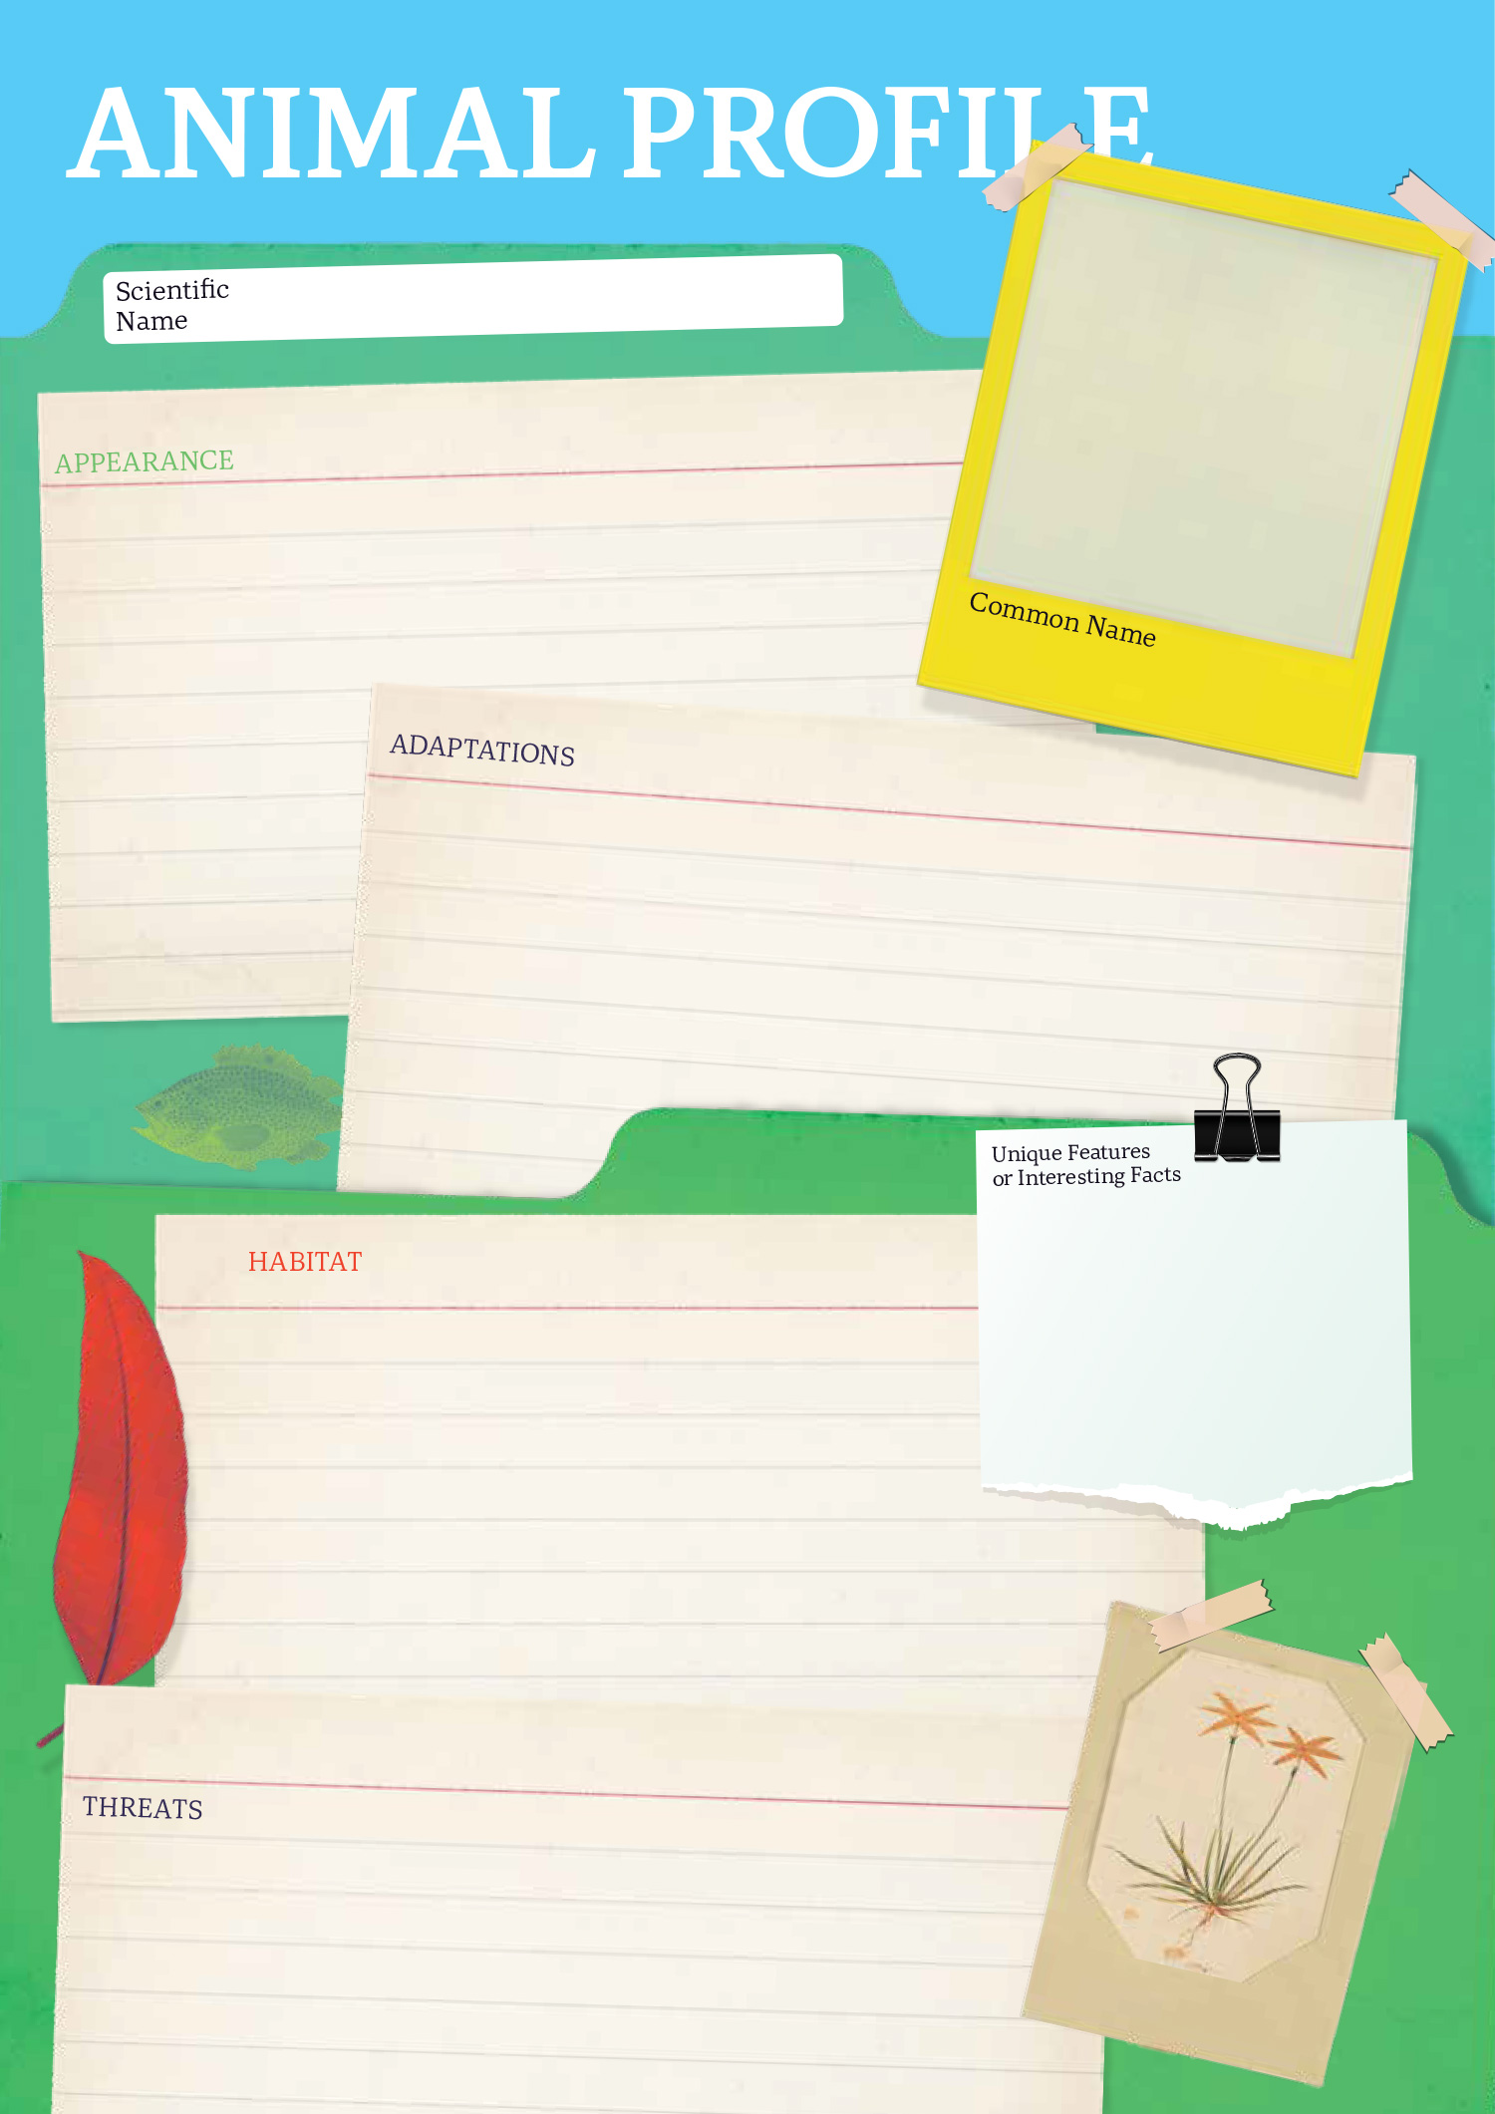

EPISODE 5
1st March 2022

KEY LEARNING
Students will examine how much waste they produce at school; the impact waste has on the environment and take action to reduce waste.

CURRICULUM
Geography – Year 4
The use and management of natural resources and waste, and the different views on how to do this sustainably.

HASS – Year 4
Reflect on learning to propose actions in response to an issue or challenge and consider possible effects of proposed actions.

Science – Year 4
Science knowledge helps people to understand the effect of their actions.

Science – Years 5 & 6
Scientific knowledge is used to solve problems and inform personal and community decisions.

  - Teacher Resource

Clean Up Australia Day

Focus Questions
Discuss the BTN story as a class and record the main points of the discussion. Students will then respond to the following:
- Briefly summarise the BTN story.
- Why has the pandemic made the waste problem worse?
- Explain the citizen science project Clean Up Australia are running.
- About how long does it take for a disposable mask to break down?
- What changes will you make to help reduce waste?

Activity: Note taking
Students will practise their note-taking skills while watching the BTN Clean Up Australia Day story. After watching the story, ask students to reflect on and organise the information into three categories. What information in the story was...?
- Positive
- Negative or
- Interesting

Activity: Class Discussion
Discuss the BTN story as a class. In small groups, ask students to brainstorm responses to the following questions:
- What impact does rubbish have on the environment? (Landfill, increased greenhouse emissions, waterways become polluted, animals become tangled in or mistakenly eat rubbish found in the ocean).
- Make a list of the types of waste created at your school, for example, paper, plastic, food scraps, e-waste, masks.
- Does your school have a recycling program?
- What questions do you have about the story?

Activity: Glossary
Students will brainstorm a list of key words that relate to the BTN Clean Up Australia Day story. Here are some words to get them started.

WASTE | LANDFILL | SINGLE USE
RECYCLE | CITIZEN SCIENCE | DISPOSE

Activity: Waste Hierarchy
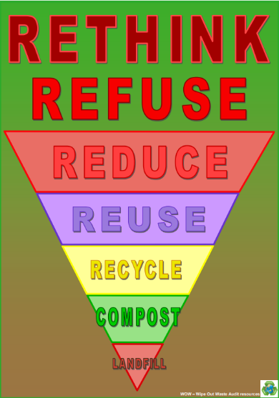
The waste hierarchy is a guide to help minimise waste. Discuss with students the different elements of the waste hierarchy and what they mean. Brainstorm a list of actions or practices that can be done for each element to reduce the amount of rubbish going to landfill.
Rethink – think about what you are buying and consuming
Refuse – say no to unnecessary things (packaging etc.)
Reduce – the amount of material that will go to landfill
Reuse – many items can be reused or upcycled
Recycle – choose items that can be recycled
Compost – organic waste can be put into green waste bins or home compost bins
Landfill – send as little waste as possible to landfill
Source: Wipe Out Waste
More information about the waste hierarchy can be found at the Wipe Out Waste website

Activity: Reduce Waste – Take Action
Discuss with students what their school already does to reduce waste. For example, their school might have recycling programs, rubbish audits or clean up days. Does their school have an Environmental Management Plan? In small groups, ask students to brainstorm how their school could improve what it already does to reduce waste.
- Make a list of new ways that your school could reduce the amount of waste it creates and new ways that you can deal with the waste it creates.
- Share and compare your ideas with the class.
- Choose 1 of your ideas to present to your SRC or the school leadership team.
Here are some suggestions:
- Hold a zero-waste day
- Hold your own school’s clean-up day
- Start a school compost or worm farm
- Audit rubbish created in one day
- Nude food days

Students will reflect on the activity and respond to the following:
- How can you reduce the amount of waste produced at your school?
- What did this challenge help you understand?

Further Investigations
- How can consumers be persuaded to make better buying and recycling decisions? Come up with a list of incentives that you think would make a difference.
- Investigate other initiatives that help reduce the amount of rubbish going to landfill. For example, banning plastic bags in supermarkets. What states/territories in Australia have already banned plastic bags in supermarkets? How does this initiative help the environment?

Activity: COVID Waste
Watch the BTN COVID Waste story and respond to the following questions:
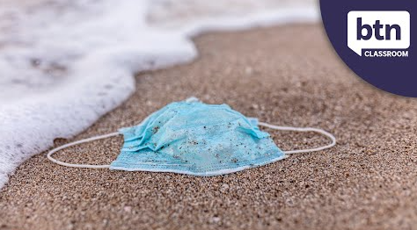
- What are some items that we can use to help protect ourselves from COVID?
- How many disposable masks are put into landfill around the world each month?
- How long does it take for plastic to break down?
- What parts of a rapid antigen test (RAT) can be recycled?
- What are some other ways we can reduce our waste?

Learn more about how to dispose of a mask properly
Help unmask Australia’s litter problem! Join Clean Up Australia’s citizen science project

Useful Websites
- Clean Up Australia – BTN
- Clean Up Australia tackling the scourge of face mask pollution through citizen science – ABC News
- COVID Waste – BTN
- Global face mask pollution jumped nearly 9,000 per cent due to COVID mandates, study finds – ABC News
- Schools Clean Up Day – BTN
- How to dispose of a mask properly – ABC News
- Wipe out Waste – KESAB

  - Teacher Resource

BTN Transcript: Episode 5 - 1/3/2022

Hey, I'm Amelia Moseley and you’re watching BTN. Thanks for joining us. Let’s see what’s coming up. We learn about Australia's plans for Antarctica, listen to the sounds of sea creatures and it's time to clean up the country. All that soon.

Russia Sanctions

Reporter: Jack Evans

INTRO: But first today to the biggest story in the news right now, Ukraine. For the past few days, you might've seen some pretty upsetting images on the news after Russia invaded the country. It's made people around the world sad and angry, and many countries have responded by bringing in sanctions. Jack found out what that means.
After months of tension and talks came the moment, many had feared.
REPORTER: Ukraine is under attack, explosions were heard across the country before sunrise.
VLADIMIR PUTIN, PRESIDENT OF RUSSIA: I have decided to conduct a special military operation.
Not long after this announcement Russian troops crossed the border into Ukraine and explosions were heard in cities around the country.
NEWSREADER: I tell you what, I just heard a big bang. There are big explosions taking place in Kiev right now.
PERSON 1: It's scary we didn't believe that this situation would come.
PERSON 2: Shattered, shattered, not for myself, I don't care about my own safety. I just care about Ukraine.
The Russian President, Vladimir Putin said the military operation was about protecting people in regions of Ukraine that he has chosen to recognise as independent. Lots of people in these regions speak Russian and have close cultural ties with Russia and these parts were already controlled by groups loyal to Russia. But most people in Ukraine and around the world saw this as an unprovoked attack and an invasion of a democratic country.
VOLODYMYR ZELENSKYY, PRESIDENT OF UKRAINE: What we have heard today are not just missile blasts, fighting and the rumbling of aircrafts. This is the sound of a new iron curtain which has come down and is closing Russia off from the civilised world.
Ukraine's president says the country will fight back. He's declared martial law, which means the military takes control over day to day running of the country and he's asked for anyone who knows how to fight to join the Ukrainian army. Meanwhile, leaders around the world spoke out against Russia.
SCOTT MORRISON, PRIME MINISTER OF AUSTRALIA: This invasion is unjustified, it's unwarranted, it's unprovoked and it's unacceptable.
BORIS JOHNSON, PRIME MINISTER OF UK: I'm driven to conclude that Putin was always determined to attack his neighbour no matter what we did.
JOE BIDEN, PRESIDENT OF US: Putin is the aggressor. Putin chose this war and now he and his country will bear the consequences.
But they said they won't send soldiers to Ukraine. Instead, they'll bring in sanctions.
BORIS JOHNSON, PRIME MINISTER OF UK: In concert with our Allies, we will agree a massive package of economic sanctions.
So, what is a sanction? Well, it's basically a way of punishing a country, a business or even an individual. Usually by taking away their ability to trade, travel or do business in other countries. As you probably know, most countries rely on being able to buy, sell and travel to and from each other and stopping that can have a big impact on their economies. The idea is that by hurting them economically, sanctions can change the country's behaviour without having to go to war.

So far, a whole bunch of countries including the US, Australia along with the UK and EU have brought in sanctions against Russia, which include blocking some trade and stopping some banks and some powerful Russian people, including Vladimir Putin himself, from doing business in other countries. Germany has decided to hold back on certifying a huge pipeline that was set to deliver Russia natural gas and leaders say there could be more sanctions to come.
JOE BIDEN, PRESIDENT OF US: We have purposely designed these sanctions to maximise a long term impact on Russia.
So, will it work? Well, there's a fair bit of debate about how effective sanctions are. Sometimes, in the past they've had unintended consequences and hurt ordinary people instead of leaders. But this time, many are hoping they'll put pressure on those at the top. Still, some say more needs to be done. Around the world there have been protests against the invasion, including in Russia where thousands of people have been arrested at anti-war demonstrations.
Meanwhile in Ukraine people are doing what they can to stay safe. Some are trying to leave the country or travel to areas where there's less fighting. Others have been sheltering underground in metro stations or wherever they can. Many countries, including Australia, have promised to take in refugees and send supplies while the world watches and hopes for an end to this terrible situation.

Ukrainian Australians

Rookie Reporters: Sofia and Andrew

INTRO: Of course, the situation in Ukraine is really worrying for a lot of people, but especially people who have friends and family over there, and that includes thousands of Australians. I spoke to some kids to find out more about Ukrainian culture and how they're coping with what's going on.

SOFIA: Hi BTN, my name is Sofia.
ANDREW: And my name is Andrew and we're going to tell you about Ukraine.
Ukraine is around many of other countries like Russia, Belarus, Poland, and some others. And in Ukraine, our grandparents they live in Lviv and Kamianka-Buzka. So, my mum and dad, they are Ukrainian. All our family is in Ukraine, and we were only born in London because our parents just moved and then we came to Australia and we've been living here for around two years, and we've just gotten a permanent residency in Australia.

Yeah, I'm actually really happy because we might soon buy a house.
I want to get a dog, but he wants to get a cat say, I don't know what my mom's gonna say about that.
It's very nice in Ukraine. There's lots of old building statues, museums, and there's a lot of good chocolate and cafes.
We also really like to go skiing when it's winter because there's lots and lots of snow.
The traditional clothing in Ukraine would be vyshyvanka, which are white shirts sometimes which are embroidered with different patterns. Yeah, we speak Ukrainian. We don't do it fluently. But we know a lot of words.

Yeah, so we have Ukrainian lessons. You say hi in Ukrainian ‘privit’. And things like yes, ‘tak’ and ‘cerkno’ near.

It's like a secret language for us because not many people in our school know it and we can just talk to each other and nobody will understand.
And there's also Ukrainian dancing.
Some Ukrainian dancing for boys would be Hopak, where they go like this in the run, they kick the legs up. In London, our family would always come to London, and we would always come to them. And now, unfortunately, we can't go back because it was in Ukraine.
My Granddad we speak to him like a half an hour ago and he said that he woke up because a bomb has fallen in three kilometres away from their house and the house started shaking. So now they're starting to pack up all the important things like their documents and stuff, and they're gonna leave to Poland.
Some family in Ukraine can't leave because they have a house, they have a dog, they have a car. We also have a great great grandmother, and she can't walk because she had a stroke. Our family's feeling a bit scared because they don't know what's going to happen. Makes me feel a bit sad and angry because we won't be able to go back and see all our family and everybody there.
I really do miss my grandparents and since of the war thing and COVID we don't know when we're actually going to come back and see them again.
We hope that all our grandparents and everybody who we know will be safe there, and that the war will clear up.
And we're hoping that peace gets a chance.

Now, if you're worried about what's happening in Ukraine or anything else in the news, make sure you talk to someone like a parent or a teacher about it. You can also head to our website to find tips on how to deal with upsetting news, so make sure you check that out.

Queensland Floods

Reporter: Leela Varghese

INTRO: Now we're heading to South East Queensland and Northern New South Wales which have been hit by really bad floods. They've damaged homes and businesses and forced hundreds of schools to close. Leela can fill you in.
The rain started last week, and it just kept coming. Over the weekend, Brisbane, Gympie and parts of the Sunshine Coast got around half their annual rainfall all at once.

SOPHIE: The last few days have been crazy with all the torrential rain.

LUCIELLA: It has been a bit scary at some points, especially on Sunday when it bucketed down.

ZALI: We had lots of water flowing through the property and we had a few water leaks in the house.

People have died in the floodwaters and homes, businesses and other buildings have been badly damaged. Thousands of people have had to evacuate. Those who can, have been told to stay home. In Brisbane, hundreds of schools were shut.

LUCIELLA: I was a bit sad when I heard that school got cancelled but at the same time, I was very happy because I got the day off.
The "rain bomb", as it's been called has been moving slowly south and people in New South Wales Northern Rivers region were also told to evacuate. In Lismore people attempted to escape the city's worst ever flood by sheltering on their rooves. Emergency services have been working hard to keep people safe and authorities are warning people to stay away from floodwaters as the wet weather continues.

Australian Antarctic

Reporter: Amelia Moseley

INTRO: Now to one of the most extreme places on our planet, Antarctica. The Aussie government is planning to spend hundreds of millions of dollars on Australia’s Antarctic Territory. Let’s find out about its plans and the treaty that protects the frozen continent.

AUSTRALIAN EXPLORER: Yes, this will do. Beautiful, pretty cold, dry and windy continent. I claim you for...
BRITISH EXPLORER: Uh hmm.
AMELIA, REPORTER: Who are you?
BRITISH EXPLORER: Well, I’m here to claim it.
AUSTRALIAN EXPLORER: Well, you can’t because I'm claiming it, right.
ARGENTINIAN EXPLORER: Ah, I actually claimed this place first.
AUSTRALIAN EXPLORER: What?
FRENCH EXPLORER: No, no, no, no, no, I claimed it first.
AUSTRALIAN EXPLORER: What do you mean?
NORWEGIAN EXPLORER: Hello.
AUSTRALIAN EXPLORER: Where did you come from?
NORWEGIAN EXPLORER: Norway.
AUSTRALIAN EXPLORER: No, that’s not what I, why are you where? Like I don’t understand. I was the one who here first. OK guys, OK everybody, just chill out.

FRENCH EXPLORER: Good one.
AUSTRALIAN EXPLORER: We can’t all claim Antarctica. Can we?
Well, in a way yes, they can and they kind of did. You see, for more than a hundred years, explorers from around the world have been, well, exploring this icy continent. But for a lot of that time, there were arguments about who owned what.
ARGENTINIAN EXPLORER: Oh yeah. We call that San Martin Land.
AUSTRALIAN EXPLORER: Well, the Americans call it Palmer Peninsula.
BRITISH EXPLORER: You guys, it’s literally called Graham's Land. You guys know Graham?

ARGENTINIAN EXPLORER: Who’s Graham?

AUSTRALIAN EXPLORER: I know a Graham.

BRITISH EXPLORER: You don’t know Graham?
In fact, things got a bit, um, heated down here for a while. There were war planes, war ships and a few international court cases, but eventually cool heads prevailed. And in 1959, 12 countries signed a treaty.
AUSTRALIAN EXPLORER: OK, so, we all agree, free use of all of Antarctica for science only, yep.

BRITISH EXPLORER: I like it.

AUSTRALIAN EXPLORER: And we all share the info.
BRITISH EXPLORER: Cool, um. But how do we feel about weapons testing and military stuff?
NORWEGIAN EXPLORER: I think it's a no?
AUSTRALIAN EXPLORER: Yeah, no.
Heaps of other countries have signed on since, but only a few claim parts of Antarctica as national territory. Although only a few countries actually recognise the claims. Australia actually claims the most about 42 per cent. We have permanent research stations, where scientists and engineers can stay and work and learn all sorts of things, like how climate change has affected the planet over hundreds of thousands of years. But now scientists are about to see a lot more activity down here.
SUSSAN LEY, ENVIRONMENT MINISTER: We'll have unmanned aerial vehicles, we'll have a fleet of drones, we'll have eyes on Antarctica.
The Aussie government's putting about 800 million dollars towards our country's presence in Antarctica. It says it'll help us explore more of the continent and protect it from any countries that might want to use it for anything other than science, like fishing or mining. Because while countries have been working together down here for years there are worries some of them wanna see the rules of the treaty relaxed.
SCOTT MORRISON, AUSTRALIAN PRIME MINISTER: They don't share the same objectives as Australia as a treaty nation when it comes to protecting Antarctica.
And some reckon Australia is trying to stake out its claim just in case the treaty ever fails. But most, including the people who work down here hope that doesn't happen, and Antarctica remains a peaceful place for cool scientific discoveries.
NORWEGIAN EXPLORER: Oh, I found a penguin egg, who wants some?

ARGENTINIAN EXPLORER: I think we agreed not eat those Norway.

AUSTRALIAN EXPLORER: Yeah, I don’t know if you should, hey no, no.

Underwater Sounds

Reporter: Amal Wehbe

INTRO: Now to another strange and amazing place, under water. You probably know there are some pretty wild creatures that live in lakes, rivers and oceans, but did you know they also make some pretty wild noises. Amal found out why researchers are trying to collect them to build a library of underwater sounds.
AQUALAD: Oh no. Aquaman we've got trouble.
AQUAMAN: Don't worry. I've got it. I'll get my sea pals to help.
AQUALAD: What are you doing?
AQUAMAN: Oh, sorry my paddle crab's a bit rusty.
Yeah, unlike Aquaman you might not think a lot about the sounds that are made by these guys. But marine scientists do.
AMAL: So, all these underwater animals, they make noises?
DR MILES PARSONS: Yes, yeah, um, there's quite a lot of animals that make noise. So, you've got animals like the bearded seal, they produce this what they call a spiralling trill. It sounds like it's come from a space TV program. It is so odd.
This is Dr Miles Parsons from the Australian Institute of Marine Science, and he says the oceans are full of weird and wacky sounds. A paddle crab for example sounds like this. This is a streaked gurnard. And a red piranha.
AMAL: What is your favourite fish out of curiosity?
DR MILES PARSONS: So, in terms of sounds my favourite fish is the mulloway. It's so loud. So, if you were to be right next to it, your chest would be in pain and your ears would hurt. It's very loud.
AMAL: If you had to try, what would a mulloway fish sound like?
DR MILES PARSONS: OK fine you're the only person I would do this for. It's a bahhh bah kind of sound.
Mile says they make sounds for all sorts of reasons. For example, attracting a mate or warding off predators and studying those noises can tell researchers a lot.
DR MILES PARSONS: So, you can use it to get an idea of the animals that are in a certain place, you can use it to monitor the migration paths of animals, like the whales.
Now Miles is leading a project to get all those aquatic sounds in to one spot.
DR MILES PARSONS: It's the Global Library of Underwater Biological Sounds, or as we've affectionately called it, GLUBS.
He says GLUBS will be a huge help to researchers.

DR MILES PARSONS: We're able to get a much better idea of how the soundscapes change in different places.

This will help scientists track the effects of things like climate change and identify species. Miles reckons there are a lot of fish sounds out there that we haven't identified. For example, have a listen to this mystery fish that he recorded.
DR MILES PARSONS: The call, I ended up calling it Machine Gun Hut of Baba Yaga.
That's a reference to this piece of music plus machine guns. Miles is hoping once the library's up and running ordinary people will be able to add their own recordings. And we'll all learn more about the mysterious, and melodious underwater world.
AMAL: So, I just feel like the kids would want me to ask you, if you are Aquaman, if you have his talents, because he can listen to fish.
DR MILES PARSONS: No, unfortunately, I'm not Aquaman. I'd love to be able to stay under water for so much longer.
Quiz

Can you guess which sea creature is making this noise? It's this one, the Bocon toadfish.

Sport

Liverpool have won the English Football League Cup after a tense penalty shoot-out. The game finished in a nil-all draw, and it took 21 penalty kicks to decide the winner. This is Liverpool’s 9th EFL Cup win, the most in history.
How's this for your first game ever. Paramatta's Maddie Studdon slotted this field goal in the last 30 seconds of their game against Newcastle in round 1 of the NRLW. It was actually a debut game for both teams who are new to the NRLW this year.
Finally, it was a history making weekend in the AFLW. Carlton Superstar Darcy Vescio became the first AFLW player to kick 50 career goals. Meanwhile, Brisbane booted the highest AFLW score ever smashing the West Coast 98 to 24.

Clean Up Australia Day

Reporter: Amal Wehbe

INTRO: This week a lot of you will be getting out into the playground, into parks and out on the street to pick up rubbish. That's because it's Clean Up Australia Day and organisers say this year's event will be more important than ever. Amal found out why.
AMAL: So, guys. How's your day been today?
KID 1: Rubbish.
KID 2: Full of rubbish.
AMAL: Oh, sorry to hear that.
KID 1: No, we pick up rubbish for Clean Up Australia Day.
AMAL: Oh, that makes way more sense.
Yep, it's that time of year when people around the country slip on their gloves and grab some garbage. Clean Up Australia Day was started back in 1989 by a man named Ian Kiernan who was out sailing and noticed a lot of pollution. He decided the Sydney Harbour needed a serious clean up and asked locals to help out.
IAN KIERNAN: Sydney Harbor belongs to the people; we want to lift the public awareness.
There was even a groovy song to promote it. From there, it's grown to be a national, annual event. And schools play a big role, with their own Schools Clean Up Day.
MOATH: Clean up Australia Day is a day where you take care of the environment from all the rubbish, so less rubbish goes to the sea.
ZIRAM: I like to pick up rubbish because it's safe for the environment and it helps the sea animals and land animals.
NOUR: It's important to pick up rubbish so then nothing bad happens to the world, so then it stays healthy.
This year, organisers are also asking volunteers to unmask effects of a relatively new type of rubbish.
AMAL: Masks.
NOUR: Sometimes I find them around the street or the park and mostly at the beach.
AMIRAH: 30,000 masks are used in this very school every month.
Ever since the pandemic started, well there's been a lot of mask action. And while they're great at keeping people safe. It makes for heaps of waste which isn't great.
PIP KIERNAN: It takes up to 450 years for them to break down, so they really don't belong in the environment.
That's Pip Kiernan, Ian's daughter and the Clean Up Australia chair. This year she wants people to become citizen scientists and count the masks they pick up as they go about their clean-up.
PIP KIERNAN: The next generation of these PPE products, really could be vastly improved on in terms of being designed not only to keep us as safe as possible but also to be designed so that they have the environment in mind.
And it's not just masks. Pip says the pandemic has led to a big increase in all sorts of rubbish.
PIP KIERNAN: Unfortunately, with COVID habits did change. And these weren't kind for the environment. So, we've used a lot more single use items, sanitised wipes, single-use face masks, take away food packaging cause we're not eating in restaurants. And in fact, it's 130,000 tonnes of plastic waste gets into the marine environment every year in Australia. That's a lot of litter.
That's why Clean Up Australia says as well as cleaning up all this waste, the best thing we can do is try make less of it in the first place.
AMIRAH: We can stop using plastic covered food and we can use nude foods.
LANSANA: We can make things out of not plastic but different materials.

Closer

Awesome work. Well, that's all we have for you today, but we'll be back before you know it and if you miss us in the meantime, you can jump online to check out more stories and quizzes and tell your teachers to check out our resources as well. Oh, and don't forget, Newsbreak is here every weeknight with all the latest news to keep you up to date. Stay safe everyone and I'll see you next week. Bye.

