EPISODE 9
29th March 2022

KEY LEARNING
Students will view a range of BTN stories and use comprehension skills to respond to a series of focus questions.

CURRICULUM
English – Year 4
Use comprehension strategies to build literal and inferred meaning to expand content knowledge, integrating and linking ideas and analysing and evaluating texts.

English – Year 5
Use comprehension strategies to analyse information, integrating and linking ideas from a variety of print and digital sources.

English – Year 6
Use comprehension strategies to interpret and analyse information and ideas, comparing content from a variety of textual sources including media and digital texts.

English – Year 7
Use comprehension strategies to interpret, analyse and synthesise ideas and information, critiquing ideas and issues from a variety of textual sources.
  - Teacher Resource

Focus Questions
As a class, discuss the stories featured in the episode of BTN Classroom and record the main points of the discussion. Students will then respond to the following focus questions.

Russia Media Freedom
- In your own words, explain what media freedom is.
- What is happening to the media in Russia right now?
- Which social media platforms have been banned in Russia?
- What impact is the lack of press freedom having on Russian people?
- What questions do you have after watching the story?

Coral Bleaching
- Elijah is the youngest ambassador for which citizen science program?
- What is coral bleaching?
- Coral gets its colour from…
  - Algae
  - Polyps
  - Minerals in the water
- What happens to coral when the water temperature rises?
- Why is it important to protect the Great Barrier Reef?

Check out the teacher resource on the Teachers page.

Women’s History Month: Evonne Goolagong Cawley
- Describe Evonne’s life growing up.
- How old was Evonne when she got her first tennis racquet?
- What was Evonne’s nickname?
- Which famous Aussie tennis star did she inspire?
- Think of a question you would like to ask Evonne Goolagong Cawley.

Daylight Saving
- When daylight saving begins, clocks move forward one hour. True or false?
- The US Senate just agreed to
  - Get rid of daylight saving
  - Making it daylight saving all the time
- What is the name of the US federal law?
- What are the pros and cons of daylight saving?
- Would you like to see daylight saving all of the time? Give reasons for your answer.

Goldilocks Bird
- Why is the plains-wanderer bird nicknamed Goldilocks?
- What has happened to the natural habitat of the plains-wanderer?
- About how many plains-wanderers are there left in the wild?
- What is being done to protect the species?
- Name three facts you learnt watching this story.

Check out the teacher resource on the Teachers page.

EPISODE 9
29th March 2022

KEY LEARNING
Students will learn more about the structural features of corals and the threats to coral reefs.

CURRICULUM
Science – Year 4
Living things depend on each other and the environment to survive.

Living things have life cycles.

Science knowledge helps people to understand the effect of their actions.

Science – Year 5
Living things have structural features and adaptations that help them to survive in their environment.

Scientific knowledge is used to solve problems and inform personal and community decisions.

Science – Year 6
The growth and survival of living things are affected by physical conditions of their environment.
Science – Year 7
Interactions between organisms, including the effects of human activities can be represented by food chains and food webs.

  - Teacher Resource

Coral Bleaching

Focus Questions
Discuss the BTN story as a class and record the main points of the discussion. Students will then respond to the following:
- Elijah is the youngest ambassador for which citizen science program?
- What is coral bleaching?
- Coral gets its colour from…
  - Algae
  - Polyps
  - Minerals in the water
- What happens to coral when the water temperature rises?
- Why is it important to protect the Great Barrier Reef?

Activity: Note taking
Students will practise their note-taking skills while watching the BTN Coral Bleaching story. After watching the story, ask students to reflect on and organise the information into three categories. What information in the story was...?
- Positive
- Negative or
- Interesting

Activity: Class Discussion
After watching the BTN Coral Bleaching story, hold a class discussion using the following discussion starters.
- What do you know about coral?
- Why are coral reefs important?
- What are some threats to coral?
- What can be done to protect coral reefs?
- Discuss the importance of the Great Barrier Reef.

Activity: Glossary
Students will brainstorm a list of key words that relate to the BTN Coral Bleaching story. Here are some words to get them started.

CORAL | ALGAE | CORAL BLEACHING
POLYP | CLIMATE CHANGE | ECOSYSTEM

Activity: Coral Reef Research
The KWLH organiser provides students with a framework to explore their knowledge on the topic of coral reefs and consider what they would like to know and learn.

What do I know? | What do I want to know? | What have I learnt? | How will I find out?

Questions to research
Students will develop their own question/s to research about coral reefs. Students will collect and record information from a wide variety of sources. Students may develop their own question for inquiry or select one of the questions below.

- What are some of the main threats to the survival of coral reefs? What are some natural threats to coral reefs? What is the human impact on coral reefs?
- What is coral bleaching? What impact is it having on the Great Barrier Reef?
- Coral has a symbiotic relationship with zooxanthellae (algae). What is a symbiotic relationship? What other examples of symbiotic relationships are there on the Great Barrier Reef? Explain the symbiotic relationship including the importance of the relationship to the Great Barrier Reef.
- Why are coral reefs called the `tropical rainforests of the sea’?
- Explore previous mass bleaching events on the Great Barrier Reef. How much of the Reef was affected? What impact did it have?
- Who do you think should be responsible for looking after the health of the Great Barrier Reef?
- What might happen if we don’t look after coral reefs? What would they look like in 30 years’ time? Make some predictions.

Activity: Investigating Coral
Students will investigate coral and create a fact sheet. The following questions can help guide students’ research:
- What do you know about coral?
- What are coral polyps?
- How are coral reefs formed?
Did you know that coral polyps are closely related to jellyfish?
- What are the two main types of corals?
- What gives coral its colour?
- What does coral feed on?
- What is a coral spawning event and how often do they happen?
- What are some threats to coral?
- What is coral bleaching?
- Can you think of three reasons why coral reefs are important? Who or what depends on coral reefs?
- Unique facts about coral

These videos will help students understand more about coral.
BTN Coral Spawning story
BTN Reef Bleaching story
What is coral bleaching?

Activity: Reef Citizen Science
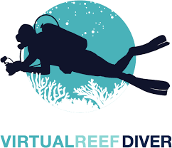
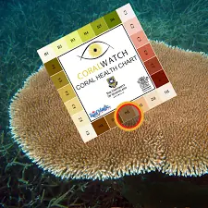

Become a CoralWatch citizen scientist Find out more
Save reefs from home Find out more

The Virtual Reef Diver project allows students to become citizen scientists, classifying underwater images of coral.

Activity: Coral Reef Quiz
- What type of coral is this?  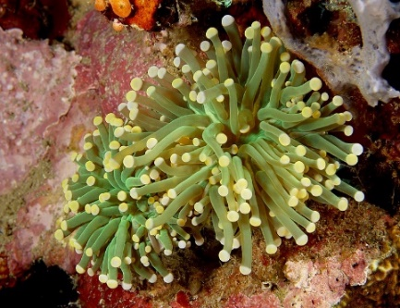  A. Soft coral  B. Hard coral  - What is this?  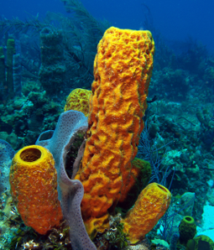  A. Sea cucumber  B. Sea sponge  C. Hard coral  - Can you name this organism?  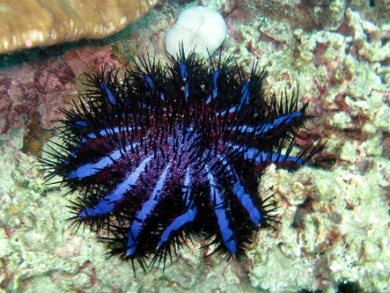  A. Sea urchin  B. Sea anemone  C. Crown-of-thorns starfish | - These are Red Sea Fingers. What type of organism is it?  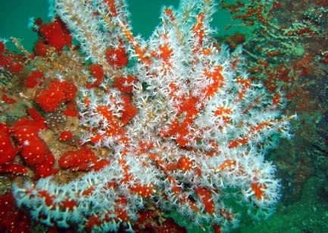  C. Sea anemone  B. Soft coral  A. Seagrass  - What is this a close up of?  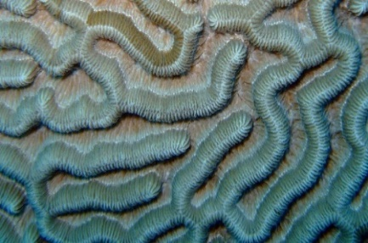  A. Deep sea worms  C. The surface of the sea floor  B. Hard coral  - What is this a picture of?  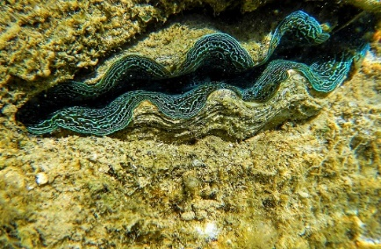  A. Giant clam  B. Sea sponge  C. Hard coral
Quiz answers
- B Source of image
- B Source of image
- C Source of image
- B Source of image
- B Source of image
- A Source of image

Useful Websites
- CoralWatch – University of Queensland
- Coral Bleaching – Great Barrier Reef Foundation
- Corals – Great Barrier Reef Marine Park Authority
- Great Barrier Reef – Australian Museum
- Great Barrier Reef: New coral bleaching detected in Australia – Newsround
- Great Barrier Reef facing another severe bleaching event ahead of UN delegation visit – ABC News
- Reef Bleaching – BTN
- Coral Bleaching – BTN
- UNESCO Great Barrier Reef – BTN

EPISODE 9
29th March 2022

KEY LEARNING
Students will develop a deeper understanding of the issues facing endangered bird populations in Australia.

CURRICULUM
Science – Year 4
Living things have life cycles.

Living things depend on each other and the environment to survive.

Science – Year 5
Living things have structural features and adaptations that help them to survive in their environment.

Science – Year 6
The growth and survival of living things are affected by physical conditions of their environment.

Science – Year 7
Classification helps organise the diverse group of organisms.

  - Teacher Resource

Goldilocks Birds

Focus Questions
Discuss the BTN story as a class and record the main points of the discussion. Students will then respond to the following:
- Why is the plains-wanderer bird nicknamed Goldilocks?
- What has happened to the natural habitat of the plains-wanderer?
- About how many plains-wanderers are there left in the wild?
- What is being done to protect the species?
- Name three facts you learnt watching this story.

Activity: Note taking
Students will practise their note-taking skills while watching the BTN Goldilocks Birds story. After watching the story, ask students to reflect on and organise the information into three categories. What information in the story was...?
- Positive
- Negative or
- Interesting

Activity: Class Discussion
Discuss the BTN story as a class. Create a class mind map with BIRDS in the middle. Ask students to record what they know about Australian birds. What questions do they have? In small groups, ask students to brainstorm responses to the following questions:
- What do you know about the plains-wanderer?
- Why is it important to protect native bird species?
- What is the conservation status of plains-wanderer birds?

Activity: Glossary
Students will brainstorm a list of key words that relate to the BTN Goldilocks Birds story. Here are some words to get them started.

ECOSYSTEM | CRITICALLY ENDANGERED | POPULATION
NATIVE SPECIES | CONSERVATION | HABITAT

Activity: Inquiry Research
The KWLH organiser provides students with a framework to explore their knowledge on the topic of endangered birds and consider what they would like to know and learn.

What do I know? | What do I want to know? | What have I learnt? | How will I find out?

Questions to research
Students will collect and record information from a wide variety of sources. Students may develop their own question for inquiry or select one of the questions below.
- Where do plains-wanderer birds live in the wild? Explore their habitat and mark where they live on a map.
- How can you identify the plains-wanderer bird? Explore its features and write a detailed description.
- What features does the plains-wanderer bird have to help it to adapt and survive in the wild?
- What does a plains-wanderer’s habitat look like? Study the habitat of the plains-wanderer and create a diorama of its habitat.
- Why is the plains-wanderer endangered? Investigate what is causing species loss of the plains-wanderer bird. Explore issues such as habitat loss, introduced species, pollution and disease. Which of these factors are caused by humans?
- What do you think could be done to help protect the habitats of Australia’s native birds?
- Who do you think should be responsible for addressing the problem of species loss? List some of the responsibilities of individuals, communities and the government.
- What might happen if we don’t look after Australia’s native birds? What would native bird populations look like in 30 years’ time? Make some predictions. Imagine that the plains-wanderer bird has tragically become extinct and then write a news article telling people why they have become extinct.

Activity: Habitat
This literacy activity demonstrates students active listening and interpreting skills. Students will listen to a description of a plains-wanderer bird habitat and create a simple black and white artwork illustrating its habitat. Teachers will use the following as a guide for this activity.
- Find a description of a plains-wanderer bird habitat to read aloud to your students. Alternatively, choose another Australian native animal that is a vulnerable or endangered species. Visit the Australian Museum to explore a range of Australian animal habitats.
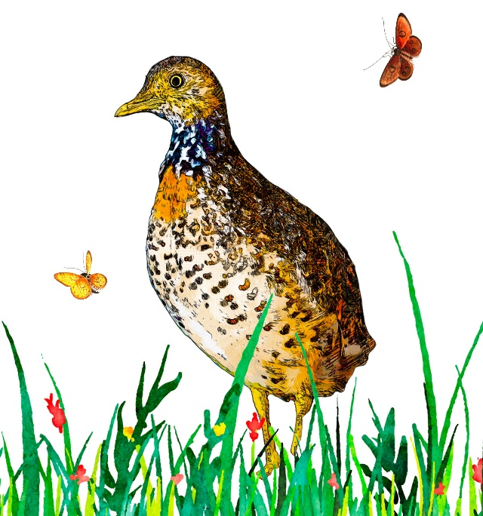
- Read the description of the plains-wanderer bird’s habitat aloud to your class, reading the description 2 or 3 times.
- Students will take notes and write down key words as they listen.
- Students will illustrate the habitat using only a black felt—tip pen (0.4 or 0.6) on a piece of A4 art paper. Students will include as much detail as they can.
- Display the student’s artwork in a school exhibition.
- We would love to see your students’ artwork! Send your artwork to us at btn@abc.net.au
- Challenge students by asking them to recreate the habitat as a diorama.

Activity: Biodiversity
Improve the biodiversity in your local environment
Students will work together to help and introduce a native animal species into their school yard. Ask them to consider the following:
- What kind of animals could you reintroduce into your school yard? E.g., birds, bees, butterflies. Research the animals native to your local area. Contact a ranger at a park near your school or the local council to learn more about the local animal species.
- Do you have the right type of habitat in your school yard for them to survive? Describe the climate and identify the plants in your school yard.
- What are some threats to the species that are caused by humans? How can you reduce these threats in your school yard?
- What materials and tools will you need to build the habitat? Consider writing a guide or procedure manual explaining how to build the new habitat.
- Build the habitat as a class and present the habitat to your school community. Teach students in other classes about the new habitat and involve them in caring for the new habitat.
- Prepare a map of the habitat which highlights key features. Include information labels in the habitat (for example, QR codes next to plants) for other students to learn more about the habitat and the biodiversity of your school yard. Include scientific information about the species. Include botanical names of any plants which are part of the habitat, when it was planted and some basic information.

Activity: Choose a project
Individually or in small groups, students will choose one of the following projects to work on and then present their findings to the class.

Reporter for a day
Investigate the issues highlighted in the BTN Goldilocks Birds story and write a newspaper article or online news report for kids.
Children’s Book
Write and illustrate a children’s book or comic which tells the story of the Goldilocks bird.
3D Model
Create a model of an endangered bird using recycled materials. Display your model in the classroom. Find a sound recording online to illustrate the sound that the animal makes.
Campaign
Design a public education campaign to raise awareness about plains-wanderer birds. Think about your campaign’s aim, your target audience, and the value of raising awareness. Create a poster in Canva.

Useful Websites
- NSW critically endangered plains-wanderers released after successful breeding program – ABC News
- Plains-wanderer Profile – Office of Environment & Heritage
- Regent Honeyeater Song – BTN
- Threatened and Endangered Species – BTN
- Plains-wanderer – Zoos Victoria

  - Teacher Resource

BTN Transcript: Episode 9 - 29/3/2022

Hey, I'm Amelia Moseley and you're watching BTN. Thanks for hanging out with us again. Let’s see what’s coming up on today’s show. More bad news for the Great Barrier Reef, an Aussie sports legend announces her retirement and is the US about to ditch daylight saving?

Russia Media Freedom

Reporter: Nat Kelly

INTRO: But first today we're going to talk about freedom of the press. Right now, that’s a big issue in Russia where laws have been brought in restricting what journalists can a can’t say about the war in Ukraine. Nat found out what press freedom is and why not having it is a big deal.

Imagine if all the news you got was controlled by the people in charge.
SHANIA: This article says you're very intelligent Mr Mayor, and good looking, and well, great.
NAT: Oh, how kind, I love it, I love it. The newspapers, they love me, they love me.
SHANIA: Now, this other post does have a bit of criticism in it about you spending all that money on that giant statue of yourself.
NAT: No. I love my giant statue of myself. Oh, beautiful. Phone the editor. Complain. No more criticism about my statue.

SHANIA: Good.
Luckily, that's not the case here in Australia.
REPORTER: Prime Minister Scott Morrison has attempted to downplay brutal personal criticism.
REPORTER: We're not seeking to be disrespectful.
ANTHONY ALBANESE, OPPOSITION LEADER: Yes, you are.
Our media is pretty free to report the news, even if that means criticising our leaders. And many say that's really important, so these people try hard to do the right thing, and we know who we want to vote for. But in some countries, what people watch, read and download is strictly controlled. And one place where the media just got a whole lot less free is here in Russia.
Earlier this month, Russia's president Vladimir Putin approved a new law that made it illegal for anyone to publicly oppose the government. Or their war in Ukraine. Or even calling it a war, for that matter. Doing that could land you 15 years in jail. He says it's in response to "lies" by the foreign media.
VLADIMIR PUTIN, RUSSIAN PRESIDENT: Access to information is being restricted, people are fed a huge number of fakes, propaganda, and manipulation.
In response, a lot of news programs, especially independent ones, have decided to close down or even leave the country. The ones that have stayed open have had to tread carefully, and censor what they say. Although the laws didn't stop this news producer, who protested on air during one of Russia's most watched news programs. She held up a sign which said: "No war. Stop the war. Don't believe propaganda. They are lying to you here".

Now, I know what you might be thinking.
SHANIA: Don't most people get their news from the internet these days?
NAT: Ah yes. The internet. Oh no the internet no, no, no. Delete it. Shut it down. Shut it down.
SHANIA: Can we do that?
While cancelling the internet is not easy, Monash University's IP Observatory, which studies internet traffic, found that the night before the invasion of Ukraine, Russia's government deliberately slowed down internet speeds to slow down any news coming through that they didn't like. And just last week, Russia banned Facebook and Instagram because they say its parent company Meta is an extremist organisation.
That was in response to a change Meta made to its hate speech policy, which allowed people to post messages calling for violence against Russian invaders. That was controversial, and not just in Russia, but it made the government there quite angry. So, the big question is, what sort of effect is this lack of press freedom having on Russian people?
Well, a lot of older people in particular who tend to rely on traditional media like TV and radio don't have much of an idea about what's going on in Ukraine at the moment, and most of them don't think Putin's done anything wrong. But the changes have definitely been noticed. There have been some protests with people risking arrest to speak out against the war and others deciding to leave Russia altogether.
ZHANNA AGALAKOVA, RUSSIAN JOURNALIST: I left Channel One precisely because the war started.
Some Russian journalists have stayed to work, even though they oppose the war. They say eventually the truth will "seep through". And they're hoping that one day their country will be free to report on anything, regardless of if the government likes it or not.

News Quiz

This is Josh Frydenberg, a federal politician with a very important job. Do you know what it is? Is he the Defence Minister, the Treasurer or the Deputy Prime Minister? He’s the Treasurer and this week he has the very, very important job of handing down the national budget. That’s the document that outlines how the government is planning to spend taxpayers’ money and with an election just around the corner, he’ll be hoping a lot of people like it.

Things got weirdly warm at the planet’s poles last week with record temperatures recorded in both the Arctic and Antarctica. Can you guess what temperature was recorded at Concordia station in Antarctica? Was it 20 degrees, 11.8 degrees, -11.8 degrees or -20 degrees? It was minus 11.8 degrees, believe it or not that’s 40 degrees hotter than average for this time of year.

Do you know the nickname of this little Golden statue? It’s Oscar, otherwise known as an Academy Award and on Monday a whole bunch of them were handed out in Hollywood but the moment that got everyone talking was when Best Actor winner Will Smith assaulted presenter Chris Rock on stage after he made a bit of mean joke about Will’s wife.

Coral Bleaching

Reporter: Amal Wehbe

INTRO: Now to some not-so-great news about the Great Barrier Reef. Recently the group that manages the marine park said it'd found signs of mass coral bleaching. Amal found out what that is and caught up with a kid on a mission to protect the reef.

Like a lot of people, Elijah is a pretty big fan of the Great Barrier Reef.
ELIJAH: It's home to so many amazing creatures, and all those creatures depend on it.
In fact, he's an ambassador, correction, he's the youngest ambassador for CoralWatch. Which is a citizen science program run by the University of Queensland, where volunteers help to observe our reefs and look out for signs of coral bleaching.
ELIJAH: So mainly looking for colours. If it’s lighter and whiter, that means it’s less healthy the coral and the darker it is, the more healthy.
Coral bleaching has been a big problem for the reef for a while now. You see coral gets its vibrant array of colours from algae that lives inside of it. That algae also helps feed the coral and gives it most of the energy it needs to survive. When the water heats up and stays warm for too long the coral gets stressed and ejects the algae. The coral then loses its colour and starts to turn white. If the temperature of the water cools down the algae can attach itself again. But if the water stays warm for too long and the coral stays bleached it can die.
Here at the Great Barrier Reef mass bleaching first started happening in 1998, then in 2002, 2016 and 2017, and then again in 2020. Now a report from the Climate Council says it might happen again this year. Reef observers say they've already found patches of the reef that have lost some of their colour and other parts that are completely white.
Experts reckon that's a big concern especially because we're in a la Nina year, which means ocean temperatures should be cooler. And they're worried that when the hot weather comes back, it could be catastrophic. They say that the biggest contributing factor of coral bleaching is climate change, which is causing marine heat waves - that's where heat is absorbed by the ocean.
DR. JODIE RUMMER, JAMES COOK UNIVERSITY: It's really, really in important for us to be addressing the frequency and severity that we're experiencing these marine heat waves now because not only is it threatening the survival of the Great Barrier Reef, but natural ecosystems Australia wide and worldwide.
This bad news came just as a UN delegation was on its way to assess the health of the reef. You might remember that last year UNESCO was ready to change its world heritage status to in danger, but the government convinced them to hold off so observers could see it for themselves. Australia's environment minister has promised to invest a billion dollars into saving the reef. But many say more needs to be done to tackle climate change before we lose this iconic reef for ever.
ELIJAH: The reef needs help now and not later because if we carry on doing what we’re doing there is going to be a point where we get to then we can’t turn back and so I really want to try and help the reef now otherwise it’s going to be past that point where we can’t help it and theirs is nothing we can do.

Ash Barty Retires

Reporter: Gladys Serugga

Now to some news that rocked the sporting world last week. World number one Ash Barty announced her retirement. The 25-year-old says she wants to take some time out to pursue other dreams outside of tennis. Here's Gladys to tell you more.

Whether it's on the stage at Wimbledon or at her local courts, Ash Barty has inspired a whole generation of tennis players.
YOUNG TENNIS PLAYER: I wanna be just like Ash Barty and win it for Australia.
Ash has been playing tennis since the age of five. She was number two in the world as a junior but took a break from tennis when she was sixteen and moved over to professional cricket for a year. Oh and did you know she's a really good golfer too. But it's here on the tennis courts that she became an international superstar and a national hero. In 2019, Barty became the first Australian since 1973 to win the women's French Open singles and that same year she became the first Aussie since Evonne Goolagong Cawley to reach world number one.
Despite COVID interrupting things, she followed that up with another two grand slams. In 2021, she won Wimbledon, then earlier this year she became the first Australian in more than 40 years to win the Australian Open. Which is why this announcement shocked the world.
ASH BARTY: I'll be retiring from tennis and it's the first time I've actually said it out loud and yeah it's hard to say.
The Aussie champion took to Instagram to share the news, chatting with her former doubles partner and good friend Casey Dellacqua.
ASH BARTY: I'm so grateful to everything that tennis has given me, all of my dreams plus more.
It's pretty unusual for someone to retire so young and while they're still at the top of their game but Barty says it's time to pursue other dreams.
ASH BARTY: I just know that I am absolutely, I am spent and physically I have nothing more to give. And that for me is success.
Of course, Barty will be hugely missed and last week, tennis stars took to Twitter to congratulate her on her amazing career. While she won't be playing professional tennis, Ash is still keen to share her skills with other young Aussies. We don't know what she'll be getting up to next, but we do know that Ash Barty will leave a huge mark on the sporting world.
ASH BARTY: Now I think it's important that I get to enjoy the next phase of my life as Ash Barty the person not Ash Barty the athlete.
Women’s History Month: Evonne Goolagong Cawley

Rookie Reporter: Shelby

Meet Evonne Goolagong-Cawley. She's a Wiradjuri woman who was born in 1951 in the tiny New South Wales town of Barellan.
When she was a kid, Evonne was good at everything. Running, swimming, cricket you name it. But the game she really loved was tennis. When she was little, she would hit a ball against a water tank with a paddle made from a wooden fruit box and at the age of nine she got her first tennis racquet and started practising at the local courts. Evonne says she read a story in a magazine back then. It was about a girl who loved tennis just like her. The girl practised a lot and one day made it to a place called Wimbledon to play on the magical centre court. Evonne didn't know it was a real place but every time she hit the ball, she'd imagine she was there.
People travelled from all over to watch Evonne play and when she was 14, she moved to Sydney to play for one of the best tennis coaches in Australia. Pretty soon she was off to England to play at Wimbledon in real life. At 19 she found herself face to face with her idol and fellow Aussie Margaret Court in the Wimbledon final. But she wasn't nervous, she just said it was a lot of fun. She won and the English newspapers nicknamed her the Sunshine Super Girl.

Back in Australia, she was named Australian of the Year the first Indigenous woman to win the award. Evonne went on to win 7 Grand Slam titles and managed to win Wimbledon again, just before she retired. People say Evonne played a bit like a ballet dancer, smooth, graceful and effortlessly skilled. Now Evonne runs a foundation to help Indigenous boys and girls achieve their dreams, not just in tennis, but in other parts of life as well. And she's even found time to inspire another one of today's tennis star. Yep, Ash Barty's hero growing up was Evonne Goolagong Cawley, the Sunshine Super Girl and one of the greatest tennis players of all time.

That brings us to the end of Women’s History Month but if you missed any of our profiles or if you want to watch them again, you can check them out on our website.

Daylight Saving

Reporter: Amelia Moseley

INTRO: Now to Daylight Saving. Depending on which state or territory you live in, you might find yourself going back in time by one hour on Sunday. Lots of countries change their clocks to get the most out of that summer sunlight. But one very big country is thinking of making it daylight saving time all the time. So, let’s head to the US to find out more.
AMELIA: Ok hi folks, hi folks. Thank you so much for being here. So I’m sorry but the President couldn't be here. Had other things on.
NAT: Classic.
AMELIA: Yeah I know right. But this is a really important meeting, and it is, of course, top secret. As usual! But this could affect literally hundreds of millions of American lives. Ok, so we need to talk about whether or not we are going to be saving, daylight. Ok?

AMAL: What?
NAT: Sorry, what does that mean?
AMAL: What happened to it?
AMELIA: Why are you not understanding me right now? Oh sorry, no this says daylight saving! Like the clocks!
NAT: Oh, of course. I know what daylight saving is.
AMAL: Yeah, I have a clock.
AMELIA: Yeah. So, thoughts?
Yes, saving daylight, I mean umm Daylight Saving really has been an important topic of discussion lately for the US government!
You see, turning your clocks forward one hour to get more sunny time in summer and back again before winter isn't just a thing that happens in these parts of Australia! About a third of the world does it too including most of the US!
But while some people quite like the extra daylight to enjoy a warm night at the beach or another round of golf or whatever, not everyone, everywhere, is a fan!
AMELIA: A lot of places have given it up over the years or made plans to like the EU!
AMAL: But like why don't they like it?
Well, OK I brought in some like "regular" people to tell us what they think!
"HEALTH EXPERT": It affects our sleep patterns, and some studies show can be really bad for our health.
"FARMER": Y'all I'm worried about my livestock! My cows freak out if they get milked at different times!
"PERSON WHO LIVES IN HOT CLIMATE": It's too hot where I live already. I can't do with more sunshine! I can’t.
"PERSON WHO LIKES DARKNESS": I hate the sunshine I prefer to live in darkness. I there should be never daylight EVER!
AMELIA Wait, who are you?
"PERSON WHO LIKES DARKNESS": Hiss.
AMELIA: Right, so some people also say it's just inconvenient.
MARCO RUBIO, US SENATOR: Switching in and out of daylight saving time is outdated and it's only a source of annoyance and confusion. Frankly it's just dumb and there's no other way to say it.
That's one of the senators who's been pushing for a US federal law to end all the clock changing by making it daylight saving time all the time! Did I mention it's a federal law called…
NAT: The Sunshine Protection Act?
AMELIA: Yes! I love it. That’s perfect, I’, writing it down, I’m writing it down.
AMAL: Can I put this on my Twitter?
Seriously. Everyone in the US senate just agreed to pass the Sunshine Protection Act, but it'll have to also pass the House of Representatives and the President himself before it becomes law.
So, you might be wondering, could daylight saving ever be changed in Australia? Well, this debate pops up pretty often, you know for all those reasons we saw before. But whether you love it, or you hate it, or you just don't do it. It seems like this time honoured tradition isn't going anywhere quickly, at least in our country!
AMELIA: OK, let's wrap this up for now.
"PERSON WHO LIKES DARKNESS": But think about it, has daylight ever saved you?
NAT: He's got a point.

AMELIA: Let’s just leave.
AMAL: I think we should just go?
AMELIA: Someone will deal with that.
"PERSON WHO LIKES DARKNESS": Where are you going? Can I come?

Did You Know?

Did you know a New Zealand entomologist named George Hudson is thought to be the first person to suggest modern Daylight Saving time? He wanted to have more time to collect insects after work.
Goldilocks Bird

Reporter: Gladys Serugga

INTRO: Finally today, to a good news story about one of Australia's most endangered animals. It's a little flightless bird that has the adorable nickname, Goldilocks. Here's Gladys to tell you their story.

Once upon a time there was a little bird named Goldilocks that wandered Australia's plains. Actually, that’s it’s real name - the plains-wanderer. A very cute little critter that's unlike any other bird in the world.
YVETTE PAULIGK, NATIVE LIFE SCIENCES MANAGER: Yeah, when you mention a plains wanderer, not many people know what you're talking about. So, we do say think of a quail, but also, they're completely distinct to a quail.
It got the nickname Goldilocks because, like the storybook character, it's a bit fussy.
YVETTE PAULIGK, NATIVE LIFE SCIENCES MANAGER: They don't like grass too thick because they can't walk through it. But they don't like grass too sparse because they can easily get taken by predators.
You see, Goldilocks here isn't very good at flying. Instead, it relies on its fluffy coat to help it hide.
YVETTE PAULIGK, NATIVE LIFE SCIENCES MANAGER: Most of the time, they're just running around on the ground. If they see an aerial predator, they'll quickly flatten themselves, make themselves invisible and they blend into the earth so well.
But that "just right" grass is getting harder and harder to come by.
YVETTE PAULIGK, NATIVE LIFE SCIENCES MANAGER: The natural habitat, there's not a lot left of it unfortunately which is one of the big issues.
One big problem is habitat loss because of land-clearing for farming or developments - along with climate change. Grazing is another problem. Cows, sheep, and rabbits eat away at the grass, leaving the birds vulnerable to predators.

GLADYS: Which leads me to the next threat – bears! Oh, sorry!

Actually, it’s cats and foxes that are the main threats to the plains wanderer. All up, those problems have nearly proved too much for the species. In fact, it’s thought there are less than 1000 of them left in the wild. But luckily, conservationists around Australia have been helping to turn the page for the plains wanderer. Like at Werribee Zoo in Victoria, where a bird sanctuary has been created. In that past few years, they've bred 30 adorable chicks in the past few years and released some into the wild.
YVETTE PAULIGK, NATIVE LIFE SCIENCES MANAGER: We've released a total of 16 birds. Eight of those were from Victoria Captive Institutions and the other 8 were from NSW.
Meanwhile for the first time in NSW ten chicks which were bred at Taronga Zoo have been released into the wild. Local farmers have been helping to create a new home for the plains-wanderers, which is just right by reducing stock grazing in the area.
The hope is that in the future more birds will be released, and their population will grow.
YVETTE PAULIGK, NATIVE LIFE SCIENCES MANAGER: What I would love is for everyone to know what a plains wanderer is, know that they’re in our backyard and they're incredibly unique and we should be so proud of that.
GLADYS: So hopefully Goldilocks really can live happily ever after.
Closer

They're so cute. Well, that's it from us for this week and this term. Can you believe it? BTN Classroom will be taking a break over the holidays, just like you, but Newsbreak will still be here every weeknight to keep you up to date. Plus, as always, we've got heaps to see and do online, including our YouTube channel full of great content and if you're 13 or older, you can subscribe. Have a great couple of weeks, stay safe everyone, and I will see you very soon. Bye.

