EPISODE 29
24th October 2023

KEY LEARNING
Students will view a range of BTN stories and use comprehension skills to respond to a series of focus questions.

CURRICULUM
English – Year 4
Use comprehension strategies to build literal and inferred meaning to expand content knowledge, integrating and linking ideas and analysing and evaluating texts.

English – Year 5
Use comprehension strategies to analyse information, integrating and linking ideas from a variety of print and digital sources.

English – Year 6
Use comprehension strategies to interpret and analyse information and ideas, comparing content from a variety of textual sources including media and digital texts.

English – Year 7
Use comprehension strategies to interpret, analyse and synthesise ideas and information, critiquing ideas and issues from a variety of textual sources.
  - Teacher Resource

Focus Questions
As a class, discuss the stories featured in the episode of BTN Classroom and record the main points of the discussion. Students will then respond to the following focus questions.

Rules of War
- Briefly summarise the BTN story.
- As a class, find Ukraine and Gaza on a world map.
- What year was the Geneva Convention created?
- What war led to the formation of the United Nations?
  - World War 1
  - World War 2
  - Vietnam War
- How did this story make you feel? Discuss as a class.

Media Literacy Week
- What is the main point of the BTN story?
- What is fake news? Discuss as a class.
- How many young Aussies believe they can tell the difference between real news and fake news?
  - 1 in 5
  - 2 in 5
  - 4 in 5
- AI technology is making it harder to tell the difference between real and fake news. True or false?
- What questions do you have about the story?

Check out the teacher resource on the Archives page.

Quantum Computing
- Which prize did Professor Michelle Simmons win recently?
- What is quantum mechanics? Describe in your own words.
- In the quantum world, what is it called when something can be in two states at the same time?
  - Supernatural
  - Superimposed
  - Superposition
- What is entanglement in the quantum world?
- What can quantum computers do?

New Olympic Sports
- What new sports will be added to the 2028 Olympic games? Name at least two.
- The six new Olympic sports will be played at which Olympic games in 2028?
  - Paris
  - Los Angeles
  - Brisbane
- Cricket featured in the 1900 Olympic games. True or false?
- When did the modern Olympic games begin?
- Name three things you learnt watching the BTN story.

Check out the teacher resource on the Archives page.

Career Kids
- Summarise the BTN Career Kids story.
- What are some of the professions that the kids learnt about? Give 2 examples.
- What was the purpose of the QUEST Expo?
- What career would you like to learn more about?
- What did you like about the BTN story?

EPISODE 29
24th October 2023

KEY LEARNING
Students will learn more about fake news, misinformation and deepfake videos to help them be critical consumers of news.

CURRICULUM
English – Year 6
Compare texts including media texts that represent ideas and events in different ways, explaining the effects of the different approaches.

English – Year 7
Understand that the coherence of more complex texts relies on devices that signal text structure and guide readers, for example overviews, initial and concluding paragraphs and topic sentences, indexes or site maps or breadcrumb trails for online texts.

Analyse and explain the effect of technological innovations on texts, particularly media texts.

Media Arts – Years 3-4, 5-6
Plan, produce and present media artworks for specific audiences and purposes using responsible media practice.

Media Arts – Year 7 and 8
Analyse how technical and symbolic elements are used in media artworks to create representations influenced by story, genre, values and points of view of particular audiences.

Present media artworks for different community and institutional contexts with consideration of ethical and regulatory issues.

  - Teacher Resource

Media Literacy

Focus Questions
Discuss the BTN story as a class and record the main points of the discussion. Students will then respond to the following:
- What is the main point of the BTN story?
- What is fake news? Discuss as a class.
- How many young Aussies believe they can tell the difference between real news and fake news?
  - 1 in 5
  - 2 in 5
  - 4 in 5
- AI technology is making it harder to tell the difference between real and fake news. True or false?
- What questions do you have about the story?

Activity: Note taking
Students will practise their note-taking skills while watching the BTN Media Literacy Week story. After watching the story, ask students to reflect on and organise the information into three categories. What information in the story was positive, negative, or interesting?

Activity: Class Discussion
Discuss the BTN story as a class. Create a class mind map with MEDIA LITERACY in the middle. Ask students to record what they know about fake news and misinformation. What questions do they have? In small groups, ask students to brainstorm responses to the following questions:
- What is media literacy and why is it important?
- Where do you get your news from?
- How do you consume the news?
- What is fake news?
- What are deepfake videos?
- Think of three questions you have about the story.

Activity: Glossary
Students will brainstorm a list of keywords that relate to understanding the news. Here are some words to get them started. Students will create their own class glossary of keywords and terms. Students can use illustrations and diagrams to help explain each keyword.
CREDIBLE
AI
MEDIA LITERACY
FAKE NEWS
BIAS
SOURCE
DEEPFAKE

MISINFORMATION

Activity: How do you consume the news?
Hold a class discussion to find out where your students get their news from and how they engage with the news. Use the following questions to guide the discussion:
- What does it mean to consume the news?
- Where do you hear, see, or listen to news?
- What news are you most interested in?
- What news are you least interested in?
- When are you most likely to learn about the news?
- How has social media changed the way we consume the news?
- Monitor your news consumption using the News Diet Challenge toolkit.

Other resources
News champions – students share their opinions on media and the news.
Use The News: An introduction - looks at ways to use the news in the classroom.

Activity: Fake News
Hold a class discussion about fake news. How do you tell the difference between real and fake news?
Come up with a class definition of fake news and some tips for recognising it. Below are some questions to guide discussion and videos to help clarify students’ understanding.

- What is fake news? Give an example of a fake news story.
- Why does fake news exist?
- How can people spot fake news? Check out the eSafety Commissioner’s tips to spot fake news.
- Why is it important to question everything you see online?
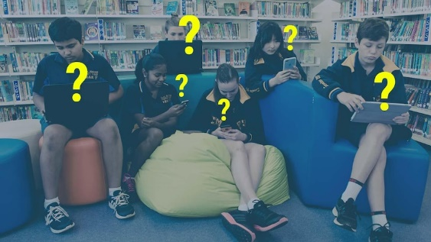
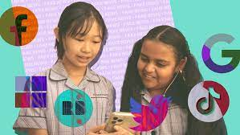

Fake News Fight Fake News
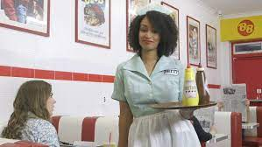
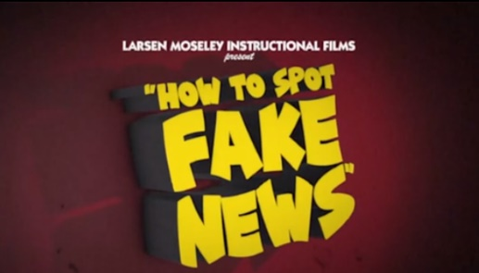

How to spot fake news Sources
Please note – these videos are intended for secondary students.

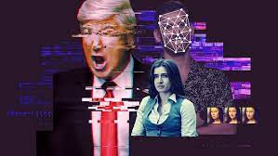
To understand more about deepfakes, students can watch the BTN Deepfake video story and Spotting Deepfake Videos and respond to the questions below:

- What is a deepfake video?
- Complete the following sentence. Deepfake videos use ______________ intelligence software to analyse and map people’s faces.
- Give an example of a deepfake video.
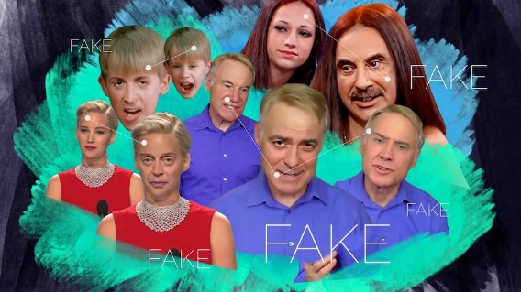
- Why are experts worried about people not being able to spot deepfake videos?
- What are researchers doing to detect deepfake videos?
- What can kids do to be more aware of deepfake videos?

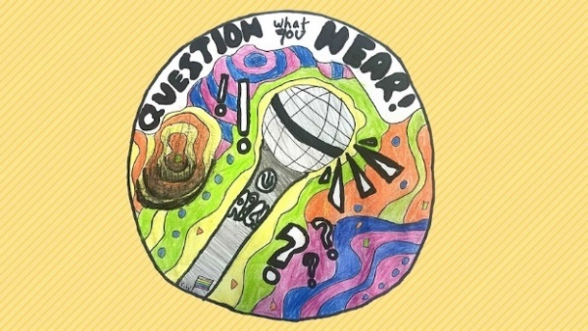
How do you fact check an image? Watch this short ABC Education video to learn how to do a reverse image search

Question What You Hear podcast features
interviews conducted and devised by students
where each guest discusses their expertise when
it comes to being a critical consumer of media.

Activity: BTN’s Media Literacy series
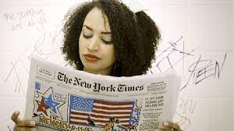
BTN has created a series of Media Literacy videos to help students understand and question news. Topics include How to Spot Fake News, News Sources, What is News? How to Spot Bias, and Media Ethics.

The videos will help students to critically analyse the news they see, hear, or read. Please note – these videos are intended for secondary students.

Useful Websites
- Media Literacy – Museum of Australian Democracy at Old Parliament House
- Media Literacy – ABC Education
- Media Literacy – BTN
- Deepfake Videos – BTN
- Fake News Fight – BTN
- Fake News – eSafety Commissioner
- Fake News – BTN

EPISODE 29
24th October 2023

KEY LEARNING
Students will learn more about the history of the Olympic games and explore news sports being added to the Olympic games.

CURRICULUM
Health & PE – Year 7/8
Investigate the benefits to individuals and communities of valuing diversity and promoting inclusivity.

Health & PE – Year 5/6
Identify how valuing diversity positively influences the wellbeing of the community.

HASS – Year 3 and 4
Pose questions to investigate people, events, places and issues.

Locate and collect information and data from different sources, including observations.

HASS – Year 5 and 6
Develop appropriate questions to guide an inquiry about people, events, developments, places, systems and challenges.

Locate and collect relevant information and data from primary sources and secondary sources.

HASS – Year 7
Construct significant questions and propositions to guide investigations about people, events, developments, places, systems and challenges.

  - Teacher Resource

New Olympic Sports

Focus Questions
Discuss the BTN story as a class and record the main points of the discussion. Students will then respond to the following:
- What new sports will be added to the 2028 Olympic games? Name at least two.
- Where are the 2028 Olympic games going to be held?
  - Paris
  - Los Angeles
  - Brisbane
- Cricket featured in the 1900 Olympic games. True or false?
- When did the modern Olympic games begin?
- Name three things you learnt watching the BTN story.

Activity: Class Discussion
Before Watching
Before watching the BTN New Olympic Sports story ask students to guess which new sports, they think will be included in the 2028 Olympic games.

After Watching
Once your students have made their predictions watch the BTN New Olympic Sports story, and then students will respond to the following:

- Are you familiar with all the new sports being introduced in the 2028 Olympics? Discuss in pairs.
- What did you learn watching the BTN story?
- What did you find surprising?
- What is your favourite sport in the Olympics? Why?

Activity: Persuasive Text
Students will identify a sport that is not currently included in the Olympic games, that they would like to see included in a future Olympics. Students will write a letter convincing the Olympic Committee to add it as a new sport in the Olympics.

Research
Students will conduct research into the sport, including the following:
- A short history of the sport
- The rules of the sport
- Its popularity around the world
- How many countries play it around the world
- Traditions associated with the sport

Students will use the following as a guide as they develop their persuasive text.

Tips
- Who is your audience? For example, are you directing your argument at kids, teachers, or politicians?
- Explore how language choices can have a big impact on persuading your audience.
- Which language devices give the report credibility and authority?
- Which are designed to create an emotional response in the listener?
- Provide facts and evidence to support your argument.
- Write in the present tense.
- Check your spelling and punctuation.

Use this Read Write Think persuasion map to plan your exposition text.

Introduction
- What is the point you are trying to argue? Construct an introductory paragraph which states the issue or topic.
- Introduce the arguments that will be developed in the body of the text.

Body
- Construct arguments that support your point of view.
- Each paragraph starts with a topic sentence which introduces each point.
- The rest of the paragraph gives more reasons.
- Arguments can be ordered from strongest to weakest.

Conclusion
- Restate your position on the argument.
- Construct a concluding paragraph that provides a summary of your arguments and a call to action.

Reflection
- Was I able to convince others of my opinion?
- What did you learn from this activity?

Further Activities
- Students will participate in a classroom debate defending their chosen sport's inclusion in the Olympics.
- Invite a guest speaker with expertise in a sport not currently part of the Olympics to talk to the class about the sport's values and challenges.

Activity: History of the Olympic Games
Students will create a timeline to sequence the history of the Olympic games, including the beginning of the Olympic games in Ancient Greece until the modern Olympics which we know today. Students will work in small groups and work through the following questions to build on their understanding of the history of the Olympics. Students will find and collect images, photographs, illustrations and video as part of their research.
- When were the Olympic games first held?
- Who is the founder of the Olympic games?
- What were the first sports included in the Olympic games?
- When did women first compete in the Olympic games?
- What sports did athletes compete in during the ancient Olympic games?

Further Investigation
Students will investigate how the Olympics have changed from ancient to modern times. Students will explore in more detail and present their findings on a timeline. Watch this TEDEd video to learn more about the origins of the Olympics games.

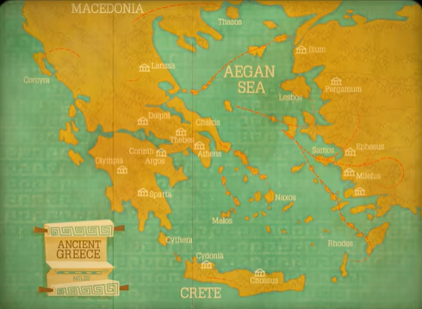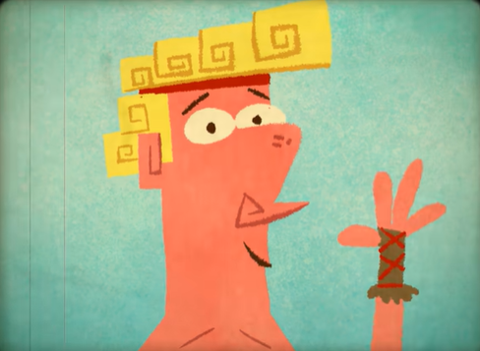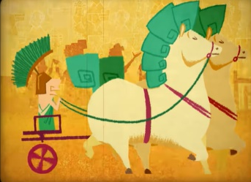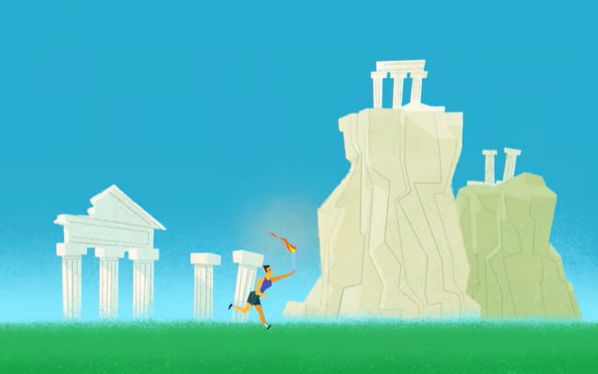

Activity: Write a Feature Story
Students will imagine they are sports journalists covering the upcoming 2024 Olympics. Students will choose one aspect of the event that they are interested in writing about. Some possible topics include:
- A new sport being introduced to the Olympics
- The Olympic mascot
- A star athlete
- A history of the Olympics
- A profile on the country hosting the next Olympics

Students can use the following to guide them throughout the research and writing process:
- Research as much as you can about the topic.
- Include statistics, quotes from players or experts, and any other significant details.
- Add visuals, such as images or infographics.
- Could you interview someone, like a player or expert? Write some interview questions.
- Write a feature story – find out what makes a good feature story here. Share your story with the class.

Activity: Olympic Games Quiz

- When was the first Olympics in history?  A. 1000 B.C.  B. 776 B.C.  C. 1896  - Which sport will feature for the first time in the 2024 Olympic games?  A. Darts  B. Cricket  C. Breakdancing  - There were no team sports at the ancient Olympics.  A. True  B. False  - How many rings are in the Olympic symbol?  A. 5  B. 6  C. 7  - Which city was home to the first ancient Olympics?  A. Opus  B. Olympia  C. Olynthus | - Figure skating was initially part of the summer Olympic games.  A. True  B. False  - What was the first event in the ancient Olympics games?  A. Discus  B. Chariot race  C. Running  - Who is hosting the 2024 Olympic games?  A. Paris  B. Los Angeles  C. Brisbane  - Where were the first modern Olympic games held?  A. Athens, Greece  B. Paris, France  C. St Louis, United States  - The Olympics is held every 8 years.  A. True  B. False

Quiz Answers: 1B, 2C, 3A, 4A, 5B, 6A, 7C, 8A, 9A, 10B

Useful Websites
- Which five new sports could be at the 2028 Olympic Games? – Newsbreak
- Olympic Games History – BTN
- 2020 Tokyo Olympics – BTN
- Cricket confirmed as one of the five new sports for 2028 Los Angeles Olympic Games by IOC – ABC News

  - Teacher Resource

BTN Transcript: Episode 29 – 24/10/2023

Hey. I'm Amelia Moseley and you're watching BTN - welcome back for another episode, thanks for hanging out with us let’s see what’s coming up on today’s show. We meet some young athletes with their eyes on Olympic glory, find out more about the weird and wonderful world of quantum computing and meet some primary school kids who are scoping out their future careers.

Rules of War

Reporter: Joshua Langman

INTRO: All that soon but first today we're going to find out about the rules of war. Now, it might seem strange to think that something as horrible as war would have rules, but it does and as Josh found out, they're really important at times like these.
JOSH LANGMAN, REPORTER: It's an unfortunate truth that humans have often turned to fighting and war to solve their problems. But there's another truth that's always been pretty clear.
War is terrible. Which is why, for a long time, we've looked for ways to limit how destructive it can be.
TV FIGURE 1: A demand human rights groups have labelled a war crime.
TV FIGURE 2: That is wrong. That is a war crime.
TV FIGURE 3: Is committing war crimes.
TV FIGURE 4: Blatant, barbaric war crimes.
Recently, we've seen fighting in Ukraine, and in Gaza. We've also heard some accusations that one side or the other isn't following the rules of war. So, what does that mean?
Our modern rules of war can be traced back to a Swiss man named Henry Dunant. In 1859, he was trying to track down Napoleon in Northern Italy, when he found himself caught up in a huge battle. He was horrified by the amount of suffering he saw, and decided to create an agency that would help people in need in a war zone, the International Committee of the Red Cross. Then, in 1864, he helped to bring about the original Geneva Convention: an international treaty where countries agreed to protect medics no matter what side they were on.
Unfortunately, wars continued. World War I brought new weapons, and a new level of destruction and suffering. Then came World War II, the horrors of the Holocaust, and the terror of nuclear weapons.
That led to the formation of the United Nations, which, at the time, was made up of over 50 countries who pledged to work towards world peace. And in 1949, those same countries, and others, came together for a big meeting in Geneva in Switzerland, where they signed a new agreement on how people should be treated during and after a war. Since then, there have been other treaties, and while not every country has agreed to every one, there are some basic rules most agree on.
The big one is that fighters should do everything they can to avoid harming people who aren't in the fight or are no longer fighting. That means they shouldn't deliberately target civilians, or recklessly put them in harm's way. They also shouldn't use weapons that are cruel or indiscriminate and should look after prisoners of war and the wounded.
DANIELA GAVSHON, HUMAN RIGHTS WATCH: You can't use, you know, wide area weaponry or things that are that are essentially going to not be able to discriminate well between a civilian and a combatant. And then you have to take precautionary measures. So, you have to be, you know, giving adequate warnings, you have to be choosing means and methods that can mitigate any civilian losses.
Serious breaches of the rules of war are sometimes known as "war crimes". And those responsible can be investigated and punished either by individual states, or, if they refuse, by the International Criminal Court at the Hague. Although that's not always easy.
DANIELA GAVSHON, HUMAN RIGHTS WATCH: You have to sign up to the Rome Statute. That's the sort of the body of law that created the International Criminal Court. And if a country hasn't signed up to ratify the Rome Statute, then they're less likely to comply with the International Criminal Court. For example, there's an arrest warrant out for Putin and his child rights commissioner, and that requires a country to comply with the arrests warrant and deliver them to the ICC. So, it relies on that state cooperation.
Of course, the way wars are fought is always changing. And as weapons technology advances, some say we need to update our rules of war. Because until we can find a way to stop war altogether, the goal is to limit suffering as much as we can.

News Quiz

Which world leader was on this plane which touched down in Israel last week? It was US President Joe Biden. He told Israel’s president that the US would support them in the war against Hamas and also unveiled a deal to allow humanitarian aid into Gaza from Egypt, although aid groups say that not enough is getting through.

Can you name the gaming company that’s just been bought by Microsoft in the biggest deal in gaming history? It’s Activision Blizzard. The deal’s been pretty controversial because of how much power it’ll give Microsoft in the gaming industry and authorities in the UK have forced them to sell Activision streaming rights, so their games won’t just be available on Microsoft’s X-Box.

The World Solar Car challenge has begun with solar cars from around the world setting off from Darwin. Do you know where they’re headed? Is it Brisbane, Perth or Adelaide? They’re travelling to Adelaide, and we’ll tell you more about it next week.

New pictures from NASA’s Juno spacecraft have given us a close up look at Io, which is a moon of which planet? Jupiter, Saturn or Neptune? Io is one of the Jupiter’s many moons and it’s the most volcanically active world in our Solar System with a surface covered in erupting volcanos.

Media Literacy Week

Reporter: Justina Ward

INTRO: This week is Media Literacy Week which was created to help fight fake news and that's pretty important because a recent study found way too many young Aussies are being fooled by false information. Justina found out more.

Crew: And we're going live in 3, 2, 1.
MC: This is In Front of the News with 10 time Wonkly award winning anchor, Pam Newsworthy.
Pam: Hello I'm Pam and welcome to In Front of the News. The News you can trust we're in front of. Coming up tonight, it's Media Literacy Week.
It wasn't that long ago that people like Pam were the only ones that brought you the news that you needed to know.
Pam: Who said that?
TV, newspapers and radio told us about the big events that happened in the world.
Pam: And professionals like me were always here to tell you exactly what you needed to know because it says it right here on my auto cue.
These days with the world in our pockets we're bombarded with information from all sorts of places, but working out what to trust can be confusing. A recent study has found that only two in five young Aussies believe they can tell the difference between real news and fake news. Which is basically articles or videos containing untrue information disguised as a credible news source. But don't worry adults often struggle to tell the difference too. Recently, we've seen examples of people sharing fake stories about really serious issues. Like this video which was said by some to show fighting between Israel and Hamas, actually it was from a video game. Experts are worried advancements in AI tech is making it even harder to tell what’s real and what's not, yeah, these photos are all fake. And so is this video of Volodymyr Zelenskyy telling Ukrainian soldiers to give up their weapons.
Justina: There are also AI programs that can copy peoples voices and make them say things they didn't actually say.
AI Justina: Hi I'm Justina and I like smelling stinking socks.
Justina: That's not true.
And we’ve already seen examples of this tech being used to make politicians look bad.
There are worries all of this fakery is undermining peoples trust in the news and causing some to lose interest in what's going on in the world and that's a big problem because without the right information we can't make the right decisions for the future. Moving forward we need to be more vigilant with what we trust on the internet.
They also say more schools should be offering lessons in media literacy so kids are equipped with the skills they need to know what news is worth knowing.
PAM: And that's all from us here from 'In Font of the News'. We'll see you tomorrow night. Stay classy Australia.

Quantum Computing

Reporter: Cale Matthews

INTRO: Now we're about to meet this year winner of the Prime Minister's Award for Science, Professor Michelle Simmons. She's a quantum physicist and is working on developing computers that are 150 million times faster than computers today. Cale caught up with her to try and learn about the world of quantum computing. Take a look.

There's a famous quote from an old Nobel Prize winner that says, "If you think you understand quantum mechanics, you don't understand quantum mechanics". That's how complicated and confusing the world of atoms and neutrons and electrons, the smallest things in our universe, is. But if there is one person that actually does understand it, it's this year’s Prime Minister's Prize for Science winner Professor Michelle Simmons.
PROFESSOR MICHELLE SIMMONS, QUANTUM PHYSICIST: That's Richard Feynman I think.. yeah look I think it's one of those things that I'm an intensely practical person. Until you've done it yourself and you've played with it, and you can see it in action, that it does seem a bit surreal.
CALE MATTHEWS, REPORTER: In your words, what is quantum mechanics?
PROFESSOR MICHELLE SIMMONS, QUANTUM PHYSICIST: Yeah, so quantum mechanics is the way that we describe the world when it's very small. So, if you imagine if you throw a tennis ball at a wall, in the kind of big world, the Newtonian world, that will bounce off the wall and come back, and you put your hand up, and you catch it.
CALE: When you shrink things down to the size of atoms the world operates a bit differently.
PROFESSOR MICHELLE SIMMONS: So, that ball if it was an electron on an atom. If that that wall was very thin, then it behaves more like a wave, and if the wall is very thin, it can actually tunnel through the wall and come out the other side.
CALE: And it gets even weirder than that. Things in the physical world can really only be in one state at a time, a light is either on or off. In the quantum world it can be both at the same time, it's something called superposition, and it's not until we actually observe or measure it that it picks a state. And it gets even spookier than that, sometimes particles can become connected to each other and a change to one will mean a change to the other even if they’re kilometres and kilometres apart, that's something called entanglement. Yeah, it's all pretty mindboggling.
GRAB: So that's why people don't like it seems like it's an impossibility for that kind of thing to happen. But it's just a different way of looking at the energy states as you get very small.
Scientists like professor Simmons can use that weird spooky quantum world to do some pretty cool stuff, like build computers.
PROFESSOR MICHELLE SIMMONS: So, quantum computing is using the quantum states of very small particles to do calculations.
See the most basic units of computing are bits, 1s and 0s, that are created by little switches being turned on or off. The more information you're trying to process the more switches you need. Over the years computers have gotten faster and smaller. But quantum computers could shrink and speed things up even more by using atoms themselves, with all of their weird spooky properties as those little switches. Professor Simmons says these computers could be more than 150 million times faster than any computer on Earth.
PROFESSOR MICHELLE SIMMONS: Oh, yeah, we should be excited the applications are across every industry that has data, how to get airlines to reduce the fuel costs, aircraft design drug design,.
With quantum computers we could simulate new chemical reactions or develop new materials, improve self-driving cars and take artificial intelligence to a new level.
PROFESSOR MICHELLE SIMMONS: There's just a huge number of different things that you can do with quantum computers. That's why it's so exciting because everyone's waiting for the hardware to come along.
Professor Simmons says it’s just one reason to be excited about the future of science.
PROFESSOR MICHELLE SIMMONS: Honestly for me, the most exciting thing about science is that you is very creative. You get to do things that no one's ever done before. My goodness, there's no better satisfying thing than to understand something for yourself and for the rest of the world and create technologies. I mean, it's really just a fantastic field.
New Olympic Sports

Reporter: Cale Matthews

INTRO: The International Olympic Committee has just revealed the six new sports that will be played at the 2028 Los Angeles Olympics, including cricket and softball. Cale met some up-and-coming athletes who could be in the running to represent Australia. Check it out.

Zoe is really good at Softball.

CALE: Hi Zoe, Softball 101, what do I need to know?

Like, plays for Australia good.

ZOE: Here you go.
CALE: Do I need this?
ZOE: Yes you do!

Like could go to the Olympics good.
Zoe Thomson, Softballer: As soon as I started the sport, I absolutely fell in love with softball and I've always kind of wanted to play at the highest level possible.
So, when the International Olympic Committee announced Softball would actually be played at the 2028 Los Angeles Olympics, Zoe and the rest of the specialist Softball program at Seaton High in Adelaide were pretty excited.
ZOE: And for a really long time Softball wasn't in the Olympics, that was never an option, but it's kind of coming back and making a bit of a comeback. So that's like, a massive childhood dream for me to play in the Olympics.
STUDENT: Ever since I was little, I always thought, okay, I'll go play in the Olympics. It's been a goal of mine.
Softball is one of 6 new sports being added to the 2028 Olympic Games. The others are Squash, Flag Football, Baseball, Lacrosse and yeah, Cricket.
Despite having more than a billion fans all around the world, Cricket has only been an Olympic Sport once, all the way back in 1900. So, this addition is big news to plenty of Aussies, including these cricketers who are part of a specialist program at Adelaide High.
STUDENT: I was very excited. Actually, I could see it coming and now it's here it's a good addition, due to the popularity of the sport.
STUDENT: Great thing to have the chance of winning a medal and compete for one. Many great athletes that have played cricket haven't had that chance.
STUDENT: It's like very popular in Australia and especially around the world. So, it'll be really good to see.
Sports dropping in and out of the Olympics is nothing new, In fact if you rewind more than 3,000 years to the very first Olympic games there were only 8 different sports and everyone competed naked, so, you know, things looked a little different. Ever since the modern Olympics were born in 1896 sports like Rugby Union, Karate and croquet have all had some Olympic exposure, and there have been some pretty weird events too like Tug of War, live pigeon shooting and horse long jump. Yeah.
Sports can be added or removed from the Olympics for different reasons but basically the IOC says the sport must increase the Olympics popularity, be easy to run and manage, and represent the Olympic values. Of course, there are lots of different sports that people would like to see included and with Brisbane hosting the games in 2032, what do you reckon should be included?
STUDENT: I think polo would be really cool.
STUDENT: Women's baseball would be a really good one to see.
STUDENT: So I reckon darts would be good after watching some of the pros on TV and stuff.
STUDENT: A lot of my friends are a bit sad about the motorsport not being in it.
STUDENT: Bit of fishing maybe as well?
The LA Games are still 5 years away which means you might see one of these guys, or these guys, donning the green and gold. Just not this guy.
CALE: How does anyone ever hit it in this sport? Ok, one more… two more.

Quiz

Which one of these has been an Olympic sport? Solo synchronised swimming, Ten Pin bowling or Tiddlywinks? It's solo synchronised swimming. It was an Olympic event between 1984 and 1992.

Sport

Australia has won the Constellation Cup. While the Diamonds actually lost todays 4th and final match against New Zealand and series was a draw on 2 for 2. The Aussies overall goal score got them over the line to win the tournament for the 11th time.
LIZ WATSON, DIAMONDS CAPTAIN: I was extremely disappointed with our last two games but also extremely proud that we are able to keep this cup and it’s something we’ve worked really hard for.
This was the kick that booked South Africa's place in the World Cup final. Handre Pollard landed a 49-metre penalty three minutes from time, sealing a 16 to 15 win over England, which means the Springboks now have a rendezvous with New Zealand in Saturday's final.
Over to the men's Cricket World Cup where India is continuing to dominate. Virat Kohli fell just short of a century, hitting 95 to lead them to a four-wicket victory over New Zealand. India's now the only unbeaten team in the comp.
INDIAN CAPTIAN: It’s important for us to stay balanced. not to think too far ahead as well but enjoy the moment as well.
Meanwhile, back in Australia, the Brisbane Heat's Grace Harris has produced a record-breaking innings against the Perth Scorchers smashing 136 off 59 balls. But that's not all she broke. Yep. With a broken bat she still managed a sixer.
Career Kids Expo

Rookie Reporter: Molly-May

INTRO: Now what would you like to be when you grow up? It's a big question and you're probably still working that out. But one school in Darwin has set up a program to help kids get a head start on their dream jobs.
MOLLIE-MAY: What do you wanna be when you grow up?
It's the question a lot of us are asked. But you might be thinking: "I'm only in year six. Isn't it a bit early to be thinking about that?" Well, at my school, we're on a quest to get kids excited about their future careers.
Me? I wanna be a news reporter.
In breaking news, Larrakeyah Primary School is holding its sixth annual QUEST expo.
FATHMA MAUGER, PRINCIPAL: QUEST is an amazing program, it's a program that our school developed ourselves. It came about from a direct response to student voice, because our kids were saying that they were nervous about the future.
QUEST gives kids like me from Year 5 and Year 6 an up-close look at a bunch of different career paths. We meet professionals and go to see where they work. And at the end of it, we all come together for a big career’s expo, to show off what we've all learnt.
It was really fun to experience what it's like being a news reporter. This is us at ABC Studios. And then this is where we tried being news reporters all by ourselves, which was really scary, but really fun.
GEORGE MAMOUZELLOS, QUEST PROGRAM FACILITATOR: We want the kids to be more hands on and practical, and actually seeing that side of the field, than just pen and paper.
If you look around, you can see some of the different professions we've been exploring. Like first aid, tourism, working in a restaurant, and investigating microplastics.
LACHLAN: I chose fishing because it's a big passion of mine. We've had NT fisheries come in, talking about the possession and size limit of fishing. The lures we made, they're very creative and they're recycled materials. And hopefully they catch something. The highlight for me was probably going fishing as a group. And also, I learned that my passion could become a career for me.
AARON: I chose photography because I just like drawing and things in general. And I think photography is a good way to capture things. This one, we added the lens to zoom in a lot. We also had an excursion to Darwin High School, and they gave us a studio where we could experience like aperture, shutter speed and etc.
Some of us even had a crack at being a detective.
GABRIEL: We need your help to figure out who ate the cookies and stole the cookies. The only the only thing we have to follow is the cookie crumbs, and they dropped the jar and cut their hand leaving blood trails. This is the little sheet to help you decipher which blood type is which. And also, there's a fingerprint left from the suspect. It's really interesting to see just how high tech it can be nowadays, because they have these machines that can see your DNA, which is very small and tiny.
The great thing about QUEST is that it makes us excited about learning, because we can see how our lessons in the classroom might be used one day. It's even inspired teachers from overseas to come check it out.
SHAUN RUSHTON, KUALA LUMPUR TEACHER: We were really, really enthused by what they're doing here, to try and get local communities involved in their teaching.
And for the first time this year, younger kids are getting to take part as well. Because we think you're never too young to start thinking about your future career.
Mollie-May, ABC News.

Closer

Oh Molly-May you’ll have my job in no time. Well, that's all we've got for today but we'll be back next week with more news. In the meantime, you can jump online to see BTN classroom and BTN High and Newsbreak will be right here in the studio every weekday keeping you up to date. Have the best week and I’ll catch you later. Bye!

