Episode 24

25th August 2020



**COVID-19 Contact Tracing**

1. Discuss the BTN *COVID-19 Contact Tracing* story as a class and record the main points of the discussion.
2. What is contact tracing?
3. Contact tracing speeds up the spread of infectious diseases. True or false?
4. Why is contact tracing important?
5. What Australian city is currently in lockdown?
6. What New Zealand city is currently in lockdown?
7. How do lockdowns help reduce the spread of COVID-19?
8. What app is the government encouraging people to download?
9. How does the app work?
10. What questions do you have after watching the BTN story?

**US Postal Voting**

1. What did the BTN *US Postal Voting* story explain?
2. When is the next US election?
3. Why is the US using mail-in voting instead of going to a polling booth?
4. Why was mail-in voting used in the US during the Civil War?
5. What is the purpose of mail-in voting?
6. Why are some people worried about using mail-in voting for the next election?
7. Why have lots of post offices been closed around the United States?
8. The US Postal Service gets it money from the government. True or false?
9. Why doesn’t President Donald Trump trust mail-in voting?
10. What did you learn watching the BTN story?

**Drought Breaking**

1. Retell the BTN *Drought Breaking* story using your own words.
2. The kids in the BTN story live in Caragabal. Find Caragabal using Google Maps.
3. How long have some places in NSW been in drought?
4. Describe what drought-affected land looks like.
5. How did the kids feed their sheep during the drought?
6. Complete the following sentence. The kids in the BTN story had strict water ______________.
7. How has the drought affected families?
8. How did the kids feel when they got rain in their town?
9. How much of NSW was declared drought free this month?
   1. One quarter
   2. One third
   3. One half
10. Illustrate an aspect of the *Drought Breaking* story.

Check out the [Drought Breaking resource](http://www.abc.net.au/btn/teachers.htm) on the Teachers page.

**Frog Spotting**

1. Retell the BTN *Frog Spotting* story to another student.
2. How do frogs communicate?
3. Why do male frogs call?
4. Where do you measure a frog to find its length?
5. What animals eat frogs?
6. What do frogs eat?
7. Complete the following sentence. Frogs are a critical part of the food _______.
8. Why are a lot of Australia’s frog species under threat?
9. What are frogs sensitive to?
   1. Pollution
   2. Sunlight
   3. Water
10. What is a citizen scientist?

Check out the [Frog Spotting resource](http://www.abc.net.au/btn/teachers.htm) on the Teachers page.

**Thank You Project**

1. Briefly summarise the BTN *Thank You Project* story.
2. What is the aim of the Thank You Project?
3. Give an example of an essential worker.
4. When did it start?
5. Who can join in the Thank You Project?
6. How many Thank You letters have been delivered in Australia?
7. Who were they delivered to?
8. What is Harry’s goal with the Thank You Project?
9. Write a thank you letter to someone who has helped in your community.
10. Write a message of support and post it in the comments section on the story page.

Teacher Resource

Episode 24

25th August 2020

**Drought Breaking**



Students will investigate what drought is and how it impacts on people and places in Australia. Students will design a drought resistant garden using native plants.



**Design and Technologies – Years 5 and 6**

Investigate how and why food and fibre are produced in managed environments and prepared to enable people to grow and be healthy.

**Design and Technologies – Years 7 and 8**

Analyse how food and fibre are produced when designing managed environments and how these can become more sustainable.

**Science – Year 5**

Scientific knowledge is used to solve problems and inform personal and community decisions.

**Science – Year 6**

Scientific knowledge is used to solve problems and inform personal and community decisions.

Sudden geological changes and extreme weather events can affect Earth’s surface.

**Science – Year 7**

Scientific knowledge has changed peoples’ understanding of the world and is refined as new evidence becomes available.

Science knowledge can develop through collaboration across the disciplines of science and the contributions of people from a range of cultures.



1. Retell the BTN *Drought Breaking* story using your own words.
2. The kids in the BTN story live in Caragabal. Find Caragabal using Google Maps.
3. How long have some places in NSW been in drought?
4. Describe what drought-affected land looks like.
5. How did the kids feed their sheep during the drought?
6. Complete the following sentence. The kids in the BTN story had strict water ______________.
7. How has the drought affected families?
8. How did the kids feel when they got rain in their town?
9. How much of NSW was declared drought free this month?
   1. One quarter
   2. One third
   3. One half
10. Illustrate an aspect of the *Drought Breaking* story.



**Class dis****cussion**

Hold a class discussion about the information raised in the *Drought Breaking* story. Create a class mind map with DROUGHT in the middle. Use the following questions to guide discussion:

**What do you know about drought?**



* What is a drought? Create a class definition.
* What causes drought in Australia?
* Who is affected by drought?
* What impact does drought have on Australia?
* How can drought be managed?
* Why do we need to think about drought?

Students will then respond to one or more of the following:

* Think of a question you would like to ask the kids featured in the BTN *Drought Breaking* story.
* Leave a message in the comments section on the BTN *Drought Breaking* story page.
* Finish one or more of the following sentences:
  + The main causes of drought are….
  + Drought affects…



**Six Hat Thinking**

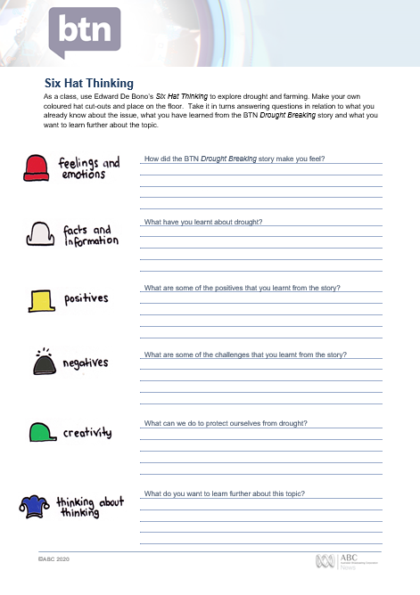

As a class, use Edward De Bono’s Six Hat Thinking to explore drought and sustainable farming. Make your own coloured hat cut-outs and place on the floor. Students will take it in turns answering questions in relation to what they already know about the issue, what they have learned from the BTN *Drought Breaking* story and what they want to learn further about the topic.

[Print this worksheet](http://www.abc.net.au/btn/resources/teacher/episode/20180821-tassiedevils_6HatThinking.pdf) (featured at the end of this activity) for students to respond to a range of questions about drought and sustainable farming.

**Reflection**

After this activity, ask students to reflect on what they have learnt. Students can include details about how their thinking on this issue has changed.



**Drought-proof your garden**

Challenge students to design a drought resistant garden using native plants to their area. In this activity students will investigate how a lack of water can affect plants, learn about plants that are native to their area, and then design a layout for a drought resistant garden in their school.

**Research**



Before starting this activity, students will work in small groups, and respond to one or more of the following questions. Students will then share their research with the class.

* Do all plants need the same amount of water to survive?
* Do you know any plants that can survive on little water?
* Which plants need a lot of water to survive?
* How does drought affect plants?
* What climate do you live in? Compare to other climates in Australia.
* What soil type do you have in your school garden? Take a sample to your local garden shop to help determine the soil type. Explain the characteristics of the soil type.
* What features do Australian plants have that enable them to conserve water? Choose one plant to explore in detail.

**Design**

Students will design a drought-resistant garden, using the following as a guide:

* Where will your drought resistant garden be located? Think about the best positioning for your garden (for example full sun or shaded). Will you add to an existing garden or plant a new garden?
* What will the layout be for your garden? Sketch a rough design of the layout of your garden.
* What size will your garden be? Measure the perimeter and area of your garden.
* What plants will you include in your garden? Choose plants that are native to your area and require little water. Choose a balance of plants for example, small trees, screening shrubs, ground covers and edible plants. Collect images and photos of the plants you choose to create an inspiration board for your design.
* How will you protect your plants during a heatwave or low rainfall? For example, add a layer of mulch to help retain water.
* What equipment and materials will you need to create your garden? Make a list.
* What jobs will need to be done before, during and after creating the garden? Write a procedural manual.
* What is unique or special about your garden? Does it incorporate indigenous bush foods, does it include a discovery walk, will it attract wildlife to the area, is it a place for mindfulness practise or does it use recycled water?
* Present your design for a drought resistant garden to your class. Explain your design and include a paragraph justifying the choices you have made in your plans.



**Choose a project**

Individually or in small groups, students will choose one of the following projects to work on and then present their findings to the class.



**Water audit**

Do you know how much water you use each day? Think of all the times you rely on water during the day. Audit your school’s water usage over one week. How will you measure how much water your school uses? How can you use less water?

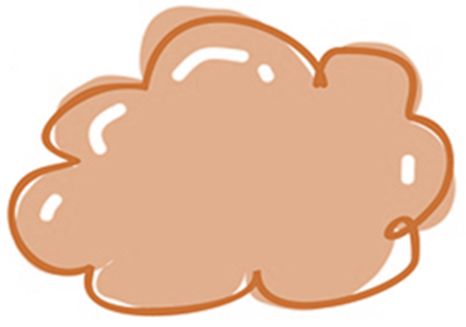

**Persuasive writing**

Write a letter to your school principal explaining why your school needs a drought resistant garden. Research the environmental benefits and include these points in your persuasive writing.

**Rain gauge**

How do you think meteorologists measure rainfall? Investigate and then create your own school rain gauge. Record the daily rainfall and calculate the average daily rainfall.

**Native plant database**

What plants grow best where you live? Investigate which plants are native to your area. Collect as much information about plants native to your area recording your findings in a database. Invite people in your community to add to your database.



Drought Kids – BTN

<https://www.abc.net.au/btn/classroom/drought-kids/11599610>

Third of NSW declared drought-free after regular rain – ABC News

<https://www.abc.net.au/news/2020-08-12/third-of-nsw-declared-drought-free/12549046>

Kreative Koalas Project – Kreative Koalas

<http://kreativekoalas.com.au/>

What you need to know about droughts – ABC News

<https://www.abc.net.au/news/2018-08-01/what-you-need-to-know-about-droughts/10051956>

Drought Explained – BTN

<https://www.abc.net.au/btn/classroom/drought-explained/10488726>

School Water audit – Cool Australia

<https://www.coolaustralia.org/activity/school-water-audit-56/>

**Six Hat Thinking**

As a class, use Edward De Bono’s *Six Hat Thinking* to explore drought and sustainable farming. Make your own coloured hat cut-outs and place on the floor. Take it in turns answering questions in relation to what you already know about the issue, what you have learned from the BTN *Drought Breaking* story and what you want to learn further about the topic.

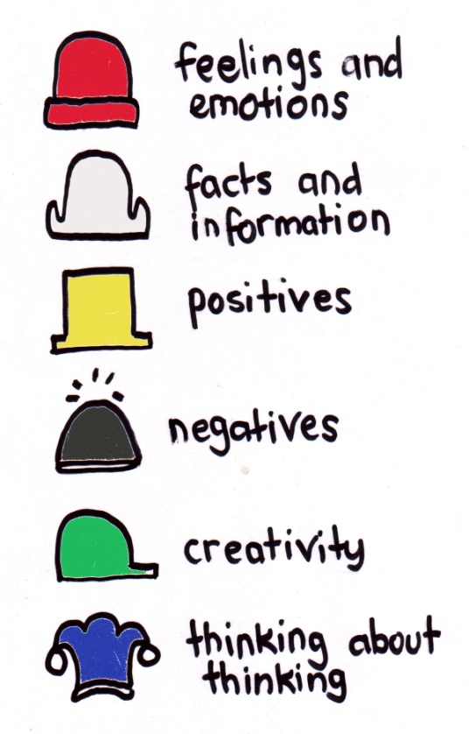

How did the BTN *Drought Breaking* story make you feel?

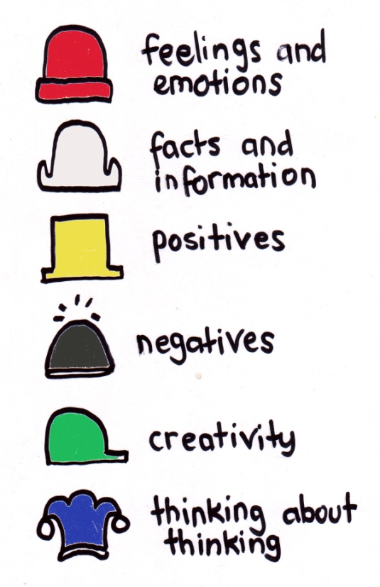

What have you learnt about drought?

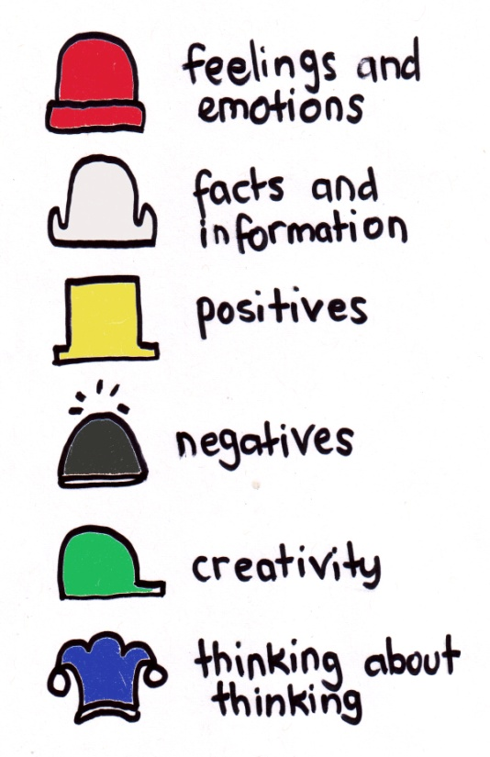

What are some of the positives that you learnt from the story?

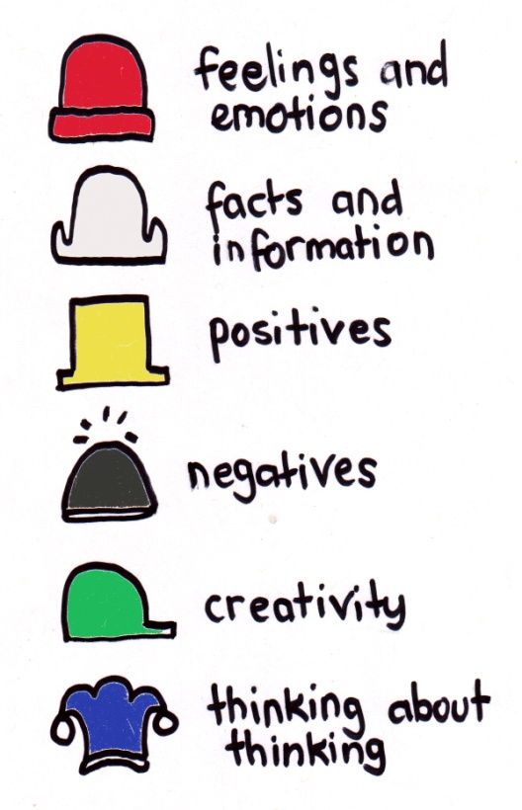

What are some of the challenges that you learnt from the story?

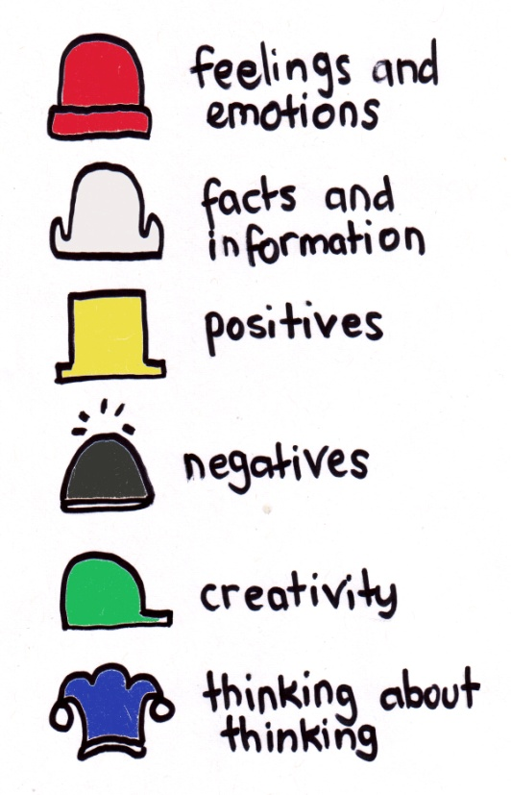

What can we do to protect ourselves from drought?

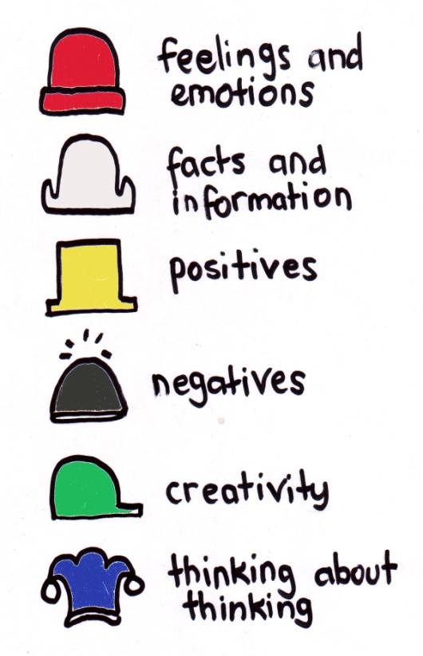

What do you want to learn further about this topic?

Teacher Resource

Episode 24

25th August 2020

**Frog Spotting**



Students will develop an understanding of the issues regarding declining frog populations and understand the importance of frogs in ecosystems.



**Science – Year 4**Living things have life cycles.

Living things depend on each other and the environment to survive.

**Science – Year 5**

Living things have structural features and adaptations that help them to survive in their environment.

**Science – Year 6**

The growth and survival of living things are affected by physical conditions of their environment.

**Science - Years 5 & 6**

Scientific knowledge is used to solve problems and inform personal and community decisions.



1. Retell the BTN *Frog Spotting* story to another student.
2. How do frogs communicate?
3. Why do male frogs call?
4. Where do you measure a frog to find its length?
5. What animals eat frogs?
6. What do frogs eat?
7. Complete the following sentence. Frogs are a critical part of the food _______.
8. Why are a lot of Australia’s frog species under threat?
9. What are frogs sensitive to?
   1. Pollution
   2. Sunlight
   3. Water
10. What is a citizen scientist?



**What do you know about frogs?**

Discuss the BTN *Frog Spotting* story using the questions below as a guide. Record the main points of discussion on a mind map.

* Why are frogs an important part of ecosystems?
* What are the main threats to Australian frogs?



* What do frogs need to survive?
* How do frogs communicate?
* Which species of Australian frogs have become extinct?
* Why is frog conservation important?



**Key words**

Students will brainstorm a list of key words that relate to the BTN *Frog Spotting* story. Students will then use the words to write their own sentences about the topic. Here are some words to get you started.

|  |  |  |
| --- | --- | --- |
| **Habitat** | **Amphibian** | **Ecosystem** |
| **Predator** | **Prey** | **Semi permeable** |
| **Adaptations** | **Threatened** | **Tadpole** |



**Profile of frog**

Students choose an Australian frog (or a frog that [lives near them](https://portal.frogid.net.au/explore)) and find out about its habitat, distribution (where in Australia the frog is found), adaptations and whether it has any threats.

|  |
| --- |
| **COMMON NAME:**  **SCIENTIFIC NAME:**  **APPEARANCE:**  **HABITAT:**  **SIZE:**  **DISTRIBUTION:**  Illustration/photo |
| **ADAPTATIONS:** |
| **THREATS:** |
| **INTERESTING FEATURES OR FACTS:** |



**What are bio-indicators?**

**Do frogs make good bio-indicators?**

**Further Investigation**

Frogs are one type of organism in an ecosystem. Students will draw a food chain to show what a frog eats and what feeds on frogs. Students will show the flow of energy between organisms in this food chain. How might other living things in the ecosystem be affected if the frog population is threatened?



**Features of a frog**

Students will learn more about the different parts of a frog by labelling the image below. They can then choose three features to explore in more depth and write a paragraph about each feature.

**Protruding eyes**

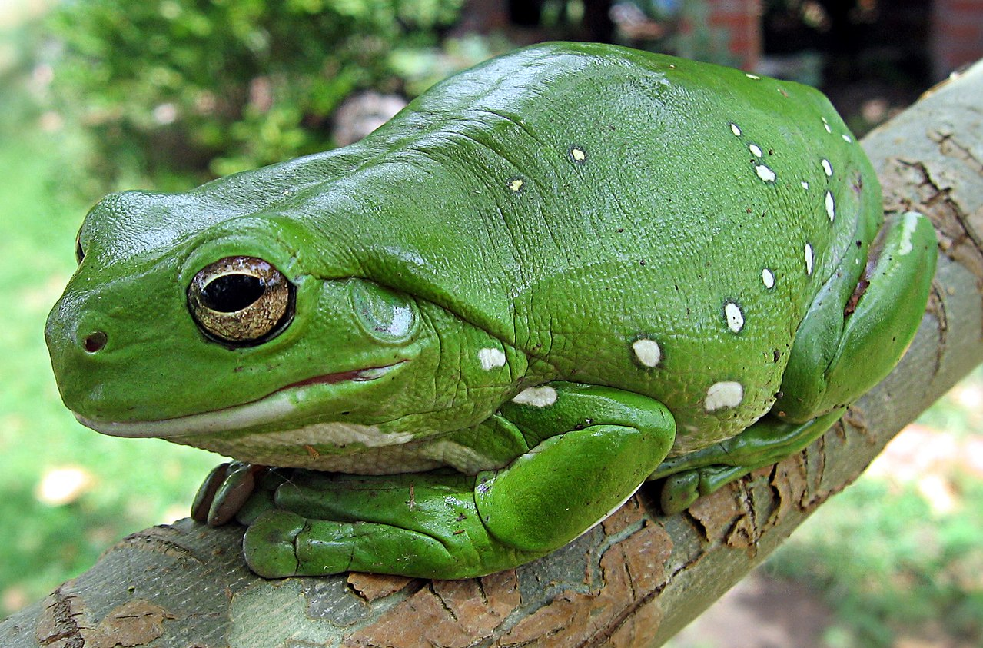

**Sac-like lungs**

**Digits – fingers and toes**

**Soft, moist skin**

**Hind limb**

**Fore limb**

**Backbone and internal  
  
External nares (nostril)**

**Tympanum (ear drum)**

[Australian Green Tree Frog](https://en.wikipedia.org/wiki/File:Australia_green_tree_frog_(Litoria_caerulea)_crop.jpg)



**Create a frog friendly garden**

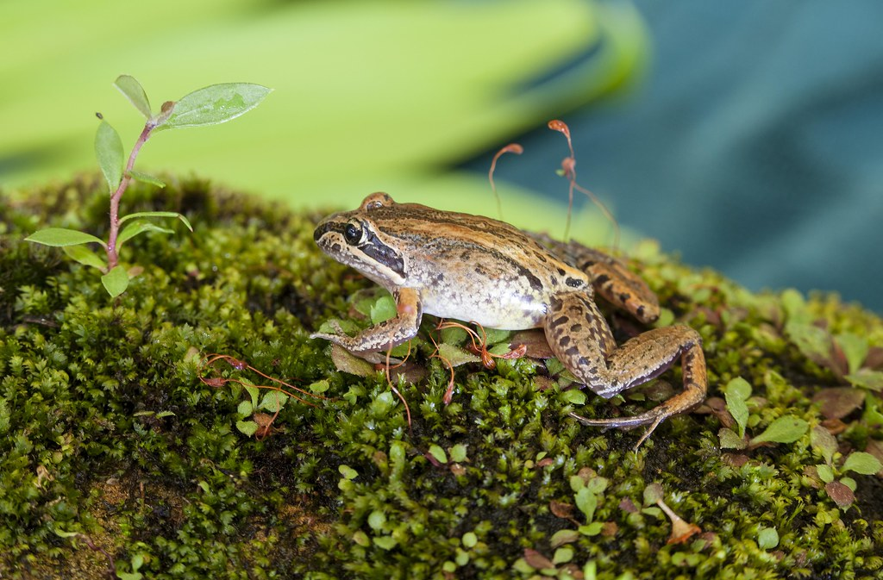

Creating a frog-friendly habitat is a great way to help protect local frog populations from decline as well as maintaining the health of the environment.

Using [Frog ID](https://portal.frogid.net.au/explore) or the [Atlas of Living Australia](https://bie.ala.org.au/species/urn:lsid:biodiversity.org.au:afd.taxon:0490a9ba-0d08-473d-a709-6c42e354f118), students will find out about the frogs that live in their local area and what their needs are.

Here is some information about how to go about constructing a frog friendly habitat:

[ABC Gardening Australia video - How to build a frog bog habitat](https://www.youtube.com/watch?v=i2RN7gmW3NQ)

[Gardening Australia Frog bog factsheet](https://www.abc.net.au/gardening/factsheets/frog-bog/9801490" \l ":~:text=Frogs%20drink%20their%20skin%2C%20so,t%20too%20hot%20also%20help.&text=And%2C%20of%20course%2C%20a%20garden%20to%20give%20the%20frogs%20habitat.)

[Australian Museum – Create a frog habitat](https://assets.ctfassets.net/7ngxgjlhb3jq/7ni3XrvT0G7ngYJ1ldGvHo/9b70774b7c25e5e3a79cf0e6bfe6b046/J4921_FrogID_Habitat_poster_07.pdf)



**FrogID Citizen Science**

Scientists need your help to count Australia’s frogs! Students can get involved in the FrogID citizen science project which is helping people learn more about what is happening to Australia’s frogs. FrogID uses a mobile app to help identify frog species by their call and geotagging to map species distribution. Each species of frog has its own unique call. By using the FrogID app to record frog calls students can help identify frogs and their habitats. To find out more go to the [FrogID website](https://www.frogid.net.au/).



|  |  |
| --- | --- |
| Quiz Questions | Your Answer |
| 1. A frog is a…    1. Mammal    2. Amphibian    3. Reptile |  |
| 1. Frogs are cold blooded.    1. True    2. False |  |
| 1. Frogs breathe using their…    1. Lungs    2. Gills    3. Lungs and skin |  |
| 1. Which part of their body do frogs use to help them swallow?    1. Eyes    2. Stomach    3. Tongue |  |
| 1. Frogs drink water through their…    1. Skin    2. Mouth    3. Gills |  |
| 1. About how many native frog species are there in Australia?    1. 40    2. 140    3. 240 |  |
| 1. How many species of Australian frogs have become extinct?    1. 2    2. 3    3. 4 |  |
| 1. Frogs are the only native amphibians in Australia.    1. True    2. False |  |
| 1. Frogs are found on every continent except…    1. Europe    2. Antarctica    3. North America |  |
| 1. What is a group of frogs called?    1. A school    2. A pod    3. An army |  |

Answers: 1b, 2a, 3c, 4a, 5a, 6c, 7c, 8a, 9b, 10c



FrogID – Australian Museum

<https://www.frogid.net.au/>

Australia’s native frogs – Australian Museum

<https://australian.museum/learn/animals/frogs/>

Why Frogs Count Information sheet – Australian Museum

<https://assets.ctfassets.net/7ngxgjlhb3jq/1rN9MtYOy2eOVjEQ8PXE1p/00c8e511aa1bbe00fb428933c04112ca/_MIAB_frogID_panels_Sml.pdf>

Why do frogs call? – Australian Museum

<https://australian.museum/blog/science/why-do-frogs-call/>

Frog Future – BTN

<https://www.abc.net.au/btn/classroom/frog-future/10541784>

Frog Bog factsheet - Gardening Australia

<https://www.abc.net.au/gardening/factsheets/frog-bog/9801490#:~:text=Frogs%20drink%20their%20skin%2C%20so,t%20too%20hot%20also%20help.&text=And%2C%20of%20course%2C%20a%20garden%20to%20give%20the%20frogs%20habitat.>

Create a frog habitat – Australian Museum

<https://assets.ctfassets.net/7ngxgjlhb3jq/7ni3XrvT0G7ngYJ1ldGvHo/9b70774b7c25e5e3a79cf0e6bfe6b046/J4921_FrogID_Habitat_poster_07.pdf>

**BTN Transcript: Episode 24 – 25/8/20**

Hey, I’m Amelia Moseley and you’re watching BTN. Here’s what’s coming up. We discover why everyone's talking about the US postage service, find out why some farmers are celebrating in New South Wales and listen carefully for the sound of frogs.

COVID-19 Contact Tracing

Reporter: Jack Evans

*INTRO: But first we're going to learn more about a term that you've probably heard a lot lately, contact tracing. There's a lot of it going on at the moment, in Australia and around the world, to try to stop the spread of COVID-19. Jack found out more about it.*

JACK: You want me to trace this is the guy?  
  
DETECTIVE: Yeah that's the guy. I want you to trace his every move. Where he lives, where he doesn't live. Work out where he works. Where he shops, where he mops, where he drops, pops and locks.   
  
JACK: Gee that sounds like a lotta tracing.   
  
DETECTIVE: Well that's why it's called contact tracing.   
  
JACK: Huh?  
  
DETECTIVE: Contact tracing.  
  
JACK: You want me to contact Tracey?   
  
DETECTIVE: No. Contact Tracing.  
  
These are contact tracers and right now there are teams of them working really hard here in Australia and, well, all around the world. And while they might not look like detectives their job is kinda similar. They have to try to slow the spread of COVID-19 by finding as many people as possible who could have come into contact with the disease.  
  
NANCY BAXTOR, UNIVERSITY OF MELBOURNE: So when you have what we call an infectious disease, a disease that we spread from one person to the other like the common cold, part of controlling it is kind of knowing who might be at risk of it and stopping them spreading it to someone else.  
  
This is Professor Nancy Baxtor from the University of Melbourne, she knows a lot about contact tracing.  
  
NANCY BAXTOR, UNIVERSITY OF MELBOURNE: So what contact tracing does is it says ok so in that 2 days before you got sick and until you got the test and then you knew you had it who was near you? Near enough to you for long enough for you to possibly give it to.   
  
Now that's not as easy as you might think especially if there are a lot of cases of COVID.   
  
NANCY BAXTOR, UNIVERSITY OF MELBOURNE: When you have 700 cases and maybe they've each been exposed to 5 people. I mean you guys do the maths.  
  
I just did and it's 3,500 which is, yeah is a lot of people. And if those people were infected and they were in contact with 5 people each you can see how quickly the numbers get really, really big.  
  
NANCY BAXTOR, UNIVERSITY OF MELBOURNE: When it gets to that number it becomes impossible and that's why you know when you started getting those numbers in the 700's that's why they had to shut things down more.  
Nancy says that's part of the reason why lockdowns like the one in Melbourne or in Auckland in New Zealand can help. It means you aren't out and about as much as you usually would be, which reduces the amount of people you are likely to come in contact with. It's also why the government has been encouraging people to download the COVIDsafe app, which uses Bluetooth to let you know if you've come into contact with someone who has the virus. As long as they have the app too. Many experts are hoping that if we can get the number of COVID-19 infections down, contact tracing will help us to keep it under control in the long run.   
  
NANCY BAXTOR, UNIVERSITY OF MELBOURNE: Unless we want to stay in lockdown for a long time to try and eliminate it, what we are going to have to do is kind of deal with little outbreaks when they happen and kind of close them down by contact tracing.   
  
JACK: Alrighty so this guy has been to the shops, then they went to the cinema, then they went to work and right after that they went to this cafe.   
  
DETECTIVE: Great Work.   
  
JACK: Well I guess I better contact Tracey.   
  
DETECTIVE: Wait what?   
  
JACK: Oh no no no, I'm pretty sure that's Tracey right there so I should contact her?  
  
DETECTIVE: Yeah, no that's, no that's right. Alright well yeah contact Tracey. Alright.

News Quiz

Which of these things have been banned in New South Wales schools to try to prevent the spread of COVID-19? School formals, choirs or playing wind instruments in groups? It’s all three. The state has also banned other interschool sport, drama, debating and other events involving big groups of people.

Australia’s government has made a deal to secure access to a coronavirus vaccine which is being tested now at which famous English University? Is it Cambridge, Durham or Oxford? It’s Oxford University. While the vaccine isn’t proven to work yet, tests have shown some promising results and the government says if it does work. Australia could have access to 25 million doses by early next year.

Which US political party does this logo belong to? The Democratic Party or the Republican Pary? It’s the logo of the Democrats. Last week the party held a big virtual convention to formally nominate its candidates for President and Vice President.

Which pop star spoke at the convention? Miley Cyrus, Taylor Swift or Billie Eilish? It was Billie Eilish. She joined a whole bunch of celebrities, politicians and ex-presidents who spoke in support of Joe Biden and Kamala Harris.

Death Valley in the US recorded what could have been the hottest day ever last week. What did the temperature get to? Was it 44.4 degrees, 52.4 degrees or 54.4 degrees? It was 54.4 degrees. The record bit is kind of complicated because a higher temperature was actually recorded there back in 1913, but experts aren’t sure how reliable that measurement was.

US Postal Voting

Reporter: Amelia Moseley

*INTRO: As you just heard the US is counting down to an election and COVID-19's going to make that a bit more complicated this year. It means a lot of people will be voting by mail, but some are worried that the US Postal service isn't getting the support it needs to make that happen. Let’s find out more.*

For hundreds of years, it's been one of America's most trusted institutions, delivering the nation's pay cheques, birthday cards and babies. Yeah, that used to be a thing. But lately, the US Postal Service has been at the centre of a lot of debate.

As you might know, the US has a big election coming up in November. As you might also know, the world is in the middle of a pandemic and the US is struggling more than most countries with the highest rate of infections. It means that for a lot of people rocking up to a polling booth isn't a safe option. Enter mail-in voting. That's an option that's been around for a long time for US voters.In fact, it was first used during the Civil War back in the 1860s to help soldiers cast their vote. And it's still used today by soldiers and all sorts of other people who can't get to a polling booth for all sorts of reasons.   
  
With more postal votes than ever expected this year the US Postal Service's job has never been more important. But some people are worried it's not up to the challenge of sending out, receiving and sorting through millions of ballots. You see, the USPS isn't what it used to be. While it used to make plenty of money from all those letters and post cards and people. Takes a lotta stamps to send a person. More recently, it's been struggling with some serious competition.   
  
Post offices have been closing across the country and lots of workers have lost their jobs. You see the USPS has to make its own money. It doesn't get help from taxpayers even though it's an independent agency of the US government, although some people think it should be getting government funding, especially with an election coming up. The US President has just picked a new boss of the Postal service and he's announced even more cuts which has made some people really angry.   
  
AMERICAN WOMAN: The postal service is under attack and that means that our right to vote by mail is under attack.   
  
Then there's the fact that President Trump has made it pretty clear he's not a fan of mail in voting, which he says can't always be trusted.  
  
DONALD TRUMP I don't want to wait for three months and then find out that the ballots are all missing and the election doesn't mean anything.   
  
Many experts say that's not the case and that mail-in voting has been used successfully for years. They say it might take a little longer to count this year's ballots, but the results will be correct.   
  
SUSAN LERNER, GOVERNMENT REFORM ADVOCATE: We're going to have to adjust our expectations. We're going to have preliminary, but no final results on election day. It takes time to get it right. And we should take that time.  
  
After all of the controversy, the new postmaster general now says he won't be making any changes to the USPS until after the election. So, while no one's quite sure what the future of this historic service will look like, many are hoping that these guys will be able to handle the important task that's ahead of them.

Did You Know?

Did you know, the US Postal Service banned sending people by mail in 1920. Before then, a few people took advantage of the cheap rates to get their loved ones from place to place.

Drought Breaking

Reporter: Amelia Moseley

*INTRO: Now to New South Wales where there's been a bit of good news for farmers. A third of the state is no longer in drought. We asked some kids in the central-west town of Caragabal to tell us what it's like to finally see some rain.*

For these kids and their families, it's been a really rough few years. They've been living through one of the worst droughts on record.  
  
DREW: The grass was all dried out and the ground was all cracked up.   
  
RYAN: School wasn't as good. When we were sitting in the classroom we'd see dust storms rolling over through the windows. Sometimes it was way too dusty to find the oval, so it was pretty bad.   
  
They live around Caragabal in New South Wales; about 400 kays west of Sydney. And, like lots of the state, it's been dry for years now, making farming really hard.   
  
GEORGE: Nothing would grow, there was no grass anywhere and every day we had to feed the sheep ‘cause they couldn't eat anything off the ground and we had to feed them hay.   
  
RYAN: We had to sell most of our sheep because we couldn't keep them alive.  
  
EVE: My family was really stressed and I was a bit sad because I wasn't able to see my parents as much.  
  
LIZZIE: You kind of feel bad but you can't do anything to make it better.   
  
Many drought hit towns have been living with strict water restrictions, which meant cutting back on stuff that some city people might take for granted.  
  
LIZZIE: We got letters from them during the drought and they were trying to take ten minute showers and I was like ten minute showers. We wouldn't even take showers here when we were in flood.   
  
EVE: We used to have 3-minute showers and now we have 1-minute showers and we weren't allowed to have baths, because it took up too much water.   
  
BRIDIE: We tried staying positive by not talking about it as much, by just acting like it was another day with or without rain.   
  
But then, finally, it was what people across the state had been waiting for - rain.   
  
BRIDIE: I remember we used to joke about what was coming from the sky when it used to come, acting like we never knew what it was.   
  
EVE: What we did when it started raining is we all went in the rain and just danced in the rain 'cause we were happy to get it.   
  
This month, a third of New South Wales has been declared drought free. Experts say some areas had more rain by the end of February this year than the whole of 2019.   
  
BRIDIE: It's been like something lifted off your shoulders.   
  
RYAN: It's meant that I can spend a lot more time with dad and help out a bit more on the farm.

ANNABELLE: The crops are growing, they're going very well and we're getting lots of water. Starting to get a little too much water. Yeah, it's amazing.

GEORGE: There is heaps of stuff to eat for the sheep and then you can sell them for heaps of money and you can buy heaps of stuff   
  
While there's been plenty to celebrate in places like this, Australia's drought is still not over and there are lots of communities that are still really struggling. That's why these guys say it's important to remember that while rain can be a little annoying, it can be a real blessing out here in the country.   
  
BRIDIE: You may get rain all of the time, but rain for us out here is a gift.

Frog Spotting

Reporter: Ella Germein

*INTRO: Now to a very noisy, and very important Aussie creature which scientists are asking the public to help track down. The Australian Museum wants citizen scientists to listen out for frog calls to help them map populations and find out which Aussie amphibians are in trouble. Here's Ella.*

Now it’s time to play 'What's Croaking'. First up can you name this frog? It’s the Bibron’s Toadlet. How about this one? It’s the Black Mountain Frog. Or how about this little croaker or should I say quacker? The Quacking Frog.  
  
Yep recognising the sounds of Australia’s frogs isn’t easy. After all we've got lots of them, 240 to be exact. And they all make a unique sound, from the whistling of the Common River frog or the squeak of the Bush Squeaker or the distinctive call of the Eastern Banjo frog. This is Steve, no he's not a frog, he's a scientist. He spends a lot of time looking for frogs and he says sounding like them can help.  
  
STEVE WALKER, FROG EXPERT: Frogs communicate by making noise. And normally what it is, is the males calling to attract the females. So if you go out there and make the noise yourself, sometimes that tricks other miles into calling, because they don't want to miss out on getting the girl.  
  
These guys have been spending time with Steve at their local creek looking after frog habitats and learning all about the species that live here.

STUDENT: It has been really fun planting the trees and we saw some a little bit of some frogs and it was like really cool.

STUDENT:  Looking after frogs is important because there are a major food to like birds.  
  
But a lot of Australia's frog species are under threat because of things like diseases, habitat loss, pollution, and climate change.

STUDENT: We’ve been learning about how sensitive they are to pollution.  
  
To help frogs scientists, like Steve, need to know more about where different species are living and how healthy their populations are. Which is why they are asking citizens scientists like these guys to go on the hunt for frogs.ELLA GERMEIN, REPORTER: Now if you've ever looked for frogs, you probably know that they can be pretty illusive and tend to blend in with their environment. But one thing that does stand out is they're call.  
  
Did you guys hear that?  
  
STUDENT: I think it's the Brown Tree frog.  
  
How did you know that?  
  
STUDENT: It’s on the app.   
  
The Australian Museum has just released an app called FrogID that lets you identify frogs by recording the sound they make.

DR JODI ROWLEY, AUSTRALIAN MUSEUM: I have been the chief scientist of FrogID, which is a national citizen science project. That is all aimed around getting the information that we need to help conserve our amazing frogs.

It is also got a pretty cool playlist of frog sound in case you ever wondered what a Buzzing Nursery frog sounded like.

DR JODI ROWLEY: We’ve had over 100,000 people download the FrogID app and around 30,000 people have contributed, signed up and contributed a frog call.

It is not the only frog spotting apps out there, different states have different versions, but all the data goes to the same place and it is all helping Australia's frogs.

STUDENT: We need to really get involved because a frog is a major part of the ecosystem. And they are very endangered species. So, I think it is very good to help protect them.

And if you’re having trouble finding them remember - you can always give them a call.

Ask A Reporter

If you’ve got any questions about frogs you can ask me live on Ask a Reporter. Head to our website for all the details.

Sport

The AFL has celebrated the Sir Douglas Nicholls Indigenous Round and, like most things in 2020, it was a little out of the ordinary. The traditional 'Dreamtime at the G' between Richmond and Essendon wasn't at the G. Because of Melbourne’s lockdown it was moved to Darwin.  
  
There was also an important symbol missing from the field, the Aboriginal Flag. It's actually copyrighted and a clothing company that's licenced to use it asked the AFL not to. That made a lot of people angry and some encouraged fans to bring their own flags as an act of protest.  
It's official. Bayern Munich is the best soccer club in Europe. For the first time since 2013 they've taken home the chocolates in the Champions League. They beat Paris Saint Germain 1-0 in a tense battle. In the end it was this 60th minute header from Kingsley Coman that sealed the deal.

Dallas Mavericks star Luka Doncic has steered his side to victory against the clippers with a whopping 43 points 17 rebounds and 13 assists, something no one else has done - oh did I mention he's only 21. To cap it off, Doncic hit this game winning bucket in overtime. The win ties their playoffs series 2 all.

Thank You Project

Rookie Reporters

*INTRO: Now, as you know we're all living through some pretty difficult times right now and there are lots of people working to keep us safe or to keep life as normal as possible. You're about to meet some kids who've gone out of their way to say thank you to as many of those people as possible. Check it out.*

ALL: Hi BTN my name is Grace, Harry and George and we're the creators of Thank You Project Australia.  
  
GEORGE: Thank you project Australia is all about giving kids the opportunity to thank the essential workers who have worked so hard to keep them safe during COVID times.  
  
HARRY: It's a kindness project.  
  
GRACE: That everyone can join in.  
  
GEORGE: The idea for the Thank You Project Australia came about on the 29th of April. Mum challenged us to see what we could do to help our community during COVID and so we came up with thanking essential workers.  
  
HARRY: We started by delivering letters to the local butcher, doctors and pharmacists.  
  
GRACE: And then mum posted a picture on social media and lots of people wanted to join in. In 4 months over 50,000 thank you letters have been delivered to.  
  
HARRY: Woolworths drivers.  
  
GEORGE: Doctors.  
  
GRACE: Scientists.  
  
HARRY: Policemen.  
  
GEORGE: Nurses.  
  
GRACE: And many more are to be thanked.  
  
HARRY: In your local community.   
  
GRACE: There have been so many amazing people who have joined in the Thank You Project Australia from families to day cares to pre-schools to schools from…  
  
HARRY: Ilford.  
  
GEORGE: Toowoomba.   
  
GRACE: Victoria.   
  
HARRY: Cowra.  
  
GEORGE: Mosman.   
  
HARRY: Wellington.   
  
GEORGE: North Sydney.  
  
ALL: And many more.  
  
HARRY: Our goal is to get every primary school student in Australia to just write one thank you letter.  
  
GEORGE: There are 2.13 million students - that means 2.13 million thank you letters - therefore 2.13 million happy people.   
  
GRACE: The thing I liked the most was seeing all the incredible reactions to all the people who we gave the thank you posters to.  
  
HARRY: The thing I liked the most is giving thank you letters to the Local Councillor, Premier and Prime Minster on behalf of Thank You Project Australia.  
  
GEORGE: The thing I liked the most was people sharing their incredible stories with us.  
  
GRACE: Thank you so much to all of the schools and teachers who have already joined.  
  
GEORGE: And helped turn our little idea, into a big idea. Thank you, we really appreciate it.

Closer

Well done guys! Well that’s it for today but we'll be back next week with more and in the meantime you can check out more stories on our website or, if you’re 13 or over, you can head to the BTN YouTube channel. Plus, there's BTN Newsbreak every weeknight to keep you up to date with what's going on in the world. I’ll catch you later. Bye.