

**EPISODE 14**  
25thMay 2021

**KEY LEARNING**

Students will view a range of BTN stories and use comprehension skills to respond to a series of focus questions.

**CURRICULUM**

**English – Year 4**Use comprehension strategies to build literal and inferred meaning to expand content knowledge, integrating and linking ideas and analysing and evaluating texts.

**English – Year 5**

Use comprehension strategies to analyse information, integrating and linking ideas from a variety of print and digital sources.

**English – Year 6**

Use comprehension strategies to interpret and analyse information and ideas, comparing content from a variety of textual sources including media and digital texts.

**English – Year 7**

Use comprehension strategies to interpret, analyse and synthesise ideas and information, critiquing ideas and issues from a variety of textual sources.

Teacher Resource

**Focus Questions**

As a class, discuss the stories featured in the episode of BTN Classroom and record the main points of the discussion. Students will then respond to the following focus questions.

# Israel and Palestine

1. The BTN story explained the conflict between which two groups?
2. Gaza, West Bank and East Jerusalem are sometimes called the ______________ territories.
3. When did Israel become an independent state?
4. What is the name of the organisation that came up with a plan to split Palestine into two states?
   1. World Trade Organisation
   2. International Monetary Fund
   3. United Nations
5. Israel and Hamas have called a ____________ and for now fighting has stopped.
6. What questions do you have about the story?

# Plastic Pact

1. What was the main point of the Plastic Pact story?
2. What are some advantages of plastic?
3. Plastic can take up to ________ years to break down?
4. Studies have shown that about 90% of birds have plastic in their stomachs. True or false?
5. Some experts say that if we don’t do something soon, there will be more plastic than _____ in the ocean by 2050.
6. What are the students in the BTN story doing to reduce plastic in the environment?
7. What have companies that have signed up to the ANZPAC Plastic Pact agreed to do?
8. Why do some people say the agreement doesn’t go far enough?
9. What was surprising about this story?
10. Name three facts you learnt watching this story.

**China Space Race**

1. Discuss the BTN story as a class and record the main points of the discussion.
2. Which planet has China just landed a spacecraft on?
3. China is only the _______ country in the world to land a spacecraft on the red planet.
4. Which two countries began the space race?
5. In which decade did the space race begin?
   1. 1950s
   2. 1960s
   3. 1970s
6. Which country sent the first satellite and human to space?
7. What significant space exploration event happened in 1969?
8. Name a private company that has been working on its own space program.
9. What is the Zhurong rover looking for on Mars?
10. What do you think is the future of space exploration?

Check out the [China Space Race](https://www.abc.net.au/btn/teachers/) resource on the Teachers page.

**Reconciliation Week 2021**

1. In your own words, explain what Reconciliation Week is.
2. What instrument are the students in the BTN story playing?
3. How are they used by Australia’s First Nations people?
4. What are students at the school doing to celebrate Reconciliation Week?
5. The start of Reconciliation Week marks what important date in Australian history?
6. What does Mabo Day commemorate?
7. What is another important milestone for reconciliation in Australia?
8. How does your school celebrate Reconciliation Week or support reconciliation?
9. List 3 ways you think Australia could become a more equal and accepting place. Discuss your ideas with the class.
10. How did this story make you feel?

Check out the [Reconciliation Week 2021](https://www.abc.net.au/btn/teachers/) resource on the Teachers page.

**Calligrapha Beetle Business**

1. What did the BTN story explain?
2. How much do Jack and Kelly sell the beetles for?
3. The beetles are native to which country?
4. Why were the beetles introduced?
5. Who is the Sida weed a big problem for?
6. Sida weed is a problem, particularly in the dry season. True or false?
7. Why is the Calligrapha beetle the perfect biological control?
8. How many beetles have they sold so far?
9. Explain the process of collecting the beetles.
10. Do you have a business idea? Share it with another student.



**EPISODE 14**  
25th May 2021

**KEY LEARNING**

Students will learn about key events in Australia’s reconciliation history. Students will explore ways they can celebrate Reconciliation Week in their school.

**CURRICULUM**

**HASS – Year 3**

Days and weeks celebrated or commemorated in Australia (including Australia Day, Anzac Day, and National Sorry Day) and the importance of symbols and emblems.

**HASS – Year 5**

How people with shared beliefs and values work together to achieve a civic goal.

**HASS – Year 6**

Experiences of Australian democracy and citizenship, including the status and rights of Aboriginal and Torres Strait Islander Peoples, migrants, women and children.

**HASS – Years 5 & 6**

Examine different viewpoints on actions, events, issues and phenomena in the past and present.

**HASS – Year 7**

The process for constitutional change through a referendum.

Teacher Resource

**Reconciliation Week 2021**

# Focus Questions

Discuss the BTN story as a class and record the main points of the discussion. Students will then respond to the following:

1. In your own words, explain what Reconciliation Week is.
2. What instrument are the students in the BTN story playing?
3. How are they used by Australia’s First Nations people?
4. What are students at the school doing to celebrate Reconciliation Week?
5. The start of Reconciliation Week marks what important date in Australian history?
6. What does Mabo Day commemorate?
7. What is another important milestone for reconciliation in Australia?
8. How does your school celebrate Reconciliation Week or support reconciliation?
9. List 3 ways you think Australia could become a more equal and accepting place. Discuss your ideas with the class.
10. How did this story make you feel?

# Activity: Class discussion

Hold a class discussion about reconciliation using the following questions as a guide. Record the main points of the discussion on a mind map with Reconciliation at the centre.



* What is reconciliation?
* Why is reconciliation important in Australia?
* What values are important to reconciliation?
* Why do we have special days or weeks like Reconciliation Week, Sorry Day, Mabo Day and NAIDOC Week?
* How does your class and/or school support reconciliation?
* What else could be done to support the reconciliation process?

# Activity: Glossary

Students will brainstorm a list of key words that relate to the BTN Reconciliation Week 2021 story. Students will then use the words to write their own sentences about the issue. Here are some words to get students started.

|  |  |  |
| --- | --- | --- |
| RECONCILIATION MOVEMENT | EQUITABLE | RECOGNITION |
| RIGHTS | REFERENDUM | FIRST NATIONS PEOPLE |

# Activity: Let’s talk about reconciliation

Reconciliation Australia’s theme for 2021 is [More than a word. Reconciliation takes action](https://nrw.reconciliation.org.au/2021/03/23/more-than-a-word-reconciliation-takes-action/), which urges the reconciliation movement towards braver and more impactful action.

Discuss the theme as a class, using the following questions to get the discussion started:

* What does the theme for Reconciliation Week 2021 mean to you?
* What are some of the important issues that are talked about during Reconciliation Week?
* What actions does your school take to help support reconciliation? (For example, Welcome to Country, celebrate Reconciliation Week with school activities).
* Why is it important to take action?

After your class discussion watch this [BTN story](https://www.abc.net.au/btn/classroom/reconciliation-week/10526496). In this story BTN finds out how some young people are working to bring together Indigenous and non-Indigenous Aussies. Students will respond to the following focus questions after watching the story.

1. 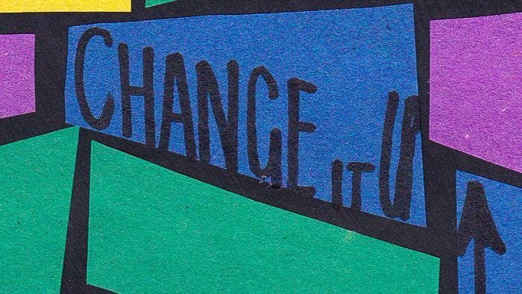What action does Jasirah take to help the reconciliation process?
2. Why did Jasirah decide to conduct the hug test?
3. Explain why Jasirah wants to increase trust between Indigenous and non-Indigenous people?
4. How is the school class in the story celebrating Reconciliation Week?
5. How does your school celebrate Reconciliation Week?

# Activity: Create a timeline

Next week (27 May to 3 June) is the beginning of Reconciliation Week in Australia, which starts on the anniversary of the 1967 Referendum and ends on Mabo Day. In this activity, students will create their own timeline which looks at key events in Australia’s reconciliation history.

As part of their research students will make a list of significant events that have helped move Australia towards reconciliation. For example:

* Mabo decision
* Native title
* The 1967 Referendum
* Bridge walk
* National apology
* *Close the Gap* campaign
* The handing back of Uluru to its traditional owners
* Aboriginal and Torres Strait Islander peoples able to vote in Federal elections.
* Racial Discrimination Act

After creating their timelines, students will choose one key event to explore in more detail and write a summary, which answers the 5 W’s – Who, What, Where, When and Why? To help with their research, students can explore the following BTN stories which look at significant events that have helped move Australia towards reconciliation. Students will then present their findings to the class.

|  |  |  |
| --- | --- | --- |
| [1967 Referendum](https://www.abc.net.au/btn/classroom/1967-referendum/10523010) | [What is a treaty?](https://www.abc.net.au/btn/classroom/what-is-a-treaty/10489008) | [Mabo Legacy](https://www.abc.net.au/btn/classroom/mabo-legacy/11143302) |
| [Bridge Walk Anniversary](https://www.abc.net.au/btn/classroom/bridge-walk-anniversary/12272786) | [Apology 10th Anniversary](https://www.abc.net.au/btn/classroom/apology-10th-anniversary/10521928) | [Constitutional Recognition](https://www.abc.net.au/btn/newsbreak/constitutional-recognition-explained/11370462) |

**Further learning**

The theme for Reconciliation Week 2021 is [More than a word. Reconciliation takes action](https://nrw.reconciliation.org.au/2021/03/23/more-than-a-word-reconciliation-takes-action/). Ask students to think about what the theme means to them and then discuss as a class. Ask students the following question: “*What future steps do you think Australia should take towards greater recognition of Aboriginal and Torres Strait Islander peoples?*”.

# Activity: Jigsaw learning activity

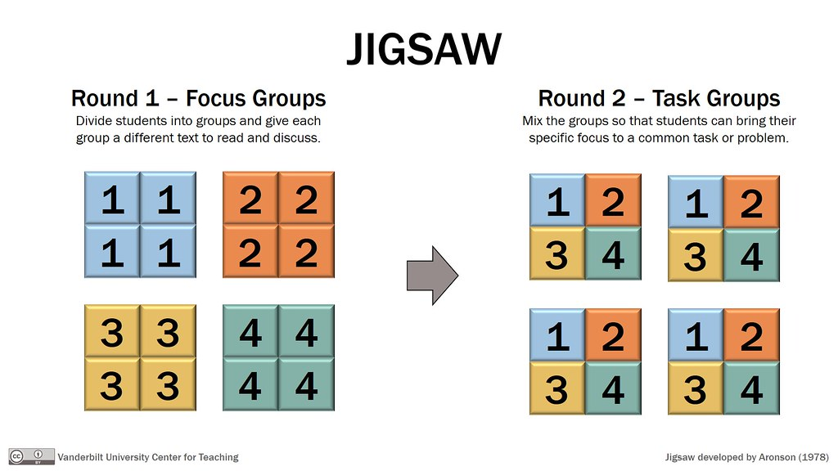In this activity students will work cooperatively to learn more about reconciliation in Australia. Each group will become experts and then share what they have learnt with other students.

|  |  |
| --- | --- |
| **Form groups** | Divide the class into 6 x Focus Groups (or more depending on your class size). Each Focus Group will be assigned a different event that has helped move Australia towards reconciliation (for example the Mabo decision, Native title, the 1967 Referendum, the Bridge walk, National apology, the handing back of Uluru to its traditional owners).  Each group will need to decide how they will collect and communicate the information they find during their research. |
| **Research** | Each Focus Group will respond to the following questions to become experts:   * What is the event? Describe what happened. * When did the event occur? * What did the event achieve? * Why is it significant? * How does it recognise Aboriginal and Torres Strait Islander peoples? * Is there a special day to commemorate the event? Explain how people celebrate this day. |
| **Share** | Mix the Focus Groups to form Task Groups (Tasks Groups include one student from each of the Focus Groups) to share the information they have collected. Students will share the information they have collected and learn from one another. |
| **Reflect** | Students will reflect on the activity by responding to one or more of the following questions:   * What did you find surprising? * What did you find challenging about this activity? * What questions do you have? |

# Activity: Recognise and Celebrate Indigenous Culture

Discuss with students, ways they could recognise and celebrate Aboriginal and Torres Strait Islander culture in their class or school. Some ideas are:

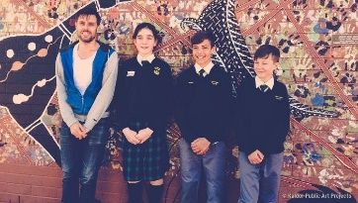Celebrate the traditional custodians of the land where you live. Who are the traditional custodians and what language/s do they speak? Explore more using this [map of Indigenous Australia](https://aiatsis.gov.au/explore/articles/aiatsis-map-indigenous-australia). Watch this BTN [Indigenous Art & Language](https://www.abc.net.au/btn/classroom/indigenous-art-38-language/10523528) story to meet some kids who recorded their voices in Wiradjuri, the traditional language they learn at school. Those recordings were then played as an important part of an art exhibition.

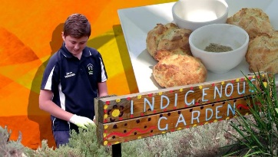Create a bush food trail/indigenous garden in your school. Find out if you have an indigenous food trail near your school that you could visit for inspiration and to learn about indigenous plants local to your area. Meet some kids in BTN’s [Bush Tucker Garden](https://www.abc.net.au/btn/classroom/bush-tucker-garden/11724674) story to learn about growing traditional Aussie foods and cooking them as well.

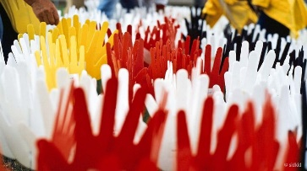Create a remembrance wall for the Anniversary of the National Apology. Use words to represent feelings, memories or write messages of commemoration for the Stolen Generations. Your artwork could be done in conjunction with an Indigenous artist in residence. Watch this BTN [Apology 10th Anniversary](https://www.abc.net.au/btn/classroom/apology-10th-anniversary/10521928) story to learn more.

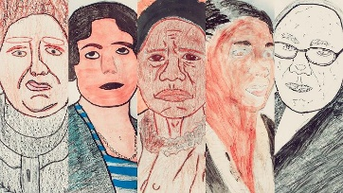Celebrate Aboriginal and Torres Strait Islander women who've made a difference and inspired others. Choose an Indigenous woman who inspires you and research in more detail. Share your findings with the class. Watch this BTN [NAIDOC Indigenous Women](https://www.abc.net.au/btn/classroom/naidoc-indigenous-women/10488838) story to learn more.

[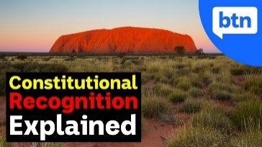](https://www.abc.net.au/btn/newsbreak/constitutional-recognition-explained/11370462)Recognition can make you feel valued, respected and that you belong. What does recognition mean to you? Create a presentation explaining what it means to you to be ‘recognised’. Constitutional recognition is something a lot of Indigenous people in Australia have been campaigning for, for a long time. But what exactly is it and why is it such a big deal? Watch BTN’s [Explainer on Constitutional Recognition](https://www.abc.net.au/btn/newsbreak/constitutional-recognition-explained/11370462) to learn more.

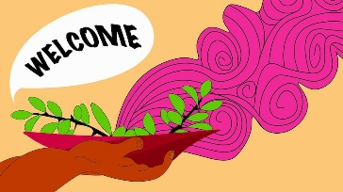

Have you held a Welcome to or Acknowledgement of Country at your school? Find out what the difference is between the two and why they are important in showing respect to and understanding First Nations people. Visit [Reconciliation Australia](https://www.reconciliation.org.au/wp-content/uploads/2017/11/Welcome-to-and-Acknowledgement-of-Country.pdf) for more info. [Read this ABC article](https://www.abc.net.au/everyday/why-acknowledgement-of-country-is-important-and-how-to-give-one/11881902) to find out why an Acknowledgement of Country is important (and advice on how to give one).

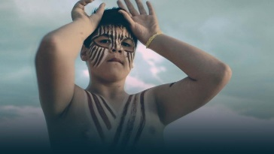Learn more about the dreaming trails in your local area. Use the internet to find out if there are any dreaming trails in your area that explain the creation theories of the traditional owners of the land. Meet Rookie Reporter Tyrone in this [BTN story](https://www.abc.net.au/btn/classroom/river-kids/10524662) to tell you what the river means to his people - the Ngarrindjeri.

# Activity: BTN stories – Indigenous Culture

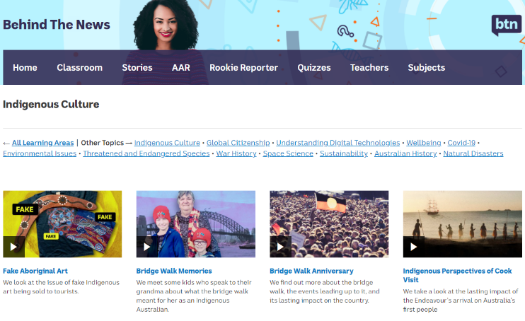Visit [BTN’s collection of stories](https://www.abc.net.au/btn/indigenous-culture/10576610) which focus on Aboriginal and Torres Strait Islander peoples’ culture and issues. After watching any one of the BTN videos ask students to respond to the discussion questions (to find the discussion questions and teacher resources go to the related BTN Classroom Episode and download the Episode Package). [**Collection of BTN stories about Indigenous culture**](https://www.abc.net.au/btn/indigenous-culture/10576610)

# Useful Websites

* [Bridge Walk Memories](https://www.abc.net.au/btn/classroom/bridge-walk-memories/12273000) – BTN
* [National Reconciliation Week](https://www.reconciliation.org.au/national-reconciliation-week/) – Reconciliation Australia
* [Mabo Legacy](https://www.abc.net.au/btn/classroom/mabo-legacy/11143302) – BTN
* [1967 Referendum](https://www.abc.net.au/btn/classroom/1967-referendum/10523010) – BTN
* [Black Lives Matter](https://www.abc.net.au/btn/classroom/australian-black-lives-matter/12344388) – BTN



Teacher Resource

**EPISODE 14**  
25th May 2021

**KEY LEARNING**

Students will learn more about the history of space exploration and investigate a space mission in depth.

**CURRICULUM**

**Science – Year 5**

The Earth is part of a system of planets orbiting around a star (the sun).

Scientific knowledge is used to solve problems and inform personal and community decisions.

**Science – Years 5 & 6**With guidance, pose clarifying questions and make predictions about scientific investigations.

Science involves testing predictions by gathering data and using evidence to develop explanations of events and phenomena and reflects historical and cultural contributions.

**China Space Race**

# Focus Questions

1. Discuss the BTN story as a class and record the main points of the discussion.
2. Which planet has China just landed a spacecraft on?
3. China is only the _______ country in the world to land a spacecraft on the red planet.
4. Which two countries began the space race?
5. In which decade did the space race begin?
   1. 1950s
   2. 1960s
   3. 1970s
6. What was the name of the first artificial satellite?
7. Which country sent the first human to space?
8. What significant space exploration event happened in 1969?
9. Name a private company that has been working on its own space program.
10. What do you think is the future of space exploration?

# Activity: Class Discussion

After watching the BTN China Space Race story, hold a class discussion using the following discussion starters. Use a mind map to record students’ responses.

* What are some reasons for humans to explore space?
* What is the space race?
* Is space exploration important? Why or why not?
* What are the advantages and disadvantages of space exploration?
* Is it important for Australia to be involved in space exploration? Why or why not?
* How has space exploration affected people’s lives?





**What questions do you have about space exploration?**

**Why should we explore space?**

# Activity: History of space exploration

Students will investigate the history of space exploration and present their research as a timeline, [infographic](https://www.canva.com/create/infographics/) or a [presentation](https://prezi.com/). Below are some key events in the history of space exploration

**1969**Apollo 11 Moon landing

**1957**Sputnik, first artificial satellite launched.

**1998**Launch of the International Space Station.

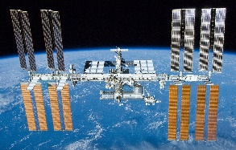

* 1957 – Sputnik, first artificial satellite launched into space
* 1961 – Yuri Gagarin, first person to enter space
* 1969 – Apollo 11, Moon landing
* 1990 – Launch of Hubble Space Telescope
* 1998 – Launch of International Space Station
* 2011 – Curiosity launches to Mars
* 2019 – First image of black hole released
* 2020 – Perseverance launches to Mars

**Further Investigation**

* How has technology used in space exploration changed over time?
* Imagine if you were the first person to land on the Moon. Write a journal describing your experience including the challenges you face on the mission.
* How have advancements in space technology helped us on Earth? Research an invention which has come from the Apollo 11 mission, for example microchips, insulation, cordless tools, satellite television and water filters. Research why the technology was needed for the Apollo 11 mission and how the invention helps us in our day-to-day living on Earth now.
* What types of careers are there in space exploration?
* Why do we have an International Space Station?
* How will space exploration change in the future? Make a prediction about how space exploration will change in the future. Illustrate your prediction/s and provide an explanation.

# Activity: Space Mission

Students will choose a space mission to explore in detail. Students can choose one of the space missions below or choose another mission.

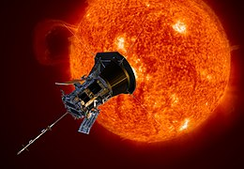

* International Space Station
* Perseverance Rover
* Hubble Space Telescope
* Parker Solar Probe

Students can use the following questions to guide their research.

* Briefly summarise the mission.
* When did the mission take place?
* What was the purpose of the mission?
* Who was the crew? What were their roles?
* What did the mission discover?
* Which countries were involved in the mission?
* How has the mission helped us understand space?
* What were some challenges of the mission?
* Include photographs and diagrams in your research project.

# Activity: Design and build your own spacecraft

Students will imagine they are the chief designer for an important NASA mission. Use this [NASA activity](https://spaceplace.nasa.gov/build-a-spacecraft/en/) to guide students during the design and building process.

NASA Video #1

Before students design their satellites, [watch this video](http://education.abc.net.au/home#!/media/1575299/and-now-to-build-the-satellite-) as a class to find out what an engineer might to do to select and test the components and techniques needed to build a satellite like NASA's MAVEN spacecraft.

NASA Video #2

Before students design their satellites, [watch this video](http://education.abc.net.au/home#!/media/1575255/getting-satellite-design-right) to find out some of the steps NASA took during the design review process for the development of a new satellite.

# Activity: Choose an Investigation

Students will choose one of the following projects to work on and then share their findings with the class.



**Earth, Moon & Sun**

What are the relationships between Earth, the Moon and the Sun? Draw a diagram showing the relative sizes and movement of Earth, the Moon and the Sun.

**International Space Station**

Find the current [location of the ISS](http://www.isstracker.com/). Mark the current location on a world map. Which country is the ISS nearest to?



**Apollo 11 and Parkes**

Investigate Australia’s involvement in the Apollo 11 mission. Watch this [BTN story](https://www.abc.net.au/btn/classroom/history-of-the-dish/11314076) to find out more.

**Astronaut Profile**

Research an Australian astronaut who has gone into space and create a profile of them.

# Useful Websites

* [China lands spacecraft on Mars](https://www.bbc.co.uk/newsround/57127234) – Newsround
* [China reports successful spacecraft landing on Mars, deploys rover in massive leap for space program](https://www.abc.net.au/news/2021-05-15/china-says-spacecraft-landed-on-mars-and-deployed-rover/100141680) – ABC News
* [Space Race](https://www.abc.net.au/btn/classroom/space-race/11313590) – BTN
* [Apollo 11 and Parkes](https://www.abc.net.au/btn/classroom/history-of-the-dish/11314076) – BTN
* [Space Future](https://www.abc.net.au/btn/classroom/space-future/11314118) – BTN
* [Mars 2020 Mission Overview](https://mars.nasa.gov/mars2020/mission/overview/) – NASA
* [Solar System Exploration](https://solarsystem.nasa.gov/missions/?order=launch_date+desc&per_page=50&page=0&search=&fs=&fc=&ft=&dp=&category=) – NASA
* [60 Years and Counting - The Future](https://www.nasa.gov/specials/60counting/future.html) – NASA
* [Science & Exploration](http://www.esa.int/Science_Exploration) – European Space Agency



Teacher Resource

**BTN Transcript: Episode 14 - 25/5/2021**

Hey. I'm Amelia Moseley and you're watching BTN. Here's what's coming up. We find out why supermarkets are breaking up with plastic, learn about the contenders in the new race to outer space and meet some kids in the beetle business.

**Israel and Palestine**

Reporter: Amelia Moseley

*INTRO: But first today to a region we've been hearing a lot about in the news lately and that's Israel and the Palestinian territories. It's an area with a long and complicated history that's seen a lot of conflict over the years and recent fighting there has had a big impact on a lot of people. Let’s find out more.*

For the past few weeks, this is what nights have been like for some people in Israel as rockets were fired from Gaza towards cities and towns.  
  
GIORDANA GREGO, TEL AVIV RESIDENT: You have about a minute to gather your children and run to the bomb shelter and then ah you just wait, and you hear explosions, and you just don't know. You check your phone and wait to hear some news.  
  
Israel has a missile defence system which stops around 90 percent of the rockets midair, but Gaza doesn’t, and Israeli bombs mostly hit their targets.  
  
LAILA BARHOUM, AID WORKER IN GAZA: So yesterday I was again in my room working and then there was an airstrike, a big sound, followed by my niece screaming. This is the international sign of children now in Gaza to close their ears, so they can’t hear the sounds.   
  
In the past two weeks, at least 13 Israelis and more than 200 Palestinians have been killed and many more injured in some of the worst fighting this region has seen in years. To understand what's going on, let's take a look at a map. This is Israel and here's Gaza and over here is the West Bank and East Jerusalem. They're known as the Palestinian territories. They have their own leadership and people here speak mostly Arabic, but not every country recognises Palestine as a separate state and for many decades there's been tension and violence between people in this part of the world.  
  
Let's go back to that map. Before 1948, there was no Israel. All of this area was known as Palestine and it was under the control of the Ottoman Empire and then Britain. The people who lived here were from different ethnic groups. The majority were Arab Muslims, but there were also Christians and Jews, all of which consider the area to be sacred. After the First World War, more Jewish people started to migrate there and buy land. Many wanted to create a Jewish state in the ancient home of their ancestors, but that led to tensions with the Palestinians who had lived on the land for a long time.   
  
Then came the Second World War and with it the Holocaust. Six million Jews were murdered by the Nazis in Europe and the world was horrified. After the war, the newly created United Nations came up with a plan to split Palestine into two states: one for Palestinians and one for Jews; including many Holocaust survivors. But the plan gave the much larger Palestinian population less than half of the land and Palestinian and other Arab leaders rejected it.  
  
In 1948, Jewish leaders declared Israel an independent state and fighting broke out. During the war, many Palestinians fled their homes and ended up as refugees in Gaza, the West Bank, East Jerusalem and neighbouring countries. By the end of the war the new Israeli state had claimed more land than the UN had originally assigned to them. In 1967 there was another war which Israel won, and then took control of Gaza, East Jerusalem and the West Bank. Since then, there've been times of violence. There have been some steps forward when it seemed like the two sides would work together to find a solution and some steps backwards.  
  
Today, many Palestinians are angry with the harsh rules and restrictions put on them by Israel. Israel controls Gaza's borders which makes it hard for people and things like food and supplies to come in and out. It has soldiers in the West Bank and over the years it's let more Jewish Israelis settle there. Palestinians who live inside Israel say they face discrimination.  
  
On the other side, Israeli Jews say they face a constant threat of violence. Since 2007, Gaza has been ruled by a militant group called Hamas which doesn't recognise Israel's right to exist. Israel blamed Hamas for firing the first rockets in this latest conflict and says, unlike Hamas' rockets, its air strikes are targeted and it's trying to avoid hurting innocent people. But many innocent people have been hurt and Israel's been criticised for using its much stronger military power against the Palestinians. Around the world, leaders have been calling for peace.  
  
ANTÓNIO GUTERRES, UNITED NATIONS SECRETARY-GENERAL: Fighting must stop.   
  
LINDA THOMAS-GREENFIELD, US REPRESENTATIVE TO UN: The United States calls on all parties to ensure the protection of civilians.  
  
T. S. TIRUMURTI, INDIAN REPRESENTATIVE TO UN: We urge both sides to show extreme restraint.  
  
Now to everyone's relief, that's happened. Last week, Israel and Hamas called a ceasefire and for now the fighting has stopped and many are hoping the peace will last.

**Upsetting News**

Now if you’re worried about that story or any other story you see in the news make sure you talk to someone about it. We’ve also got some resources on our website with tips for dealing with upsetting news. So, you can check that out.

**News Quiz**

Now, let’s test your news knowledge with a quiz. What country can you see here being hit by a powerful cyclone? It’s India. Cyclone Tauktae was a category three storm when it hit India’s west coast killing more than 100 people and causing a huge amount of destruction.

The world’s biggest iceberg has broken off the Ronne Ice Shelf into the Weddell Sea. Do you know where that is? Here in the Artic, or here in the Antarctic? It’s down south in Antarctica.

Can you name these noisy insects that have emerged by the billion in the US? Crickets, cicadas or cockroaches? They’re cicadas, periodic cicadas to be precise. This kind only live in North America and they only come out like this every 17-years.

US CITIZEN: They simply have been developing very slowly underground growing from the size of a grain of rice, to about this big and it’s going to take 17 years to do this.

And do you know which country won this year’s Eurovision song contest? It was Italy. Bravo guys.

**Plastic Pact**

Reporter: Amal Wehbe

*INTRO: Now to a new plan to combat plastic pollution in Australia and the Pacific. A bunch of supermarkets and big international companies have signed an agreement to get rid of single-use plastics by 2025. Amal can you tell more.*

AMAL: Look you know, there's actually something I've been meaning to talk to you about. This relationship, it’s not working. And I want to say it's definitely not me, and it's all you. Look, I know I used you in the beginning but, I just, I regret it now. You're just way too clingy. I see you everywhere and you're so suffocating and I’m not the only one that thinks so. We’re breaking up.   
  
It's a love affair that's been going on for a while: humans, and plastic. Since it burst onto the scene last century, plastic has become one of our favourite things to make things out of, and wrap things in. And there are good reasons for that. Plastic's cheap to make, and it lasts a really long time. Like a really, really long time.  
  
AMAL: You’re gonna be around for like at least 500 years. That's just way too much of a commitment for me.  
  
And while some of it gets recycled, most ends up in landfill or worse.

Every week these guys go down to their local beach and collect bits of rubbish, including plastic.  
  
KID 2: Plastic doesn't really go away, it just stays around.

KID 3: Some plastic gets washed up in the ocean and the animals will eat them and it's not good for them.  
  
Studies have shown that about 90 percent of birds have plastic in their stomachs. It's also being eaten by turtles and fish. And experts reckon if we don't do something about it there'll be more plastic than fish in the ocean by 2050. It's pretty clear that we have a plastic problem, one that lots of people have been working to solve.  
  
KID 4: We put plastics like these in a special bin and then we take it to Coles to get it recycled.

KID 5: We do nude food at school, so it’s basically we just get normal food, but we take away the plastic wrapper.  
  
Recently state leaders agreed to a plan to phase out single use plastics, like straws and cutlery and food containers, right around the country by 2025. And now, supermarkets and international manufacturers have agreed to tackle the problem here on the shelves. Last week more than 60 companies including Coles, Woolies, Coca-Cola and Nestle signed up to something called the ANZPAC Plastic Pact*.* They've agreed that by 2025, they'll get rid of unnecessary packaging in the products they make and sell, in Australia, New Zealand and the Pacific Islands. They've also promised that all of the plastic they use will be reusable, recyclable or biodegradable and more of it will be made from recycled material.  
  
It's taken three years to get the companies to agree to the pact. But some say it doesn't go far enough. You see, it's voluntary, so it'll be up to the businesses to see that they keep their promises. Some reckon it needs to be backed up with laws which would punish companies if they do the wrong thing. But others say it's good start and a sign that the big plastic break-up has finally begun.   
  
AMAL: No more excuses plastic. That was my last straw. We’re done.

**Ask a Reporter**

If you want to find out more about this story, I’ll be doing Ask A Reporter this week all about plastic. So, you can head to the website to find out more.

**Reconciliation Week 2021**

Reporter: Jack Evans

*INTRO: This week is the start of Reconciliation Week, which is a big celebration of Australia's Indigenous cultures. It also marks some really important milestones in Australian history. Jack found out more about it and how one school will be celebrating. Take a look.*  
They're an instrument you've probably heard before. Used by Australia's First Nations people for thousands of years and now, these guys have been learning how to make their own.   
  
ALICIA: Clapping sticks are used for like singing and dancing performances as traditional songs. And they also have multipurpose use of being used for like digging and harvesting food from the land. So we started early last term. We went around throughout all the community and we found like broken branches.   
  
JERVIS: We then all sanded them down with sandpaper and made the pointed ends with an electric sander. We're now up to engraving them, like burn them, and also painting them.  
  
These guys will be using their clapping sticks during a traditional Torres Strait Islander song and dance, that they've learnt as part of a special celebration at their school.  
  
LIVY: We're doing FRINGDIGENOUS. It's a mix between the Adelaide Fringe and Indigenous culture. We've got we've lined up food trucks and traditional artists to come and we've got people painting our preschool water tank. And we've also got some musicians coming in.  
  
It's going to be just one of the hundreds of celebrations held around the country. As Aussies come together to celebrate Reconciliation week.

JERVIS: Reconciliation is a celebration of the culture diversity. We're very lucky to have an amazing Aboriginal community education officer here. And everyone who is really supportive and everyone who kind of comes together and celebrate this on a daily basis, pretty much, but to have a celebration with the community. I think it's very special.  
  
As well as being a celebration, Reconciliation Week marks some really important dates in Australia's history. It starts on the 27th of May, which is the anniversary of the 1967 Referendum. When 90 percent of Aussies voted to change the constitution to make sure Indigenous people were counted as Australian citizens. It ends on the 3rd of June, also known as Mabo Day. It marks the day, Meriam man, Eddie Mabo successfully convinced the High Court of Australia that Indigenous people had rights to land their ancestors had lived on for 1000’s of years.   
  
Of course, there have been many other big milestones for reconciliation in Australia.

KEVIN RUDD, 26TH PRIME MINISTER OF AUSTRALIA: As Prime Minister of Australia, I am sorry.

But despite the steps forward many say we still have work to do to bring about equality and justice for all Australians. That's why Reconciliation Week is an important time to come together to listen and learn from each other.  
  
ALICIA: It's important to celebrate Reconciliation Week because we're all one community.  
  
LILY: Reconciliation is about building community awareness and recognition of how the Aboriginal and Torres Strait Islander people were treated during colonisation. It is an ongoing journey that reminds us all about how the Aboriginal people had to fight hard for a meaningful way in how they were treated.   
  
BROCK: They were here first, and their traditions are very important to this land.  
**China Space Race**

Reporter: Amelia Moseley

*INTRO: Now let's leave Earth for a bit and head to Mars. Last week we got the first pictures back from the Zhurong rover, China's first ever Martian space craft. It's only the third country to successfully land on the surface and some reckon it's a giant leap forward in the new race to space. Check it out.*This was the moment everyone at China's space agency had been crossing their fingers for, the successful landing of a spacecraft on Mars.  
  
SCIENTIST, CHINA NATIONAL SPACE ADMINISTRATION: We've been waiting for the landing since yesterday morning. We've been on edge and I've only slept an hour.   
  
While space exploration is usually a big deal for us earthlings, this feat was an extra big deal because China is only the third country in the whole world to land a spacecraft on the red planet. Oh, and only the second behind the US to successfully send a rover out here. But both the US and China say they aren't stopping there. The plan is to send humans to Mars, possibly as soon as the 2030s and some reckon that's all sounding like a good old fashioned race to space or space race, if you will.  
  
Yeah, we've been here before. Well, not here but here. In the 1950s, the two most powerful countries in the world were the US and Soviet Union which was a group of states including Russia. They were political rivals that started taking their rivalry all the way to space. At first, the Soviet Union took the lead launching the first satellite into space and then the first human. But then the US set an even bigger goal.  
  
JOHN F KENNEDY, FORMER US PRESIDENT: We choose to go to the moon in this decade.  
  
And in 1969, well, you know who won this race.   
  
BUZZ ALDRIN, ASTRONAUT: One small step for man. One giant leap for mankind.  
  
Today, these are considered the biggest government space agencies in the world. There’s NASA, the European Space Agency, and Russia, India, China and Japan's space agencies. But there's another up-and-coming competitor, private companies. SpaceX and Virgin Galactic and many others have been working on their own space programs; from ferrying people into earth's orbit on private shiny ships, to being the first to launch rockets and land them safely down again. Umm, after a couple of goes, there we go.  
  
SPACEX: We are down the starship has landed.  
  
And many are working on missions to Mars. Space and getting there is an expensive business, but it can also be big business and for countries it can mean more jobs, more money and, if history has taught us anything, more prestige. Which is why the race to the red planet is on starting with unmanned missions. NASA has two working rovers on the surface, Perseverance and Curiosity, and now they've been joined by this little guy, Zhurong. China’s rover will spend 90 days exploring the planet, looking for water beneath the surface which could point to signs of ancient life. And every discovery is another small step forward, not just in the new space race, but hey, for all of humankind.

**Did You Know?**

Do you know the name of this Russian man who was the first human who ever went into space? It's Yuri Gagarin.

**Sport**

It's game over for the Aussie Olympic skateboarding team. Three team members tested positive for COVID-19 and the rest have had to go into quarantine after they travelled to the US to compete in a qualifying event. It was their final chance to earn a spot at the Tokyo games but the whole team was sadly disqualified.  
After nearly a year of training and experimenting, Simone Biles has made gymnastics history. The Olympic champion landed the Yurchenko double pike at the US Classic Gymnastics event. It's a move that had only ever been done in a competition before by men.

SIMONE BILES, US GYMNAST: I’ve been working so hard on it in the gym, and to finally just put it out in competition, was really nice.  
  
In Formula 1, Max Verstappen has won the Monaco Grand Prix with special guest, Serena Williams, waving the chequered flag. Verstappen has now taken the championship lead from 7 time world champion Lewis Hamilton, but for Aussie Daniel Ricciardo things didn't go so well. He ended up finishing the race in twelfth.  
  
**Calligrapha Beetle Business**

Reporter: Amelia Moseley

*INTRO: And finally, today to the NT where some kids have started their own, very unique business, selling beetles. Let’s find out more.*

Jack and Kelly are in the business of hunting for beetles. But not just any old beetles.  
  
JACK: We got in the car coming home from school and mum's like you know those beetles that we used to find, we can make 2 dollars off of it for every beetle, I'm like "Ooh."   
  
Yep, these pretty little creatures are worth a pretty penny. They're Calligrapha beetles, also known as Sida beetles and they're actually native to Mexico. They were introduced into the Northern Territory more than thirty years ago to do a very important job, helping to control the spread of this pesky introduced plant. It's called Sida weed and it's a big problem for farmers in the Top End, especially during the wet season when it grows up to 1.5 metres high and stops livestock from being able to graze on grass. That's where the beetles come in as a great alternative to harsh chemicals.  
  
SALLY ISBERG, JACK AND KELLY'S MUM: The Calligrapha beetle is the perfect biological control because it only eats Sida. So once that Sida weed population is gone it doesn't eat anything else, which makes it perfect for the purpose of what we are doing.  
  
Once Jack and Kelly learned about the beetles, they thought they'd give farmers a hand by collecting them on their own property and selling them in batches.   
  
JACK: I have always been dreaming of starting my own business. I didn’t know these bugs were worth 2 dollars each.   
  
And finding the bugs is pretty easy, they just look out for Sida plants.  
  
KELLY: We get the beetles, and we collect them in. And then every time we get one, we then use this button to click and once we are done, we fill up this bucket of Sida weed and then we put the Calligrapha beetles in there and pass them on to the farmers.   
  
So far, they've sold around 150 beetles to their neighbours and after that it's up to the hungry little insects to do their part.  
  
JACK: It was astonishing that in a few weeks a single colony of Sida beetles could wipe a bunch of Sida and make it into just sticks growing out of the ground.  
  
A great solution to a problem that's been bugging a whole lot of people.

**Closer**

Awesome guys. Well, that's all for today. But we'll be back with more next week and in the meantime, you can check out our website for more stories and teacher resources and specials. There are also new Newsbreak episodes every weeknight. And if you're 13 or over, don’t forget you can subscribe to our YouTube channel. Have a great week and I’ll see you next time. Bye.