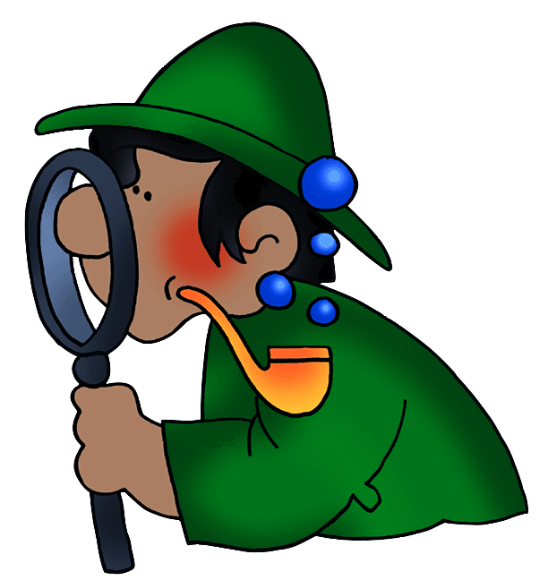
Managing Behaviour
… finding the middle ground
How to have reasonably behaved children and teachers most of the time.

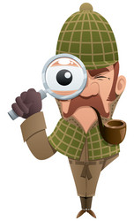
How can I change a child’s behaviour?

Short answer, you can’t! So, you should stop reading now right? No! It is possible to bring about change in a child’s behaviour, you just need to know how and work with them. In truth, there is only one person whose behaviour you can change and that is you. So, let’s start with you and see what you might be able to change that will have a positive flow on to your children and / or students.

All human behaviour satisfies needs – our needs as adults and their needs as children. These needs are
Basic needs for food, shelter and rest;
Love or belonging;
Power – not power over others, but power to make choices in their world;
Fun – we all need to play and laugh; and
Freedom – in making choices for good options.

Children need to be guided showing them positive ways to achieve their needs.

Let’s get some questions answered, first shall we?

You need to be really honest now … seriously! Put a tick or cross in the box that reflects your current action/s:

I / We have a set of rules which we set together and which apply to us all equally.
The rules are on display for all to see.
I / We refer to the rules if misbehaviour begins to occur.
There are known positive consequences for sticking to the rules – after all good things should happen to good people.
There are known negative consequences for breaking the rules. Bad things ought to happen when people choose bad behaviour. The consequences should be either natural – you were told not to run on the concrete, you did and now you have a big scrape on your leg – or logical – you knocked the water and paint brushes over being silly, so now you clean the mess up.
The rules are consistently applied. It does not matter if they come up with a ‘reason’, rules are rules for everyone.
You are careful to target the correct behaviour and the correct offender.
You make time for regular conferences to discuss the rules. There may be emerging patterns of misbehaviour that you want to nip in the bud, or you might want to seek student input as to whether some rules or consequences need to be reviewed.

Why do children misbehave?

Children engage in behaviours which we may not like and so view as misbehaviours for a wide range of reasons.

They don’t know what’s appropriate.
They have no rules to set boundaries for them.
You are inconsistent in your application of rules and consequences.
You are sending mixed messages – sometimes you find a behaviour funny and sometimes you’re annoyed by it – or you let one child get away with something and get cross with another.
You have picked the wrong child to get cross with – targeting the wrong player – they will take their anger out on you!
They are engaging in attention seeking behaviour – sometimes a child will choose bad attention over no attention at all. If attention seeking does not work they may ‘up the ante’ to power seeking (power over others), revenge seeking (destruction of others’ fun, game or possession/s and finally, displaying inadequacy – after they have tried all these means to get your attention and failed, they may behave as if they can do nothing and will no longer engage at all.
They mimic adults of other children whom they have seen ‘get away’ with inappropriate behaviour. For example, they see you laugh at a joke with swearing in it, but chastise them for swearing.
Children do not have enough life experience to know what the possible outcomes of inappropriate behaviour choices may be – it is our job to teach them this.
You might have caused the problem by engaging in long lectures, using physical threats, loud voice, physical contact – these are all road blocks to working out a peaceful solution.
You fail to model appropriate responses in similar situations.

How can I help children to make good behaviour choices?

There are three related elements to consider to bring about positive behaviours.
- Preventive – preventing misbehaviour before it starts;
- Supportive – supporting children in making good behaviour choices; and
- Corrective – correcting misbehaviours already evident.

Preventing misbehaviour

- Have rules. Rules should be written in simple positive language – ‘Speak kind words’ – that states what you do want them to do. Avoid negatives – ‘Don’t yell!’ – young children do not understand negatives and hear only the instruction ‘yell’. Instead use, ‘Speak in little inside voices when in our learning space’. No more than 5 rules please or it gets very confusing!
- Have known consequences:
Positive – if all rules have been kept for the day by everyone, then you might get a gold star for the chart. If you get a week’s worth of stars (5 stars) then there may be a surprise like a popcorn party or a fruit juice frozen icy pole or something else they value.
Negative – if rules are broken, there must be a negative consequence – negotiate these together – try to ensure that they are fair, natural or logical. Rules apply to the teacher too!
- Be clear and succinct – state what the problem is – keep the word ‘you’ out of it – avoid long lectures, theyll turn off. State the situation – there are people borrowing pencils and not returning them – that is not a loan, that is theft. I’m going to close my eyes for 15 seconds and I’d like all the borrowed pencils returned.
- Be firm but fair – a great flood of tears should not get someone out of a consequence – they must be upheld by all and for all.
- Never be physically rough – children may well retaliate (the fight or flight reflex) if they believe they are being physically threatened.
- Be timely – deal with the problem when it happens (when it’s small), don’t allow it to grow into something bigger and don’t dredge up old issues – nothing is served by not forgiving and dredging up old incidents over and over. Each day is a new start to write on afresh … for us ALL.
- Be able to multitask – while writing on the white board also be sweeping to room for off task behaviour and deal with it quickly and without fanfare.
- Have ‘eyes in the back of your head’ and always be aware of what is happening around you. Catch a small issue and redirect it before it becomes a big problem.
- Have routines and procedures in place so that the children always know what is supposed to be going on when. These lead to a happy life for all – put things away after Maths or Art, get a sharp pencil ready before handwriting, have set squares and geometry equipment ready for Maths on Tuesday etc. Have a large timetable for the children to check and prepare.
- Encourage independence in the children – show them how to do things or how to check the spelling of a word or find a better word to use. Have Maths rules on charts about the room as well as other subject resources. Time spent waiting for teacher attention is potentially time for mischief – prevent this.
- Be alert to the changing moods, interests and needs of the children – stop and refocus, get the wiggles and jiggles out, play a quick game to refocus – have a quick quiz on what you’ve covered.
- Correctly target the source of misbehaviour – get the wrong person and they are going to be rightfully angry!
- Catch them being good – when you see them doing the right thing acknowledge them – Thanks Jon I can see you’ve finished with that puzzle and a ready to put it away – that’s really helpful! Sally you’re sharpened the pencils in the jar for everyone – that was very kind of you! They get to feel good and so do you because it’s positive and warm and makes everyone feel better.

Supporting good behaviour

Supportive approaches to behaviour require us to:

- Implement practices that support good behaviour once it has been established – have rules and routines and no matter how busy or tired you are always follow through with them – it becomes easier once it becomes a habit.
- Catch them being good – it’s easy to catch children doing the wrong thing, now try catching them doing the right thing. It’s fun for you and for them and it gives you an opportunity to acknowledge effort – ‘Pete, thank you so much for helping out while I was working with others!’ – ‘Jenny thank you so much for showing Sally where to find the spare colouring pencils!’ – ‘Tim thank you for speaking so calmly to Jack when he was messing up the quiet area’. You’ll need to find out who likes public acknowledgement and who would prefer a private word in their ear – not all like to be on show.
- Assist the children in making good behaviour choices. Remember, children don’t have enough life experience to recognise what might, in the longer term, be a bad choice. They may think that cutting up the fruit for the heath unit on the desk is helping – you need to explain why we use a cutting board and how it ensures a clean surface and why using a knife needs to be with adult help as some skins are tough – like watermelon or pineapple – and may slip and cause injuries.
- Recognise and model appropriate behaviours – being reasonable, not raising your voice, keeping your hands and feet to yourself, using appropriate language and so on.
- Use incentives – rewards, group or class rewards, stickers – to recognise good behaviour. Don’t think of these as bribes, imagine your own situation, you love teaching, but if they stopped paying you, you’d probably stop. Never take any rewards away – they have been given – just explain that ‘I can’t give you a sticker right now because of behaviour choice you made. Once you can show me that you won’t choose to behave that way again, we can pick up once more.’
- Assist the child to see the potential outcomes of their behaviour choices. Find a quiet spot and discuss this gently in a calm and quiet voice. For example – ‘We have a run about only walking on the concrete, if you are running and fall you are going to scrape your skin badly if you fall.’
- Assist the child/ren to own their own behaviour and its consequences – ‘What are you doing?’ (You’ll need to persevere here as they will probably answer ‘Nothing’.) Once they have identified their behaviour ask calmly ‘Is this helping you or the rest of the class?’ Follow up with ‘What might happen if you keep doing this?’ Once they identify possible consequences ask ‘What should you be doing?’ If they cannot identify what they ought to be doing, redirect their behaviour and move on.
- Ensure that consequences – positive and negative – always follow action.
- Deal consistently and persistently with behaviour – both good and bad. Never play favourites with children – everyone is equal.
- Use non-intrusive techniques for dealing with off-task behaviour including non-verbal techniques. Children will always look at the adult involved before doing something naughty – we don’t know why – this is a good time for a finger to the lips, a shake of the head, a mime of turning the volume down.
- Remember always to remind the children that you like them, it’s the behaviour that you do not like and want them to stop. You can use this technique with your own children at home – ‘Janey, I love you and I always will, but the unmade bed each day is not acceptable and must change. Can I help you to make better choices and plans in the morning so you have time to do this?

Correcting misbehaviour

It would be nice if we never had to correct misbehaviour, but it will happen from time to time and we need to find ways to reduce frequency.

Corrective approaches require us to:

- Implement techniques which deal with present behaviour and its causes. Don’t keep old scores, children will rightly resent you for it – each day is a fresh page.

- Correctly identify the person or persons requiring attention.
- Apply a consequence to the misbehaviour that relates to it. Think of this as being either a natural or logical consequence. A natural consequence would be falling over and scraping a knee after being told not to run on the concrete. While giving first aid, make the link between the rule and the consequence of not following it – remind them not to repeat their actions. A logical consequence would be where a child has been asked not to reach over everyone to the paint brush cleaning bucket and continues knocking over the brushes and the water. They would be required to mop up the water and refill the brush bucket and return the brushes. As they are doing so, you would discuss with them how their actions led to the problem and why they are fixing it up.

- Always help the child to plan a better action for next time – this should always be part of the discussion. It is very important for the child to see the link between action and consequence. Take time out to sit comfortably eye to eye with the child and really talk it through. This is not punishment time, this is one-to-one time for making better plans.

- Ensure consequences are used consistently with all the children. This is harder than it seems – we’re human and we’re flawed – try not to let the children know that you’re tired, cross or distracted.

Barriers to managing behaviour effectively

We’ve all been guilty of these – the trick is being alert to when we do so that we can recognise these errors and avoid them in future.

These are true roadblocks to positive communication.

Judging:

- Criticising – judging negatively the actions of other;
- Name calling – labelling others – never call the child silly, the behaviour choice they made might have been silly, but they are not;
- Diagnosing – probing for hidden causes constantly (home life, expectations, friends etc); and
- Praising evaluatively – using praise to manipulate the children – ‘Oh you are my favourite girl in the class for sitting up straight and tall and waiting quietly.’ This might be better stated as ‘I can see that there are people who have tidied up and are sitting waiting quietly to find out what we are going to do next.’

Sending Solutions:

- Ordering – demanding action, not seeking solution – ‘You go and stand in that corner and face the wall!’;
- Threatening – implied forthcoming punishment – ‘You’re not going to go for morning tea, you’re going to stay right here with me and we’ll see what happens then!’
- Moralising – preaching your own brand of solution – ‘Now when I was your age I would never have spoken to a teacher like that. We had respect in those days, we knew what to do and when to do it and we knew when to keep quiet!’
- Excessive questioning – you are having a discussion not taking part in an interrogation; and
- Advising – always suggesting ways for others to behave – you need to ensure that they are making behaviour choices and owning their own behaviour, then the solution will be theirs and they will be more likely to stick to it.

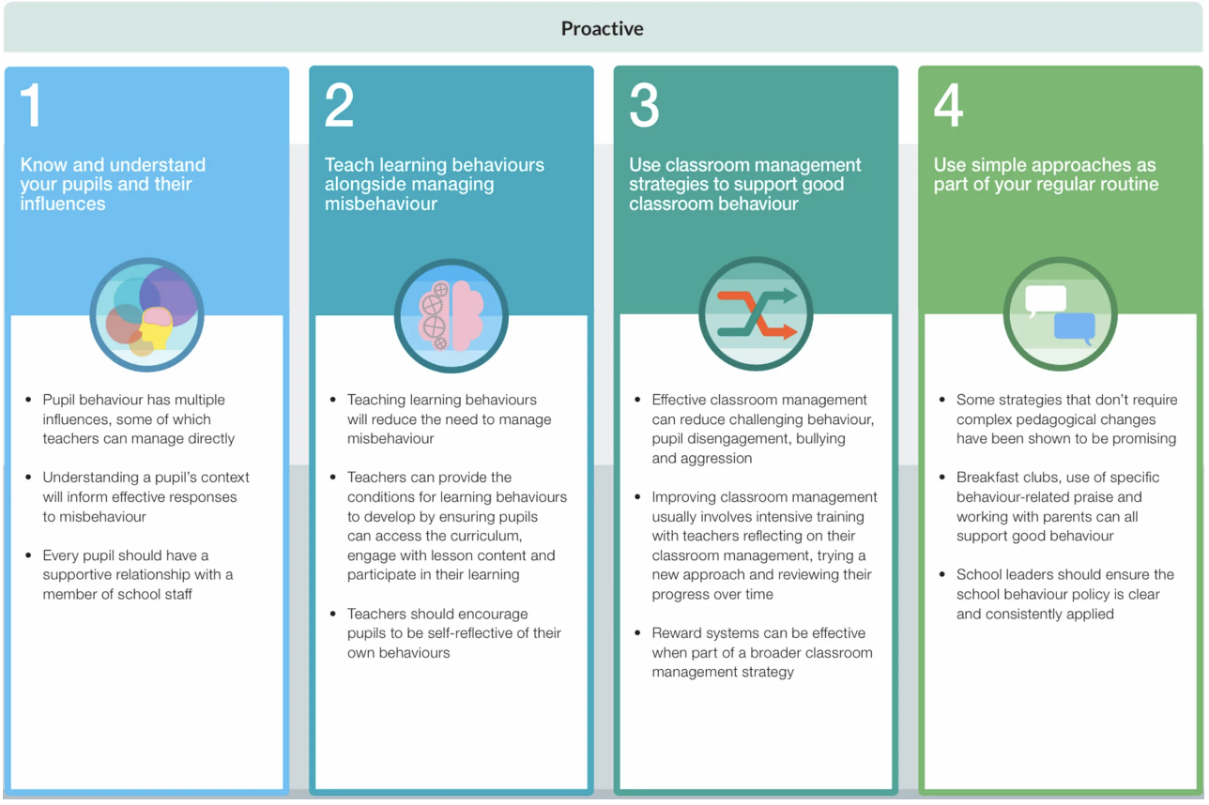
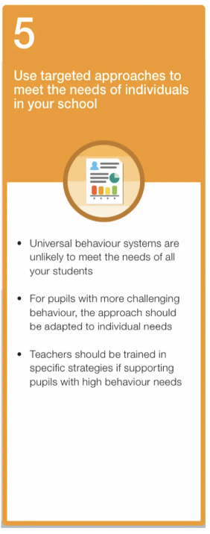
If proactive strategies alone are not working, then you may need reactive or corrective strategies. Consequences would escalate in line with the nature of the behaviour problem.

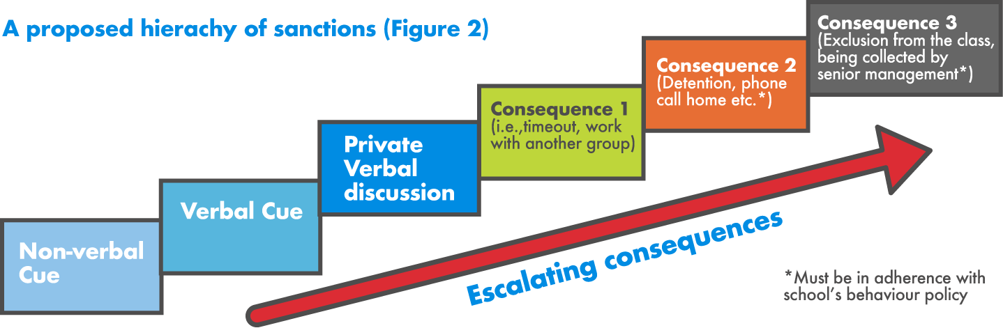

That’s a very quick wander through behaviour
management.

Importantly, be positive and consistent. Your goal
is to give them ownership of their behaviour and
its outcomes – positive and negative.

Remember, you too are a work in progress and may
make errors, if you do, acknowledge them and make a plan to address the issue.

Best of luck with your new directions!

Sue-Belinda Meehan

