EPISODE 14
30th May 2023

KEY LEARNING
Students will view a range of BTN stories and use comprehension skills to respond to a series of focus questions.

CURRICULUM
English – Year 4
Use comprehension strategies to build literal and inferred meaning to expand content knowledge, integrating and linking ideas and analysing and evaluating texts.

English – Year 5
Use comprehension strategies to analyse information, integrating and linking ideas from a variety of print and digital sources.

English – Year 6
Use comprehension strategies to interpret and analyse information and ideas, comparing content from a variety of textual sources including media and digital texts.

English – Year 7
Use comprehension strategies to interpret, analyse and synthesise ideas and information, critiquing ideas and issues from a variety of textual sources.
  - Teacher Resource

Focus Questions
As a class, discuss the stories featured in the episode of BTN Classroom and record the main points of the discussion. Students will then respond to the following focus questions.

Calling Out Racism
- What is racism? Find a definition.
- Why has ABC journalist Stan Grant stepped away from his job for a while?
- In a survey conducted last year, what percentage of Aboriginal and Torres Strait Islander people experienced racism?
  - 20%
  - 40%
  - 60%
- Why have some social media platforms been criticised about the issue?
- What do you think can be done to fight racism?

Animal Testing
- Why was testing cosmetics on animals introduced?
- When did the public start questioning the testing of products on animals?
- What alternatives to animal testing are available?
- Testing cosmetics on animals is banned in Australia. True or false?
- How did this story make you feel?

Volcanoes Explained
- The word volcano comes from the word Vulcan, the Roman god of ___________.
- Where is the Popocatépetl volcano?
- What is another word for molten rock?
- Explain what a pyroclastic flow is and why are they dangerous?
- There are no active volcanoes in Australia. True or false?

Check out the teacher resource on the Archives page.

Andy Warhol
- Who was Andy Warhol. Give three facts about him.
- What is pop art?
- In which decades did the pop art movement come about?
  - 1940s and 1950s
  - 1950s and 1960s
  - 1960s and 1970s
- What mediums did Warhol use to create his art?
- Do you like Warhol’s art? Why or why not?

Check out the teacher resource on the Archives page.

Drop Bears
- Before watching the BTN story, had you heard of drop bears? Record what you know.
- Summarise the BTN Drop Bears story.
- In your own words, describe a drop bear.
- What have researchers discovered recently about the Nimbadon?
- Create your own mythical creature.

EPISODE 14
30th May 2023

KEY LEARNING
Students will investigate the characteristics of volcanoes and what causes volcanoes to erupt.

CURRICULUM
Science – Year 6
Sudden geological changes and extreme weather events can affect Earth’s surface.

Science involves testing predictions by gathering data and using evidence to develop explanations of events and phenomena and reflects historical and cultural contributions.

Scientific understandings, discoveries and inventions are used to solve problems that directly affect peoples’ lives.

Scientific knowledge is used to solve problems and inform personal and community decisions.

Science – Years 5 & 6
With guidance, pose clarifying questions and make predictions about scientific investigations.

Science – Year 7
Identify questions and problems that can be investigated scientifically and make predictions based on scientific knowledge.

Collaboratively and individually plan and conduct a range of investigation types, including fieldwork and experiments, ensuring safety and ethical guidelines are followed.
  - Teacher Resource

Volcanoes Explained

Focus Questions
Discuss the BTN story as a class and record the main points of the discussion. Students will then respond to the following:
- The word volcano comes from the word Vulcan, the Roman god of ___________.
- Where is the Popocatépetl volcano?
- What is another word for molten rock?
- Explain what a pyroclastic flow is and why are they dangerous?
- There are no active volcanoes in Australia. True or false?

Activity: Class Discussion
Discuss the BTN Volcanoes Explained story as a class. Ask students to record what they know about volcanoes. What questions do they have? Use the following questions to help guide discussion:
- What are volcanoes?
- What words would you use to describe volcanoes?
- What causes a volcano to erupt?
- Who studies volcanoes and why is it important to study volcanoes?

Activity: Questions and Answers
Are you curious about volcanoes? Students will make a list of questions they have about volcanoes and learn why it’s important to understand volcanoes. Students will use the internet to find answers to their questions.
Who studies volcanoes?
What are volcanoes?

Activity: Research project
After watching and discussing the BTN Volcanoes Explained story, what questions do students have and what are the gaps in their knowledge? The following KWLH organiser provides students with a framework to explore their knowledge on this topic and consider what they would like to know and learn.

What do I know? | What do I want to know? | What have I learnt? | How will I find out?

Act like a volcanologist
Students will start to think like scientists and develop their own question/s for inquiry, collecting and recording information from a wide variety of sources. Students may develop their own question for inquiry or select one or more of the questions below.
- What is a volcano? Why do they happen?
- What is the tallest volcano? Create a profile on the volcano.
- How do you know a volcano is going to erupt? Explain using your own words.
- What is the connection between volcanoes and tectonic plates?
- What impact can volcanic eruptions have on people and the environment? Consider the negative and positive effects.
- What are some of the main risks during a volcanic eruption? What is the most dangerous aspect of a volcano?
- What are the different layers of a volcano? Draw a cross section of a volcano showing the following features: crust, mantle, crater, magma chamber, magma, ash, cloud, vent.

Activity: Map Maker
MapMaker is an interactive mapping tool for exploring the world through a variety of data layers. Students will use National Geographic’s MapMaker to interpret geographic information about the world’s volcanoes.

Students will investigate the world’s volcanoes using MapMaker.
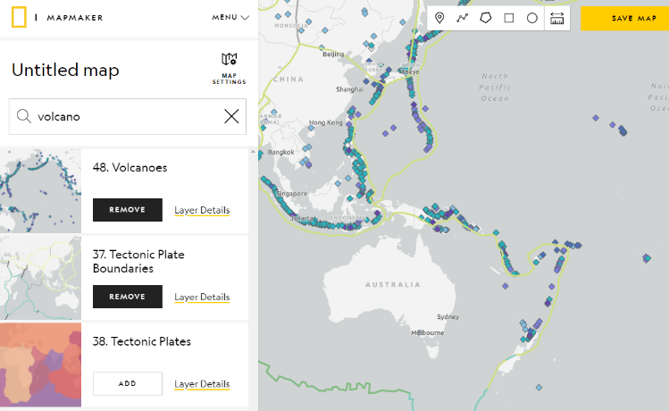
- Open MapMaker.
- Search for ‘Volcanoes’ in Layers.
- Add the Volcanoes Layer.
- Experiment with adding and removing different layers, including Volcanoes, Tectonic Plate Boundaries & Tectonic Plates.
- Show the legend. Explore the different types of volcanoes, tectonic plates & tectonic plate boundaries. Adjust the opacity level for each layer.

Further Investigation using MapMaker
- What are the different types of volcanoes?
- Where are the majority of the world’s volcanoes located?
- What do you notice about the location of the world’s volcanoes and tectonic plates?
- What is the name of the tectonic plate which covers Australia?
- Find the Ring of Fire on the map.

Activity: Ring of Fire
Students will investigate the geography of the Ring of Fire. Students will gather geographical data and make connections between the location of volcanoes and tectonic plates. Students can use the world map at the end of this activity to record their findings.

On a map of the world students will locate and highlight the following geographical data:
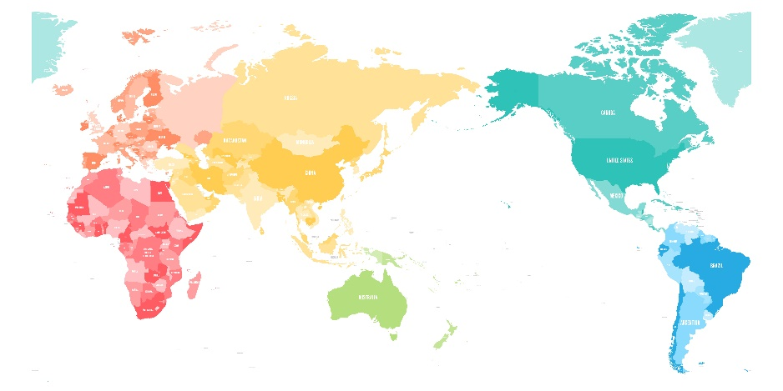
- Draw the Ring of Fire on your map.
- There are many active volcanoes along the Ring of Fire. Identify some well-known volcanoes and mark on the map (for example, Mauna Loa, Popocatépetl, Mount Fuji, Mount Tambora, Mount Pinatubo & Krakatoa).
- Circle nearby cities and towns to each of the volcanoes you mark.
- Draw the major tectonic plate boundaries.
- What ocean is in the path of the Ring of Fire? Label on your map.
- Locate and label Marianas Trench.

Further investigation
Students will respond to one or more of the following:
- What shape is the Ring of Fire?
- How long is the Ring of Fire?
- What tectonic plates sit on the Ring of Fire?
- What percent of the Earth’s active volcanoes are located on the Ring of Fire?
- What countries are located near or on the Ring of Fire?
- What is an ocean trench? Why are there so many trenches in the Ring of Fire?

Activity – Jigsaw learning
In this activity students will work cooperatively to learn more about Earth’s volcanoes. Each group will become experts and then share what they have learnt with other students.

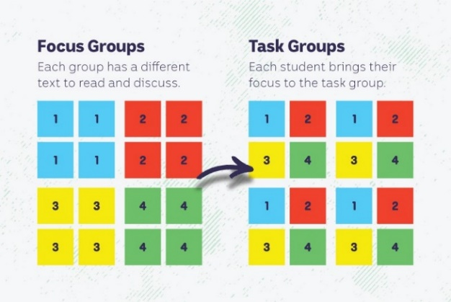
Form Groups
Divide the class into 4 x Focus Groups. Each Focus Group will be assigned a different volcano to study. Below is a list of volcanoes to choose from:
- Mount Vesuvius (BTN story)
- Popocatépetl
- Hunga Tonga-Hunga Ha'apai (BTN story)
- La Palma (BTN story)
Each group will need to decide how they will collect and communicate the information they find during their research.

Research
Each Focus Group will respond to one or more of the following questions to become experts:
- Where is the volcano? Find on a map.
- What type of volcano is it?
- What is the history of the volcano?
- Think of an interesting way to teach other students about this volcano. You could draw a cross-section of the volcano or create a diorama.

Share
Mix the Focus Groups to form Task Groups (Tasks Groups include one student from each of the Focus Groups) to share the information they have collected. Students will share the information they have collected and learn from one another.

Reflect
Students will reflect on the activity by responding to one or more of the following questions:
- What did you enjoy about this investigation?
- What did you find surprising?

Activity: Reading rocks
Provide your students with opportunities to examine rocks and make observations about them. Students may want to bring rocks in from home or you can explore the environment around your school and collect a small sample of rocks. Challenge your students by asking them to bring in a piece of volcanic rock to school (e.g., obsidian, pumice or granite).

Spark a discussion about rocks in your classroom by using one or more of the following questions. Record your students’ responses on a mind map, with the word ROCKS in the centre.
Discussion questions:
- Have you ever looked at rocks or collected them?
- Where would you look to find rocks?
- What do rocks feel and look like? Describe the characteristics of rocks. Are they heavy or light? What colour are rocks? Do they have texture?
- How are rocks the same and how are they different?
- What can you use rocks for?
- What is the relationship between rocks and volcanoes?

Encourage students to discuss what they already know about rocks and prompt them to ask questions they might have about rocks. Record your students’ responses on a KWLH chart.

Activity: BTN Stories
These BTN stories look at the impact that volcanoes have on people and the environment. After watching any one of the BTN videos ask students to respond to the discussion questions (to find the teacher resources go to the related BTN Classroom Episode and download the Episode Package).

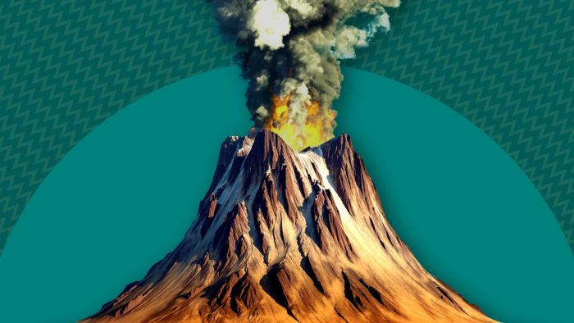  Volcanic Activity | 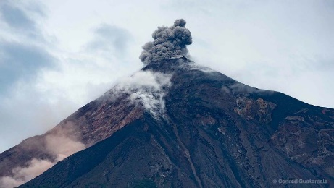  Volcanoes Explained | 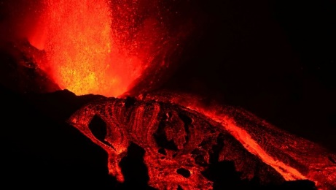  La Palma Volcano
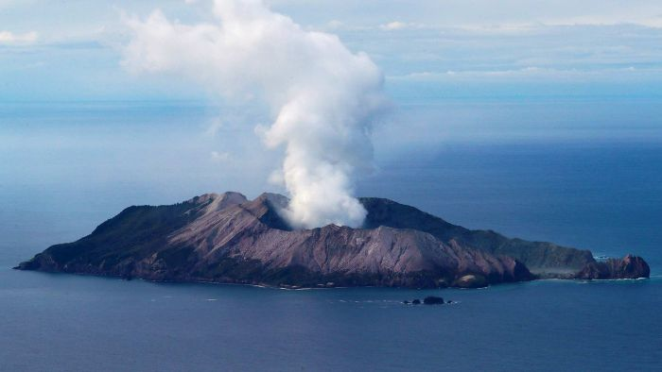  Volcano Warning | 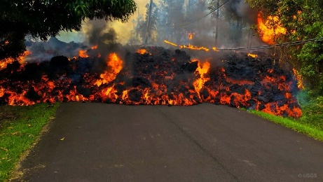  Hawaii Vaolcano | 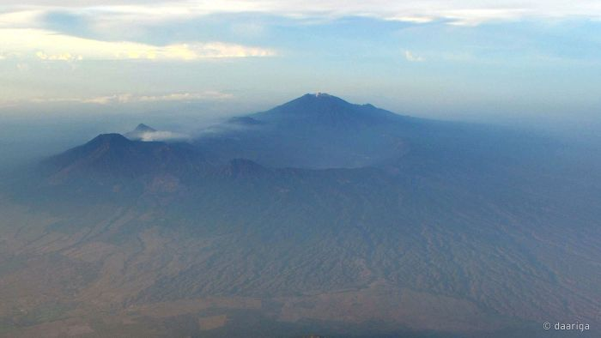  Volcano Safety

Useful Websites
- Popocatépetl volcano rumbles near Mexico City, coating towns with ash and disrupting flights – ABC News
- Tonga Volcano – BTN
- Volcanoes Explained – BTN
- Everything you need to know about volcanoes – Newsround
- What is a volcano? – Geoscience Australia
- Volcano Facts – National Geographic
- Structure of Volcanos – Australian Museum
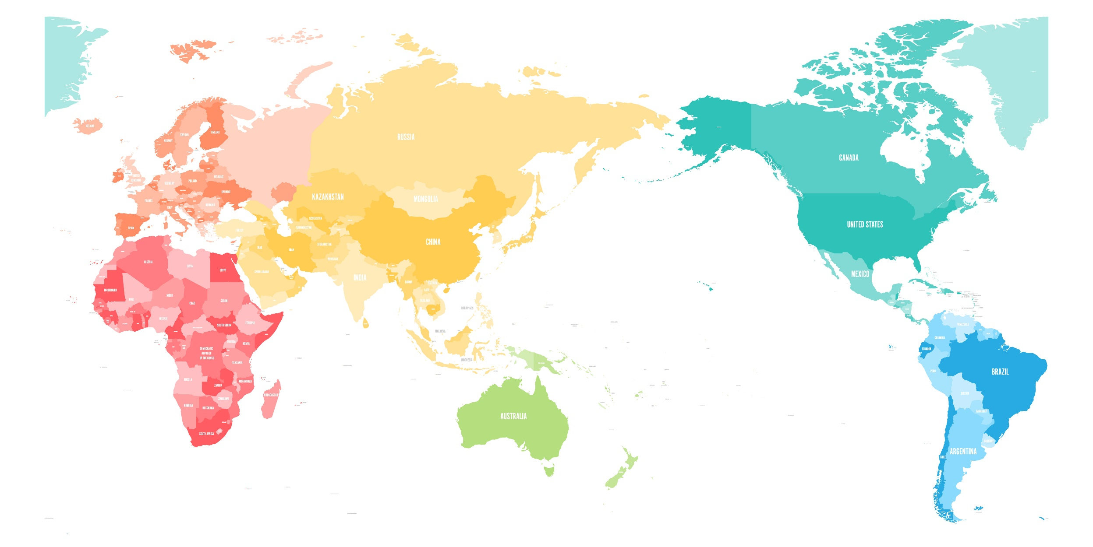

EPISODE 14
30th May 2023

KEY LEARNING
Students will learn more about pop artist, Andy Warhol and respond to his artwork. They will create a Warhol inspired artwork.

CURRICULUM
Visual Arts – Years 3 and 4
Explore where, why and how visual arts are created and/or presented across cultures, times, places and/or other contexts.

Use visual conventions, visual arts processes and materials to create artworks that communicate ideas, perspectives and/or meaning.

Share and/or display artworks and/or visual arts practice in informal settings.
Visual Arts – Years 5 and 6
Explore ways that visual conventions, visual arts processes and materials are combined to communicated ideas, perspectives and/or meaning in visual arts across cultures, times, places and/or other contexts.

Use visual conventions, visual arts processes and materials to plan and create artworks that communicate ideas, perspectives and/or meaning.

Select and present documentation of visual arts practice, and display artworks in informal and/or formal settings.
  - Teacher Resource

Andy Warhol

Focus Questions
Discuss the BTN story as a class and record the main points of the discussion. Students will then respond to the following:
- Who was Andy Warhol. Give three facts about him.
- What is pop art?
- In which decades did the pop art movement come about?
  - 1940s and 1950s
  - 1950s and 1960s
  - 1960s and 1970s
- What mediums did Warhol use to create his art?
- Do you like Warhol’s art? Why or why not?

Activity: Class Discussion
Discuss the Andy Warhol story as a class using the following questions to guide discussion:
- Before watching the BTN story, had you heard of Andy Warhol? What did you know about him?
- What is pop art? Come up with a class definition.
- How would you describe Warhol’s style?
- What are the subjects of his art?
- What techniques did he use to create his art?
- Why is Warhol considered an influential artist? What impact has his art had?
What themes does Andy Warhol explore in his work?
What questions do you have about Andy Warhol and pop art?

Activity: Glossary
Students will brainstorm a list of key words that relate to the BTN Andy Warhol story. Here are some words to get them started.
POP ART | POPULAR CULTURE | REPETITION
TECHNIQUE | SCREEN PRINTING | ICON

Activity: Responding to Warhol
Students will select one or more of the Warhol artworks below or choose another pop art piece by searching on the internet. They will analyse and reflect on the artwork and then respond to the questions below.
- What is your first impression of the artwork?
- Why do you think Warhol chose to create art about everyday objects and celebrities?
- What techniques did he use?
- What effect does repeating an image over and over have on the viewer?
- What themes are present in Warhol’s artwork?
- What do you think the Warhol’s art is trying to communicate?
- How does the artwork make you feel? What do you like about it?

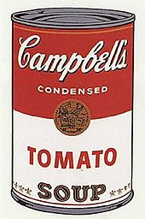  Campbell’s Soup | 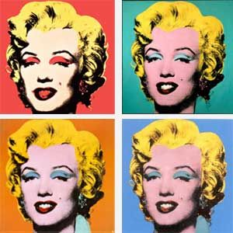  Shot Marilyns
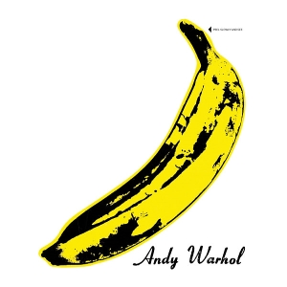  Banana | 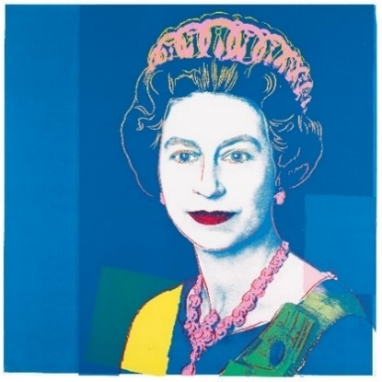  Queen Elizabeth II

Activity: Create a Warhol inspired artwork
Students will create an Andy Warhol inspired artwork or they can choose another pop artist such as Keith Haring or Roy Lichtenstein. Below are examples of their artwork.
- Begin by brainstorming some ideas for your artwork. What will be the subject of your artwork? Think about everyday objects (you could choose a soup can or piece of fruit) a popular culture icon or yourself as potential subjects. To create a pop art portrait, check out the NGV’s short video and teachers notes.
- What techniques will you use to create your artwork? (bright colours, repetition, bold lines). Think about taking a selfie or creating a self-portrait and repeating the image.

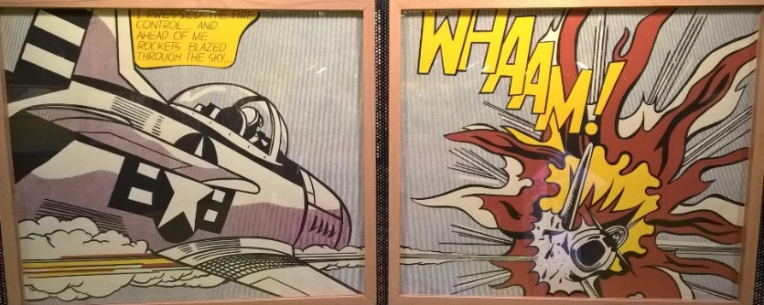
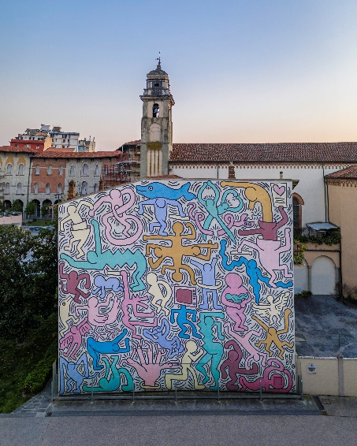

Whaam! – Roy Lichtenstein

Keith Haring
Pop Art Exhibition
Curate a class exhibition that showcases the students’ pop artwork. Invite students from other classes at your school to attend your exhibition. Consider holding your exhibition at your local library or local council.

Biography
Learn more about Andy Warhol’s life (or another pop artist) by creating a biography.
Your favourite pop art
Reflect on your favourite pop artwork. Give reasons why you like it.

Useful Websites
- Who is Andy Warhol? - Tate Kids
- Pop Art – Tate
- Andy Warhol Biography – The Warhol

  - Teacher Resource

BTN Transcript: Episode 14 - 30/5/2023

Hey, I'm Amelia Moseley and you're watching BTN. Thanks for hanging out with us again. Let’s see what’s coming up on today’s show. The debate over animal testing, we visit a pop art exhibition and are drop bears real? Hmm, Jack finds out.

Calling Out Racism

Reporter: Jack Evans

INTRO: We'll get to all that soon, but first up. Well known ABC presenter Stan Grant has announced he's stepping away from his job for a while. He says he's been experiencing a lot of racist abuse online and it's led to debate about who should be responsible for calling out racism and what we can all do about it. Take a look.

This is Stan Grant, he's a pretty well-known journalist and media personality on the ABC. He is a Wiradjuri man, and his Indigenous identity has shaped his perspective on social issues. Recently Stan was part of the ABC’s coverage of the King’s Coronation.
STAN GRANT: The symbol of that crown represented the invasion, the theft of land. Where's our treaty? Where is the recognition of what happened under the name of the crown?
Not everyone watching agreed with what Stan was saying and thought that it wasn't appropriate for him to share those views during a time of celebration. Stan quickly became the target of online harassment, in the form of derogatory racial comments and slurs. Which he spoke out about and gave as the reason for him deciding to take a break from the media.
STAN GRANT: Many of you would know by now that I'm stepping away for a little while. Sometimes we need to just take time out, sometimes our souls are hurting and so it is for me.
Stan also said he felt unsupported by the ABC when the racial attacks were happening and that when the ABC bosses did speak up it was too late.
LOWANNA GRANT, STAN GRANT'S DAUGHTER: It's really hard to see him struggling and that he's had to cop the racism and the disgusting filth that has been put online.
JACK, REPORTER: The whole thing has ignited a national conversation around racism here in Australia and it's raised the question about who should be responsible for calling it out. Because unfortunately this sort of thing happens all the time.
NINA, RECONCILIATION AUSTRALIA: From my perspective, you know, racism, sometimes it comes out of the blue, and it surprises you when you least expect it. And sometimes it's expected, you know, it's going to happen. It reminds you that sometimes there's a different set of rules for Aboriginal and Torres Strait Islander people than what there are for non-Indigenous Australians.
Nina is from National Reconciliation Week Australia and says that last year 60% of Aboriginal and Torres Strait Islander people surveyed, reported experiencing racism in at least one form or another.
NINA, RECONCILIATION AUSTRALIA: It can make you feel like hopeless and helpless. And it's tiring, it makes you feel tired. As young people experience racism at school, it means that they don't feel safe to be themselves, and they don't feel like they belong in that place.
Days after Stan Grant's announcement, NITV suspended its official Twitter account because of ongoing racism and hate on the platform. Twitter’s not the only social media company to be called out over what's happening. Victoria's Aboriginal treaty body has now publicly asked Facebook parent company Meta to better control racist abuse online. It says there's been a surge in hate speech, and it's linked to increased political debate about the Voice to Parliament and the upcoming referendum.
AMY RUST, FIRST PEOPLES' ASSEMBLY: It's not something that the Victorian community at large would accept as normal discourse. It’s offensive online, it’s offensive in person and Facebook need to step up and moderate.
They want stronger moderation and more protections for First Nations peoples. But lots of people reckon that's not enough on its own. Nina says that right now, especially during National Reconciliation Week, it's important for all Australians to come together and work towards eliminating racism.
NINA, RECONCILIATION AUSTRALIA: I think it's really important that children and young people know that when they see racism, they should speak up and call it out. But only if they feel safe to do so. Whenever you see an opportunity to educate someone, take it. And that's, that's what you can do as, as non-Indigenous people in Australia, you can help spread the word of the truth of the histories and everything else. That's what you can do to be an ally.

News Quiz

France has banned domestic flights that can be done by train in less than two and a half hours. Why have shorter flights been banned? Is it to save money, to save time or to reduce emissions? It’s a move aimed at reducing airline emissions by 40 percent by 2030.
Classifications for movies we watch at the cinema or on streaming services are about to change. How will they be different? Will the ratings be renamed, will they be more detailed, or will they stay on screen throughout. The ratings will be more detailed. They’ll provide viewers with a better explanation of the movie’s classification, including listings like animated violence and bullying.

Who is this super famous musician from the 70s and 80s? It’s Tina Turner. The “Queen of Rock’n’roll” has died at aged 83. She’s one of the most successful recording artists of all time with a string of huge hits.

Animal Testing

Reporter: Michelle Wakim

INTRO: Animal testing for things like makeup and hair products is banned in many parts of the world, including Australia. But over in the UK some animal testing has still been going on there despite a 25-year ban. And that's upset many shoppers and animal rights groups. Here's Michelle.

MICHELLE, REPORTER: When we talk about cosmetics, we're not just talking about makeup. Cosmetics include everything from toothpastes to sunscreen to bath bombs. It's a big business. Around the world it's believed we spend more than $380 billion dollars a year on products to make us look good. But there's an ugly side to the beauty business, animal testing.
MEMBER OF PUBLIC: Some people think that animal testing is just putting makeup on the animals when it's actually a lot like crueler than that.
MEMBER OF PUBLIC: And they test products on their eyes or their skin.
It all started around the 1950s. Heaps of new stuff was hitting the market but there weren't a lot of rules to make sure the products were safe. So, some people got burned, scarred or even worse from trying out dodgy products. It forced countries to bring in laws to make cosmetic companies test the safety of their products before they could be sold.

At the time they decided that the easiest way to do this was to test them on animals like rats, rabbits, dogs, cats and guinea pigs. Researchers would put substances on the animal's skin to look for blistering or scarring or in their eyes to test for redness.
But in the 80s word got out about animal testing and over time angry customers forced companies to find other ways to test products. Now there are heaps of alternatives like testing on donated tissue samples or artificial skin and body parts or simply using ingredients that we already know are safe. And there are even labels like these to show that a product is cruelty free.
MICHELLE: But despite these alternatives, animal testing is still legal in a lot of places around the world and people have a lot of opinions about it.
MEMBER OF PUBLIC: It's inhumane. Like, I don’t think you wouldn’t test on yourself, so why would you test on animals.
MEMBER OF PUBLIC: I've seen videos of animal testing and I'm not too happy about it because they're getting hurt.
MEMBER OF PUBLIC: It's very unethical and it's really horrible to hear about and it's bad they don't really tell us about it.
In many countries including Australia new medications and treatments have to be tested on animals before humans to make sure they're safe. But when it comes to cosmetic testing the government here passed a law in 2019 to stop the practise. There is an exception though. If an ingredient is used not just in cosmetics but on other stuff like household cleaning products, it's still allowed to be tested on animals.
MICHELLE: And on stores shelves here in Australia you can still find heaps of products that have been tested on animals overseas which can make it hard to spot and has a lot of people concerned.
It's a hot topic in the UK right now. Cosmetic testing has been banned there since 1998 but over the last few years the UK government has been giving out licenses which actually allow testing. You see in 2019 the government changed its policy to match the rules in the EU where some ingredients are allowed to be tested on animals to make sure they are safe for workers to handle. Animal rights groups and some big brands like The Body Shop have criticised the move especially because news of it has only come out recently.
MICHELLE: This reaction has kind of forced the government to back pedal, a little bit.

It now says that no new licenses will be given out to allow testing.
MEMBER OF PUBLIC: I think if I was aware that like one of my favourite companies or something was like animal testing, I wouldn't buy the product, yeah.
MEMBER OF PUBLIC: It would kind of influence how many times I would use that product because I would know that that animal could’ve been harmed by that product.
Volcanoes Explained

Reporter: Lyeba Khan

INTRO: One of the world's most active volcanoes has erupted in Mexico. Ash from Popocatépetl volcano, has delayed flights, closed schools, and covered cities. Lyeba finds out more about volcanoes and what makes some more dangerous than others.
Volcanoes. They're nature at its most spectacular. Their name comes from the word 'Vulcan', the Roman god of fire, and, well, you can see why. But while they're pretty cool to look at, they can also be dangerous. Just last week, a volcano in Mexico erupted, coating nearby towns in ash, forcing schools to close, and disrupting flights.
Esteban De Olarte Agustín, Santiago Xalitzintla Farmer: It was very active last night. It was rumbling, it was spewing a lot of ash and it was almost on fire.
Diana Vázquez, monitoring deputy director: It has been seen over the years that ash clouds can cause damage to aircraft turbines and if a turbine fails an imminent crash of an aircraft will occur.
It's called Popocatépetl and is one of the country's most active volcanoes. People here are, well, pretty used to it. But there's a lot going on here that we can't see.
Lyeba, REPORTER: Underneath the Earth's crust, that's the bit we live on and grow plants in, things get much hotter.
In fact, the centre of the Earth is as hot as the surface of the sun, which sends a lot of pressure out through the next layer, the mantle. In some spots, molten rock called magma pools at the surface of the mantle and breaks through weak spots in the crust as a volcano. Sometimes, it rushes out from the ground in streams of hot ash, gas and lava which is just what molten rock is called when it's above the ground.
Lyeba: Turns out, while lava may be incredibly hot it's actually not the most dangerous part of a volcano.
It usually moves pretty slowly, giving people time to get out of the way. This is the sort of volcanic eruption that's really dangerous. It's called a pyroclastic flow. It's when really hot ash and rock blast out and race down the sides of the volcano. It's too fast to outrun and destroys everything in its path. The most famous example of this is the eruption of Mount Vesuvius in 79 AD which smothered Pompeii, and everyone inside, under layers of hot ash.
Lyeba: But most of the time volcanoes are pretty manageable and countries have plans in place in case they do erupt.
Today, there are hundreds of active volcanoes around the world, although none of them are on mainland Australia. You see, the earth's outer layer is actually a bit like a jigsaw. It's broken into pieces, which are constantly and very slowly moving together. Where the jigsaw pieces meet there are often weak spots and gaps where volcanoes can form. And we're smack bang in the middle of one of those pieces, or tectonic plates. Mexico sits on top of three of Earth's largest tectonic plates so there are lots of active volcanoes in this area. For now, authorities are monitoring Popocatépetl and while they say there's no sign these small eruptions will turn into anything more destructive, they're staying on alert.

Andy Warhol Exhibition

Reporter: Amelia Moseley

INTRO: Next up to the famous pop artist Andy Warhol. He rose to fame during the 1960s thanks to his colourful prints and paintings of iconic celebrities and everyday items like soup cans. But it turns out he also had a passion for photography, and I headed down to an exhibition in Adelaide to learn more.

Amelia, Reporter: I'm here at the Art Gallery of South Australia where as you can see behind me, there is a big exhibition going on all about the artist Andy Warhol. So, who was he? What was he all about? Let's go in and find out.
AMELIA: Julie, can you tell me a little bit about Andy Warhol, the person? You know, what was his history? How did he become such a famous artist?
Julie ROBINSON, Curator, Art Gallery of SA: It's really interesting, because he grew up in a town called Pittsburgh in America. He had a really humble and poor upbringing, and after he graduated from college there, he left, and he went to New York. And New York is the place where you can reinvent yourself, and so he became an all-American artist and became very successful as a pop artist in New York.
The famous pop art movement came about in the US and UK in the 1950s and 60s, it took popular everyday culture and made it into art; from mass produced objects to celebrity icons, comic book style, and cartoons.
Julie ROBINSON, Curator, Art Gallery of SA: There were people out there that were thinking, you know ‘he's taking us for a ride. He’s just, this can't be art’. But actually, there were the people who supported him and thought it was fantastic and they've proved to be right, because his art is still as relevant today as it was, like, 50 or 60 years ago. They're in all the museums around the world, and they're very valuable works of art.
AMELIA: How valuable are we talking, Julie?
Julie ROBINSON, Curator, Art Gallery of SA: In the art gallery, you can't talk about value, but I just say, Google it.
This one went for nearly $293 million in 2022, making it the most expensive artwork by a 20th century artist ever sold. But anyway, Andy wasn't just into painting and screen printing. He also loved photography and video.
Christopher Makos, Warhol's Friend and Photographer: Andy was way ahead of his time. He was the original Kim Kardashian. I mean, he always was with a camera.
But his photos, often of famous people doing what he called 'unfamous' things were rarely seen. In fact, it wasn't until after he died that about 60,000 of them were discovered in his estate.
Julie ROBINSON, Curator, Art Gallery of SA: He photographed people in candid moments, his friends and famous people in candid moments. And when you look at them now they tell you where he was, who he was meeting, what he was doing, what he was eating, and it's like his Instagram feed but many, many years ago, all before social media existed and all before digital cameras existed.
AMELIA: Why do you think that Andy Warhol is still relevant to people today?
Zoe, Student: I think for me, personally, it's really interesting to see the culture of the time in famous spots like Studio 54 in New York, and I think that's what young people can relate to now is being able to see that sort of street culture and atmosphere and pop culture of that time.
Mackenzie, Student: I feel like a lot of it is to do with the amount of social issues he talked about, like looking through here, he's photographed some really big icons in history, as well as photos of trans and drag queens. I thought it was really relevant to today's society, especially with all that's going on in the political sphere.
Lara, Student: So, at the moment, I've started my folio for my year 12 design, and I'm looking at screen printing. So, being able to come and look at all his screen printing and all the different pieces was really great.
Amelia: Do you think you could be the next Andy Warhol, Lara?
Lara, Student: I don't know. He's very high up there.
Zoe, Student: Probably not. But would be nice to try.
Julie ROBINSON, Curator, Art Gallery of SA: Anyone could be the next Andy Warhol out there. It's just a matter of how you can get past the everyday and turn it into something extraordinary.
AMELIA: Well, that's something to aspire to.

Sport

Kokkinakis, Kubler and Hunter. Our Aussies are off to a flyer at the French Open. Jason Kubler grinded his way to a 5 set win while the weather was clear for Storm Hunter who cruised into the 2nd round. But it was Thanasi Kokkinakis that caused an upset taking down 20th seed Dan Evans in straight sets.
Over to Formula 1 and the most prestigious Grand Prix has turned into one of the slipperiest. After a downpour in Monaco drivers were slippin' and crashin' on the track, but eventually it was Red Bull's Max Verstappen who came out on top.
And finally, does Sam Kerr ever lose? If she does, I don't wanna know about it. The Aussie soccer superstar has helped Chelsea to win their 4th Women's Super League title in a row scoring twice in their 3-nil win over Reading.
Drop Bears

Reporter: Jack Evans

INTRO: For years, Australians have been scaring tourists with tales of drop bears; a koala-like carnivorous bear living in the treetops that drops onto the heads of its victims. But they're not real, surely? Well, researchers say the animal actually existed in parts of eastern Australia about 15 million years ago. Seriously, check it out.

DEBI EDWARD, SCOTTISH BROADCASTER: I've been told that this is quite a dangerous bear that's been known to attack people. It's called a drop bear because they drop out of the tree to attack people. I've just been handed it and had to put on all this protection gear because of what it might do to me. I'm not quite sure what it's doing right now.
Yeah to be fair I'd be a little worried too if I was handed what has been described as one of the most dangerous animals in Australia. But that's just a koala and the only thing it's going to attack are some eucalyptus leaves.
DEBI EDWARD, SCOTTISH BROADCASTER: You're kidding me. You're kidding me.
JACK, REPORTER: For years us Aussies have taken it upon ourselves to terrify tourists with tales of drop bears. But what are they exactly? Oh, that was weird.
Drop bears are said to be quite large, carnivorous creatures that inhabit the treetops of Australia. They have fangs, sharp claws and a ferocious appetite for their prey. Which they would capture by well dropping out of a tree and landing on them. Early settlers and explorers to Australia began circulating stories about the mysterious drop bear, as a way to scare children and outsiders from venturing too far. Over time the legend of drop bears became a part of Aussie culture. Alongside many other mythical Australian creatures.
JACK: But they're just that, mythical. Drop Bears aren't real or so we thought. Thanks to some new discoveries scientists think that perhaps something very similar to a drop bear may have actually existed. Where do those bears keep dropping from?
MICHAEL ARCHER, UNSW: I'm afraid I'm going to have to tell you that myth has sort of come back to life.
This is Michael Archer from the University of New South Wales. He and his team of researchers have been studying fossil remains of something called a Nimbadon. It was a mammal that lived in the rainforests of North West Queensland some 15 million years ago and after close inspection of its fossilised claws, they now believe Nimbadons may have hung out in trees and perhaps dropped from them, like a drop bear.
MICHAEL ARCHER, UNSW: These things were not running around on the ground, they were upside down in the trees over your head. So, and occasionally, you know, they made a little mistake, some of them would just drop, lose the grip and drop down. And you know, heaven forbid, they land on some of the animals down there.
JACK: Okay, so perhaps they weren't falling on purpose. But from the sounds of it you wouldn't want one dropping on you. Okay, right, who’s dropping those bears? Seriously I’m trying to, I’m trying to do a story.
MICHAEL ARCHER, UNSW: It's probably distantly related to koalas among living animals, but it was very different. It was 70 kilos. You're talking about a seriously large animal here. They had huge claws. You didn't want to grapple with one of these things.
Fortunately, they don't exist anymore. But learning about them helps us understand more about the unique Australian wildlife that lives alongside us today.
JACK: And as for drop bears, well trust me, they're just a myth and definitely don't exist. Oh god, what, okay no, okay, I get it they’re bears and they’re dropping.
Closer

Well, that’s it, thanks for hanging out with us again. We'll be back same time, same place next week. In the meantime, though, you can catch Newsbreak every weeknight right here in the studio. You can also check out our website where there's more news content and teacher resources for both primary and high schoolers. Have the best week and I'll see you soon. Bye.

